**The University of Hong Kong:**

**Supervisor statement 2025**

**Name: Hongshan Guo**

**Portrait Photo:**

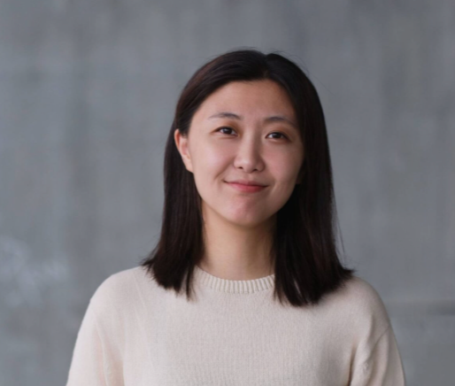

**Thesis Topics:** (200-500 words)

**Expertise and Research Interests:** My research centers on computational approaches to building performance optimization, with expertise in machine learning, deep learning, and large language model applications for architectural problems. I specialize in time series predictive analytics, data mining techniques, thermal comfort modeling, and building energy simulation. My work focuses on developing predictive systems that integrate multiple data streams for real-time building optimization and human-building interaction analysis.

**Methodology and Topics:** I supervise projects that apply rigorous computational methods to solve specific architectural design challenges. Methodologically, I emphasize data-driven approaches that combine empirical analysis with predictive modeling. Suitable research areas include: machine learning approaches for building energy prediction and optimization; time series analysis of occupant behavior and environmental performance data; deep learning models for thermal comfort prediction and personalized environmental control; large language model applications for design optimization and spatial analysis; data mining techniques applied to building performance datasets; IoT sensor networks integrated with predictive analytics for responsive building systems; and computational workflows that combine building simulation with machine learning optimization.

**Thesis Types and Requirements:** I supervise projects that demonstrate clear technical implementation pathways with measurable outcomes. Suitable typologies include residential, commercial, and institutional buildings where performance optimization is central to the design proposition. Technology-focused projects could be either hardware (sensors, control systems) or software-driven (algorithms, interfaces) in creating functioning prototypes or validated simulations.

Projects must include actual datasets, working code implementations, and validation methodologies, i.e. I will not supervise purely theoretical projects about computational design potential, projects that treat AI as a conceptual framework without concrete application, or traditional architectural design projects without significant computational components. Students must demonstrate programming capability (primarily Python) and willingness to learn relevant tools to their thesis topic.

**MODE OF SUPERVISING:** (100-200 words)

I provide individual thesis supervision with a technical coaching approach. Students develop their own research questions and architectural concepts while I provide expert guidance on computational implementation, methodological rigor, and technical feasibility. Consider me more as a technical coach to help make ambitious ideas achievable, not a director of research direction.

My supervision combines individual consultation with periodic group sessions for peer feedback and mock thesis defenses. This hybrid approach maximizes learning while respecting time constraints.

My supervision leverages expertise in machine learning, time series analytics, building simulation, and computational modeling to guide students toward technically rigorous solutions. I emphasize validated computational methods and concrete implementation. Projects that only leverage AI conceptually without concrete applications will not be considered.

This supervision style works best for students drawn to technically challenging problems that may initially appear infeasible, but who have curiosity and determination to investigate systematic approaches. Students should expect to engage with uncertainty, iterate through multiple approaches, and maintain persistence when facing technical obstacles. I will help you scope challenges appropriately to become achievable thesis projects within academic timeframes.

**Studio Preference:** Flexible - can accommodate both thesis studio and personal studio arrangements based on student preferences and project requirements.

**PREVIOUS SUPERVISED THESES:**

* None

**CONTACT:**

* hongshan@hku.hk
* KB722