Hidden Spatial Intelligence: Revealing Thermal Comfort Heterogeneity Through Occupant-Level Heat-Balance Assessment
Abstract
A single thermostat setpoint applied to one apartment produces substantial thermal comfort variation across rooms and occupant cohorts, with room-level PMV spans ranging from roughly one to nearly four units depending on cohort and setpoint. This paper presents a spatial comfort assessment framework that computes ISO 7730 heat-balance decomposition for individually placed occupant agents across a gridded floor plan, translating anticipated design conditions into occupant-level thermal outcomes. Applied to a 24-room apartment under 120 scenarios (five air temperatures, four humidity levels, six occupant cohorts spanning demographic and behavioral variation), the framework produces 2,520 agent-level records and per-agent JSON snapshots carrying full convective, radiative, evaporative, and respiratory heat-loss breakdowns. In the apartment case, orientation-driven mean radiant temperature offsets shift radiative heat loss by about 5 W/m², while cohort configurations involving clothing and activity shift convective and radiative loss by similar magnitudes. These effects are comparable in order: the architectural plan is not a passive container for thermal conditions but an active participant in the comfort equation. The framework surfaces this hidden spatial intelligence without energy modeling or computational fluid dynamics, operating at the resolution and speed accessible to designers during early design.
Keywords: thermal comfort, spatial intelligence, heat-balance decomposition, PMV, floor plan assessment
1 Introduction
Room orientation, plan depth, and adjacency to exterior walls carry thermal consequences that propagate to occupant experience. Standard practice evaluates these consequences at the building level through energy models reporting zone-average temperatures and aggregate loads. The embedded assumption is that comfort within a conditioned zone is uniform: set the thermostat, and the zone is comfortable.
This assumption conceals substantial heterogeneity. Under a single 25°C setpoint, mean radiant temperature varies by orientation, air velocity varies by room function, and occupants themselves modulate the thermal balance through their age, body mass, clothing, and activity. A south-facing bedroom occupied by an elderly person in light clothing produces a fundamentally different thermal experience than a north-facing kitchen with a younger person standing and cooking. The plan encodes this differentiation. Conventional tools do not reveal it.
This paper presents a framework that translates anticipated design conditions into individual-level heat-balance outcomes across a floor plan. The framework computes ISO 7730 Predicted Mean Vote for each placed occupant agent and decomposes the result into convective, radiative, evaporative, and respiratory heat-loss pathways. Distributing agents across a settled design and sweeping environmental parameters reveals hidden spatial intelligence: thermal comfort patterns latent in the spatial organization but invisible in drawings or zone-level outputs.
The underlying data model captures a holistic snapshot of each occupant’s experience: thermal state, lighting, acoustics, spatial context, demographics, and preferences. This paper exercises the thermal channel quantitatively, demonstrating that the agent-level structure supports rigorous heat-balance analysis at the plan scale.
The contribution is threefold: (1) a lightweight, deterministic framework linking spatial design to occupant-level thermal decomposition; (2) a 120-scenario apartment case study demonstrating that spatial geometry and body configuration produce comparable magnitudes (~5 W/m²) of heat-transfer heterogeneity; and (3) evidence that floor plans contain recoverable thermal intelligence that zone-level analysis does not surface.
To be clear about what this framework does and does not do: it does not optimize a plan. It reveals where a given design becomes population-conditioned and spatially fragile, where comfort outcomes diverge sharply across occupant profiles and room positions. This changes early design judgment about room assignment, orientation, partition placement, glazing specification, and environmental setpoints, because the consequences of those decisions become visible before construction.
2 Related Work
Fanger’s Predicted Mean Vote model (Fanger 1970), codified in ISO 7730 (ISO 2005) and ASHRAE Standard 55 (ASHRAE 2020), remains the primary analytical framework for assessing steady-state thermal comfort in mechanically conditioned buildings. The model resolves the six-variable heat balance—air temperature, mean radiant temperature, relative humidity, air velocity, metabolic rate, and clothing insulation—into a single-index prediction of occupant thermal sensation. Its strength lies in its traceability: every intermediate quantity, from clothing surface temperature to convective film coefficient, is computable and auditable.
In practice, however, the PMV model is typically applied at the zone level. The CBE Thermal Comfort Tool (Tartarini et al. 2020) provides an accessible web-based calculator for evaluating individual conditions but does not map comfort across spatial layouts. Building performance simulation platforms such as EnergyPlus (Crawley et al. 2008) produce zone-level temperature and humidity outputs that feed PMV calculations, but the spatial resolution stops at the zone boundary—room-to-room gradients within a single dwelling are collapsed. Higher-fidelity approaches including computational fluid dynamics and zonal models (Megri and Haghighat 2007) can resolve spatial thermal fields but require substantial modeling effort and computational time, placing them outside the workflow of most architectural designers.
Agent-based modeling has a longer history in architectural research, primarily for pedestrian movement simulation, evacuation analysis, and space utilization studies (Yan and Kalay 2006). Agents serve as spatial probes: by distributing synthetic occupants across a design and tracking their experience, patterns emerge that static analysis cannot reveal. Extending the agent metaphor to thermal comfort—placing thermally characterized agents on a floor plan and computing their individual heat balance—is the approach this paper takes.
Adaptive comfort models (de Dear and Brager 1998; Nicol and Humphreys 2002) have broadened the theoretical frame beyond PMV by incorporating occupant behavioral adaptation, but these models are most applicable to naturally ventilated buildings and do not decompose the heat balance into spatial components.
More broadly, computational architecture has developed a tradition of making latent spatial performance visible through analysis feedback. Space Syntax (Hillier and Hanson 1984) revealed measurable connectivity and integration patterns in plans that were invisible to inspection alone. Daylighting analysis, pedestrian simulation, and acoustic mapping followed the same pattern: translating a spatial design into a performance field that designers can read and act on. The framework presented here extends this tradition to thermal comfort at the individual occupant level. The plan is treated not as a container to be conditioned uniformly but as a differentiated field whose spatial organization produces heterogeneous thermal outcomes that are recoverable through computation.
3 Methods
3.1 Framework Overview
The framework operates on three input layers (Figure 1). The first is spatial geometry: a grid-based floor plan with rooms defined as contiguous sets of cells, bounded by walls and connected by doors and openings. The second is environmental conditions: each room carries a static set of anticipated design parameters (air temperature, mean radiant temperature, relative humidity, air velocity, illuminance, and background noise level) assigned from design specifications rather than simulated. The third is occupant agents: individually placed persons characterized by demographics, clothing insulation, activity level, and preferences.
The framework is structured to accept any floor plan that can be segmented into rooms with assigned environmental conditions. Geometry enters through an assisted PDF import tool that traces architectural drawings onto the working grid, or through a direct Rhino export pathway. The apartment presented in this paper is one instance; the pipeline is structured to accommodate other typologies (offices, healthcare facilities, educational buildings) provided room-level conditions can be reasonably anticipated, though these have not been validated in the current study. An online version of the geometry import and assessment tools is available (URL withheld for anonymous review).
These three layers feed a deterministic heat-balance engine that computes ISO 7730 PMV and full thermal decomposition per agent. The computation is not a simulation in the dynamic sense: room states do not evolve over time, and occupant heat gains do not feed back into room conditions. The tool evaluates the instantaneous thermal balance at each agent’s position given the specified conditions. This is a calculation, not a simulation. The distinction is deliberate: the framework runs instantly and produces fully traceable results, enabling rapid iteration during design.
The per-agent output is a structured JSON snapshot (Figure 2) carrying the full context of one occupant’s experience: environment, spatial position, computed thermal state with heat-loss decomposition, demographics, and preferences. The record is computationally grounded in empirical heat-transfer relationships while remaining structured for downstream consumption by analytical or interpretive tools.
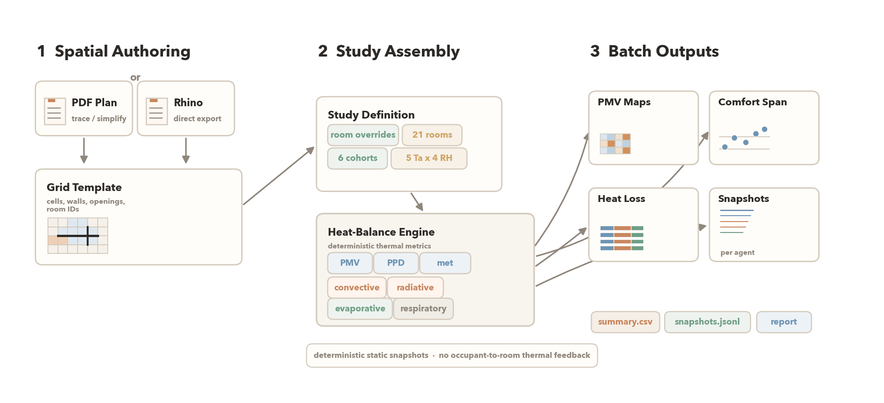
Figure 1. Workflow from plan authoring to batch outputs. PDF- or Rhino-derived geometry is simplified into a grid-based template, enriched with room conditions and occupant cohorts, then evaluated by thermBAL’s deterministic heat-balance engine to produce PMV maps, comparative plots, and per-agent JSON snapshots.
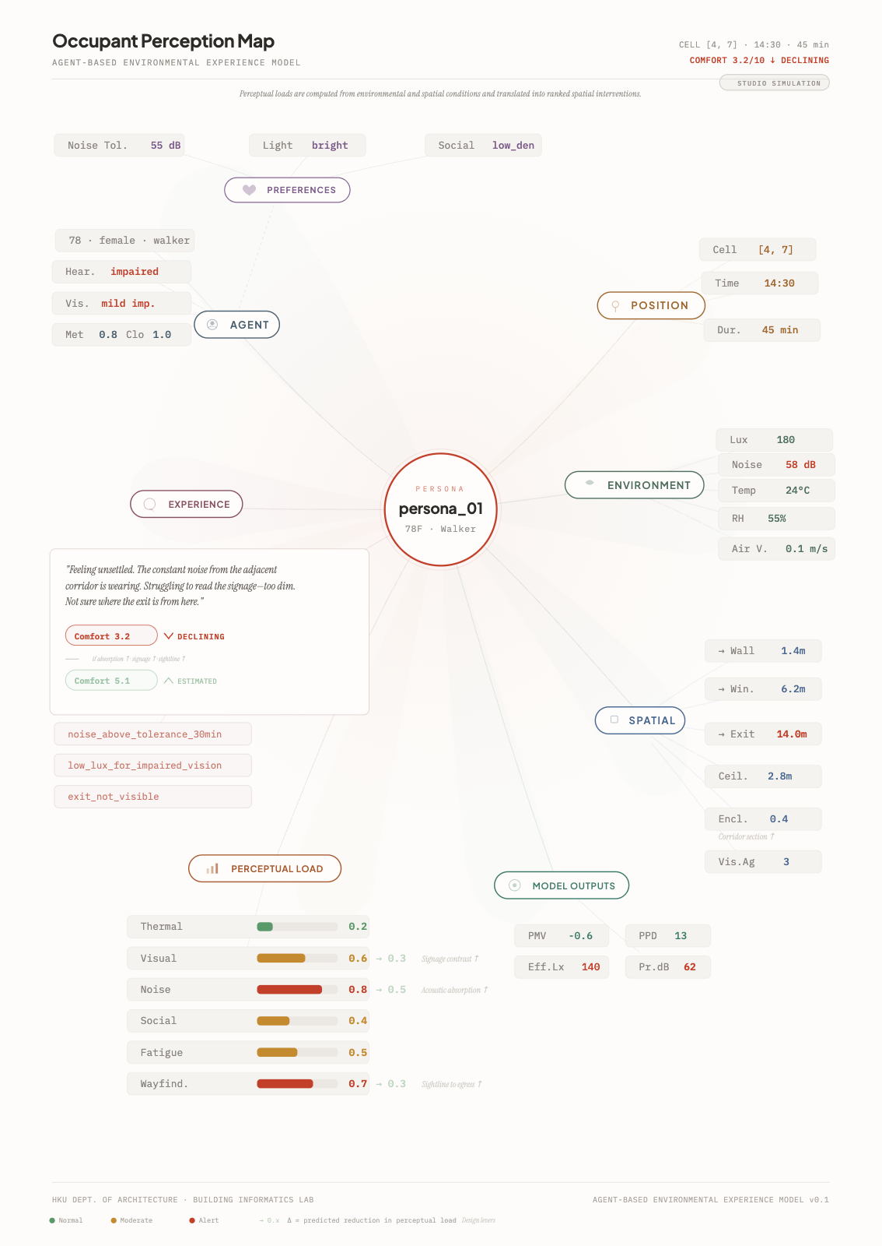
Figure 2. Occupant perception map showing the structured snapshot for one agent. The record carries environment, spatial context, computed thermal state with heat-loss decomposition, agent demographics, and subjective preferences.
3.2 Thermal Computation
The thermal core implements the standard ISO 7730 iterative procedure. Metabolic rate is estimated from occupant demographics using the Mifflin-St Jeor basal metabolic rate equation (Mifflin et al. 1990) scaled by a Du Bois body surface area estimate (Du Bois and Du Bois 1916), then adjusted by an activity multiplier corresponding to seated, standing, or walking postures. Clothing insulation converts to the intrinsic thermal resistance of the clothing ensemble.
The iterative solver finds the clothing surface temperature at which the heat-balance equation is satisfied, then computes each outgoing heat-transfer pathway independently: convective loss from the clothing surface to ambient air, radiative exchange between the clothing surface and surrounding surfaces at the mean radiant temperature, evaporative loss through skin diffusion and regulatory sweating, and respiratory heat loss through convection and evaporation in the lungs. These four components—reported in watts per square meter of body surface area—are preserved in the agent snapshot alongside the aggregate PMV and PPD values. It is this decomposition that enables the spatial analysis presented in the results: by examining which heat-loss channel varies across rooms or across occupant profiles, the framework reveals the physical mechanism driving comfort heterogeneity, not merely its summary index.
3.3 Case Study Design
To demonstrate the framework on a realistic plan, the case study uses a 24-room apartment traced from architectural drawings through the PDF import pipeline. The plan is discretized onto a 32×24 meter grid at one-meter cell resolution (Figure 3). Twenty-one rooms are occupied; three circulation zones are excluded. The apartment was selected as a reasonably generic residential typology; the framework is equally applicable to any plan that can be segmented into rooms with assigned conditions.
Environmental conditions are assigned deterministically rather than simulated. Air temperature and relative humidity are set uniformly across the apartment for each scenario, representing a centrally conditioned dwelling. Mean radiant temperature is differentiated by solar exposure: south-facing rooms receive a +1.5 K offset above air temperature, east- and west-facing rooms receive +0.75 K, and north-facing or interior rooms receive no offset. Air velocity is assigned by room function: 0.08 m/s for bedrooms, 0.12 m/s for day spaces, 0.15 m/s for the kitchen, 0.08 m/s for bath and laundry spaces, and 0.10 m/s for the remaining support rooms. These values represent typical conditions in a mechanically cooled apartment during daytime operation.
Six occupant cohorts are defined to span a range of demographic and behavioral profiles: a mixed-gender young cohort (ages 25–45), a male-only control, an age-shifted cohort (+50 years), a higher-clothing sedentary cohort, a lighter-clothing mobile cohort, and a higher-BMI cohort. Within each cohort, individual agent demographics are generated from a seeded random process producing variation in age, height, weight, and sex assignment across the 21 occupied rooms. Clothing insulation and activity level are assigned by room function and modified by cohort definition.
The climate sweep covers five air temperatures (20.0, 22.0, 23.5, 25.0, 28.0°C) and four relative humidity levels (35, 55, 75, 80%), producing 20 environmental conditions per cohort and 120 scenarios total. Each scenario places 21 agents—one per occupied room—yielding 2,520 individual agent records with full heat-balance decomposition.
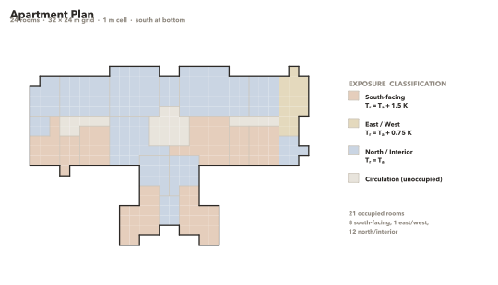
Figure 3. Apartment plan with 24 rooms classified by solar exposure. South-facing rooms receive a mean radiant temperature offset of +1.5 K; east/west rooms receive +0.75 K; north and interior rooms receive no offset.
4 Results
4.1 Spatial Comfort Heterogeneity Under Varying Design Conditions
Figure 4 presents the central result as a three-by-three matrix of apartment plans colored by occupant PMV. Columns correspond to three occupant cohorts (higher clothing, young mixed, and age-shifted), and rows correspond to three air temperature setpoints (20, 25, and 28°C), all at 55% relative humidity. Reading horizontally across any row reveals the body-configuration effect: at the same temperature, the higher-clothing cohort shows consistently milder thermal stress than the age-shifted cohort, with mean PMV differences of roughly 1.1 to 2.4 units across the shown setpoints. Reading vertically down any column reveals the design-condition effect: raising the setpoint from 20 to 28°C shifts the entire comfort landscape from deep cold stress to near-neutral or mildly warm conditions for some cohorts while older occupants remain cooler overall.
Critically, the spatial pattern within the plan is visible at every combination. South-facing rooms consistently appear warmer than north-facing rooms due to the mean radiant temperature offset, producing a legible thermal gradient across the plan that persists regardless of cohort or setpoint. The framework makes this gradient—encoded in the spatial organization but invisible in conventional plan representations—directly visible.
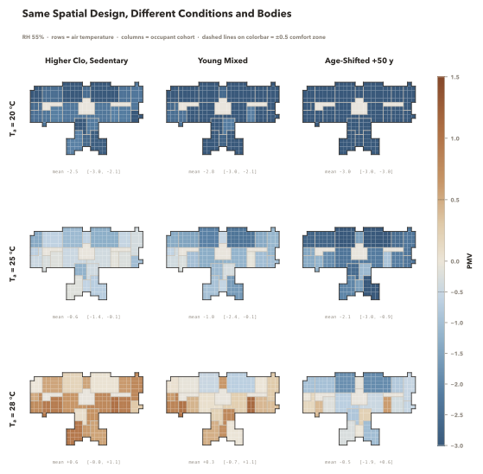
Figure 4. Same spatial design under varying conditions and bodies. Columns: three occupant cohorts. Rows: three air temperature setpoints (20, 25, 28°C). Room color encodes occupant PMV clamped to [−3, +1.5]. All scenarios at 55% RH.
4.2 Quantified Comfort Span
Figure 5 presents the comfort span as a strip chart plotting each occupant’s PMV across five air temperatures for three cohorts. Each dot represents one agent in one room; marker shape encodes solar exposure. Several patterns are immediately apparent.
First, within any cohort column at any temperature, the vertical spread of dots spans roughly one to nearly four PMV units depending on cohort and setpoint. This is the spatial component of the heterogeneity: the floor plan produces meaningfully different thermal conditions room to room even under a uniform setpoint. Second, between cohort columns at the same temperature, the cohort means separate by roughly one to more than two PMV units. The spatial and demographic effects compound. Third, south-facing rooms (triangular markers) consistently plot above north-facing rooms (circular markers) within each cohort, confirming that the MRT gradient from orientation is a persistent and legible spatial signal. Fourth, the span narrows as temperature increases toward the comfort zone, but it does not disappear, indicating that the spatial intelligence encoded in the plan is a structural feature of the design, not an artifact of extreme conditions.
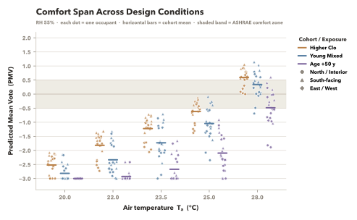
Figure 5. Comfort span across design conditions. Each dot is one occupant; horizontal bars show cohort mean. Marker shape encodes solar exposure. Depending on cohort and setpoint, the within-plan PMV spread ranges from roughly 1 to nearly 4 units and narrows toward the comfort zone without disappearing.
4.3 Heat-Balance Decomposition
Figure 6 presents the heat-loss decomposition for the young mixed cohort at 25°C and 55% relative humidity. Each horizontal bar represents one occupied room, sorted by total heat loss and divided into convective, radiative, evaporative, and respiratory components. Exposure zone is indicated by color chips on the left margin; mean radiant temperature and air velocity are annotated on the right.
Total heat loss ranges from 58 to 69 W/m² across the 21 rooms. The variation is driven primarily by two spatial factors. The radiative component drops approximately five watts per square meter from north-facing rooms (mean radiant temperature equal to air temperature) to south-facing rooms (mean radiant temperature 1.5 K above air temperature). This is the thermal signature of solar exposure encoded in the plan’s orientation. The convective component peaks in the kitchen at 28.1 W/m², driven by the higher assigned air velocity of 0.15 m/s, compared to 22–23 W/m² in bedrooms at 0.08 m/s. Evaporative and respiratory losses are comparatively uniform across rooms, contributing approximately 11 and 4 W/m² respectively, and varying primarily with individual metabolic rate rather than room conditions.
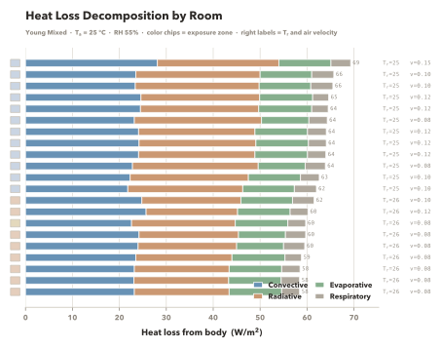
Figure 6. Heat-loss decomposition for the young mixed cohort at 25°C / 55% RH. Stacked bars show convective, radiative, evaporative, and respiratory components per room, sorted by total heat loss. Exposure chips on left; room conditions on right.
5 Discussion
5.1 Comparable Magnitudes of Spatial and Body Effects
Figure 7 plots convective against radiative heat loss for each room in three cohorts at 25°C. Color encodes cohort; marker shape encodes solar exposure. A diagonal reference marks equal convective and radiative loss.
Three findings emerge. First, cohort clusters separate clearly along both axes. At 25°C / 55% RH, the higher-clothing sedentary cohort shifts mean convective and radiative loss down by about 4.8 and 5.0 W/m² respectively relative to the young mixed baseline. The body acts as a thermal shell modulating multiple outgoing pathways simultaneously.
Second, within each cohort cluster, south-facing rooms (triangles) pull down by approximately 5 W/m² in radiative loss relative to north-facing rooms (circles), while convective loss shifts only slightly. The orientation-driven MRT gradient modulates the radiative pathway directly without proportionally affecting convection.
The central finding is that these two effects are comparable in magnitude. A 1.5 K MRT offset from room orientation and a cohort configuration change centered on higher clothing and reduced activity each displace the heat-transfer balance by roughly 5 W/m². Design decisions about spatial organization carry thermal consequences of the same order as the occupant variables designers typically consider uncontrollable. The plan is not thermally neutral. It is an active participant in the comfort equation.
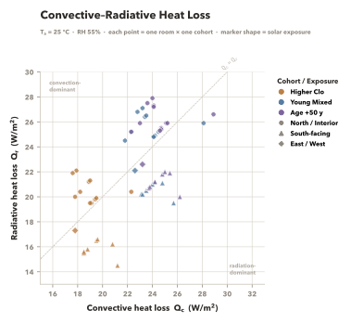
Figure 7. Convective versus radiative heat loss per occupant for three cohorts at 25°C. Marker shape encodes exposure. Spatial factors (orientation) and cohort configuration effects (especially clothing and activity) shift heat loss by comparable magnitudes on the order of 5 W/m².
5.2 Limitations
Several hard limitations bound the current results and should be stated plainly. All room environmental conditions are static and hand-authored: air temperature, mean radiant temperature, humidity, and air velocity are assigned per room from anticipated design values, not derived from simulation. Occupant heat gains do not feed back into room state. A room occupied by twenty people will report the same air temperature as an empty one. This is the most consequential simplification.
Grid resolution is one meter. This is adequate for room-level comfort mapping but does not resolve microclimate gradients near windows, radiant panels, or diffusers. Mean radiant temperature is differentiated by exposure classification (south, east/west, north/interior) rather than by geometric view-factor calculation, and no solar penetration or radiant asymmetry is modeled. The MRT offsets used in this study (+1.5 K south, +0.75 K east/west) are reasonable assumptions for a daytime-cooled apartment but are not derived from radiation modeling.
The PMV model itself is validated for steady-state conditions within a bounded input range. Values approaching ±3 should be interpreted as indicators of strong thermal stress rather than precise predictions of occupant sensation. Some plotted PMV figures in this paper are clamped on the cold side for legibility, but the stored batch outputs retain the full computed range.
5.3 Design Interventions and Future Work
Within these limitations, the framework supports design interventions beyond those exercised in this case study. Modifying wall partitions changes room geometry and zone assignment. Increasing glazing area or changing facade type alters the mean radiant temperature assigned to affected rooms. Adjusting mechanical ventilation changes per-room air velocity. Each intervention propagates instantly through the heat-balance engine, enabling real-time comparison of comfort outcomes across plan variants.
The occupant model accepts arbitrary agent definitions beyond the six cohorts presented here, including high-density layouts and sparse occupancy patterns. Scheduled events allow agents to move between rooms and change clothing or activity over time. Future work will address transient room-level coupling, view-factor-based MRT calculation, and probabilistic agent placement to quantify comfort robustness across occupancy scenarios. The data model already carries fields for illuminance, background noise, and social density alongside the thermal variables exercised here, positioning the framework for multi-channel environmental quality assessment.
6 Conclusion
This paper presented a spatial thermal comfort assessment framework that computes occupant-level heat-balance decomposition from anticipated design conditions across a floor plan. Applied to a 24-room apartment under 120 scenarios, the framework reveals persistent comfort heterogeneity ranging from roughly one to nearly four PMV units within a single plan under uniform setpoints—a hidden spatial intelligence that is encoded in the plan’s geometry and environmental differentiation but invisible in conventional representations.
The heat-balance decomposition provides the mechanism behind the heterogeneity. Spatial factors—primarily orientation-driven mean radiant temperature gradients—and body-configuration factors—in this case most visibly clothing and activity configuration—shift heat loss by comparable magnitudes on the order of five watts per square meter. These comparable magnitudes suggest that the architectural plan is not a passive container for thermal conditions but an active instrument whose spatial decisions carry thermal consequences on the same order as the occupant variables that designers do not typically control.
By making spatial thermal intelligence visible and quantifiable at the plan level, without requiring energy simulation or computational fluid dynamics, the framework supports informed design decisions about room layout, orientation, partition placement, glazing, and environmental specification before physical construction. The holistic data model, which already carries lighting, acoustic, and preference fields alongside the thermal channel exercised here, positions this work for extension to multi-channel environmental quality assessment at the same spatial resolution.
References
ASHRAE. 2020. ANSI/ASHRAE Standard 55-2020: Thermal Environmental Conditions for Human Occupancy. Atlanta: ASHRAE.
Crawley, Drury B., Jon W. Hand, Michaël Kummert, and Brent T. Griffith. 2008. “Contrasting the Capabilities of Building Energy Performance Simulation Programs.” Building and Environment 43 (4): 661–673.
de Dear, Richard J. and Gail S. Brager. 1998. “Developing an Adaptive Model of Thermal Comfort and Preference.” ASHRAE Transactions 104 (1): 145–167.
Du Bois, Delafield and Eugene F. Du Bois. 1916. “A Formula to Estimate the Approximate Surface Area if Height and Weight Be Known.” Archives of Internal Medicine 17 (6): 863–871.
Fanger, Poul O. 1970. Thermal Comfort: Analysis and Applications in Environmental Engineering. Copenhagen: Danish Technical Press.
Fountain, Marc and Charles Huizenga. 1995. “A Thermal Sensation Model for Use by the Engineering Profession.” ASHRAE Technical Data Bulletin 11 (1): 1–12.
Hillier, Bill and Julienne Hanson. 1984. The Social Logic of Space. Cambridge: Cambridge University Press.
Holopainen, Riikka. 2012. “A Human Thermal Model for Improved Thermal Comfort.” VTT Science 23. Espoo: VTT Technical Research Centre of Finland.
ISO. 2005. ISO 7730:2005 Ergonomics of the Thermal Environment—Analytical Determination and Interpretation of Thermal Comfort Using Calculation of the PMV and PPD Indices and Local Thermal Comfort Criteria. Geneva: International Organization for Standardization.
Megri, Ahmed Cherif and Fariborz Haghighat. 2007. “Zonal Modeling for Simulating Indoor Environment of Buildings: Review, Recent Developments, and Applications.” HVAC&R Research 13 (6): 887–905.
Mifflin, Mark D., Sachiko T. St Jeor, Lisa A. Hill, Barbara J. Scott, Sandra A. Daugherty, and Young O. Koh. 1990. “A New Predictive Equation for Resting Energy Expenditure in Healthy Individuals.” American Journal of Clinical Nutrition 51 (2): 241–247.
Nicol, J. Fergus and Michael A. Humphreys. 2002. “Adaptive Thermal Comfort and Sustainable Thermal Standards for Buildings.” Energy and Buildings 34 (6): 563–572.
Tartarini, Federico, Stefano Schiavon, Tyler Cheung, and Tyler Hoyt. 2020. “CBE Thermal Comfort Tool: Online Tool for Thermal Comfort Calculations and Visualizations.” SoftwareX 12: 100563.
Yan, Wei and Yehuda E. Kalay. 2006. “Simulating the Behavior of Users in Built Environments.” Journal of Architectural and Planning Research 23 (4): 289–310.

