Jens-Peter Kopelke, Tommi Nyman, Kévin Cazelles, Dominique Gravel, Steve Vissault, Tomas Roslin. 2016. Food-web structure of willow-galling sawflies and their natural enemies across Europe. Ecology XX:XXX. http://dx.doi.org/XXXXX

# Metadata

## Class I. Data Set Descriptors

### A. Data Set Title

Food-web structure of willow-galling sawflies and their natural enemies across Europe.

### B. Data Set Identification Code

Salix_webs.xlsx and CSV file

### C. Data Set Description

#### General Description

The data set includes 2029 spatiotemporally explicit records of 641 site-visits across 374 unique sites (Fig. 1A) visited over 29 years. It includes snapshot community data of gall-inducing sawflies (Hymenoptera: Tenthredinidae: Nematinae: Euurina) and their diverse natural enemies (hymenopteran parasitoids and coleopteran, lepidopteran, dipteran, and hymenopteran inquilines) encountered on willows (*Salix* spp.). Each entry (row) in the data matrix includes information about the location of the study site, the date of visit, the *Salix* and galler species inspected, the number of galls collected and dissected or reared, the taxa recorded in the galls, the taxonomic affinity of the nodes (species, genus, family and order), the gall type (for herbivores) and the mode of parasitism (for natural enemies). Most sites were visited only once, with a few sites visited during multiple years (Fig. 1B).

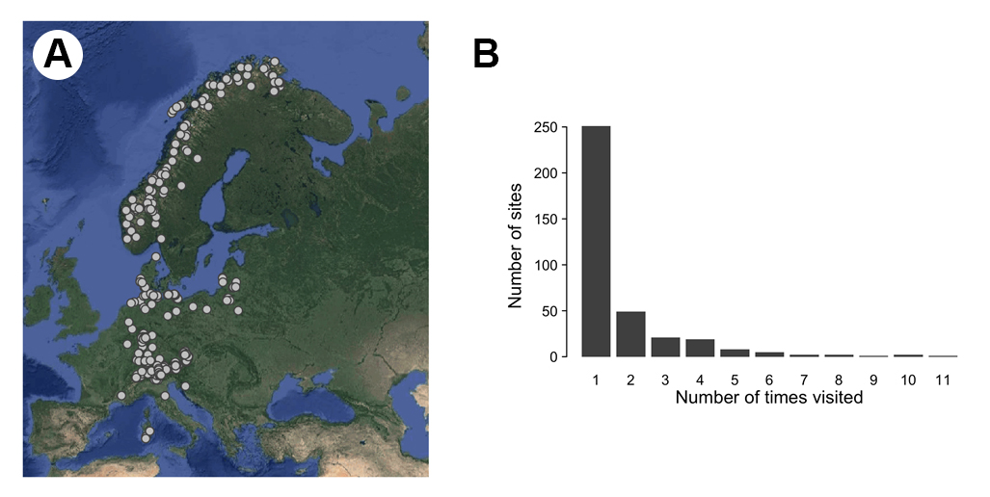

Fig. 1. Distribution of sampling sites (A), and of number of visits per each unique site (B). Note that the R scripts for recreating both panels are offered below (see Section IV C. Tools for Working with the Data).

#### Principal Investigators

Jens-Peter Kopelke, Senckenberg Research Institute and Natural History Museum Frankfurt, Senckenberganlage 25, D-60325 Frankfurt, Germany

Tommi Nyman, Department of Environmental and Biological Sciences, University of Eastern Finland, P.O. Box 111, FI-80101 Joensuu, Finland

Kévin Cazelles, Departement de Biologie, Chimie et Géographie, Université du Québec à Rimouski, 300 Allée des Ursulines, Rimouski, QC G5L 3A1, Canada

Dominique Gravel, Departement de Biologie, Faculté des Sciences, Université de Sherbrooke, 2500 Boulevard de l'Université, Sherbrooke, QC J1K 0A5, Canada

Steve Vissault, Departement de Biologie, Faculté des Sciences, Université de Sherbrooke, 2500 Boulevard de l'Université, Sherbrooke, QC J1K 0A5, Canada

Tomas Roslin, Department of Ecology, Swedish University of Agricultural Sciences, SE-750 07 Uppsala, Sweden

#### Abstract

Communities consist of species and their interactions. They can thus be described as networks, with species as nodes and interactions as links. Within such networks, the diversity of nodes and the distribution of links may affect patterns of energy transfer between trophic levels, the dynamics of the system, and the outcome in terms of ecosystem functioning. To date, most descriptions of networks have focused on single or relatively few sites, and have oftentimes been built on poorly-resolved nodes and links. Yet, comparisons of local interaction networks reveal variation in space and in time – thus spurring interest in methods and theory for understanding patterns, drivers and consequences of this variation. Progress in this field relies on access to replicate samples of comparable food webs across large spatiotemporal scales, resolved to species rather than to compound nodes. Due to the massive efforts required, high-quality data sets are still scarce. We created a data set on a single community type sampled across Europe: willow species (Salix), willow-galling sawflies (Hymenoptera: Tenthredinidae: Nematinae: Euurina), and their natural enemies (hymenopteran parasitoids and coleopteran, lepidopteran, dipteran, and hymenopteran inquilines). Each sample was referenced in space and time, and each node resolved with the highest possible resolution, including taxonomic affinity, gall type (for herbivores) and mode of parasitism (for natural enemies). Galler survival and link structure were resolved by dissection and rearing of gall inhabitants. In total, the data set is based on 641 site-visits over 29 years, and on 165,424 galls representing 96 herbivore nodes and 52 plant nodes. The dissections and rearings yielded 42,129 natural enemies belonging to 126 species, and revealed 1,173 different links. The spatiotemporal and taxonomic resolution of these data make them amenable to analyses of both ecological and evolutionary processes of network assembly. Thus, this data set will facilitate testing of important hypotheses in recent community theory, concerning, e.g., the sampling effort needed to adequately describe interaction structure within ecological communities, the impact of environmental conditions and biotic filters on the distribution of species and their interactions, and the relationship between the global ‘metaweb’ and its local realizations.

D. Key Words

Europe; trans-continental census; decadal census; ecological interaction networks; food webs; spatiotemporal community structure; trophic interactions; galler; parasitoid; inquiline; *Salix*.

## Class II. Research Origin Descriptors

### A. Overall Project Description

#### Identity

A spatiotemporally explicit compilation of local food web structure on *Salix* including naturally occurring, gall-forming herbivores and their natural enemies.

#### Period of Study

Sampling conducted from 1982 to 2010.

#### Sources of Funding

The collection trips of J.-P. Kopelke were financially supported by the Deutsche Forschungsgemeinschaft (DFG: 1990, 1993, 1999, 2000) and the research foundations of the Senckenbergische Naturforschende Gesellschaft (Ungerer-Stiftung, Rüppell Expeditions Fond) (SNG: 1985, 1988, 1997, 2001). The compilation of this data set was supported by the Academy of Finland (grant number 14868 to TN).

### B. Research Motivation

Ecological communities consist of species and their interactions. They can thus be described as networks, with species forming the nodes and interactions the links (Ings et al. 2009). Within such networks, the diversity of nodes and the distribution of links may affect patterns of energy transfer between trophic levels, the dynamics of the system, and the outcome in terms of ecosystem functioning (Thompson et al. 2012). How food webs are structured is also informative of patterns and processes occurring over longer time spans. By comparing food web structure to phylogenetic signal, we may explore how interacting species coevolve (Nyman et al. 2007, 2015; Vazquez et al. 2009; Rafferty and Ives 2013; Fontaine and Thébault 2015).

Now evidence is mounting that interaction networks vary considerably in space and time (Tylianakis et al. 2007; Kaartinen and Roslin 2011, 2012; Baiser et al. 2012; Martín González et al. 2015; Baker et al. 2015; Troejelsgaard et al. 2015; Laliberté and Tylianakis 2010). These insights have generated increasing interest in methods and theory for understanding patterns, drivers and consequences of variation in local network structure (Poisot et al. 2012, 2015). As a key dimension, linking variation in network structure to environmental variation forms the basis for understanding and predicting the consequences of current environmental change (Tylianakis et al. 2007; Albouy et al. 2014). As another line of investigation, comparisons of networks along sites of different glacial or geological history will help us understand the rules for how communities disassemble and reassemble over time (Stone et al. 2012). All of these lines of research rely on access to replicate samples of comparable networks across large spatiotemporal scales.

Yet, data sets on commensurate ecological networks sampled repeatedly in space and in time are in short supply. This is partly due to practical constraints, as the effort involved in reconstructing the composition of even a single food web is oftentimes prohibitive. Even scarcer are replicate food webs described at high resolution. Most food webs constructed to date are poorly resolved in terms of both nodes and links (Roslin and Majaneva 2016). Where species-level descriptions have been hard to achieve, a widely-adopted approach is to pool taxa presumed to share the same set of predators and/or prey into “trophic species” (Briand and Cohen 1984; Williams and Martinez 2000; Staniczenko et al. 2010). Importantly, such pooling will affect many descriptors of food web structure (e.g, Paine 1988; Martinez 1991, 1993, 1994). Much ecological research will require access to well-resolved networks, in particular when targeting questions related to population-level dynamics and indirect interactions such as apparent competition or apparent mutualism (Müller et al 1999; Morris et al. 2004, 2005; van Veen et al. 2006; Tack et al. 2011). Likewise, questions on coevolution and phylogenetic structuring will naturally call for adequately resolved taxa (Nyman et al. 2007, 2015; Vazquez et al. 2009; Rafferty and Ives 2013; Fontaine and Thébault 2015). Species fused into compound taxa will hardly share the same population dynamics, let alone the same evolutionary trajectories.

The current shortage of well-resolved data sets describing comparable food webs in space and time prevents the efficient exploration of factors generating spatiotemporal variation, and the consequences thereof. Thus, creating a joint repository of standardized and comparable food webs sampled in space and in time provides a valuable resource that can help address many research questions. The high spatiotemporal and taxonomic resolution of the data set presented here makes it amenable to analyses of both ecological and evolutionary processes of network assembly. This data set will hence facilitate the testing of important hypotheses in recent community theory, concerning, for example, the role of biotic and abiotic filters in community assembly (Cornell and Harrison 2014; Kraft et al. 2015), the relationship between the global ‘metaweb’ and its local realizations (Poisot et al. 2012, 2015; Wood et al. 2015), the sampling effort needed to adequately describe interaction structure within ecological communities (Martinez et al. 1999; Bersier et al. 2002; Banašek-Richter et al. 2004; Wood et al. 2015), and the impact of environmental conditions on the distribution of both species and their interactions (Albouy et al. 2014; Wisz et al. 2013).

### C. General Methodology

#### Study System

The data set describes local realizations of a single, well-defined food web: willows (genus *Salix*), their gall-inducing sawflies, and the natural enemies (parasitoids and inquilines) of these gallers. Communities of willows, gallers, and parasitoids are species-rich and widely distributed, with pronounced variation in community composition across space. The genus *Salix* includes over 400 species, most of which are shrubs or small trees (Argus 1997), and is common in most habitats across the Northern Hemisphere (Skvortsov 1999, Cronk et al. 2015).

Willows support a highly diverse community of herbivorous insects (Kopelke 1999), with one of the main herbivore groups being gall-inducing sawflies (Hymenoptera: Tenthredinidae: Nematinae: Euurina; for examples of target species, see Fig. 2). Gall formation is induced by sawfly females during oviposition, and includes marked manipulation of host-plant chemistry by the galler (Nyman and Julkunen-Tiitto 2000).

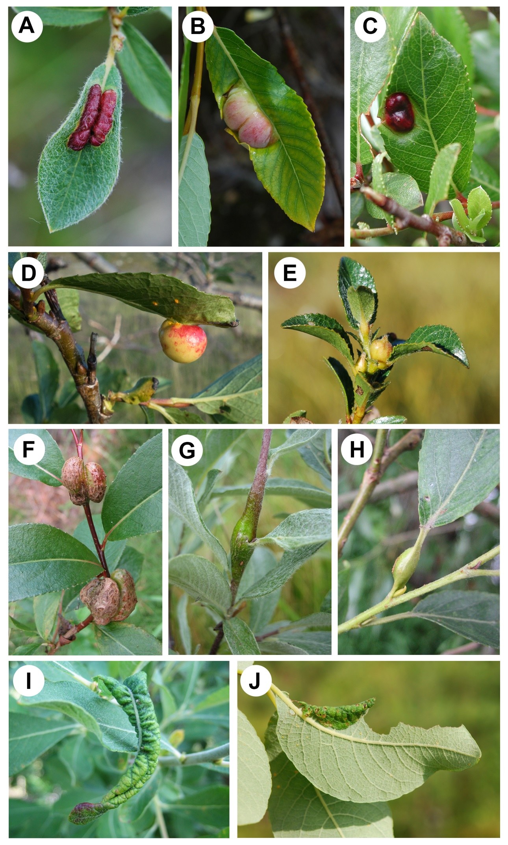

Fig.2. Examples of the main types of galls induced by sawflies on *Salix* species. (A) leaf blade sausage gall induced by *Pontania glaucae* on *Salix glauca*; (B) leaf midrib bean gall induced by *Pontania pustulator* on *Salix phylicifolia*; (C) leaf blade bean gall induced by *Pontania foetidae* on *Salix foetida*; (D) leaf midrib pea gall induced by *Pontania norvegica* on *Salix borealis*; (E) bud gall induced by *Euura* sp. on *Salix myrsinites*; (F) walnut-shaped stem gall induced by *Euura amerinae* on *Salix pentandra*; (G) shoot gall induced by *Euura lapponica* on *Salix lapponum*; (H) petiole gall induced by *Euura venusta* on *Salix fragilis*; (I) leaf roll induced by *Phyllocolpa leucapsis* on *Salix cinerea*; and (J) leaf fold induced by *Phyllocolpa leucosticta* on *Salix caprea*. Letters correspond to the coding used by Kopelke (1999) (Photographs by TN).

The enemy community of the gallers includes over 100 species belonging to 17 insect families of four orders (Kopelke 1999, 2003a, 2010, 2011; Kasparyan and Kopelke 2009, 2010; this study). These encompass two main types: inquiline larvae (Coleoptera, Lepidoptera, Diptera, and Hymenoptera) feed primarily on gall tissue, but typically kill the galler larva in the process, while parasitoid larvae (representing many families in Hymenoptera) kill the galler larvae by direct feeding (Kopelke 2003a) (Fig. 3).

In terms of associations between the trophic levels, phylogeny-based comparative studies have demonstrated that many willow species have been colonized repeatedly by galler lineages inducing different galls (Nyman et al. 2000, 2007). By contrast, gall type is conserved on the galler phylogeny, demonstrating that galls represent "extended phenotypes" of the gallers, i.e., gall form, location, and chemistry is determined mainly by the galling sawflies and not by their host plants (Nyman et al. 2000; Nyman and Julkunen-Tiitto 2000). Because galler parasitoids have to penetrate a protective wall of modified plant tissue in order to gain access to their victims, gall morphology has been inferred to strongly affect the associations between parasitoids and hosts (Kopelke 2003a, Nyman et al. 2007). Thus, the set of parasitoids attacking each galler is presumably constrained by the location, form, size, and thickness of its gall (cf. Fig. 3), but also by the habitat in which the willow host grows (Nyman et al. 2015).

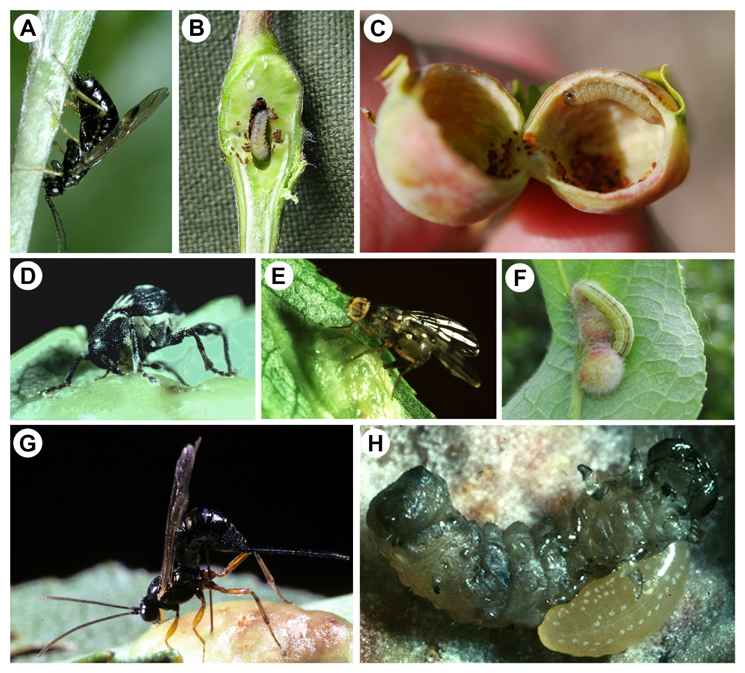

Fig. 3. Examples of species and ecological interactions present in the dataset. (A) Female of *Euura lapponica* ovipositing on *Salix lapponum*; (B) Larva of *Euura lapponica* inside opened shoot gall on *Salix lapponum*; (C) Larva of *Pontania pustulator* inside opened leaf midrib bean gall on *Salix phylicifolia*; (D) Female of the inquiline weevil *Curculio crux* boring leaf blade bean gall of *Pontania proxima*; (E) Female of the inquiline fly *Euphranta toxoneura* ovipositing in *Pontania proxima* gall; (F) Lepidopteran larva feeding facultatively on gall of *Pontania glabrifrons* on *Salix lanata*; (G) The ichneumonid parasitoid *Scambus vesicarius* ovipositing in *Pontania proxima* gall; (H) Larva of the ichneumonid ectoparasitoid *Adelognathus cubiceps* feeding on dead *Pontania* larva. (Photographs A, D–E, G, and H by JPK; B, C, and F by TN).

#### Data Acquisition

Local realizations of the willow–galler–parasitoid network were reconstructed from community samples collected by JPK between 1982 and 2010. During this period, willow galls were collected at 374 different sites across Central and Northern Europe (Fig. 1A). Some sites were visited more than once (Fig. 1B), with a total of 641 site visits across the 374 sites. Variation in site-specific visitation rates reflects the logistics of large-scale sampling across Europe. Sites closer to the center of the sampling area (the Senckenberg Research Institute in Frankfurt, Germany) were typically visited more frequently than were distant sites (Fig. 1).

The sampling effort was focused on typical *Salix*-growing habitats, such as river banks, lakesides, mountain valleys, and Lapland tundra. At each site, a set of galls was collected from practically all willow specimens sporting galls of focal species within an area of about 0.1–0.3 km2. Sampling was conducted in the summer months of June and/or July, i.e., during the later stages of larval development, and galler species were identified on the basis of willow host species and gall morphology, as these are distinct for each sawfly species (Kopelke 1999).

The methods used for rearing parasitoids and inquilines from the galls are described by Kopelke (1999, 2003a). In brief, galls were opened to score the presence of galler or parasitoid/inquiline larvae. Parasitoid larvae were classified to preliminary morphospecies, and the identity of each morphospecies was determined by connecting them to adults emerging after hibernation. The galls were reared by storing them singly in small glass tubes (Kopelke 1985, 1999). Hibernation of galls containing parasitoids took place either within the glass tubes or between blotting paper in flowerpots filled with clay granulate or a mixture of peat and sand. These pots were stored over the winter in a roof garden and/or in a climatic chamber.

In most cases, the matching of larval morphospecies with adult individuals emerging from the rearings allowed the identification of the parasitoids to the species level. Nonetheless, in some cases, individuals could only be assigned to genera or identified to one of the (super)families Braconidae, Ichneumonidae, and Chalcidoidea. This was particularly the case when only remains of faeces, vacant cocoons of parasitoids, and/or dead host larvae were found, as was the case when parasitoids had already emerged from the gall. As a result, the largest taxon in the data set, "Chalcidoidea indeterminate", represents a superfamily of very small parasitoids that are hard to distinguish from each other (Fig. 4).

In total, 165,424 galls from 52 *Salix* taxa were collected for dissection and rearing. These galls represented 96 galler species, and yielded 42,129 individually-identified parasitoids. Of these, 25,170 (60%) could be identified to the species level. Overall, 126 parasitoid and inquiline taxa were distinguished in the material. Different taxa are generally fairly evenly represented in the data (Fig. 4).

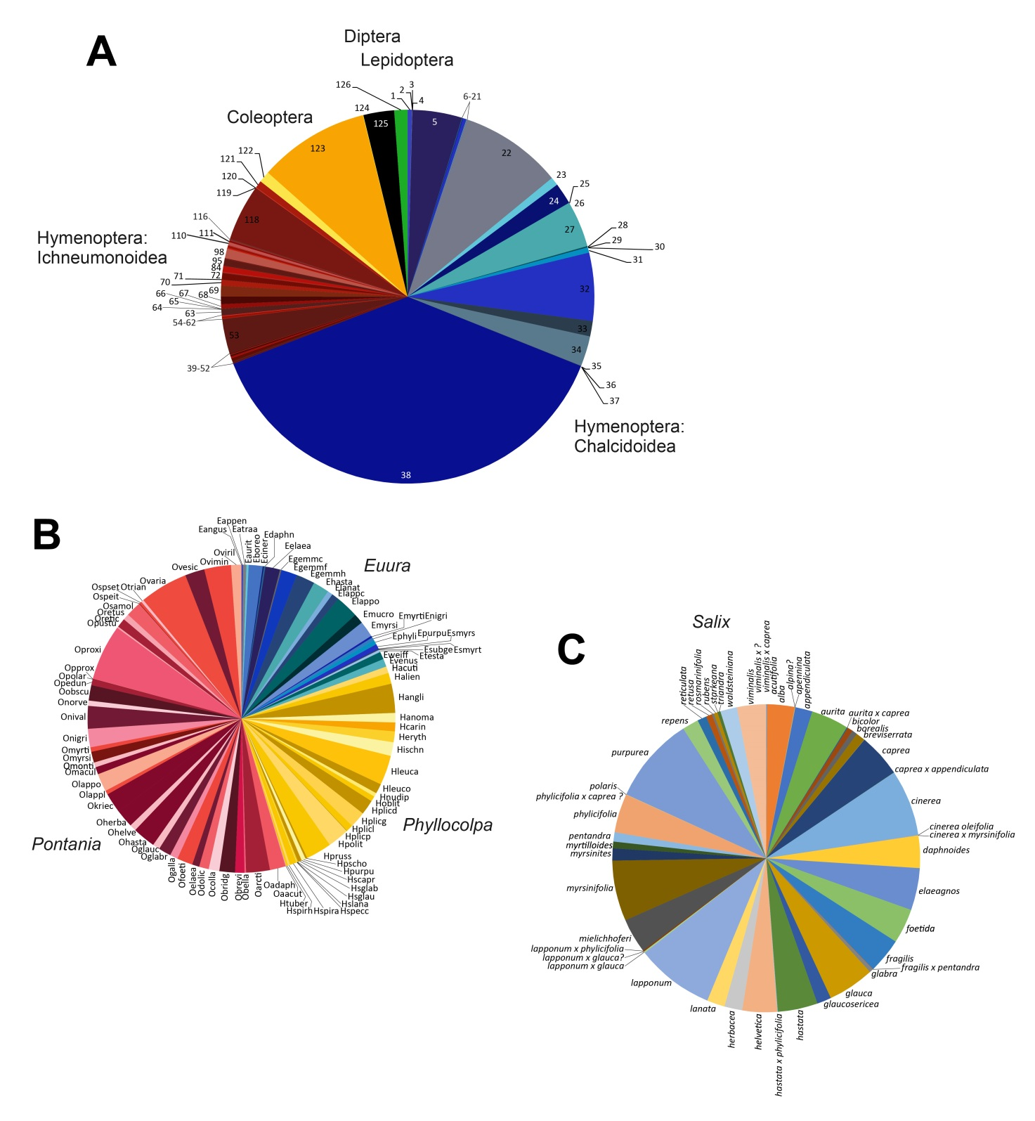

Fig. 4. Taxonomic composition of the data set records at three tropic levels: (A) natural enemies (parasitoids and inquilines; here, the numbering corresponds to the order of enemy species or taxa in the data set table), (B) herbivores (sawfly gallers; here, species are identified by the R abbreviations used in the data set table) and (C) plants (*Salix*; species names indicated).

### D. Data Limitations and Enhancements

The data set presented here comes with two important caveats, which should be acknowledged by researchers using the data set.

First, the records will not necessarily represent a random selection of sites, nor of *Salix* or galler species within the region. This solution was dictated by practical constraints, so that sites were selected on the basis of opportunistic search of *Salix* stands along passable roads and the availability of a sufficient number of galls of targeted species to collect. Furthermore, constraints on time and the difficulties involved in delimiting *Salix* “individuals” (which frequently blend into large stands or continuous mats) meant that the person conducting the sampling (JPK) was unable to record the total number of willow specimens present in a sampling area, or the number of such units attacked by a gall former. The total number of galls collected per site was in turn constrained by rearing capacity (all galls were reared individually), so the total number of galls collected per site was capped at a level roughly comparable among gall-rich sites (number of galls per galler species per site per visit: range = 1–768, mean = 81.5). Given these constraints, we strongly recommend that data on *Salix* and gallers are treated as records of presence-only and, depending on the analysis, the number of galls is included as a correction for sampling effort and reliability of data. Visits in different years to the same site should preferentially be treated as repeated observations (see Fig. 1).

Second, while every effort was made to resolve the nodes of the interaction networks to species level, this was unfeasible in two contexts: Where only faeces, vacant cocoons of parasitoids, and/or dead host larvae were found, the natural enemies were identified only to the level of (super)families Braconidae, Ichneumonidae, and Chalcidoidea (as based on the remains). And where the natural enemy belonged to the very small parasitoids in the superfamily Chalcidoidea, species-level identification was often unfeasible, especially if no adults emerged from the rearings. For this reason, a substantial fraction (n=16,048; taxon #38 in Fig. 4A) of natural enemies was attributed to the category “Chalcidoidea indeterminate”. As this taxon represents a compound node of lower resolution than the others, the researcher will want to examine its impacts on his/her specific results, and to be explicit about how it was dealt with.

The data set also offers scope for simple enhancements. As each data point is carefully referenced in space and time, it allows the extraction of environmental covariates from global data on climate and other abiotic and biotic descriptors. Network indices and other patterns can also be related to recently-generated information on latitudinal trends in willow diversity (e.g., Cronk et al. 2015) and geographic variation in communities of other herbivores (e.g., Canty et al. 2016) across Europe. Thus, current variation in the distribution of both node and link distribution can be easily connected to the wider environment; Section IV C. Data import and manipulation offers R-based tools for achieving this.

A further issue to notice is that, as in many other species-rich insect taxa, the nomenclature of the focal groups has recently undergone changes based on taxonomic revisions and molecular-phylogenetic analyses. We have here followed the generic classification and species names used by Kopelke (1999, 2001, 2003a,b, 2007a-c, 2010, 2011) and Kasparyan and Kopelke (2009, 2010) in order to facilitate comparisons to existing literature, but the focal sawfly genera (*Phyllocolpa*, *Pontania* (including subgenus *Eupontania*), and *Euura*), as well as numerous free-feeding genera within the tribe Nematini of the subfamily Nematinae, have recently been combined under *Euura* (Prous et al. 2014). Ongoing revisions will propose changes to species names of gallers, and some galler lineages currently presumed to be monophagous will be synonymized to become oligophagous species (A. D. Liston, personal communication). However, exact taxonomy is not always needed in quantitative analyses (as long as the species are known to be distinct), and the combination of gall type and willow host given for each row in the present dataset will generally enable linking old and new names.

As important additional resources for performing corrections for non-independence of species in eco-evolutionary statistical analyses, we note that at least partial phylogenetic information is available for all levels of the sampled network. Resolving relationships among *Salix* species has proven notoriously difficult due to the presence of rapid radiations within the group, interspecific variation in ploidy levels, as well as occasional hybridization among taxa (Wu et al. 2014, Lauron-Moreau et al. 2015). Nonetheless, phylogenetic trees including many of the focal species have been published (Percy et al. 2015, Volf et al. 2015), and given the current rapid advances in phylogenomic approaches, the situation will undoubtedly improve in the near future. For the gall-inducing sawflies, trees can be obtained from Nyman et al. (2000, 2007) or reconstructed using published DNA barcode data (Schmidt et al. 2016). A phylogenetic analysis including over 90% of the species in the present dataset and sequence data from three genes (mtDNA: CoI, Cytb; nDNA: NaK) is currently underway (TN, in preparation). For the trophic level of natural enemies, rough phylogenies can be constructed with relative ease using DNA barcode sequences extracted from GenBank or the Barcode of Life database (cf. Nyman et al. 2015).

## Class III. Data Set Status and Accessibility

### A. Status

#### Latest Update

October 2016.

#### Latest Archive Date

October 2016.

### B. Accessibility

#### Contact Person

Jens-Peter Kopelke, Senckenberg Research Institute and Natural History Museum Frankfurt, Senckenberganlage 25, D-60325 Frankfurt, Germany. e-mail: jens.kopelke@senckenberg.de.

#### Copyright Restrictions

None.

#### Proprietary Restrictions

Please cite this data paper when the data are used in publications. We also request that researchers and teachers inform us how they are using the data.

#### Costs

None.

## Class IV. Data Structural Descriptors

### A. Data Set File

#### Identity

Salix_webs.xlsx and CSV table.

#### Size

2029 records, 350 597 bytes**.**

#### Format and Storage Mode

Excel (.xlsx) and plain text, as Comma Separated Values (.csv).

#### Header Information

See column descriptions in section B.

#### Data Anomalies

If no information is available for a given record, this is indicated by 'NA'. In the host-by-enemy matrix, an empty cell equals a zero.

### B. Variable information

|  |  |
| --- | --- |
| **Column header** | **Explanation** |
| Year of coll | Year of collection |
| Rearing | Identification code of individual rearing |
| leg | Date of collection |
| country | Country of collection |
| region | Region of collection |
| site | Name of site |
| Ndecdeg | Decimal degrees north |
| Edecdeg | Decimal degrees east |
| Elevation | Elevation (m) |
| *Salix* | *Salix* species |
| *Salix* author | Author of *Salix* species |
| genus | Genus of galler |
| species | Species of galler |
| Genus species | Scientific name of galler |
| Rgaller | Code name of galler species (for R) |
| author | Author of galler species |
| code galltype | Gall types as coded by Kopelke (1999, 2003a,b). For leaf galls, codes are as follows: RK1 = thick-walled, elongated sausage-shaped galls on the upper surface of the leaf; RK2 = thin-walled, kidney-shaped spacious galls transected horizontally by the leaf blade; RK3 = thick-walled, bean-shaped galls with a narrow cavity, transected horizontally by the leaf blade; RK4 = thin to thick-walled, pea-shaped galls at the underside of the leaf |
| code galltype simplified | Simplified gall type classification used by Nyman et al. (2000, 2007) |
| distribution | Distribution of galler species |
| n galls | Number of galls reared |
| n clean galls | Number of galls that were "fake galls": the egg-laying galler will often induce fake galls around her real galls to throw off predators |
| n real galls | Number or REAL gall reared: use this number! |
| parasitised galls | Number of galls that were parasitized |
| unparasitised galls | Number of galls that were unparasitized |
| total parasitism rate | Rate of parasitism summed across rearing |
| *Anaprostocetus acuminatus* (Ratzeburg 1848) | Number of individuals of parasitoid/inquiline species |
| *Aprostocetus alveatus* Graham 1961 | Number of individuals of parasitoid/inquiline species |
| *Aprostocetus tymber* (Walker 1839) | Number of individuals of parasitoid/inquiline species |
| *Aprostocetus* sp. | Number of individuals of parasitoid/inquiline species |
| *Chrysocharis elongata* (Thomson 1878) | Number of individuals of parasitoid/inquiline species |
| *Cirrospilus vittatus* Walker 1838 | Number of individuals of parasitoid/inquiline species |
| *Closterocerus trifasciatus* Westwood 1833 | Number of individuals of parasitoid/inquiline species |
| *Dicladocerus westwoodi* Westwood 1832 | Number of individuals of parasitoid/inquiline species |
| *Entedon heyeri* (Ratzeburg 1848) | Number of individuals of parasitoid/inquiline species |
| *Euderus albitarsis* (Zetterstedt 1838) | Number of individuals of parasitoid/inquiline species |
| *Pediobius saulius* (Walker 1839) | Number of individuals of parasitoid/inquiline species |
| *Pnigalio nemati* (Westwood 1838) | Number of individuals of parasitoid/inquiline species |
| *Pnigalio pectinicornis* (Linnaeus 1758) | Number of individuals of parasitoid/inquiline species |
| *Pnigalio soemius* (Walker 1839) | Number of individuals of parasitoid/inquiline species |
| *Tetrastichus* sp.1 | Number of individuals of parasitoid/inquiline species |
| *Tetrastichus* sp.2 | Number of individuals of parasitoid/inquiline species |
| *Tetrastichus* sp.3 | Number of individuals of parasitoid/inquiline species |
| *Tetrastichus* sp.4 | Number of individuals of parasitoid/inquiline species |
| *Tetrastichus* sp.5 | Number of individuals of parasitoid/inquiline species |
| Tetrastichus sp.6 | Number of individuals of parasitoid/inquiline species |
| Tetrastichus sp. | Number of individuals of parasitoid/inquiline species |
| *Eurytoma aciculata* Ratzeburg 1848 | Number of individuals of parasitoid/inquiline species |
| *Eurytoma nobbei* Mayr 1878 | Number of individuals of parasitoid/inquiline species |
| *Eurytoma salicis* Walker 1834 | Number of individuals of parasitoid/inquiline species |
| *Eurytoma* sp. | Number of individuals of parasitoid/inquiline species |
| Mymaridae gen. sp. | Number of individuals of parasitoid/inquiline species |
| *Eulonchetron torymoides* (Thomson 1878) | Number of individuals of parasitoid/inquiline species |
| *Eupelmus urozonus* Dalman 1820 | Number of individuals of parasitoid/inquiline species |
| *Macroneura vesicularis* (Retzius 1783) | Number of individuals of parasitoid/inquiline species |
| *Mesopolobus* ?*longicollis* Graham 1969 | Number of individuals of parasitoid/inquiline species |
| *Pteromalus cyniphidis* (Linnaeus 1758) | Number of individuals of parasitoid/inquiline species |
| *Pteromalus dolichurus* (Thomson 1878) | Number of individuals of parasitoid/inquiline species |
| *Pteromalus euurae* Askew 1995 | Number of individuals of parasitoid/inquiline species |
| *Pteromalus pontaniae* Askew 1985 | Number of individuals of parasitoid/inquiline species |
| *Pteromalus* sp. | Number of individuals of parasitoid/inquiline species |
| *Sympiesis* ?*alcalle* (Walker 1848) | Number of individuals of parasitoid/inquiline species |
| *Torymus* sp. | Number of individuals of parasitoid/inquiline species |
| Chalcidoidea indet. | Number of individuals of parasitoid/inquiline species |
| *Apanteles* ?*morrisi* Mason 1974 | Number of individuals of parasitoid/inquiline species |
| *Apanteles xanthostigma* (Haliday 1834) | Number of individuals of parasitoid/inquiline species |
| *Apanteles* sp. | Number of individuals of parasitoid/inquiline species |
| *Bracon breviusculus* (Wesmael 1838) | Number of individuals of parasitoid/inquiline species |
| *Bracon conjugellae* Bengtsson 1924 | Number of individuals of parasitoid/inquiline species |
| *Bracon discoideus* (Wesmael 1838) | Number of individuals of parasitoid/inquiline species |
| *Bracon epitriptus* Marshall 1885 | Number of individuals of parasitoid/inquiline species |
| *Bracon immutator* Nees 1834 | Number of individuals of parasitoid/inquiline species |
| *Bracon intercessor* Nees 1834 | Number of individuals of parasitoid/inquiline species |
| *Bracon kopelkei* Papp 2000 | Number of individuals of parasitoid/inquiline species |
| *Bracon lividus* Telenga 1936 | Number of individuals of parasitoid/inquiline species |
| *Bracon obscurator* Nees 1811 | Number of individuals of parasitoid/inquiline species |
| *Bracon picticornis* (Wesmael 1838) | Number of individuals of parasitoid/inquiline species |
| *Bracon pulcher* Bengtsson 1924 | Number of individuals of parasitoid/inquiline species |
| *Bracon romani* Fahringer 1927 | Number of individuals of parasitoid/inquiline species |
| *Bracon* sp. | Number of individuals of parasitoid/inquiline species |
| *Colastes flavitarsis* (Thomson 1892) | Number of individuals of parasitoid/inquiline species |
| *Colastes gracilis* Papp 1975 | Number of individuals of parasitoid/inquiline species |
| *Colastes* ?*incertus* (Wesmael 1838) | Number of individuals of parasitoid/inquiline species |
| *Colastes laevis* (Thomson 1892) | Number of individuals of parasitoid/inquiline species |
| *Colastes* nr. *subquadratus* Achterberg | Number of individuals of parasitoid/inquiline species |
| *Dolichogenidea coleophorae* (Wilkinson 1938) | Number of individuals of parasitoid/inquiline species |
| *Dolichogenidea longicauda* (Wesmael 1837) | Number of individuals of parasitoid/inquiline species |
| *Ichneutes brevis* Wesmael 1835 | Number of individuals of parasitoid/inquiline species |
| *Ichneutes lapponicus* Thomson 1895 | Number of individuals of parasitoid/inquiline species |
| *Ichneutes reunitor* Nees 1816 | Number of individuals of parasitoid/inquiline species |
| *Ichneutes* sp. | Number of individuals of parasitoid/inquiline species |
| *Lissogaster subcompleta* (Nees v. Esenbeck 1834) | Number of individuals of parasitoid/inquiline species |
| *Shawiana lapponica* (Thomson 1892) | Number of individuals of parasitoid/inquiline species |
| Braconidae indet. | Number of individuals of parasitoid/inquiline species |
| *Adelognathus cubiceps* Roman 1925 | Number of individuals of parasitoid/inquiline species |
| *Adelognathus pusillus* Holmgren 1857 | Number of individuals of parasitoid/inquiline species |
| *Adelognathus trochanteratus* Kasparyan 1986 | Number of individuals of parasitoid/inquiline species |
| *Adelognathus* sp. | Number of individuals of parasitoid/inquiline species |
| *Anoncus gallicola* Kasparyan & Kopelke 2009 | Number of individuals of parasitoid/inquiline species |
| *Aptesis nigrocincta* (Gravenhorst 1815) | Number of individuals of parasitoid/inquiline species |
| *Campodorus variegatus* Jurine 1807 | Number of individuals of parasitoid/inquiline species |
| *Campoplex* sp. | Number of individuals of parasitoid/inquiline species |
| *Cteniscus dorsalis* Cresson 1864 | Number of individuals of parasitoid/inquiline species |
| *Ctenochira* ?*oreophila* (Schmiedeknecht 1912) | Number of individuals of parasitoid/inquiline species |
| *Ctenochira romani* (Pfankuch 1925) | Number of individuals of parasitoid/inquiline species |
| *Ctenochira* sp. | Number of individuals of parasitoid/inquiline species |
| *Diaparsis stramineipes* (Brischke 1880) | Number of individuals of parasitoid/inquiline species |
| *Eclytus* sp. | Number of individuals of parasitoid/inquiline species |
| *Eridolius frontator* Kasparyan 1985 | Number of individuals of parasitoid/inquiline species |
| *Eridolius pygmaeus* (Holmgren 1857) | Number of individuals of parasitoid/inquiline species |
| *Eridolius taigensis* Kasparyan 1985 | Number of individuals of parasitoid/inquiline species |
| *Eridolius* sp. | Number of individuals of parasitoid/inquiline species |
| *Erromenus analis* Brischke 1871 | Number of individuals of parasitoid/inquiline species |
| *Exochus* sp. 1 | Number of individuals of parasitoid/inquiline species |
| *Exyston calcaratus* Thomson 1883 | Number of individuals of parasitoid/inquiline species |
| *Gambrus ornatus* (Gravenhorst 1829) | Number of individuals of parasitoid/inquiline species |
| *Gelis* sp. | Number of individuals of parasitoid/inquiline species |
| *Itoplectis alternans* (Gravenhorst 1829) | Number of individuals of parasitoid/inquiline species |
| *Lathrostizus alpicola* Horstmann 2004 | Number of individuals of parasitoid/inquiline species |
| *Lathrostizus alpinus* Horstmann 1971 | Number of individuals of parasitoid/inquiline species |
| *Lathrostizus flexicauda* (Holmgren 1860) | Number of individuals of parasitoid/inquiline species |
| *Lathrostizus forticauda* (Thomson 1887) | Number of individuals of parasitoid/inquiline species |
| *Lathrostizus lapponicus* Horstmann 2004 | Number of individuals of parasitoid/inquiline species |
| *Lathrostizus lugens* (Gravenhorst 1829) | Number of individuals of parasitoid/inquiline species |
| *Lathrostizus punctipes* (Thomson 1887) | Number of individuals of parasitoid/inquiline species |
| *Lissonota* ?*alpinistor* Aubert 1969 | Number of individuals of parasitoid/inquiline species |
| *Mesochorus* sp.1 | Number of individuals of parasitoid/inquiline species |
| *Mesoleius* sp. | Number of individuals of parasitoid/inquiline species |
| *Olesicampe* sp. | Number of individuals of parasitoid/inquiline species |
| *Polyblastus pumilus* Holmgren 1855 | Number of individuals of parasitoid/inquiline species |
| *Polyblastus* sp.? | Number of individuals of parasitoid/inquiline species |
| *Probles clavicornis* Horstmann 1971 | Number of individuals of parasitoid/inquiline species |
| *Rhinotorus brachycerus* Kasparyan & Kopelke 2009 | Number of individuals of parasitoid/inquiline species |
| *Saotis alpinator* Kasparyan & Kopelke 2009 | Number of individuals of parasitoid/inquiline species |
| *Saotis boreator* Kasparyan & Kopelke 2010 | Number of individuals of parasitoid/inquiline species |
| *Saotis granulator* Kasparyan & Kopelke 2010 | Number of individuals of parasitoid/inquiline species |
| *Saotis morleyi* Fitton 1976 | Number of individuals of parasitoid/inquiline species |
| *Saotis nigriscuta* (Thomson, 1883) | Number of individuals of parasitoid/inquiline species |
| *Saotis pygidiator pygidiator* Kasparyan & Kopelke 2009 | Number of individuals of parasitoid/inquiline species |
| *Saotis renovata* (Morley, 1911) | Number of individuals of parasitoid/inquiline species |
| *Saotis subarctor* Kasparyan & Kopelke 2010 | Number of individuals of parasitoid/inquiline species |
| *Saotis tricolor* (Thomson 1883) | Number of individuals of parasitoid/inquiline species |
| *Saotis* sp. | Number of individuals of parasitoid/inquiline species |
| *Scambus vesicarius* (Ratzeburg 1844) | Number of individuals of parasitoid/inquiline species |
| *Theroscopus hemipteron* (Riche 1791) *insignipennis* (Schmiedeknecht 1905) | Number of individuals of parasitoid/inquiline species |
| *Lathrostizus*/*Olesicampe* sp. | Number of individuals of parasitoid/inquiline species |
| Ichneumonidae indet. | Number of individuals of parasitoid/inquiline species |
| *Apion minimum* Herbst 1797 | Number of individuals of parasitoid/inquiline species |
| *Curculio crux* Fabricius 1776 | Number of individuals of parasitoid/inquiline species |
| *Curculio salicivorus* Paykull 1792 | Number of individuals of parasitoid/inquiline species |
| *Euphranta toxoneura* (Loew 1846) | Number of individuals of parasitoid/inquiline species |
| *Hydriomena ruberata* Freyer 1831 | Number of individuals of parasitoid/inquiline species |
| ORDER | Order of parasitoid/inquiline species |
| SUPERFAMILY | Superfamily of parasitoid/inquiline species |
| FAMILY | Family of parasitoid/inquiline species |
| GENUS | Genus of parasitoid/inquiline species |
| GOODNESS OF ID | Level to which parasitoid/inquiline has been identified |
| P/I | Parasitoid/Inquiline |
| ENDO/ECTO | Endoparasite/Ectoparasite |
| KOINO/IDIO | Koinobiont/Idiobiont |
| 1INSTAR/LINSTAR/COCOON/EGG | Target of attack: 1st instar larvae / later instar larvae / cocoons / eggs |
| RPAR | Code name of parasitoid/inquiline species (for use in R) |

### C. Tools for Working with the Data

#### Purpose

For conciseness, the data are offered as a single spreadsheet with its variables defined in section B (above). To provide the tools for the correct import of this complex data set into R, for reshaping the spreadsheet format as a series of relational objects, and for exploring the resulting data structure, we here provide R code for the benefit of the data user. The approach is based on splitting the data set into different files for which primary keys (i.e. unique identifiers) are assigned, thus allowing the user to easily retrieve pieces of information from each file. Below, we offer examples of how to handle the data, how to obtain a quick map and how to use the data for network analyses. For this purpose, we use R (version ≥ 3.2; R Core Team 2016) and the following set of add-on packages: *bipartite* 2.07, *dismo* 1.1.1, *igraph* 1.0.1, *magrittr* 1.5, *raster* 2.5.8, *rgdal* 1.1.10, *reshape2* 1.4.2, *sp* 1.2.3.

To run the following lines of code properly, each of these packages must first be installed. For instance, the function used to reshape the data set requires function *magrittr* to be installed and loaded. The code below will install the package if not previously available:

if(!require(magrittr)) install.packages(magrittr)  
library(magrittr)

#### Reshaping the Original Dataset

The commands below can be used to reshape the original dataset.

Cleaning the existing ./csv/ and ./rdata/ folders if any:

unlink("./csv", recursive = TRUE)  
unlink("./rdata", recursive = TRUE)

Importing the R script which contains the reshaping function:

source("./lib/format4R.r")

Applying the reshaping function to the original dataset:

get_formatData("./Salix_webs.csv")

Two new folders have now been created (./csv/ and ./rdata/) in your working directory, within which six files have been added with the following contents:

|  |  |  |
| --- | --- | --- |
| File | Rows | Description |
| df_site | 2029 | Locations of the sites |
| df_salix | 52 | Information on willow nodes |
| df_galler | 96 | Information on sawfly nodes |
| df_parasit | 126 | Information on parasitoid/inquiline nodes |
| df_interact | 4749 | Interaction details among each node (willows, gallers, enemies) |
| df_salix_galler | 2029 | Summary statistics on interactions among willows, gallers and enemies |

#### Exploring the New Data Structure

##### Sampling Sites

The next few lines will import and display the structure of the file describing the sampling units (i.e. file ./rdata/df_site.rds).

df_site <- readRDS("./rdata/df_site.rds")  
str(df_site, strict.width="cut")

## 'data.frame': 2029 obs. of 9 variables:  
## $ REARING_NUMBER: Factor w/ 2029 levels "198203W1-R3Ovimin",..: 320 321 ..  
## $ YEAR_OF_COLL : num 1987 1987 1987 1987 1987 ...  
## $ LEG : Date, format: "1987-07-20" "1987-07-20" ...  
## $ COUNTRY : chr "Austria" "Austria" "Austria" "Austria" ...  
## $ REGION : chr "Tirol" "Tirol" "Tirol" "Tirol" ...  
## $ SITE : chr "Gern-Alm" "Gern-Alm" "Zillertal, Hintertux/ Wei"..  
## $ NDECDEG : num 47.5 47.5 47.1 47.4 47.5 ...  
## $ EDECDEG : num 11.6 11.6 11.7 11.8 11.6 ...  
## $ ELEVATION : num 1253 1253 1769 1875 1253 ...

In this file, each row refers to a willow species sampled at a specific time (YEAR_OF COLL) in a given location (SITE). The field REARING NUMBER is the primary key of this table, and thus points to a unique record.

##### Nodes

The command lines below will import and display the structure of the tables (available in ./rdata) associated with the different levels of the network.

Willow species (df_salix.rds):

df_salix <- readRDS("./rdata/df_salix.rds")  
str(df_salix, strict.width="cut")

## 'data.frame': 52 obs. of 3 variables:  
## $ RSAL : Factor w/ 52 levels "Sal1","Sal10",..: 1 12 23 34 45 49 50 51..  
## $ SPECIES: chr "elaeagnos" "appendiculata" "myrsinifolia" "foetida" ...  
## $ AUTHOR : chr "Scop. 1772" "Villars 1789" "Salisbury 1796" "Schleich."..

This file contains information on the *Salix* species, with RSAL as its unique identifier (primary key).

Galler species (df_galler.rds):

df_galler <- readRDS("./rdata/df_galler.rds")  
str(df_galler, strict.width="cut")

## 'data.frame': 96 obs. of 7 variables:  
## $ RGALLER : Factor w/ 96 levels "Eangus","Eappen",..: 63..  
## $ GENUS : chr "Pontania" "Pontania" "Pontania" "Pont"..  
## $ SPECIES : chr "elaeagnocola" "bridgmanii" "varia" "o"..  
## $ GENUS_SPECIES : chr "Pontania elaeagnocola" "Pontania brid"..  
## $ AUTHOR : chr "Kopelke 1994" "(Cameron 1883)" "Kopel"..  
## $ CODE_GALLTYPE : chr "RK1" "RK3" "RK4" "RK3" ...  
## $ CODE_GALLTYPE SIMPLIFIED: chr "Leaf blade sausage gall" "Leaf blade "..

This file contains information on galler species, with RGALLER as its unique identifier.

Parasitoid and inquiline species (df_parasit.rds):

df_parasit <- readRDS("./rdata/df_parasit.rds")  
str(df_parasit, strict.width="cut")

## 'data.frame': 126 obs. of 11 variables:  
## $ RPAR : Factor w/ 126 levels "Aacumi","Aalvea",..:..  
## $ ORDER : chr "Hymenoptera" "Hymenoptera" "Hymenop"..  
## $ SUPERFAMILY : chr "Chalcidoidea" "Chalcidoidea" "Chalc"..  
## $ FAMILY : chr "Eulophidae" "Eulophidae" "Eulophida"..  
## $ GENUS : chr "Anaprostocetus" "Aprostocetus" "Apr"..  
## $ GOODNESS OF ID : chr "species" "species" "species" "genus"..  
## $ P/I : chr "P" "P" "P" "P" ...  
## $ ENDO/ECTO : chr "Endo" "Endo" "Endo" "Endo" ...  
## $ KOINO/IDIO : chr "Koino" "Koino" "Koino" "Koino" ...  
## $ 1INSTAR/LINSTAR/COCOON/EGG: chr "1INSTAR" "1INSTAR" "1INSTAR" "1INST"..  
## $ FULL_NAME : chr "Anaprostocetus acuminatus (Ratzebur"..

This file contains information on parasitoid species, with RPAR as its unique identifier.

Links:

df_interact <- readRDS("./rdata/df_interact.rds")  
str(df_interact, strict.width="cut")

## 'data.frame': 4749 obs. of 6 variables:  
## $ REARING_NUMBER: Factor w/ 2029 levels "198203W1-R3Ovimin",..: 320 320 ..  
## $ RSAL : Factor w/ 52 levels "Sal1","Sal10",..: 1 1 1 1 1 12 12..  
## $ RGALLER : Factor w/ 96 levels "Eangus","Eappen",..: 63 63 63 63 ..  
## $ RPAR : chr "Pdolic" "Chalci" "Svesic" "Ccruxx" ...  
## $ N_GALLS : num 22 22 22 22 22 32 32 66 66 66 ...  
## $ NB_GALLS_PAR : num 9 3 2 5 1 7 8 2 27 1 ...

This file provides information of the interactions among gallers, willows and parasitoids/inquilines. Here, RSAL, RGALLER and RPAR are foreign keys allowing us to retrieve information from files df_salix, df_galler and df_parasit, respectively.

Summary information:

df_salix_galler <- readRDS("./rdata/df_salix_galler.rds")  
str(df_salix_galler, strict.width="cut")

## 'data.frame': 2029 obs. of 10 variables:  
## $ RSAL : Factor w/ 52 levels "Sal1","Sal10",..: 1 12 23 ..  
## $ RGALLER : Factor w/ 96 levels "Eangus","Eappen",..: 63 60..  
## $ REARING_NUMBER : chr "198714E1-J1Oelaea" "198714L1-V1Obridg" ""..  
## $ LEG : chr "20.07.87" "20.07.87" "22.07.87" "20.07.8"..  
## $ N_GALLS : num 22 32 66 66 91 92 54 125 129 14 ...  
## $ N_CLEAN GALLS : num 0 7 0 14 0 8 8 0 12 5 ...  
## $ N_REAL GALLS : num 22 25 66 52 91 84 46 125 117 9 ...  
## $ PARASITISED_GALLS : num 20 15 30 34 78 27 24 8 1 1 ...  
## $ UNPARASITISED_GALLS : num 2 10 36 18 13 57 22 117 116 8 ...  
## $ TOTAL_PARASITISM RATE: num 0.909 0.6 0.455 0.654 0.857 ...

This file provides summary statistics on interactions among *Salix* and sawfly species.

#### Manipulation of Files Containing Nodes and Links

##### Binding Files Together

df_site <- readRDS("./rdata/df_site.rds")  
 df_interact <- readRDS("./rdata/df_interact.rds")  
 site_interact <- merge(df_site, df_interact, by="REARING_NUMBER")  
 head(site_interact)

## REARING_NUMBER YEAR_OF_COLL LEG COUNTRY REGION  
## 1 198203W1-R3Ovimin 1982 1982-06-15 Germany Hessen  
## 2 198203W1-R3Ovimin 1982 1982-06-15 Germany Hessen  
## 3 198203W1-R3Ovimin 1982 1982-06-15 Germany Hessen  
## 4 198203W1-R3Ovimin 1982 1982-06-15 Germany Hessen  
## 5 198204A-V1Ovimin 1982 1982-06-15 Germany Hessen  
## 6 198204A-V1Ovimin 1982 1982-06-15 Germany Hessen  
## SITE NDECDEG EDECDEG ELEVATION RSAL RGALLER RPAR  
## 1 Kühkopf, Mordhecke I 49.81667 8.416667 87 Sal10 Ovimin Eacicu  
## 2 Kühkopf, Mordhecke I 49.81667 8.416667 87 Sal10 Ovimin Etorym  
## 3 Kühkopf, Mordhecke I 49.81667 8.416667 87 Sal10 Ovimin Ilappo  
## 4 Kühkopf, Mordhecke I 49.81667 8.416667 87 Sal10 Ovimin Ccruxx  
## 5 Griesheim bei Darmstadt 49.85000 8.516667 92 Sal10 Ovimin Eacicu  
## 6 Griesheim bei Darmstadt 49.85000 8.516667 92 Sal10 Ovimin Etorym  
## N_GALLS NB_GALLS_PAR  
## 1 48 5  
## 2 48 8  
## 3 48 1  
## 4 48 5  
## 5 51 6  
## 6 51 1

To include taxonomic information on, for instance, sawflies, we have to merge df_galler with site_interact using the shared key RGALLER.

df_galler <- readRDS("./rdata/df_galler.rds")  
 site_interact_wth_taxo <- merge(site_interact, df_galler, by="RGALLER")  
 head(site_interact_wth_taxo)

## RGALLER REARING_NUMBER YEAR_OF_COLL LEG COUNTRY REGION  
## 1 Eangus 199436XEangus 1994 1994-10-19 Germany Hessen  
## 2 Eappen 1998SZ18Eappen 1998 1998-08-22 Austria Salzburg  
## 3 Eappen 1998SZ14Eappen 1998 1998-08-22 Austria Salzburg  
## 4 Eappen 1998SZ11Eappen 1998 1998-08-22 Austria Salzburg  
## 5 Eappen 1998SZ14Eappen 1998 1998-08-22 Austria Salzburg  
## 6 Eappen 1998SZ11Eappen 1998 1998-08-22 Austria Salzburg  
## SITE NDECDEG EDECDEG ELEVATION RSAL RPAR N_GALLS  
## 1 Kühkopf, Mordhecke III 49.85000 8.383333 85 Sal31 none 1  
## 2 Obertauern III 47.23333 13.566667 1656 Sal2 Chalci 10  
## 3 Tauernpaß, Tweng 47.18333 13.583333 1266 Sal2 Enobbe 92  
## 4 Obertauern III 47.23333 13.566667 1656 Sal2 Pdolic 160  
## 5 Tauernpaß, Tweng 47.18333 13.583333 1266 Sal2 Chalci 92  
## 6 Obertauern III 47.23333 13.566667 1656 Sal2 Chalci 160  
## NB_GALLS_PAR GENUS SPECIES  
## 1 0 Euura angusta  
## 2 5 Euura E. sp. / S. appendiculata  
## 3 1 Euura E. sp. / S. appendiculata  
## 4 1 Euura E. sp. / S. appendiculata  
## 5 50 Euura E. sp. / S. appendiculata  
## 6 15 Euura E. sp. / S. appendiculata  
## GENUS_SPECIES AUTHOR CODE_GALLTYPE  
## 1 Euura angusta (Hartig 1837) Sproß  
## 2 Euura E. sp. / S. appendiculata nicht vorh Knospe  
## 3 Euura E. sp. / S. appendiculata nicht vorh Knospe  
## 4 Euura E. sp. / S. appendiculata nicht vorh Knospe  
## 5 Euura E. sp. / S. appendiculata nicht vorh Knospe  
## 6 Euura E. sp. / S. appendiculata nicht vorh Knospe  
## CODE_GALLTYPE SIMPLIFIED  
## 1 Shoot gall  
## 2 Bud gall  
## 3 Bud gall  
## 4 Bud gall  
## 5 Bud gall  
## 6 Bud gall

##### Turning Tables into Matrices

The package reshape2 allows us to turn long data formats into simple matrices:

if(!require(reshape2)){install.packages(reshape2);library(reshape2)}

##### Community Matrix

To build a community matrix detailing which species of willows are present in a specific year at a specific site, we write:

commat_willows <- dcast(SITE+YEAR_OF_COLL~RSAL,data=site_interact,fun.aggregate=length,  
 value.var="RSAL")  
head(commat_willows[,1:7])

## SITE YEAR_OF_COLL Sal1 Sal10 Sal11 Sal12 Sal13  
## 1 Ahrenshoop, Darß 2009 0 0 0 0 0  
## 2 Albulapaß nr. Paßhöhe 1999 0 0 0 0 0  
## 3 Albulapaß nr. Paßhöhe 2000 0 0 0 0 0  
## 4 Aldino 2009 0 5 0 0 0  
## 5 Alta 2001 0 0 0 0 0  
## 6 Alta, Baeskades 1988 0 0 0 0 0

To achieve a similar tabulation of sawflies present at a specific site in a specific year, we use:

commat_gallers <- dcast(SITE+YEAR_OF_COLL~RGALLER,data=site_interact,fun.aggregate=length,  
 value.var="RGALLER")  
head(commat_gallers[,1:7])

## SITE YEAR_OF_COLL Eangus Eappen Eatraa Eaurit Eboreo  
## 1 Ahrenshoop, Darß 2009 0 0 0 0 0  
## 2 Albulapaß nr. Paßhöhe 1999 0 0 0 0 0  
## 3 Albulapaß nr. Paßhöhe 2000 0 0 0 0 0  
## 4 Aldino 2009 0 0 0 0 0  
## 5 Alta 2001 0 0 0 0 0  
## 6 Alta, Baeskades 1988 0 0 0 0 0

To generate an interaction matrix among willows and sawflies, we use:

df_interact <- readRDS("./rdata/df_interact.rds")  
sal_vs_gall <- dcast(RSAL~RGALLER,data=df_interact,fun.aggregate=sum,  
 value.var="N_GALLS")  
head(sal_vs_gall[,1:7])

## RSAL Eangus Eappen Eatraa Eaurit Eboreo Eciner  
## 1 Sal1 0 0 0 0 0 0  
## 2 Sal10 0 0 0 0 0 0  
## 3 Sal11 0 0 695 0 0 0  
## 4 Sal12 0 0 872 0 0 0  
## 5 Sal13 0 0 0 0 0 0  
## 6 Sal14 0 0 0 0 0 0

To generate an interaction matrix among sawflies and parasitoids, we write:

df_interact <- readRDS("./rdata/df_interact.rds")  
gall_vs_par <- dcast(RGALLER~RPAR,data=df_interact,fun.aggregate=sum,  
 value.var="NB_GALLS_PAR")  
head(gall_vs_par[,1:7])

## RGALLER Aacumi Aalvea Acubic Adelog Agalli Aminim  
## 1 Eangus 0 0 0 0 0 0  
## 2 Eappen 1 0 0 0 0 0  
## 3 Eatraa 10 0 0 0 0 0  
## 4 Eaurit 28 0 0 0 0 0  
## 5 Eboreo 0 0 0 0 0 0  
## 6 Eciner 22 0 0 0 0 0

#### Mapping Sites

Here we show how to derive a map of the sampling, as shown in Fig. 1A.

We first load the packages needed and import the data set:

library(rgdal)  
library(raster)  
library(dismo)

We then convert the sites into a spatial object (as described in the *sp* package):

df_site <- readRDS("rdata/df_site.rds")[,c(  
 "SITE", "NDECDEG", "EDECDEG")] %>% unique  
#  
sp_site <- SpatialPointsDataFrame(  
 df_site[,c("EDECDEG", "NDECDEG")],  
 df_site[c("SITE")],  
 proj4string = CRS("+proj=longlat +datum=WGS84 +no_defs  
 +ellps=WGS84 +towgs84=0,0,0")  
 )

We adopt a background map available on-line and add our points on top of it:

## background map  
bg_map <- gmap('Europe', type="satellite",  
 zoom=3, exp=1.1, scale=2, add=T)  
## map  
par(mar=c(1,1,1,1))  
plot(c(-258698, 4351808), c(4350881, 11745460), asp=1, ann=F, axes=F, type="n")  
plot(bg_map, add=TRUE)  
plot(spTransform(sp_site, CRS("+init=epsg:3857")), add=TRUE,  
 col="grey25", bg="grey75", cex=1, pch=21)

#### Number of Times that each Site was Visited

We are now able to easily retrieve the number of times that each site was visited. The code below generates and displays the frequency histogram shown in Fig. 1B.

tmp <- readRDS("rdata/df_site.rds")  
par(las=1, cex.axis=.8, mgp=c(2, .4, 0), tcl=-0.2)  
cool <- tmp %>% `[`(,c("EDECDEG", "NDECDEG", "YEAR_OF_COLL")) %>%  
 unique %>% `[`(,c("EDECDEG", "NDECDEG")) %>%  
 apply(1,paste, collapse="/") %>% table %>% table %>%  
 graphics::barplot(border=NA, col="grey25")  
mtext(1, text= "Number of times visited", line=1.25)  
mtext(3, at=-1, text= "Number of sites", line=.8, adj=0)

#### **Extracting Environmental Data from WorldClim**

Converting sites into spatial objects in R (*sp* package) allows us to retrieve environmental data from WorldClim (http://www.worldclim.org/) using the *raster* package.

For instance, to retrieve the bioclimatic variables at each site, we first download the bioclimatic grids and then extract the grid values at the location of each site (using the sp_site object previously created):

climate <- getData('worldclim', var='bio', res=2.5)  
clim_site <- extract(climate,sp_site,df=TRUE)

As a result, we obtain a dataset wherein each row corresponds to a specific site and each column to a bioclimatic variable (http://worldclim.org/bioclim):

clim_site <- data.frame(SITE=sp_site@data$SITE,clim_site[,-1])  
str(clim_site)

## 'data.frame': 374 obs. of 20 variables:  
## $ SITE : Factor w/ 374 levels "Ahrenshoop, Darß",..: 60 369 265 370 222 107 103 81 356 266 ...  
## $ bio1 : num 28 0 29 27 -19 80 83 79 81 84 ...  
## $ bio2 : num 81 68 83 84 55 66 64 57 55 68 ...  
## $ bio3 : num 31 29 31 31 27 29 27 25 24 28 ...  
## $ bio4 : num 6173 5686 6251 6233 5252 ...  
## $ bio5 : num 161 119 163 164 87 205 205 187 189 212 ...  
## $ bio6 : num -94 -108 -97 -99 -115 -22 -26 -40 -33 -27 ...  
## $ bio7 : num 255 227 260 263 202 227 231 227 222 239 ...  
## $ bio8 : num 105 71 106 105 47 151 159 92 96 162 ...  
## $ bio9 : num -52 -71 -53 -54 -82 31 31 27 28 32 ...  
## $ bio10: num 105 71 106 105 47 155 159 153 155 162 ...  
## $ bio11: num -52 -71 -53 -54 -82 6 7 6 8 6 ...  
## $ bio12: num 1109 1217 1122 1044 1349 ...  
## $ bio13: num 152 154 153 146 154 81 72 98 98 71 ...  
## $ bio14: num 59 69 60 53 84 45 41 41 41 40 ...  
## $ bio15: num 33 27 33 35 20 19 18 30 30 17 ...  
## $ bio16: num 421 430 425 403 439 225 200 288 288 199 ...  
## $ bio17: num 190 220 195 167 270 138 125 132 132 126 ...  
## $ bio18: num 421 430 425 403 408 222 200 211 211 199 ...  
## $ bio19: num 190 220 195 167 270 177 154 155 155 153 ...

#### Interaction Networks

We next show how to prepare the data to be used in R packages dedicated to network analyses.

For this, we first load additional packages:

library(igraph)  
library(bipartite)  
df_interact <- readRDS("rdata/df_interact.Rds")

##### Using the bipartite Package

The lines below create an association table suited for the *bipartite* package:

bip_salgal <- df_interact[,c("RSAL","RGALLER")] %>% table  
bip_galpar <- df_interact[,c("RGALLER","RPAR")] %>% table

As an example of the information to be extracted, we compute the C-score using the same package:

C.score(bip_galpar)

## [1] 0.7891025

##### Using the igraph Package

We here create the metaweb, *i.e*, the network including all the interactions described in the dataset.

First, we create two networks, one for associations between plants and herbivores, and one for associations between herbivores and their parasitoids, respectively:

mweb_salgal <- df_interact[,c("RSAL","RGALLER")] %>% unique  
igr_salgal <- data.frame(  
 from = mweb_salgal$RSAL,  
 to = mweb_salgal$RGAL  
 ) %>% graph_from_data_frame(directed=TRUE)  
#  
id <- df_interact$RPAR!="none"  
mweb_galpar <- df_interact[id,c("RPAR","RGALLER")] %>% unique  
igr_salpar <- data.frame(  
 from = mweb_galpar$RGAL,  
 to = mweb_galpar$RPAR  
 ) %>% graph_from_data_frame(directed=TRUE)

Then we combine the two networks:

metweb <- igraph::union(igr_salgal, igr_salpar)

As an example of the information contained by these matrices, we compute the degree for (i.e. number of species associated with) each *Salix* species:

igraph::degree(metweb)[1:20]

## Sal1 Sal2 Sal3 Sal4 Sal5 Sal6 Sal7 Sal8 Sal9 Sal10 Sal11 Sal12   
## 3 4 4 4 3 3 4 3 7 6 4 4   
## Sal13 Sal14 Sal15 Sal16 Sal17 Sal18 Sal19 Sal20   
## 2 8 3 6 5 8 4 4

### D. History of Data Set Usage

#### Use in Previous Studies

The raw sample-level data presented here have hitherto not been publicly available. Kopelke (1999, 2003a, 2010, 2011) reported qualitative galler–enemy associations and some summary statistics (mean and maximum rates of enemy-inflicted mortality, maximum observed attack rate of each enemy species, number and proportion of localities where each enemy species was observed) within subsets of this material. Gravel et al. (2017) used the dataset to study continental-scale geographic variation in species diversity and food-web metrics, and modelled the effects of site-specific annual average temperature and rainfall on the probability of local occurrence, co-occurrence and interaction of galler and enemy species. Nyman et al. (2007) combined maximum observed attack rates (across all sampled localities) of 72 enemy species with phylogenetic information of 43 galler species in tests of the effect of willow host and gall morphology on species-level maximum attack rates. The analyses of Nyman et al. (2015), which focused on location, habitat, and host-plant effects on galler–enemy associations in Northern Fennoscandia, were based on a separate community dataset constructed using DNA barcoding of field-collected parasitoid and inquiline larvae.

#### Data Request History

**N**one.

#### Data Set Update History

None.

# Acknowledgments

We thank Bess Hardwick for extensive help in preparing both data files and data descriptors.

# Literature Cited in Metadata

Albouy, C., L. Velez, M. Coll, F. Colloca, F. Le Loc’h, D. Mouillot, and D. Gravel. 2014. From projected species distribution to food-web structure under climate change. Global Change Biology 20: 730–741.

Argus, G. 1997. Infrageneric classification of *Salix* (Salicaceae) in the New World. Systematic Botany Monographs 52:1–121.

Baiser, B., N. J. Gotelli, H. L. Buckley, T. E. Miller, and A. M. Ellison. 2012. Geographic variation in network structure of a Nearctic aquatic food web. Global Ecology and Biogeography 21, 579–591.

Baker, N. J., R. Kaartinen, T. Roslin, and D. B. Stouffer. 2015. Species’ roles in food webs show fidelity across a highly variable oak forest. Ecography 38:1380–139.

Banašek-Richter, C., M. F. Cattin, and L. F. Bersier. 2004. Sampling effects and the robustness of quantitative and qualitative food-web descriptors. Journal of Theoretical Biology 226:23–32.

Bersier, L. F., C. Banašek-Richter, and M. F. Cattin. 2002. Quantitative descriptors of food‐web matrices. Ecology 83:2394–2407.

Briand, F., and J. E. Cohen. 1984. Community food webs have scale-invariant structure. Nature 307:264–266.

Canty, R., E. Ruzzier, Q. Cronk, and D. Percy. 2015. *Salix* transect of Europe: patterns in the most abundant chrysomelid beetle (Coleoptera: Chrysomelidae) herbivores of willow from Greece to Arctic Norway. Biodiversity Data Journal 4: e10194.

Cornell, H. V., and S. P. Harrison. 2014. What are species pools and when are they important? Annual Review of Ecology, Evolution and Systematics 45:45–67.

Cronk, Q., E. Ruzzier, and D. Percy. 2015. *Salix* transect of Europe: latitudinal patterns in willow diversity from Greece to arctic Norway. Biodiversity Data Journal 3: e6258.

Csardi G., and Nepusz T. 2006. The igraph software package for complex network research, InterJournal, Complex Systems 1695. URL [http://igraph.org](http://igraph.org/)

Dormann C.F., Gruber B., and Fruend J. 2008. Introducing the bipartite oackage: analysing ecological networks. R news Vol 8/2, 8 -11.

Fontaine, C., and E. Thébault. 2015. Comparing the conservatism of ecological interactions in plant-pollinator and plant-herbivore networks. Population Ecology 57:29–36.

Gravel, D., Baiser, B., Dunne, J.A. Kopelke, J.-P., Martinez, N., Nyman, T., Poisot, T., Wood, S.A., Stouffer, D.B., Tylianakis, J., and Roslin, T. 2016. Bringing Elton and Grinnell together: a quantitative framework to represent the biogeography of ecological interaction networks. biorXiv. doi: 10.1101/055558.

Hijmans R. J. 2015. raster: Geographic Data Analysis and Modeling. R package version 2.4-18. URL http://CRAN.R-project.org/package=raster

Hijmans R. J., Phillips S., Leathwick J., and Elith J. 2016. dismo: species distribution modeling. R package version 1.0-15. URL http://CRAN.R-project.org/package=dismo

Ings, T. C., J. M. Montoya, J. Bascompte, N. Blüthgen, L. Brown, C. F. Dormann, F. Edwards, D. Figueroa, U. Jacob, J. I. Jones, R. B. Lauridsen, M.E. Ledger, H. M. Lewis, J. M. Olesen, F.J. F. Van Veen, P. H. Warren, and G. Woodward. 2009. Ecological networks – beyond food webs. Journal of Animal Ecology 78:253–269.

Kaartinen, R., and T. Roslin, T. 2012. High temporal consistency in quantitative food web structure in the face of extreme species turnover. Oikos 121:1771–1782.

Kaartinen, R., and T. Roslin. 2011. Shrinking by numbers: landscape context affects the species composition but not the quantitative structure of local food webs. Journal of Animal Ecology 80:622–631.

Kasparyan, D. R., and J.-P. Kopelke. 2009. Taxonomic review and key to European ichneumon-flies (Hymenoptera, Ichneumonidae), parasitoids of the gall-forming sawfly genera *Pontania* Costa, *Phyllocolpa* Benson and *Euura* Newman (Hymenoptera, Tenthredinidae) on willows. Part I. Entomological Review 89:933–957.

Kasparyan, D. R., and J.-P. Kopelke. 2010. A taxonomic review of ichneumon-flies (Hymenoptera, Ichneumonidae), parasitoids of gall-forming sawflies (Hymenoptera, Tenthredinidae) on *Salix*. Part II. Review of the Palaearctic species of the genus *Saotis* Förster with description of four new species. Entomological Review 90:71–98.

Kopelke, J.-P. 1985. Über die Biologie und Parasiten der gallenbildenden Blattwespenarten *Pontania dolichura* (Thoms. 1871), *P. vesicator* (Bremi 1849) und *P. viminalis* (L. 1758) (Hymenoptera: Tenthredinidae). Faunistisch-Ökologische Mitteilungen 5:331–344.

Kopelke, J.-P. 1999. Gallenerzeugende Blattwespen Europas – Taxonomische Grundlagen, Biologie und Ökologie (Tenthredinidae: Nematinae: *Euura, Phyllocolpa, Pontania*). Courier Forschungsinstitut Senckenberg 212:1–183.

Kopelke, J.-P. 2001. Die Artengruppe von *Euura mucronata* und *laeta* in Europa (Hymenoptera: Tenthredinidae: Nematinae). Senckenbergiana biologica 81:191–225.

Kopelke, J.-P. 2003a. Natural enemies of gall-forming sawflies on willows (*Salix* spp.). Entomologia Generalis 26:277–312.

Kopelke, J.-P. 2003b. Gall-forming Nematinae, their willow hosts (*Salix* spp.) and biological strategies (Insecta, Hymenoptera, Symphyta, Tenthredinidae, Nematinae: *Euura, Phyllocolpa, Pontania*). Senckenbergiana biologica 82:163–189.

Kopelke, J.-P. 2007a. The European species of the genus *Phyllocolpa*, Part I *leucosticta*-group (Hymenoptera: Tenthredinidae: Nematinae). Senckenbergiana biologica 87:75–109.

Kopelke, J.-P. 2007b. The European species of the genus *Phyllocolpa*, Part II *leucapsis*-group (Hymenoptera: Tenthredinidae: Nematinae). Senckenbergiana biologica 87:149–161.

Kopelke, J.-P. 2007c. The European species of the genus *Phyllocolpa*, part III: *crassispina*-, *scotaspis*-, and *piliserra*-group (Hymenoptera: Tenthredinidae: Nematinae). Senckenbergiana biologica; 87:163–183.

Kopelke, J.-P. 2010. Community structure and mortality in European populations of *Pontania* leaf gallers of the *dolichura*-group (Hymenoptera: Tenthredinidae: Nematinae). Entomologia Generalis 32: 277–299.

Kopelke, J.-P. 2011. Community structure and mortality in European populations of *Phyllocolpa* leaf-gallers (Hymenoptera: Tenthredinidae: Nematinae). Entomologia Generalis 33:1–34.

Kraft, N. J. B., P. B., Adler, O. Godoy, E. C. James, S. Fuller, and J. M. Levine. 2015. Community assembly, coexistence and the environmental filtering metaphor. Functional Ecology 29:592–599.

Laliberté, E., and J. M. Tylianakis. 2010. Deforestation homogenizes tropical parasitoid host networks. Ecology 91:1740–1747.

Lauron-Moreau, A., F. E. Pitre, G. W. Argus, M. Labrecque, and L. Brouillet. 2015. Phylogenetic relationships of American willows (*Salix* L., Salicaceae). PLoS ONE 10: e0121965.

Martín González, A. M., B. Dalsgaard, D. Nogués-Bravo, C. H. Graham, M. Schleuning, P. K. Maruyama, S. Abrahamczyk, R. Alarcón, A. C. Araujo, F. P. Araújo, S. M. de Azevedo, A. C. Baquero, P. A. Cotton, T. T. Ingversen, G. Kohler, C. Lara, F. M. G. Las-Casas, A. O. Machado, C. G. Machado, M. A. Maglianesi, J. A. McGuire, A. C. Moura, G. M. Oliveira, P. E. Oliveira, J. F. Ornelas, L. d. C. Rodrigues, L. Rosero-Lasprilla, A. M. Rui, M. Sazima, A. Timmermann, I. G. Varassin, J. Vizentin-Bugoni, Z. Wang, S. Watts, C. Rahbek, N. D. Martinez. 2015. The macroecology of phylogenetically structured hummingbird–plant networks. Global Ecology and Biogeography 24:1212–1224.

Martinez, N. D., B. A. Hawkins, H. A. Dawah, and B. P. Feifarek. 1999. Effects of sampling effort on characterization of food‐web structure. Ecology 80:1044–1055.

Martinez, N. D. 1991. Artifacts or attributes? Effects of resolution on the Little Rock Lake food web. Ecological Monographs 61:367–392.

Martinez, N. D. 1993. Effects of resolution on food web structure. Oikos 66:403–412.

Martinez, N. D. 1994. Scale-dependent constraints on food-web structure. American Naturalist 144:935–953.

Morris, R. J., O.T. Lewis, and H.C.J. Godfray. 2004. Experimental evidence for apparent competition in a tropical forest food web. Nature 428:310–313.

Morris, R. J., O. T. Lewis, and H. C. J. Godfray. 2005. Apparent competition and insect community structure: towards a spatial perspective. Annales Zoologici Fennici 42:449–462.

Müller, C. B., I. C. T. Adriaanse, R. Belshaw, and H. C. J. Godfray. 1999. The structure of an aphid-parasitoid community. Journal of Animal Ecology 68:346–370.

Nyman, T., and R. Julkunen-Tiitto. 2000. Manipulation of the phenolic chemistry of willows by gall-inducing sawflies. Proceedings of the National Academy of Sciences of the USA 97:13184–13187.

Nyman, T., A. Widmer, and H. Roininen. 2000. Evolution of gall morphology and host-plant relationships in willow-feeding sawflies (Hymenoptera: Tenthredinidae). Evolution 54: 526–533.

Nyman, T., F. Bokma, and J.-P. Kopelke. 2007. Reciprocal diversification in a complex plant–herbivore–parasitoid food web. BMC Biology 5:49.

Nyman, T., S. A. Leppänen, G. Várkonyi, M. R. Shaw, R. Koivisto, T. E. Barstad, V. Vikberg, and H. Roininen. 2015. Determinants of parasitoid communities of willow-galling sawflies: habitat overrides physiology, host plant and space. Molecular Ecology 24:5059–5074.

Paine, R. T. 1988. Food webs: road maps of interactions or grist for theoretical development? Ecology 69:1648–1654.

Pebesma, E.J., R.S. Bivand. 2005. Classes and methods for spatial data in R. R News 5 (2). URL http://cran.r-project.org/doc/Rnews/.

Poisot, T., E: Canard, D. Mouillot, N. Mouquet, and D. Gravel. 2012. The dissimilarity of species interaction networks. Ecology Letters 15:1353–1361.

Poisot, T., D. B. Stouffer, and D. Gravel. 2015. Beyond species: why ecological interactions vary through space and time. Oikos 124:243–251.

Prous, M., S. M. Blank, H. Goulet, E. Heibo, A. Liston, T. Malm, T. Nyman, S. Schmidt, D. R. Smith, H. Vårdal, M. Viitasaari, V. Vikberg, and A. Taeger. 2014. The genera of Nematinae (Hymenoptera, Tenthredinidae). Journal of Hymenoptera Research 40: 1–69.

R Core Team. 2016. R: A language and environment for statistical computing. R Foundation for Statistical Computing, Vienna, Austria. URL <https://www.R-project.org/>.

Rafferty, N. E., and Ives, A. R. 2013. Phylogenetic trait-based analyses of ecological networks. Ecology 94: 2321–2333.

Roslin, T., and S. Majaneva. 2016. The use of DNA barcodes in food web construction – terrestrial and aquatic ecologists unite! Genome 59:603–628.

Schmidt, S., A. Taeger, J. Morinière, A. Liston, S. M. Blank, K. Kramp, M. Kraus, O. Schmidt, E. Heibo, M. Prous, T. Nyman, T. Malm, and J. Stahlhut. 2016. Identification of sawflies and horntails (Hymenoptera, ‘Symphyta’) through DNA barcodes: successes and caveats. Molecular Ecology Resources, in press.

Skvortsov, A. K. 1999. Willows of Russia and adjacent countries. Taxonomical and geographical revision. Univ. Joensuu Fac. Math. Natl. Sci. Rep. Ser. 39:1–307.

Staniczenko, P., O. T. Lewis, N. S. Jones, and F. Reed-Tsochas. 2010. Structural dynamics and robustness of food webs. Ecology Letters 13:891–899.

Stone, G. N., K. Lohse, J. A. Nicholls, P. Fuentes-Utrilla, F. Sinclair, K. Schönrogge, G. Csóka, G. Melika, J.-L. Nieves-Aldrey, J. Pujade-Villar, M. Tavakoli, R. R. Askew, and M. J. Hickerson. 2012. Reconstructing community assembly in time and space reveals enemy escape in a western Palearctic insect community. Current Biology 22:532–537.

Tack, A., S. Gripenberg, and T. Roslin. 2011. Can we predict indirect interactions from quantitative food webs? – An experimental approach. Journal of Animal Ecology 80:108–118.

Thompson, R. M., U. Brose, J. A. Dunne, R. O. Hall Jr., S. Hladyz, R. L. Kitching, N. D. Martinez, H. Rantala, T. N. Romanuk, D. B. Stouffer, and J. M. Tylianakis. 2012. Food webs: reconciling the structure and function of biodiversity. Trends in Ecology & Evolution 27:689–697.

Trøjelsgaard, K., P. Jordano, D. W. Carstensen, and J. M. Olesen. 2015. Geographical variation in mutualistic networks: similarity, turnover and partner fidelity. Proceedings of the Royal Society B: Biological Sciences 282:20142925.

Tylianakis, J. M., T. Tscharntke, and O. T. Lewis. 2007. Habitat modification alters the structure of tropical host–parasitoid food webs. Nature 445:202–205.

van Veen, F. J. F., C. B. Muller, J. K. Pell, and H. C. J. Godfray. 2008. Food web structure of three guilds of natural enemies: predators, parasitoids and pathogens of aphids. Journal of Animal Ecology 77:191–200.

Vazquez, D. P., N. P. Chacoff, and L. Cagnolo. 2009. Evaluating multiple determinants of the structure of plant–animal mutualistic networks. Ecology 90:2039–2046.

Volf, M., J. Hrcek, R. Julkunen-Tiitto, and V. Novotny. 2015. To each its own: differential response of specialist and generalist herbivores to plant defence in willows. Journal of Animal Ecology 84:1123–1132.

Williams, R. J., and N. D. Martinez. 2000. Simple rules yield complex food webs. Nature 404:180–183.

Wisz, M. S., J. Pottier, W. D. Kissling, L. Pellissier, J. Lenoir, C. F. Damgaard, C. F. Dormann, M. C. Forchhammer, J. Grytnes, A. Guisan, R. K. Heikkinen, T. T. Hoye, I. Kuhn, M. Luoto, L. Maiorano, M. Nilsson, S. Normand, E. Öckinger, N. M. Schmidt, M. Termansen, A. Timmermann, D. A. Wardle, P. Aastrup, and J. Svenning. 2013. The role of biotic interactions in shaping distributions and realised assemblages of species: implications for species distribution modelling. Biological Reviews 88:15–30.

Wood, S. A., R. Russell, D. Hanson, R. J. Williams, and J. A. Dunne. 2015. Effects of spatial scale of sampling on food web structure. Ecology and Evolution 5:3769–3782.

Wu, J., T. Nyman, D.-C. Wang, G. W. Argus, Y.-P. Yang, and J.-H. Chen. 2015. Phylogeny of *Salix* subgenus *Salix* s.l. (Salicaceae): delimitation, biogeography, and reticulate evolution. BMC Evolutionary Biology 15: e31.