Title

# The model

This is a citation: Martinez (2002) – we can also have citations in brackets (Martinez 2002).

## Lists

1. one fish
2. two fish
3. red fish
4. blue fish

# Methods

There is an equation, which we can cite with 1.

$$J′(p)=\frac{1}{\text{log}(S)}×\left(−∑p\text{log}(p)\right) (1)$$

# Tables

We can do tables:

Table 1: Demonstration of a simple table.

|  |  |  |
| --- | --- | --- |
| Column 1 | Column 2 | Column 3 |
| c1 | c2 | $α$ |

The first column is neat, the second centered and the third right-aligned. We can also cite table with 1

# Figures

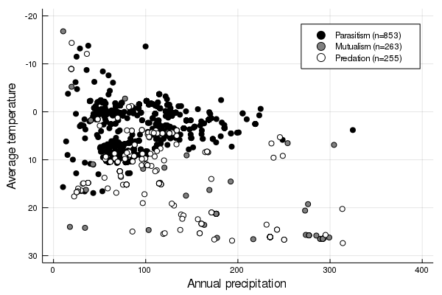

Figure 1: This is the legend of the figure

We can refer to 1.

# Code?

Yes

for i in eachindex(x)  
 x[i] = zero(eltype(x)) # Don't do that  
end

# References

**Martinez**. (2002). Constant Connectance in Community Food Webs. *The American Naturalist.* 139:1208–18.