Clement Twagiramungu

Professor Wang

CIS 310

3 March 2023

Exercise 2

Part 1

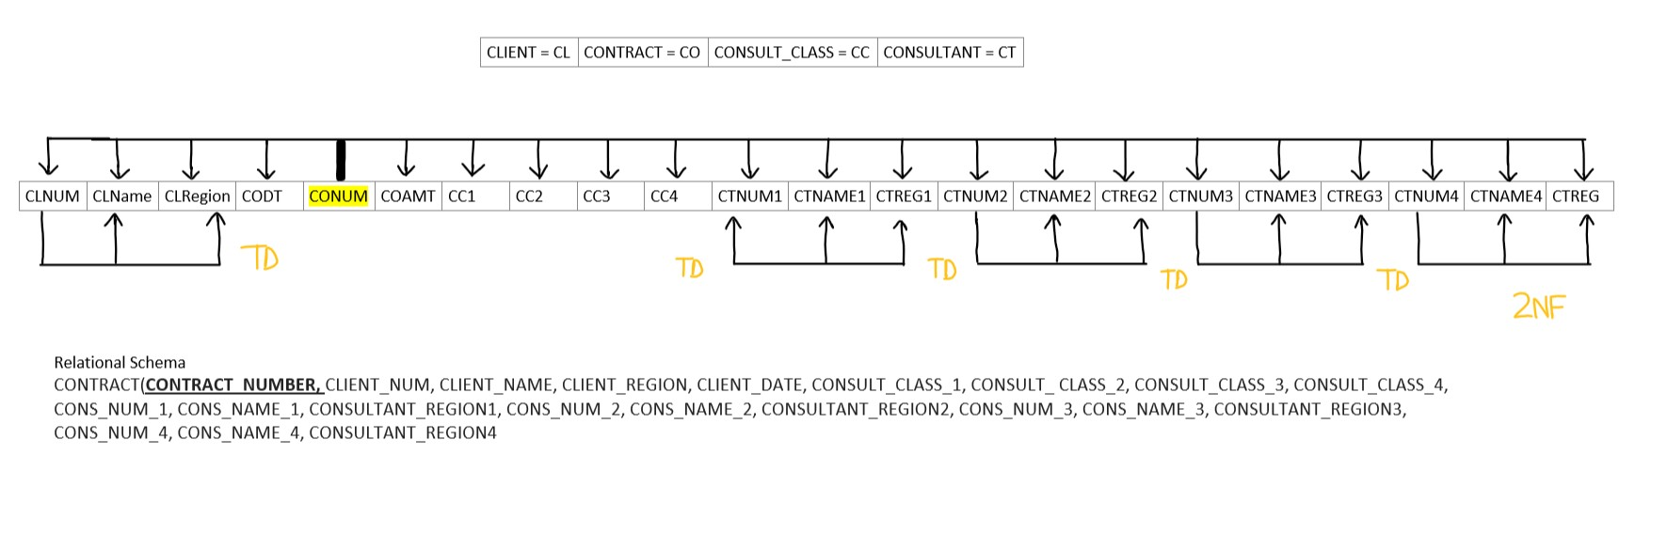

Part 2

