To give you a little background, the website I am constructing is spiritual, dealing with energy & the afterlife, health & wellness and to launch a book I am writing, but to serve as a marketing and website design platform of what can be designed/created from my web shop when assembling the right talent in many areas. I am working with a photographer to create a photo spread, with me, depicted as lady in white, in the forest, with sun rays shining through - embodying the powers of nature with a biblical tone. That feel, the essence of nature & folklore is what I am in pursuit of – where Disney meets MTV in class & style. Below I outline 7 specific icons needed to be drawn out in gold (see page 3). I will need from you after the Logo and 7 Icons below are completed;

* A Victorian era house drawn out image as if it appears as if it is a hologram, to give that haunting allure of Hansel & Gretel and to insert into the photography, see example below, my pictures will be very similar in nature. Use of color > or iridescent, home would be inserted in back right

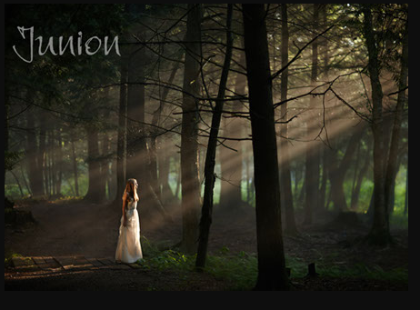

* Image of Ogun (site and pic) to insert in similar pictures as above
  + <https://www.google.com/imgres?imgurl=https://i.pinimg.com/originals/42/2f/72/422f72e7cb8ef616553c8e4a11488382.jpg&imgrefurl=https://www.pinterest.com/pin/402298179188912213/&tbnid=JqYneeRv52MD0M&vet=1&docid=aVyrdKTQbUYKvM&w=480&h=640&itg=1&q=pictures+of+ogun&source=sh/x/im#h=640&imgdii=3lYCSY-pxQOXtM&vet=1&w=480>

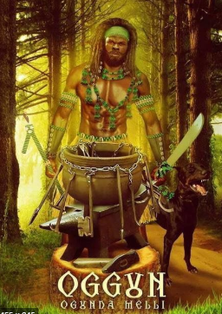

* Blue Butterfly that will be placed on my forehead in a portrait type picture

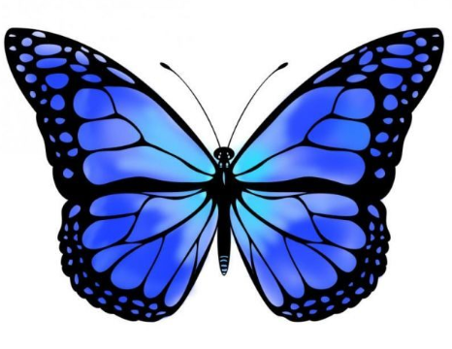

* Owl

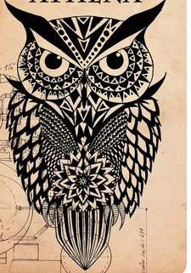

Summary: (7) Icons

* Need images, .jpegs, designs for symbols to click off of on page site
* Website for Images Below: <https://thoughtcatalog.com/christine-stockton/2018/05/witchcraft-symbols-and-meanings/>
* Icons are to be in gold, flat images with the purpose of them serving as section guides within a website. Linking guest to particular Category of Interest clicked on/selected.
* The Parent Icon will carry over to the children subcategories

1. Air Element (Symbol) Category ((Talk With Me))
   1. Contact form will have drop downs categories
      1. Story to Share
      2. Marketing/Advertising
      3. Website Build & Design
      4. Product Reviews
      5. Vendors
      6. Health & Wellness
      7. Humor/Art
      8. Faith
      9. Topic to Cover
      10. Misc

**Represents:** air, the east, the soul, life, communication, wisdom.

**Used in rituals for:** momentum, wisdom.

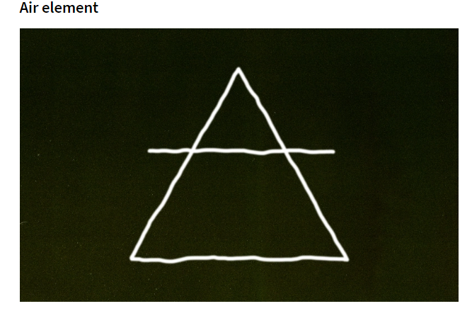

1. Earth Element (Symbol) Category ((Humor/Art/Conversation))

**Represents:** divine feminine, earth, nourishment, endurance, the body.

**Used in rituals for:** money, fertility.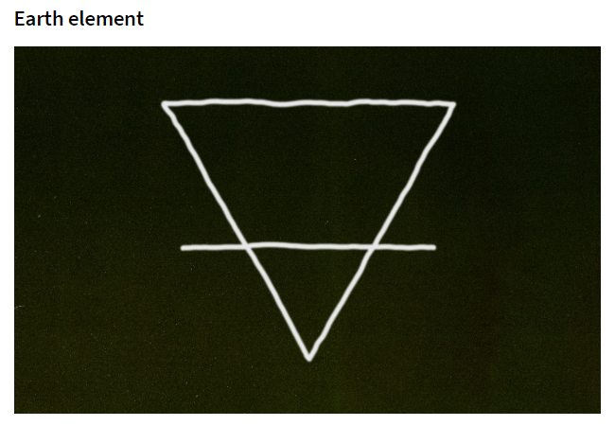

1. Fire Element (Symbol) Category ((Health & Wellness))

**Represents:** fire, masculine energy, purifying energy.

**Used in rituals for:** purifying, new action.

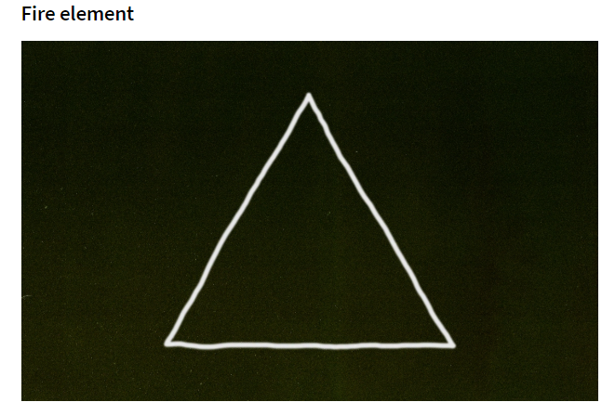

1. Water Element (Symbol) Category ((Stories))

**Represents:** feminine energy, the womb, water, the west, healing.

**Used in rituals for:** love, emotions, “washing away” negative energy.

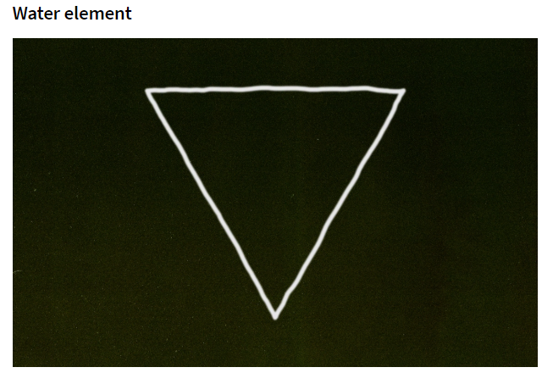

1. Triquetra (Symbol) Category ((Products & Services))

**Represents:** earth, wind, sky, mind, body, soul.

**Used in rituals for:** any reference to three things you want to tie together.

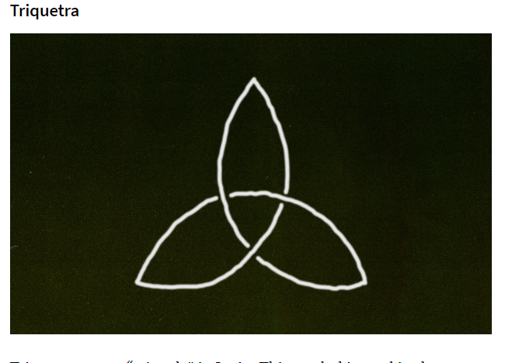

1. Ankh (Symbol) ((Beverage, Food, Recipies))

**Represents:** earth, wind, sky, mind, body, soul.

**Used in rituals for:** any reference to three things you want to tie together.

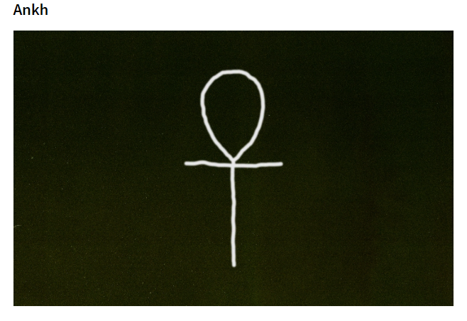

1. Yin Yang (Symbol) Extra at this time

**Represents:** light and dark, good and bad, duality, balance.

**Used in rituals for:**  good luck, balance.