**PROJECT ON RONALDO**

**EXECUTIVE SUMMARY**

This project is aimed at extracting various information of Ronaldo from a given dataset. In the course of this project, the following questions will be satisfied:

* Plot a graph showing Goals per competition
* Plot a graph showing Goals per season
* Plot a graph showing Goals per clubs
* Plot a graph showing Goals per playing Position
* Plot a graph showing Goals per Game Minute
* Plot a graph showing Goals per Type of goal
* Plot a graph showing Favourite Opponents
* Plot a graph showing Goals Assisted by Others

**INTRODUCTION**

Cristiano Ronaldo was born on**February 5, 1985**, in Madeira, Portugal, to Jose Dinis Aveiro and his wife Maria Dolores dos Santos Aveiro. His father was a gardener with the municipality while his mother worked as a cook. Ronaldo was the youngest child among four children; others being a son and two daughters

Cristiano Ronaldo is a professional soccer player who has set records while playing for the Sporting CP, Manchester United, Real Madrid and Juventus clubs, as well as the Portuguese national team.

The information provided in this project is based on the dataset provided.

**METHODOLOGY**

Python programming language was used throughout the work which was done using jupyter notebook.

Different EDA techniques were deployed in order to achieve the desired goal of the questionnaire.

**RESULTS**

1. **Plot a graph showing Goals per competition:**

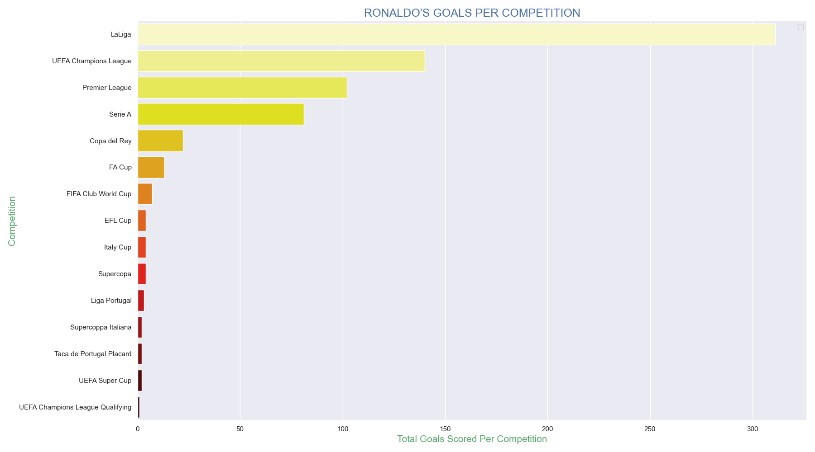

**NOTES:**

* Ronaldo scored most of his goals in La Liga
* Ronaldo scored 311 goals in La Liga
* Ronaldo scored the least number of goals in UEFA Champions League Qualitfying
* Ronaldo scored 1 goal in UEFA Champions League Qualitfying

1. **Plot a graph showing Goals per season:**

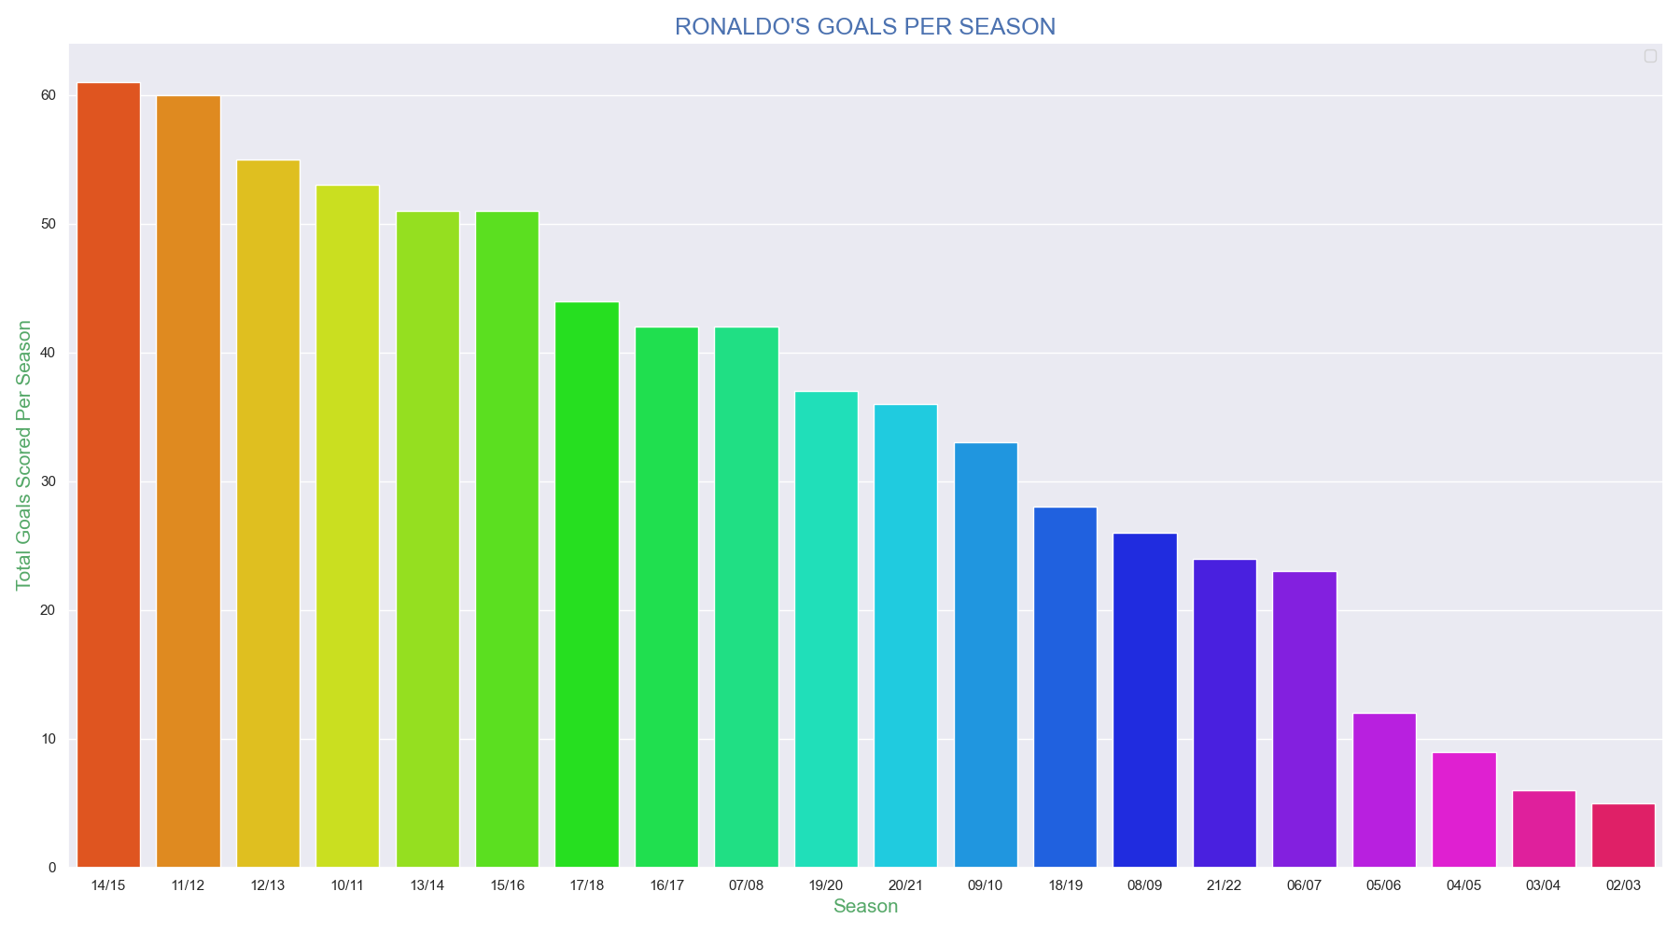

**NOTES:**

* Ronaldo scored the highest number of goals in 2014/2015 Season
* Ronaldo scored 61 goals in 2014/2015 Season
* His Second highest scoring season so far is the 2011/2012 Season with a total of 60 goals
* Ronaldo scored the least number of goals in 2002/2003 Season
* He Scored only 5 goals in 2002/2003 Season

1. **Plot a graph showing Goals per clubs**

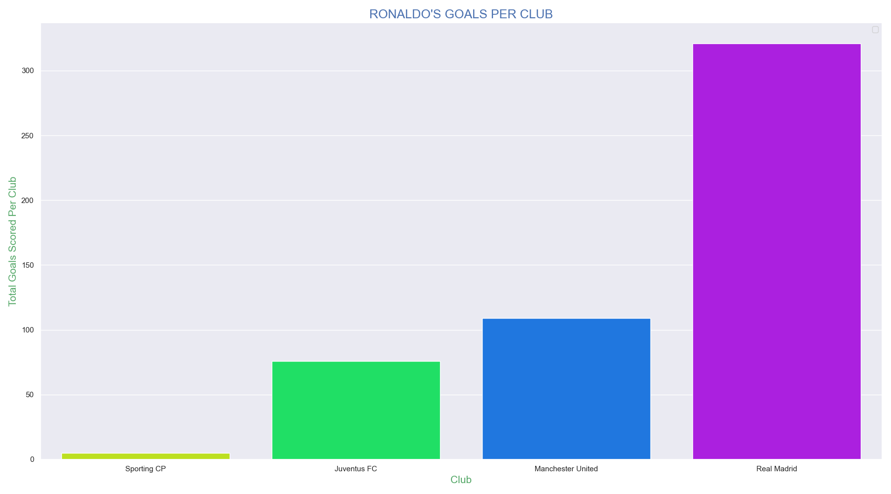

**NOTES:**

* Ronaldo scored the highest number of goals in Real Madrid
* Ronaldo scored 321 goals in Real Madrid
* Ronaldo scored the least number of goals in Sporting CP
* He Scored only 5 goals in Sporting CP

1. **Plot a graph showing Goals per playing Position**

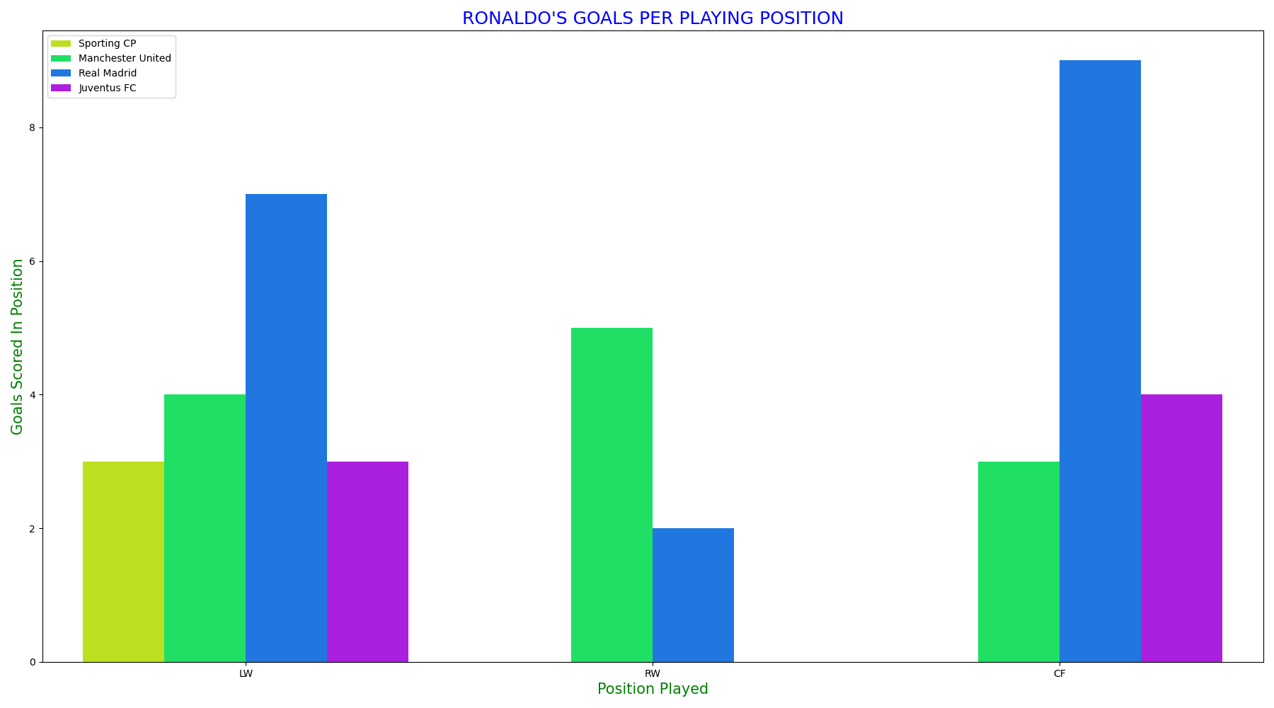

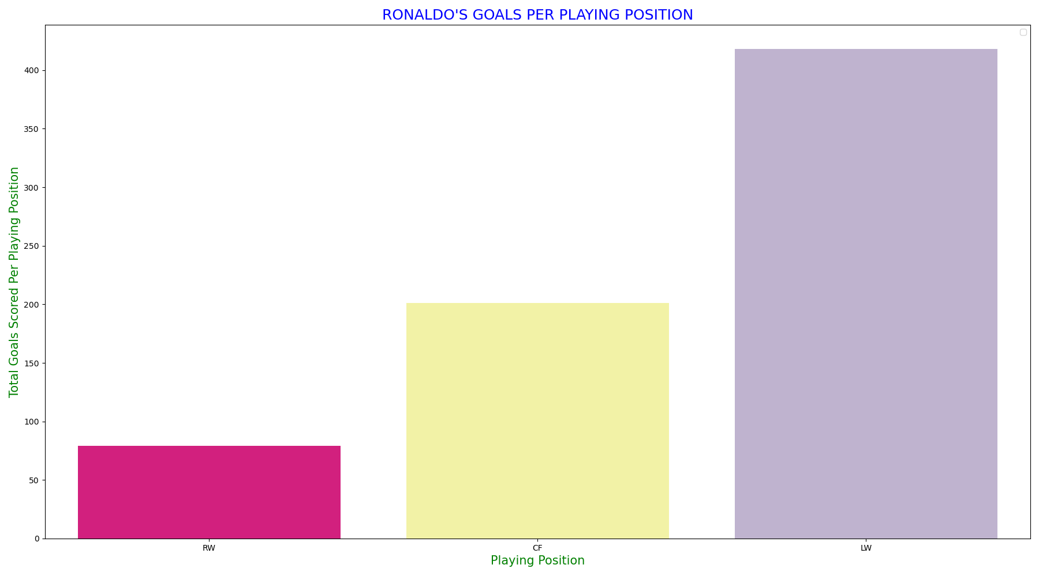

**NOTES:**

* In Real Madrid, Ronaldo scored most of his goals as a CF and scored least as a RW
* In Manchester United, Ronaldo scored most of his goals as a RW and scored least as a CF
* In Sporting CP, Ronaldo scored only playing from the LW
* In Juventus, Ronaldo scored as a LW and a RW only
* Ronaldo Scored most of his goals playing from the LW
* As a LW, Ronaldo scored a total of 418 Goals
* As a RW, Ronaldo scored least number of goals – 79 Goals

1. **Plot a graph showing Goals per Game Minute**

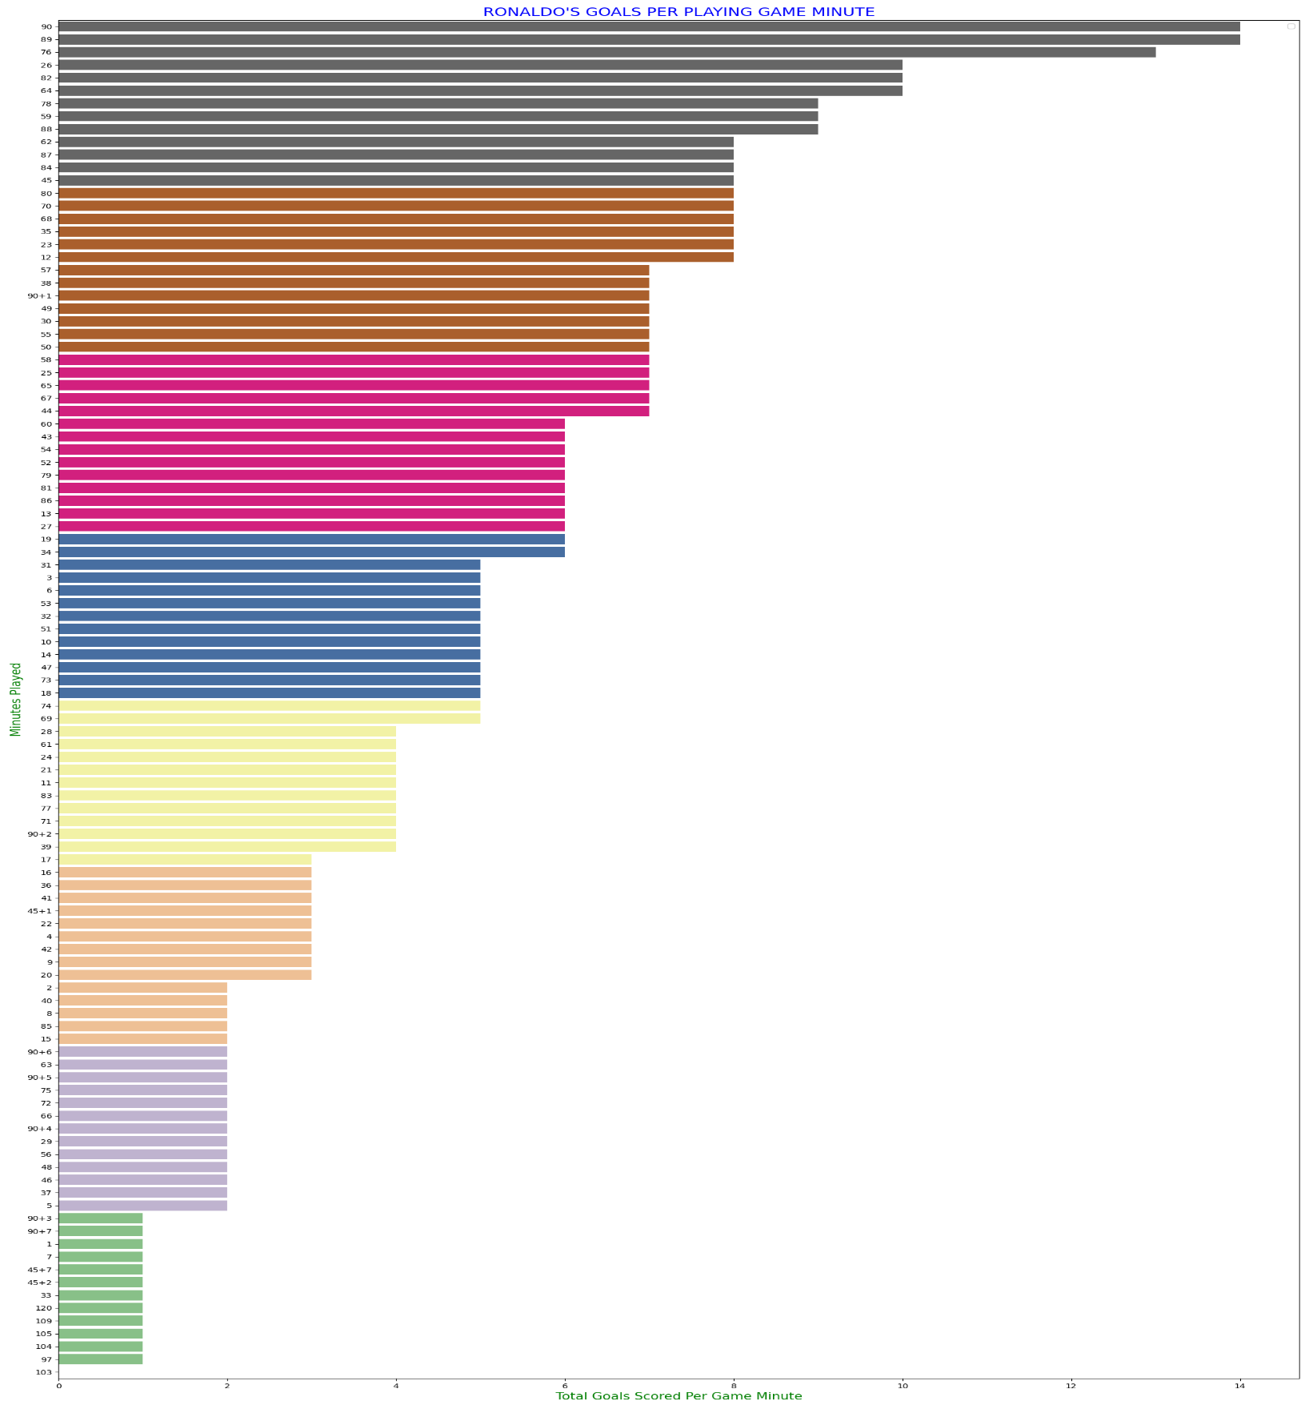

**NOTES:**

* Ronaldo scored more goals between the 75th minute and 90th minute
* Ronaldo shows more threat towards the end of a match.

1. **Plot a graph showing Goals per Type_of_goal**

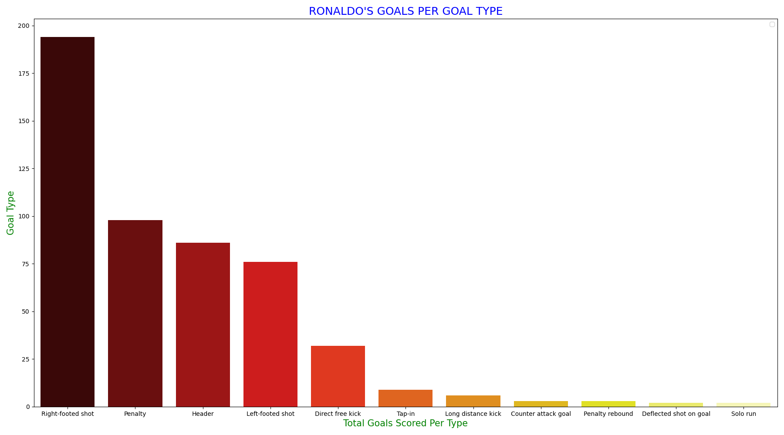

**NOTES:**

* Ronaldo scored 194 goals via a Righted Footed Shoot
* Ronaldo scored 98 goals via Penalty
* Ronaldo scored the least number of goals via deflected shot on goal, and solo run

1. **Plot a graph showing Favourite Opponents**

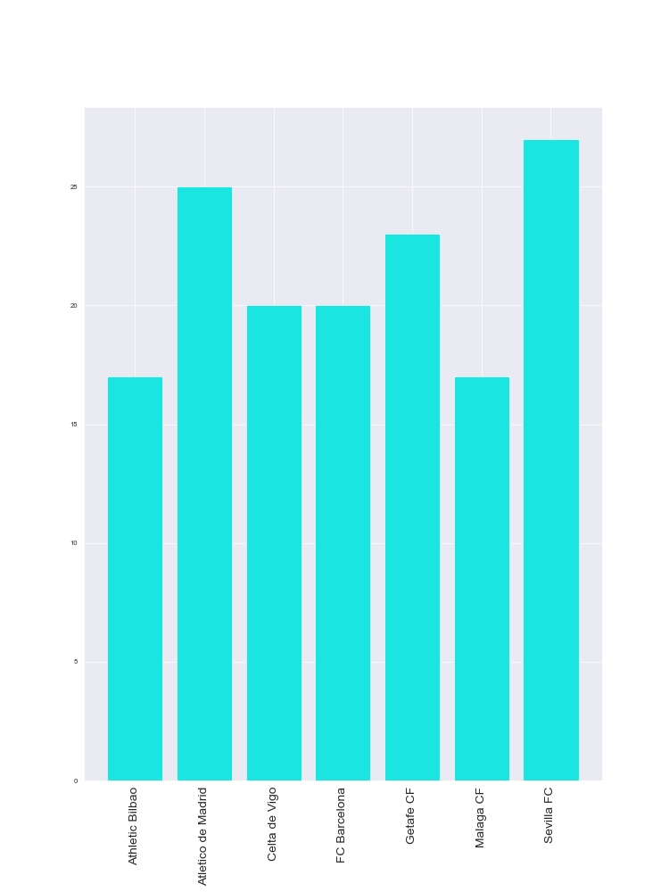

**NOTES:**

* Ronaldo has scored SEVILLA more goals than he has scored any other team
* Ronaldo is favorite to score opponents like Athletic Bilbao, Atletico Madrid, Celta de Vigo, FC Barcelona, Getafe CF, Malaga CF, and Sevilla

1. **Plot a graph showing Goals Assisted by Others**

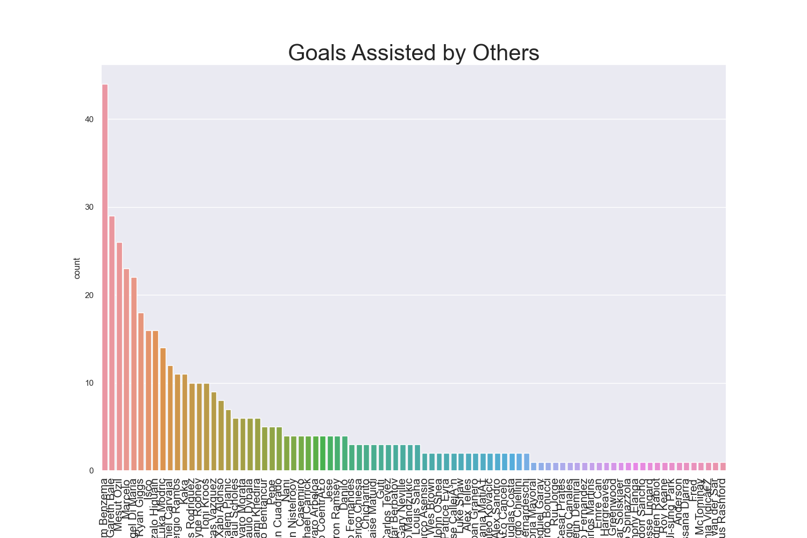

**NOTES:**

* Benzema has assisted Ronaldo the most.
* Marcus Rashford has assisted Ronaldo the list

**CONCLUSION**

This information here is subject to update and modification in future considering new outcomes in the world of football today as the point of reference – RONALDO CHRISTIANO DOS SANTOS is still actively playing and scoring goals,