**PROJECT ON UEFA CHAMPIONS LEAGUE 2021/2022**

**EXECUTIVE SUMMARY**

This project is aimed at extracting various information of the 2021/2022 UEFA Champions League Season from a set of data stored in different files/tables. In the course of this project, the following questions will be satisfied:

* Number of goals scored per club (PLOT A GRAPH)
* Average playing time per player per club (PLOT A GRAPH)
* PLOT AND RETURN A TABLE FOR Top 10 scorers
* Top 15 Teams in terms of goals (PLOT A GRAPH AND TABLE)
* Goal types analysis (How scored: PLOT A GRAPH)
* Goal types analysis (From where scored: PLOT A GRAPH)
* Goal types analysis (Player position: PLOT A GRAPH)
* Top 15 dribblers (PLOT A GRAPH)
* Top 15 Corner Takers (PLOT A GRAPH)

**INTRODUCTION**

The UEFA Champions League (abbreviated as UCL) is an annual club football competition organized by the Union of European Football Associations (UEFA) and contested by top-division European clubs, deciding the competition winners through a round robin group stage to qualify for a double-legged knockout format, and a single leg final. It is one of the most prestigious football tournaments in the world and the most prestigious club competition in European football, played by the national league champions (and, for some nations, one or more runners-up) of their national associations.

Introduced in 1955 as the Coupe des Clubs Champions Européens (French for European Champion Clubs' Cup), and commonly known as the European Cup, it was initially a straight knockout tournament open only to the champions of Europe's domestic leagues, with its winner reckoned as the European club champion. The competition took on its current name in 1992, adding a round-robin group stage in 1991 and allowing multiple entrants from certain countries since the 1997–98 season. It has since been expanded, and while most of Europe's national leagues can still only enter their champion, the strongest leagues now provide up to four teams. Clubs that finish next-in-line in their national league, having not qualified for the Champions League, are eligible for the second-tier UEFA Europa League competition, and from 2021, teams not eligible for the UEFA Europa League qualify for the third-tier UEFA Europa Conference League.

In its present format, the Champions League begins in late June with a preliminary round, three qualifying rounds and a play-off round, all played over two legs. The six surviving teams enter the group stage, joining 26 teams qualified in advance. The 32 teams are drawn into eight groups of four teams and play each other in a double round-robin system. The eight group winners and eight runners-up proceed to the knockout phase that culminates with the final match in late May or early June The winner of the Champions League qualifies for the following year's Champions League, the UEFA Super Cup, and the FIFA Club World Cup.

**METHODOLOGY**

Python programming language was used throughout the work which was done using Jupyter notebook. Different EDA techniques were deployed in order to achieve the desired goal of the questionnaire, but first data mining and cleaning was deployed to enable accuracy of facts pulled from the given datasets.

**RESULTS**

1. **Number of goals scored per club (PLOT A GRAPH):**

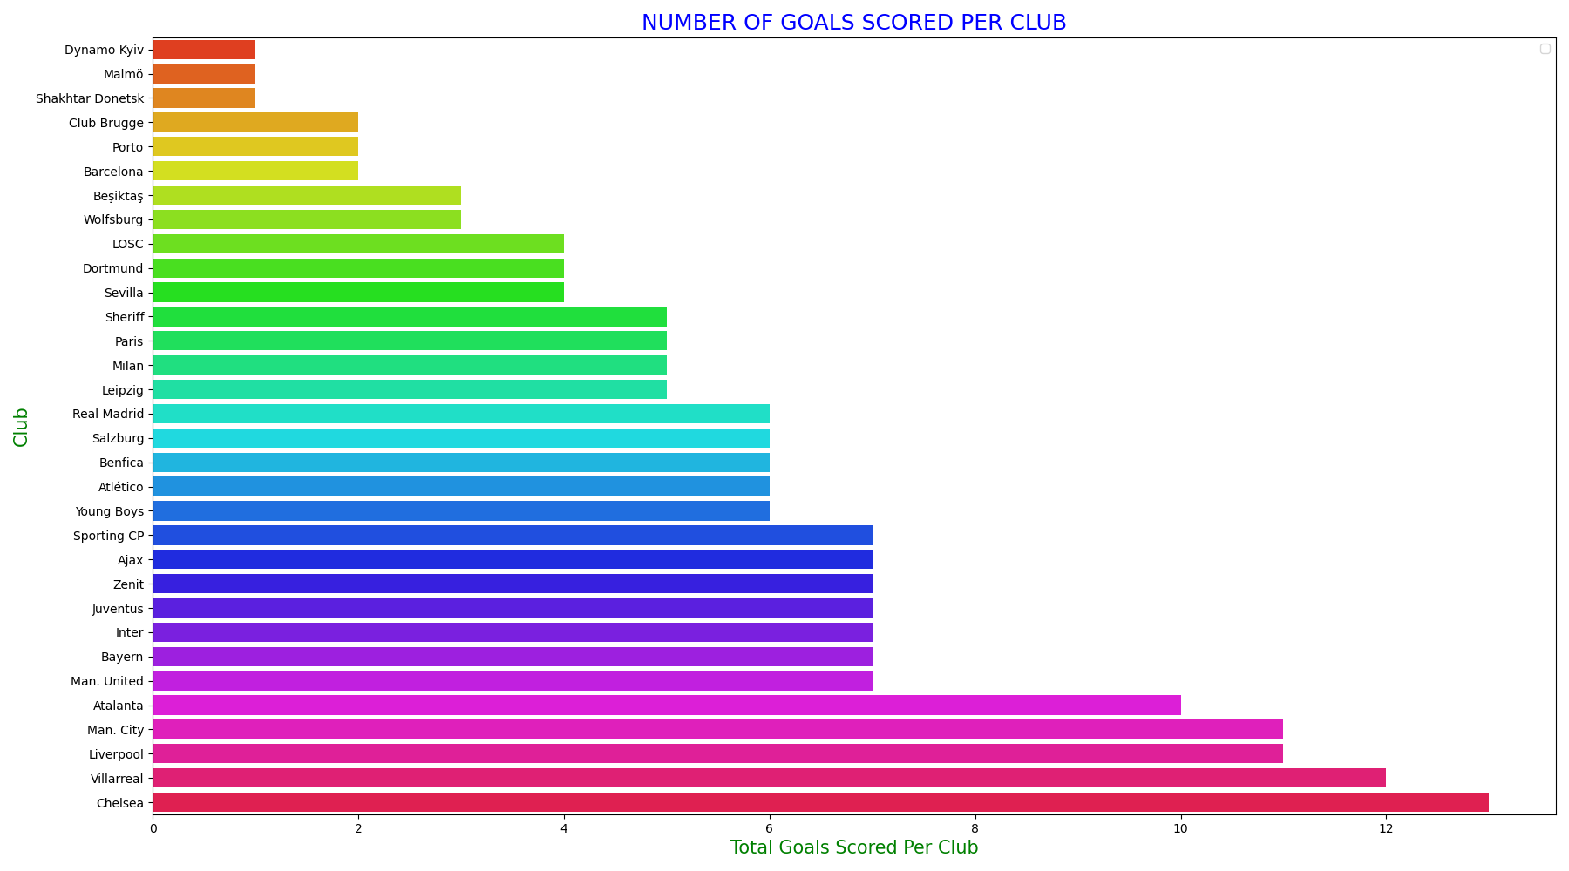

**NOTES:**

* Chelsea Scored the highest Number of Goals in the 2021/2022 UCL Season, scoring 13 goals in total
* Villareal is the 2nd highest scoring team with a total of 12 goals
* Dynamo Kiev, Maimo, and Shakhter Donetsk are the teams with the least number of goals; scoring only 1 goal each.

1. **Average playing time per player per club (PLOT A GRAPH):**

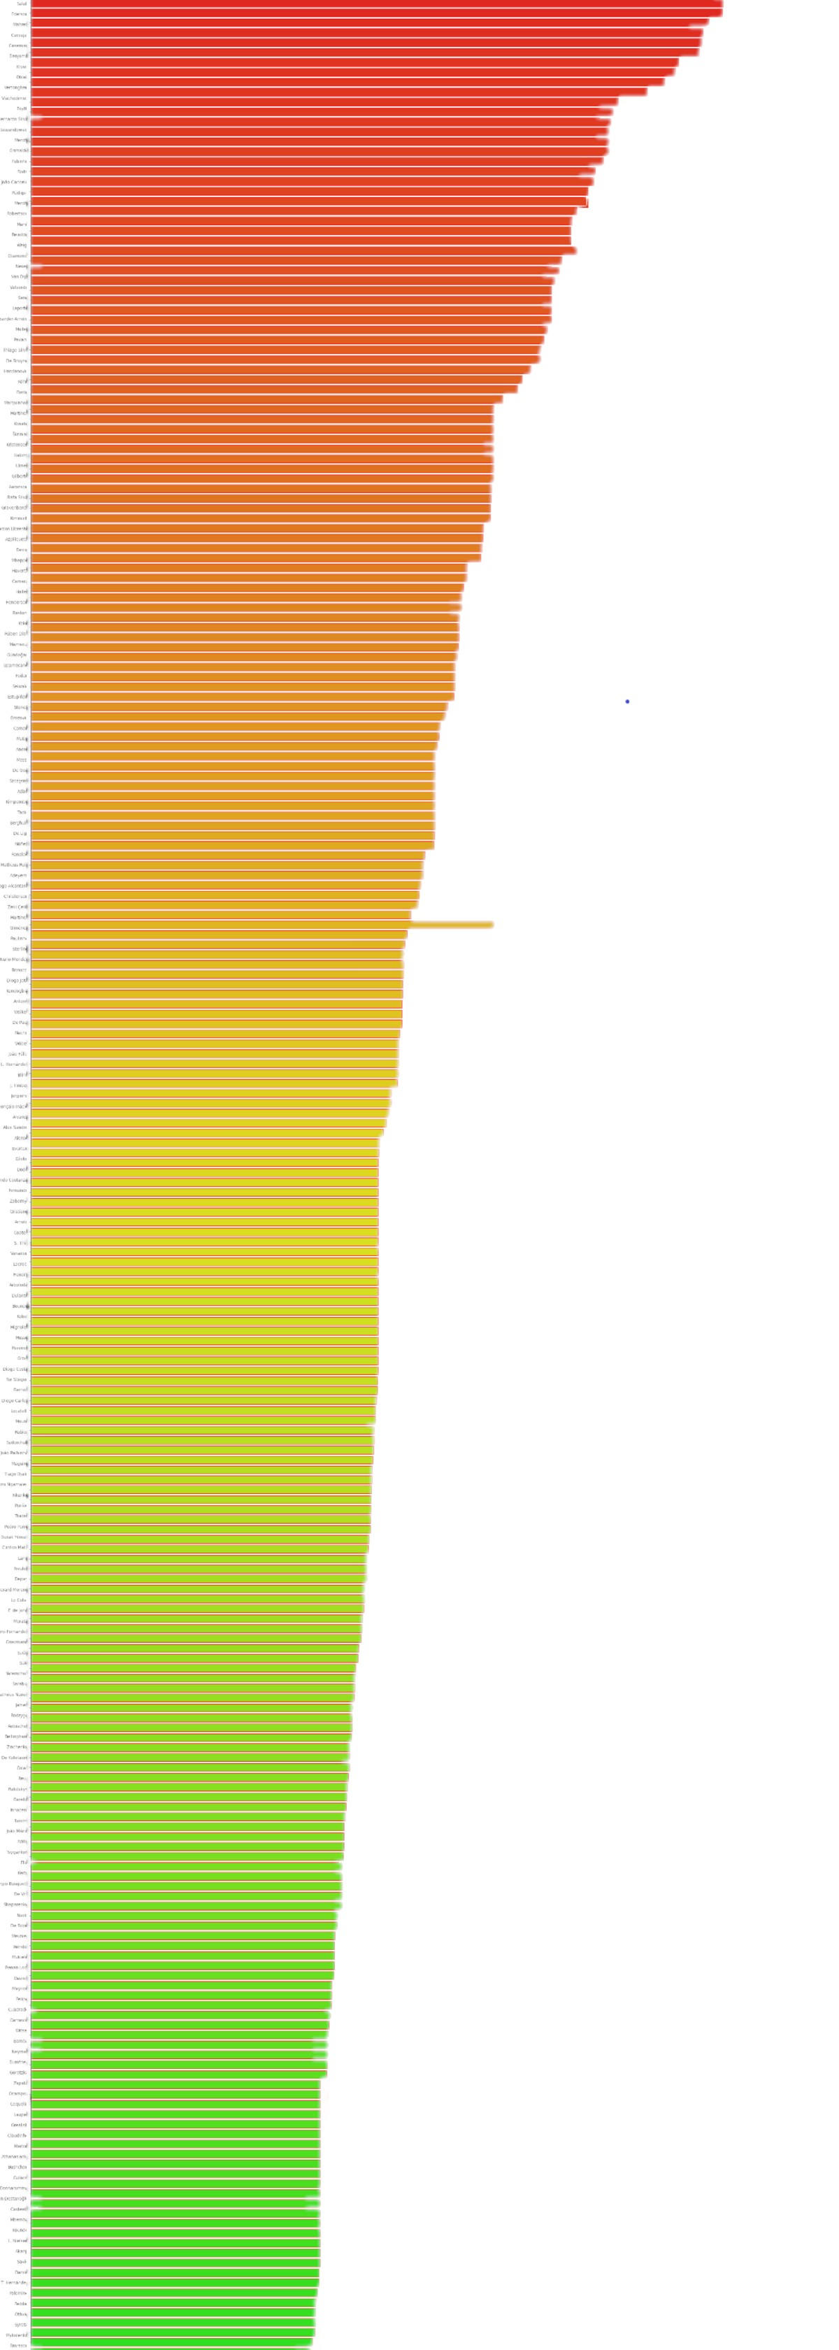

**NOTES:**

* Courtois and Vinicius have the highest playing time and both play for Real Madrid
* Veltman is the 2nd lowest in terms of playing time

1. **PLOT AND RETURN A TABLE FOR TOP 10 SCORERS:**

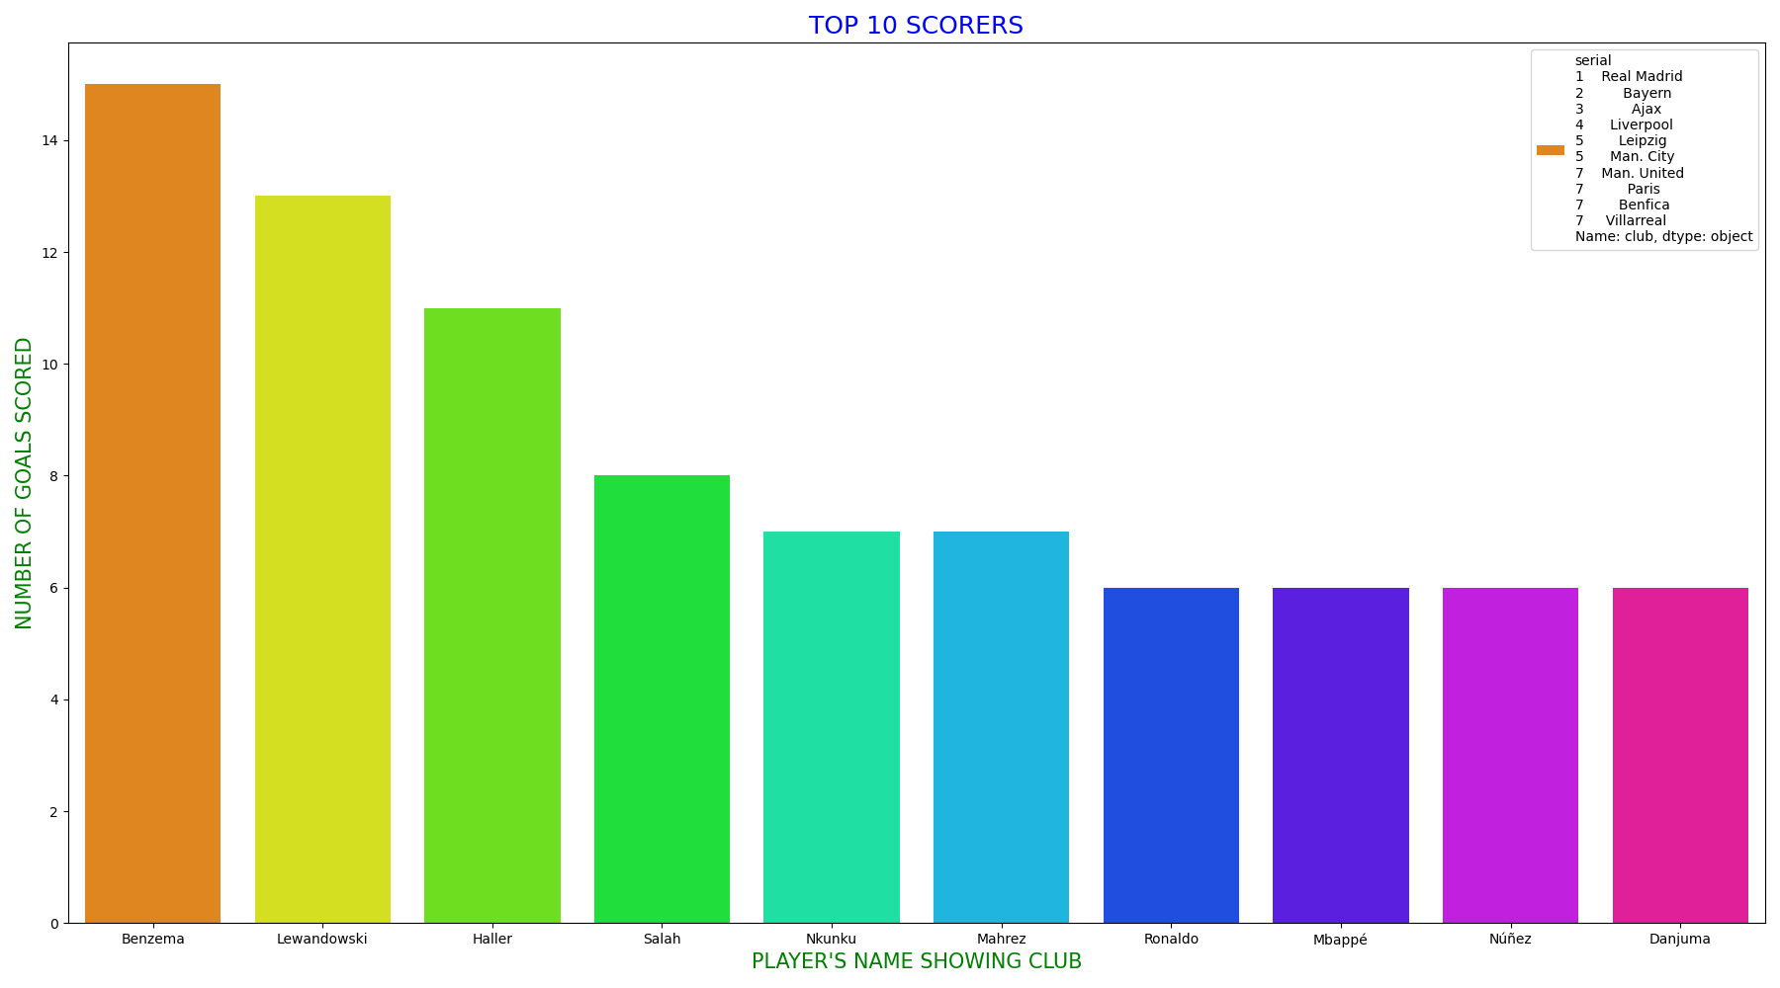

**NOTES:**

* Benzema is the highest goal scorer in the UCL this season
* Lewandoski is the runner up in terms of top10 scorers
* Ronaldo, Mbappe, Nunez, and Danjuma are least on the list of top 10 scorers
* Ronaldo, Mbappe, Nunez, and Danjuma have a tie of 6 goals scored each

1. **Top 15 Teams in terms of goals (PLOT A GRAPH AND TABLE)**

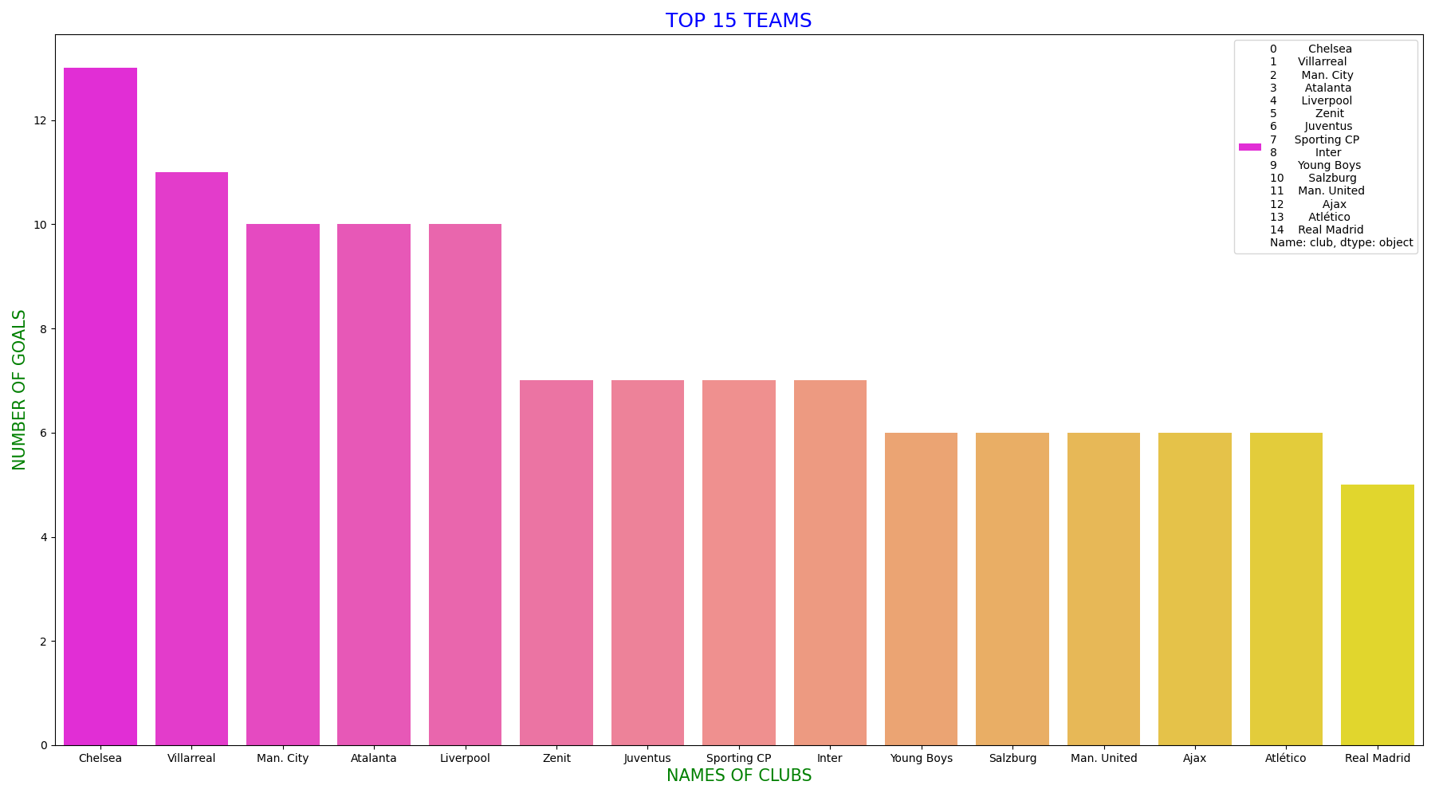

**NOTES:**

* Chelsea Scored the highest Number of Goals in the 2021/2022 UCL Season, scoring 13 goals in total
* Villareal is the 2nd highest scoring team with a total of 12 goals
* Manchester City, Atlanta, and Liverpool have a tie as 3rd on the list.
* Real Madrid is the least on the top 15 list

1. **Goal types analysis (How scored: PLOT A GRAPH)**

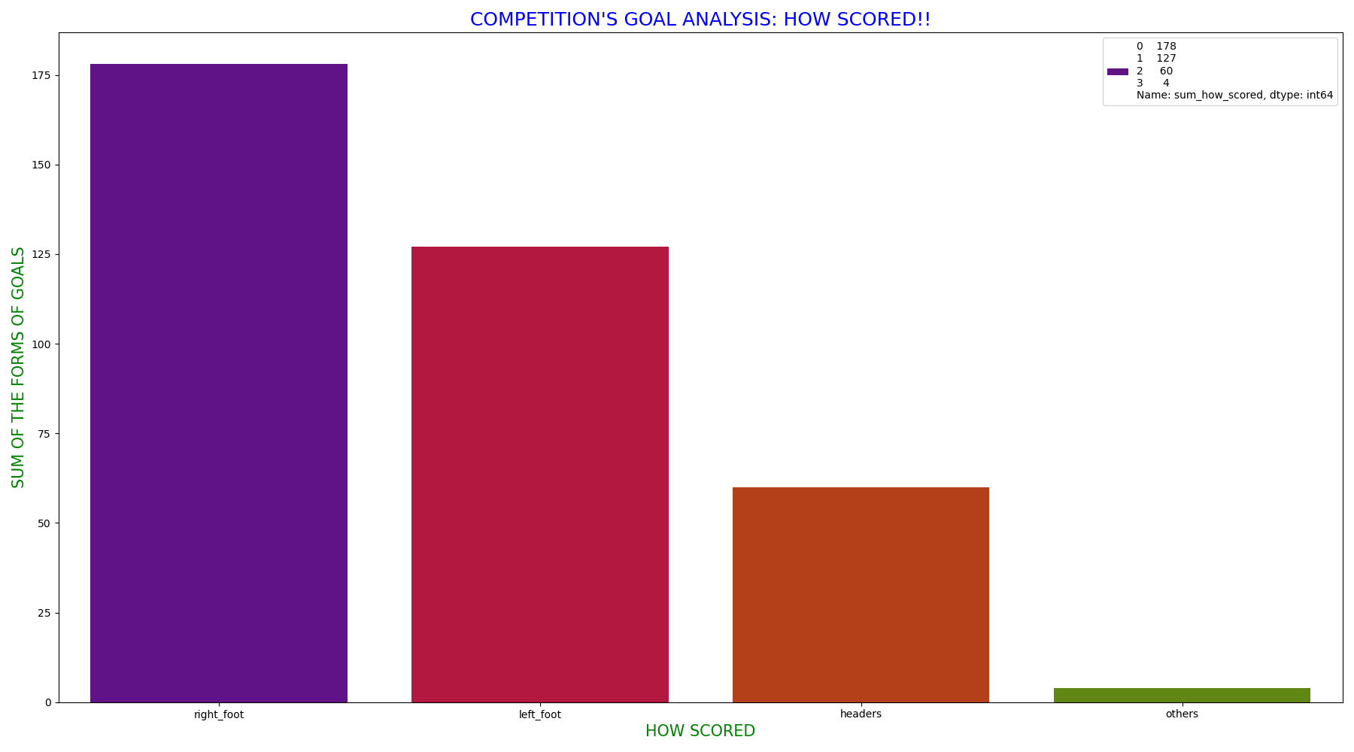

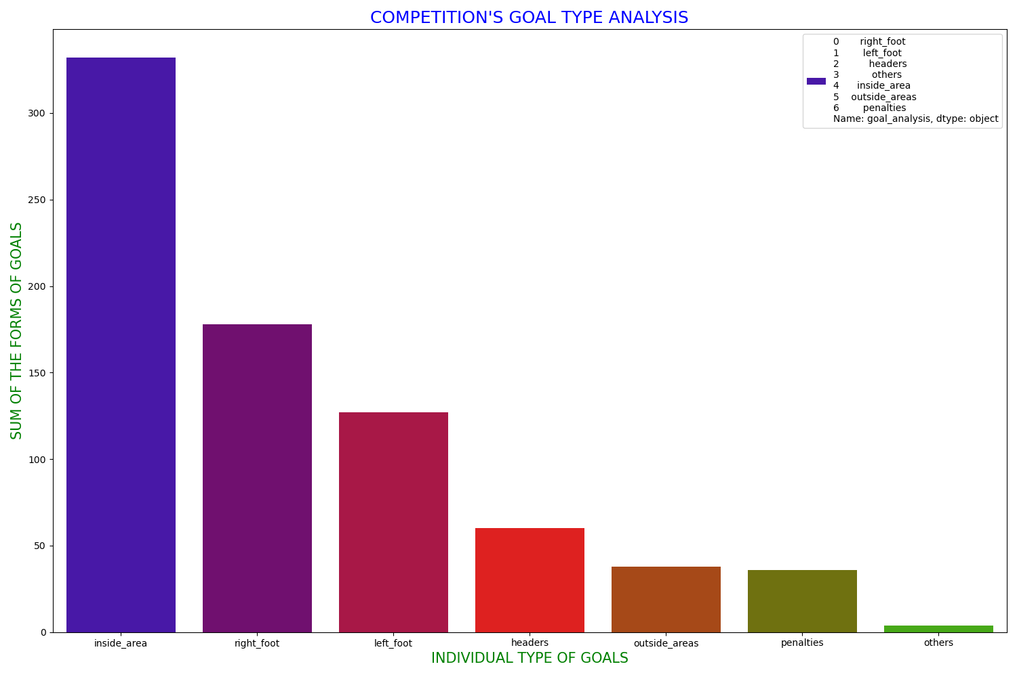

**NOTES:**

* Most goals in the tournament were scored using the right foot
* A lot of goals were scored using the left foot as well.

1. **Goal types analysis (From where scored: PLOT A GRAPH)**

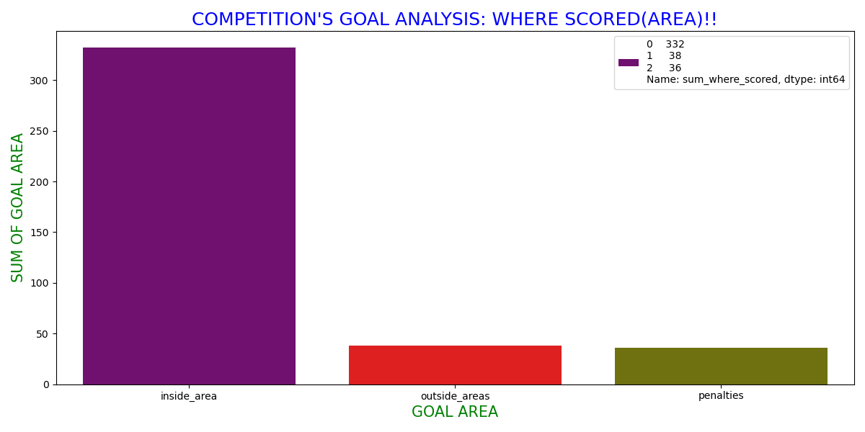

**NOTES:**

* Most goals are scored from the inside area
* Goals scored from the penalty spot equals the number of goals scored from outside the penalty box

1. **Goal types analysis (Player position: PLOT A GRAPH):**

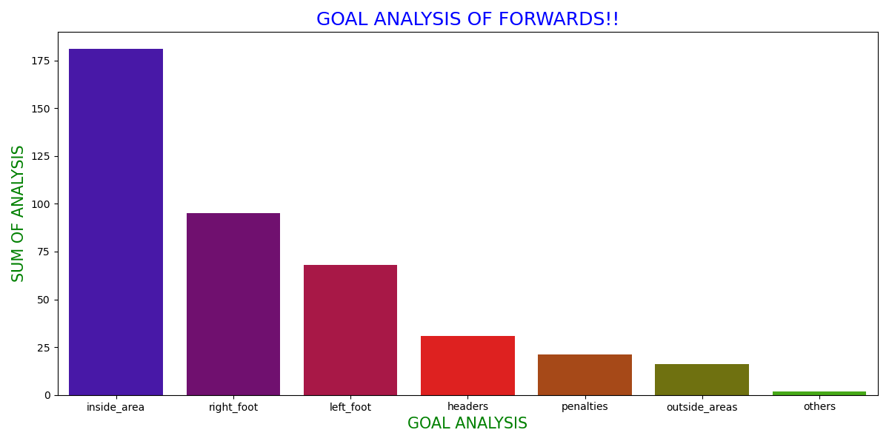

**NOTES:**

* Forwards/Strikers scored most goals from the inside area
* More goals were scored by right footed Forwards than the left footed Forwards

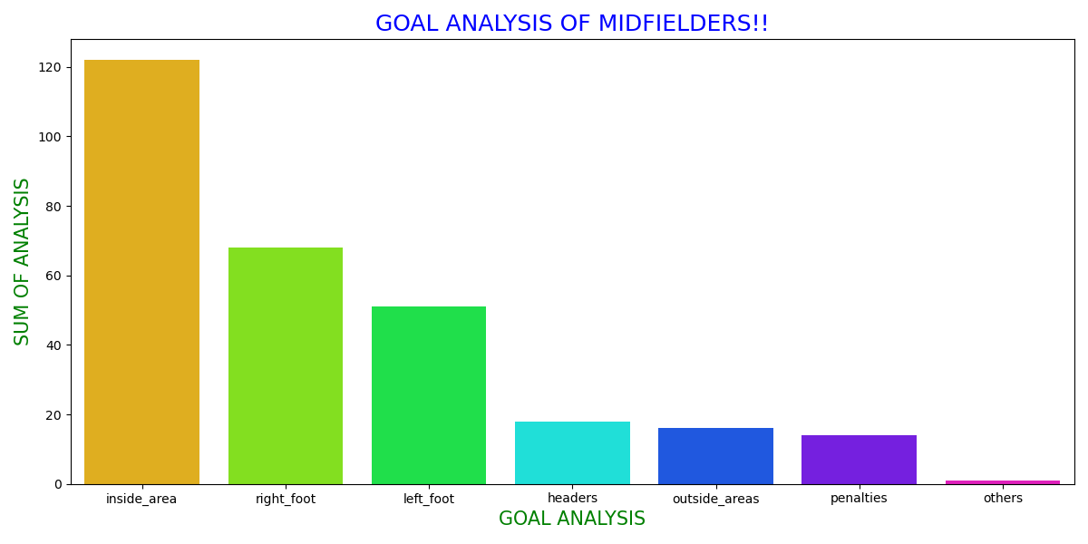

**NOTES:**

* Midfielders scored most goals from the inside area too
* More goals were scored by right footed Midfielders than the left footed Midfielders

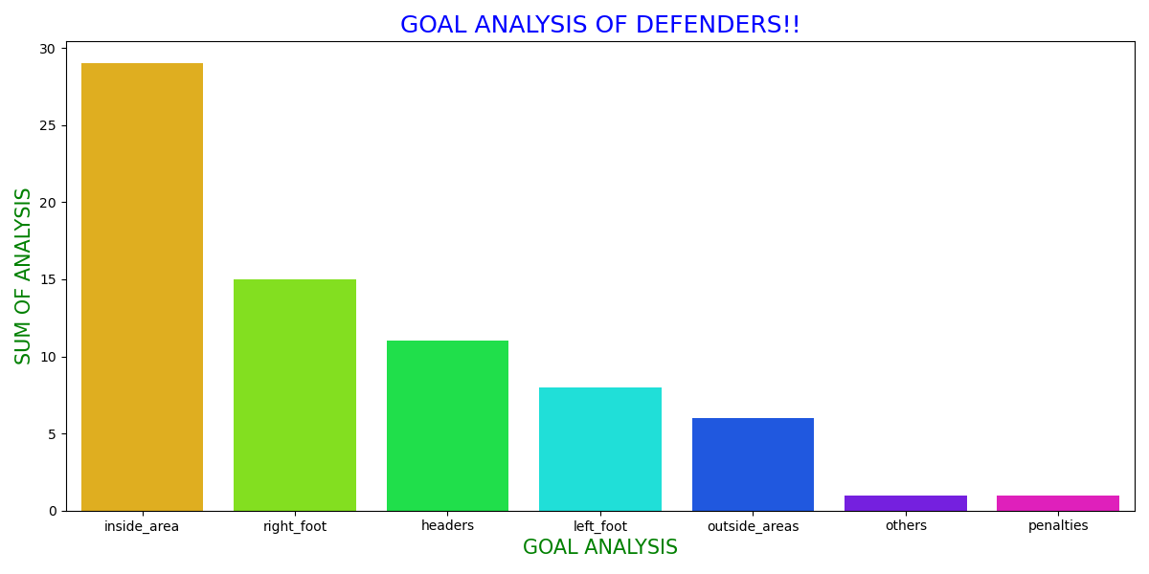

**NOTES:**

* Defenders scored most goals from the inside area too
* More goals were scored by right footed Defenders than the left footed Defenders
* More goals came from header than from left foot of midfielders.

1. **Top 15 dribblers (PLOT A GRAPH):**

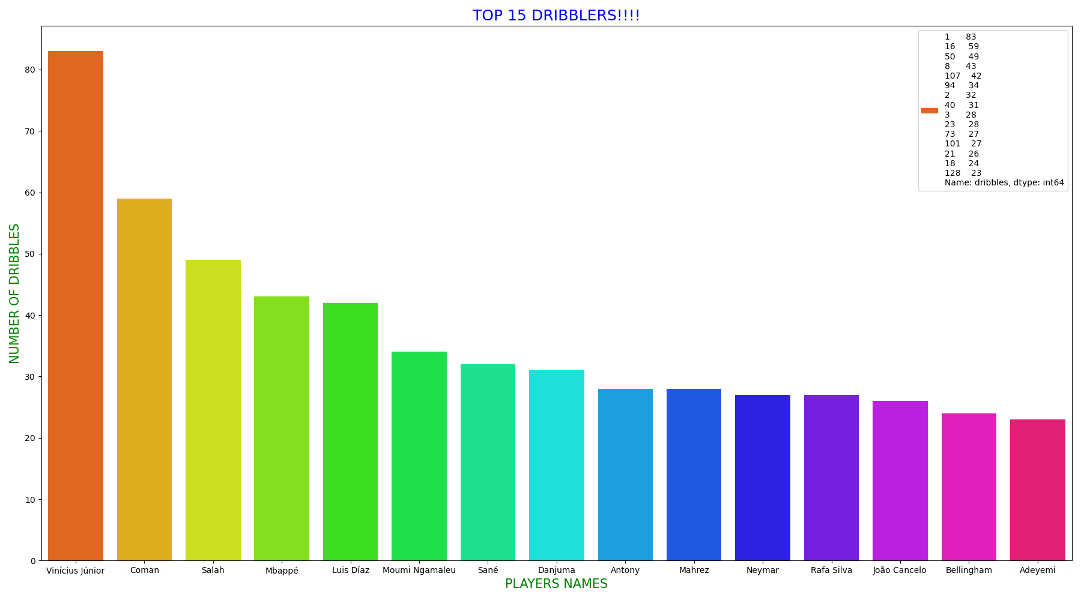

**NOTES:**

* Vinicius Junior of Real Madrid made the most dribbles in the tournament this year, followed by Coman of Bayern Munich
* The least number of dribbles was made by Adeyemi

1. **Top 15 Corner Takers (PLOT A GRAPH):**

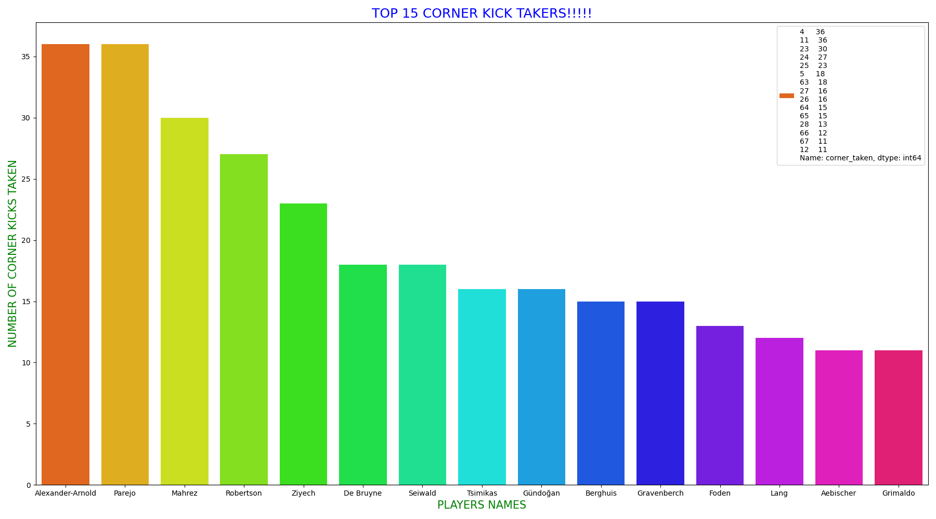

* Alexander Arnold and Parejo are the highest corner kick takers in the tournament with a total corner kicks of 36 each.
* Aesbischer and Grimaldo are the least in the pecking order of corner kicks taken this season

**CONCLUSION**

This information here is subject to update and modification in future considering new outcomes in the world of football today as the point of reference – UEFA Champions League is still active, and considered the highest competition in the world at the moment