VANNET
Trust-Aware Robust Federated Reinforcement Learning for Secure Task Offloading in Vehicular Edge Networks
Project Progress Report | B.Tech Final Year Project
Code and evidence: https://github.com/clenser/Trust-Aware-Robust-FRL-for-Vehicular-Task-Offloading-TAR-FRL-VEC-

1. Purpose of this report
This report summarises what has been built, how the roadmap hypotheses were tested, which data the system uses, and what could not be achieved. All numbers come from simulation and are taken from the files in the repository (docs/HYPOTHESES.md, docs/BASELINES.md, docs/LIMITATIONS.md). Nothing here is a real-world measurement.

2. The problem in brief
Vehicles offload heavy tasks (e.g. object detection) to roadside units (RSUs) or nearby vehicles. A learned offloading policy can be trained across vehicles with federated learning, but some participants may send poisoned model updates. The project asks whether a trust score, built from behaviour and from the quality of each model update, can protect the shared policy.

3. What has been built
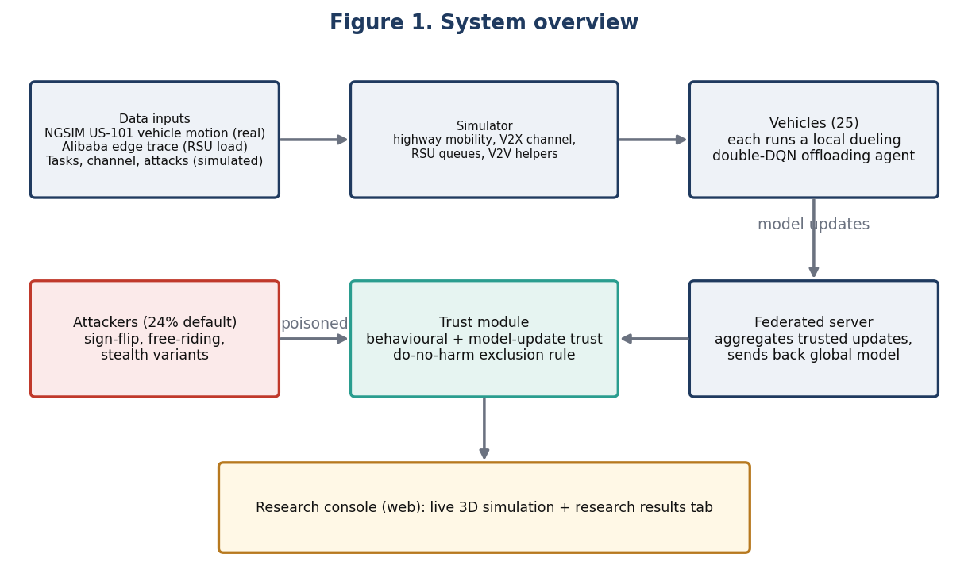
- Simulator: highway mobility, V2X channel, RSU queues and V2V helper vehicles.
- Learning: a dueling double-DQN offloading agent per vehicle, combined by federated averaging.
- Attacks: sign-flip, free-riding, partial, norm-matched (stealth), scaling and noise; plus V2V data-plane sabotage.
- Trust: behavioural trust, model-update trust, their joint score, and a do-no-harm exclusion rule that avoids excluding honest clients.
- Baselines: FedAvg, Multi-Krum, coordinate median, trimmed mean, an adapted FLTrust, and heuristic offloading policies.
- Research console: a web app with a live 3D simulation and a research-results tab read from the stored results.
- Reproducibility: about 400 automated tests, raw result files with checksums, and fixed seeds.

4. How the method works
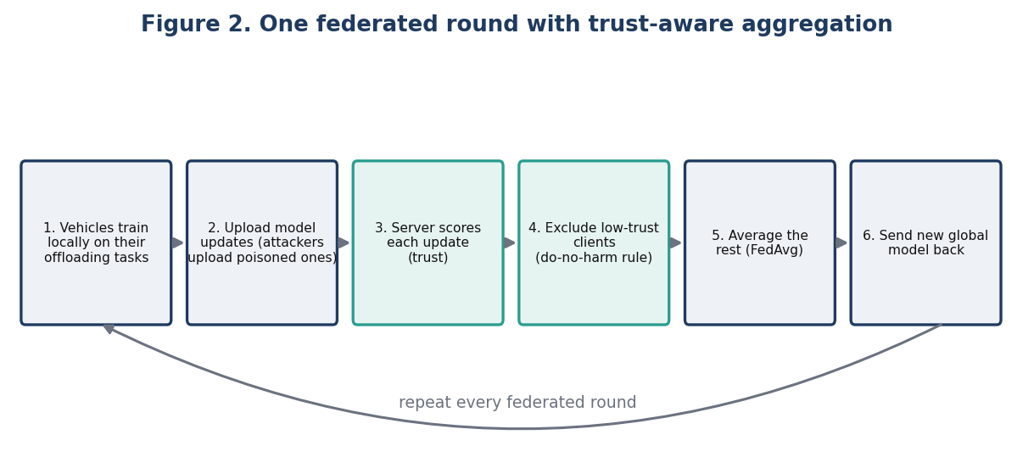
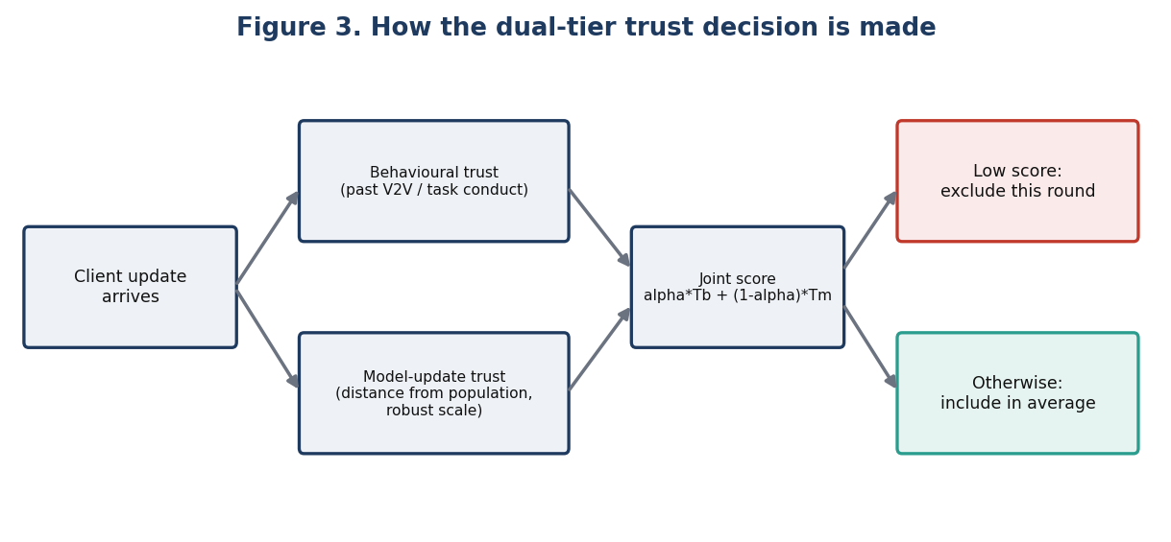
The joint trust score follows the roadmap formula T = alpha * T_behaviour + (1 - alpha) * T_model. The do-no-harm rule is an added mechanism that excludes a client only when the evidence is strong, because excluding honest clients was found to cost accuracy.

5. How the hypotheses were tested
- Pre-specified: the ten comparisons and the correction for multiple testing (Holm) were fixed in the script before any run.
- Paired by seed: each method is compared with FedAvg on the same random seeds (24 seeds for 24% and 40% attackers; 12 for other conditions).
- Reported with 95% confidence intervals, not just point values.
- Fresh-seed confirmation: a later claim was re-tested on seeds not used before.
- Scope: sign-flip attacker, 25 vehicles, simulation only.

Hypothesis tally against the roadmap
ID | Roadmap hypothesis | Status | Evidence
H1 | Lower latency than non-trust-aware FRL | Partly | Completion improves; latency of completed tasks differs by 3 ms or less (none at 24%)
H2 | More robust than FedAvg as malicious share grows | Supported | +6.1 pp at 24%, +16.2 pp at 40% attackers
H3 | Joint trust beats behavioural trust alone | Supported (with caveat) | +5.3 pp at 24%, +19.7 pp at 40%; behavioural-only gives no protection, so the model tier is what matters
H4 | Holds under other mobility / connectivity | Supported for tested cases | Synthetic and real NGSIM mobility; offline clients on the raw interval only
H5 | No impractical overhead | Met | 136 ms vs 12 ms per aggregation round; no extra upload

pp = percentage points of task completion. Seven of ten pre-specified tests are supported after correction, two on the raw interval only, one not established.

Comparison with standard robust aggregation
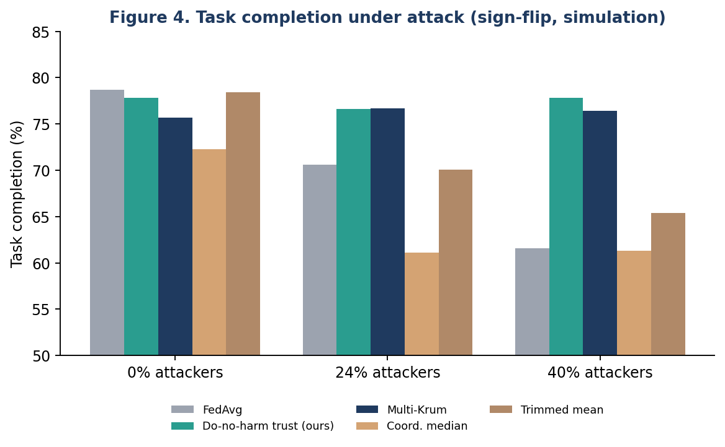
The do-no-harm rule matches Multi-Krum (within noise) and clearly beats coordinate median and trimmed mean once 24-40% of clients are attackers. It is therefore reported as comparable to the strongest baseline, not better than it, for this attack. Against the label-free stealth variant at 40% attackers, it beat Multi-Krum on fresh seeds.

6. Roadmap versus current system
Roadmap item | Current state
Literature review and gap | Done: verified literature matrix, gap and novelty documents
Mathematical model of trust | Done: documented in docs/METHODOLOGY.md
Implementation | Done: simulator, federated RL, trust, baselines, console
Experiments with statistics | Done: pre-specified, paired, Holm-corrected; raw evidence retained
RQ1-RQ2 dynamic and dual-tier trust | Answered: the model-update tier carries the protection; the behavioural tier adds little
RQ3 trust inside the RL decision | Not supported (see section 8)
RQ4 robustness as attackers grow | Supported
RQ5 dynamic environments | Supported for the conditions tested
Paper | Draft in docs/PAPER.md; not yet submitted

7. Data used by the system
Data | Source | Used for | Real or simulated
NGSIM US-101 trajectories | US Federal Highway Administration (public) | Vehicle motion (681 m, 2,847 vehicles) | Real, motion only
Edge workload trace (EdgeWorkloadsTraces) | Alibaba edge platform; obtained on request, about 63 GB, not stored in the repository | Calibrating RSU capacity, load and backhaul delay from 149 sites and about 7,400 VMs | Real, edge side only
Tasks, wireless channel, rewards | Generated by the simulator (3GPP/ETSI-style catalogue) | Offloading decisions | Simulated
Attackers and their updates | Generated by the simulator | Poisoning and free-riding | Simulated

Neither real dataset contains tasks, radio measurements or attack labels, so the project does not claim an end-to-end real-data pipeline. Provenance and checksums are in data/PROVENANCE.md.

8. What could not be achieved, and why
Not achieved | Why (simple terms)
Trust did not improve the learned offloading policy itself (RQ3) | Adding trust features to the policy's inputs gave no measurable gain; the benefit comes only from protecting the aggregation.
Latency reduction (H1) | Trust helps tasks finish, but finished tasks are not noticeably faster (3 ms or less).
Learned policy beating simple heuristics under measured edge load | It wins only in the benchmark environment; under measured edge load it ties a simple heuristic.
Detecting partial sign-flip attackers | Their updates look too similar to honest ones; detection rates stay low.
Advantage over Multi-Krum | The rule ties Multi-Krum for plain sign-flip attacks, so no claim of beating the state of the art.
Real-world validation | Only simulation was done; no real vehicles, network or attack data exist for this setup.
Clear gain at the default 24% attack with the original joint rule | The effect is small and that study could not resolve it; only the do-no-harm rule shows a gain.
A novel algorithm claim | The trust score recombines known statistics; the contribution is the careful evaluation and the do-no-harm rule.

9. Next steps
- Finish and submit the manuscript draft.
- Run the full test suite once more on an idle machine.
- Test stronger stealth attackers and longer horizons.
- Re-check the learned policy under measured edge load.
Full details: README and the docs/ folder of the repository. Every claim above can be traced to a file in results/ or evidence/.

