Programmer’s Report
Research Title: “Hybrid Quantum-Classical Machine Learning Approaches for Investigating the Anticancer Potential of Hibiscus sabdariffa Phytochemicals”
I have identified some issues regarding the research. First, the former research title, “Hybrid Quantum Simulation and Machine Learning Approaches for Investigating the Anticancer Potential of Hibiscus sabdariffa Phytochemicals: Precise Molecular Interaction and Lead Optimization,” has been changed to “Hybrid Quantum-Classical Machine Learning Approaches for Investigating the Anticancer Potential of Hibiscus sabdariffa Phytochemicals.”
Quantum simulation requires specialized expertise in quantum chemistry and molecular modeling. Since a quantum chemist is not currently available for this research, this component cannot be implemented at this stage. The redocking validation loop is a separate matter: it uses the same classical docking tools (AutoDock Vina, Meeko, OpenBabel) already applied in the main docking stage and does not require additional expertise, but it was not completed within the current timeline and remains a recommended next step. Therefore, we will proceed with virtual screening and machine learning methods as the main computational approaches. Quantum simulation and quantum-chemistry-based molecular interaction analysis will not be included in the current implementation. Research Question 4 below does not require the redocking validation loop; it is answered directly from the machine learning and docking results already obtained.
Second, your research questions are not consistent with the current process flow. Therefore, I made the necessary changes to align the research questions with the actual research process.
STATEMENT OF THE PROBLEM
1. What are the descriptive statistical characteristics — physicochemical descriptor distributions, predicted bioactivity distributions (EGFR, HER2, VEGFR2), and predicted ADMET distributions (solubility, CYP3A4 inhibition, hERG cardiotoxicity, mutagenicity) — of the final roselle-derived analog library?

2. Among Random Forest, Graph Neural Network, and Quantum Machine Learning models, which yields the best predictive performance for each bioactivity (EGFR, HER2, VEGFR2) and ADMET (solubility, CYP3A4, hERG, mutagenicity) label, and is the difference in performance statistically significant?

3. Which Hibiscus sabdariffa-derived analogs emerge as the final candidate compounds following multi-stage virtual screening (composite ML-based ranking followed by molecular docking confirmation against EGFR, HER2, and VEGFR2)?

4. Is there a statistically significant correlation between the machine learning-based composite ranking and the docking-confirmed binding affinity among the finalist compounds?

Please use this conceptual framework for your research, as it is well aligned with your research objectives and process. You may edit it as needed, but please make sure that it follows the proposed process flow.
CONCEPTUAL FRAMEWORK (PROCESS FLOW)
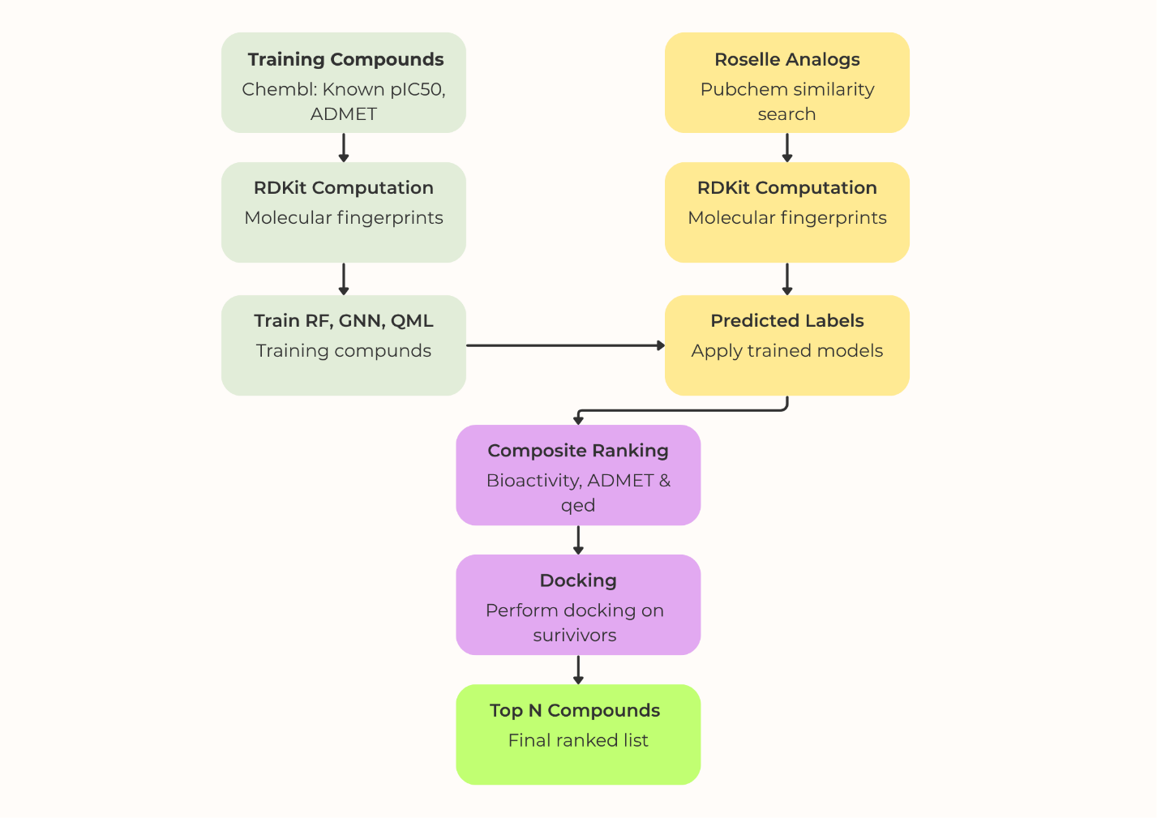

RESULTS AND STATISTICS
- Roselle analogs were obtained using seed compounds that have already been identified and reported in previous studies. Using PubChem's similarity search, we obtained more than 1,000 compounds, which are provided in roselle_analogs.csv. The descriptive statistics of these compounds are presented below.

Metric | Value
Total compounds | 1284
Total variables | 1056
Physicochemical descriptors | 17
Bioactivity endpoints | 3
ADMET endpoints | 4
Morgan fingerprint size | 1024-bit

The complete descriptive statistics are provided in the Excel file accompanying this report, roselle_analogs_descriptives.xlsx. Please review the information and use it as appropriate for your research.
- The programmer trained seven machine learning models, including Random Forest, Graph Neural Network, and Quantum Machine Learning models, designed for regression and analysis. The performance metrics of these models are presented below. I suggest formatting these tables according to APA style, as advised by your research adviser.
REGRESSION

Target | Model | MAE | MSE | RMSE | R²
cyp3a4 | Random Forest | 0.4483 | 0.3698 | 0.6081 | 0.6339
cyp3a4 | Graph NN | 0.4952 | 0.45 | 0.6708 | 0.5448
cyp3a4 | Quantum ML | 0.4592 | 0.3861 | 0.6214 | 0.6094
solubility | Random Forest | 0.8483 | 1.3570 | 1.1649 | 0.7534
solubility | Graph NN | 0.8699 | 1.3760 | 1.1730 | 0.7485
solubility | Quantum ML | 0.9116 | 1.5441 | 1.2426 | 0.7177
egfr | Random Forest | 0.5775 | 0.5679 | 0.7535 | 0.6956
egfr | Graph NN | 0.5536 | 0.5177 | 0.7195 | 0.7226
egfr | Quantum ML | 0.5561 | 0.5312 | 0.7288 | 0.7153
her2 | Random Forest | 0.4374 | 0.3420 | 0.5848 | 0.7286
her2 | Graph NN | 0.4398 | 0.3568 | 0.5973 | 0.7170
her2 | Quantum ML | 0.4390 | 0.3266 | 0.5715 | 0.7409
vegfr2 | Random Forest | 0.5065 | 0.4478 | 0.6692 | 0.6099
vegfr2 | Graph NN | 0.6648 | 0.4420 | 0.6648 | 0.6150
vegfr2 | Quantum ML | 0.4754 | 0.4211 | 0.6489 | 0.6331

CLASSIFICATION

Target | Model | Class | Precision | Recall | F1 Score | Accuracy
mutagenicity | Random Forest | 0 | 0.76 | 0.78 | 0.77 | 0.79
mutagenicity | Random Forest | 1 | 0.83 | 0.80 | 0.81 | 0.79
mutagenicity | Graph ML | 0 | 0.79 | 0.75 | 0.77 | 0.80
mutagenicity | Graph ML | 1 | 0.81 | 0.84 | 0.83 | 0.80
mutagenicity | Quantum ML | 0 | 0.77 | 0.75 | 0.75 | 0.78
mutagenicity | Quantum ML | 1 | 0.79 | 0.81 | 0.80 | 0.78
herg | Random Forest | 0 | 0.76 | 0.64 | 0.69 | 0.81
herg | Random Forest | 1 | 0.83 | 0.90 | 0.86 | 0.81
herg | Graph ML | 0 | 0.73 | 0.50 | 0.59 | 0.77
herg | Graph ML | 1 | 0.78 | 0.91 | 0.84 | 0.77
herg | Quantum ML | 0 | 0.83 | 0.83 | 0.83 | 0.89
herg | Quantum ML | 1 | 0.92 | 0.92 | 0.92

The programmer evaluated and judged that no single machine-learning model consistently outperformed the others across all prediction tasks. Therefore, each model was assessed separately for each target using appropriate evaluation metrics. The Graph ML model used Graph Isomorphism Convolution (GIN) to learn molecular graph representations, while the hybrid quantum-classical model used a quantum estimator as a quantum layer embedded within a classical neural network. For regression, lower MAE, MSE, and RMSE and higher R² indicate better performance. For classification, accuracy, precision, recall, and F1-score were considered in selecting the best-performing model.
Regression Models
- CYP3A4: Random Forest was selected as the best model based on the lowest errors and highest R² (0.6339).
- Solubility: Random Forest performed best, achieving the lowest errors and highest R² (0.7534).
- EGFR pIC50: Graph NN was selected, with the lowest errors and highest R² (0.7226).
- HER2 pIC50: Quantum ML was selected, achieving the best MSE, RMSE, and R² (0.7409); its MAE was nearly identical to Random Forest's.
- VEGFR2 pIC50: Quantum ML performed best, achieving the lowest errors and highest R² (0.6331).
Classification Models
- Mutagenicity: Graph ML was selected, achieving the highest accuracy (0.80) and class 1 F1-score (0.83).
- hERG Cardiotoxicity: Quantum ML was clearly the best, with the highest accuracy (0.89) and strong F1-scores for both classes.

Prediction Target | Best Model | Programmer's Judgment
CYP3A4 | Random Forest | Best overall regression performance
Solubility | Random Forest | Lowest prediction errors and highest R²
EGFR | Graph NN | Best overall regression performance
HER2 | Quantum ML | Best MSE, RMSE, and R²
VEGFR2 | Quantum ML | Best overall regression performance
Mutagenicity | Graph ML | Best classification performance overall
hERG | Quantum ML | Clearly strongest classification performance

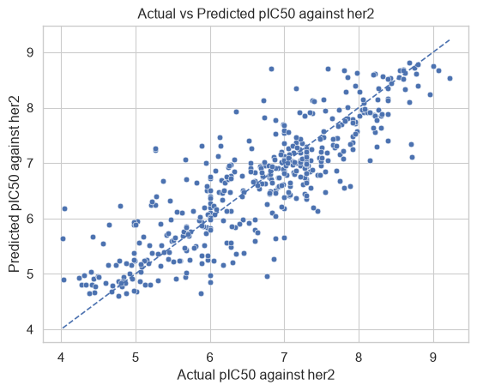
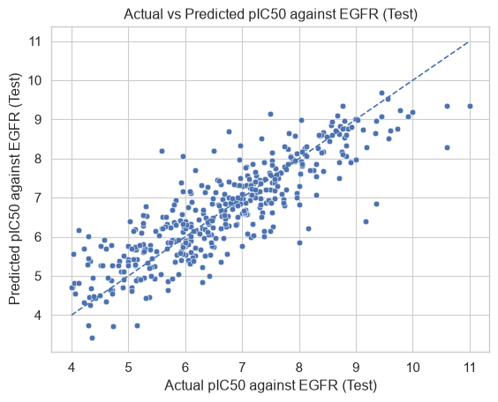

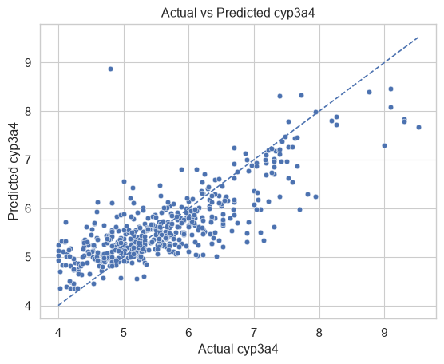
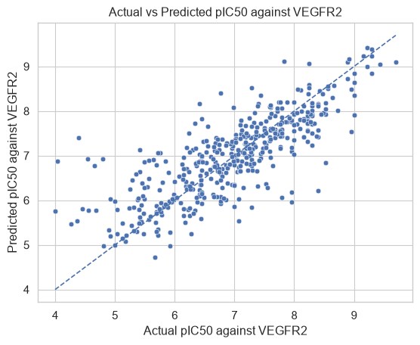

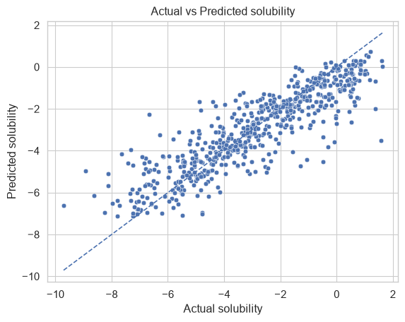

- The final ranked list of compounds obtained through molecular docking after the composite ranking process is provided in final_docking_survivors.csv, along with their corresponding binding affinity scores.

- Correlation Between ML Composite Ranking and Docking-Confirmed Binding Affinity
This question is answered directly from the ml_composite_score and mean_docking_affinity columns already present in final_docking_survivors.csv, and does not require the redocking validation loop. Each variable was first tested for normality using the Shapiro-Wilk test; Pearson's r was used if both variables were normally distributed, and Spearman's rank correlation was used otherwise, as the standard nonparametric alternative.
Table []. Correlation between ML Composite Score and Mean Docking Affinity
Variable Pair | N | Normality Assessment | Correlation Method | Correlation  Coefficient | p-value | Decision (α = 0.05)
ML Composite Score × Mean Docking Affinity | 38 | Not jointly normal* |  | −0.3816 | 0.0181 | Significant
  Spearman's rho
ML Composite Score × Mean Docking Affinity | 38 |  |  | −0.2831
  —
  Kendall's tau
  0.0124
  Significant
The ML composite score did not significantly deviate from normality (Shapiro–Wilk, p = 0.0665), whereas mean docking affinity significantly deviated from normality (Shapiro–Wilk, p = 0.0010). Therefore, a non-parametric correlation analysis was used.

Table []. Hypothesis
Hypothesis | Statement | Result
H₀ | There is no significant association between ML composite score and mean docking affinity. | Rejected
H₁ | There is a significant association between ML composite score and mean docking affinity. | Supported
There is sufficient statistical evidence at the 0.05 significance level to conclude that a significant association exists between the ML composite score and mean docking affinity. The association is negative and moderate in strength.
The results indicate a statistically significant negative association between the ML composite score and mean docking affinity. Spearman's rank-order correlation revealed a moderate inverse relationship (ρ = −0.3816, p = 0.0181). Since the p-value was below the 0.05 significance level, the null hypothesis of no significant association was rejected. This suggests that higher ML composite scores tend to be associated with lower mean docking-affinity values within the analyzed sample.



CLENT AGUNOD
Programmer

