EGFR - Target Protein (PDB FILE: IM17)  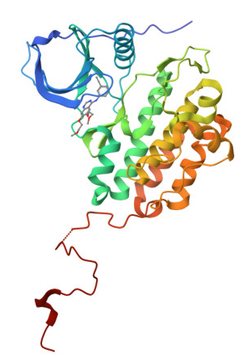 | Molecular Model  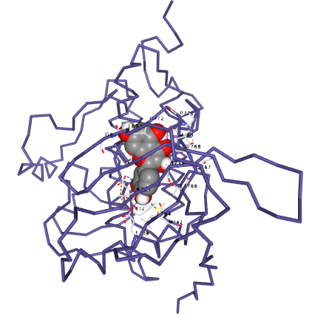  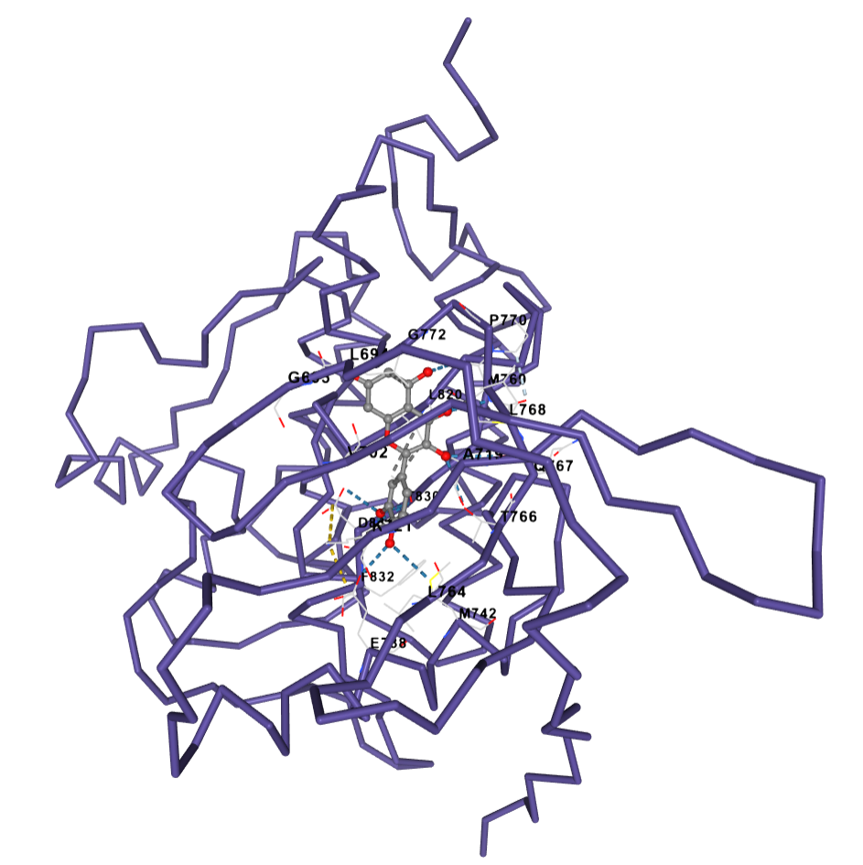
QUERCETIN - Ligand
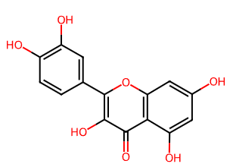

Molecular Docking Results EGFR: Quercetin
Cavity ID | Volume (Å³) | Center (X, Y, Z) | Size (X × Y × Z) | Score (kcal/mol) | Cavity Contact Residues
1 | 991 | 36.006, 8.207, 50.812 | 21 × 21 × 21 | −6.8 | ALA698(A), PHE699(A), GLY700(A), VAL702(A), LYS721(A), GLU722(A), LEU723(A), ALA731(A), ASN732(A), GLU734(A), ILE735(A), GLU738(A), LEU764(A), ASP813(A), ARG817(A), ASN818(A), ASP831(A), PHE832(A), GLY833(A), LEU834(A), LYS851(A), VAL852(A), PRO853(A)
2 | 665 | 23.535, 0.357, 54.495 | 21 × 21 × 21 | −8.3 | LEU694(A), GLY695(A), SER696(A), GLY697(A), PHE699(A), VAL702(A), ALA719(A), ILE720(A), LYS721(A), GLU738(A), MET742(A), CYS751(A), LEU753(A), LEU764(A), ILE765(A), THR766(A), GLN767(A), LEU768(A), MET769(A), PRO770(A), PHE771(A), GLY772(A), CYS773(A), ASP776(A), ARG817(A), ASN818(A), LEU820(A), THR830(A), ASP831(A), PHE832(A)
3 | 416 | 31.014, −4.460, 40.414 | 21 × 21 × 21 | −5.8 | GLU685(A), LYS690(A), SER696(A), GLY697(A), ALA698(A), PHE699(A), GLY700(A), THR701(A), TYR703(A), GLU722(A), LEU723(A), ARG724(A), GLU725(A), ALA726(A), THR727(A), SER728(A), PRO729(A), ALA731(A), GLU734(A), THR759(A), SER760(A), THR761(A), GLN763(A)
4 | 184 | 40.034, 17.544, 67.320 | 21 × 21 × 21 | −6.1 | ASN802(A), GLU805(A), ASP806(A), ARG808(A), VAL810(A), LEU838(A), GLY839(A), ALA840(A), GLU841(A), GLU842(A), LYS843(A), GLU844(A), GLU860(A), ILE866(A), TYR867(A), THR868(A), HIS869(A), GLN870(A), SER871(A), ALA931(A), ASP932(A), LYS936(A), ARG938(A)
5 | 173 | 2.666, 15.406, 62.646 | 21 × 21 × 21 | −6.4 | HIS781(A), LYS782(A), ASP783(A), ASN784(A), ILE785(A), GLY786(A), MET884(A), THR885(A), PHE886(A), GLY887(A), SER888(A), PRO912(A), PRO913(A), ILE914(A), GLN952(A), VAL956(A), ILE957(A), GLN958(A), GLY959(A), ASP960(A), ARG962(A), MET963(A)

Molecular Docking of Quercetin with EGFR
The molecular docking analysis showed that quercetin can bind to several possible regions of the EGFR protein, with docking scores ranging from −5.8 to −8.3 kcal/mol. Among the five predicted binding cavities, Cavity 2 showed the strongest interaction, with a docking score of −8.3 kcal/mol. Since a more negative docking score generally represents a more favorable predicted interaction, this result suggests that Cavity 2 is the most preferred binding region of quercetin within the EGFR structure.
Interestingly, Cavity 2 was not the largest pocket identified in the protein. It had a volume of 665 Å³, compared with 991 Å³ for Cavity 1. Despite its smaller size, quercetin showed considerably stronger predicted binding in Cavity 2. This indicates that the quality of the chemical environment within a binding pocket may be more important than pocket size alone. In other words, the arrangement and properties of the amino acid residues surrounding quercetin appear to provide a more favorable environment for its binding.
The residues surrounding quercetin in Cavity 2 included LEU694, PHE699, VAL702, ALA719, ILE720, LYS721, GLU738, MET742, CYS751, LEU753, LEU764, THR766, GLN767, LEU768, MET769, PHE771, ASP776, ARG817, ASP831, and PHE832, among others. The presence of both polar and nonpolar amino acids suggests that the ligand may be accommodated through a combination of different intermolecular interactions. However, the cavity-contact data alone do not establish which residues form specific hydrogen bonds or other direct interactions; these would need to be confirmed through detailed 2D or 3D interaction analysis.
The other cavities showed less favorable binding energies. Quercetin produced docking scores of −6.8 kcal/mol in Cavity 1, −6.4 kcal/mol in Cavity 5, −6.1 kcal/mol in Cavity 4, and −5.8 kcal/mol in Cavity 3. Thus, although quercetin was predicted to fit into several regions of EGFR, its interaction was clearly most favorable in Cavity 2.
Overall, the docking results suggest that quercetin has a favorable predicted interaction with EGFR, particularly within Cavity 2, as indicated by the binding energy of −8.3 kcal/mol. This finding supports the possibility that EGFR may be one of the molecular targets through which quercetin could exert biological activity. Nevertheless, molecular docking represents a computational prediction of binding rather than direct evidence of EGFR inhibition. Further molecular dynamics simulations and experimental assays would therefore be needed to determine whether this predicted interaction translates into actual modulation or inhibition of EGFR activity.

EGFR - Target Protein (PDB FILE: IM17) | Molecular Docking Model  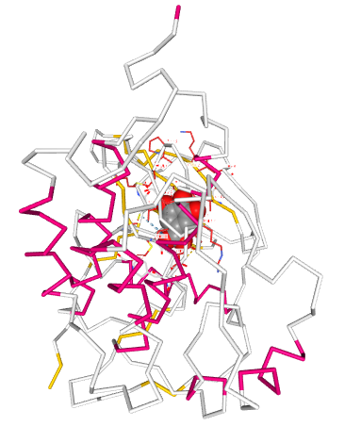  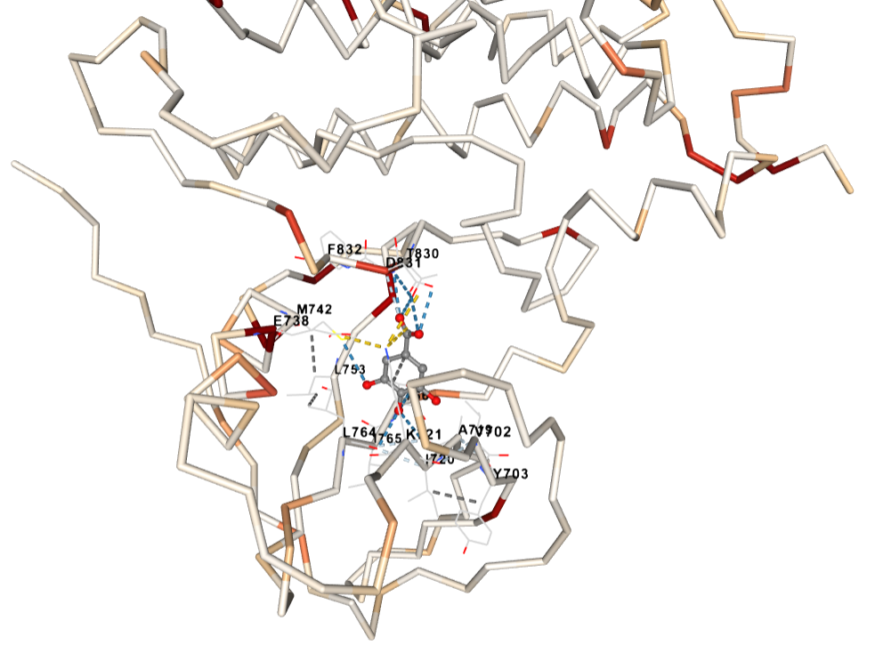
Gallic Acid - Ligand
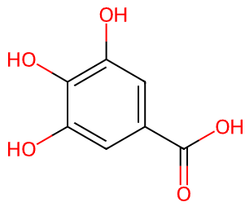

Molecular Docking Results of EGFR: Gallic acid

Cavity ID | Volume (Å³) | Center (X, Y, Z) | Size (X × Y × Z) | Score (kcal/mol) | Cavity Contact Residues
1 | 991 | 36.006, 8.207, 50.812 | 17 × 17 × 17 | −5.0 | ALA698(A), PHE699(A), GLY700(A), LYS721(A), GLU722(A), LEU723(A), LYS730(A), ALA731(A), ASN732(A), GLU734(A), ILE735(A), ASP737(A), GLU738(A), TYR740(A), VAL741(A), LEU764(A), ASP813(A), ARG817(A), ASP831(A), PHE832(A), GLY833(A), LEU834(A), ALA835(A), LYS836(A), LEU837(A), LYS851(A), PRO853(A)
2 | 665 | 23.535, 0.357, 54.495 | 17 × 17 × 17 | −5.7 | LEU694(A), PHE699(A), VAL702(A), TYR703(A), ALA719(A), ILE720(A), LYS721(A), GLU738(A), MET742(A), CYS751(A), LEU753(A), LEU764(A), ILE765(A), THR766(A), GLN767(A), LEU768(A), MET769(A), PRO770(A), GLY772(A), LEU820(A), THR830(A), ASP831(A), PHE832(A)
3 | 416 | 31.014, −4.460, 40.414 | 17 × 17 × 17 | −4.4 | GLU685(A), LYS690(A), SER696(A), GLY697(A), ALA698(A), PHE699(A), GLY700(A), THR701(A), TYR703(A), GLU722(A), LEU723(A), ARG724(A), GLU725(A), ALA726(A), THR727(A), SER728(A), ALA731(A), THR759(A), SER760(A), THR761(A), VAL762(A), GLN763(A)
4 | 184 | 40.034, 17.544, 67.320 | 17 × 17 × 17 | −4.4 | GLU805(A), ASP806(A), ARG807(A), ARG808(A), VAL810(A), LEU838(A), GLY839(A), ALA840(A), GLU841(A), GLU842(A), LYS843(A), GLU844(A), TYR867(A), THR868(A), HIS869(A), GLN870(A), SER871(A), ASP932(A), LYS936(A)
5 | 173 | 2.666, 15.406, 62.646 | 17 × 17 × 17 | −4.6 | HIS781(A), LYS782(A), ASP783(A), ASN784(A), ILE785(A), GLY786(A), THR885(A), PHE886(A), PRO913(A), ILE914(A), VAL956(A), ILE957(A), GLN958(A), GLY959(A), ASP960(A), GLU961(A), MET963(A)

Molecular Docking of Gallic Acid with EGFR
The molecular docking results showed that gallic acid was able to bind to different predicted regions of EGFR, although the strength of binding varied among the five cavities. The docking scores ranged from −4.4 to −5.7 kcal/mol, with Cavity 2 showing the most favorable binding at −5.7 kcal/mol. This suggests that gallic acid preferentially fits within Cavity 2 compared with the other predicted binding regions of the protein.
Cavity 2 had a volume of 665 Å³ and contained several amino acid residues surrounding the docked gallic acid, including PHE699, VAL702, TYR703, ALA719, ILE720, LYS721, GLU738, MET742, CYS751, LEU753, LEU764, THR766, GLN767, LEU768, MET769, ASP831, and PHE832. The variety of residues within this pocket provides a chemical environment in which gallic acid can be accommodated. In particular, the hydroxyl and carboxylic acid groups of gallic acid provide potential sites for polar interactions, while its aromatic ring may contribute to interactions with hydrophobic or aromatic residues. However, the listed cavity residues represent residues surrounding the binding pocket and should not automatically be interpreted as specific hydrogen-bonding or direct-contact residues without further ligand–protein interaction analysis.
Although Cavity 1 was the largest predicted pocket at 991 Å³, gallic acid produced a weaker docking score of −5.0 kcal/mol in this region. This shows that having a larger cavity does not necessarily result in stronger ligand binding. Instead, the orientation of the ligand and the chemical characteristics of the amino acids within the pocket appear to play a more important role in determining the predicted binding affinity.
The remaining cavities showed weaker interactions. Gallic acid had a docking score of −4.6 kcal/mol in Cavity 5, while both Cavities 3 and 4 produced −4.4 kcal/mol. These values indicate that gallic acid can occupy several regions of EGFR, but these alternative sites are less favorable than Cavity 2.
Overall, the findings indicate that gallic acid has a modest but favorable predicted interaction with EGFR, with its strongest binding observed in Cavity 2 at −5.7 kcal/mol. The result suggests that EGFR could potentially interact with gallic acid; however, the docking score alone is not sufficient to conclude that gallic acid inhibits EGFR. Rather, the docking result provides computational evidence of possible molecular recognition between the compound and the protein. Confirmation through detailed interaction analysis, molecular dynamics simulation, or experimental EGFR inhibition assays would be necessary to establish whether this predicted binding has biological significance.

EGFR - Target Protein (PDB FILE: IM17) | Molecular Docking Model  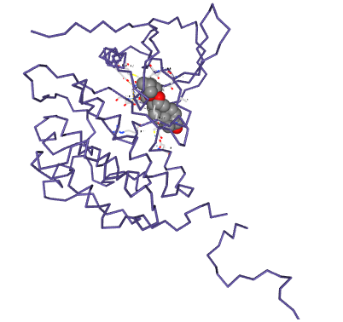  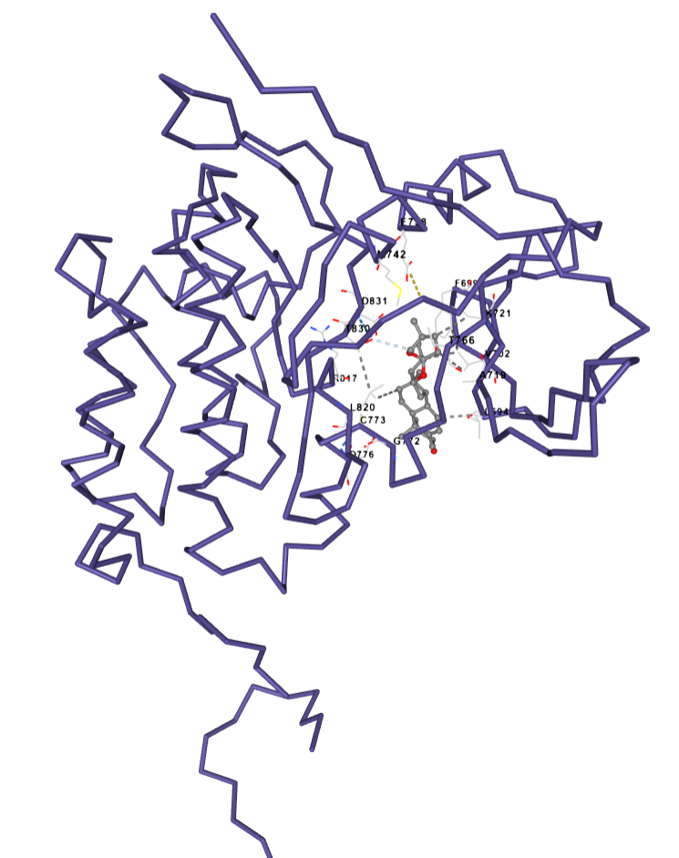
Diosgenin - Ligand
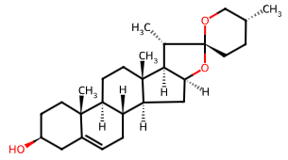

Molecular Docking Results EGFR:Diosgenin

Cavity ID | Volume (Å³) | Center (X, Y, Z) | Size (X × Y × Z) | Score (kcal/mol) | Cavity Contact Residues
1 | 991 | 36.006, 8.207, 50.812 | 23 × 23 × 23 | −7.7 | ALA698(A), PHE699(A), LYS721(A), LEU723(A), LYS730(A), ALA731(A), ASN732(A), LYS733(A), GLU734(A), ILE735(A), ASP737(A), GLU738(A), TYR740(A), VAL741(A), LEU764(A), ASP813(A), ARG817(A), ASP831(A), GLY833(A), LEU834(A), ALA835(A), LYS836(A), LEU837(A), TYR845(A), GLU848(A), LYS851(A), VAL852(A), PRO853(A), ILE854(A), LYS855(A), TRP856(A)
2 | 665 | 23.535, 0.357, 54.495 | 23 × 23 × 23 | −9.1 | LYS692(A), LEU694(A), GLY695(A), SER696(A), GLY697(A), ALA698(A), PHE699(A), VAL702(A), ALA719(A), LYS721(A), GLU738(A), MET742(A), CYS751(A), THR766(A), GLN767(A), LEU768(A), MET769(A), PRO770(A), PHE771(A), GLY772(A), CYS773(A), LEU775(A), ASP776(A), ASP813(A), ARG817(A), ASN818(A), LEU820(A), THR830(A), ASP831(A), GLY833(A), LEU834(A), LYS851(A)
3 | 416 | 31.014, −4.460, 40.414 | 23 × 23 × 23 | −6.4 | GLU685(A), LYS690(A), ILE691(A), LYS692(A), VAL693(A), SER696(A), GLY697(A), ALA698(A), PHE699(A), GLY700(A), THR701(A), TYR703(A), GLU722(A), LEU723(A), ARG724(A), GLU725(A), ALA726(A), THR727(A), SER728(A), PRO729(A), LYS730(A), ALA731(A), GLU734(A), THR759(A), SER760(A), THR761(A), GLN763(A), LYS851(A)
4 | 184 | 40.034, 17.544, 67.320 | 23 × 23 × 23 | −8.0 | GLU805(A), ASP806(A), ARG807(A), ARG808(A), LEU838(A), GLY839(A), ALA840(A), GLU841(A), GLU842(A), LYS843(A), GLU844(A), GLU860(A), HIS864(A), ILE866(A), THR868(A), HIS869(A), GLN870(A), ILE929(A), ASP930(A), ALA931(A), ASP932(A), LYS936(A), ARG938(A)
5 | 173 | 2.666, 15.406, 62.646 | 23 × 23 × 23 | −8.4 | LYS782(A), ASP783(A), ASN784(A), ILE785(A), TRP881(A), MET884(A), THR885(A), PHE886(A), SER888(A), PRO910(A), GLN911(A), PRO912(A), PRO913(A), ILE914(A), VAL956(A), ILE957(A), GLN958(A), GLY959(A), ASP960(A), ARG962(A), MET963(A), HIS964(A), MET978(A), ASP979(A), GLU980(A), GLU981(A), ASP982(A), MET983(A)

Molecular Docking of Diosgenin with EGFR
The molecular docking results showed a strong predicted interaction between diosgenin and EGFR, with docking scores ranging from −6.4 to −9.1 kcal/mol across the five predicted binding cavities. Among these sites, Cavity 2 produced the most favorable docking score of −9.1 kcal/mol, suggesting that this region provides the best molecular environment for accommodating diosgenin.
Cavity 2 had a volume of 665 Å³ and was surrounded by several amino acid residues, including PHE699, VAL702, ALA719, LYS721, GLU738, MET742, CYS751, THR766, GLN767, LEU768, MET769, PHE771, CYS773, LEU775, ASP776, ASP813, ARG817, ASN818, LEU820, ASP831, and LEU834. Diosgenin is largely hydrophobic because of its steroidal ring system, and the presence of several nonpolar residues within this cavity may provide a favorable environment for its accommodation. Its hydroxyl group may also contribute to polar interactions with suitable residues in the binding region. However, the listed residues represent the amino acids surrounding the predicted cavity; specific hydrogen bonds and hydrophobic contacts would need to be confirmed from the detailed ligand–protein interaction map.
Interestingly, diosgenin also showed favorable binding in other regions of EGFR. Cavity 5 produced a docking score of −8.4 kcal/mol, followed by Cavity 4 at −8.0 kcal/mol and Cavity 1 at −7.7 kcal/mol. Only Cavity 3 showed a noticeably weaker interaction at −6.4 kcal/mol. This pattern suggests that diosgenin can be accommodated favorably in several regions of the EGFR structure, although Cavity 2 remains the preferred predicted binding site.
Another important observation is that the largest pocket did not produce the strongest binding. Cavity 1 had the largest volume at 991 Å³ but gave a docking score of −7.7 kcal/mol, whereas the smaller Cavity 2, with a volume of 665 Å³, produced the considerably more favorable score of −9.1 kcal/mol. This indicates that the predicted affinity of diosgenin is influenced not simply by the available space within the protein but also by how well its molecular structure complements the shape and chemical environment of the binding pocket.
Overall, the results indicate that diosgenin has a strong predicted affinity toward EGFR, particularly at Cavity 2, with a docking score of −9.1 kcal/mol. The consistently favorable scores observed in several cavities further suggest that diosgenin interacts well with the EGFR structure. These findings support EGFR as a potential molecular target of diosgenin. However, the docking results represent computational predictions of binding and should not by themselves be interpreted as evidence that diosgenin inhibits EGFR activity. Further ligand–protein interaction analysis, molecular dynamics simulation, and experimental EGFR inhibition studies would be needed to confirm the biological relevance of this predicted interaction.

VEGF- Target Protein (PDB FILE: IVPF)  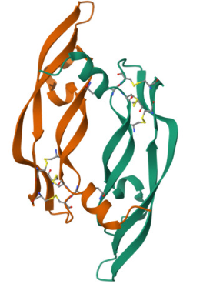 | Molecular Docking Model  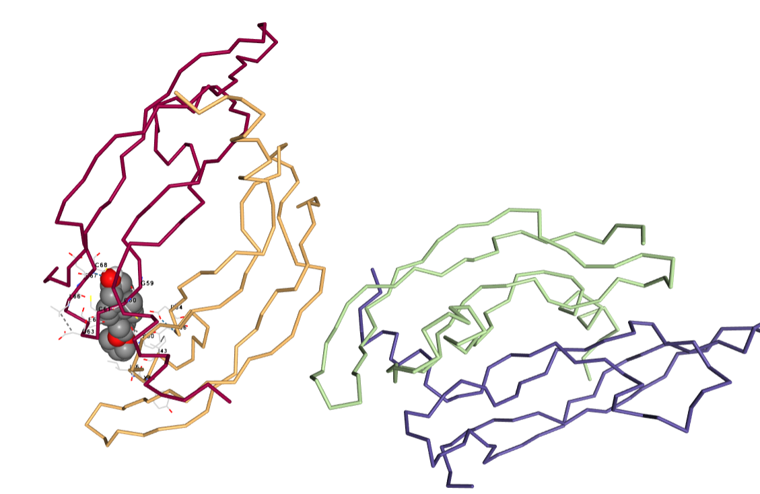  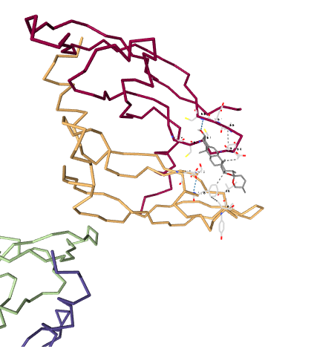
Diosgenin - Ligand

Molecular Docking Results VEGF: Diosgenin
Cavity ID | Volume (Å³) | Center (X, Y, Z) | Size (X × Y × Z) | Score (kcal/mol) | Cavity Contact Residues
1 | 404 | 4.251, 11.785, 5.837 | 23 × 23 × 23 | −6.3 | LEU32(A), ASP34(A), PHE36(A), GLN37(A), PRO40(A), ILE43(A), TYR45(A), ILE46(A), SER50(A), CYS51(A), ILE83(A), LYS84(A), PRO85(A), HIS86(A), GLN87(A), GLY88(A), CYS57(B), GLY58(B), GLY59(B), CYS60(B), CYS61(B), GLU64(B), LEU66(B), GLU67(B), CYS68(B), VAL69(B), LYS107(B)
2 | 383 | −24.685, −7.715, 53.738 | 23 × 23 × 23 | −7.1 | CYS26(C), CYS57(C), GLY58(C), GLY59(C), CYS60(C), CYS61(C), ASN62(C), ASP63(C), GLU64(C), LEU66(C), GLU67(C), CYS68(C), VAL69(C), CYS104(C), LYS107(C), ASP34(D), PHE36(D), GLN37(D), ILE43(D), GLU44(D), TYR45(D), ILE46(D), SER50(D), CYS51(D), PRO85(D)
3 | 373 | 37.000, 10.541, 14.267 | 23 × 23 × 23 | −7.9 | CYS57(A), GLY59(A), CYS60(A), CYS61(A), ASN62(A), ASP63(A), GLU64(A), GLY65(A), LEU66(A), GLU67(A), CYS68(A), VAL69(A), LYS107(A), ASP34(B), PHE36(B), GLN37(B), ILE43(B), GLU44(B), TYR45(B), ILE46(B), PHE47(B), LYS48(B), SER50(B), ILE83(B), LYS84(B), PRO85(B), HIS86(B), GLN89(B)
4 | 363 | 8.486, −6.089, 44.527 | 23 × 23 × 23 | −7.5 | ASP34(C), PHE36(C), GLN37(C), ILE43(C), GLU44(C), TYR45(C), ILE46(C), PHE47(C), LYS48(C), PRO49(C), SER50(C), CYS51(C), ILE83(C), LYS84(C), PRO85(C), HIS86(C), CYS57(D), GLY58(D), GLY59(D), CYS60(D), CYS61(D), ASN62(D), ASP63(D), GLU64(D), LEU66(D), GLU67(D), CYS68(D), VAL69(D), LYS107(D)
5 | 180 | 6.098, −3.017, 26.896 | 23 × 23 × 23 | −6.5 | THR71(B), GLU72(B), LYS101(B), GLU103(B), ARG105(B), TYR39(C), ASP41(C), GLU42(C), TYR45(C), THR77(C), ARG82(C), GLU93(C), MET94(C), SER95(C)

Molecular Docking of Diosgenin with VEGF
The molecular docking analysis showed that diosgenin can bind favorably to VEGF, with docking scores ranging from −6.3 to −7.9 kcal/mol across the five predicted cavities. Among these sites, Cavity 3 showed the strongest predicted binding, with a docking score of −7.9 kcal/mol. This indicates that diosgenin fits more favorably within this region of VEGF than in the other identified cavities.
Cavity 3 had a volume of 373 Å³ and contained residues from both chains A and B of the VEGF structure. The surrounding residues included CYS57, CYS60, CYS61, ASN62, ASP63, GLU64, LEU66, GLU67, CYS68, VAL69, LYS107, ASP34, PHE36, ILE43, GLU44, TYR45, ILE46, PHE47, LYS48, SER50, ILE83, LYS84, PRO85, and HIS86. This pocket contains a mixture of hydrophobic, polar, acidic, and basic amino acids that may provide a favorable environment for diosgenin. Given the largely hydrophobic steroidal structure of diosgenin, residues such as PHE36, ILE43, ILE46, PHE47, VAL69, and ILE83 may help accommodate its ring system, while polar or charged residues may contribute additional stabilizing interactions. The exact nature of these interactions, however, should be confirmed using a detailed 2D or 3D ligand–protein interaction analysis.
Diosgenin also showed favorable binding in the other VEGF cavities. Cavity 4 gave the second-best docking score at −7.5 kcal/mol, followed by Cavity 2 at −7.1 kcal/mol, Cavity 5 at −6.5 kcal/mol, and Cavity 1 at −6.3 kcal/mol. The relatively favorable scores across several cavities suggest that diosgenin can be accommodated at different regions of the VEGF structure, although Cavity 3 appears to provide the most favorable binding environment.
It is also interesting that Cavity 1 was the largest predicted pocket, with a volume of 404 Å³, but it produced the weakest docking score of −6.3 kcal/mol. In contrast, the smaller Cavity 3, with a volume of 373 Å³, produced the strongest score of −7.9 kcal/mol. This shows that a larger binding pocket does not necessarily result in stronger binding. Rather, how well the shape and chemical properties of the ligand complement the amino acid environment of the pocket appears to be more important.
Overall, the results indicate that diosgenin has a favorable predicted interaction with VEGF, particularly at Cavity 3, where it achieved a docking score of −7.9 kcal/mol. This finding supports the possibility that VEGF may be a molecular target associated with the biological activity of diosgenin. However, molecular docking demonstrates predicted molecular recognition and binding rather than actual inhibition of VEGF activity. Therefore, these findings should be considered preliminary computational evidence and would require further molecular dynamics simulations and experimental validation to establish their biological significance.

VEGF - Target Protein (PDB FILE: IVPF) | Molecular Docking Model  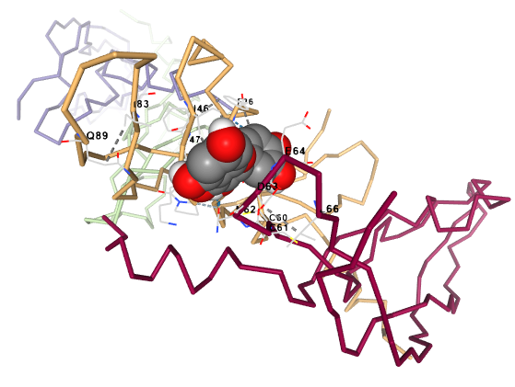  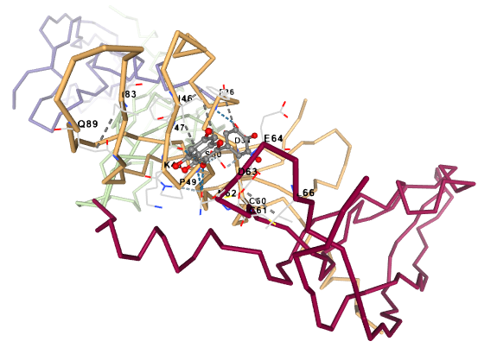
QUERCETIN - Ligand

Molecular Docking Results VEGF:Quercetin
Cavity ID | Volume (Å³) | Center (X, Y, Z) | Size (X × Y × Z) | Score (kcal/mol) | Cavity Contact Residues
1 | 404 | 4.251, 11.785, 5.837 | 21 × 21 × 21 | −6.9 | LEU32(A), VAL33(A), ASP34(A), PHE36(A), GLN37(A), ILE46(A), PHE47(A), SER50(A), CYS51(A), CYS57(B), GLY58(B), GLY59(B), CYS60(B), CYS61(B), ASN62(B), ASP63(B), GLU64(B), GLY65(B), LEU66(B), GLU67(B), CYS68(B), VAL69(B), CYS104(B), LYS107(B)
2 | 383 | −24.685, −7.715, 53.738 | 21 × 21 × 21 | −6.4 | CYS57(C), GLY58(C), GLY59(C), CYS60(C), CYS61(C), ASN62(C), ASP63(C), GLU64(C), LEU66(C), GLU67(C), CYS68(C), VAL69(C), LYS107(C), LEU32(D), ASP34(D), PHE36(D), GLN37(D), ILE43(D), ILE46(D), PHE47(D), LYS48(D), PRO49(D), SER50(D), CYS51(D), ILE83(D), GLN89(D)
3 | 373 | 37.000, 10.541, 14.267 | 21 × 21 × 21 | −7.2 | CYS26(A), GLY58(A), GLY59(A), CYS60(A), CYS61(A), ASN62(A), ASP63(A), GLU64(A), GLY65(A), LEU66(A), GLU67(A), CYS68(A), VAL69(A), CYS104(A), LYS107(A), LEU32(B), VAL33(B), ASP34(B), PHE36(B), TYR45(B), ILE46(B), PHE47(B), LYS48(B), PRO49(B), SER50(B), CYS51(B), ILE83(B), GLN89(B)
4 | 363 | 8.486, −6.089, 44.527 | 21 × 21 × 21 | −7.1 | ASP34(C), PHE36(C), ILE43(C), TYR45(C), ILE46(C), PHE47(C), LYS48(C), PRO49(C), SER50(C), CYS51(C), ILE83(C), CYS57(D), GLY58(D), GLY59(D), CYS60(D), CYS61(D), ASN62(D), ASP63(D), GLU64(D), GLY65(D), LEU66(D), GLU67(D), CYS68(D), VAL69(D), CYS104(D), LYS107(D)
5 | 180 | 6.098, −3.017, 26.896 | 21 × 21 × 21 | −6.1 | THR71(B), GLU72(B), LYS101(B), CYS102(B), GLU103(B), ARG105(B), TYR39(C), ASP41(C), GLU42(C), TYR45(C), PHE47(C), THR77(C), ILE80(C), MET81(C), ARG82(C), HIS90(C), ILE91(C), GLY92(C), GLU93(C), MET94(C), SER95(C)

Molecular Docking of Quercetin with VEGF
The molecular docking results showed that quercetin can bind favorably to VEGF, with docking scores ranging from −6.1 to −7.2 kcal/mol across the five predicted cavities. Among these binding sites, Cavity 3 showed the strongest predicted interaction, with a docking score of −7.2 kcal/mol. This indicates that Cavity 3 provides the most favorable environment for quercetin binding among the regions examined.
Cavity 3 had a volume of 373 Å³ and contained residues from both chains A and B of the VEGF structure. Some of the surrounding amino acids included CYS60, CYS61, ASN62, ASP63, GLU64, LEU66, GLU67, CYS68, VAL69, LYS107, ASP34, PHE36, TYR45, ILE46, PHE47, LYS48, SER50, and CYS51. The presence of different types of amino acids within this pocket provides several possible ways for quercetin to be accommodated. Quercetin contains multiple hydroxyl groups that may participate in polar interactions, while its aromatic rings may favor interactions with aromatic and hydrophobic residues such as PHE36, TYR45, PHE47, ILE46, LEU66, and VAL69. However, the cavity-contact list only identifies residues surrounding the predicted binding site; specific hydrogen bonds or other direct interactions would need to be confirmed using detailed ligand–protein interaction analysis.
The other cavities also showed favorable but slightly weaker binding. Cavity 4 produced a docking score of −7.1 kcal/mol, followed closely by Cavity 1 at −6.9 kcal/mol. Cavity 2 showed a score of −6.4 kcal/mol, while Cavity 5 had the least favorable score at −6.1 kcal/mol. The relatively narrow range of scores suggests that quercetin can fit into several regions of VEGF, although Cavity 3 remains the most favorable predicted site.
An interesting observation is that the largest pocket was not the strongest binding site. Cavity 1 had the largest volume at 404 Å³ but produced a docking score of −6.9 kcal/mol, whereas the smaller Cavity 3, with a volume of 373 Å³, showed a more favorable score of −7.2 kcal/mol. This suggests that the predicted binding of quercetin depends more on how well its structure and functional groups complement the chemical environment of the pocket than on cavity size alone.
Overall, the docking results indicate that quercetin has a favorable predicted interaction with VEGF, with its strongest binding occurring at Cavity 3 at −7.2 kcal/mol. The findings support the possibility of molecular recognition between quercetin and VEGF. However, this should not be interpreted as direct evidence that quercetin inhibits VEGF. Molecular docking predicts the likelihood and favorability of binding, while experimental assays and further computational studies would be needed to determine whether this interaction can meaningfully alter VEGF activity.

VEGF - Target Protein (PDB FILE: IVPF) | Molecular Docking Model  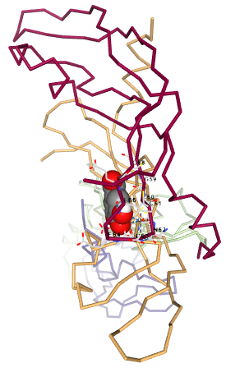  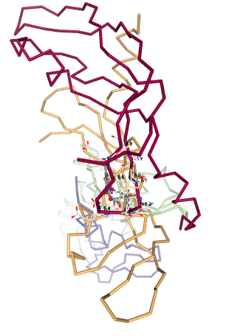
Gallic Acid - Ligand

Molecular Docking Results VEGF: Gallic acid
Cavity ID | Volume (Å³) | Center (X, Y, Z) | Size (X × Y × Z) | Score (kcal/mol) | Cavity Contact Residues
1 | 404 | 4.251, 11.785, 5.837 | 17 × 17 × 17 | −5.3 | ASP34(A), PHE36(A), TYR45(A), ILE46(A), PHE47(A), SER50(A), CYS51(A), GLY58(B), GLY59(B), CYS60(B), CYS61(B), ASN62(B), ASP63(B), GLU64(B), GLY65(B), LEU66(B), GLU67(B), CYS68(B), LYS107(B)
2 | 383 | −24.685, −7.715, 53.738 | 17 × 17 × 17 | −5.2 | GLY58(C), GLY59(C), CYS60(C), CYS61(C), ASN62(C), ASP63(C), GLU64(C), GLY65(C), LEU66(C), GLU67(C), CYS68(C), LYS107(C), ASP34(D), PHE36(D), ILE46(D), PHE47(D), LYS48(D), PRO49(D), SER50(D), CYS51(D), ILE83(D), GLN89(D)
3 | 373 | 37.000, 10.541, 14.267 | 17 × 17 × 17 | −5.4 | GLY58(A), GLY59(A), CYS60(A), CYS61(A), ASN62(A), ASP63(A), GLU64(A), GLY65(A), LEU66(A), GLU67(A), CYS68(A), LYS107(A), ASP34(B), PHE36(B), ILE46(B), PHE47(B), LYS48(B), PRO49(B), SER50(B), CYS51(B), GLN89(B)
4 | 363 | 8.486, −6.089, 44.527 | 17 × 17 × 17 | −5.2 | LEU32(C), ASP34(C), PHE36(C), TYR45(C), ILE46(C), PHE47(C), LYS48(C), PRO49(C), SER50(C), CYS51(C), ILE83(C), GLY58(D), GLY59(D), CYS60(D), CYS61(D), ASN62(D), ASP63(D), GLU64(D), GLY65(D), LEU66(D), GLU67(D), CYS68(D), VAL69(D), LYS107(D)
5 | 180 | 6.098, −3.017, 26.896 | 17 × 17 × 17 | −4.7 | THR71(B), GLU72(B), LYS101(B), CYS102(B), GLU103(B), ARG105(B), TYR39(C), GLU42(C), TYR45(C), PHE47(C), THR77(C), ILE80(C), MET81(C), ARG82(C), HIS90(C), ILE91(C), GLY92(C), GLU93(C), MET94(C), SER95(C)

Molecular Docking of Gallic Acid with VEGF
The molecular docking analysis showed that gallic acid can interact with several predicted binding regions of VEGF, with docking scores ranging from −4.7 to −5.4 kcal/mol. Among the five cavities examined, Cavity 3 showed the most favorable predicted binding, with a docking score of −5.4 kcal/mol. Although this interaction is favorable, the relatively moderate docking score suggests that gallic acid does not bind to VEGF as strongly as some of the other compounds examined.
Cavity 3 had a volume of 373 Å³ and contained residues from chains A and B of VEGF. The surrounding amino acids included GLY58, GLY59, CYS60, CYS61, ASN62, ASP63, GLU64, LEU66, GLU67, CYS68, LYS107, ASP34, PHE36, ILE46, PHE47, LYS48, SER50, CYS51, and GLN89. Gallic acid is a relatively small phenolic molecule containing three hydroxyl groups and a carboxylic acid group. These functional groups provide several opportunities for polar interactions with amino acids in the binding region. Its aromatic ring may also contribute to interactions with aromatic or hydrophobic residues such as PHE36 and PHE47. However, the listed residues describe the predicted cavity environment and should not automatically be considered direct hydrogen-bonding residues without further interaction analysis.
The docking scores for the other cavities were relatively close to that of Cavity 3. Cavity 1 produced a score of −5.3 kcal/mol, while Cavities 2 and 4 both showed −5.2 kcal/mol. Cavity 5 had the weakest predicted interaction at −4.7 kcal/mol. The small differences among Cavities 1–4 suggest that gallic acid does not show a very strong preference for a single VEGF binding region, although Cavity 3 remains the most favorable based on the docking score.
The results also show that pocket size alone did not determine binding strength. Cavity 1 was the largest pocket at 404 Å³ but produced a docking score of −5.3 kcal/mol, while the slightly smaller Cavity 3 at 373 Å³ gave the best score of −5.4 kcal/mol. This suggests that the orientation of gallic acid and its compatibility with the amino acid environment of the pocket are more important than cavity size alone.
Overall, the results indicate that gallic acid has a moderate predicted affinity for VEGF, with the strongest interaction occurring in Cavity 3 at −5.4 kcal/mol. This suggests that gallic acid is capable of molecular recognition with VEGF, although the predicted interaction is not particularly strong. When compared with the other tested ligands, diosgenin showed the strongest predicted VEGF binding at −7.9 kcal/mol, followed by quercetin at −7.2 kcal/mol, while gallic acid showed the weakest at −5.4 kcal/mol. Thus, based specifically on docking scores, the predicted VEGF-binding preference follows diosgenin > quercetin > gallic acid. These findings provide computational evidence of possible VEGF interactions but would still require experimental validation before any direct VEGF inhibitory or anti-angiogenic activity can be concluded.

