1. To start, install Django and folium

pip install Django

pip install folium

1. Open the kernel and go to the location where you want your project to be created
2. Create the project “geo”

django-admin startproject geo

1. Change the “path” to “geo”

cd geo

1. Create the app “geoApp”

python manage.py startapp geoApp

1. Create the file “urls.py” inside geoApp
2. Inside “geoApp/urls.py”, paste the following lines

from django.urls import path

from django.contrib.auth import views as auth_views

from . import views

urlpatterns = [

path('', views.home,name='home'),

]

1. Now we have to register this “geoApp/urls.py” inside “geo/urls.py”, add “include” to “Django.urls”

from django.urls import path, include

add the following line to “urlspatterns”

path('',include('geoApp.urls')),

You now have something like this:

from django.contrib import admin

from django.urls import path, include

urlpatterns = [

path('admin/', admin.site.urls),

path('',include('geoApp.urls')),

]

1. Inside “geoApp:
   1. Create a folder called “templates”
   2. Inside “templates” create a folder called “geoApp”
2. Before configuring the “Html” files, let´s define the “static” files and “path”. In the “/geo/settings.py”

First, at the top of the file add

import os

search “STATIC_URL” it is located at the end of the file and replace with the following commands

STATIC_URL = '/static/'

MEDIA_URL = '/media/'

STATICFILES_DIRS = [

os.path.join(BASE_DIR, 'static')

]

MEDIA_ROOT = os.path.join(BASE_DIR, 'media')

1. Add the folders “static” and “media” in the root folder:
2. Inside the “static” folder, paste the folders that are inside the “static” folder given, it contains a “bootstrap” folder” and a “jquery” folder
3. Return to “settings.py”, and in “INSTALLED_APPS” add:

'geoApp'

1. Continuing in the “settings.py” file, in “DIRS” inside “TEMPLATES” add

os.path.join(BASE_DIR, 'geoApp','templates')

You would have something like the following

TEMPLATES = [

{

'BACKEND': 'django.template.backends.django.DjangoTemplates',

'DIRS': [

os.path.join(BASE_DIR, 'geoApp','templates'),

],

'APP_DIRS': True,

'OPTIONS': {

'context_processors': [

'django.template.context_processors.debug',

'django.template.context_processors.request',

'django.contrib.auth.context_processors.auth',

'django.contrib.messages.context_processors.messages',

],

},

},

]

1. Edit “/geoApp/views.py”, here we create a home function that returns to our “home.html” template, this template is created in the next step

from django.shortcuts import render, redirect

# Create your views here.

def home(request):

context={}

return render(request,'geoApp/home.html',context)

1. Create a new file inside the new folder called “home.html”, paste this html code inside

{% load static %}

<!DOCTYPE html>

<html lang="en">

<head>

<meta charset="utf-8">

<meta name="viewport" content="width=device-width, initial-scale=1, shrink-to-fit=no">

<meta name="description" content="">

<meta name="author" content="">

<title>GeoGida</title>

<!-- Bootstrap core CSS -->

<link rel="stylesheet" href="{% static '/bootstrap/css/bootstrap.min.css' %}">

</head>

<body>

<!-- Navigation -->

<nav class="navbar navbar-expand-lg navbar-dark bg-dark static-top">

<div class="container">

<a class="navbar-brand" href="#">GeoGida</a>

<button class="navbar-toggler" type="button" data-toggle="collapse" data-target="#navbarResponsive" aria-controls="navbarResponsive" aria-expanded="false" aria-label="Toggle navigation">

<span class="navbar-toggler-icon"></span>

</button>

<div class="collapse navbar-collapse" id="navbarResponsive">

<ul class="navbar-nav ml-auto">

<li class="nav-item active">

<a class="nav-link" href="">Welcome</a>

</li>

</ul>

</div>

</div>

</nav>

<!-- Page Content -->

<div class="container">

<div class="row">

<div class="col-lg-12 text-center">

<h1 class="mt-5">GeoApp developed by Hatarilabs</h1>

<p class="lead">You´ll be seeing shapefiles storaged in Database</p>

<ul class="list-unstyled">

<li>Developed by Hatarilabs</li>

<li>2020</li>

</ul>

</div>

</div>

</div>

<!-- Bootstrap core JavaScript -->

<script src="{% static '/jquery/jquery.slim.min.js' %}"></script>

<script src="{% static '/bootstrap/js/bootstrap.bundle.min.js' %}"></script>

</body>

</html>

1. Till this point go to the kernel and run your app

python manage.py runserver

Go to localhost and you should be able to see the next interface:

http://127.0.0.1:8000/

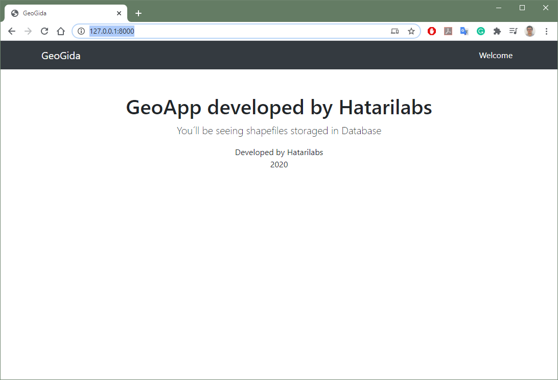

1. Now, we will add the geospatial view, to do this copy the “shp” folder of the given data to “media”, this contains two “.geojson” files
2. Modify the “geoApp/views.py” file as follows:

from django.shortcuts import render, redirect

import os

import folium

# Create your views here.

def home(request):

shp_dir = os.path.join(os.getcwd(),'media','shp')

# folium

m = folium.Map(location=[-16.22,-71.59],zoom_start=10#)

## style

style_basin = {'fillColor': '#228B22', 'color': '#228B22'}

style_rivers = { 'color': 'blue'}

## adding to view

folium.GeoJson(os.path.join(shp_dir,'basin.geojson'),name='basin',style_function=lambda x:style_basin).add_to(m)

folium.GeoJson(os.path.join(shp_dir,'rivers.geojson'),name='rivers',style_function=lambda x:style_rivers).add_to(m)

folium.LayerControl().add_to(m)

## exporting

m=m._repr_html_()

context = {'my_map': m}

## rendering

return render(request,'geoApp/home.html',context)

1. Now, add the map to the html code, open “home.html” an add after “<p class="lead">You´ll be seeing shapefiles storaged in Database</p>”, the following command

{{ my_map|safe }}

The complete “home.html” would be as follows

{% load static %}

<!DOCTYPE html>

<html lang="en">

<head>

<meta charset="utf-8">

<meta name="viewport" content="width=device-width, initial-scale=1, shrink-to-fit=no">

<meta name="description" content="">

<meta name="author" content="">

<title>GeoGida</title>

<!-- Bootstrap core CSS -->

<link rel="stylesheet" href="{% static '/bootstrap/css/bootstrap.min.css' %}">

</head>

<body>

<!-- Navigation -->

<nav class="navbar navbar-expand-lg navbar-dark bg-dark static-top">

<div class="container">

<a class="navbar-brand" href="#">GeoGida</a>

<button class="navbar-toggler" type="button" data-toggle="collapse" data-target="#navbarResponsive" aria-controls="navbarResponsive" aria-expanded="false" aria-label="Toggle navigation">

<span class="navbar-toggler-icon"></span>

</button>

<div class="collapse navbar-collapse" id="navbarResponsive">

<ul class="navbar-nav ml-auto">

<li class="nav-item active">

<a class="nav-link" href="">Welcome</a>

</li>

</ul>

</div>

</div>

</nav>

<!-- Page Content -->

<div class="container">

<div class="row">

<div class="col-lg-12 text-center">

<h1 class="mt-5">GeoApp developed by Hatarilabs</h1>

<p class="lead">You´ll be seeing shapefiles storaged in Database</p>

{{ my_map|safe }}

<ul class="list-unstyled">

<li>Developed by Hatarilabs</li>

<li>2020</li>

</ul>

</div>

</div>

</div>

<!-- Bootstrap core JavaScript -->

<script src="{% static '/jquery/jquery.slim.min.js' %}"></script>

<script src="{% static '/bootstrap/js/bootstrap.bundle.min.js' %}"></script>

</body>

</html>