GitSupport-

<https://github.com/contact>

or

[support@github.com](mailto:support@github.com)

Info:

[gjjz99@gmail.com](mailto:gjjz99@gmail.com)

Github0905**

Frist try to use yahoo-mail

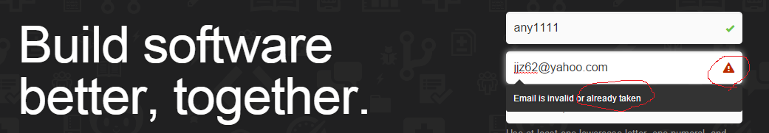

Then, recover PW with that

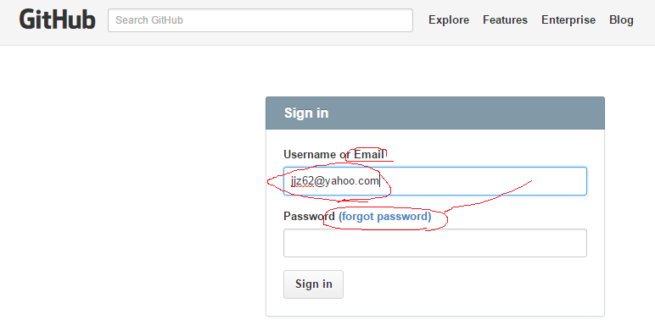

Clicking on ‘forgot password’



If no such email, it should be –



So jjz62 acct becomes a dead lock, need to call or figure out later…

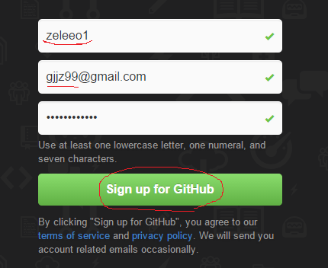

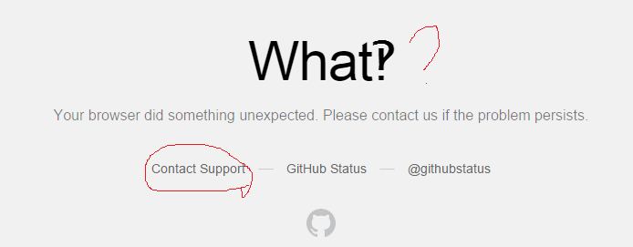

Send request to Cust_Service, no response.

Redo it:

