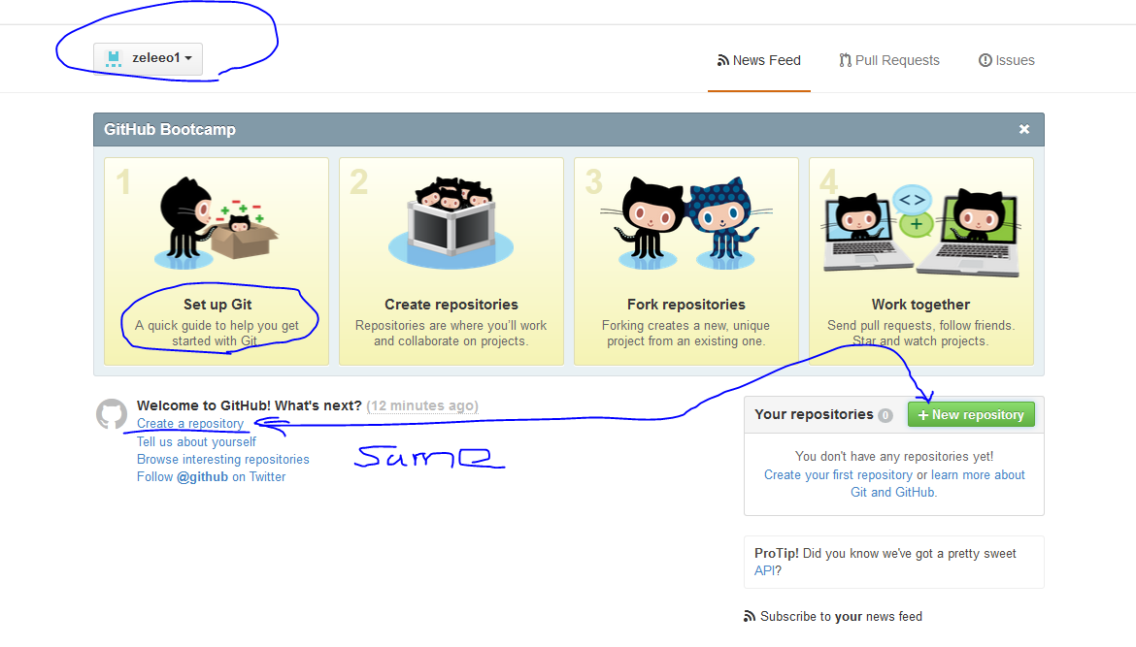

Clicking on either of above –

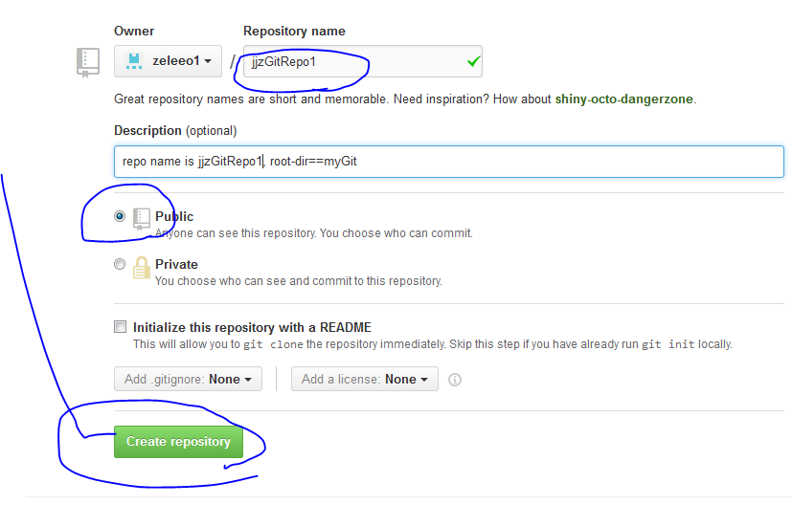

Got to –

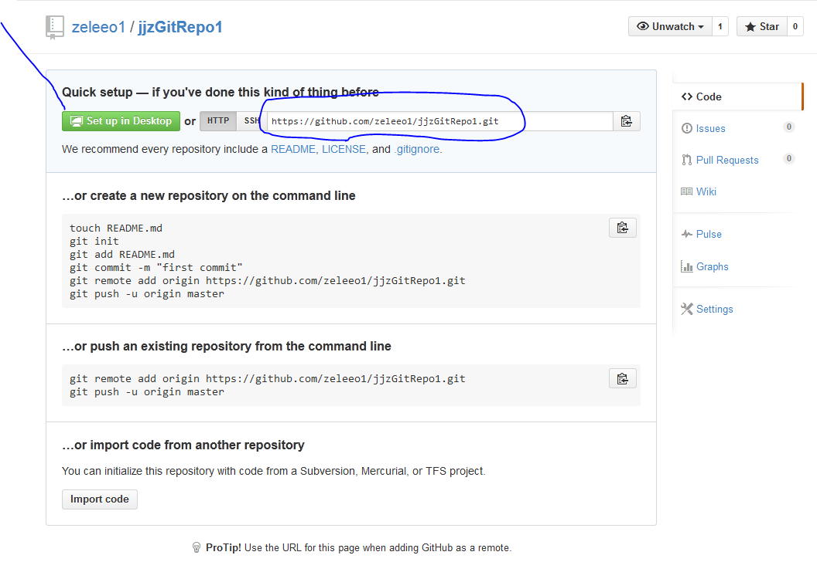

Clicking on “set up in desktop” will bring you to download page for GitHubSetup.exe

<https://github.com/zeleeo1/jjzGitRepo1.git>

above will be your URL for this page, and for accessing your GH from browser and anywhere else.

Since you see that “jjzGitRepo1.git” used in the reference, yes, it’s one of your repo, and you can create as many repo as possible under your account to expose them for people for different purpose.

For those real ‘public’ Repos, you may prefix it as pubXYZ etc.

In other words, REPO is a level lower than your accout. RepoName refers to your root-dir of your project or collection of dirs.

The above URL is also your index pages for everything.

See now your repo is empty.

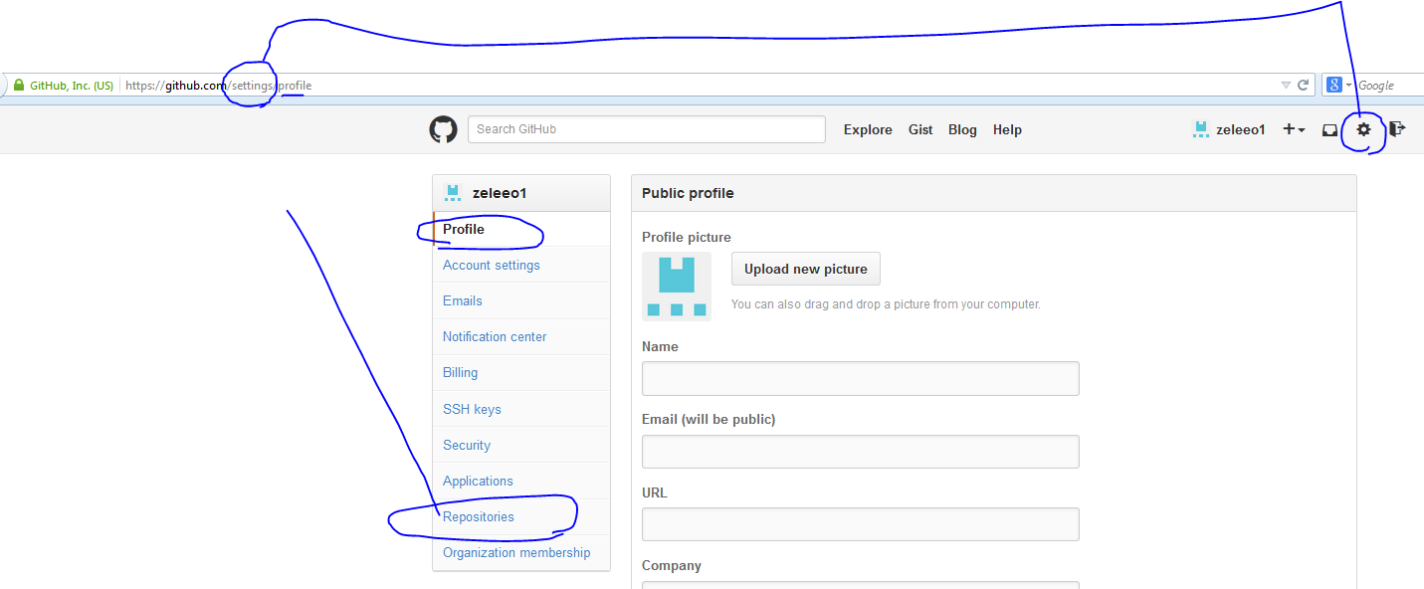

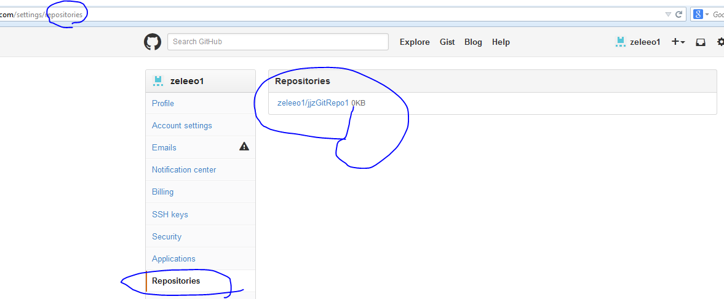

Now, let move on to your local for basic set-up.

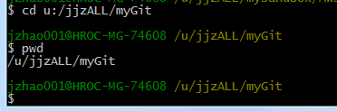

Very first time, do a config for your account level

git config --global user.name "zeleeo1"

then

git config --global user.email “[gjjz99@gmail.com](mailto:gjjz99@gmail.com)”

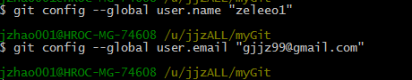

Next –

