Insert your name, centre number and candidate number into the header above.
Save this evidence document as evidence_ followed by your centre number_ candidate number. For example: evidence_ zz999_9999
Screenshots or program listings must be copied into appropriate cells in the following tables.
Examiners must be able to read the contents including any screenshots without the use of a magnifying glass. Answers that are not readable or missing will not be awarded any marks.
Save this evidence document at regular intervals, for example, every 10 minutes.
Question 1
Part 1(a)
class node:
def __init__(self,datap,nextnodep):
self.data=datap
self.nextnode=nextnodep

Part 1(b)
LinkedList=[node(1,1),node(5,4),node(6,7),node(7,-1),node(2,2),node(0,6),node(0,8),node(56,3),node(0,9),node(0,-1)]
startPointer=0
endPointer=5

Part 1(c)(i)
def outputNodes(linkedlist,startpointer):
while startpointer !=-1:
print(linkedlist[startpointer].data)
startpointer=linkedlist[startpointer].nextnode

Part 1(c)(ii)
1
5
2
6
56
7

Part 1(d)(i)
def addnode(linkedlist,startpointer,emptylist):
datatoadd=input("Enter the data to add: ")

if emptylist<0 or emptylist>9:
return False
else:
newNode=node(int(datatoadd),-1)
linkedlist[emptylist]=newNode
previousPointer=0
while(startpointer!=-1):
previousPointer=startpointer
startpointer=LinkedList[startpointer].nextnode
linkedlist[previousPointer].nextnode=emptylist
emptylist=LinkedList[emptylist].nextnode
return True

x=addnode(LinkedList,startPointer,emptyList)
print(x)
outputNodes(LinkedList,startPointer)

Part 1(d)(ii)
outputNodes(LinkedList,startPointer)
outputNodes(LinkedList,startPointer)
x=addnode(LinkedList,startPointer,emptyList)
print("added node: ",x)
outputNodes(LinkedList,startPointer)

Part 1(d)(iii)
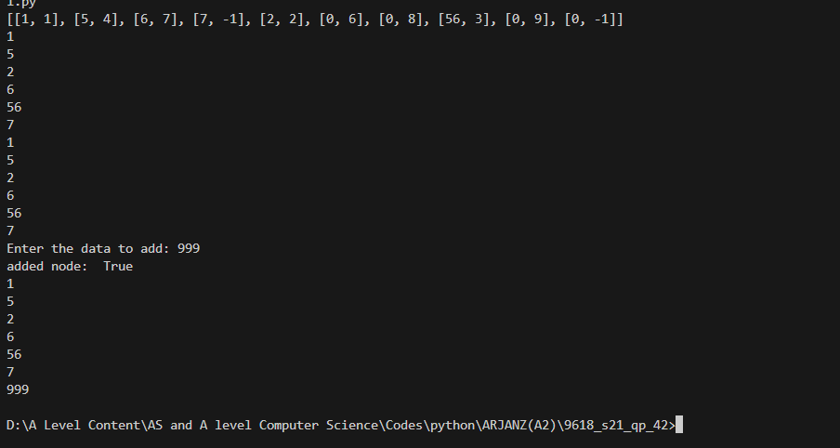

Question 2
Part 2(a)
arrayData=[10,5,6,7,1,12,13,15,21,8]

Part 2(b)(i)
def linearsearch(searchkey):
for x in range(len(arrayData)):
if arrayData[x]==searchkey:
return True
else :
return False

Part 2(b)(ii)
searchkeyp=int(input("enter a number: "))
x=linearsearch(searchkeyp)
if x==True:
print("found! ")
else:
print("not found")

Part 2(b)(iii)
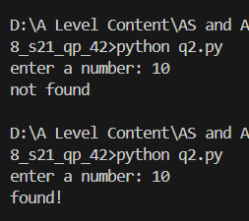

Part 2(c)
def bubbleSort(arrayDatap):
for x in range(0,len(arrayDatap)):
for y in range(0,len(arrayDatap)-1):
if arrayDatap[y]<arrayDatap[y+1]:
temp=arrayDatap[y]
arrayDatap[y]=arrayDatap[y+1]
arrayDatap[y+1]=temp

Question 3
Part 3(a)
class TreasureChes():
#PRIVATE question :STRING
#PRIVATE answer :INTEGER
#PRIVATE points : INTEGER

def __init__(self,questionP,pointsp,answerP):
self.__question=questionP
self.__points=pointsp
self.__answer=answerP

Part 3(b)
#DECLARE arrayTreasure as TreasureChest

arrayTreasure=[]
def readData():
filename="TreasureChestData.txt"
try:
file=open(filename,"r")
datafeched=(file.readline()).strip()
while datafeched != " ":
question=datafeched
answer=(file.readline()).strip()
points=(file.readline()).strip()

arrayTreasure.append(TreasureChest(question,answer,points))
datafeched=(file.readline()).strip()

file.close()
except IOError:
print("File not found")

Part 3(c)(i)
def getQuestion(self):
return self.__question

Part 3(c)(ii)
def checkAnswer(seld,answerpp):
if int(self.__answer)==answerpp:
return True
else:
return False

Part 3(c)(iii)
def getPoints(self, attempts):
if attempts == 1:
return int(self.__points)
elif attempts == 2:
return int(self.__points) // 2
elif attempts == 3 or attempts == 4:
return int(self.__points) // 4
else:
return 0

Part 3(c)(iv)
readData()
choice = int(input("Pick a treasure chest to open"))
if choice > 0 and choice < 6:

result = False
attempts = 0
while result == False:
answer = int(input(arrayTreasure[choice-1].getQuestion()))
result = arrayTreasure[choice-1].checkAnswer(answer)
attempts = attempts + 1
print(int(arrayTreasure[choice-1].getPoints(attempts)))

Part 3(c)(v)
Screenshot: outputting 2*2 entering 4 outputting 10
Screenshot: outputting 3000+4000
7000 outputting 9

