POÇO 442/94

=== STEP 1: MONTHLY AGGREGATION ===
Original data points: 750
Monthly data points: 589
Missing months: 199
Data completeness: 66.2%

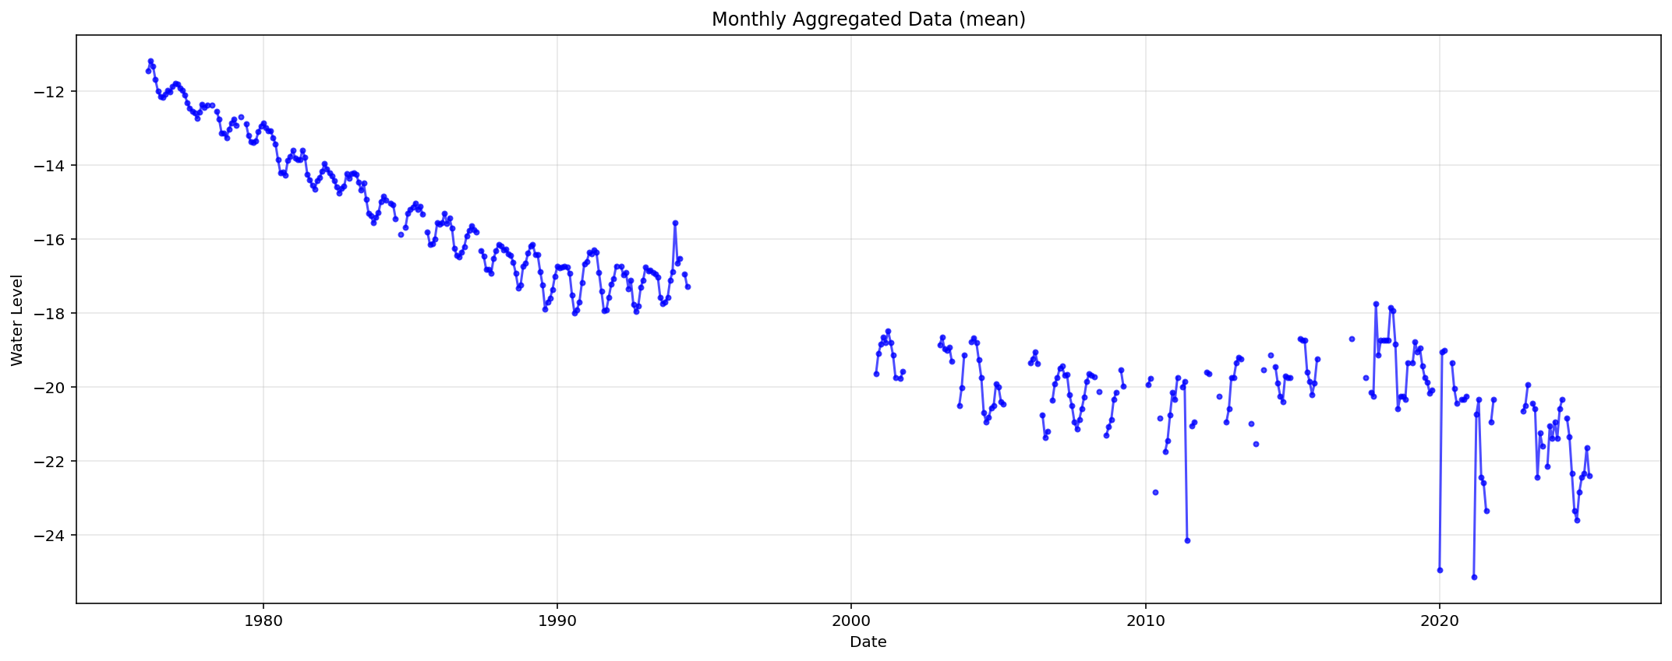
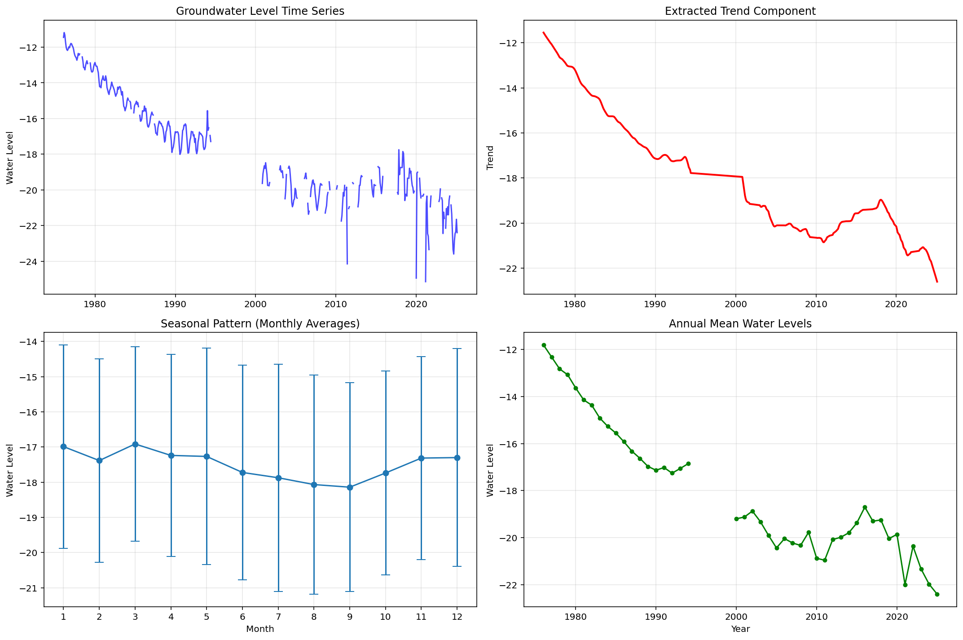

Decomposição da série mensal: original=Tendência + sazonalidade + resíduos
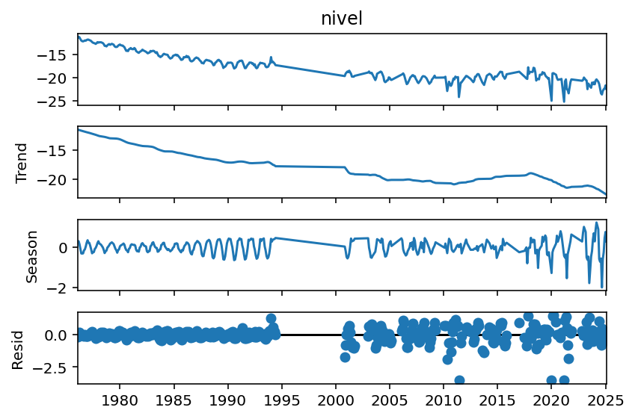

=== STEP 2: SEGMENT BY GAPS (≥24 months) ===
Found 1 significant gaps:
Created 2 segments:
Segment 1: 1976-01 to 1994-05
Length: 221 months, Valid: 210 (95.0%)
Segment 2: 2000-10 to 2025-01
Length: 292 months, Valid: 180 (61.6%)

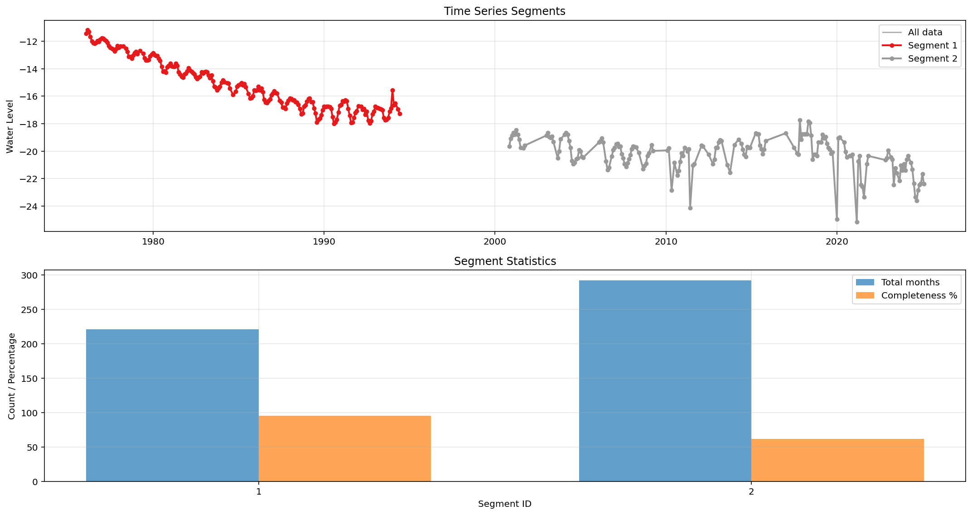

=== STEP 3: FILL MISSING DATA (seasonal_decompose) ===

Processing Segment 1:
Missing values: 11/221
After filling: 0 missing values

Processing Segment 2:
Missing values: 112/292
After filling: 0 missing values

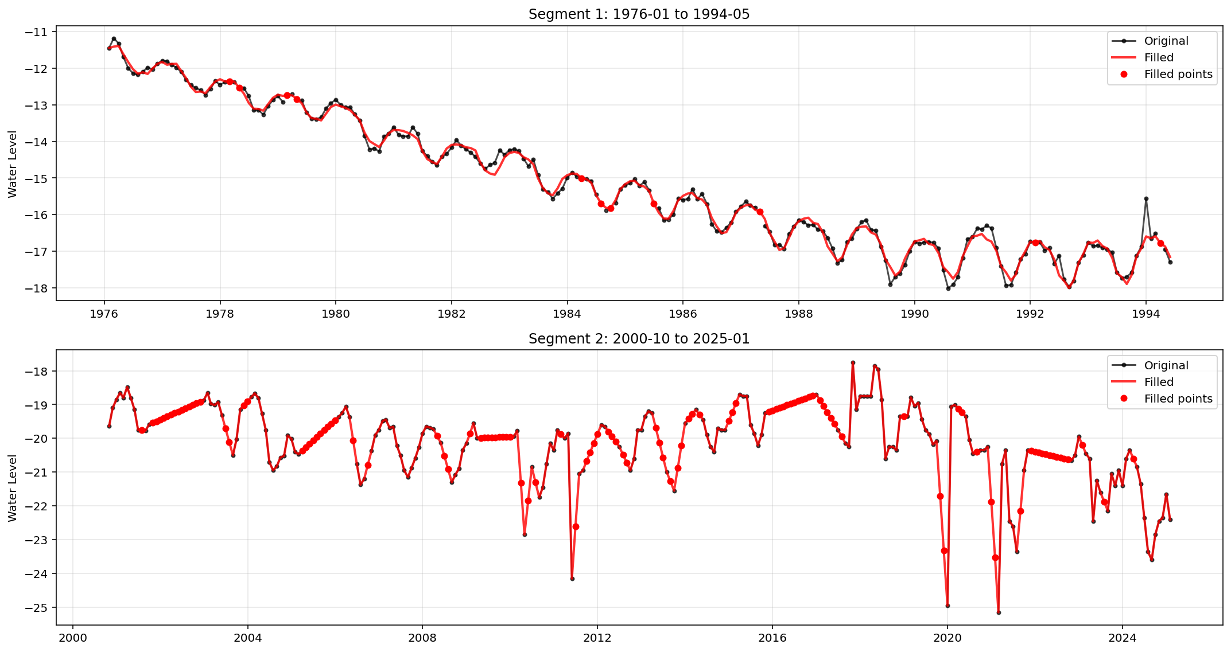

=== STEP 4: TREND TESTING (α=0.05) ===

--- Segment 1 Trend Analysis ---
Mann-Kendall: decreasing (p=0.0000, τ=-0.845)
Sen's slope: -0.3411 units/year
Seasonal Mann-Kendall: decreasing (p=0.0000)
Seasonal Sen's slope: -4.1503 units/year
Hamed Rao Mann-Kendall: decreasing (p=0.0000, τ=-0.845)
Sen's slope: -0.3411 units/year
Linear regression: decreasing (p=0.0000, R²=0.923)
Linear slope: -0.3265 ± 0.0064 units/year

--- Segment 2 Trend Analysis ---
Mann-Kendall: decreasing (p=0.0000, τ=-0.221)
Sen's slope: -0.0465 units/year
Seasonal Mann-Kendall: decreasing (p=0.0000)
Seasonal Sen's slope: -0.5215 units/year
Hamed Rao Mann-Kendall: no trend (p=0.0582, τ=-0.221)
Sen's slope: -0.0465 units/year
Linear regression: decreasing (p=0.0000, R²=0.127)
Linear slope: -0.0573 ± 0.0088 units/year

=============================================================================
TREND ANALYSIS SUMMARY
=============================================================================

Segment | 1 | 2
Period | 1976-01 to 1994-05 | 2000-10 to 2025-01
Years | 18.4 | 24.3
N_obs | 221 | 292
MK_Trend | decreasing | decreasing
MK_p_value | 0 | 0
MK_Slope_yr | -0.3411 | -0.0465
SMK_Trend | decreasing | decreasing
SMK_p_value | 0 | 0
SMK_Slope_yr | -4.1503 | -0.5215
HRMK_Trend | decreasing | no trend
HRMK_p_value | 0 | 0.0582
HRSMK_Slope_yr | -0.3411 | -0.0465
Lin_Slope_yr | -0.3265 | -0.0573
Lin_p_value | 0 | 0
R² | 0.923 | 0.127

