TL;DR: In this series, you will learn how to build modern applications with Golang and Angular. In the first article, you will build a secure backend API with Golang that will support a to-do list application. Then, in the second part, you will use Angular to develop the frontend of the to-do list app. To facilitate the identity management, you will use Auth0 both in your backend API and in your Angular app to authenticate users. If needed, you can find the final code developed throughout this article in this GitHub repository.
"I'm developing a modern application with @angular and @golang."

Tweet This

Why Choose Golang and Angular
As mentioned, the technologies of choice for this series is Golang for the backend and Angular for the frontend. In this section, you will learn more about both platforms and why they are great options to develop applications nowadays.

Golang Overview
Golang (or simply Go), is a statically-typed and pre-compiled programming language invented by Google. Over the last few years, Golang has become a very popular language, being the language of choice for projects such as Docker, Kubernetes, and all of Hashicorps suite of programs.
Golang is not quite like other programming languages. This platform has a very strong standard library and can get very far before having to use third-party libraries. Also, Golang stands out for being compiled into a single binary, for having amazing support for concurrency, for facilitating testing and benchmarking, and for having a fantastic community behind it.
Although amazing, Golang is by no means the perfect language. However, the reason that I use it every day is for the simple reason that it get's the job done. Other than Python or Ruby, I don't believe there is a language as effective in time-to-deliver as Golang.
Note: Wondering why I haven't chosen Ruby or Python? Well, the main reason is that I prefer statically typed compiled languages. This kind of programming language results in a faster application and avoids dependency hell for the end user. Also, I chose Golang because it has excellent cross-platform compilation support, making it even more attractive as a programming language.

Angular Overview
Currently, the only real viable choice for writing a frontend web app is using JavaScript. All browsers support it to a satisfactory degree and, as such, using it will make you avoid strange dependency and compatibility issues.
So, that makes choosing the frontend technology easy, right? Nope! As of writing this article, there are currently three major frameworks/libraries that professional web app developers are using. They are React, Vue.js, and Angular. If you go out there and research, you will probably find another 100 smaller frameworks. But, for the moment, they still have to prove that they can handle production-ready applications.
Now, you can find articles around the web that states that "Framework X is much better than frameworks Y & Z, because of whatever". Or, you can find articles describing that all three frameworks mentioned are essentially dead because of some new framework.
Going into the politics of the frontend frameworks and getting into these discussions is just not worth the effort. The truth is, if you stick to one of the three major frameworks/libraries, you will be able to accomplish the same thing. Also, the result that they produce is quite similar. If you take a closer look, you will see that all of these frontend solutions use Yarn or NPM to download hundreds of megabytes of god knows what in your node_modules directory to then compress all of this into smaller HTML and JavaScript files.
Nevertheless, I feel like you deserve an explanation on why I chose Angular for this job. I like Angular because it comes with everything that I expect to come to a web framework. Some standard components, easy management of libraries, routing and authentication support, etc. Basically speaking, Angular makes life easy and, well, who doesn't like an easy life?.
React is also a super strong library (and a great alternative for this job). However, I have OCD (Obsessive-Compulsive Disorder) issues with HTML elements being added to JavaScript files. Just like many people have issues with their different foods touching one another on their plate.
Lastly, there is Vue.js, which is also a very strong and popular framework. As of now, I cannot tell you a technical reason to choose Angular over Vue.js. One thing I know, though, is that Angular still is much more popular and well supported than Vue.js. However, I started out with Angular and Angular does the job for me.
Either way, Angular is another project backed by Google, much like Golang. This framework has sprouted from its old brother AngularJS, which was THE JavaScript framework a few years ago. The new Angular is not as popular, which I think there are a few reasons for. For example, nowadays there is more competition, mainly with React and Vue.js. Also, there were a lot of breaking changes during the first Angular versions released (even when no breaking changes were supposed to be published). And, the last reason (which causes a lot of confusion) is the versioning convention.
Instead of making versions such as 2.2.1.1, the team responsible for Angular decided that all breaking changes would cause a total version aggregation. So, the current version of Angular (as of writing this article) is Angular 6. This makes it difficult to Google (ironically) and also weird to refer to, and there are many different ways to refer to it: Angular, Angular 2+, Angular 6, etc.
Despite all of this, I still think that Angular is an excellent frontend framework for web applications. I love that it leverages the use of TypeScript and, thereby standardizing the structure of code and as mentioned earlier, I love the angular-cli toolbox (which comes with all the tools I need and expect out of the box).

Prerequisites
For this tutorial, you will need to install Golang, Node.js, and Angular. However, as you will see, the process is quite simple. For starters, you can visit the official installation instructions provided by Golang to install the programming language.
After that, you will need to install Node.js (which comes with NPM). For that, you can follow the instructions described here.
Then, after installing Node.js and NPM, you can issue the following command to install the Angular CLI tool:
npm install -g @angular/cli
Note: By adding -g in the command above, you make NPM install the Angular CLI tool globally. That is, after issuing this command, you will have the ng command in all new sessions of your terminal.

Building Backend APIs with Golang
In this section, you will learn how to build backend APIs with Golang. To facilitate your life, you will use Gin, an HTTP web framework written in Golang. Gin is, like many other frameworks, an open-source project that simplifies creating API endpoints.
What is good to keep in mind is that nothing that you will build in this article is impossible to do with the standard library of Golang. The only reason why you are using Gin is because it simplifies and standardizes the process a little, making your life easier.

Creating an In-Memory To-Do List with Golang
Before you start developing your web server, you will start writing the component that will handle the to-do list. To keep things simple, the implementation of this component will consist of a static object that will store all to-do items in-memory. Essentially, this component will work a very simple database (one that does not persist data to disk though).
Typically, this is not a bad way to start out the development process. Implementing a mock version of your database (before implementing your actual database) not only makes testing easier (and something that you can do from the beginning of your project) but it also helps to imply an interface for your store (or database).
Enough said, it's time to get started with your backend API. Golang, by default, will look for packages in the GO_PATH environment variable. This variable usually refers to a place in the user directory (i.e., on Unix-like systems, this would be ~/go, and on Windows, this would be %USERPROFILE%/go).
Packages are then stored in $GO_PATH/src/ and, therefore, placing your projects there will make your life a lot easier. For this tutorial, you can place your Golang project in the ~/go/src/github.com/<YOUR_GITHUB_USER>/golang-angular (you might have to create some of these directories). For the rest of the article, this directory will be referred to as the project root or simply ./.
Note: You will have to replace <YOUR_GITHUB_USER> with your own GitHub username. That is, you do have a GitHub account, right?
So, in your project root (./), create a new directory called todo. Then, inside this directory, create a new file called todo.go with the following code:
package todo

import (
"errors"
"sync"

"github.com/rs/xid"
)

var (
list []Todo
mtx sync.RWMutex
once sync.Once
)

func init() {
once.Do(initialiseList)
}

func initialiseList() {
list = []Todo{}
}

// Todo data structure for a task with a description of what to do
type Todo struct {
ID string `json:"id"`
Message string `json:"message"`
Complete bool `json:"complete"`
}

// Get retrieves all elements from the todo list
func Get() []Todo {
return list
}

// Add will add a new todo based on a message
func Add(message string) string {
t := newTodo(message)
mtx.Lock()
list = append(list, t)
mtx.Unlock()
return t.ID
}

// Delete will remove a Todo from the Todo list
func Delete(id string) error {
location, err := findTodoLocation(id)
if err != nil {
return err
}
removeElementByLocation(location)
return nil
}

// Complete will set the complete boolean to true, marking a todo as
// completed
func Complete(id string) error {
location, err := findTodoLocation(id)
if err != nil {
return err
}
setTodoCompleteByLocation(location)
return nil
}

func newTodo(msg string) Todo {
return Todo{
ID: xid.New().String(),
Message: msg,
Complete: false,
}
}

func findTodoLocation(id string) (int, error) {
mtx.RLock()
defer mtx.RUnlock()
for i, t := range list {
if isMatchingID(t.ID, id) {
return i, nil
}
}
return 0, errors.New("could not find todo based on id")
}

func removeElementByLocation(i int) {
mtx.Lock()
list = append(list[:i], list[i+1:]...)
mtx.Unlock()
}

func setTodoCompleteByLocation(location int) {
mtx.Lock()
list[location].Complete = true
mtx.Unlock()
}

func isMatchingID(a string, b string) bool {
return a == b
}
In the very top of the bottom (right after defining the package and importing a few other packages), you will find the variables that will be globally-available in this file:
- list: This is the array that will hold all to-do items.
- mtx: This is the mutex that will allow you to safely access/manipulate the data in this package across different goroutines.
- once: This is a Golang native functionality (sync.Once), which will help you assure that a specific operation will run only once.
After the declaration of these variables, you will find the init function and you will see that it runs another function called initialiseList. The latter is responsible for initializing the array of to-do items but will ensure that this initialization will run only once. As Golang runs the init function whenever the package is initialized (i.e., whenever the package is loaded), you needed to wrap the initialiseList function inside once.Do. In this way, you avoid resetting the array on the runtime.
Then, after these two functions that initialize the package, you will find the Todo structure. This struct defines that to-do items will have an ID, a Message and whether the todo item is Complete or not. Also, while defining this struct, you are also mapping all properties of your struct into its JSON equivalent. This is a very useful feature in Golang and, if needed, you can find more info about it here. As the naming convention in Golang defines that all properties starting with a capital letter are public and all starting with a small letter are private in a struct, this mapping also helps you ensure you can stick with the naming conventions available in JSON.
Note: If you were to define other packages that would use this struct, it would be a good idea to place it in another package for itself. However, for this simple application, placing it here will suffice.
Right after the definition of the Todo struct, you will find the first method of your to-do store: Get. This method starts with a capital letter and, therefore, is public (meaning it can be accessed by other packages). The Get method implementation is very simple, it simply returns your current static to-do list (the global list variable).
Then, below this method, you will find the Add method, which will create a new to-do (based on a user input message) and append to the global list. Notice that you are using your mutex to Lock before you append new items to your list and then Unlock again once the operation ends. As your server might handle multiple operations at the same time, this is a very important step. If these operations try to access the same memory, you can run into a race-condition that might make Golang crash. To avoid this, you are using mutex, which is scoped to your package.
After Add, you will find the last two public functions. First, you will find Delete, which, as the name states, will remove an item from the list. Then, you will find Complete, which will mark a to-do item as complete (based on its ID) in your list.
Then, after the public functions, you will find the private functions of your package. For starter, you will find the newTodo function, which will take in a msg in the form of a string and return a new instance of the Todo struct. This instance will contain an ID (i.e., a UUID in the form of a string) and the complete flag set to false.
The next private function you will find is the findTodoLocation function. You will use this function to find the index location of a to-do item based on its ID. If no matches are found after iterating over all the items, this function will return an error saying that it couldn't find the desired item. Notice that you are using mutex again in this method. This time, you are using the RLock (Read Lock) function since you will only be reading from your list and not writing to it.
Right after the findTodoLocation function, you will see the removeElementByLocation function. In this function, you are setting your list variable to a new array, which contains all elements from the previous list up to a given location, appended with all elements after (but not including) the same given location. This means that, by giving a specific location to this function, you will get a new list without that given location (essentially deleting it from the previous list).
Then, the very last function in your store package is setTodoCompleteByLocation. Just like your remove function, this function takes in a location in the form of an integer. However, this function is much less complex and simply sets the Complete property of the item found on the given location to true.
Lastly, if you take a close look at the source code of this package, you will notice that it is using a third-party package called xid for generating UUIDs (Universally Unique Identifiers). As such, you will need to obtain this package before compiling your application. To do so, you will have to run the following command:
go get github.com/rs/xid

Building the Golang Web Server and Serving Static Files
Right on! Now is the time to develop a web server with Golang and Gin. So, for starters, you will need to grab Gin from the internet. To do this, run the following code:
go get github.com/gin-gonic/gin
Great. Now, in your project root (./), you will create a file called main.go and insert the following code into it:
package main

func main() {
r := gin.Default()
r.NoRoute(func(c *gin.Context) {
dir, file := path.Split(c.Request.RequestURI)
ext := filepath.Ext(file)
if file == "" || ext == "" {
c.File("./ui/dist/ui/index.html")
} else {
c.File("./ui/dist/ui/" + path.Join(dir, file))
}
})

r.GET("/todo", handlers.GetTodoListHandler)
r.POST("/todo", handlers.AddTodoHandler)
r.DELETE("/todo/:id", handlers.DeleteTodoHandler)
r.PUT("/todo", handlers.CompleteTodoHandler)

err := r.Run(":3000")
if err != nil {
panic(err)
}
}
Compared to the package you built in the last section, this file is pretty straightforward. First, you create your Gin server using gin.Default(). This command will return an object that you can use to configure and run the web server.
Then, you do something that can be considered a little bit hacky. As you may know, routing in Gin is quite specific and cannot have ambiguous routes for the root path. Essentially, Gin will complain if you have a configuration like /* because this will interfere with every other route in your web server (those would never be called). In Node.js (and other popular web servers), you can do this because the path routing is determined by the most specific to the least specific configuration. So, in that case, a route like /api/something would have precedence over /*.
Unfortunately, this is not the case by default in Gin. However, to implement this in your server, you will take advantage of the NoRoute function, which matches all routes that have not been specified already. This route function will assume that this call is asking for a file and attempt to find this file.
If a client asks for the root path, or if the file is not found, you will serve them the index.htmlfile (which will be produced from your Angular project at a later point). Otherwise, you will serve the file requested by the client.
Note: There are other ways to do this and, depending on what you want to achieve, better ways to achieve that. However, for this tutorial, this will do just fine.
Now, after this generic endpoint, you are adding routes to fetch the data from your to-do list. They are all pointing to the same path '/todo', but they all use different HTTP methods:
- GET: This endpoint enables users to retrieve the entire to-do list.
- POST: This endpoint enables users to add new items to the list.
- DELETE: This endpoint enables users to delete a to-do from the list based on an ID.
- PUT: This endpoint enables users to change a to-do item from incomplete to complete.
Each one of these endpoints is structured in the same manner (i.e., r.<METHOD>(<PATH>, <Gin function>). Your Gin function is basically any function that takes the parameter of a gin.Context pointer. If you look at the NoRoute function, you will see an example of an anonymous function with the input of a gin.Context pointer.
Lastly, the main.go script runs your web server on port 3000 and panic if an error occurs while running the web server.
In the next section, you will learn how to develop the handlers that will manage the incoming HTTP requests.

Developing the API Endpoints with Gin Handlers
To handle the incoming HTTP requests, in this section, you will learn how to develop Gin handlers. To begin with, you will create a new directory called handlers in the project root. Then, inside this directory, you will create a file called handlers.go. In this file, you will write the code necessary to handle all methods (GET, POST, PUT, and DELETE) available in your API endpoints (/todo).
Since you already implemented most of the functionality necessary in the todo package, this will be a relatively simple exercise. The final code in the handlers.go file will look as such:
package handlers

import (
"encoding/json"
"io"
"io/ioutil"
"net/http"

"github.com/<YOUR_GITHUB_USER>/golang-auth0-example/todo"
"github.com/gin-gonic/gin"
)

// GetTodoListHandler returns all current todo items
func GetTodoListHandler(c *gin.Context) {
c.JSON(http.StatusOK, todo.Get())
}

// AddTodoHandler adds a new todo to the todo list
func AddTodoHandler(c *gin.Context) {
todoItem, statusCode, err := convertHTTPBodyToTodo(c.Request.Body)
if err != nil {
c.JSON(statusCode, err)
return
}
c.JSON(statusCode, gin.H{"id": todo.Add(todoItem.Message)})
}

// DeleteTodoHandler will delete a specified todo based on user http input
func DeleteTodoHandler(c *gin.Context) {
todoID := c.Param("id")
if err := todo.Delete(todoID); err != nil {
c.JSON(http.StatusInternalServerError, err)
return
}
c.JSON(http.StatusOK, "")
}

// CompleteTodoHandler will complete a specified todo based on user http input
func CompleteTodoHandler(c *gin.Context) {
todoItem, statusCode, err := convertHTTPBodyToTodo(c.Request.Body)
if err != nil {
c.JSON(statusCode, err)
return
}
if todo.Complete(todoItem.ID) != nil {
c.JSON(http.StatusInternalServerError, err)
return
}
c.JSON(http.StatusOK, "")
}

func convertHTTPBodyToTodo(httpBody io.ReadCloser) (todo.Todo, int, error) {
body, err := ioutil.ReadAll(httpBody)
if err != nil {
return todo.Todo{}, http.StatusInternalServerError, err
}
defer httpBody.Close()
return convertJSONBodyToTodo(body)
}

func convertJSONBodyToTodo(jsonBody []byte) (todo.Todo, int, error) {
var todoItem todo.Todo
err := json.Unmarshal(jsonBody, &todoItem)
if err != nil {
return todo.Todo{}, http.StatusBadRequest, err
}
return todoItem, http.StatusOK, nil
}
Note: You will have to replace <YOUR_GITHUB_USER> in the code above with your own GitHub username.
As mentioned earlier, all of your handler functions take a pointer to gin.Context as a parameter. This parameter essentially contains the http.Request reader and an http.ResponseWriter writer. Besides these functionalities that allow you to read from the request and to write a response, this pointer contains a lot of metadata about the request.
Basically speaking, this code is structured as follows:
- Grab input and convert if necessary.
- Check for errors.
- Perform operation.
- Return error or the ok status.
At the bottom of the code, you will notice two helper functions specifically tailored to parse input. The convertHTTPBodyToTodo function will read the body from the request and return it as a Todo object. This is done by using the ioutil.ReadAll which will read all bytes from an io.Reader stream. Once this function reads all bytes, you use convertJSONBodyToTodo to convert them from JSON (which is the original format of the request body) to a Todo object.
With these convert operations encapsulated in their functions, it's pretty easy to keep your handlers logic simple and neat. The only other thing that might be worth mentioning the usage of the c.JSON function. You are using this function to convert the response into JSON objects before sending them to your users.
After these changes, you are ready to run your Golang API. So, go to your project root and issue the following command:
go run main.go
This will make your server start listening requests on localhost:3000. To test it, you can then use a command-line tool like curl or a graphical solution like Postman. Using curl, you can test your application like this:
# add a new to-do item
curl localhost:3000/todo -d '{"message": "finish writing the article"}'

# get all to-do items
curl localhost:3000/todo
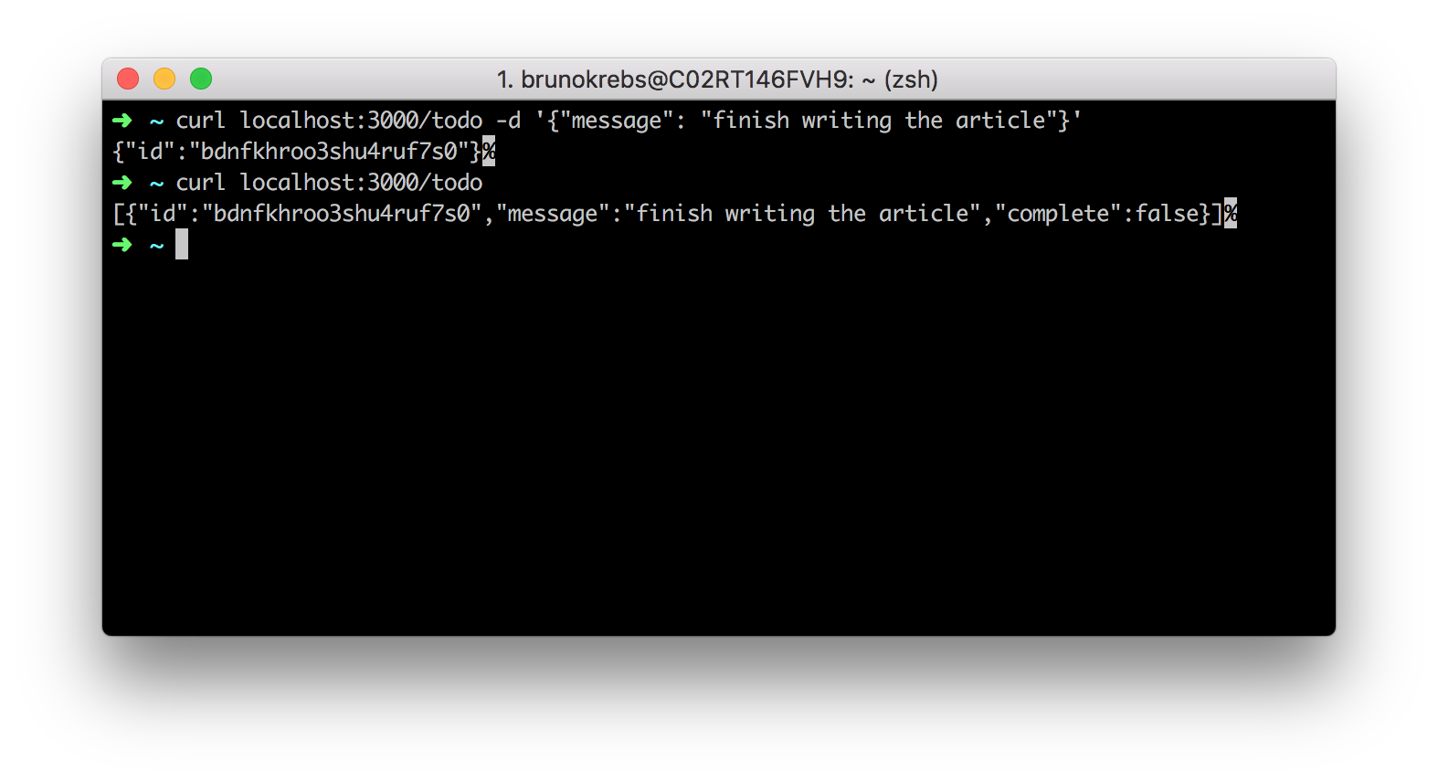

Securing the Golang API with Auth0
That's awesome. You now have a Golang backend API up and running. Time to celebrate? Not quite yet... you have one big issue. Right now, anyone can issue requests to your API. That's not ideal. You probably want to make sure that only people that you trust can access and edit your to-do list. To do this, you will use Auth0 as the Identity and Access Management (IAM) system of your service.
If you don't have an Auth0 account yet, you can sign up for a free one here.
After signing up for Auth0, you will have to go to your Auth0 dashboard and proceed as follows:
- go to the APIs section;
- click on Create API;
- define a Name for your API (e.g., "Golang API");
- define an Identifier for it (e.g., https://my-golang-api);
- and click on the Create button (leave the Signing Algorithm with RS256).
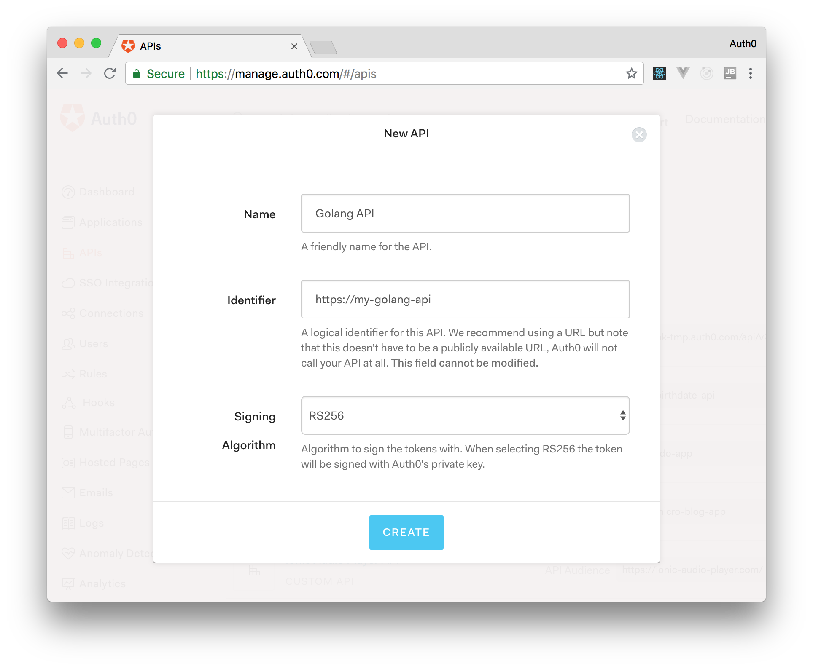
In a second or two, Auth0 will redirect you to your new Auth0 API. For this article, you won't have to change any other configuration on Auth0's dashboard. However, you can leave it open as you will have to copy a few values from it soon.
So, back in your code, you will want to refactor your API to check if the requests arriving have access tokens issued by Auth0. To do this, open your main.go file and replace its code with this:
package main

import (
"log"
"net/http"
"os"
"path"
"path/filepath"

"github.com/auth0-community/go-auth0"
"github.com/gin-gonic/gin"
jose "gopkg.in/square/go-jose.v2"

"github.com/<YOUR_GITHUB_USER>/golang-auth0-example/handlers"
)

var (
audience string
domain string
)

func main() {
setAuth0Variables()
r := gin.Default()

// This will ensure that the angular files are served correctly
r.NoRoute(func(c *gin.Context) {
dir, file := path.Split(c.Request.RequestURI)
ext := filepath.Ext(file)
if file == "" || ext == "" {
c.File("./ui/dist/ui/index.html")
} else {
c.File("./ui/dist/ui/" + path.Join(dir, file))
}
})

authorized := r.Group("/")
authorized.Use(authRequired())
authorized.GET("/todo", handlers.GetTodoListHandler)
authorized.POST("/todo", handlers.AddTodoHandler)
authorized.DELETE("/todo/:id", handlers.DeleteTodoHandler)
authorized.PUT("/todo", handlers.CompleteTodoHandler)

err := r.Run(":3000")
if err != nil {
panic(err)
}
}

func setAuth0Variables() {
audience = os.Getenv("AUTH0_API_IDENTIFIER")
domain = os.Getenv("AUTH0_DOMAIN")
}

// ValidateRequest will verify that a token received from an http request
// is valid and signyed by Auth0
func authRequired() gin.HandlerFunc {
return func(c *gin.Context) {

var auth0Domain = "https://" + domain + "/"
client := auth0.NewJWKClient(auth0.JWKClientOptions{URI: auth0Domain + ".well-known/jwks.json"}, nil)
configuration := auth0.NewConfiguration(client, []string{audience}, auth0Domain, jose.RS256)
validator := auth0.NewValidator(configuration, nil)

_, err := validator.ValidateRequest(c.Request)

if err != nil {
log.Println(err)
terminateWithError(http.StatusUnauthorized, "token is not valid", c)
return
}
c.Next()
}
}

func terminateWithError(statusCode int, message string, c *gin.Context) {
c.JSON(statusCode, gin.H{"error": message})
c.Abort()
}
Note: You will have to replace <YOUR_GITHUB_USER> in the code above with your own GitHub username.
If you analyze the new version of this code carefully, you will notice that you added a routing group (called authorized) to secure all endpoints in your backend. That is, by calling authorized.Use(authRequired()) and putting all endpoint definitions inside the authorized routing group, you are telling Gin that all requests made to these endpoints must be evaluated by the authRequired function first.
Another change in this code is the addition of two new global variables: audience and domain. You need these variables so you can validate access tokens against Auth0. As you can see, these variables will be retrieved from your environment variables on start, using the setAuth0Variables function. You will set them with your Auth0 values before running your backend again.
As the core piece of validation is the authRequired function, a better explanation about it is required. The authRequired function is what is known as a middleware function. In Gin terms, a middleware must return a gin.HandlerFunc function that contains a call to Next() in the body. Basically, your function validates a token, which is found in the Authorization header of the incoming request. The middleware does this by using JWKS (JSON Web Key Set). Essentially, JWKS is a method for verifying JWT, using a public/private key infrastructure.
Luckily for you, using Auth0's Golang library makes this process extremely simple. All you have to do is to write a few lines of code to validate the incoming token. If this results in an error, you terminate the current connection, responding to it with an http.StatusUnauthorized (401) status. If the token is valid, then you send the request onto the next function (by calling Next()) in the handler chain.
Before wrapping up, you still need to install the two new libraries that this code is now using:
go get github.com/auth0-community/go-auth0 gopkg.in/square/go-jose.v2
"Securing a @golang backend API with @auth0 is really, really simple."

Tweet This
That's it. Securing a Golang backend API with Auth0 is as simple as that. To see this in action, hit Ctrl + c to stop the previously running instance of your API and then run it again:
# set env variables
export AUTH0_API_IDENTIFIER=<YOUR_AUTH0_API>
export AUTH0_DOMAIN=<YOUR_AUTH0_TENANT>.auth0.com

go run main.go
Note: You have to replace <YOUR_AUTH0_API> with the identifier you set in your Auth0 API while creating it. Also, you have to replace <YOUR_AUTH0_TENANT> with the subdomain you chose while creating your Auth0 account.
Now, if you try to issue a request to your API without sending an access token retrieved from Auth0:
curl GET localhost:3000/todo
You will get a nice error sent back:
{
"error":"token is not valid"
}
To fetch a temporary access token to validate that your server still works, you can go to the Test section of your Auth0 API and copy the curl command shown there.
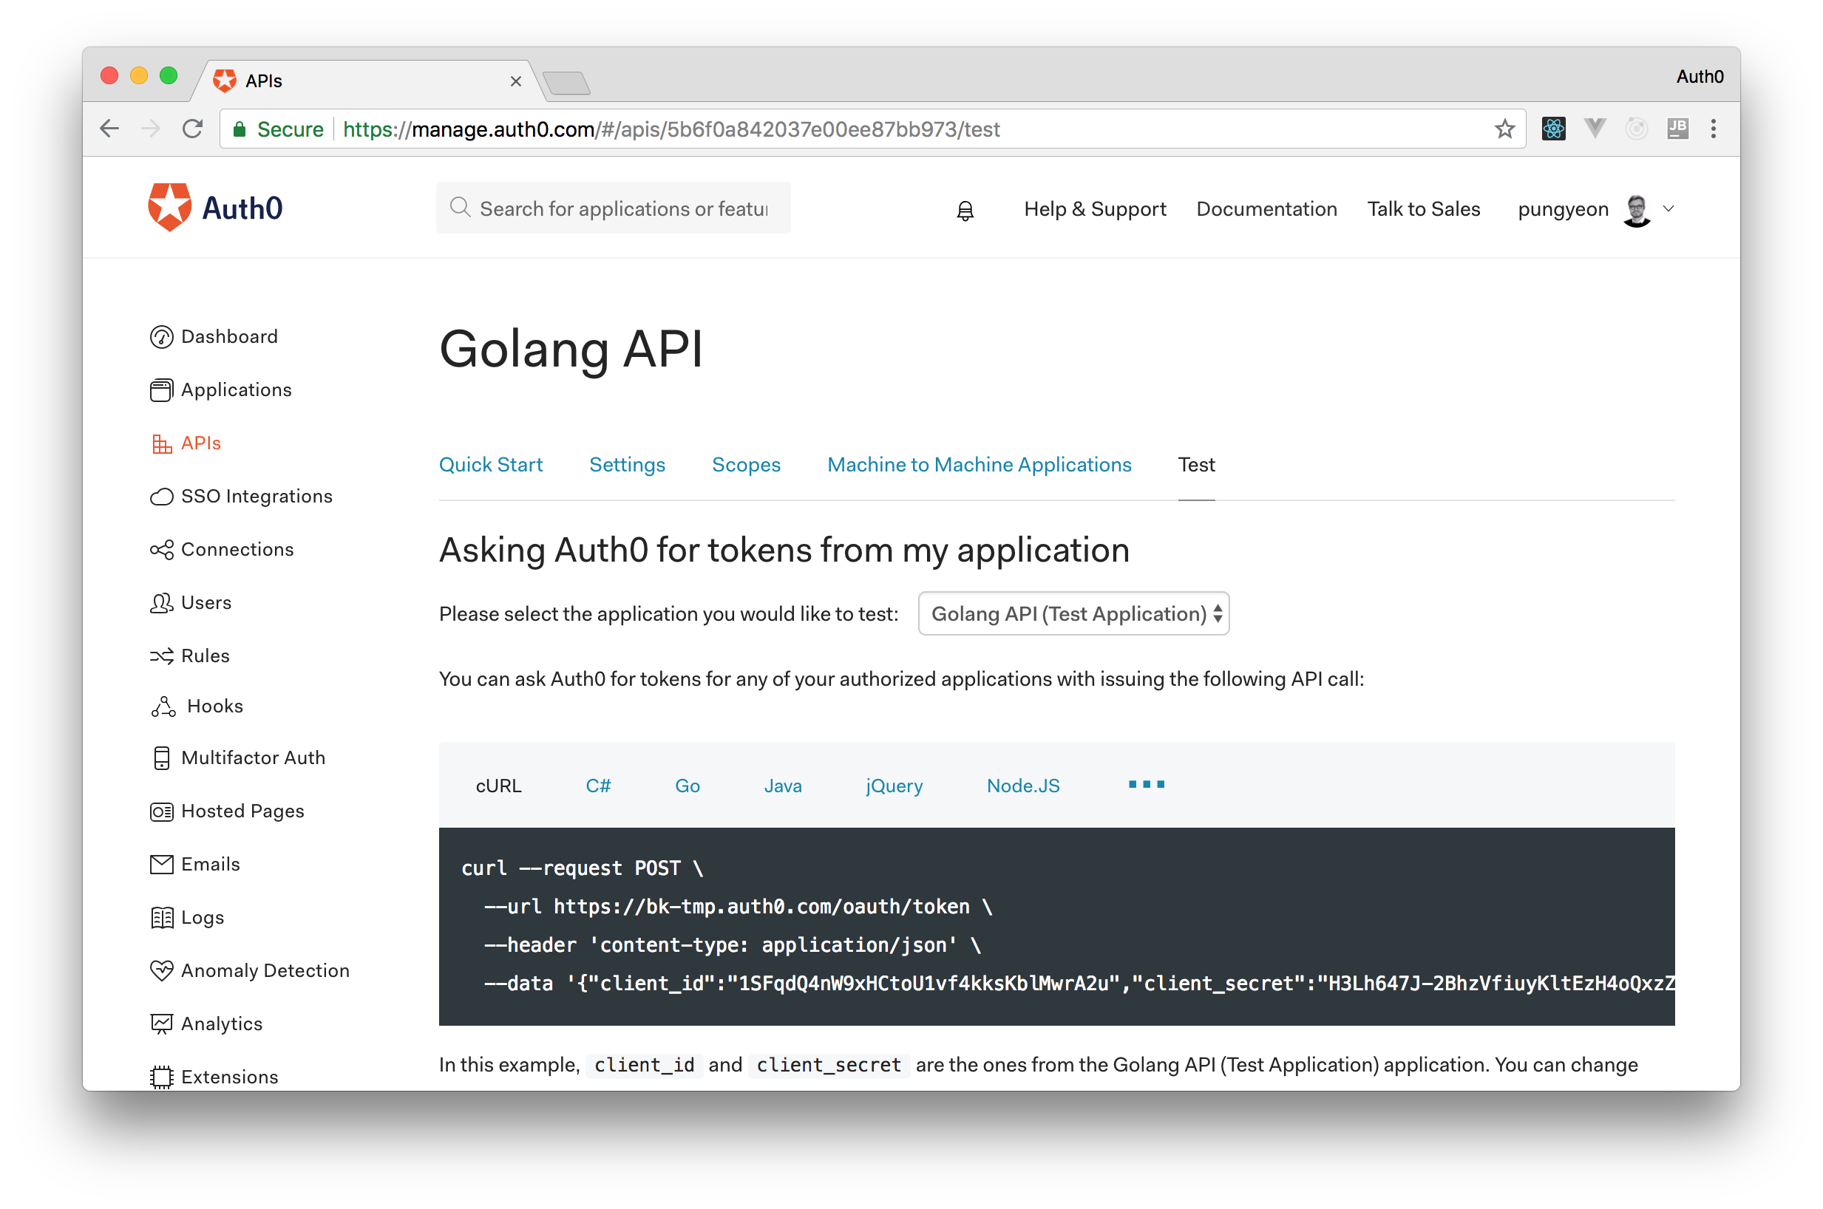
Executing this curl command will make Auth0 generate an access token that you can use to communicate with your backend API.
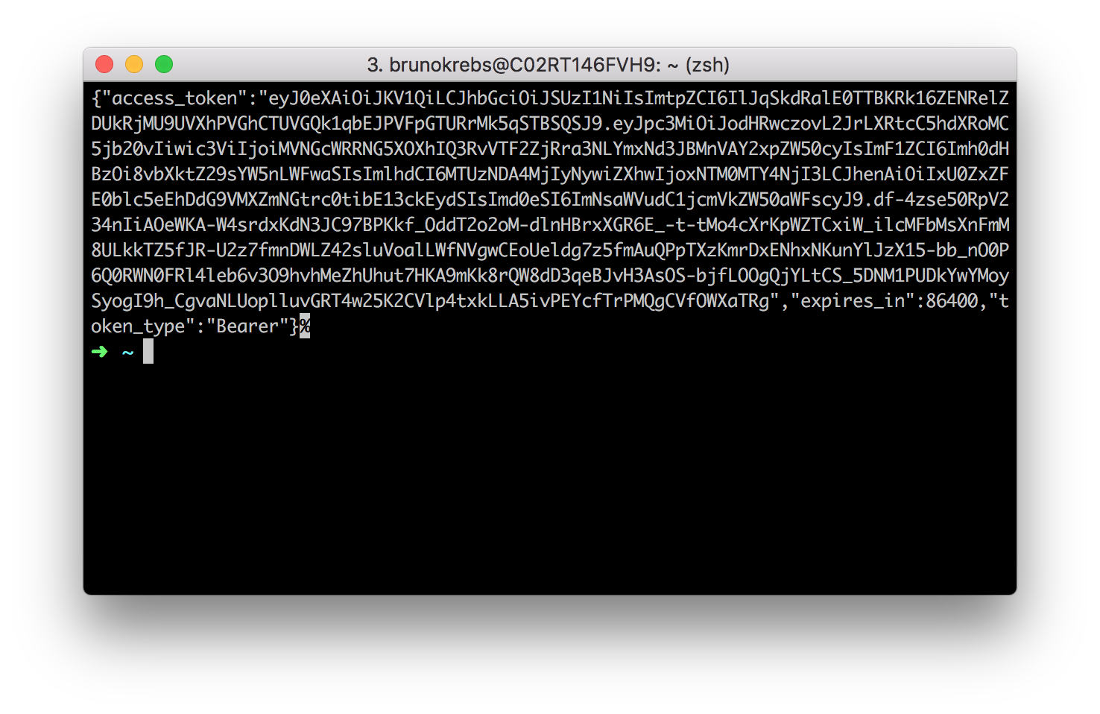
To facilitate issuing requests to your backend, you can copy the access token generated and save it in an environment variable:
ACCESS_TOKEN="eyJ0eX...WXaTRg"
After that, you can issue authenticated requests like this:
# authenticated req to add a new to-do item
curl -H 'Authorization: Bearer '$ACCESS_TOKEN localhost:3000/todo -d '{"message": "finish writing the article"}'

# authenticated req to get all to-do items
curl -H 'Authorization: Bearer '$ACCESS_TOKEN localhost:3000/todo
"I just finished building a @golang backend API for my to-do list."

Tweet This

Conclusion and Next Steps
Done! You just finished developing a secure backend API with Golang, Gin, and Auth0. The application that you created was pretty simple, just a todo list where you can add, delete, and to-do items as complete. However, the framework around your application is quite sound. You handled authentication via Auth0, which creates a very strong starting point for your application (it is important to think about security and identity management from the start).
Adding features to your application now becomes a lot easier. Once you have established a strong fundament in security, you can add different to-do lists for different users. Using a third-party security solution like Auth0 is also a great advantage because you can rest assured that this solution will keep your users' personal data safe. With a few changes here and there (such as serving your API and static files over HTTPS), you can quite confidently deploy this code to production.
I hope the first part of this series has been helpful and that it has given some insight on how easy it is to implement Auth0 as a third-party authentication service on Golang. In the second part of this series, The Front-end - Developing and Securing Angular Apps, you will learn how to implement the frontend client of your to-do list with Angular and how to integrate it with your Golang backend API.
Stay tuned!
In this series, you will learn how to build modern applications with Golang and Angular. In Part 1 - The Backend - Developing and Securing Golang APIs, you learned how to build a secure backend API with Golang to support a to-do list application. Now, in the second part, you will use Angular to develop the front-end of the to-do list app. To facilitate the identity management, you will use Auth0 both in your backend API and in your Angular app to authenticate users. If needed, you can find the final code developed throughout this article in this GitHub repository.
"I'm developing a modern application with @angular and @golang."

Tweet This

Prerequisites
For this tutorial, you will need to install Golang, Node.js, and Angular. However, as you will see, the process is quite simple. For starters, you can visit the official installation instructions provided by Golang to install the programming language.
After that, you will need to install Node.js (which comes with NPM). For that, you can follow the instructions described here.
Then, after installing Node.js and NPM, you can issue the following command to install the Angular CLI tool:
npm install -g @angular/cli
Note: By adding -g in the command above, you make NPM install the Angular CLI tool globally. That is, after issuing this command, you will have the ng command in all new sessions of your terminal.

Part 1: The Golang Backend Recap
In the first part of this series - Part 1 - The Backend - Developing and Securing Golang APIs - you have developed a secure backend API with Golang and Gin. If you have followed the previous article, you can jump to the next section. Otherwise, you can still follow this article along. However, you will have to fork and clone this GitHub repository and, after that, you will have to sign up for a free Auth0 account here so you can properly configure and run your backend API.
After signing up for Auth0, you will have to go to your Auth0 dashboard and proceed as follows:
- go to the APIs section;
- click on Create API;
- define a Name for your API (e.g., "Golang API");
- define an Identifier for it (e.g., https://my-golang-api);
- and click on the Create button (leave the Signing Algorithm with RS256).
Then, to run your API, you will have to issue the following commands:
# set env variables
export AUTH0_API_IDENTIFIER=<YOUR_AUTH0_API>
export AUTH0_DOMAIN=<YOUR_AUTH0_TENANT>.auth0.com

go run main.go
Note: You will have to replace <YOUR_AUTH0_API> with the identifier you set in your Auth0 API while creating it. Also, you will have to replace <YOUR_AUTH0_TENANT> with the subdomain you chose while creating your Auth0 account.

Developing a To-Do List Application with Angular
Now that you have your backend sorted out, you will proceed with the creation of the front-end app with Angular. This application will consist of a simple home page with a button to redirect users to the to-do list. To access this list, users will have to be authenticated.

Initializing the Angular Project
For starter, you will have to scaffold your new Angular project. You will do this in a new directory called ui inside the project root of your Golang. To create this directory and to scaffold your Angular application, you will use the Angular CLI tool. So, head to the project root of your Golang API and issue the following command:
# make sure you are on your backend project root
ng new ui
This will place a new Angular quick-start project inside the ui directory. Now, you need to go into this new directory and download all your project's dependencies. To do this, run the following commands:
# move into the ui directory
cd ui

# install all dependencies
npm install
The last command issued will look at the package.json file and see what are the dependencies defined there so it can download everything.
Then, another thing you will need to do before start writing your application is to add CDN links to Bootstrap and Font Awesome. These libraries (or UI frameworks) will help your application look a little bit better without the need of investing too much time on CSS files and icons. So, open the ./ui/src/index.html file and replace its contents with this:
<!doctype html>
<html lang="en">
<head>
<meta charset="utf-8">
<title>Auth0 Golang Example</title>
<base href="/">
<meta name="viewport" content="width=device-width, initial-scale=1">
<link rel="icon" type="image/x-icon" href="favicon.ico">
<link rel="stylesheet" href="https://stackpath.bootstrapcdn.com/bootstrap/4.1.1/css/bootstrap.min.css">
<link rel="stylesheet" href="https://use.fontawesome.com/releases/v5.1.0/css/all.css">
</head>
<body>
<app-root></app-root>
</body>
</html>
Then, the last change that you will have to do is to edit the environment files found inside the ./ui/src/environments directory. These files will act as global variables for your application and distinguish between whether you are running a local development environment or if you are running in production.
So, first, you will open the environment.prod.ts file and replace its content with this:
export const environment = {
production: true,
gateway: '',
callback: 'http://localhost:4200/callback',
domain: '<YOUR_AUTH0_TENANT>.auth0.com',
clientId: '<YOUR_AUTH0_APPLICATION_CLIENT_ID>',
audience: '<YOUR_AUTH0_API_IDENTIFIER>'
};
Then, as you will spend most of your time developing, you will have to open the environment.ts file (which is considered the config for your development environment by default) and replace its contents with this:
export const environment = {
production: false,
gateway: 'http://localhost:3000',
callback: 'http://localhost:4200/callback',
domain: '<YOUR_AUTH0_TENANT>.auth0.com',
clientId: '<YOUR_AUTH0_APPLICATION_CLIENT_ID>',
audience: '<YOUR_AUTH0_API_IDENTIFIER>'
};
Now, as you already created your Auth0 API in the last part of this series, you can replace <YOUR_AUTH0_API_IDENTIFIER> in both files (for example, you can replace this placeholder with https://my-golang-api). In the next section, you will create an Auth0 Application and then you will be able to replace the other placeholders used above with your own Auth0 values.

Creating an Auth0 Application
Now that you have scaffolded your Angular application, you will need to register it at Auth0 so you can properly offer authentication and authorization features to your users. So, head to the Applications section of your Auth0 dashboard and hit the Create Application button. When Auth0 shows you the form to create your Application, fill in the following information:
- Name: You can name your application with anything that might help you identify it in the future. For example, "To-Do Angular App".
- Application Type: For this one, you will have to choose the Single Page Web Applications option, as this is exactly what you are going to create.
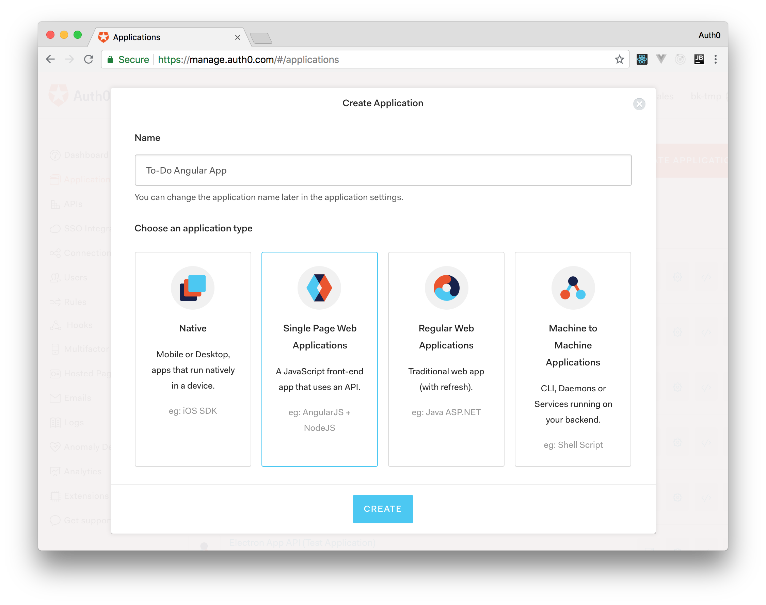
Then, when you hit the Create button, Auth0 will redirect you to the Quick Start section of your new application. From there, you will have to move to the Settings section so you can finish configuring your application.
So, now that you are in the Settings section, search for the Allowed Callback URLs field and insert http://localhost:4200/callback there. You need this configuration because, after the authentication process, Auth0 will only redirect users to the URLs listed in this field (this is a security measure that Auth0 puts in place). After that, you can hit Save to persist the change and leave this page open. You will copy values from it in a moment.
Now, back into your project, open both the environment.prod.ts and environment.ts files and replace the placeholders as follows:
- <YOUR_AUTH0_TENANT>: In the place of this placeholder, you will have to insert the Auth0 subdomain you chose while creating your account. In the end, you will have something similar to domain: 'pungyeon.auth0.com'.
- <YOUR_AUTH0_APPLICATION_CLIENT_ID>: In the place of this placeholder, you will have to insert the value that Auth0 shows in the Client ID field of your new application. This will be a random string similar to z4Z09pinlP93aqTVaIBkCzzQ9vjZ6eEX.
Note: You have to make sure you replace both placeholders on both files. Otherwise, you might end up with a buggy sign-in feature.

Creating the Welcome Component
Ok, after configuring the environments of your Angular app, you are ready to start developing it. So, for starters, you will make a new Angular component to show the home page of your app. To do so, you will use Angular CLI one more time:
# make sure you are executing this from the ui directory
ng g c home
Note: The command above is the shortened version of ng generate component home.
This command will create a new directory insideapp, named home, and it will place four files in it:
- home.component.css: This is the CSS file that will allow you to style your new component.
- home.component.html - This is the HTML representation of your new component.
- home.component.spec.ts - This is where you would write automated tests for your component.
- home.component.ts - This is the main piece of your component.
Note: The CLI will also automatically add this newly created class to our app.module.ts, in the @NgModule.declarations section.
To keep things simple, your home page will be extremely simple. Actually, the only file you will have to change is the home.component.html one. So, open it and replace its content with this:
<div class="c-block">
<h2>Welcome Home!</h2>
<a class="btn btn-primary" routerLink="/todo">Show Todo List</a>
</div>
In this case, all you are doing is creating a title and a link that will redirect users to the /todo route. You haven't determined the routing yet, so that won't work right now. You will get to that soon.

Creating the To-Do Component
After creating the home page, you can focus on creating the component that will provide the to-do list functionality. So, the first step here will be using Angular CLI to create the component:
# make sure you are executing this from the ui directory
ng g c todo
For this article, you will split the to-do functionality into two things: a component (the one you just created) and a service. The service will be in charge of issuing HTTP requests to your Golang backend API. After creating this service, your component will be able to use it to communicate with your backend so it can display the correct information retrieved by the service.
So, to create your service, issue the following command:
# make sure you are executing this from the ui directory
ng g s todo
Then, open the todo.service.ts file and replace its content with this:
import { Injectable } from '@angular/core';
import { HttpClient } from '@angular/common/http';
import { environment } from '../environments/environment';

@Injectable()
export class TodoService {
constructor(private httpClient: HttpClient) {}

getTodoList() {
return this.httpClient.get(environment.gateway + '/todo');
}

addTodo(todo: Todo) {
return this.httpClient.post(environment.gateway + '/todo', todo);
}

completeTodo(todo: Todo) {
return this.httpClient.put(environment.gateway + '/todo', todo);
}

deleteTodo(todo: Todo) {
return this.httpClient.delete(environment.gateway + '/todo/' + todo.id);
}
}

export class Todo {
id: string;
message: string;
complete: boolean;
}
In the new version of this file, you are stating that you want to export your TodoService class, thereby making it available for other components to use. On the initialization of this class, you are defining that it needs an instance of HttpClient. Then, you are defining four methods to issue HTTP requests to your backend API: getTodoList, addTodo, completeTodo, and deleteTodo.
Note: The @Injectable() decorator ensures this class is available to Injector for creation.
Also, at the bottom of the file, you are exporting a class called Todo, which is a mirror of the todo structure you used in the backend. You use this class throughout your project to ensure a more accurate description in code of what you are sending and receiving from your backend.
One important thing to notice in this service is that you are using the environment.gateway variable to determine where your HTTP calls are headed. This makes running the same code base in different environments easier.
Now, to take your new service out for a spin, you can open the todo.component.ts file and replace its code with this:
import { Component, OnInit } from '@angular/core';
import { TodoService, Todo } from '../todo.service';

@Component({
selector: 'app-todo',
templateUrl: './todo.component.html',
styleUrls: ['./todo.component.css']
})
export class TodoComponent implements OnInit {

activeTodos: Todo[];
completedTodos: Todo[];
todoMessage: string;

constructor(private todoService: TodoService) { }

ngOnInit() {
this.getAll();
}

getAll() {
this.todoService.getTodoList().subscribe((data: Todo[]) => {
this.activeTodos = data.filter((a) => !a.complete);
this.completedTodos = data.filter((a) => a.complete);
});
}

addTodo() {
var newTodo : Todo = {
message: this.todoMessage,
id: '',
complete: false
};

this.todoService.addTodo(newTodo).subscribe(() => {
this.getAll();
this.todoMessage = '';
});
}

completeTodo(todo: Todo) {
this.todoService.completeTodo(todo).subscribe(() => {
this.getAll();
});
}

deleteTodo(todo: Todo) {
this.todoService.deleteTodo(todo).subscribe(() => {
this.getAll();
})
}
}
Starting from the export class TodoComponent, what you have is three properties that respectively contain your activeTodos list, your completedTodos list, and a todoMessage that will hold data inputted by users. Then, you have the constructor of your component, which is expecting a TodoService instance and that stores it as a private property called todoService.
Then, the first function of your component, ngOnInit, is a built-in standard of Angular and derives from the interface OnInit. Essentially, the implementation of the OnInit interface will wait for the component to be loaded before executing the ngOnInit function. Then, ngOnInit will retrieve data from your backend with the help of the getAll method. This method, will invoke the todoService.getTodoList function. As you know, this function is an HTTP call to your backend to get all of your todo items.
The HttpClient in Angular does not return with the response but, rather, with an Observable. Essentially, this is an object that you can 'subscribe' so, whenever new data is retrieved, you get notified and can act in some way or another. In this scenario, you are using the observable more like a callback, but it's strongly recommended reading up on RxJs and Observables. They are super useful in modern JavaScript.
So, the getAll function subscribes to data from the todoService.getTodoList and, whenever data is received, it assigns all active todos to your activeTodos property (by filtering out any complete items) and do the opposite for the completedTodos property.
The rest of your class methods are corresponding to your TodoService, which in turn was mapped up against your backend API. In other words, you have functions to add, complete, delete, and update your to-do lists.
Now that your TypeScript logic is done, you can open the todo.component.html file and replace its contents with this:
<h2>Todos</h2>
<table class="table">
<thead>
<tr>
<th>ID</th>
<th>Description</th>
<th>Complete</th>
</tr>
</thead>
<tbody>
<tr *ngFor="let todo of activeTodos">
<td>{{todo.id}}</td>
<td>{{todo.message}}</td>
<td>
<button *ngIf="!todo.complete" class="btn btn-secondary" (click)="completeTodo(todo)">
<i class="fa fa-check"></i>
</button>
<button *ngIf="todo.complete" class="btn btn-success" disabled>
<i class="fa fa-check"></i>
</button>
<button class="btn btn-danger" (click)="deleteTodo(todo)">
<i class="fa fa-trash"></i>
</button>
</td>
</tr>
</tbody>
</table>
<h3>Completed</h3>
<table class="table">
<thead>
<tr>
<th>ID</th>
<th>Description</th>
<th>Complete</th>
</tr>
</thead>
<tbody>
<tr *ngFor="let todo of completedTodos">
<td>{{todo.id}}</td>
<td>{{todo.message}}</td>
<td>
<button *ngIf="!todo.complete" class="btn btn-secondary" (click)="completeTodo(todo)">
<i class="fa fa-check"></i>
</button>
<button *ngIf="todo.complete" class="btn btn-success" disabled>
<i class="fa fa-check"></i>
</button>
<button class="btn btn-danger" (click)="deleteTodo(todo)">
<i class="fa fa-trash"></i>
</button>
</td>
</tr>
</tbody>
</table>
<input placeholder="description..." [(ngModel)]="todoMessage">
<button class="btn btn-primary" (click)="addTodo()">Add</button>
Basically, your to-do page consists of two tables that use the *ngFor directive to iterate over all the to-do items in activeTodos and completedTodos. These tables contain the id and message of the to-do items, as well as two buttons that allow users to complete and delete items. Also, this page indicates whether the to-do items are completed or not. This happens in the usage of *ngIf directives. If the todo.complete property is false, this page shows an active green button and, if the todo is already completed, it shows a grey disabled button.
At the very bottom of this HTML page, you have an input text and a button that, when clicked, triggers the addTodo function. This is what gives your users the possibility of adding new to-do items. The input content is mapped to the todoMessage property via the ngModel directive. This directive works like a two-way data binding, meaning that the property is tied to the input element and the element is tied to the variable. In other words, should one change so will the other.
Then, to have a component that looks good, you can open the todo.component.css and insert the following code:
button {
width: auto;
margin: 5px;
}

td {
vertical-align: unset;
}
If you were to spin up your project now, none of your hard work would show. That happens because you are not routing your clients anyway and, even if you were, they are not authenticated to get the to-do list from your backend. In the next section, you address both issues.

Setting up Routing and Securing Angular with Auth0
For starters, you will have to install auth0-js as a dependency to your project:
# from the ui directory, run:
npm install --save auth0-js
Then, you will have to create a service to handle the authentication process. To do this, use Angular CLI as follows:
ng g s auth
Now that you have your AuthService created, open its file (auth.service.ts) and replace its code with this:
import { Injectable } from '@angular/core';
import { environment } from 'src/environments/environment';
import { Router } from '@angular/router';

import * as auth0 from 'auth0-js';

(window as any).global = window;

@Injectable()
export class AuthService {
constructor(public router: Router) {}

access_token: string;
id_token: string;
expires_at: string;

auth0 = new auth0.WebAuth({
clientID: environment.clientId,
domain: environment.domain,
responseType: 'token id_token',
audience: environment.audience,
redirectUri: environment.callback,
scope: 'openid'
});

public login(): void {
this.auth0.authorize();
}

public handleAuthentication(): void {
this.auth0.parseHash((err, authResult) => {
if (err) console.log(err);
if (!err && authResult && authResult.accessToken && authResult.idToken) {
window.location.hash = '';
this.setSession(authResult);
}
this.router.navigate(['/home']);
});
}

private setSession(authResult): void {
// Set the time that the Access Token will expire at
const expiresAt = JSON.stringify((authResult.expiresIn * 1000) + new Date().getTime());
this.access_token = authResult.accessToken;
this.id_token = authResult.idToken;
this.expires_at = expiresAt;
}

public logout(): void {
this.access_token = null;
this.id_token = null;
this.expires_at = null;
// Go back to the home route
this.router.navigate(['/']);
}

public isAuthenticated(): boolean {
// Check whether the current time is past the
// Access Token's expiry time
const expiresAt = JSON.parse(this.expires_at || '{}');
return new Date().getTime() < expiresAt;
}

public createAuthHeaderValue(): string {
return 'Bearer ' + this.access_token;
}
}
As you can see, you have the familiar @Injectable() decorator that makes this service injectable into other components. Then, you define three string properties and a single auth0.WebAuth object. This object is what is used for authenticating against Auth0. As such, you will need to use the information from your environment files with this object to send your users to Auth0 and to inform which application they are trying to get access to.
Your login function is quite simple looking but, essentially, this will initialize the authentication process on Auth0. If the user is authenticated, Auth0 will send them to the specified callback location with a tailing hash on the URL. Then, auth0-js will parse this hash with the parseHash function. If everything goes ok, your code will call the setSession function which will set three properties with the appropriate values: access_token, id_token, and expires_at.
The lougout function resets all tokens from memory and the isAuthenticated method just returns whether the token has expired or not. You will use this information later while getting an authentication status of your user.
Lastly, you have the createAuthHeaderValue function, which returns a string in the form of an Authorization bearer header.
Now you need to create the callback component, which will be done like the other components:
# from the ui directory
ng g c callback
After creating it, change the content of the callback.component.ts file with this:
import { Component, OnInit } from '@angular/core';
import { AuthService } from '../auth.service';

@Component({
selector: 'app-callback',
templateUrl: './callback.component.html',
styleUrls: ['./callback.component.css']
})
export class CallbackComponent implements OnInit {

constructor(private auth: AuthService) { }

ngOnInit() {
this.auth.handleAuthentication();
}
}
All you are doing here is to invoke the handleAuthentication method of your authentication service once the component is initialized. As you learned, this function parses the URL hash and redirects users to the /home route.
Once you have set your authentication session with your callback component, you will need to make sure that all future requests include the token retrieved from Auth0 in the Authorization header. To do this, you will create an Angular interceptor.
So, create a new file called token.interceptor.ts under the ./src/app/ directory and insert the following code into it:
import { Injectable } from '@angular/core';
import { HttpInterceptor, HttpRequest, HttpHandler, HttpEvent } from '@angular/common/http';
import { AuthService } from './auth.service';
import { Observable } from 'rxjs/internal/Observable';

@Injectable()
export class TokenInterceptor implements HttpInterceptor {
constructor(public auth: AuthService) {}
intercept(request: HttpRequest<any>, next: HttpHandler): Observable<HttpEvent<any>> {
request = request.clone({
setHeaders: {
Authorization: this.auth.createAuthHeaderValue()
}
});
return next.handle(request);
}
}
This interceptor service intercepts (of course) all of the outgoing HTTP requests and add an authentication header if a token is available. To do this, this interceptor implements HttpInterceptor, which has the constraint of needing the intercept function. This function is then invoked upon an HTTP request.
Much like the middleware in your backend, this will return a next.handle, which basically forwards the modified request to the original destination. The intercept function, in this case, is quite simple. You are cloning the incoming request to add an Authorization header. Remember, if no token is found, nothing is added. Once the request has been altered, this interceptor invokes the next.handle passing the modified request.
The reason why you are creating this interceptor is to ensure that all of your requests contain the appropriate Authorization header. Centralizing the header management like this makes it easier in the future. If changes are made to authentication or if new requests are added to the project, no changes are needed.
To include this in your app.module.ts file, you will need to add the following object to the providers array:
// ... other imports ...
import {HTTP_INTERCEPTORS} from '@angular/common/http';
import {TokenInterceptor} from './token.interceptor';

@NgModule({
// ... declarations and imports ...
providers: [{
provide: HTTP_INTERCEPTORS,
useClass: TokenInterceptor,
multi: true
}],
// ... bootstrap ...
})
export class AppModule { }
Almost there! Now, you need to change your app.component.ts page to include routing and actually define your routes. You can start by creating the routes. So, create a new file called app-routing.module.ts inside ./src/app and insert the following code into it:
import { HomeComponent } from './home/home.component';
import { RouterModule, Routes } from "@angular/router";
import { NgModule } from '@angular/core';
import { AuthGuardService } from './auth-guard.service';
import { CallbackComponent } from './callback/callback.component';
import { TodoComponent } from './todo/todo.component';

const routes: Routes = [
{ path: '', redirectTo: 'home', pathMatch: 'full' },
{ path: 'home', component: HomeComponent },
{ path: 'todo', component: TodoComponent, canActivate: [AuthGuardService] },
{ path: 'callback', component: CallbackComponent }
];

@NgModule({
imports: [ RouterModule.forRoot(routes) ],
exports: [ RouterModule ]
})
export class AppRoutingModule { }
The only important aspect of this file is your routes constant. This constant defines an array of paths. The root ('') path will redirect to your HomeComponent, the todo path will redirect to the TodoComponent, and callback to the CallbackComponent. However, as you will notice, the todo path is slightly different in that it is using the canActivate property and using AuthGuardService. Well... you haven't written the AuthGuardService yet. So, you can do that right away.
The canActivate property basically asks a service (which implements CanActivate) for a boolean response of whether or not a user is able to activate this page. To create this service, execute the following command:
# from the ui directory
ng g s auth-guard
Then, open the auth-guard.service.ts file and replace its code with this:
import { CanActivate, Router } from '@angular/router';
import { Injectable } from '@angular/core';
import { AuthService } from './auth.service';

@Injectable()
export class AuthGuardService implements CanActivate {
constructor(private auth: AuthService, private router: Router) {}

canActivate(): boolean {
if (this.auth.isAuthenticated()) {
return true;
}

this.auth.login()
}
}
This is actually a really simple service. This service simply calls the AuthService asking whether the current user is authenticated or not. If the user is authenticated, it returns true, forwarding the user to the request route. If not, it will invoke the auth.login function, which will send your user to the Auth0 login page.
Now, to make sure all components, services, interceptors, and routers are included in your app, open the app.module.ts file and update it as follows:
import { BrowserModule } from '@angular/platform-browser';
import { NgModule } from '@angular/core';

import { AppRoutingModule } from './app-routing.module';
import { HttpClientModule, HTTP_INTERCEPTORS } from '@angular/common/http';

import { AppComponent } from './app.component';
import { HomeComponent } from './home/home.component';
import { AuthGuardService } from './auth-guard.service';
import { AuthService } from './auth.service';
import { CallbackComponent } from './callback/callback.component';
import { TodoComponent } from './todo/todo.component';
import { TodoService } from './todo.service';
import { FormsModule } from '@angular/forms';
import { TokenInterceptor } from './token.interceptor';

@NgModule({
declarations: [
AppComponent,
HomeComponent,
CallbackComponent,
TodoComponent
],
imports: [
AppRoutingModule,
BrowserModule,
FormsModule,
HttpClientModule
],
providers: [AuthGuardService, AuthService, TodoService, {
provide: HTTP_INTERCEPTORS,
useClass: TokenInterceptor,
multi: true
}],
bootstrap: [AppComponent]
})
export class AppModule { }
For the routing, as you can see, you have imported the AppRoutingModule class. So, now you can finally include this routing to your application, which will be the last part of this tutorial.

Putting it all together
So, it's been a long while, but now you are finally going to add routing to your Angular application. Also, you will create a little menu bar for navigation and to allow users to log out. First, you need to edit the app.component.ts file to add AuthService to it:
import { Component } from '@angular/core';
import { AuthService } from './auth.service';

@Component({
selector: 'app-root',
templateUrl: './app.component.html',
styleUrls: ['./app.component.css']
})
export class AppComponent {

constructor(public auth: AuthService) {}
}
Next, you need to edit the app.component.html file and set it with the following code:
<nav class="navbar navbar-default">
<div class="container-fluid">
<div class="navbar-header">
<a class="navbar-brand" href="#">Auth0 - Angular</a>
<button
class="btn btn-light btn-margin"
routerLink="/">
Home
</button>
<button
class="btn btn-light btn-margin"
*ngIf="!auth.isAuthenticated()"
(click)="auth.login()">
Log In
</button>
<button
class="btn btn-light btn-margin "
*ngIf="auth.isAuthenticated()"
(click)="auth.logout()">
Log Out
</button>
</div>
</div>
</nav>
<div class="container-fluid">
<div class="row">
<div class="col-sm">
<router-outlet></router-outlet>
</div>
</div>
</div>
Here, you are creating a new navigation bar including functions from AuthService to allow users to log in and log out. Underneath this navigation bar, you are including the router-outlet component inside a div.container-fluid element (this is part of Bootstrap). The outlet element is what tells Angular to ask to the routing module which page it should load.
It's a very common practice to include the navigation bar together with the routing component. This ensures that the menu is present on all of your pages, without having to reload the navigation bar for each individual page.
The final touch to your Angular project will be adding some style to it. So, open the styles.css file and insert the following CSS rules:
.c-block {
width: 50%;
margin-left: 50%;
transform: translateX(-50%);
text-align: center;
}

button {
margin: 5px;
border-radius: 5px;
width: 200px;
}

img {
margin: 20px;
}

h3 {
margin-top: 30px;
}
Finally, you are done developing your Angular project! Your to-do list is now ready for prime time. So, to test your Angular app, go to your terminal and run this:
# from the ui directory
ng serve
Then, open a new terminal window and go to the project root. There, you will just need to tweak one more configuration. As you backend runs on a different "domain" (http://localhost:3000) than your Angular app (http://localhost:4200) you will have to enable Cross-Origin Resource Sharing (CORS) in your Golang backend API.
To do this, you will have to update the main.go file as follows:
// ... package definition, import statements, and var definitions ...

func main() {
setAuth0Variables()
r := gin.Default()
r.Use(CORSMiddleware())

// ... the rest of the function ...
}

// ... setAuth0Variables, authRequired, terminateWithError functions ...

func CORSMiddleware() gin.HandlerFunc {
return func(c *gin.Context) {
c.Writer.Header().Set("Access-Control-Allow-Origin", "*")
c.Writer.Header().Set("Access-Control-Allow-Headers", "Content-Type, Content-Length, Accept-Encoding, X-CSRF-Token, Authorization, accept, origin, Cache-Control, X-Requested-With")
c.Writer.Header().Set("Access-Control-Allow-Methods", "DELETE, GET, OPTIONS, POST, PUT")

if c.Request.Method == "OPTIONS" {
c.AbortWithStatus(204)
return
}

c.Next()
}
}
From there, execute the following commands:
# set env variables
export AUTH0_API_IDENTIFIER=<YOUR_AUTH0_API>
export AUTH0_DOMAIN=<YOUR_AUTH0_TENANT>.auth0.com

go run main.go
Note: You have to replace <YOUR_AUTH0_API> with the identifier you set in your Auth0 API while creating it. Also, you have to replace <YOUR_AUTH0_TENANT> with the subdomain you chose while creating your Auth0 account.
Now, if you open http://localhost:4200 in a web browser, you will see the following screen:
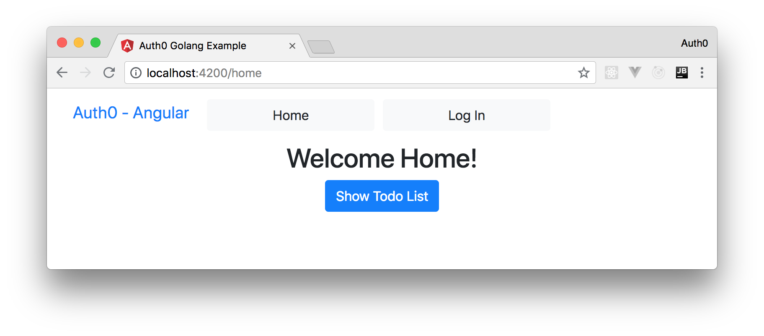
Then, if you click on Log In or on Show Todo List, your app will redirect you to Auth0 so you can authenticate. After authenticating, Auth0 will redirect you back to your app so you can proceed using it.
When properly logged in, you can click on Show Todo List and start using your app.
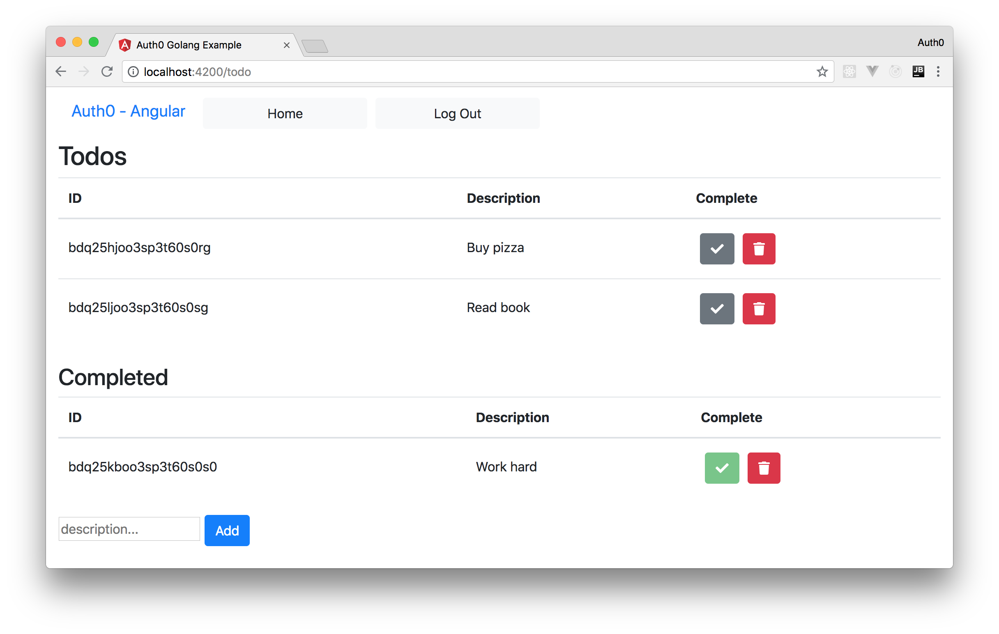
Fun, right?
"I just finished building a full-stack app with @golang and @angular."

Tweet This

Conclusion
So, you finally made it! The application that you created was pretty simple. Just a to-do list where you can add, delete, and complete some to-do items. However, the framework around your application is quite sound. You have handled authentication via Auth0, creating a very strong starting point for your application, by starting with security in mind.
Adding features to your application becomes a lot easier once you have established a strong fundament in security. You can add different to-do lists for different users relatively easily without having to worry about how this will affect your application down the road. Using a third-party security solution like Auth0 is also a great advantage because you can rest assured that this solution will keep your application data safe. With a few changes here and there (such as serving our API and static files over HTTPS), you could quite confidently deploy this code to production.
I hope this series has been helpful and that it has given some insight on how easy it is to implement a full-stack application with Golang and Angular. Feedback and questions are very welcome!
- 
- 
- 

More like this
- 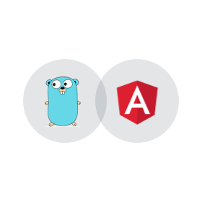

Golang

Golang & Angular Series - Part 1: Developing and Securing Golang APIs
- 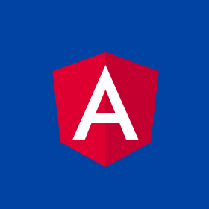

Angular

Create Secure Angular Apps in the Cloud with StackBlitz and Auth0

