COMP229 - Web Application Development
Assignment Submission: Portfolio Backend API & Authentication
Student Name: Sarah Cleroux | Course: COMP229 Web App Development
GitHub Repository:  https://github.com/clerous90-design/COMP229--Portfolio | Date: October 18, 2026

Part I: Server Setup & Database Connection
The Node.js and Express backend application was initialized with environment variable support via .env. The server successfully established a connection with MongoDB Atlas and served the primary API root endpoint.
- Server Initialization: Express server started on port 3000 using Nodemon.
- Database Connection: Successfully connected to the MongoDB Atlas 'Portfolio' database.
- Root Endpoint Verification: GET request to http://localhost:3000/ returned welcome JSON message.

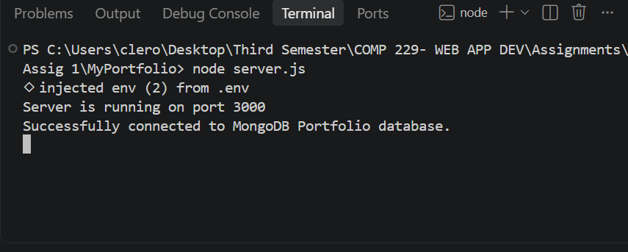
Figure: Server & MongoDB Connection Log — Terminal output demonstrating server startup on port 3000 and successful MongoDB Portfolio database connection.

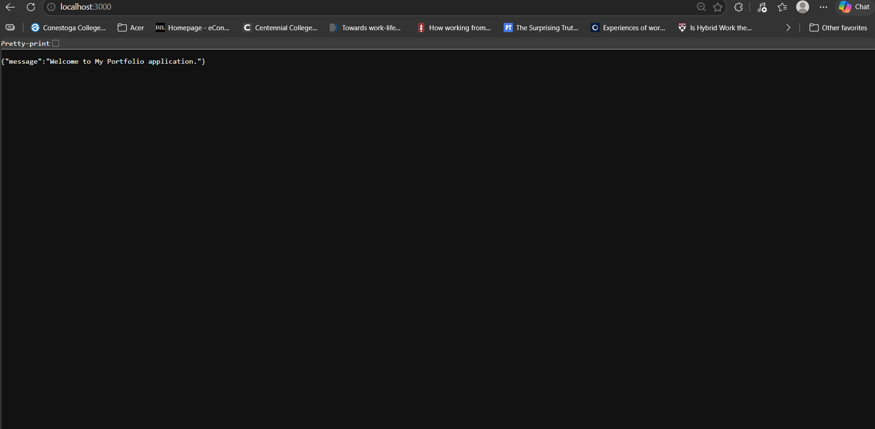
Figure: Root API Endpoint Response — Browser output verifying response from http://localhost:3000/ returning JSON welcome message.

Part II & III: API Endpoints & Thunder Client Testing
All four primary controller routes (Contacts, Projects, Qualifications, and Users) were thoroughly tested using Thunder Client to confirm full CRUD operations and data persistence in MongoDB.
- Contacts API (/api/contacts)
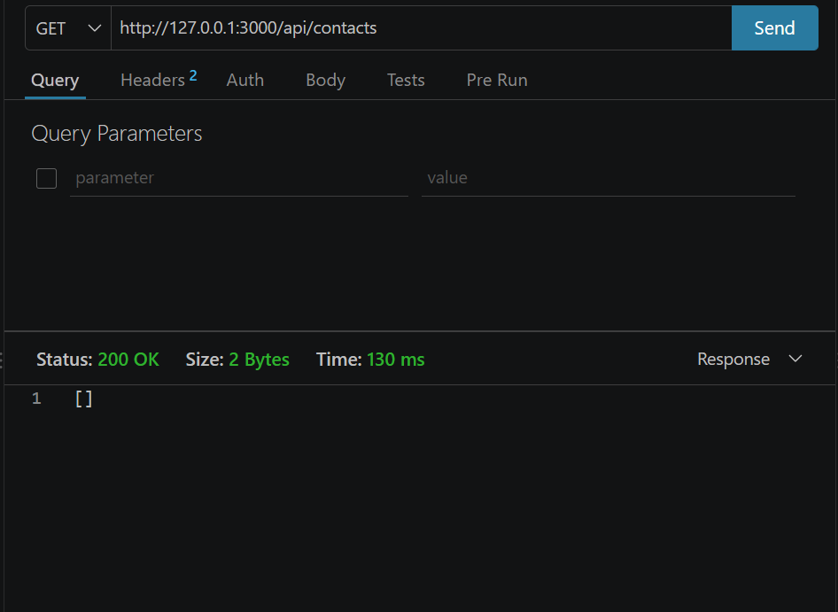
Figure: GET /api/contacts (Initial State) — Querying contacts before record creation, returning an empty JSON array [].
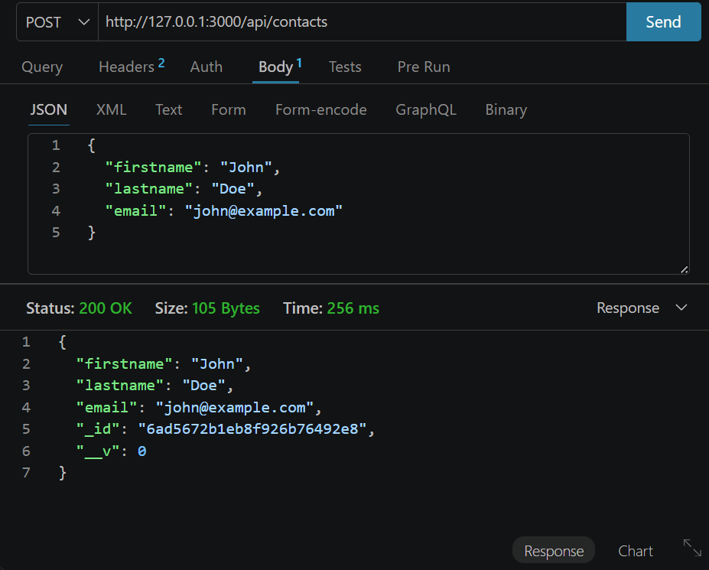
Figure: POST /api/contacts (Create Contact) — Submitting a POST request to create a new contact record ('John Doe', 'john@example.com'), returning status 200 OK with MongoDB generated _id.

- Projects API (/api/projects)
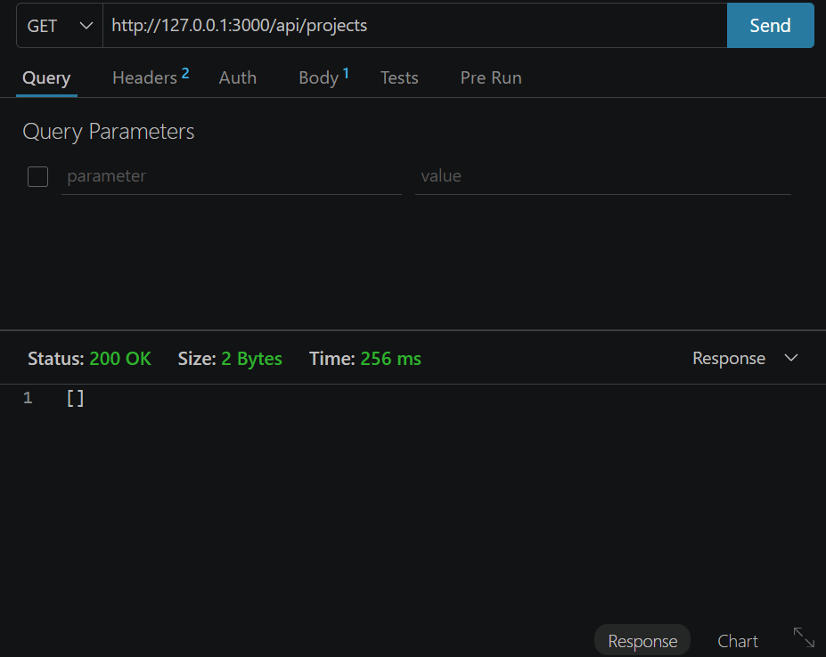
Figure: GET /api/projects (Initial State) — Querying projects endpoint prior to adding entry.

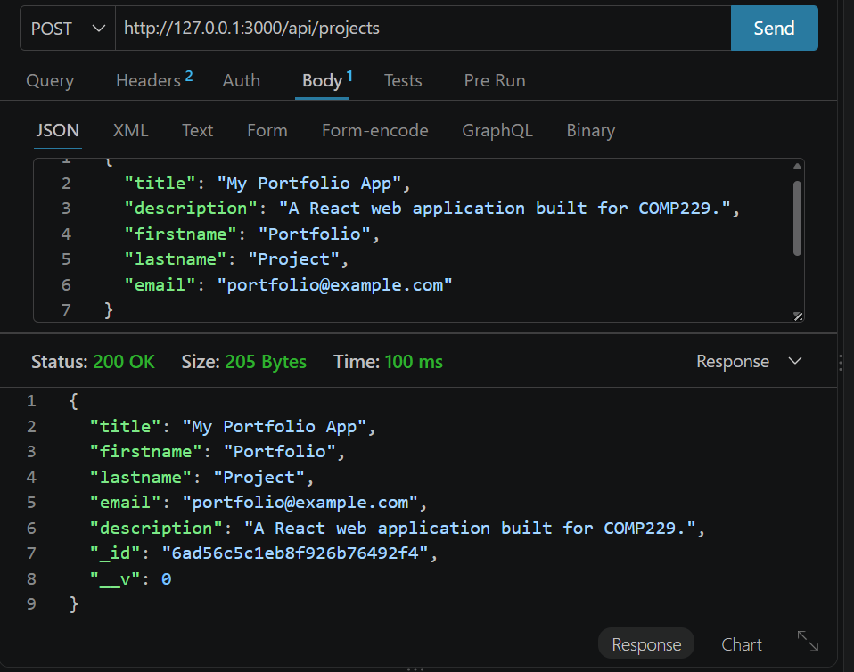
Figure: POST /api/projects (Create Project) — Successfully posting portfolio web application details ('My Portfolio App') to the database.

- Qualifications API (/api/qualifications)
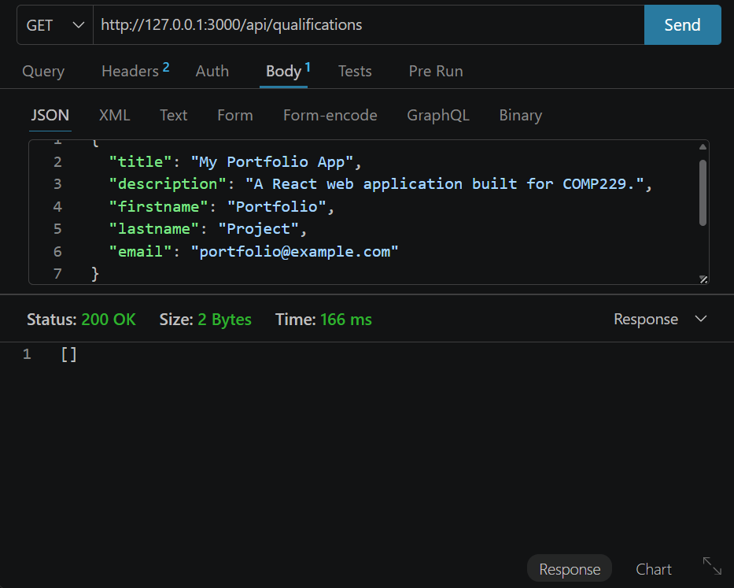
Figure: POST /api/qualifications (Initial Entry) — Submitting test qualification details to the database.

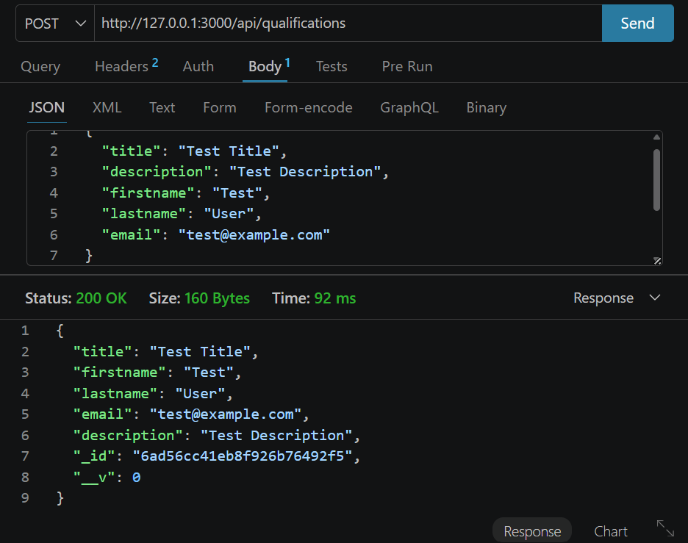
Figure: POST /api/qualifications (Web Development Certificate) — Creating an entry for 'Web Development Certificate' (Completed COMP229).

- Users API (/api/users)
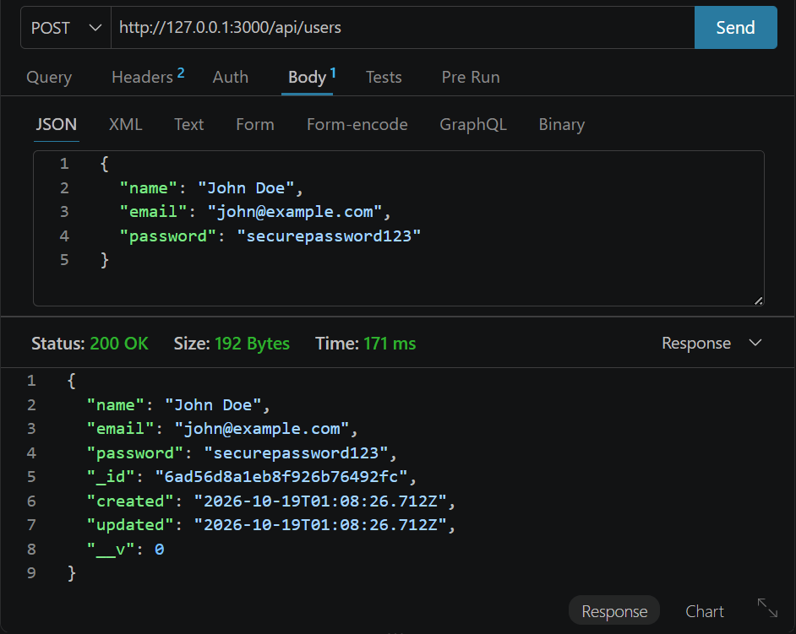
Figure: POST /api/users (Create User) — Creating a user record satisfying schema validation requirements (name, email, password), returning 200 OK and timestamps.

Part IV: JWT Authentication & Protected Routes
To satisfy Part IV requirements (10 Marks), backend authentication was implemented using JSON Web Tokens (JWT) based on the Week 6 lecture material:
- Auth Controller (app/controllers/auth.controller.js): Handles user signin by checking credentials and issuing a signed JWT token valid for 1 hour. Provides signout response for client-side session clearing.
- Auth Middleware (app/middlewares/auth.middleware.js): Intercepts requests on protected routes, extracts the token from headers (x-access-token or Bearer scheme), and verifies cryptographic validity.
- Protected Routes: Secured sensitive data modification routes (POST, PUT, DELETE across controllers) with the verifyJWT middleware.

GitHub Repository Verification

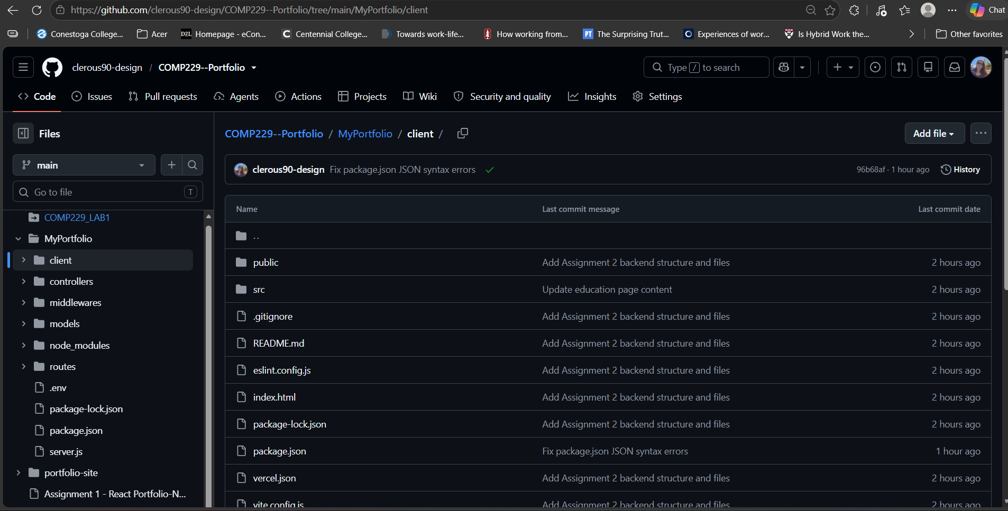
Figure: GitHub Repository Structure — GitHub view of clerous90-design/COMP229--Portfolio containing client, controllers, middlewares, models, and routes folders.

