

Dashboard Mockup
New Dashboard Design v3.0

June 2019

Overview

With Administrators under much more pressure and higher workloads, they require a much more meaningful and high level data delivered to them to allow for quicker assessments of system and application statuses. GigaCloud needs to approach this with a redesigned dashboard with this in mind. An Administrator should be able to glance at the GigaCloud dashboard and ascertain the status of these three core areas easily: Security, System and Activity. There should be a means to reset alerts in these three core areas of GigaCloud directly from the dashboard, and on reset the dashboard should automatically refresh to indicate the updated status.
Additional widgets with a variety of diagnostic tools and higher level reporting should be included. The widgets and the arrangement of them on the dashboard should be customizable for the Super User, Tenant Administrators, and Delegated Tenant Administrators, and respective preferences should be saved per Username in the GigaCloud database. Widget parameters that have been customized by users should be saved by cookie.
Goals
The new dashboard goals are as follows:
- Provide a rich dashboard experience, with user friendly customization, eye catching alerts, colorful styling, and a diverse selection of data point reporting for more granular, user specific dashboard reporting.
- Include a high level Cloud status section for Alert summaries.
- Include a method to reset Alerts from the dashboard.
- Use GT styling and colors where appropriate.
- Use default widgets containing more data rich controls such as pie and donut charts, real-time activity charting, and high level table data points.
- Provide a method for the user to rearrange and add, or remove, widgets from the user’s dashboard.
- Where appropriate, allow report parameter configuration and cookie it for future visits.
- Save dashboard configurations by user profile.
- Tie in data points and components with the GigaCloud reporting redesign.
- Include a Demo mode for sales with fake data.
Mockups
Below are mockups and descriptions of proposed design of the new dashboard. 90% of the mockups are using the actual libraries in a test project with fake data. This document is divided into the following areas:
- Dashboard status panels
- Widgets and configuration
- Dashboard customization
- Appendix
Supporting Documents
- New Dashboard Use Cases – In-progress….
- Dashboard Design Document Not started…

Dashboard Status Panels

On the top of the dashboard there should be panels divided into three categories of alerts. These categories are explained below:
Security | Health | Activity
Security status/violations for cloud access & content | Status for the Cloud  (all components) | Activity for Users and content management
Access Log (Errors/Violations) | Servers Up/Down | Events
Alerts (Security) | Services Up/Down | Tenant Event Log
Content Access Failures | Database Health | Client Errors
Content Access Violations | Mobile Access Up/Down | Audit Trail
 | AD RMS Health | Sync Agent Log
 | Application Errors

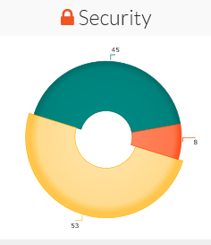
A donut chart shall display a count of alerts since the dashboard was last viewed by the logged on user in these three areas: Security, Health and Activity.

The Alert Levels reported are listed in the following tables:

Alert Level | Color | Displayed
Error | Red (Hex #f05423) | Yes
Warning | Yellow (Hex #fdbb30) | Yes
Info | Green (Hex #006c67) | Yes
Status | Blue (Hex #003d79) | No

Note: Default Alerts will need to be added to GigaCloud as well as alerts specific to cloud health.

Here is a screen shot of the entire Cloud Status panel:
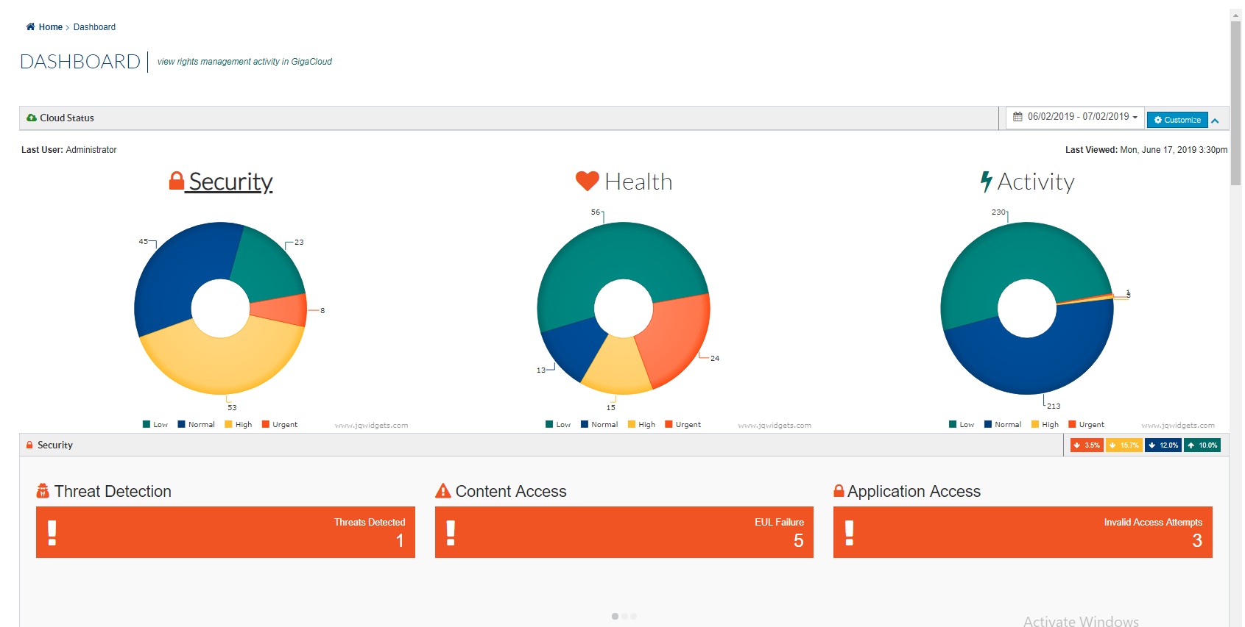
Percent Change since Last Login
The panel below the charts slides and loads Alert summaries for the three areas of GigaCloud represented by the charts themselves. The icon on the left hand-side of the second panel is colored to indicate the status of the area displayed as well as the main icon next to the respective chart title.
These rules are followed when displaying the status:
- If there are no errors or warnings then everything is flagged Green (Info.)
- If there is at least one Warning then the category is flagged Yellow (Warning.)
- If there is at least one Error then the category is flagged Error (Red.)
Clicking on another category will slide the second panel left to the selected Alert summary panel.
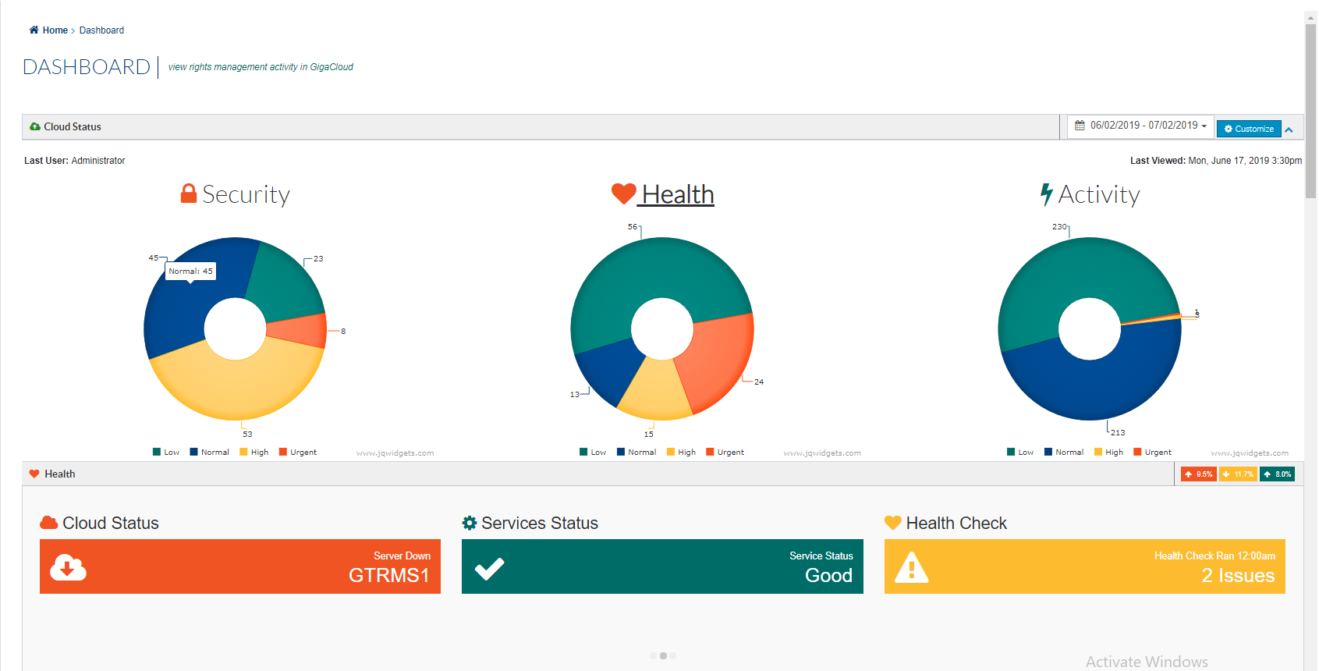
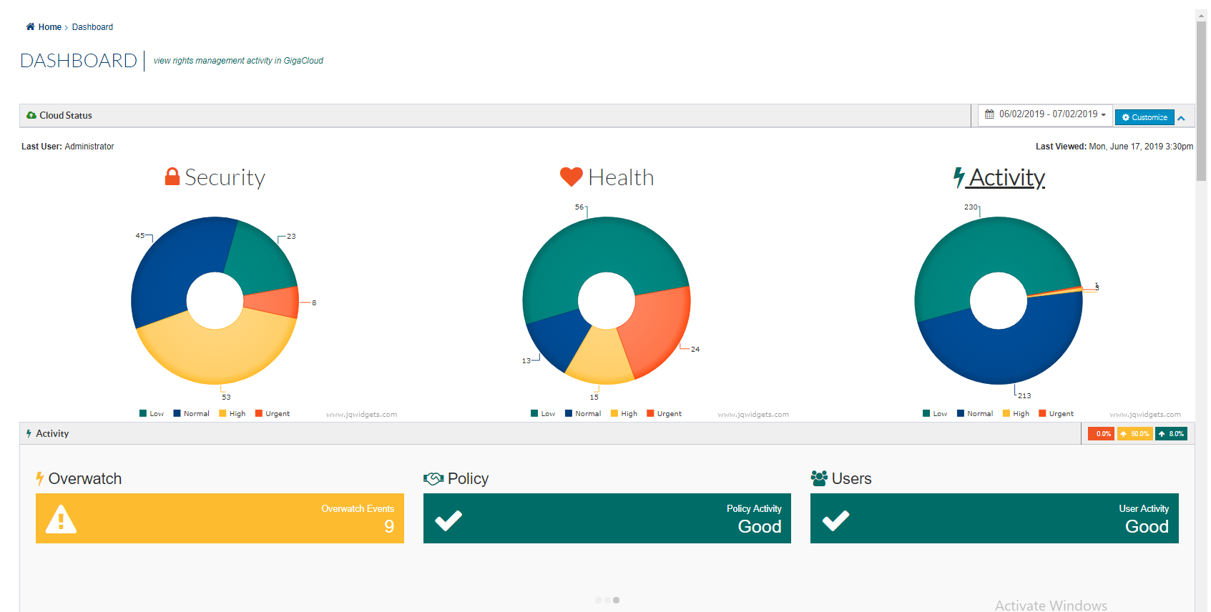
- A filter at the top allows custom time interval selection and it is also cookied for subsequent visits.
- A Customize button is displayed to allow for configuration of the dashboard.
- The far top right icon will collapse and conversely expand the top widget.
- The last User to have logged in will be displayed as well as the last date and time the dashboard was viewed.
- Alerts are displayed based on the throttling (number of occurrences per time frame.) So if an Alert Warning was triggered for an Invalid External User event (5 occurrences per 5 minutes, for instance) only one Warning would be displayed per triggered Alert.

Clicking on an Alert Summary displays a modal with details.
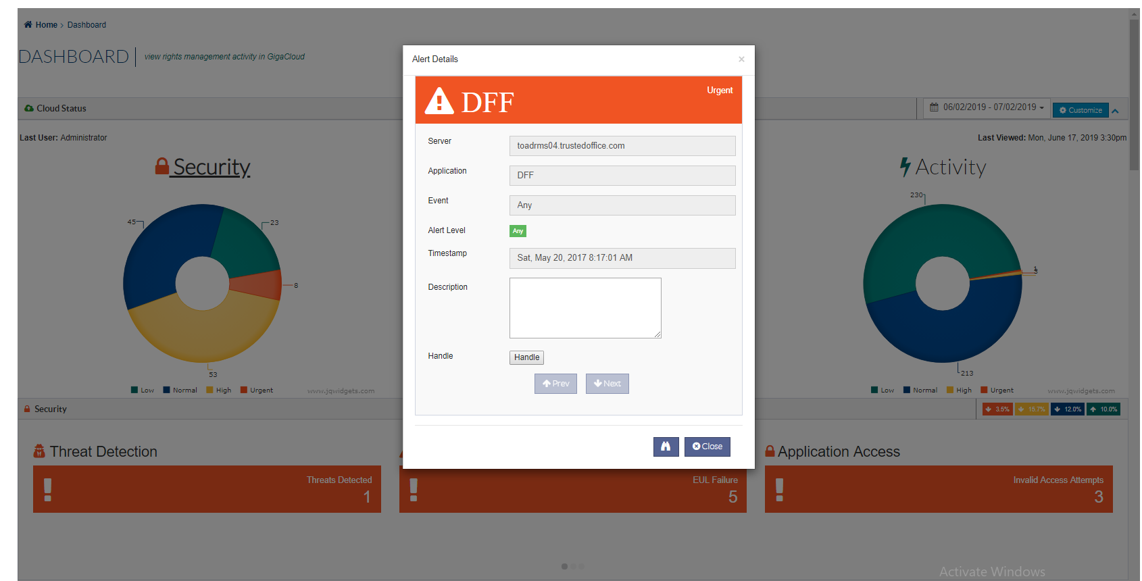
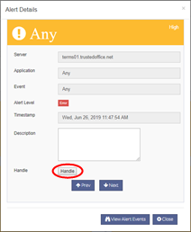
Clicking on Handle will remove the alert from the Status count and the dashboard will refresh. If there are more than one of the same alert the User can use the Prev/Next arrow button to view the other alerts and handle them. Clicking on the View Alert Event button will navigate to the System > Alert Events page and display events for this Alert.
If all Error Alerts are handled, the donut charts should only be Green or Yellow/Green. If ALL Error and Warnings are handled the charts should be ALL green or empty.

Widgets and configuration

A default number of widgets are loaded below the Cloud Status panels on the first visit by an Administrator. This is also dependent by the type of Administrator they are and the permissions they have been given by default or by another Administrator. These widgets should give the user the ability to view other snapshots of important areas of GigaCloud to assess health and status.
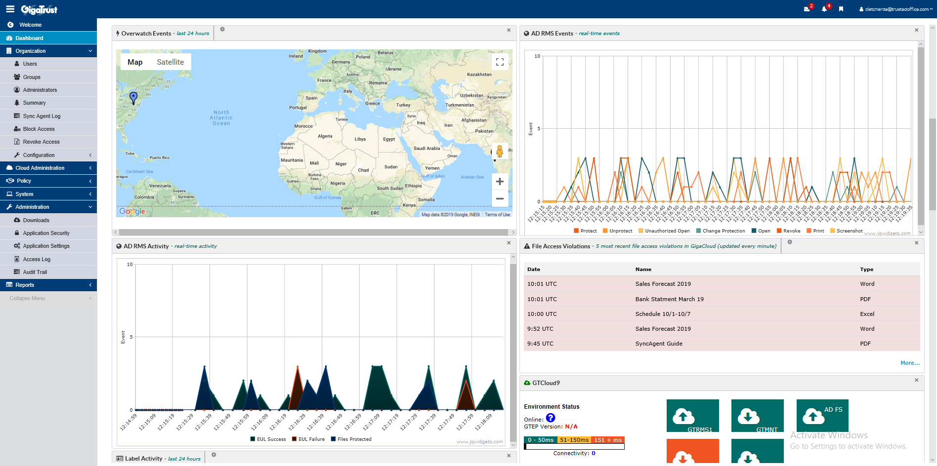
Widgets can be hidden and drag and dropped to rearrange them on the main dashboard page. These changes are not saved, however. They need to use the Customize feature to configure and save new dashboard customizations.

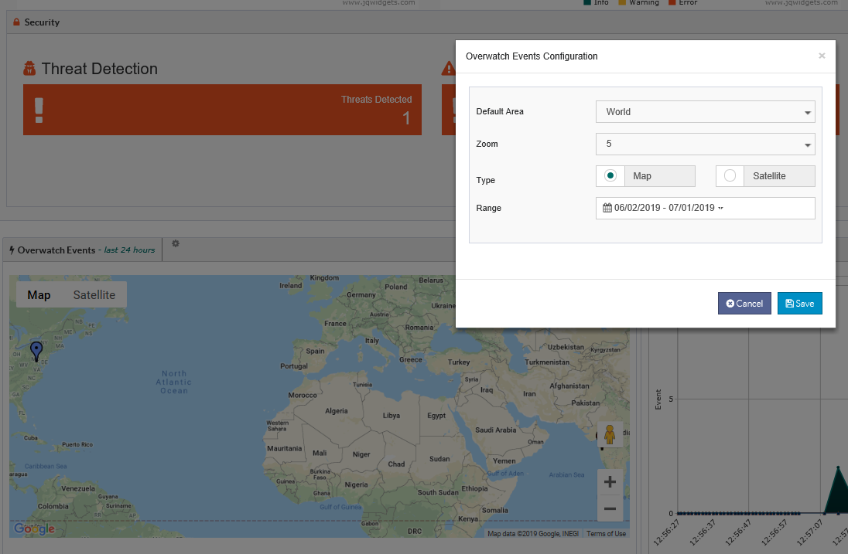

Overwatch Map
- Type: Google Map
- Access: Tenant Administrator
- Description: Map is loaded from Google Maps API and centered based on a default or custom Latitude and Longitude. Zoom is defaulted to 3 and can be customized from 1-15. The map has two views: Map and Satellite. Zoom buttons are provided and the map also has an automatic full screen mode. Dragging the map will move it around.
- Method: Overwatch events are plotted by color pins to match the type of event. Mouse over on the pin will display a tool tip with the following information:
  - User: user that triggered event.
  - Event: type of Overwatch event
  - Timestamp: event date time
  - Name: document name
  - Type: type of document
  - Location: full street address
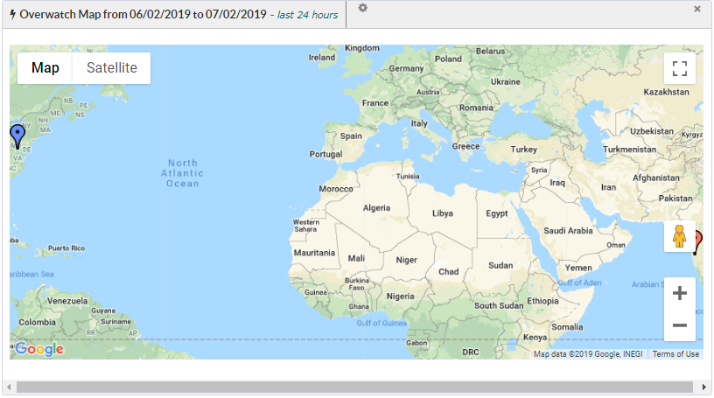
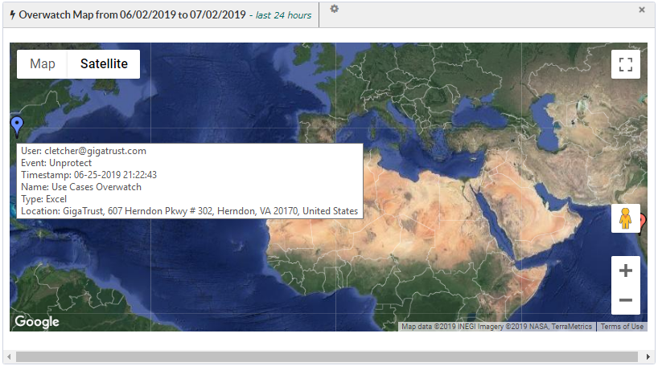
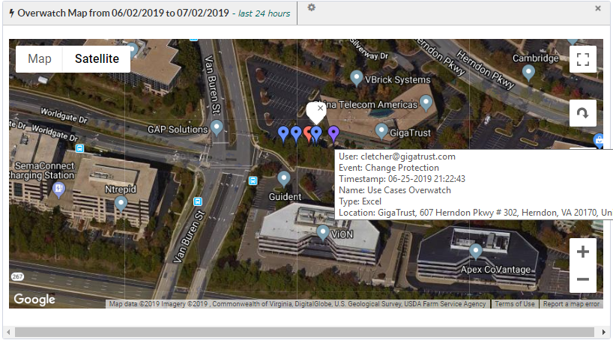
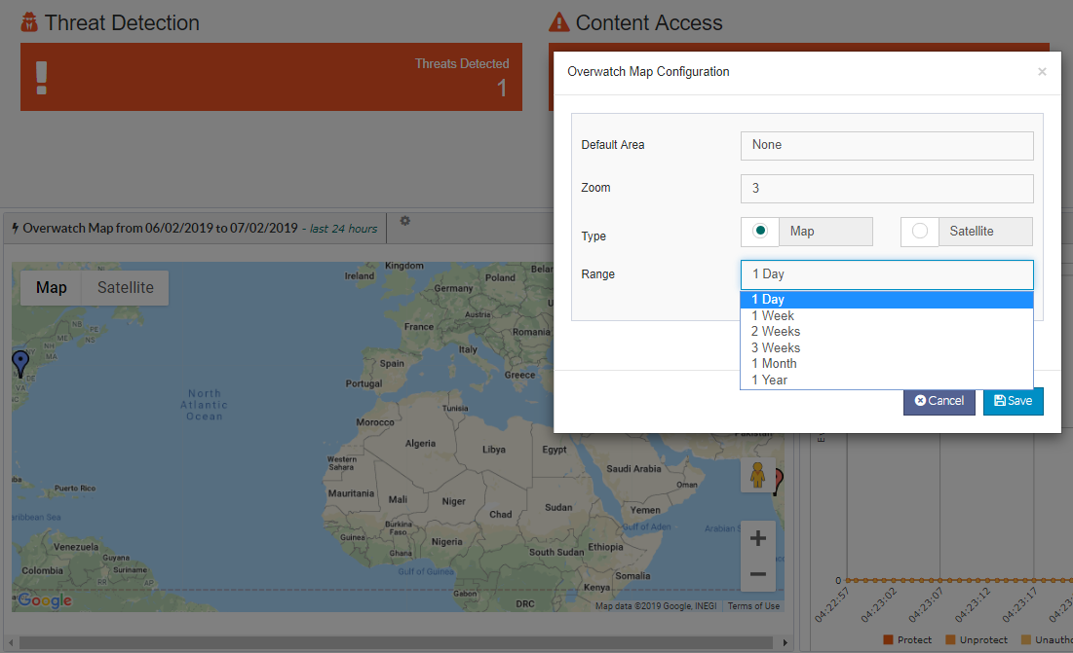
- Configuration: Clicking on the Gear icon will open the Overwatch Map Configuration modal. The following settings can be configured here:
- Default Area: users can select World, or choose any country to default center the map and zoom on.
- Zoom: zoom options of 1-15 are provided.
- Type: the default type of map displayed can be selected.
- Range: a custom time span can be configured.

AD RMS Events
- Type: JQX Widgets Chart
- Access: Tenant Administrator
- Description: Displays a real-time updated chart of Overwatch Event data. Default timespan is 15 seconds.
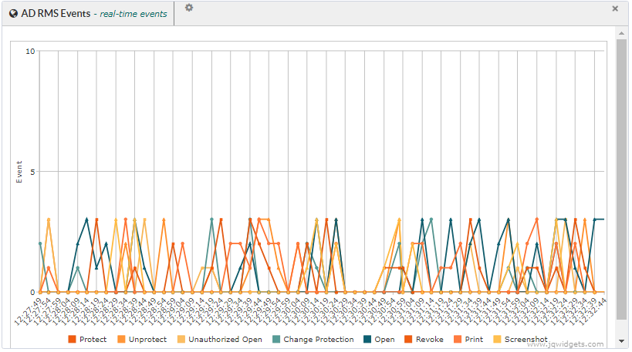
- Configuration: Clicking on the Gear icon will open the AD RMS Events Configuration modal. The following settings can be configured here:
- Chart Type: Administrators can select from Line, Area, or Stacked Bar charts.
- Frequency: options are 15 seconds, 30 seconds, 1 min, 2 minutes and 5 minutes.

- Filtering: Clicking on an element in the legend will remove it from the chart or conversely add it back.

AD RMS Activity
- Type: JQX Area Chart
- Access: Tenant Administrator
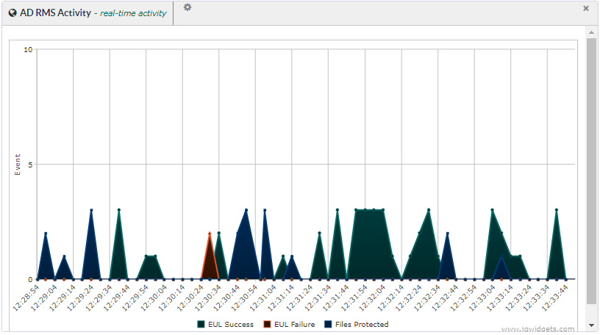

File Access Violations
- Type: Table
- Access: Tenant Administrator
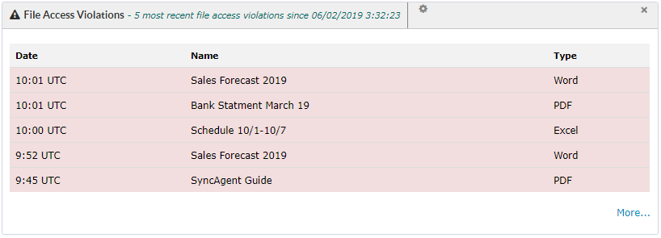

Label Activity
- Type: JQX Donut Chart
- Access: Tenant Administrator
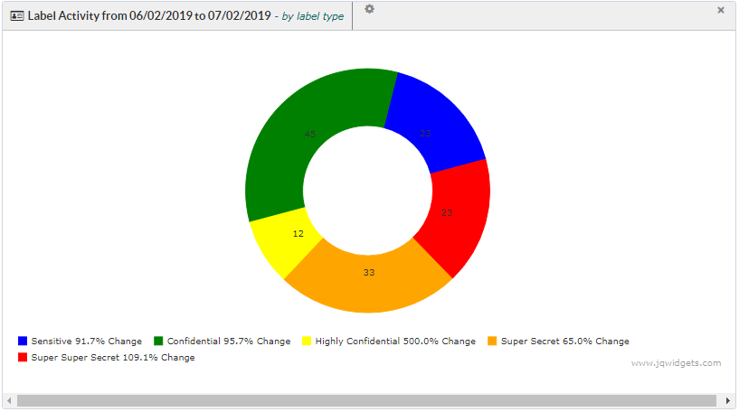

Cloud Status
- Type: Tabbed Widget
- Access: Super User
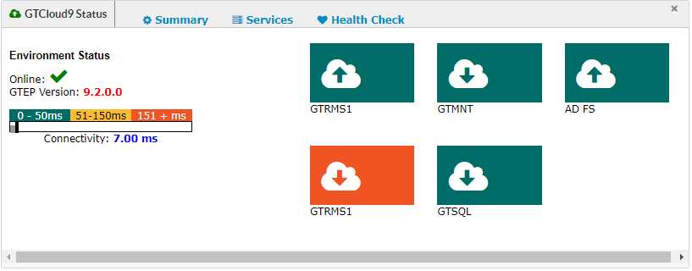
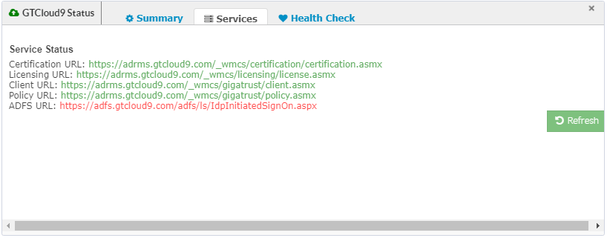
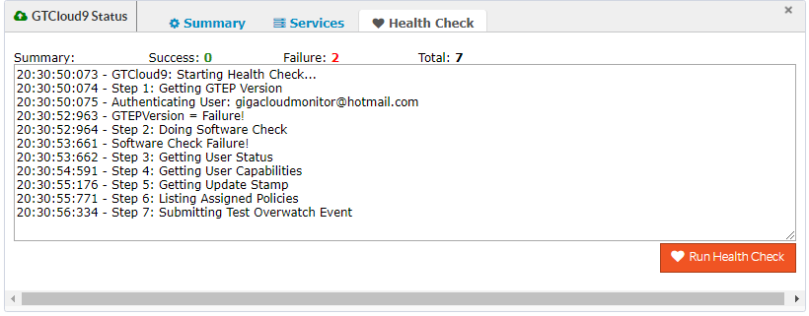
Document Activity
- Type: JQX Stacked/Grouped Bar Chart
- Access: Tenant Administrator
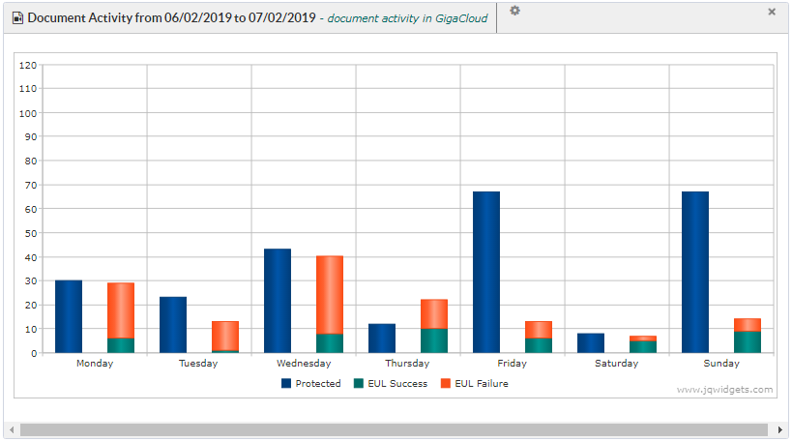

Overwatch Events
- Type: JQX Pie Chart
- Access: Tenant Administrator
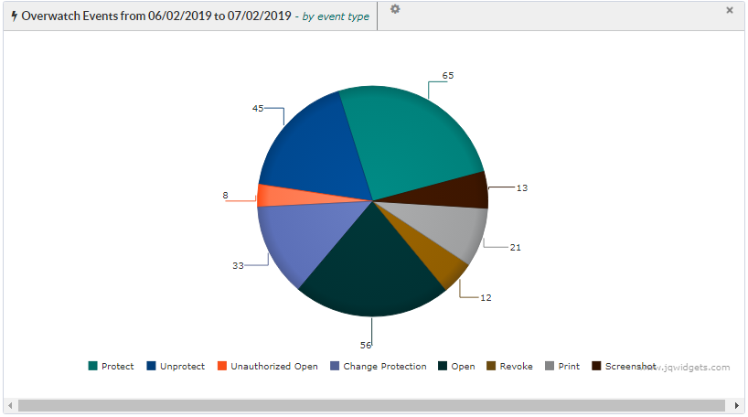

Top User Access
- Type: Table
- Access: Tenant Administrator
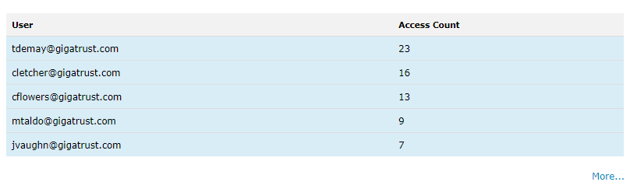

System Events
- Type: Tabbed Widget
- Access: Super User/Tenant Administrator
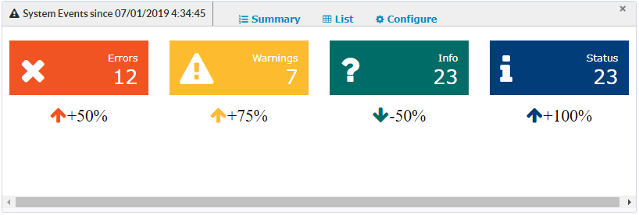
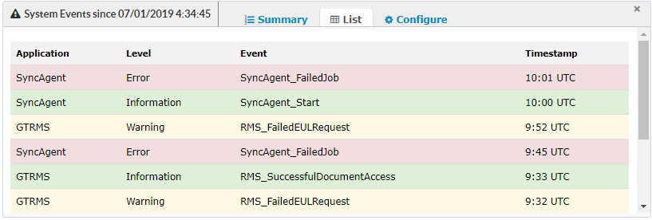

User Information
- Type: JQX Donut Charts
- Access: Super User/Tenant Administrator
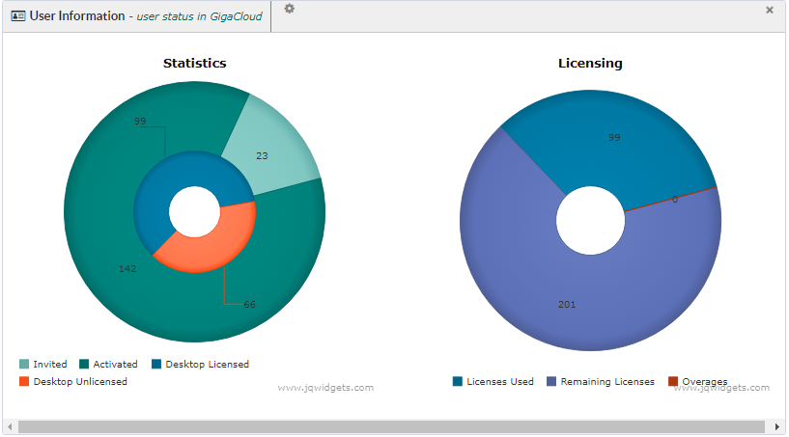

Top Files Protected
- Type: Table
- Access: Tenant Administrator
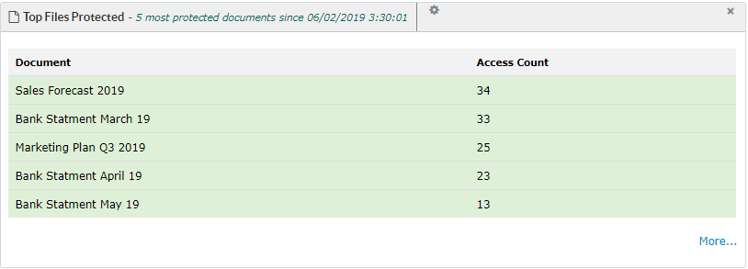

Client Errors
- Type: Table
- Access: Super User
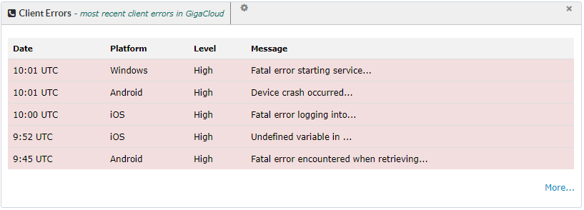

Dashboard customization

Administrators can customize the dashboard by clicking on the Customize button on the top right of the dashboard.
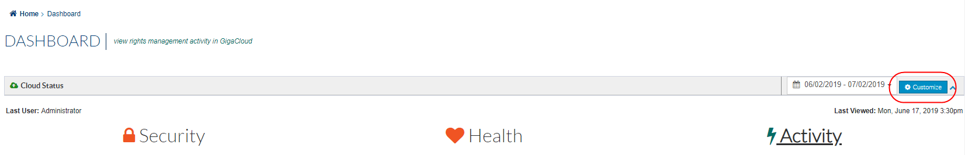
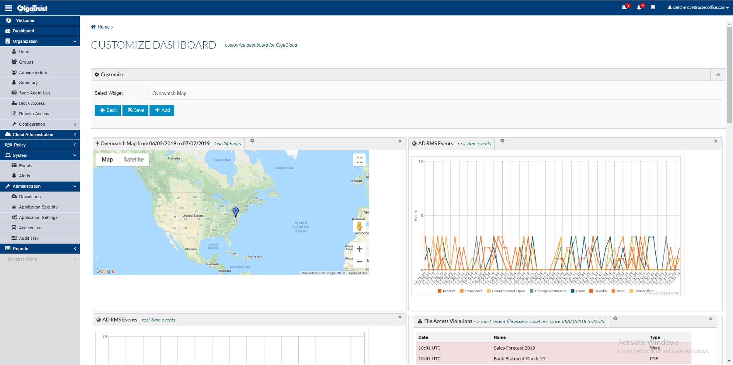
- Widgets with pictures of the widgets are displayed in order as they are displayed in the dashboard.
- Widgets can be removed by clicking on the X in the top right of any widget.
- Widgets can be added by selecting from the dropdown and clicking on the + Add button.
- Dragging a widget will allow dropping it in a new location.
- Dashboard custom configurations are saved in the database per user.
- Only widgets the Administrator has permission to view are listed and displayed.
- Adding or deleting a widget will remove it or add it back into the dropdown list respectively.
- Clicking on the Back button will return to the Dashboard and prompt to save if something was changed but not saved yet.
- Turning on Demo Mode will use fake data for all charts for sales to use when with potential clients.

Appendix

Tools Reference
Google Maps: https://developers.google.com/maps/documentation/javascript/tutorial
JQX Charts: https://www.jqwidgets.com/jquery-widgets-documentation/documentation/jqxchart/jquery-chart-getting-started.htm?search=
King Admin Template: http://demo.thedevelovers.com/dashboard/kingadmin-v1.6.2/ui-elements-general.html

