

Rushes
October - Day before Halloween
November - Black Friday
December - Christmas Eve

Someone who thinks they died but didn’t
Someone who died but doesn’t want to go
Someone who died but does want to go
Someone who doesn’t think they are dead but they are

The rule probably should be that if you want to move on you do
If you don’t want to move on you don’t

Here's a conscious zombie story: I had an idea the other day where I saw a zombie and its brothers and sisters were zombies as well and they were running towards the Fortress of humanity and Humanity was defending itself by tearing those zombies into dust to protect themselves from the scaryness of the mindless zombies. But then I saw a soul descend from the heavens and it fell into one of the zombies and then that zombie started looking around and it froze in place because it saw its brothers and sisters getting destroyed by The Fortress of humanity and it saw the suffering of its brothers and sisters even though they were not conscious but now that this soul-infused zombie became conscious they were now a witness to the suffering in the world and in their zombie brothers and sisters.

And the conscious zombie thought it was alone in its suffering in the world and it fell to its knees and it covered its face to try to suppress the pain it had witnessed and that was all that was on its mind which was this first experience that it had which was the
Identity shopping vs identity building
Where do people’s memories go when they die
What do people become a part of, the earth? The “ether”?
The need to live in the past and in the future is turned towards procreation
Your child is a part of you - the past making up them - and you in the future, a part of you lives on
full suffering of all of the existence of what it saw in itself from its brothers and its sisters being taken from the earth who appeared to be not conscious and so it had no other consciousness to share that suffering with as far as it knew so it was maybe the only one that was giving the potential suffering around it meaning.

Because before that body of Flesh was conscious the suffering had no meaning but when a soul descended from the sky or from heaven and created a witness then the suffering had meaning now but now that body was wondering why, why was it picked to witness the suffering and what did that mean? What power is there to give meaning to suffering and to be on your knees and to have tears fall from your eyes as you witness others who cannot share with you as a witness because they did not appear to be conscious with you but you are giving their suffering meaning by seeing their pain.

And then I could ask why would heaven create a witness to the suffering by creating someone who could give the suffering meaning because before there was no suffering until heaven sent a soul down and gave a body of Flesh meaning. But now that body of Flesh sees the suffering and wonders why it exists but there is no answer from the heavens because the heavens gave its answer when it sent the soul and put it into a body of Flesh and now that body of Flesh needs to find its own answer to what the suffering means for it.

I wonder what it is about being the first witness being the one to see, and then wondering why your existence is filled with suffering. And what does it mean? That you were created by a heaven, and their answer and their question was the same thing which was your existence. But when you wonder why then you realize they have already answered by existing, but then you wonder what to do after that. Because maybe when you witness suffering then you wonder why there was suffering in the first place but then they can't give you any more details because maybe if they knew then they'd have already solved it, but your own ability to witness on a deep level might give you the details you need to help them. To give them what you think the suffering meant. And maybe why you and they existed in the world.

What If Heaven, in order to exist, sent the soul that awakened the zombie into witnessing a kind of hell not for the soul to take the highway towards hell but to better know what to avoid because the hell was Heaven guiding the soul towards how to build a staircase to Heaven which is not a simple staircase but is led by transforming the suffering of hell into well-being and peace, and without hell which was what existed before heaven then Heaven could not have been formed and that is why heaven sent the soul to turn hell into heaven because otherwise Heaven would not have existed to send the soul to transform the hell of suffering into the heaven.

What is the plug?
1910ish
Tree in the middle of the mall - atrium caves in, rain to frozen by December

Ghost Town Mall Otherworlds - Yggdrasil Connection
- Asgard
  - Thor’s Hotel 540 Rooms - Bilskinr

https://github.com/facebookresearch/end-to-end-negotiator

Ghost Town Mall is set in present day America. It is a video game set in a mall where there is little business left. There are two restaurants left in the food court, a few shops here and there, a few big names with sales all over. In other words, a mall “ghost town”. Very few people visit the mall during the weekdays, and weekends have a few regulars, but business is slow, and parts of the mall have become more derelict and abandoned.

Ghost Town Mall is a video game about the permanent residents of the mall. They are spirits who, for whatever reason, have ended up “haunting” the mall as it is increasingly abandoned by outside humanity.

Chapter 1: First chapter takes place in the mall. Hero and old man, as the mall deteriorates, your choices are noted and may affect how things go down physically. However we establish that there is another “side” to the mall where ghosts can buy specialized “goods” that are different from the living need. In this chapter, you are rated by your “good” deeds and accumulate “spiritual currency”, an unnamed, unshown point system spent in a later chapter. The old mall is in trouble, and therefore the ghost mall also is in trouble. Normally a mall closing isn't a problem for the otherworld, this time though, some ghosts have become “trapped” in the “ghost town mall” and cannot go “back home” because of a severed connection of some sort.

In fact, they appeared there and started their businesses. No one knows how they got there or why they haunt the mall. Shops have opened up and accumulated over time. Everyone that arrives assumes those that have been there before have always been there. No one can remember a time before the mall, which is odd (since it was founded as a department store in 1910). There is a hidden plaque in the building (Today’s Special reference).

Chapter 2: Chapter 2 is the story of a woman who attended business school, and wants to “invest” in the mall’s real-estate. It is up to you in her chapter, to use your ingenuity to develop the mall into something new/different. How you develop the mall also pertains to a later chapter. The theme of this chapter is “good business ethics” and what it means to run fair trade. The conclusion is, good business ethics are a child-like fantasy, made for school-children: the lesson is cynical, and illustrated through “business school flashbacks” (raise your hand, what are ethics?).

Chapter 3: Enterprise! Someone has died! They now have control of the “ghost town mall” and it’s business. The mall is dead, but the new connections in Chapter 2 have given the otherworld residents hope. They begin their businesses again, hoping that whatever has happened to sever their connection back home, will be reversed by returning things to as they were (or better).

Is everything transactional
Dog eat dog

Organ harvesting in china???

Truthfulness (Zhen): To be honest and authentic in one's words and actions.
Compassion (Shan): To be kind, empathetic, and altruistic toward others, acting with magnanimity and goodwill.
Forbearance (Ren): To exercise patience, endurance, and forgiveness, especially when facing hardship or conflict.

Falun Gong is "opposed to the Communist Party of China and the central government, preaches idealism, theism and feudal superstition".^{[210]} Xinhua also asserted that "the so-called 'truth, kindness and forbearance' principle preached by [Falun Gong] has nothing in common with the socialist ethical and cultural progress we are striving to achieve", and it also argued that it was necessary to crush Falun Gong in order to preserve the "vanguard role and purity" of the Chinese Communist Party.^{[211]} Other articles which appeared in the state-run media in the first days and weeks after the ban was imposed posited that Falun Gong must be defeated because its "theistic" philosophy was at odds with the Marxist–Leninist paradigm and the secular values of materialism.^{[212]}

I've always wondered about some stores I see. Like some shop in the mall that you never really see anyone in that sells candles or something. How do they afford to pay the rent and the employees and still make money?

Money laundering.

Mattress Firm

malls are weird because they have contracts and technically none of the businesses own their space. the owner of the mall is interested in the psychological feeling of being in a mall and doesn't want customers to think 'wow this mall sure has a lot of closed businesses" so you definitely get situations where small businesses end up not having to pay to keep their storefront open even if they don't make a lot of money especially for seasonal or low volume stores

also those businesses cost basically nothing to run. you have the labor of maybe 3-4 people and almost all of your expenses are the lease payment/utilities, they figure they'd lose more money from the psychological impact of other shoppers walking by an empty storefront than paying three teenagers minimum wage to sell candles

That happened with my BBQ place after 9 years as we were discussing closing down the landlord said the city did not want empty business's and the news did not want to cover another business closing so we could stay rent free for a while, that lasted about a year....

Situations where small businesses end up not having to pay rent in the mall? That's hard to believe. And even then, the store wouldn't be making enough to pay employees and still turn a decent profit.

SAME HERE, I owned a BBQ joint for 9 years and scraped by working my tail off, I had a candy shop next to me that never had any customers, kids clothing shop, and several others that I knew had virtually zero customers ever.
I did some digging most of them could be simply explained. Two of them in fact were losing money for years (this did not go over well when I asked basic questions about their overhead and sales as a fellow business owner)but run by wives of rich men. It is basically their "job" to play business owner in their little shop. They go to the Chamber meetings socialize etc....Just a hobby no differen than paying for a club membership somewhere...

NOW, a furniture shop and a few others I determined were without question front companies for drugs, money laundering or any number of possible things. Perfect example of the world is never what it seems on the surface. all these shops or eating places and only a handful turning an actual profit from the actual business.

The two reasons you give are what I supposed.

Reminds me of the 'King of the Hill' episode where Peggy tries to run a bookstore and doesn't make any money. Turns out the lady she bought it from had a rich husband that paid for everything so she could have her snobby book club. Peggy ends up letting a friend sell guns out of the basement of the bookstore.

Really says something about the state of the USA. It's so evident what and where these things are happening, but nothing is done.

I guess we're learning about the way the FBI actually works now though. Instead of stopping money laundering companies, they're looking into presidential opponents.

with furniture shops, mattress shops, and other low-volume high-price outlets that seem like they should never be profitable, basically their entire stock is borrowed. like dealerships. the manufacturer wants to have their products on display in a storefront because the purchasing experience is part of the reason why they can charge two grand for a chair

the e-cigarette shops in my city seemed like they are drug fronts but a little digging makes you realize they were buying outdated stock wholesale and selling at insane markup. $40 'starter kits' are like five dollars worth of goods if you bought them online and who knows how low the price gets if you're buying wholesale

you'd be amazed how many businesses literally just resell cheap chinese garbage from alibaba at 5x markup

This is arguably a conspiracy, but not in the way you described. It’s pretty unfair that Uber has so much private equity money that they can afford to operate at a loss until every independent cab has gone out of business, but that doesn’t mean they’re a sinister front for something. Same logic applies to the tech companies you mentioned. The conspiracy is that they’re so rich they can operate at a loss until we’re completely addicted to them, at which point they’ll try to make back all that money.

Welcome to late capitalism, where Silicon Valley will throw billions of dollars behind any half baked idea and let tech bros burn it for years, but the rest of us can’t get a loan to start a small business.

https://en.wikipedia.org/wiki/Richard_Cooey

http://www.ohio.com/two-women-found-slain-in-norton-sept-2-1986-1.120283

http://www.cleveland.com/akron/index.ssf/2015/05/rolling_acres_mall_timeline.html

https://youtu.be/kvk1dgy9DtE

http://stuffblackpeopledontlike.blogspot.com/2010/11/52-mall-envy.html

http://www.businessinsider.com/23-haunting-photos-of-a-dead-mall-in-ohio-2015-8

http://www.dailymail.co.uk/news/article-2951596/Stunning-photographs-abandoned-Ohio-mall-transformed-Winter-wonderland-blizzard.html

http://www.cleveland.com/akron/index.ssf/2015/03/vandal_turn_rolling_acres_mall.html

http://www.ohio.com/business/demolition-of-former-rolling-acres-begins-1.722864

http://www.cleveland.com/akron/index.ssf/2015/05/remembering_rolling_acres_mall.html
Body found hanging from tree near Rolling Acres in Akron

News 5 Staff
10:43 AM, Jan 7, 2016
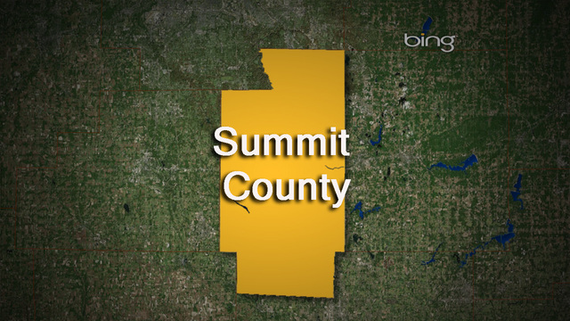
Copyright Associated Press
SHOW CAPTION
AKRON, Ohio - EDITOR'S NOTE: newsnet5.com does not typically report suicides. However, since this suicide happened in a public place and we have received a lot of questions about the body, we are providing the public with the small amount of information we received from officials. newsnet5.com will not be reporting the name of the victim or reporting on this incident any further.
The Summit County Medical Examiner was called Thursday morning for a report of a body hanging from a tree.

The body was spotted by drivers along Romig Road in Akron near Rolling Acres Mall.
According to the Summit County Medical Examiner, the death appears to be a suicide.

St. Augustine's "Mansion of the Soul": The Christian theologian St. Augustine, who was familiar with the memory techniques of ancient orators, used the metaphor of the soul as a vast mansion in his Confessions. He described the mind as an expansive, internal space where one could find memories and, ultimately, encounter God

- St. Teresa of Ávila's Interior Castle: A 16th-century Spanish mystic and Carmelite nun, St. Teresa wrote The Interior Castle, a classic work of Christian spirituality. She uses the extended metaphor of the soul as a castle with seven sets of dwelling places or mansions that a person must pass through in their spiritual journey to achieve union with God in the innermost chamber. This is a direct spiritual application of the ancient memory palace metaphor.
- Medieval Monks: Monks and priests used memory palaces to memorize extensive religious texts, including the Bible. The process of organizing and dwelling on these texts in their minds was considered a form of meditation and spiritual practice known as Lectio Divina (Divine Reading).
- Puritans and Preaching: Even later, some preachers explored using the technique to memorize sermons, viewing it as a disciplined way to internalize and deliver God's word without notes, though some debated the use of the vivid imagery it required as potentially "profane".
- Giulio Camillo's "Memory Theatre": A famous 16th-century Italian philosopher, Giulio Camillo, designed a literal, physical "Theatre of Memory" that was also a complex mental system. His goal was not just to remember things, but to access "eternal knowledge" and connect the soul to celestial consciousness by using specific symbols placed in the structure.

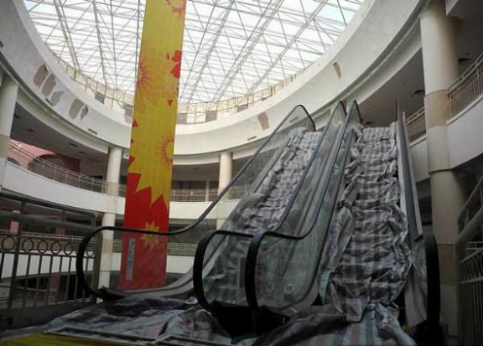

DGB said...
Rolling Acres Mall -- Akron,OH.
Opened 1975... 1.3 million sq. ft.. 2-story.. state-of-the-art.
Diversity showed up in the 80's, doing what diversity always does; paying customers refused to go back.
Mall renovation in mid-90's to attract customers back, to no avail.
Mall dies in 2005. RIP.
A microcosm of America.
https://www.reddit.com/r/interestingasfuck/comments/13vuput/richard_beasley_aka_the_craigslist_killer_used/
And now they are in the woods, looking for this "watch." Rich pulls back a branch and lets it slap back at Brogan and Tim. Then Tim holds it back for Brogan so he can walk by. This act of kindness disturbs Brogan, though he doesn’t say anything
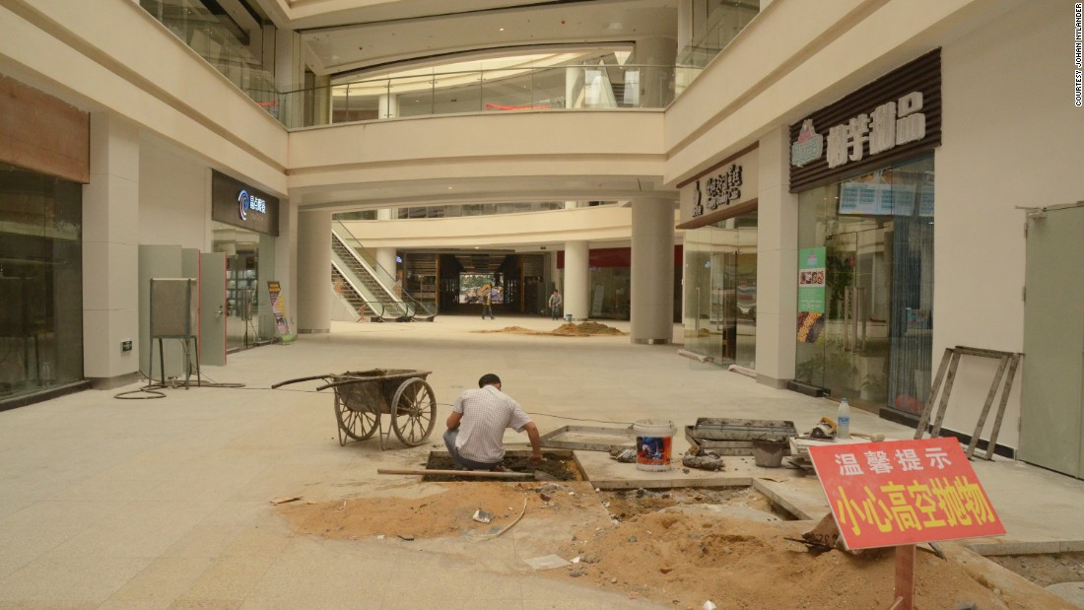

Useful
https://www.reddit.com/r/gamedev/comments/3pengd/documenting_the_steps_required_to_get_an_html5/

The Mall and the premises around it may have been built on a sacred site before, which is why the atrium is a “holy” place. The otherworld is accessed via the Mall after it becomes a place of memories, stirred up by modern times, as an access point to the past. Spirits have become drawn to the portal.

In the 1820s, immigrant Welsh and Cornish miners brought tales of the Tommyknockers[7] and their theft of unwatched items and warning knocks to western Pennsylvania.

