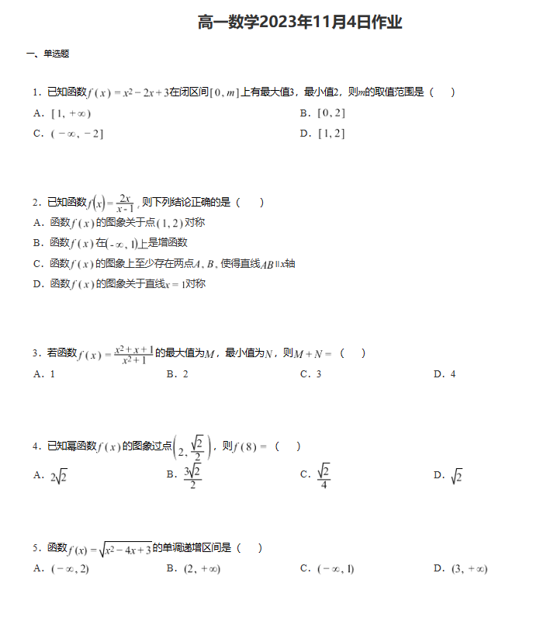

班级 姓名 学号 成绩

|  |  |  |  |  |  |
| --- | --- | --- | --- | --- | --- |
| 1 | 2 | 3 | 4 | 5 | 6 |
|  |  |  |  |  |  |

