# **Capstone Project Website Materials Collection Template**

## **Basic Project Information**

* **Project Title**: Quitly
* **Team Name**:
* **Team Members**: Daniel Luo
* **Advisor/Mentor**: [Tomi Odunsi](mailto:odunsi.tomi@gmail.com)

## **Project Overview**

* **Summary**: (100-150 word description of your capstone project)

**Quitly** is a habit-breaking app designed to help people quit a bad habit by leveraging the power of group accountability. Quitly focuses on behavior change through social support. Users can join small groups, check in daily to maintain shared streaks, and track their progress on a group leaderboard. Inspired by *Atomic Habits* and behavioral psychology, Quitly leverages behavioral psychology to turn quitting from an isolating experience into a shared challenge. By transforming peer pressure into a positive force, Quitly helps users build lasting habits in an environment where progress can be made together.

* **Keywords**: (3-5 keywords that describe your project)
  + Positive peer pressure, accountability, and community
* **Problem Statement**: (What problem does your project address?)
  + Quitting is not just a physical challenge — it’s a deeply social and behavioral one. Most quit attempts fail because people try to do it alone, in environments filled with triggers and without consistent support.
* **Solution**: (Brief description of your solution)
  + Quitly helps people quit smoking by turning it into a shared challenge. Through daily check-ins, group streaks, and leaderboards, it creates a supportive environment where positive peer pressure and accountability drive real behavior change.

## 

## 

## **Team Information**

* Daniel Luo
* 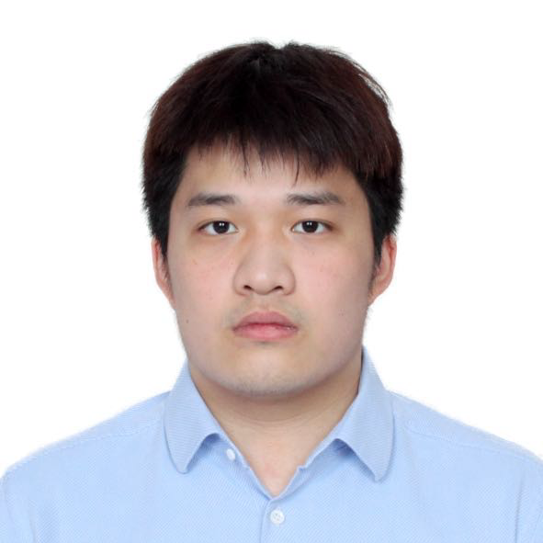
* Founder
* Student in BTE, with experience in consulting. Loves to play golf. Quit smoking for 5 months and going strong.
* [www.linkedin.com/in/daniel-luo-b82606235](http://www.linkedin.com/in/daniel-luo-b82606235)

## **Project Details**

### **Background & Research (from your** [**BTE Capstone Proposal Template**](https://docs.google.com/document/d/1wyFrX-KcpFqpgw5KjX7UhiyceMU8BY-e8z7RG66vEME/edit?usp=drive_link)**)**

* Motivation
  + **As someone personally working to quit vaping, I understand the challenges of breaking nicotine addiction. Combined with the rising prevalence of vaping among my peers, this project is driven by the need for a fun, engaging, and effective solution that helps others on the same journey.**
* Market/Need analysis summary
  + **Inspired by Duolingo’s interactive, reward-driven approach, my research has focused on creating engaging, gamified solutions for behavioral change. Also, I have read books on behavioral change, which focus on environmental changes that help quitting easier with friends. Existing tools lack the interactive design and group element, which highlights the need for a platform like Quitly.**
* Key research findings
  + People tend to quit alone, which is isolating and difficult. When quit, the group of friends with the shared goal became much easier.
* Relevant statistics/data
* Literature review summary
  + **“One of the most effective things you can do to build better habits is to join a culture where your desired behavior is the normal behavior.” –** James Clear (Atomic Habits)

### **Goals & Objectives**

* List of specific goals
  + Personally quit smoking and help friends around me to do it with me
* What makes this project a success in your eyes?
  + Have a demo up and running and be tested with my friends
* Target audience/users
  + A group of friends who are trying to quit a bad habit together.

### **Technical Approach**

* Technologies used.
  + ChatGPT, Xcode, Replit
* Key technical challenges and how did you overcome them
  + There were many technical challenges along the way. Initially, I created a demo page through Python and tried to set up a back end with Firebase. I got stuck on making the page interactive and having the simple features I desired. Then, I tried to use Xcode to have an IOS app running and was not able to have the demo showing. Lastly, I settled with an AI-generating platform that was able to create the website I desired.

### **Design & Implementation**

* What was your design process
  + The design process was mani
* User interface mockups/wireframes
* Testing approach and results

## **Visual Materials**

| Link to these resources directly on google drive (rather than copy-pasting them into the doc here, that way when I build your site I don’t have to do extra work! |
| --- |

* Project logo (if you have one)

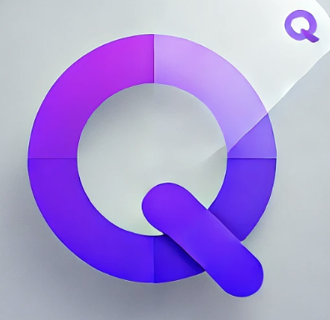

* [Hero image](https://www.optimizely.com/optimization-glossary/hero-image/#:~:text=A%20hero%20image%20is%20a,welcomes%20visitors%20to%20a%20webpage.) for project landing page
* 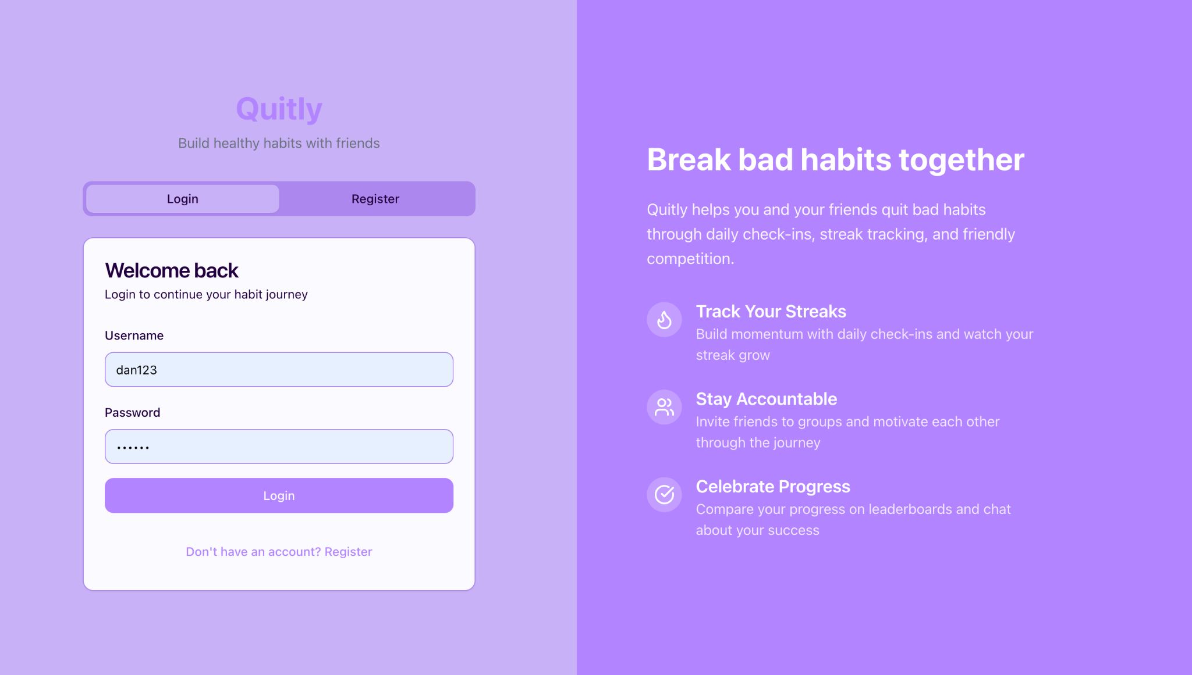
* Screenshots/images showing key features (with captions so I know what we’re looking at)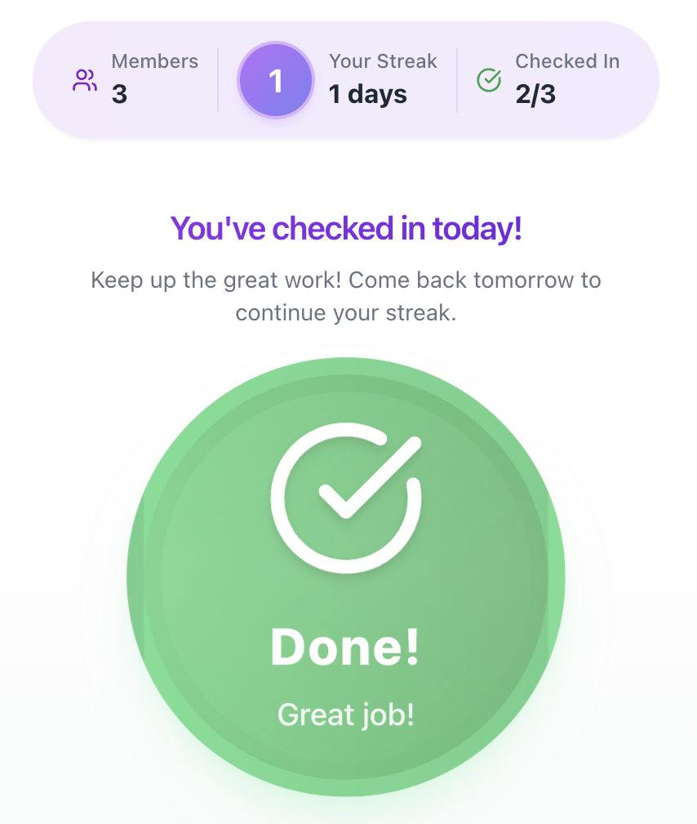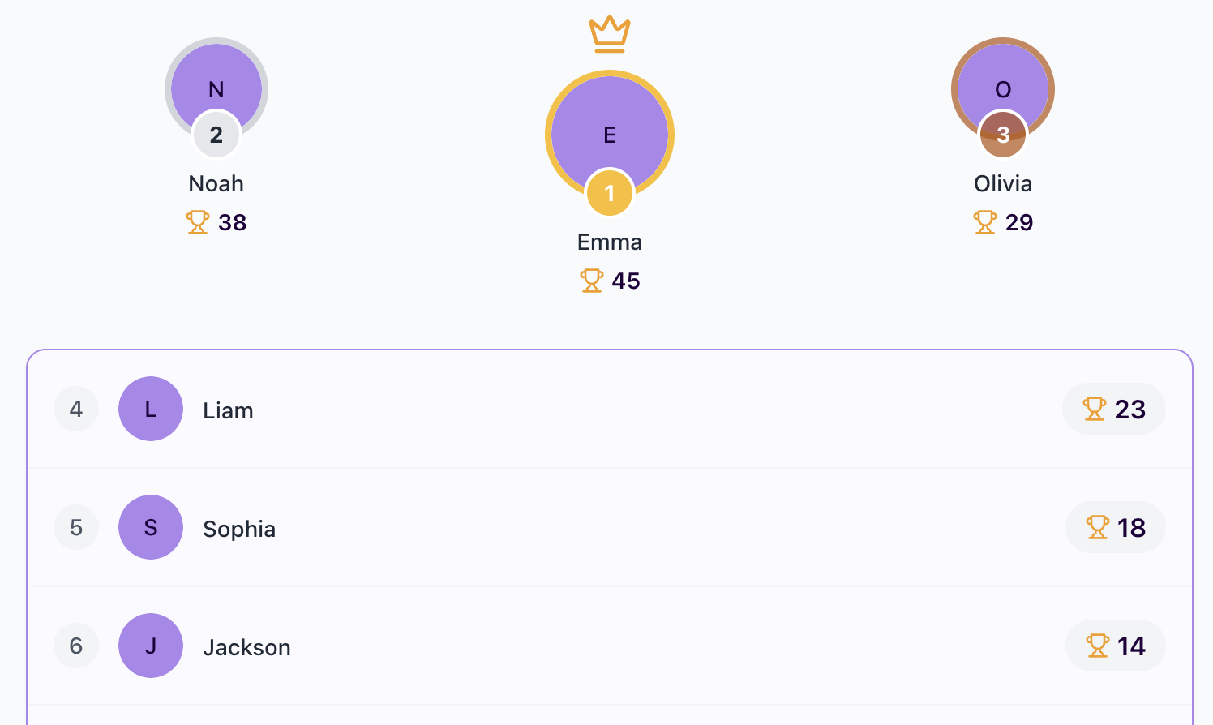
* Process photos links
* Video demo link (check out loom)
* <https://www.loom.com/share/b187f346b4c44232983a2353213ddd59?sid=8f09cc6f-6c18-4ce0-a48e-89d484b26f6f>
* Diagrams/flowcharts explaining the system

## 

## 

## **Documentation**

* Link to or copy of <https://docs.google.com/document/d/1gI6XbJCRVxyVAvDqqAlFOYsi2ZuDdgOMMm5VBDC75xw/edit?usp=sharing>

## **Results & Impact**

* What outcomes achieved
  + I was able to quit and motivate myself through the whole process and motivate a lot of my peers around me.
* Lessons learned
  + Quitting is difficult, but it is essential to be consistent. Find meaning in anything that you do. Tech is difficult, but it is important to embrace AI. Seek help and take feedback seriously.
* User/client testimonials (if available, don’t make these up)
  + My friends all really enjoyed the idea. They did not exactly use the prototype, but we did the daily check-in to motivate each other. It was helpful.
* Future work/next steps
  + In the near future, I want to be able to have the app running so I can at least use it with my friends. I need to test more and get user feedback on how useful the feature is. See if the app has a retention rate.

## **Presentation Materials**

* Slide deck from final presentation
  + <https://docs.google.com/presentation/d/1ajXW-o83NYjk5tmYW9r4YjGlhPmh8OIcoO-YwULvonU/edit?usp=sharing>
* Pitch video (if you made one)

## **Additional Resources**

* Acknowledgments

## **Submission Checklist**

* [] All team member information complete
* [ ] Project overview finalized
* [ ] At least 5 high-quality images included
* [ ] Project video or demo created
* [ ] All documentation files compiled
* [ ] Final presentation materials prepared
* [ ] All links checked and working
* [ ] Materials reviewed by advisor/mentor

## **Notes:**

1. Organize all materials in clearly labeled folders within the shared folder
2. PLEASE name files consistently using the convention: *TeamName_ContentType_Description*
3. Review all materials for spelling, grammar, and professionalism. I will be simply copying and pasting these