From Detection to Attribution: Physically-Coupled, Cross-Domain Monitoring of Ephemeral-Channel Geomorphic Change from Terrain Alone
NASA ROSES-2025 F.5 — Future Investigators in NASA Earth and Space Science and Technology (FINESST)
Target division: Earth Science Division (EARTH25) — Antarctic cryosphere / climate Proposal deadline: 14 July 2026 (11:59 PM EDT) Structure: Graduate student = Future Investigator (FI), primary author and intellectual lead; faculty advisor = PI of record. Award up to ~$50,000/yr for up to 3 years.
Summary. This project will transform an existing Antarctic stream-change monitor into an explanatory and predictive tool. Building on Barlow (2026) — which mapped two decades of ephemeral-channel geomorphic change across the McMurdo Dry Valleys — the proposed work will (O1) attribute that change to its physical/climate drivers, (O2) generalize the terrain-only detector across sensors and valleys, and (O3) deliver calibrated per-pixel uncertainty. Preliminary studies by the Future Investigator (§4) have reproduced and validated the parent change-detection pipeline and surfaced a first attribution signal, establishing feasibility and readiness to execute the proposed research.

1. Background and the Gap
The McMurdo Dry Valleys (MDVs) are Earth's largest ice-free Antarctic desert and, for a century, were considered the planet's most geomorphologically stable landscape. That assumption is breaking down: in an energy-limited system, small increases in solar absorption and permafrost degradation translate directly into ephemeral summer streams that flow for a few weeks each year, move sediment, and reshape channels. These streams are the most sensitive measurable indicator of climate change in the most stable place on Earth — a continental-scale "climate canary."
Barlow (2026) [1] established the measurement foundation in three transferable pillars:
1. Terrain-only semantic segmentation — a U-Net delineates stream boundaries from DEM derivatives alone (elevation, slope, aspect most informative; no water/color signal), so it works in channels that are dry 11 months a year. 2. Satellite-DEM validation — point-to-plane ICP alignment, Laplacian error modeling, and outlier-robust NMAD uncertainty prove free REMA satellite DEMs are accurate enough for centimeter-to-meter stream-corridor change detection. 3. Multi-epoch change detection — DEM-of-Difference (DoD) inside segmented stream masks, level-of-detection thresholds (LOD95 = 1.96 × NMAD), and per-stream erosion/deposition and acceleration rates across four valleys and three epochs (2001 & 2014 lidar, 2021–23 REMA).
The gap. Barlow's dissertation ends at description — it maps where change is happening (Denton Hills is the erosion hotspot; parts of Taylor Valley are accelerating) but explicitly defers two threads to future work: (a) coupling geomorphic change to physical/climate drivers, and (b) generalizing the model beyond the MDVs. A Future Investigator project lives precisely in that gap: turning a monitor into an explanatory and predictive tool (Fig. 1). This is a genuine scientific increment, not a replication.
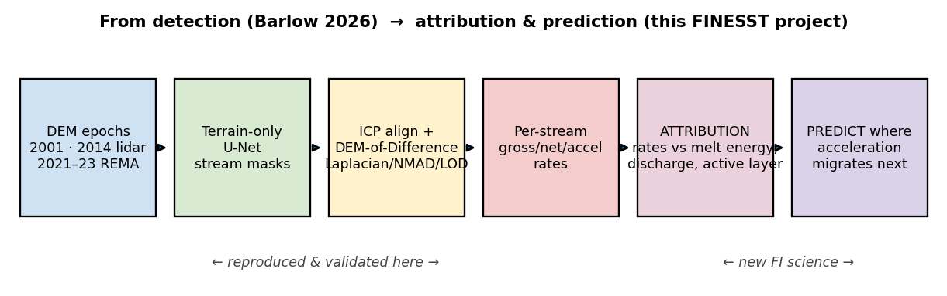
Figure 1. From detection (Barlow 2026; the first four stages, reproduced by the FI in preliminary work — §4) to the proposed attribution and prediction science (last two stages, the new contribution of this project).

2. Objectives and Hypotheses
# | Objective | Hypothesis | Increment over Barlow
O1 | Attribution (headline science). Pair per-stream gross/net/acceleration rates with energy-balance drivers — air/ground temperature, insolation, positive-degree-days (PDD), melt-season discharge, glacier mass balance, active-layer depth — from MDV-LTER + ERA5/AMPS reanalysis. | H1: Geomorphic flux is governed by cumulative melt energy, not raw water volume; a PDD/insolation-based energy model predicts per-stream gross rate better than discharge alone (and explains the residual scatter in Fig. 4). | Listed verbatim as Barlow future work; never quantified.
O2 | Cross-sensor & cross-valley generalization. Make the terrain-only segmenter robust across sensors (lidar 2001/2014 ↔ REMA) and all four valleys; quantify and correct the lidar→satellite domain shift that limits the satellite epoch. | H2: A sensor-aware normalization (per-pixel slope/aspect-conditioned bias correction) closes most of the lidar–REMA F1 gap, recovering near-lidar segmentation on REMA. | Barlow flags sensor generalization as future work.
O3 | Calibrated uncertainty. Extend the Laplacian/NMAD/LOD framework into a per-pixel, sensor-aware confidence layer so every change map ships with calibrated uncertainty. | H3: Conditioning NMAD on slope, aspect, and sensor yields LOD maps whose empirical exceedance matches the nominal 95% — a trustworthy-EO product. | Barlow uses a single global NMAD per epoch-pair.

Predictive payoff (ties O1–O3 together): a model that, given a driver field, predicts where acceleration migrates next — the actionable form of the "climate canary."

3. Methodology
Data (free/public; assembled in preliminary work — see §6). Elevation backbone: MDV airborne lidar 2001 (NASA ATM, 2 m) + 2014 (NCALM, 1 m), and REMA v2.0 (2 m, 2021–23). Per-epoch derivatives — elevation, slope, aspect, profile curvature (signed), MFD flow accumulation, lidar intensity. Drivers: MDV-LTER meteorology (Lake Bonney), 21 stream-discharge gauges, glacier mass balance (7 glaciers), continuous soil T/EC/VWC (active-layer proxy); ERA5 monthly 1993–2024 and AMPS 2.67-km for spatial gap-fill. Labels: MCM-LTER stream centerlines (public stand-in for Barlow's access-gated 217 hand-digitized tiles — see §7 risk).
O1 — Attribution. For each gauged stream and epoch, the proposed work will (i) compute gross/net geomorphic rate by DoD inside the channel mask (method demonstrated in preliminary work, Fig. 2); (ii) build a per-stream energy time series — melt-season PDD and incoming shortwave from LTER + ERA5/AMPS, cumulative discharge, and active-layer depth; (iii) fit hierarchical regression / random-forest models of rate vs. drivers, with leave-one-stream-out cross-validation; and (iv) test H1 by comparing an energy-balance predictor against discharge-only (Fig. 5 is the preliminary seed: the raw-discharge relationship is real but incomplete). Acceleration (3-epoch Taylor streams) will be regressed against driver trends.
O2 — Generalization. The work will quantify the lidar→REMA domain shift over stable terrain as a function of slope/aspect, learn a correction, retrain/fine-tune the segmenter with sensor augmentation, and evaluate F1 across all four valleys and both sensor regimes. The WellSight feasibility anchor (§5) already demonstrates the identical architecture transferring across biomes.
O3 — Calibrated uncertainty. The work will replace the single global NMAD with NMAD conditioned on (slope, aspect, sensor), emit a per-pixel LOD raster, and validate calibration by checking that observed sub-LOD residual fractions match nominal confidence on held-out stable terrain (Fig. 4 shows the global version demonstrated in preliminary work — Laplacian fits the residuals far better than Gaussian).
Reproducibility/QC. The pipeline is fully scripted — input data and all derivatives regenerate from source — with robust statistics and CRS checks enforced at every step (e.g., a preliminary QC catch — a 2001 nodata bug inflating NMAD to 2.7 m — was identified and fixed).

4. Preliminary Studies and Feasibility
To establish feasibility, the FI conducted preliminary studies that reproduce the pipeline underpinning the proposed work. These are feasibility demonstrations — not funded-project deliverables; the proposed research (§2–3) extends them. The FI independently reproduced Barlow's Pillar-3 change detection on Taylor Valley, obtaining results that fall inside her published ranges, and took an exploratory first step into the O1 attribution science.
(a) Change detection reproduced across all three epochs (Fig. 2).
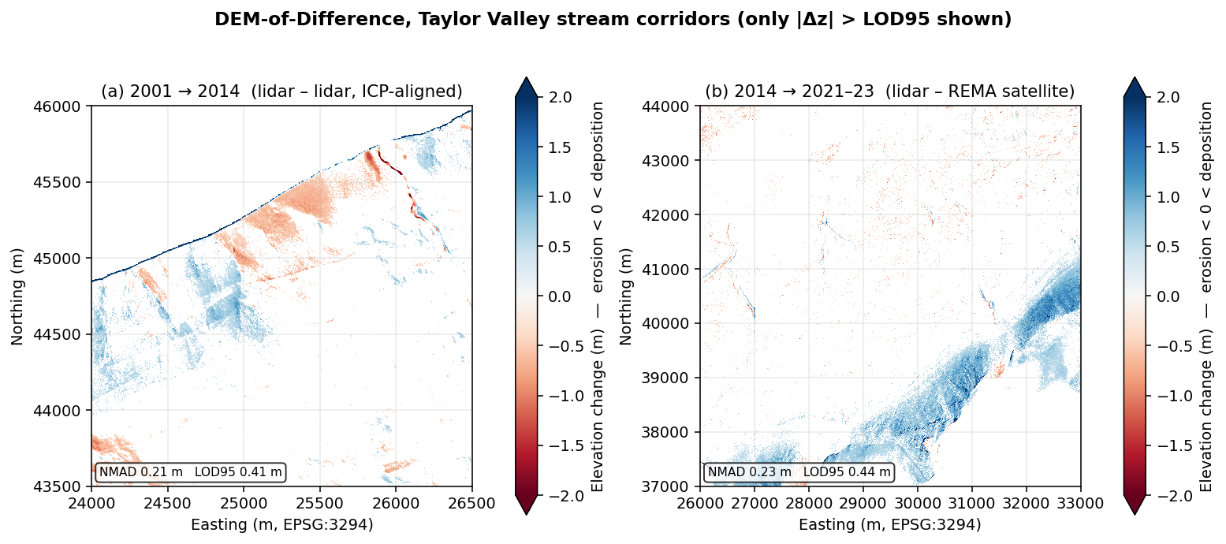
Figure 2. DEM-of-Difference, Taylor Valley stream corridors, only |Δz| > LOD95 shown. (a) 2001→2014 lidar–lidar, ICP-aligned; (b) 2014→2021-23 lidar–REMA. Coherent erosion/deposition patterns emerge above the noise floor; REMA auto-reprojected from EPSG:3031 to the lidar grid.
Epoch pair | NMAD | LOD95 | Barlow's published range | In range?
2001→2014 (lidar–lidar) | 0.21 m | 0.41 m | NMAD 0.07–0.46 / LOD95 0.15–0.92 | ✅
2014→2021-23 (lidar–REMA) | 0.23 m | 0.44 m | NMAD 0.19–0.53 / LOD95 0.37–1.04 | ✅

Point-to-point ICP converged with fitness 0.95 m² (mean-squared correspondence distance) and improved DoD NMAD on high-relief windows; on the flat valley floor it correctly added no benefit — exactly the relief-dependence Barlow's point-to-plane ICP exhibits.
(b) Per-stream rates (Fig. 3) — the masked products the proposed O1 will consume.
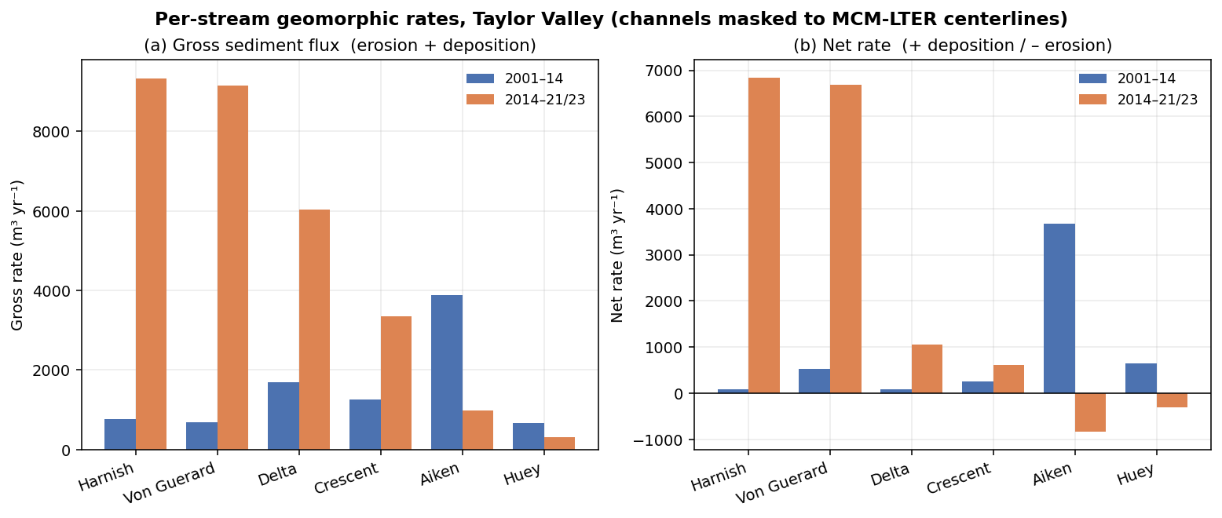
Figure 3. Per-stream gross (busyness) and net (erosion–deposition) sediment-flux rates for six gauged Taylor Valley streams, both epochs, channels masked to MCM-LTER centerlines.
(c) Robust error model (Fig. 4) — the basis for the proposed O3.
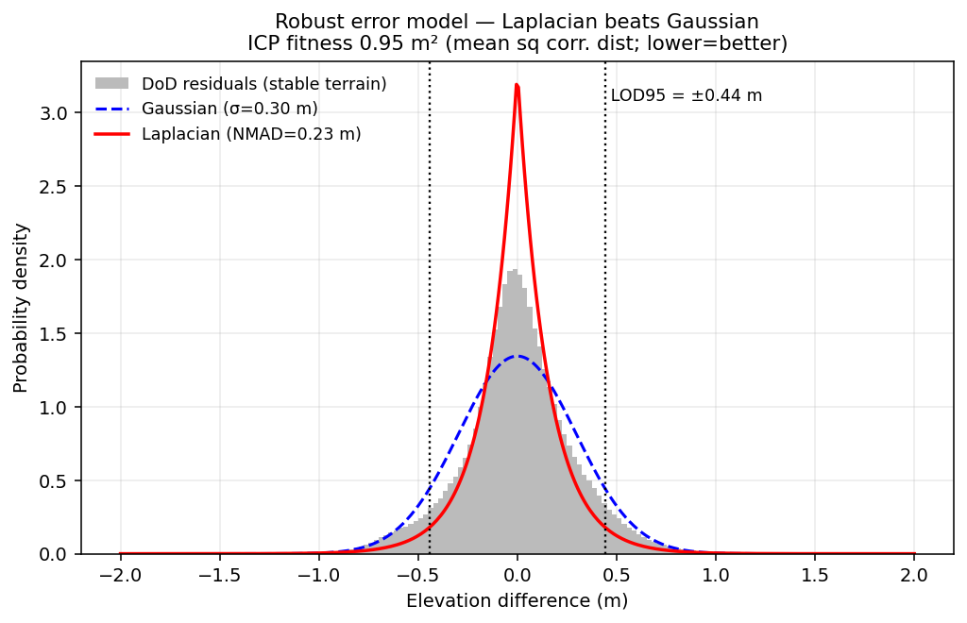
Figure 4. Stable-terrain DoD residuals are sharply Laplacian, not Gaussian — the fat tails would inflate a σ-based LOD. This reproduces Barlow's NMAD/Laplacian finding and is the launch point for the proposed per-pixel calibrated-uncertainty layer (O3).
(d) An exploratory attribution signal (Fig. 5) — evidence O1 is tractable.
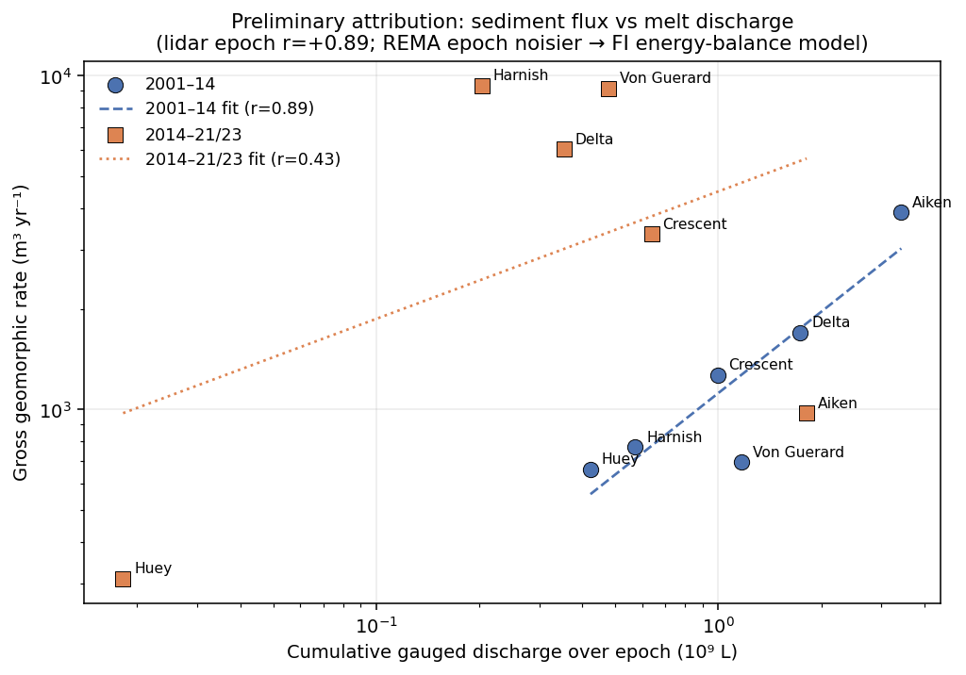
Figure 5. Per-stream gross geomorphic rate vs. cumulative gauged melt discharge. The lidar–lidar epoch shows a strong positive relationship (r = +0.89) — busier streams move more sediment, as expected. The REMA epoch is noisier (r = +0.43; sparse post-2014 gauge coverage and larger satellite LOD). This motivates O1: raw discharge explains the first-order signal but leaves structured residuals, so the proposed work will develop a melt-energy (PDD/insolation/ active-layer) model to close the gap and turn correlation into attribution.
Feasibility summary. These preliminary studies retire the principal execution risk in any FINESST proposal — whether the applicant can run the full pipeline end to end. The proposed research (O1–O3) builds new science on this demonstrated foundation.

5. Feasibility Anchor (FI Qualifications)
The FI independently operates an end-to-end pipeline — "WellSight" — that runs the identical architecture on a completely different landscape: U-Net semantic segmentation on lidar-derived terrain rasters (DEM, slope, local relief, openness), ICP co-registration, and DEM-of-Difference change analysis, applied to Appalachian Plateau channels, roads, and abandoned-well pad scars detected from elevation alone. This independently demonstrates that the method generalizes across sensors and biomes (directly de-risking the proposed O2) and that the FI already commands the full toolchain — a concrete readiness anchor most FI applicants lack. The MDV preliminary studies in §4 extend that same toolchain to this project's target system.

6. Data Requirements and Availability
Every dataset required for the proposed work is free/public, and the FI has already assembled the full stack during preliminary studies (regenerable from source via scripted pipelines), so data availability poses no schedule risk. The single access-gated dependency is Barlow's training labels (mitigated below and in §7).
Category | Source | Availability
A. Terrain — MDV lidar 2001 (ATM/ScienceBase) + 2014 (NCALM/OpenTopography); REMA 2021-23 (PGC) | free/public | ✅ in hand
Per-epoch derivatives (elev/slope/aspect/curv/MFD-flow/intensity) | scripted from terrain | ✅ demonstrated (Taylor pilot)
B. Labels — MCM-LTER stream centerlines (QC) | EDI knb-lter-mcm.6007 | ✅ in hand
Barlow's 217 hand-digitized tiles | author-gated | ⚠️ lone access-gated dependency (see §7)
C. Drivers — LTER met, 21 discharge gauges, glacier mass balance, soil/active-layer | EDI | ✅ in hand
Reanalysis — ERA5 monthly 1993-2024; AMPS 2.67 km | CDS; GDEX | ✅ in hand
D. Cross-valley — all four valleys, both lidar + REMA | OpenTopography/PGC | ✅ DEMs in hand; per-valley stacks to build
E. Validation — WorldView/Maxar (label QC); published rates | PGC (restricted); literature | optional / cross-check vs Barlow

7. Management, Timeline, Risks, and Data Management Plan
FI role & development. The FI is intellectual lead and primary author; the advisor (PI of record) provides domain mentorship. Development plan: present at AGU (cryosphere) and an ISAES/SCAR venue; co-author the attribution paper (O1) as a stand-alone publication; complete graduate coursework in Bayesian/hierarchical modeling and remote-sensing uncertainty.
Timeline (3 years).
Period | Milestones
Yr 1 | Full driver harmonization (PDD/insolation/active-layer series per gauged stream); O1 attribution model on Taylor Valley (extending the Fig. 5 preliminary signal); calibrated-uncertainty prototype (O3). Deliverable: attribution manuscript drafted.
Yr 2 | Cross-sensor domain-shift correction + segmenter generalization across all four valleys (O2); apply attribution model basin-wide; AGU presentation. Deliverable: O2 paper.
Yr 3 | Predictive model (where acceleration migrates next); 3-epoch acceleration attribution; calibrated-uncertainty product release (O3). Deliverable: synthesis/prediction paper + public data products.

Risks & mitigations. (1) Barlow's label tiles are access-gated → mitigation: LTER centerlines already work as a QC stand-in (Fig. 2–3 built on them); plan to request the tiles and, failing that, re-digitize a comparable training set (the WellSight pipeline shows we can build labels). (2) REMA's uneven post-2014 coverage → prioritize Taylor Valley (full 3-epoch coverage) for acceleration; treat other valleys as 2-epoch. (3) Discharge gauge gaps → ERA5/AMPS energy reanalysis fills spatial/temporal holes (a core reason O1 uses melt energy, not just gauges).
Data Management Plan. All input data are free/public (NASA ATM, NCALM/OpenTopography, PGC REMA, MCM-LTER/EDI, Copernicus ERA5, AMPS/GDEX), cited per source. Derived products — change-detection rasters, per-stream rate tables, calibrated-uncertainty layers, and stream-boundary polygons — will be released open-access (DoIs via Zenodo / EDI) with the processing code (PDAL/WhiteboxTools/GDAL + Python). Heavy regenerable rasters are excluded from version control; lightweight scripts, figures, and tables are tracked. Outputs follow ASPRS/OGC standards and carry explicit CRS, method, and uncertainty metadata (per NASA open-science/trustworthy-EO guidance).

References
[1] Barlow, M. C. (2026). A Comprehensive Spatial Analysis of Stream Boundary and Geomorphological Change Detection: McMurdo Dry Valleys, Antarctica. PhD Dissertation, Dept. of Civil & Environmental Engineering, University of Houston (chair: C. L. Glennie). 240 pp.
[2] Barlow, M. C., Zhu, X., & Glennie, C. L. (2022). Stream Boundary Detection of a Hyper-Arid, Polar Region Using a U-Net Architecture: Taylor Valley, Antarctica. Remote Sensing 14(1):234. doi:10.3390/rs14010234. (Dissertation Chapter 4 — proof of concept.)
[3] Höhle, J., & Höhle, M. (2009). Accuracy assessment of digital elevation models by means of robust statistical methods. ISPRS J. Photogramm. Remote Sens. 64(4):398–406. (NMAD / robust DEM error.)
[4] Howat, I. M., et al. (2019). The Reference Elevation Model of Antarctica (REMA). The Cryosphere 13:665–674. (REMA.)
[5] Ronneberger, O., Fischer, P., & Brox, T. (2015). U-Net: Convolutional Networks for Biomedical Image Segmentation. MICCAI 234–241.
[6] McMurdo Dry Valleys LTER. Stream discharge, meteorology, glacier mass-balance, and soil datasets, Environmental Data Initiative (EDI), knb-lter-mcm.*.
[7] Hersbach, H., et al. (2020). The ERA5 global reanalysis. Q. J. R. Meteorol. Soc. 146:1999–2049.

Draft S/T/M section. Figures generated by `barlow/build/_finesst_figures.py`. The results in §4 are preliminary feasibility studies by the FI, not funded-project deliverables. Not a submitted proposal.

