Detection to Attribution: Linking Two Decades of Antarctic Stream-Channel Change to Climate Drivers Utilizing Terrain Data
Summary: Previous work [1] has identified places where Antarctic Dry Valley streams are reshaping the land, but it stops at location and doesn’t examine the causes of stream migration. This project attempts to elucidate the drivers of channel migration. Using remote sensing and machine learning, it links the measured changes to the driving processes (heat, melt, thawing ground), extends the measurement from the channel centerline into the near-channel corridor, and attaches a real uncertainty value to every pixel.
The Setup and the Gap
The McMurdo Dry Valleys (MDVs) are the largest ice-free region of Antarctica. For most of a century they were treated as one of Earth's most stable landscapes, lacking strong erosive forces. That view is now an open question. The valleys are energy-limited: ice is everywhere, and there is barely enough summer heat to melt much of it [9]. A small warming produces a measurable response — ephemeral streams (channels that flow only during a brief melt season) carry more water, move sediment, and reshape the terrain.
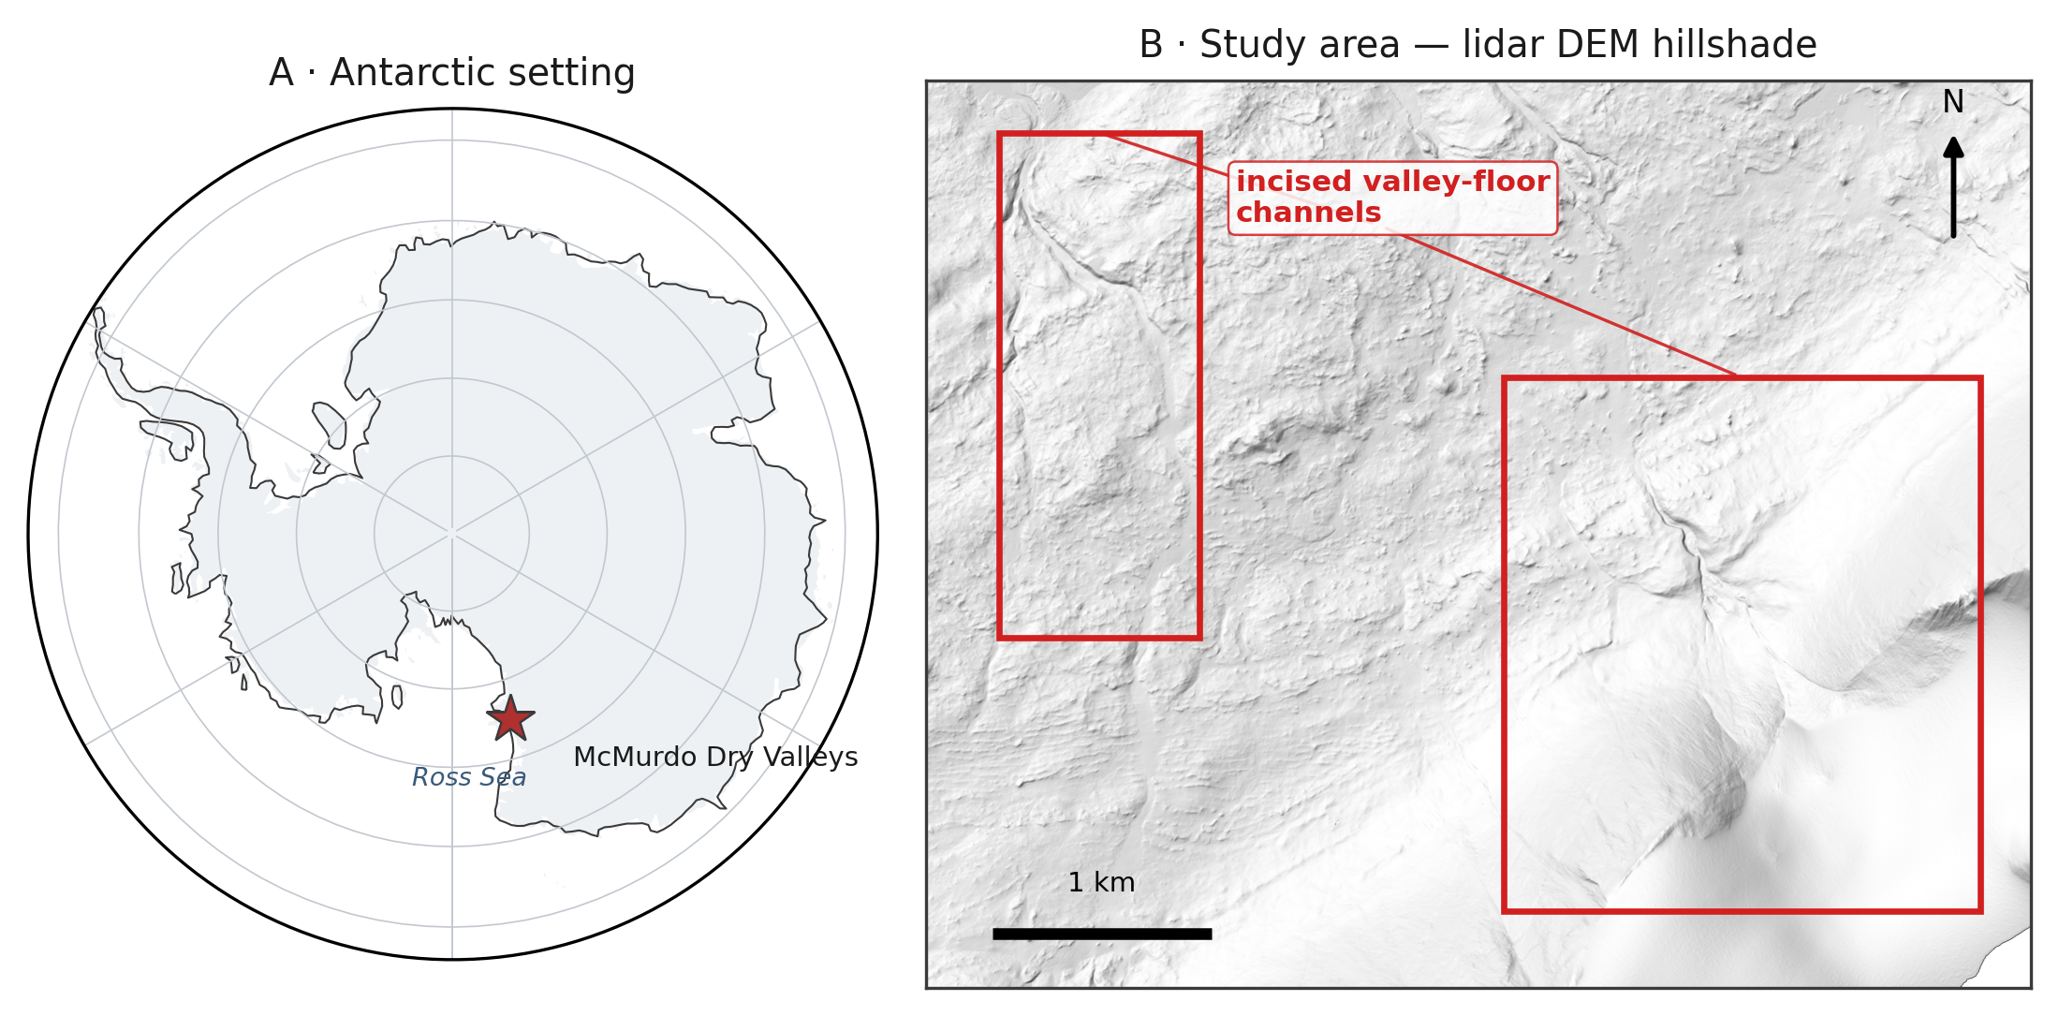
Figure 1. Study area. (A) The McMurdo Dry Valleys within Antarctica (coastline: Natural Earth). (B) Hillshade of the study-area lidar DEM (1 m), showing the incised valley-floor channels this project measures.
Present Data
The prior dissertation and related publications [1, 2] laid the foundation for this study by providing the following initial data products:
- A U-Net ML methodology [5] that finds stream channels using high-resolution terrain (elevation, slope, aspect).
- Initial verification that repeat-acquisition airborne lidar and valley-wide REMA (Reference Elevation Model of Antarctica) satellite DEMs [4] are precise and high-resolution enough to detect stream-corridor change once aligned to external control.
- Maps of elevation change (erosion and deposition) across four Antarctic valleys and three survey periods (2001, 2014, 2021-23).
The Open Question
Detecting where channels change is now feasible; explaining why is not. The open question is which climate drivers set the rate of channel change, and whether melt energy or water volume dominates. This project attributes measured stream-channel change to those drivers and attaches calibrated per-pixel uncertainty to every measurement.
NASA Relevance
The project sits in NASA’s Earth Science Division. The closest programs are Cryospheric Sciences and Terrestrial Hydrology, and both fund work on cold-region surface change and meltwater. The 2001 baseline is NASA data — an airborne lidar swath never fully exploited for surface change [8]. The project turns the airborne lidar, REMA satellite DEMs (corrected and controlled by airborne lidar and ICESat-2 observations) and reanalysis into a continuing, uncertainty-calibrated record of climate-driven surface change in the Dry Valleys. The methods travel beyond the site to any elevation-differencing problem, including the surface-change records NASA missions such as ICESat-2 and NISAR produce. The analysis will also enable future change detection from the high-resolution terrain observations resulting from the possible future Surface Topography and Vegetation (STV) observing system. The Dry Valleys are also the canonical terrestrial analog for cold-desert planetary surfaces such as Mars. The proposed research also develops the skills NASA's open-science strategy calls for: open geospatial data, machine learning on remote sensing, and honest uncertainty.
Objectives
The project considers three objectives:
- Attribution. Determination of which climate drivers control each stream's rate of geomorphic change. Candidate drivers — air temperature, incoming sunlight, meltwater discharge, glacial mass balance, and summer thaw — come from the McMurdo Dry Valleys LTER network (meteorology, stream gauges, glacier mass balance, and soil climate) [6], with ERA5 [7] and AMPS reanalysis filling coverage gaps. We hypothesize that melt energy will predict channel change better than water volume alone (H1). The hypothesis is testable: if discharge alone predicts channel migration as well as melt energy does, the hypothesis fails.Process attribution along the stream corridor. Beyond the channel centerline, classify change in the near-channel corridor — channel shift and avulsion, bank thaw and subsidence, and fan growth — by process type. Bedrock and stable soils outside the corridor provide the fixed reference used to georeference the REMA satellite DEM to the airborne lidar, so change is measured against genuinely stable ground rather than an assumption that the whole surface is moving. We expect each process type to carry its own driver fingerprint. Bank thaw should track summer thaw, channel shift should track peak discharge, and fan growth should follow both (H2). If every process type responds to the drivers the same way, the fingerprint idea fails and the classification carries no explanatory weight.
The satellite record past 2014 exists only on the free REMA DEM, whose elevations are tricky to combine with lidar in terrain-dependent ways. Correcting that is part of the method, not a chief objective.
- Calibrated uncertainty. Provide a per-pixel detection threshold for slope, aspect, and sensor, in place of a single valley-wide noise value. Success test: on ground that did not change, a 95% confidence threshold should be exceeded by 5% of pixels.
Approach
By objective:
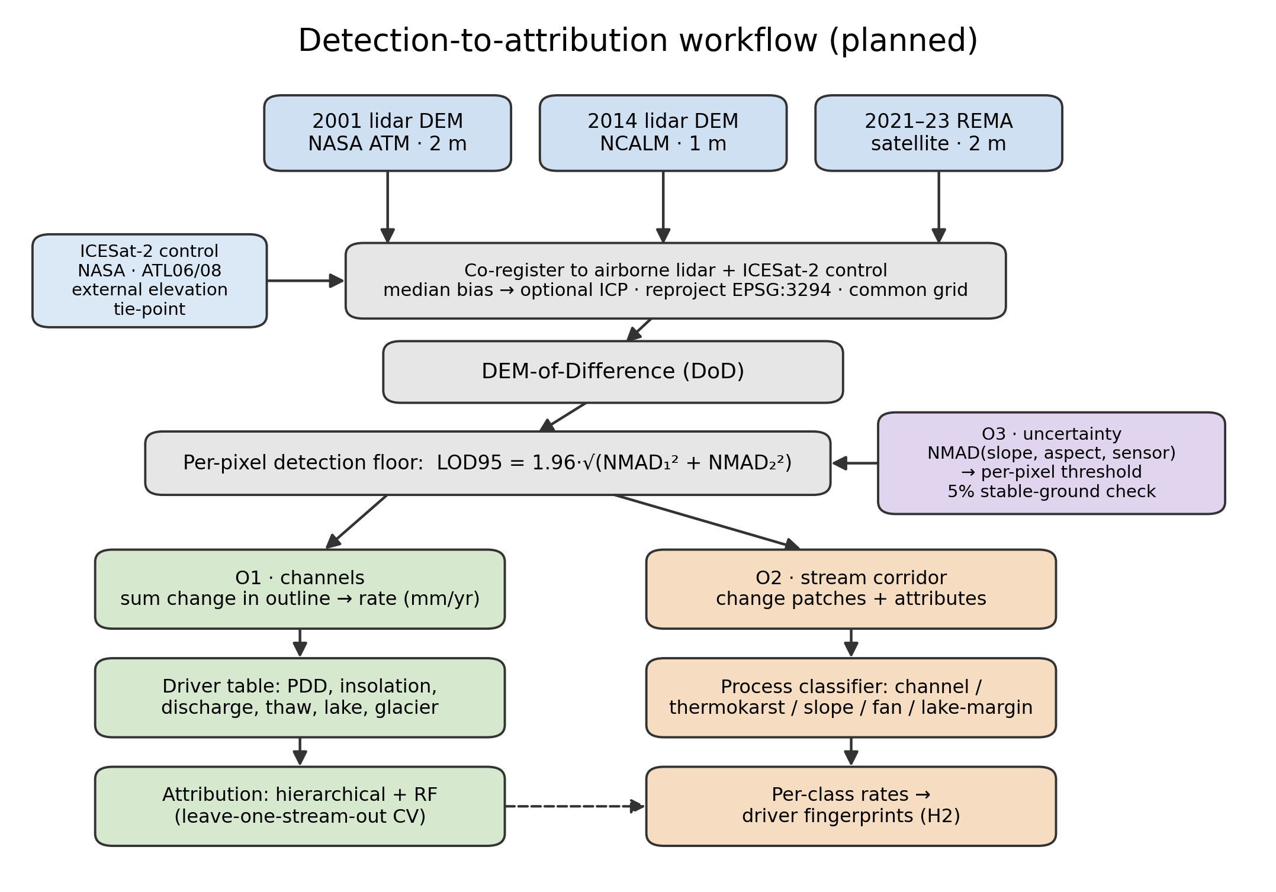
Figure 2. Planned detection-to-attribution workflow: three DEM epochs, co-registration to airborne-lidar and ICESat-2 control, DEM-of-Difference, per-pixel detection floor, then the O1 (channel), O2 (stream-corridor), and O3 (uncertainty) objectives. Method schematic; no results shown.
Objective 1:
- Objective 1 tests whether melt energy predicts channel change better than water volume alone. To test it, I measure each gauged stream's change rate: co-register the two elevation epochs (removing the median vertical offset over stable ground, with an optional ICP refinement), resample to a shared grid, difference them, keep only pixels whose change clears the detection floor (the per-pixel LOD95 threshold from objective 3), and integrate that change inside the channel outline, normalized by channel area and years elapsed to a rate in mm/yr.
- Build each stream's driver history from MDV-LTER station records, filling coverage gaps with the ERA5 and AMPS weather models. Some streams have no gauge and some gauges stopped recording early. For those, estimate discharge from sunlight. Fit a regression between measured discharge and the summer insolation on each gauged stream's source glacier, then apply it to the ungauged streams. That pushes the analysis past the 21 gauged streams and fills in the thin record after 2015.
- Fit two models, a hierarchical regression (grouped by stream) and a random forest. Validate by leave-one-stream-out cross-validation, so every score comes from a stream held out of the fit, and check that the two model families agree.
- Test the melt energy hypothesis against the water volume alternative.
Objective 2:
- Apply the objective-3 per-pixel thresholds along the stream corridor and pull out each change patch as a connected group of super-threshold pixels, dropping patches below a minimum mapping unit to suppress isolated-pixel noise. Bedrock and stable soils flanking the corridor supply the fixed reference used to co-register the sensors, so change is measured against genuinely stable ground. Stable ground is not a judgment call here. It is any area the channel detector marks as non-stream in every epoch, and that computed surface is the reference.
- Describe each patch by area, mean elevation change, local slope and aspect, and distance to the nearest channel and lake, then classify it by process type from that signature. I start with rules and fall back to a learned classifier only if they underperform.
- Run each type’s rates through the objective 1 driver models and compare.
- As mentioned before, I measure the REMA-minus-lidar difference over stable ground, model it against slope and aspect, and remove that bias before mixing the two sensors in any differencing.
Objective 3:
- Model the noise as a function of slope, aspect, and sensor pair instead of a single valley-wide value. I bin the stable-ground differences on those variables, take the NMAD in each bin, and fit a smooth surface through the bins so every pixel carries its own LOD95 (= 1.96 x NMAD) threshold.
- Publish it as a per-pixel threshold map and verify the 5%-on-stable-ground property. There is also a check that assumes nothing about stable ground. Difference a 2014 REMA DEM against the 2014 lidar DEM. Both map the same year, so the true change is zero. Whatever is left over is sensor error, and that is what calibrates the noise model.
Note that all methods use robust statistics [3], since elevation errors here are heavy-tailed and an ordinary standard deviation would be thrown off by a few blunders. The noise scale throughout is the NMAD (1.4826 times the median absolute deviation from the median). For a single surface the detection floor is LOD95 = 1.96 x NMAD; since a difference subtracts two noisy surfaces, their NMADs add in quadrature, so the differencing floor is 1.96 x sqrt(NMAD1^2 + NMAD2^2), the change that noise alone clears only 5% of the time. Everything (DEMs, channel outlines, driver fields) is reprojected to one common Antarctic polar-stereographic grid (EPSG:3294) first, and the two lidar epochs (2 m and 1 m native) are resampled to a shared cell size before differencing.
Project Needs:
All data is freely available or has been given with permission from the author.
Need | Source | Availability
2001 airborne lidar DEM (2 m) | NASA ATM via USGS ScienceBase | public, free
2014 airborne lidar DEM (1 m) + point cloud | NCALM via OpenTopography | public, free
REMA satellite DEM (2 m, 2021–23) | Polar Geospatial Center / AWS | public, free
Stream discharge, 21 gauges (daily) | MCM-LTER via EDI | public, free
Meteorology, glacier mass balance, soil temperature | MCM-LTER via EDI | public, free
ERA5 reanalysis; AMPS Antarctic weather model | Copernicus CDS; NCAR GDEX | public, free
Stream channel outlines (labels) | MCM-LTER via EDI | public, free
The prior dissertation's hand-digitized training tiles | dissertation author | acquired directly from the author
ICESat-2 elevation (external control) | NASA NSIDC DAAC | public, free

Labels. The detector needs training examples. The gold-standard set — the dissertation author's hand-digitized tiles — has been requested and acquired directly.
Computing
A single workstation GPU trains the segmentation models, and the elevation processing is CPU-bound and modest. Free access to the host institution's high-performance computing cluster is available for any heavier batch processing, though the project does not depend on it. Raster stacks reach tens of gigabytes and need only local storage.
Skills and Mentoring
The researcher has built terrain-segmentation and change-detection pipelines on non-Antarctic data but is new to Antarctic hydrology and hierarchical statistical modeling. Coursework and mentorship are detailed elsewhere.
Dissemination
Results will reach the cryosphere community through presentations at AGU and polar-science meetings and through open-access publications and archived data products with DOIs. Because the analysis relies only on public data, it can proceed independently.
Assessment
Several things could go wrong and yield bad or incomplete results.
Attribution Signal
The signal may be weak. With 21 gauged streams and only 3 epochs, the sample is small. If no driver clearly outperforms another, the deliverable becomes a rigorous null result with calibrated uncertainty — useful, if less exciting. The risk is to impact, not feasibility.
Gauge Records
Gauge records are patchy after 2015. Stream gauging in the MDVs declined, and some streams have only a few dozen recorded days in the satellite epoch. This is why objective 1 leans on modeled melt energy rather than gauges alone — though it means the discharge side of the hypothesis is weakest in the most recent period. The sunlight-to-discharge regression in objective 1 buys part of that back. The gauged years teach the proxy, and the proxy then covers the ungauged streams and seasons.
Satellite Coverage
Coverage is uneven. REMA quality varies by location and date. Taylor Valley has the best three-epoch coverage and will anchor the acceleration claims; other valleys may support only two.
Change Scale
Outside the channels, change may be too small to detect. The valley floors change slowly, so much of the surface may sit below our detection threshold. If so, objective 2 stays tight to the channel and its immediate margins, and results are reported at that scope.
Even so, the proposal is worth doing. The MDV streams are the most direct, measurable climate response in one of Earth's most stable landscapes, and the data — two lidar epochs, a satellite record, and LTER station records — already exist and are free.

Timeline
Period | Work | Deliverable
Stage 1 | Rebuild the change-detection chain from public data; harmonize driver records per stream; secure or rebuild training labels; first attribution model (Taylor Valley) | Attribution manuscript drafted; labeled training set archived
Stage 2 | Stream-corridor process attribution (O2), gated by the O3 thresholds; driver tests per change type; sensor-disagreement correction | Process-classification paper; AGU presentation
Stage 3 | Per-pixel calibrated-uncertainty product; three-epoch acceleration analysis; extension beyond Taylor Valley where REMA supports it; synthesis | Synthesis paper; public data products with DOIs

Data Management and Open Science
All inputs are public and cited to source (NASA ATM, NCALM/OpenTopography, PGC REMA, MCM-LTER/EDI, Copernicus ERA5, AMPS/GDEX). All derived products — change rasters, process-classified change maps, per-stream rate tables, uncertainty layers, channel outlines, and processing code — will be released open-access with DOIs (Zenodo / EDI). Heavy regenerable rasters stay out of version control; scripts, tables, and figures are tracked. Products carry explicit coordinate-system, method, and uncertainty metadata.
References
[1] Barlow, M. C. (2026). A Comprehensive Spatial Analysis of Stream Boundary and Geomorphological Change Detection: McMurdo Dry Valleys, Antarctica. PhD Dissertation.
[2] Barlow, M. C., Zhu, X., & Glennie, C. L. (2022). Stream Boundary Detection of a Hyper-Arid, Polar Region Using a U-Net Architecture: Taylor Valley, Antarctica. Remote Sensing 14(1):234.
[3] Höhle, J., & Höhle, M. (2009). Accuracy assessment of digital elevation models by means of robust statistical methods. ISPRS J. Photogramm. Remote Sens. 64(4):398–406.
[4] Howat, I. M., et al. (2019). The Reference Elevation Model of Antarctica (REMA). The Cryosphere 13:665–674.
[5] Ronneberger, O., Fischer, P., & Brox, T. (2015). U-Net: Convolutional Networks for Biomedical Image Segmentation. MICCAI 234–241.
[6] McMurdo Dry Valleys LTER. Stream, meteorology, glacier, and soil datasets. Environmental Data Initiative (EDI), knb-lter-mcm.*.
[7] Hersbach, H., et al. (2020). The ERA5 global reanalysis. Q. J. R. Meteorol. Soc. 146:1999–2049.
[8] Schenk, T., Csatho, B., Ahn, Y., Yoon, T., Shin, S. W., & Huh, K. I. (2004). DEM generation from the Antarctic LiDAR data: Site report. US Geological Survey.
[9] Fountain, A. G., et al. (1999). Physical controls on the Taylor Valley ecosystem, Antarctica. BioScience 49(12):961–971.

