Detection to Attribution: Linking Two Decades of Antarctic Stream-Channel Change to Climate Drivers Utilizing Terrain Data
Summary: Previous work [1] has identified places where Antarctic Dry Valley streams are reshaping the land, but the analysis stops at identifying locations and doesn’t examine the causes of stream migration. This project attempts to elucidate the drivers of channel migration. Using remote sensing and machine learning, it links the measured changes to the driving processes (heat, melt, thawing ground), extends the measurement from the channel centerline into the near-channel corridor, and attaches an estimated uncertainty value to every pixel.
The Setup and the Gap
The McMurdo Dry Valleys (MDVs) are the largest ice-free region of Antarctica. They were long treated as one of Earth's most stable landscapes. That view is now an open question. The valleys are energy-limited: ice is everywhere, and there is barely enough summer heat to melt much of it [2]. A small warming produces a measurable response — ephemeral streams (channels that flow only during a brief melt season) carry more water, move sediment, and reshape the terrain. Their pace of change is an early, direct measure of the ice-free Antarctic crossing a climate threshold [3].
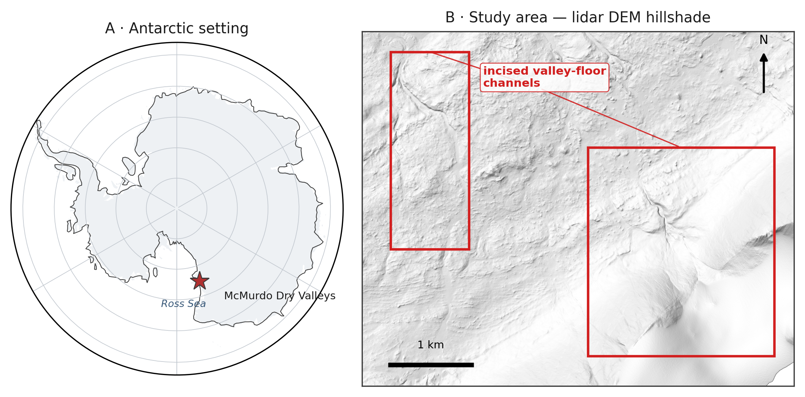
Figure 1. Study area. (A) The McMurdo Dry Valleys within Antarctica (coastline: Natural Earth). (B) Hillshade of the study-area airborne lidar DEM (1 m), showing example incised valley-floor channels this project identifies and mensurates.
Present Data
Recent contributions to knowledge [1, 2] laid the foundation for this study by providing the following initial data products:
- A U-Net ML methodology [4], [5] that automatically identifies stream channels using high-resolution terrain (elevation, slope, aspect).
- Initial verification that repeat-acquisition airborne lidar and valley-wide REMA (Reference Elevation Model of Antarctica) satellite DEMs [6] are precise and high-resolution enough to detect stream-corridor changes once aligned to a common geodetic datum and independent external ground control.
- Partial maps of elevation change (erosion and deposition) across four Antarctic valleys and three survey periods (2001, 2014, 2021-23).
The Open Question
Detecting where ephemeral channels are changing is now feasible; explaining the cause(s) of these changes is not. The open question is which climate or landscape drivers set the rate of channel change, and whether melt energy, water volume or another possible variable dominates. This project attributes measured stream-channel change to those drivers and attaches calibrated per-pixel uncertainty to every measurement of change. Knowing the driver turns monitoring into forecasting, projecting channel response from climate scenarios here and in any polar region with repeat elevation data.
NASA Relevance
The project directly relates to NASA’s Earth Science Division. It spans three of the Division’s research spheres. The Cryosphere covers the glaciers and their meltwater, the Hydrosphere the stream network, and the Geosphere the changing surface topography. The 2001 baseline is NASA data — airborne lidar swath mapping never fully exploited for surface change [7]. The project turns the airborne lidar, REMA satellite DEMs (corrected and controlled by airborne lidar and ICESat-2 observations) and reanalysis into a temporal, uncertainty-calibrated record of climate-driven surface change in the Dry Valleys. The methodology is applicable beyond the McMurdo Dry Valleys to any elevation-differencing problem, including the surface-change records NASA missions such as ICESat-2 and NISAR produce. NISAR's left-looking, 12-day L-band coverage includes the Dry Valleys [8]. It cannot supply DEMs but can flag melt-season bank disturbance as an independent check. The Dry Valleys are also the canonical terrestrial analog for cold-desert planetary surfaces such as Mars. The proposed research also develops the skills NASA's open-science strategy calls for: open geospatial data, machine learning on remote sensing, and rigorous uncertainty.
Objectives
The project considers three objectives:
- Attribution (Objective 1). Determination of the climate and landscape drivers that control each stream's rate of geomorphic change. Candidate controls fall into two groups. Climate forcing includes air temperature, incoming sunlight, meltwater discharge, glacial mass balance, and summer thaw. These records come from the McMurdo Dry Valleys Long Term Ecological Research (LTER) network [9]. Coverage gaps are filled with the European Centre for Medium-Range Weather Forecasts ERA5 reanalysis [10] and the Antarctic Mesoscale Prediction System (AMPS). Substrate susceptibility includes microclimate zone, mapped permafrost and ground-ice class, and bed material, drawn from published MDV mapping [3], [11]. We hypothesize that melt energy will predict channel change better than water volume alone after controlling for substrate (H1). Forcing should matter most where ground ice is present. The hypothesis fails if discharge alone predicts channel migration as well as melt energy does, or if substrate class alone absorbs the explanatory power.
- Process attribution along the stream corridor (Objective 2). Beyond the channel centerline, classify change in the near-channel corridor — channel shift and avulsion, bank thaw and subsidence, and fan growth — by process type. Bedrock and stable soils outside the corridor provide the fixed reference used to georeference the REMA satellite DEM to the airborne lidar and ICESat-2, so change is measured against genuinely stable ground rather than an assumption that the whole surface is moving. We expect each process type to carry its own driver fingerprint. Bank thaw should track summer thaw and ground-ice class, channel shift should track peak discharge, and fan growth should follow both (H2). If every process type responds to the drivers the same way, the fingerprint idea fails and the classification carries no explanatory weight.
- Calibrated uncertainty (Objective 3). Provide a per-pixel detection threshold for slope, aspect, and sensor, in place of a single valley-wide noise value. Success test: on ground that did not change, a 95% confidence threshold should be exceeded by 5% of pixels.
REMA, the only elevation observations past 2014, is built from optical stereo imagery. Its offset from lidar shifts with slope, aspect, and seasonal snow. The terrain-aware uncertainty model absorbs those offsets as part of the method.
Approach
By objective:
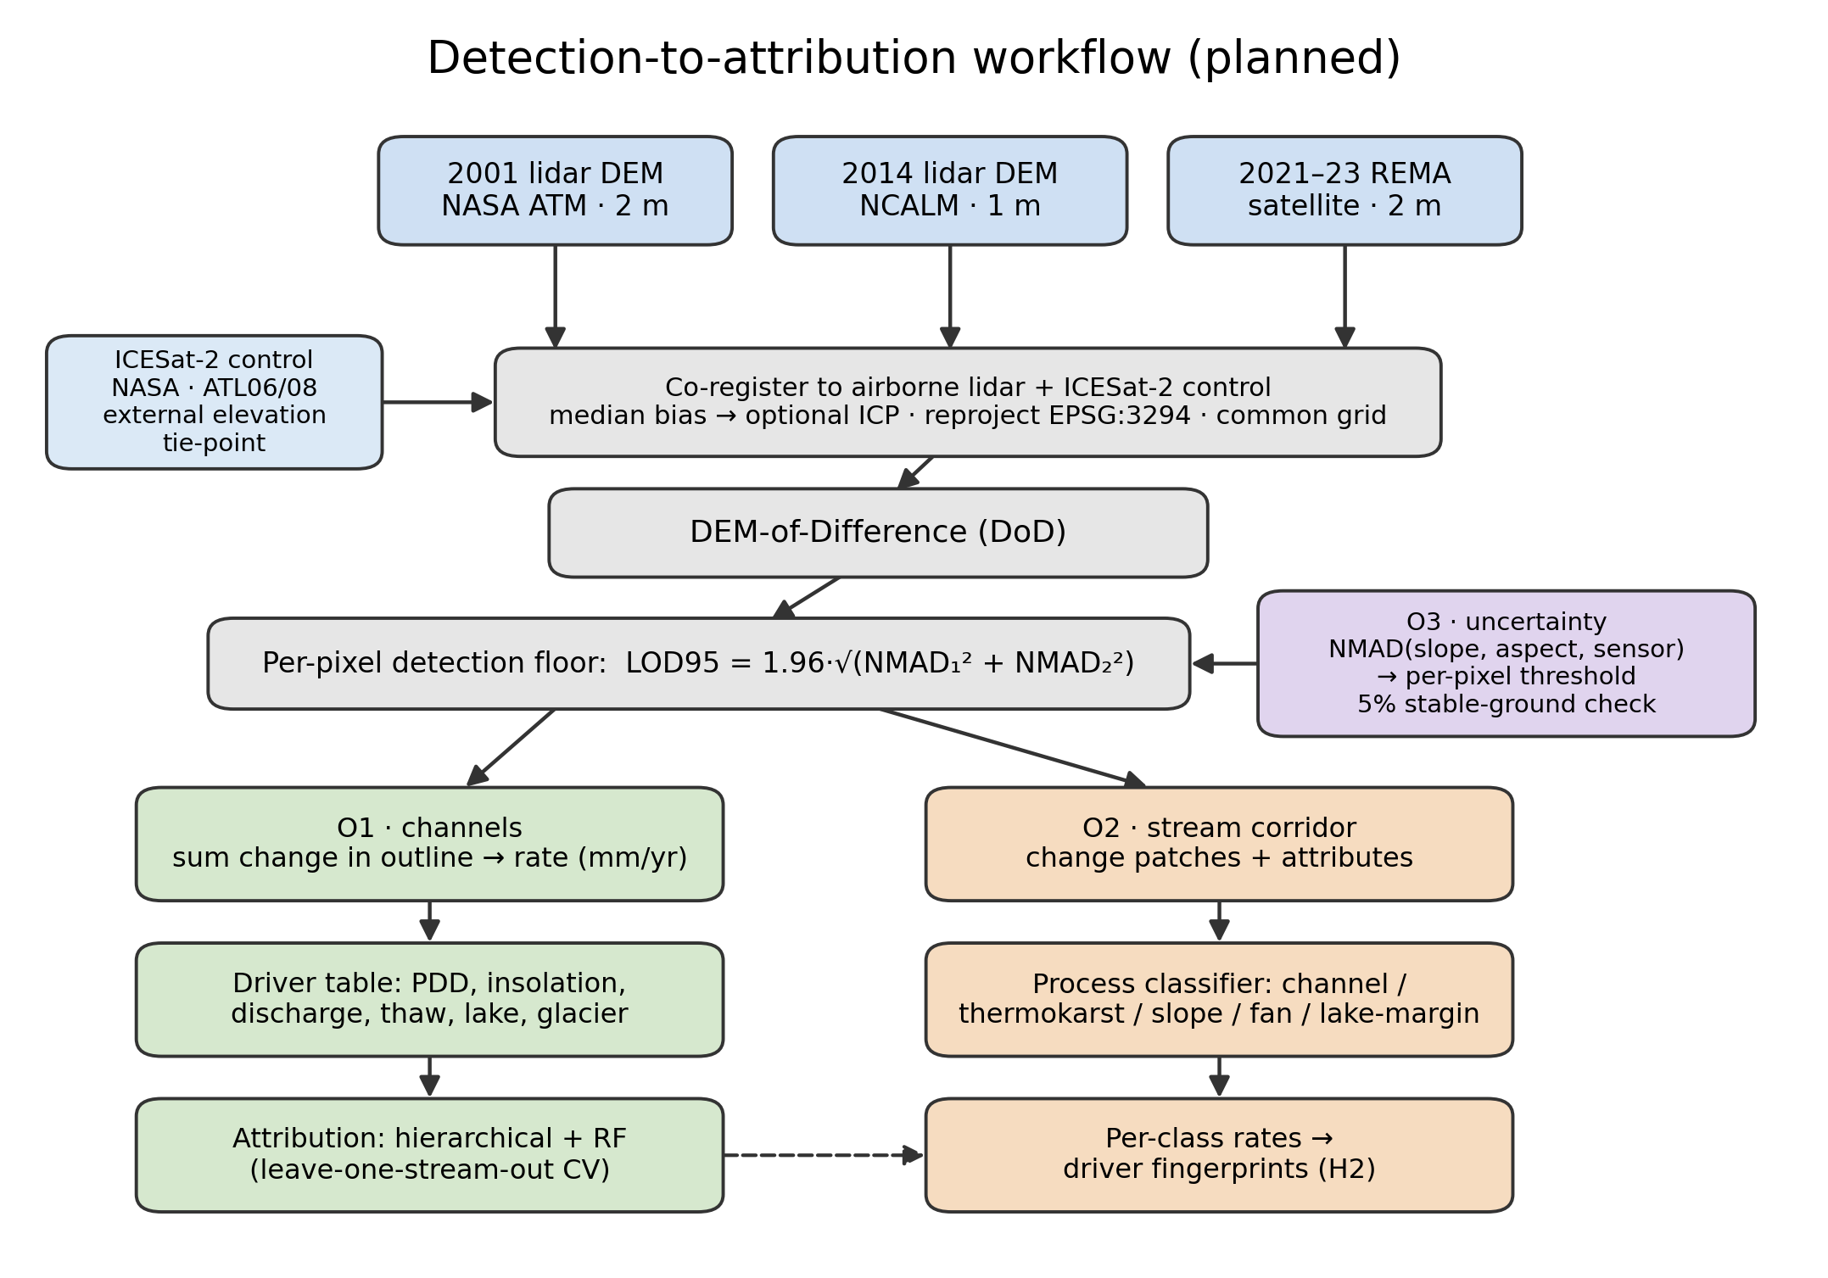
Figure 2. Planned detection-to-attribution workflow: three DEM epochs, co-registration to airborne-lidar and ICESat-2 control, DEM-of-Difference, per-pixel detection floor, then the Objective 1 (channel), Objective 2 (stream-corridor), and Objective 3 (uncertainty) analyses. Method schematic; no results shown.
Objective 1:
- Objective 1 tests whether melt energy predicts channel change better than water volume alone. To test it, each gauged stream's change rate is measured: co-register the two elevation epochs (removing the median vertical offset over stable ground, with an optional iterative closest point (ICP) refinement), resample to a shared grid, difference them, keep only pixels whose change clears the detection floor (the per-pixel level of detection at 95% confidence, LOD95, from Objective 3), and integrate that change inside the channel outline, normalized by channel area and years elapsed to a rate in cm/yr.
- Build a driver history for every stream, gauged or not. ERA5 and AMPS supply temperature and radiation for every basin, per-basin insolation comes from the project DEMs with terrain shading, and substrate covariates come from published maps. The 21 LTER gauge records calibrate a regression between measured discharge and summer insolation on each gauged stream's source glacier, which then covers the ungauged streams and the sparse record after 2015. LTER data calibrate and validate the driver set, but they do not limit its coverage.
- Fit two models, a hierarchical regression (grouped by stream, with substrate covariates) and a random forest, ranking variable importance across the full forcing-plus-substrate set. Validate by leave-one-stream-out cross-validation, so every score comes from a stream held out of the fit, and check that the two model families agree.
- Test the melt energy hypothesis against the water volume alternative, controlling for substrate class.
Objective 2:
- Apply the Objective 3 per-pixel thresholds along the stream corridor and pull out each change patch as a connected group of super-threshold pixels, dropping patches below a minimum mapping unit to suppress isolated-pixel noise. Bedrock and stable soils flanking the corridor supply the fixed reference used to co-register the sensors (using ICESat-2 and 2014 NCALM lidar), so change is measured against genuinely stable ground. Stable ground is defined as any area the channel detector marks as non-stream in every epoch, and that computed surface is the reference.
- Describe each patch by area, mean elevation change, local slope and aspect, and distance to the nearest channel and lake, then classify it by process type from that signature. The classification will start with rules and fall back to a learned classifier only if they underperform.
- Run each process type’s rates through the Objective 1 driver models and compare.
- As mentioned before, the REMA-minus-lidar difference over stable ground can be modeled against slope and aspect, and used to remove any bias before differencing the two sensors.
Objective 3:
- Model the noise as a function of slope, aspect, and sensor pair instead of a single valley-wide value, as previously used, to adaptively estimate the level of change significance. Bin the stable-ground differences on those variables, take the normalized median absolute deviation (NMAD) in each bin, and fit a smooth surface through the bins so every pixel carries its own LOD95 (= 1.96 x NMAD) threshold.
- Publish the per-pixel threshold map and verify the 5%-on-stable-ground property. There is also a check that assumes nothing about stable ground. Difference a 2014 REMA DEM against the 2014 lidar DEM. Both map the same year, so the true change should be zero. Whatever is left over is sensor error, and that is what can be used to calibrate the noise model.
Note that all methods use robust statistics [12], since elevation errors here are heavy-tailed and an ordinary standard deviation would be thrown off by a few blunders. The noise scale throughout is the NMAD (1.4826 times the median absolute deviation from the median). For a single surface the detection floor is LOD95 = 1.96 × NMAD; since a difference subtracts two noisy surfaces, their NMADs add in quadrature, so the differencing floor is
$${LOD}_{95,diff} = 1.96 \sqrt{{NMAD}_{1}^{2} + {NMAD}_{2}^{2}}$$
The change that noise alone clears only 5% of the time. Everything (DEMs, channel outlines, driver fields) is reprojected into one common Antarctic polar-stereographic grid (EPSG:3294) first, and the two lidar epochs (2 m and 1 m native) are resampled to a shared cell size before differencing.
Project Needs:
All data is freely available or has been given with permission from the author of the initial studies.
Need | Source | Availability
2001 airborne lidar DEM (2 m) | NASA ATM via USGS ScienceBase | public, free
2014 airborne lidar DEM (1 m) + point cloud | NCALM via OpenTopography | public, free
REMA satellite DEM (2 m, 2021–23) | Polar Geospatial Center / AWS | public, free
Stream discharge, 21 gauges (daily) | MCM-LTER via EDI | public, free
Meteorology, glacier mass balance, soil temperature | MCM-LTER via EDI | public, free
ERA5 reanalysis; AMPS Antarctic weather model | Copernicus CDS; NCAR GDEX | public, free
Stream channel outlines (labels) | MCM-LTER via EDI | public, free
The prior dissertation's hand-digitized training tiles [1] | dissertation author | acquired directly from the author
ICESat-2 elevation (external control) | NASA NSIDC DAAC | public, free
Permafrost / ground-ice and microclimate-zone maps | published MDV mapping [3], [11] | public, free

Labels. The gold-standard training set, the dissertation author's hand-digitized tiles, has been acquired directly.
Computing
A single workstation GPU trains the segmentation models, and the elevation processing is CPU-bound and modest. The host institution's computing cluster is available for heavier batches, though the project does not depend on it. Raster stacks reach tens of gigabytes and need only local storage.
Skills and Mentoring
The researcher has built terrain-segmentation and change-detection pipelines on non-Antarctic data but is new to Antarctic hydrology and hierarchical statistical modeling. Coursework and mentorship are detailed elsewhere.
Dissemination
Results will reach the cryosphere community through AGU and polar-science presentations, open-access publications, and archived data products with DOIs.
Assessment
The project is designed to keep risk low. The remaining threats that could affect the completeness of the results are described below with their proposed mitigations.
Attribution Signal
The signal may be weak. With 21 gauged streams and only 3 epochs, the sample is small. If no driver clearly outperforms another, the deliverable becomes a rigorous null result with calibrated uncertainty — useful, if less exciting. The risk is to impact, not feasibility.
Gauge Records
Gauge records are patchy after 2015. Stream gauging in the MDVs declined, and some streams have only a few dozen recorded days in the satellite epoch. The sunlight-to-discharge regression in Objective 1 mitigates this risk, though the discharge side of the hypothesis stays weakest in the most recent period.
Satellite Coverage
Coverage is uneven. REMA quality varies by location and date. Taylor Valley has the best three-epoch coverage and will anchor the acceleration claims; other valleys may support only two epochs – this requires a more thorough analysis of the individual available REMA DEMs.
Change Scale
Outside the channels, much of the slowly changing valley floor may sit below our detection threshold. If so, Objective 2 stays tight to the channel and its immediate margins, and results are reported at that scope.
Even so, the proposal is worth doing. The MDV streams are the most direct, measurable climate response in one of Earth's most stable landscapes, and the data — two lidar epochs, a satellite record, and LTER station records — already exist and are free.

Timeline
Period | Work | Deliverable
Stage 1 | Rebuild the change-detection chain from public data; harmonize driver records per stream; secure or rebuild training labels; first attribution model (Objective 1, Taylor Valley) | Attribution manuscript drafted; labeled training set archived
Stage 2 | Stream-corridor process attribution (Objective 2), gated by the Objective 3 thresholds; driver tests per change type; sensor-disagreement correction | Process-classification paper; AGU presentation
Stage 3 | Per-pixel uncertainty product; three-epoch acceleration analysis; extension beyond Taylor Valley | Synthesis paper; public data products with DOIs

Data Management and Open Science
All inputs are public and cited to source, and all derived products and code will be released open-access with DOIs (Zenodo / EDI), as detailed in the accompanying OSDMP.
References
[1] Barlow, M. C. (2026). A Comprehensive Spatial Analysis of Stream Boundary and Geomorphological Change Detection: McMurdo Dry Valleys, Antarctica. PhD Dissertation.
[2] Fountain, A. G., et al. (1999). Physical controls on the Taylor Valley ecosystem, Antarctica. BioScience 49(12):961–971.
[3] Fountain, A. G., Levy, J. S., Gooseff, M. N., & Van Horn, D. (2014). The McMurdo Dry Valleys: A landscape on the threshold of change. Geomorphology 225:25–35.
[4] Ronneberger, O., Fischer, P., & Brox, T. (2015). U-Net: Convolutional Networks for Biomedical Image Segmentation. MICCAI 234–241.
[5] Barlow, M. C., Zhu, X., & Glennie, C. L. (2022). Stream Boundary Detection of a Hyper-Arid, Polar Region Using a U-Net Architecture: Taylor Valley, Antarctica. Remote Sensing 14(1):234.
[6] Howat, I. M., et al. (2019). The Reference Elevation Model of Antarctica (REMA). The Cryosphere 13:665–674.
[7] Schenk, T., Csatho, B., Ahn, Y., Yoon, T., Shin, S. W., & Huh, K. I. (2004). DEM generation from the Antarctic LiDAR data: Site report. US Geological Survey.
[8] NASA-ISRO SAR (NISAR) Mission Science Users' Handbook, 2nd ed. (2025). NASA Jet Propulsion Laboratory.
[9] McMurdo Dry Valleys LTER. Stream, meteorology, glacier, and soil datasets. Environmental Data Initiative (EDI), knb-lter-mcm.*.
[10] Hersbach, H., et al. (2020). The ERA5 global reanalysis. Q. J. R. Meteorol. Soc. 146:1999–2049.
[11] Bockheim, J. G., Campbell, I. B., & McLeod, M. (2007). Permafrost distribution and active-layer depths in the McMurdo Dry Valleys, Antarctica. Permafrost and Periglacial Processes 18(3):217–227.
[12] Höhle, J., & Höhle, M. (2009). Accuracy assessment of digital elevation models by means of robust statistical methods. ISPRS J. Photogramm. Remote Sens. 64(4):398–406.

