Urban LiDAR Point Cloud Classification
Colton Goodrich

Introduction
Urban LiDAR filtering offers a unique challenge. Comprising most terrain types such as buildings, vegetation, pavement, grass, sidewalks, power lines, and cars, it creates a wide variety of terrains that must be analyzed and processed in order to generate a usable dataset. The ultimate deliverable is a classification that feeds DEM generation utilizing footprint extraction of buildings, tree inventory, and proper flagging of aberrant values. This report covers the full pipeline from beginning to end as far as I was able to process. This involves initial QA of data, ground extraction and comparison of different types of filters, and vegetation and building stratification and classification. Overall comparison of various filter values is performed as well.

Data
Our dataset was provided in class and consists of a single .laz file entitled “UH-Lidar-Assignment-2026_UnClassified”. The entire dataset contains 15,357,396 individual lidar points. The dataset shows the regional geometry of the University of Houston Campus, centered on the Bauer College of Business and University Lofts region.
The defined region is roughly 0.44 km², approximately 636 meters by 698 meters, and is illustrated in Figure 1 (Appendix A). Our mean point density is 34.61 pts/m² with a nominal point spacing of 0.170 m. Our return distribution is shown in Table 1.
Table 1: Raw dataset return distribution
Return Category | Total Points | Percent (%)
Single return (1 of 1) | 9,848,860 | 64.13%
First of many | 2,226,277 | 14.50%
Last of many | 2,222,998 | 14.48%
Intermediate | 1,059,261 | 6.90%
Total | 15,357,396 | 100.00%

Methodology

Environment
Given limitations on the part of the writer, the pipelines were executed through a Python subprocess wrapper, allowing for iterative alteration of code through a Jupyter Notebook. PDAL libraries run directly inside Python were unreliable and were discarded in favor of this methodology. Each PDAL pipeline was generated as a JSON file that could be chained in sequence through the Jupyter notebook. Claude (Anthropic) was used as an assistant in cleaning and reorganizing code and in cleaning up this document.

Pre-processing
Preprocessing consisted of several small initial steps meant to limit noise and duplications of points. The PDAL filter filters.outlier was used to drop flagged noise with mean_k = 8 and multiplier = 3.
Before running the feature-based classification, we also applied a Poisson-disk sampling step (filters.sample) to the non-ground points. This thins out areas where points are packed too closely together, which helps the later filters behave more consistently across dense and sparse areas of the scene. The step reduced our non-ground point count from about 7.4 million to 1.2 million. Ground points were left alone and kept at full resolution.

Ground Classification
Ground classification can be done primarily through three different methods: the Progressive Morphological Filter, the Simple Morphological Filter, and the Cloth Simulation Filter. The latter two were used for our methodology for ease of processing.
After multiple iterations, the following parameters were deemed to be the most reliable for our purposes.
Table 2: Cloth Simulation Filter Settings
Parameter | Value | Purpose
Resolution | 1 | Size of our cell
Rigidness | 3 | Stiffness of “draped” cell
Threshold | 0.5 | Proximity of point to be counted as ground
Hdiff | 0.3 | Largest tolerated height difference between neighbors
Smooth | True | Boolean to smooth out cells
Iterations | 500 | How many times to iterate the simulation

Table 3: SMRF Settings
Parameter | Value | Purpose
Cell | 1 | Size of pixel in the built image
Window | 40 | The biggest “window” size in pixels (must be as big as the largest building)
Slope | 0.05 | Allowed natural ground tilt before it is no longer considered ground
Scalar | 1.05 | Height tolerance growth multiplier per window step
Threshold | 0.5 | How high a point can be before it is not considered ground

A side-by-side comparison of the two ground filters is shown in Figure 2 (Appendix A).

Building Classification
Building classification and vegetation stratification are so interconnected that they cannot be discussed separately. Our study area presents dynamic mixtures of flat roofs, vertical walls, dense tree canopy, and ambiguous edge features where geometric rules begin to overlap. The primary building classification pipeline applied the parameters listed in Tables 4 and 5.
Table 4: Roof parameters
Parameter | Value
Planarity | > 0.5
Verticality | < 0.3
Coplanar | > 0
Rank | < 3
Radial Density | < 18 pts/m³

Table 5: Wall parameters
Parameter | Value
Verticality | > 0.7
Normal Z | < 0.3
(strong) Normal Z | < 0.1

Past that classification, last-return enforcement demoted Building points where the return number did not equal the number of returns, passing them as a blanket assignment to vegetation. The resulting building layer after this enforcement pass is shown in Figure 3 (Appendix A).

Refinement
Following this, a more solid wall detection pipeline was run to ensure that as many wall points as possible were removed from the vegetation classification. Extended PDAL features were initially calculated for potential use but were never needed. The covariance features and surface normal Z were modified to use a larger neighborhood of knn = 16, ideally to generate a more stable measurement for the wall surfaces. The wall surfaces presented a unique difficulty as a feature that was vertical, planar, and sparsely sampled — very often showing many parameters in common with vegetation, causing the vast majority of the headaches involved. Table 6 shows the ultimately used parameters, and Figure 4 (Appendix A) shows the walls detected through this refinement.
Table 6: Advanced Wall Parameters
Parameter | Value
Height Above Ground | > 1 m
Verticality | > 0.7
NormalZ | -0.5, 0.5

Corner and edge recovery again proved to be a difficult variable as it had the same problems as the walls did, but with the added difficulty of not having a planar surface. We attempted to solve this by promoting vegetation points according to three separate rules for three different circumstances:
• High linearity greater than 0.6 was used where two walls meet at a vertical corner. The walls doing this show a linear pattern.
• High curvature greater than 0.1 occurs at roof edges and parapets where the surface ends sharply. The bending shows high curvature, which will not be seen when looking at flat roofs or vertical walls.
• Verticality greater than 0.5 and linearity greater than 0.4 was an attempt to capture surfaces that did not fully qualify for the wall rule and were not strong enough for the linear rule. This was an attempt to relax the threshold and stitch them together. All three values are then gated by a height above ground of two meters to prevent low structures from being caught in.
The final refinement applied coplanarity and curvature rules to the accumulated classification output. Coplanar vegetation and noise points were promoted to building. Non-coplanar building points were demoted to vegetation. Low-curvature vegetation points (curvature < 0.05) were promoted to building to capture flat surfaces that persisted in the vegetation layer. Table 7 shows the rules applied.
Table 7: Curvature and coplanarity refinement
Parameter | Value | Target Layer
Coplanar | > 0 | Building
Coplanar | < 1 | Vegetation
Curvature | < 0.05 | Building

The final parameter tuning set was the ultimate result of a long series of attempted iterations through visual inspection in CloudCompare, point distributions, feature histograms, and wild leaps of reasoning. Each revision attempted to address problems that arose, and ultimately none were completely satisfying. Of note is the aberrant values of cars and the inability to differentiate them from low-lying vegetation with any reliability. The final vegetation layer is shown in Figure 5 (Appendix A).

Three-Pass Final Refinement
After curvature refinement, a final three-pass cleanup was applied to give the wall detection logic one more chance to catch facades pulled into vegetation by the earlier rules, and to promote any residual flat surfaces still sitting in the vegetation layer.
Pass A demoted any current building point with Verticality greater than or equal to 0.10 back to high vegetation. This was deliberately loose. The earlier rules promoted many points to building based on planarity, but strongly vertical points among those are more often tree trunks, light poles, or similar non-building vertical features. Flipping them back to vegetation first gave the next pass a clean slate.
Pass B re-ran the wall reclassification on the demoted cloud with covariance features, surface normals, and plane fit recomputed at knn = 16. Any Class 5 or Class 7 point meeting the wall criteria (HAG ≥ 1.0 m, Verticality ≥ 0.70, NormalZ within -0.50 to 0.50) was re-promoted to building, giving actual walls a second chance to be recovered without noise from the over-aggressive planarity-based promotions.
Pass C applied a SurfaceVariation-based reshuffle. Any remaining vegetation point with SurfaceVariation less than 0.25 was promoted to building. SurfaceVariation is a covariance-derived roughness metric where low values indicate locally flat neighborhoods. This caught flat surfaces persisting in vegetation after all prior rules. Building points committed by Pass B were not touched.

Parameter Exploration
The final parameter set was reached through iterative tuning informed by visual inspection in CloudCompare, per-class point distributions, and feature histograms. Each revision addressed a specific observed failure mode in the classified output. Table 8 summarizes the major iterations and the diagnostic observations that motivated each change.
Table 8: Parameter iteration summary
Revision | Key Change | Observation | Resolution
Rev 1 | Absolute Planarity threshold (0.55) as sole building discriminator | Buildings and vegetation swapped — threshold fell on wrong side of distributions | Replaced with feature-dominance approach
Rev 2 | Feature dominance + Scattering veto (0.45) | Ambiguous leaf clusters slipping through | Added planarity margin (0.10) and absolute Scattering veto
Rev 3 | NumberOfReturns == 1 veto | 28% of Class 6 had multi-return — veto silently failing | Discovered PDAL 2.6.0 integer-equality parser bug; switched to inequalities
Rev 4 | RadialDensity veto (radius=0.907 m, threshold=18.0) | Dense canopy passing geometric checks | Volume density provided independent physical signal
Rev 5 | Published Weinmann/Demantké conventions + filters.normal | Empirical thresholds hard to defend | Citable defaults: Planarity > 0.5, Verticality < 0.3 for roofs
Rev 6 | Added approximatecoplanar + estimaterank + Poisson-disk | Residual canopy false positives | Independent confirmation layers + density-stable features
Rev 7 | Dedicated wall pass at knn=16 with extended features | Facades missed at knn=8 scale | Larger neighborhood captured wall geometry correctly
Rev 8 | Corner recovery + coplanarity/curvature refinement | Building edges and flat outlines in vegetation layer | Linearity, Curvature, Coplanar rules targeted geometric edge cases
Final | Three-pass final refinement (demote, walls, SurfaceVariation) | Over-aggressive building promotions mixed with missed walls | Demote-then-reclassify cycle plus SurfaceVariation-based veg reshuffle

Results
CSF was the ultimately used filter and was able to produce continuous coverage across the terrain, roads, and parking. Visual comparison with SMRF confirmed ground selections. Table 9 shows the point count progression through each pipeline stage, and Table 10 shows the final classification distribution.
Table 9: Point count progression by pipeline stage
Stage | Total Points | Notes
Raw input | 15,357,396 | 100% unclassified
After CSF ground | 15,357,396 | Ground identified; remainder temporarily flagged
After main classification | 9,110,747 | Poisson-disk sampling thinned non-ground points
After corner + curvature | 9,110,747 | Reclassification only
After coplanar refinement | 9,110,747 | Reclassification only
After curvature refinement | 9,110,747 | Reclassification only
After Pass A (vertical demote) | 9,110,747 | Reclassification only
After Pass B (wall refine) | 9,110,747 | Reclassification only
After Pass C (SurfaceVariation) | 9,110,747 | Reclassification only
Final (vegetation stratified) | 9,110,747 | Class 5 split into 3, 4, 5 by height

Table 10: Final classification distribution (after vegetation stratification)
Class | Count | Percent (%) | Extrapolated Count | Extrapolated %
2 — Ground | 7,908,909 | 86.81% | 7,908,909 | 51.50%
3 — Low Vegetation | 6,758 | 0.07% | 41,880 | 0.27%
4 — Medium Vegetation | 87,410 | 0.96% | 541,700 | 3.53%
5 — High Vegetation | 607,772 | 6.67% | 3,766,360 | 24.53%
6 — Building | 417,393 | 4.58% | 2,586,600 | 16.84%
7 — Noise | 82,505 | 0.91% | 511,300 | 3.33%
Total | 9,110,747 | 100.00% | 15,356,749 | 100.00%

Building footprints were generated with roof surfaces and partial wall recovery. The wall detection methodology captured some facades that were missed by the primary pipeline. The corner methodology added to this. The three-pass final refinement demoted over-aggressive planarity promotions, re-ran wall detection on the cleaned cloud, and promoted flat surfaces still sitting in vegetation, pushing the final Class 6 count to 417,393 points or 4.58% of the classified total.
Vegetation captured tree canopy, shrubs, ground-level vegetation, and vehicles. Vegetation purity was maintained through aggressive control of coplanarity. The vegetation stratification step applied standard height-band cutoffs, assigning points below 0.5 m as low vegetation, 0.5–2.0 m as medium vegetation, and above 2.0 m as high vegetation. The overwhelming majority of vegetation on this urban campus was high vegetation at 6.67% of the classified total, with medium vegetation at 0.96% and low vegetation at 0.07%. The low vegetation count is small because most ground-adjacent points were already captured by the ground classification stage.

Discussion

What Worked
CSF proved itself valuable as a reliable ground classification tool, especially on this urban campus. It produced a clean and continuous ground surface with very little parameter tuning and was the easiest classification to use.
Coplanarity as a tool for building discrimination proved more effective than continuous planarity thresholds. The boolean coplanar test made building footprints more easily visible. This helped deal with threshold tuning from regular planarity. It is important to note however the limitations of coplanarity when it comes to edge detection.
Volume density or radial density provided some support for point discrimination. Rather than asking a question about shapes, it asks about fullness and acts as a veto against shape qualifiers. A roof would not have high density, a tree would.
Last-return enforcement is a straightforward and logical process proven multiple times. Trees trend towards multiple returns, buildings generally do not.

What Did Not
Absolute planarity thresholds never fully delivered. The published conventions in Weinmann et al. 2015 did not seem adequate to our study area. No single threshold cleanly separated rooftops from tree canopy, and the distributions constantly overlapped.
The rank filter as a scatter veto seemed to have little to no observational impact. Ideally, blocking scattered points should filter out canopy, but because coplanar and radial density were already catching the points, Rank was redundant.
Corner and edge recovery were only partially successful, and the issue again lies with the interspersion of tree canopy and buildings where there was no cleanly defined break between one and the other. The geometry is ambiguous and would require manual correction that PDAL does not support.

Conclusion
The project was to classify an urban university campus airborne LiDAR dataset into ground, building, vegetation, and noise using rule-based pipeline values. Ground classification used the Cloth Simulation Filter (Zhang et al., 2016), selected over SMRF due to simplicity and consistent performance. Building and vegetation separation required iterative development across multiple revisions, ultimately combining coplanarity and dimensionality features as well as surface normals, volume density, and last-return physics, since no single feature was cleanly able to discriminate from one to the other. The constraints and limitations are well known and are a large reason why manual reclassification is still in use today.

References
Pingel, T. J., Clarke, K. C., & McBride, W. A. (2013). An improved simple morphological filter for the terrain classification of airborne LIDAR data. ISPRS Journal of Photogrammetry and Remote Sensing, 77, 21–30.
Weinmann, M., Jutzi, B., Hinz, S., & Mallet, C. (2015). Semantic point cloud interpretation based on optimal neighborhoods, relevant features and efficient classifiers. ISPRS Journal of Photogrammetry and Remote Sensing, 105, 286–304.
Zhang, K., Chen, S.-C., Whitman, D., Shyu, M.-L., Yan, J., & Zhang, C. (2003). A progressive morphological filter for removing nonground measurements from airborne LIDAR data. IEEE Transactions on Geoscience and Remote Sensing, 41(4), 872–882.
Zhang, W., Qi, J., Wan, P., Wang, H., Xie, D., Wang, X., & Yan, G. (2016). An Easy-to-Use Airborne LiDAR Data Filtering Method Based on Cloth Simulation. Remote Sensing, 8(6), 501.

Appendix A: Figures
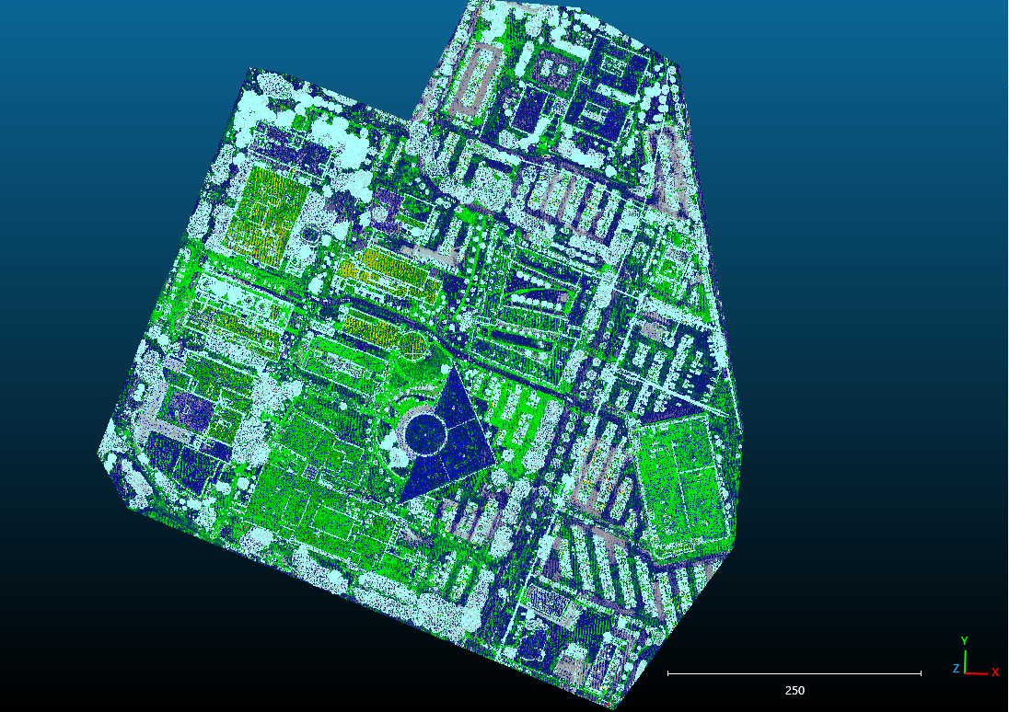
Figure 1: Campus point cloud.
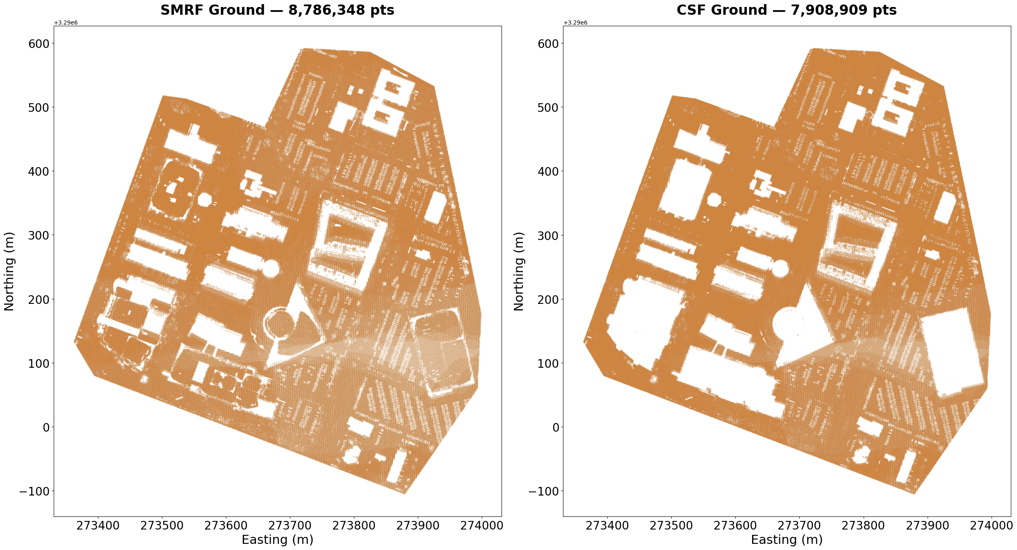
Figure 2: Comparison of SMRF and CSF ground classification. Note the interior of buildings covered due to low window value.
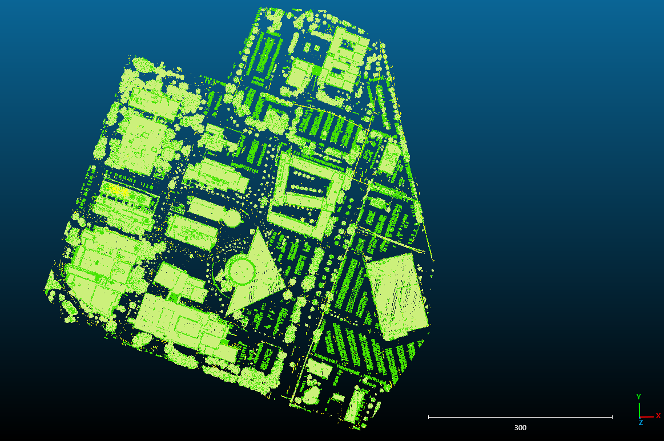
Figure 3: Building classification after last-return enforcement.
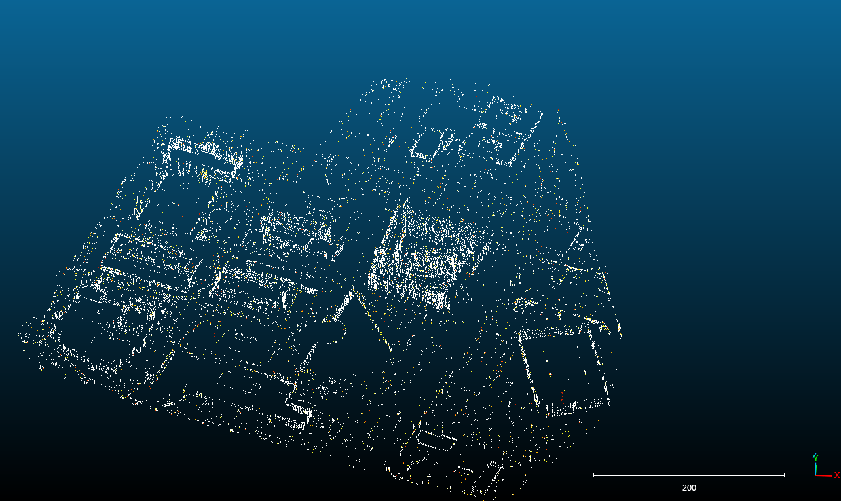
Figure 4: Walls detected through refinement.
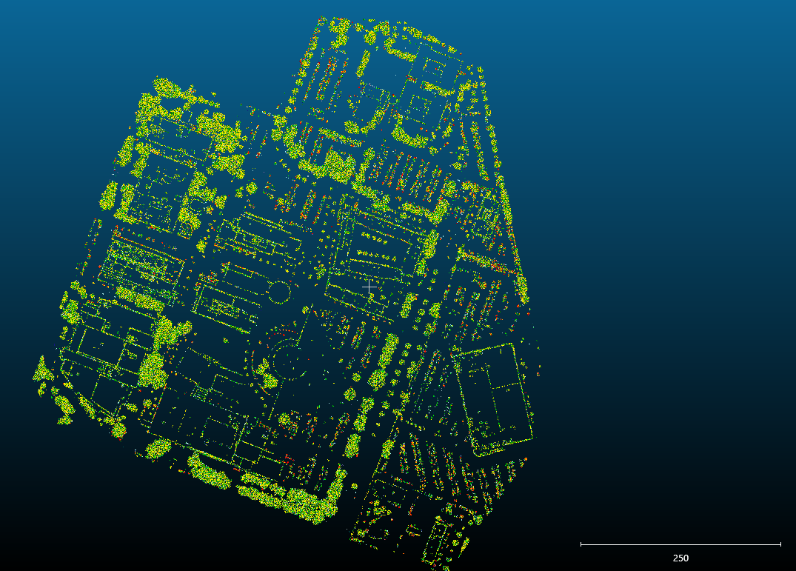
Figure 5: Final vegetation layer.

