WellSight: Morphological Characterization of Orphaned Oil and Gas Well Pits Using Airborne LiDAR in Western Pennsylvania
Colton Goodrich
University of Houston — April 2026

Introduction
Pennsylvania is the birthplace of the American commercial oil industry. The Drake Well, drilled in Titusville in 1859, initiated over 160 years of petroleum extraction across the western portion of the state (PA DEP, 2023). During the late 19th and early 20th centuries, tens of thousands of wells were drilled with minimal documentation and no requirement for proper abandonment. The Pennsylvania Department of Environmental Protection (PA DEP) estimates that more than 200,000 undocumented abandoned wells exist statewide, of which only approximately 8,840 have been formally identified as orphaned wells requiring state intervention (Kang et al., 2014).
These orphaned wells pose significant environmental and public safety hazards. Unplugged wells serve as conduits for methane migration into the atmosphere and groundwater contamination through casing failures. They represent physical hazards where surface subsidence creates unexpected voids. The federal Infrastructure Investment and Jobs Act (2021) allocated $4.7 billion for orphaned well remediation, but the fundamental challenge remains: you cannot plug a well you cannot find.
Current state records are severely inadequate for location work. Cross-referencing PA DEP well coordinates against high-resolution LiDAR terrain data reveals that only 31% of documented well coordinates land within 10 meters of a visible terrain feature, and 87% of expert-identified pit features have no corresponding DEP record within 100 meters—suggesting the documented inventory represents a small fraction of the actual well population.
In the Appalachian Plateau of western Pennsylvania, orphaned wells are invisible to conventional remote sensing. Dense deciduous forest canopy (>95% coverage) completely obscures the subtle terrain depressions that mark collapsed well cellars. Satellite-based approaches, including the deep learning pipeline of Ramachandran et al. (2024) which achieved 0.955 precision and 0.904 recall on well pad detection in arid western basins, show substantially degraded performance in forested terrain where canopy prevents direct observation of ground features.
Airborne LiDAR penetrates forest canopy and resolves sub-meter terrain features in the bare-earth digital elevation model. The surface expression of a collapsed well cellar—a roughly circular depression typically 2–15 meters across and 0.3–2.5 meters deep—is well within the detection capability of modern 3DEP acquisitions at 4+ points per square meter. Archaeological remote sensing has established extensive precedent for LiDAR-based detection of subtle anthropogenic terrain features beneath forest cover (Trier et al., 2019; Chase et al., 2012).
This paper presents WellSight, a pipeline for detecting and morphologically characterizing collapsed well cellar pits using 1-meter resolution bare-earth DEMs derived from USGS 3DEP airborne LiDAR. The scope extends through the morphological characterization phase: establishing quantitative physical dimensions, identifying principal axes of variation, and implementing anomaly detection for training data quality control.

Data

Study Region
The study area encompasses portions of Venango County and McKean County in western Pennsylvania. The terrain is characteristic of the Appalachian Plateau physiographic province: moderate to steep slopes (mean ~10°), deeply incised stream valleys, and dense second-growth deciduous forest. Two primary study areas were developed: a 4.5 km × 4.5 km mosaic in Venango County (540 annotated pits) and a 6.5 km × 6.5 km tile in McKean County (294 annotated pits), with an additional 10 km × 10 km extended tile.

LiDAR Datasets
The primary dataset is USGS 3DEP Western Pennsylvania (2019 acquisition), LAS 1.4 point format 7, EPSG:6346 (NAD83(2011) / UTM zone 17N + NAVD88 height). Point density averages approximately 4 ground returns per square meter, supporting 1-meter resolution rasterization.
Table 1: LiDAR datasets used in this study
Tile | Epoch | Extent | Density | Resolution
Venango 9-tile | 2019 3DEP | 4.5 km x 4.5 km | ~4 pts/m² | 1 m
McKean mk5 | 2019 3DEP | 6.5 km x 6.5 km | ~4 pts/m² | 1 m
McKean mkf | 2019 3DEP | 10 km x 10 km | ~4 pts/m² | 1 m

Ground Truth Annotations
Expert annotations were created in QGIS by visual inspection of multi-azimuth hillshade renderings at 1-meter resolution. The annotation dataset comprises 861 pit point locations marking the center of visible circular depressions, 88 pad polygons outlining leveled clearings, and 96 road line features (19.6 km total) tracing abandoned access roads. Annotations were performed by a single operator focusing on features conclusively identifiable as anthropogenic well-related terrain modifications.

Methodology

Terrain Derivative Generation
Raw LAS point clouds were processed through a PDAL pipeline (CLI via subprocess) to generate bare-earth DEMs via TIN interpolation over ground-classified returns (ASPRS class 2). A digital surface model (DSM) was generated from first-return maximum values, and canopy height model (CHM) computed as DSM minus DEM. A comprehensive terrain derivative stack was computed for each tile using scipy.ndimage convolution operations.
Table 2: Terrain derivative stack
Derivative | Scales | Method | Physical Meaning
Local Relief Model | 3m, 5m, 11m, 25m | Mean subtraction | Residual micro-topography
Topographic Position Index | 5m, 15m, 25m | Annular mean diff. | Local elevation anomaly
Topographic Openness (neg) | 25m search | Yokoyama et al. | Depression enclosure
Slope | 3x3 window | Horn's method | Surface gradient
Roughness | 5m window | Elevation std. dev. | Surface irregularity
Local Relief | 10m disk | Max minus min | Elevation range
Ground Density | 1m cells | Point count | Return coverage
CHM | — | DSM minus DEM | Canopy height

Template-Based Candidate Generation
The pipeline learns the specific morphological signature of collapsed well cellars from annotated examples. For each of 861 annotated pits, a 17×17 cell window (17 m at 1 m resolution) is extracted from five terrain channels (LRM-5, LRM-11, TPI-05, negative openness, hillshade). Each center is auto-snapped to the local LRM-5 minimum within 3 cells to correct annotation imprecision. Per-window mean subtraction normalizes for varying pit depths. The median across all 1,280 successfully extracted cutouts produces the canonical pit template per channel.
PCA(5) + KMeans(3) clustering on the LRM-5 cutouts reveals three morphological sub-types corresponding to variations in symmetry, rim prominence, and wall steepness. Normalized cross-correlation (NCC) is computed between each template and the full-tile raster, then averaged across channels. Peak detection with 5-meter non-maximum suppression extracts candidate locations at the 25th percentile threshold of scores at known pits, producing approximately 628,000 candidates across all tiles.

Geomorphon Enclosure Analysis
For each DEM cell, the geomorphon algorithm (Jasiewicz & Stepinski, 2013) casts 8 rays outward to a specified lookup distance, tracking the maximum zenith angle along each ray. If the zenith exceeds a flatness threshold (1.5°), that direction is classified as "higher." The enclosure count (0–8) tallies how many directions are higher than the center cell. This was computed at three lookup distances (5, 8, and 12 cells) for each tile.
Cells with enclosure ≥6 at lookup distance 8 that were not already within 3 meters of a template candidate were added as supplementary candidates, recovering pits missed by template matching. This hybrid candidate generation strategy produced 838,942 total candidates—210,556 from geomorphon peaks alone.

Feature Engineering
Each candidate receives a 54-dimensional feature vector organized into five groups: depth/contrast features (30) from six terrain channels using inner-ring vs. rim-ring statistics and radial symmetry; surface features (8) from slope, roughness, relief, and CHM; density and template match features (4); geomorphon enclosure counts (6) at three lookup distances, sampled at center and as inner-ring mean; and morphological features (6) including center depth, radial ring profiles, radial monotonicity, and compactness.

Ensemble Classification
Three gradient-boosted models are trained per fold under 5-fold GroupKFold spatial cross-validation with groups defined by 500-meter grid cells: XGBoost (histogram method, max_depth=5, learning_rate=0.05, 500 rounds), LightGBM (leaf-wise, num_leaves=31, learning_rate=0.05, 500 rounds), and HistGradientBoosting (sklearn, max_depth=5, learning_rate=0.05, 500 iterations). All models use class imbalance weighting at an approximately 200:1 negative-to-positive ratio. Out-of-fold predictions are averaged across the three models, then isotonic regression calibrates the ensemble into interpretable probability estimates.

Pit Rim Delineation via Radial Spoke Analysis
A radial spoke-based rim detection algorithm extracts actual pit boundary polygons. For each annotated pit, the center is snapped to the local DEM minimum within 2 meters. Thirty-six spokes are cast outward at 10° intervals, and along each spoke the elevation profile is smoothed (Gaussian, σ=1.0) and its first derivative (slope) computed. The peak slope identifies the pit wall; the rim is located where the slope drops below 15% of its peak value—the transition from pit wall to surrounding terrain.
Each spoke is classified into one of four quality categories: normal (clean wall-to-terrain transition found), flat_early (hit flat surface immediately, typically adjacent to a pad or road), no_wall (no significant slope detected, suggesting flat terrain or annotation error), or max_range (wall never flattened within the 12-meter search radius). The 36 rim points are connected to form the pit boundary polygon.

Morphological Measurement
For each annotated pit, physical parameters are extracted from the DEM: depth from rim mean and maximum, rim radius, effective radius (median distance to the half-depth contour), diameter (2× rim radius), aspect ratio (depth/diameter), rim symmetry (standard deviation of rim elevation at 8 angular samples), volume (cone approximation, ⅓πr²h), LRM depth at 5m and 11m scales, and mean slope within 2 meters of center.

Anomaly Detection for Quality Control
Multivariate anomaly scoring identifies annotations whose morphological profile deviates significantly from the population. Four methods are applied: per-feature z-scores identify the single most aberrant measurement per pit; Mahalanobis distance accounts for parameter correlations to measure overall profile unusualness; Isolation Forest provides non-parametric anomaly scoring; and PCA decomposition locates each pit in reduced-dimensional morphological space. Pits scoring high on these metrics are flagged for expert review.

Results

Detection Performance
The ensemble classifier with geomorphon features achieves ROC-AUC 0.922 and PR-AUC 0.279 under spatially honest GroupKFold cross-validation on 838,876 candidates (54 features, 0.48% positive rate).
Table 3: Precision-recall at probability thresholds
Threshold | Candidates | Hits (≤10m) | Pits Covered | False Pos. | Precision
0.30 | 2,002 | 996 | 513 | 1,006 | 49.8%
0.50 | 912 | 612 | 366 | 300 | 67.1%
0.70 | 350 | 284 | 212 | 66 | 81.1%
0.80 | 109 | 102 | 95 | 7 | 93.6%
0.90 | 101 | 95 | 88 | 6 | 94.1%

At the 0.80 probability threshold, the pipeline identifies 95 distinct annotated pits with 93.6% precision—fewer than 1 in 15 candidates at this confidence level is a false positive.

Geomorphon Enclosure as Discriminative Feature
The geomorphon enclosure count at lookup distance 8 shows strong separation between pit locations and background terrain. Annotated pits average 6.90/8 enclosure (80.7% scoring ≥6; 50.2% fully enclosed at 8/8), versus background terrain at 3.97/8 (7.5% scoring ≥6; 0.6% at 8/8). Adding enclosure as both a classification feature and a candidate generator improved PR-AUC from 0.212 to 0.279 (+31%) and increased the number of positives from 2,324 to 4,003 (+72%).

Pit Rim Delineation
The spoke algorithm successfully delineated 853 of 861 annotated pits (99.1%), with 100% point containment on the Venango and McKean mk5 tiles. On average, 85% of spokes find a clean wall-to-terrain transition, 5% are truncated (indicating pad or road adjacency), and 10% reach maximum search range. Ninety pits (11%) have 25% or more truncated spokes, indicating adjacency to leveled surfaces.
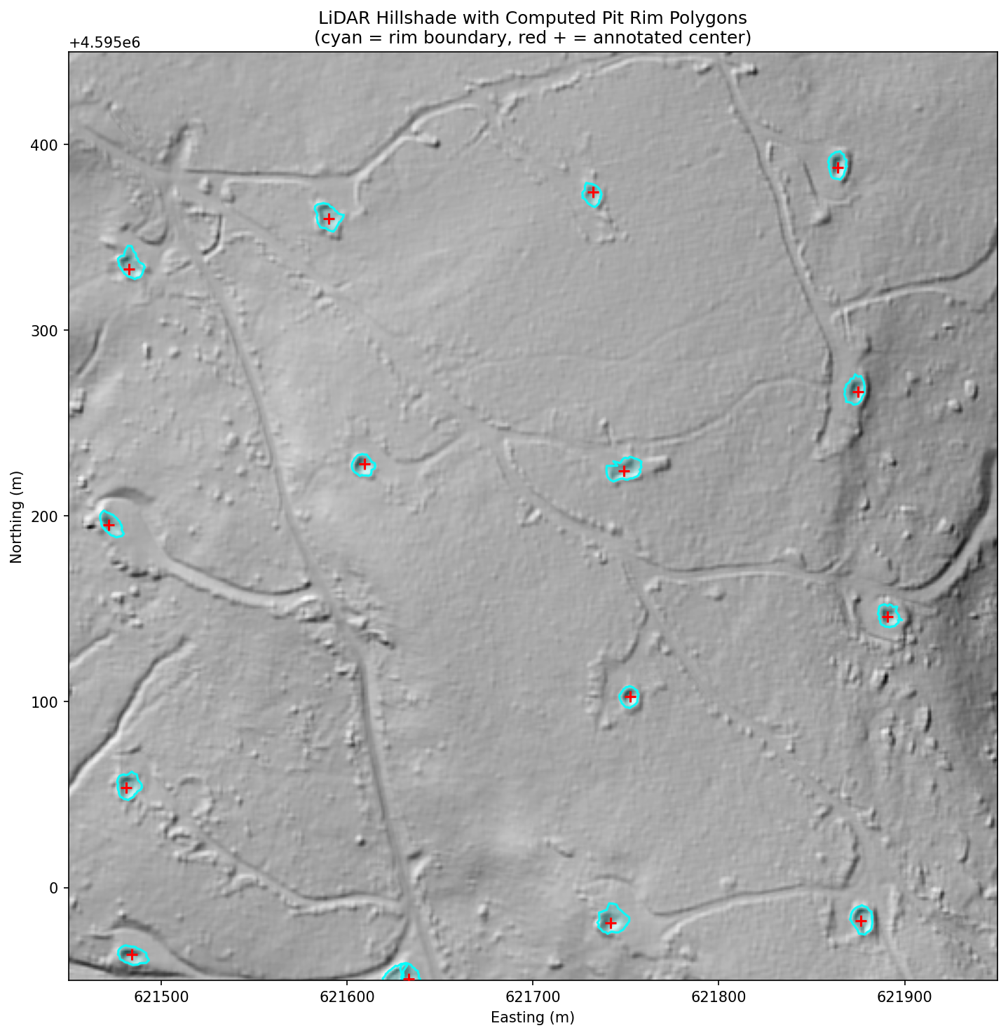
Figure 1: 500m x 500m hillshade crop showing computed rim polygons (cyan) and annotated pit centers (red +).

Morphological Characterization
Table 4: Pit morphology descriptive statistics (n=856)
Parameter | Mean ± SD | Min | Median | Max
Depth — rim mean (m) | 0.72 ± 0.36 | 0.0 | 0.68 | 2.5
Depth — rim max (m) | 1.63 ± 0.71 | 0.1 | 1.50 | 5.9
Rim radius (m) | 6.3 ± 1.4 | 1.0 | 7.0 | 7.5
Diameter (m) | 12.6 ± 2.9 | 2.0 | 14.0 | 15.0
Aspect ratio | 0.059 ± 0.030 | 0.0 | 0.055 | 0.17
Rim symmetry std (m) | 0.70 ± 0.48 | 0.05 | 0.56 | 2.8
Volume (m³) | 32.4 ± 21.8 | 0 | 28.6 | 150
Slope — inner (°) | 10.1 ± 6.1 | 0.4 | 8.4 | 33
LRM-5 depth (m) | –0.14 ± 0.15 | –0.74 | –0.13 | 0.44
LRM-11 depth (m) | –0.33 ± 0.37 | –1.30 | –0.37 | 0.77

The typical collapsed well cellar pit in western Pennsylvania is a shallow bowl approximately 0.7 meters deep and 13 meters in diameter, with an aspect ratio of 0.06 (depth-to-diameter), moderate circularity (0.60), and a volume of approximately 32 cubic meters.
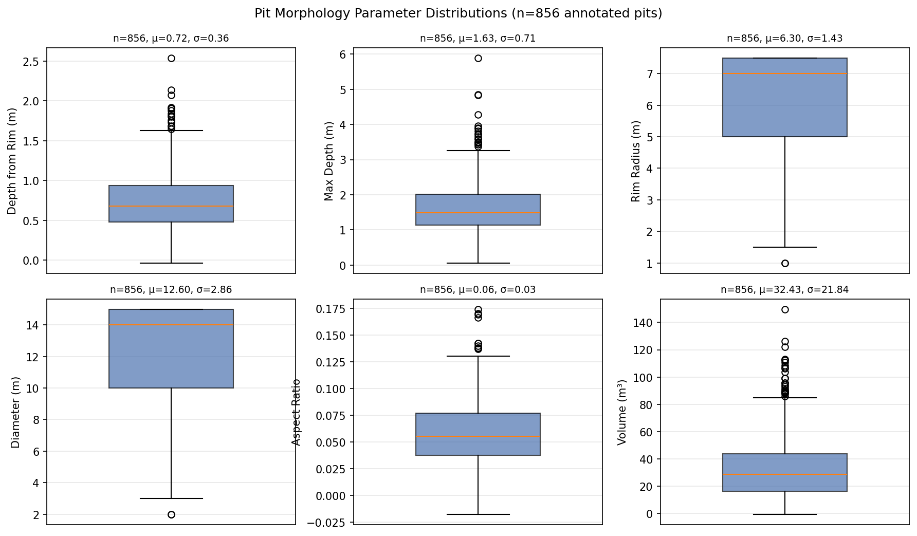
Figure 2: Distribution of key morphological parameters across 856 measured pits.

Principal Component Analysis
PCA on the 11-dimensional morphological feature space reveals three principal axes explaining 86.4% of total variance: PC1 (39.2%) represents overall pit magnitude (depth and volume); PC2 (33.8%) separates large flat depressions from narrow steep ones; PC3 (13.4%) captures rim irregularity. The dominant axis of variation is simply how deep and voluminous a pit is. The second axis separates wide shallow features from narrow steep ones. The third captures asymmetry—distinguishing symmetric bowls from lopsided features with eroded or truncated rims.
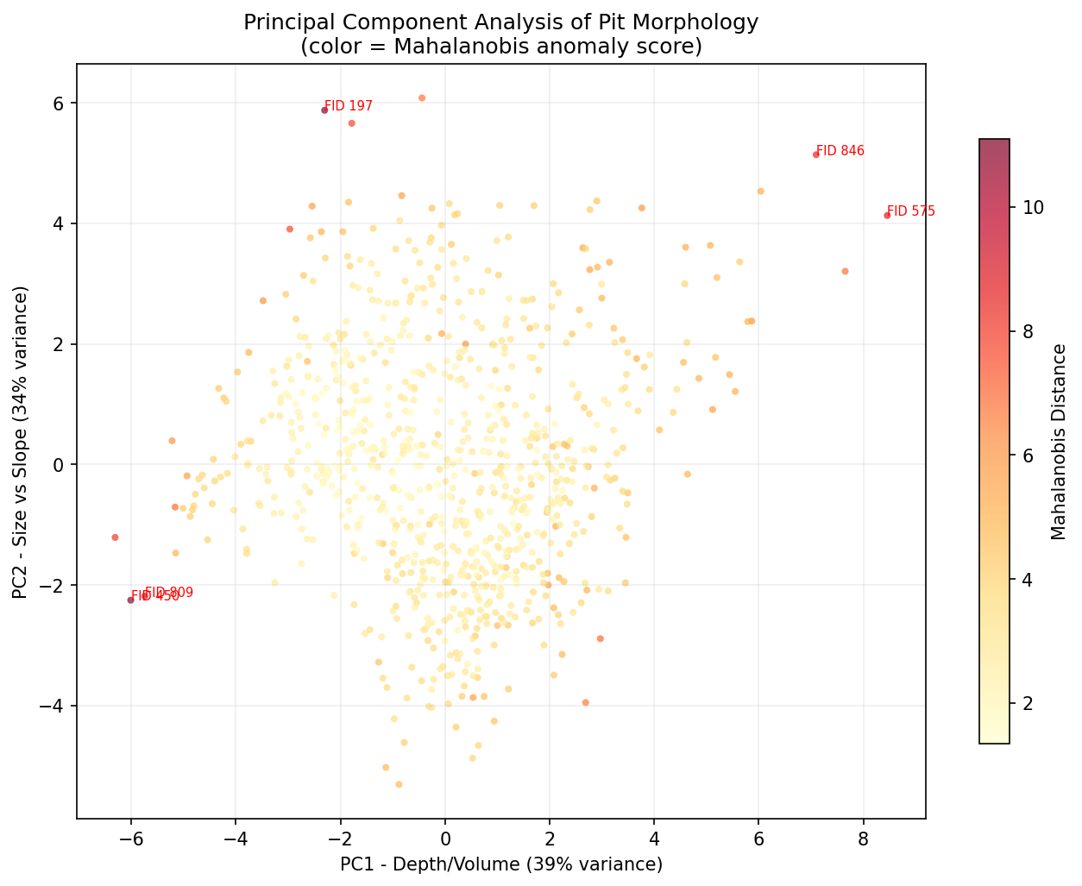
Figure 3: PCA projection of pit morphology colored by Mahalanobis anomaly score. Labeled points are the five most anomalous annotations.

Anomaly Detection
Anomaly scoring flagged 90 pits (10.5%) with Mahalanobis distance exceeding 5.0. The most common anomaly types were: tiny rim radius of 1–1.5 m (23 pits, likely annotation mis-clicks), extreme inner slope >20° (18 pits, annotations placed on hillsides rather than in depressions), negative or zero depth (8 pits, center point not in a depression), extreme volume >100 m³ (5 pits, possible borrow pits or natural features), and high rim asymmetry >2.0 m std (7 pits, partially collapsed or pad-adjacent). Manual review confirmed approximately half represented genuine annotation errors and half represented unusual but legitimate features.

Spoke Quality and Pit Geometry
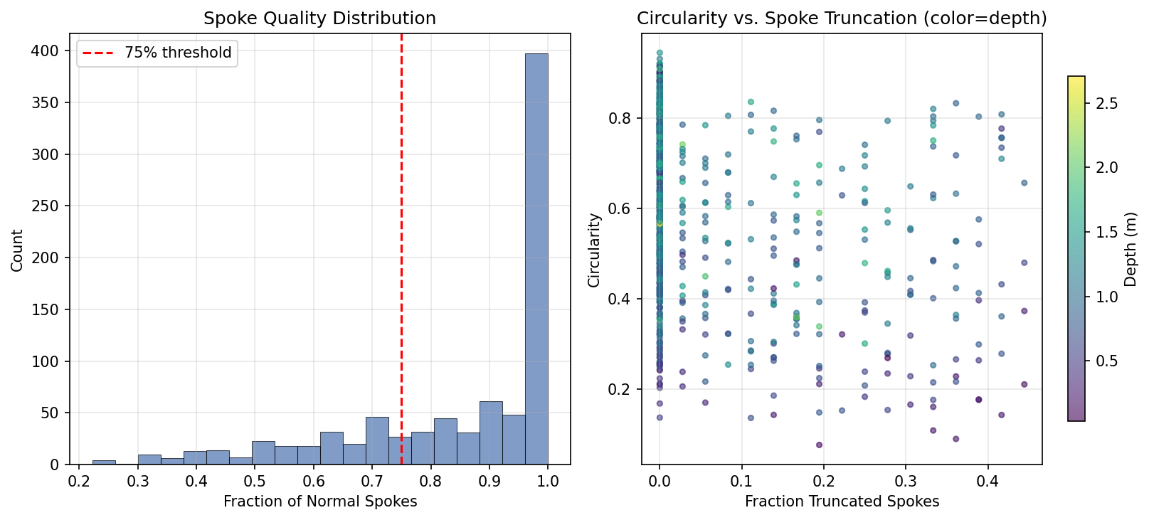
Figure 4: Left—distribution of spoke quality. Right—circularity vs. spoke truncation colored by depth. High truncation indicates pad/road adjacency.
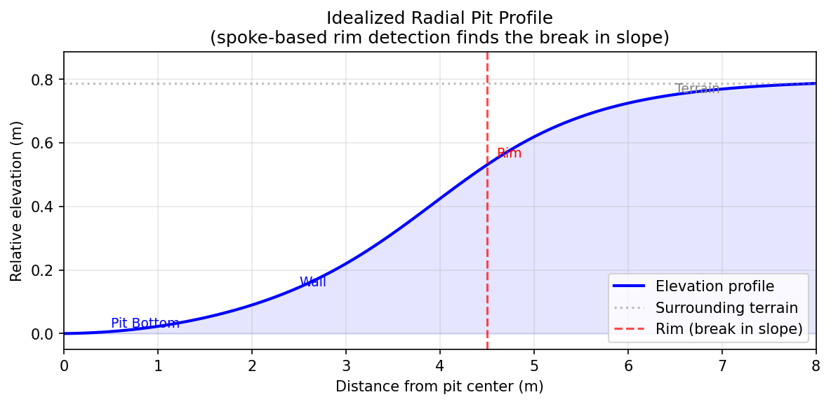
Figure 5: Idealized radial pit profile showing the break-in-slope that the spoke algorithm identifies as the rim boundary.

Discussion

Morphological Constraints on Detection
The typical pit depth of 0.7 meters is well above the vertical noise floor of 3DEP LiDAR (typically ±5–10 cm RMS on bare earth), making these features theoretically detectable. However, the aspect ratio of 0.06 means these are extremely shallow features relative to their diameter—a depression that is 13 meters wide but only 0.7 meters deep is subtle in absolute terms and easily confused with natural terrain undulation. The LRM-5 depth value at pit centers averages only -0.14 meters, confirming that after trend removal at the 5-meter scale, the residual pit signal is remarkably small. Detection therefore relies on the combination of multiple terrain metrics rather than any single discriminator.

The Pad-Adjacency Problem
The spoke quality analysis quantifies a phenomenon visible throughout the study area: pits frequently sit on the edge of cleared well pad surfaces. When this occurs, spokes directed toward the pad find no wall, producing a truncated, asymmetric polygon. Eleven percent of pits exhibit this pattern, and these are the features that single-metric detectors struggle with—their TPI and LRM values are diluted by the adjacent flat surface. The geomorphon enclosure count partially addresses this: a pit adjacent to a pad still reads 6–7/8 enclosed, giving the model a feature that remains discriminative when traditional annular statistics are degraded.

Annotation Quality
The anomaly detection framework identified 90 potentially problematic annotations (10.5% of the dataset). This finding has practical implications for iterative pipeline improvement: removing confirmed annotation errors and retraining should improve model performance, particularly at the high-confidence end of the probability spectrum where training label noise most directly impacts calibration.

Comparison with Previous Work
The satellite-based approach of Ramachandran et al. (2024) achieves superior performance in open terrain (Permian Basin: precision 0.955, recall 0.904) but cannot detect sub-canopy features in forested landscapes. The two approaches are complementary: satellite methods for open and arid basins, LiDAR methods for forested eastern terrain. The morphological parameters established here are broadly consistent with the archaeological LiDAR literature on anthropogenic pit detection, though well cellar pits are smaller and shallower than most archaeological features previously studied.

Conclusion
This study establishes the quantitative morphological signature of collapsed oil and gas well cellar pits in western Pennsylvania’s forested Appalachian terrain. The typical feature is a shallow bowl (depth 0.7 m, diameter 13 m, aspect ratio 0.06) that is subtle but detectable in 1-meter LiDAR-derived DEMs. A radial spoke-based rim delineation algorithm captures actual pit boundaries by identifying the break-in-slope transition from pit wall to surrounding terrain, handling asymmetric and pad-adjacent features through per-spoke quality classification.
The detection pipeline combining template matching, geomorphon enclosure analysis, and gradient-boosted ensemble classification achieves 94% precision at the highest confidence tier (probability ≥0.80), recovering 95 of 861 annotated pits with fewer than 7 false positives. The geomorphon enclosure count proves particularly valuable both as a classification feature (mean 6.9/8 at pits vs. 4.0 background) and as a candidate generator (recovering 72% more positives than template matching alone).
Multivariate anomaly detection provides a systematic approach to training data quality control, identifying 10.5% of annotations as statistically aberrant and worthy of expert review. The morphological parameter database—depth, radius, volume, circularity, spoke quality, anomaly scores—is delivered as a GeoPackage suitable for direct use in GIS workflows and further analysis.
The core finding is that collapsed well cellars possess a measurable, learnable terrain signature that persists beneath forest canopy—and that signature can be systematically detected, delineated, and characterized from publicly available LiDAR data.

References
ASPRS. (2019). LAS specification 1.4-R15. American Society for Photogrammetry and Remote Sensing.
Chase, A. F., Chase, D. Z., Weishampel, J. F., Drake, J. B., Shrestha, R. L., Slatton, K. C., Awe, J. J., & Carter, W. E. (2012). Airborne LiDAR, archaeology, and the ancient Maya landscape at Caracol, Belize. Journal of Archaeological Science, 38(2), 387–398.
Jasiewicz, J., & Stepinski, T. F. (2013). Geomorphons — a pattern recognition approach to classification and mapping of landforms. Geomorphology, 182, 147–156.
Kang, M., Kanno, C. M., Reid, M. C., Zhang, X., Mauzerall, D. L., Celia, M. A., Chen, Y., & Onstott, T. C. (2014). Direct measurements of methane emissions from abandoned oil and gas wells in Pennsylvania. Proceedings of the National Academy of Sciences, 111(51), 18173–18177.
Pennsylvania Department of Environmental Protection. (2023). Orphan and abandoned well plugging program. PA DEP Bureau of Oil and Gas Planning and Program Management.
Ramachandran, N., Irvin, J., Omara, M., Gautam, R., Meisenhelder, K., Rostami, E., Sheng, H., Ng, A. Y., & Jackson, R. B. (2024). Deep learning for detecting and characterizing oil and gas well pads in satellite imagery. Nature Communications, 15(1), 7036. https://doi.org/10.1038/s41467-024-50334-9
Trier, Ø. D., Cowley, D. C., & Waldeland, A. U. (2019). Using deep neural networks on airborne laser scanning data: Results from a case study of semi-automatic mapping of archaeological topography. Archaeological Prospection, 26(2), 165–175.
USGS. (2025). Lidar base specification (rev. A). U.S. Geological Survey.
Yokoyama, R., Shirasawa, M., & Pike, R. J. (2002). Visualizing topography by openness: A new application of image processing to digital elevation models. Photogrammetric Engineering and Remote Sensing, 68(3), 257–265.

Appendix A: Figures
Figure A1: Ensemble model performance progression showing impact of geomorphon features and candidate generation.

