Detection to Attribution: Linking Two Decades of Antarctic Stream-Channel Change to Climate Drivers Utilizing Terrain Data
Colton Goodrich
Summary: A working tool generated by Barlow (2026) presently is capable of finding where Antarctic Dry Valley streams are reshaping the land but the tool stops at location. It says where, never why. This project starts at that line. I’ll connect the measured change to the processes driving it (heat, melt, thawing ground), widen the measurement from the stream channels to the whole valley floor, and attach a real uncertainty value to every pixel.

The Setup and the Gap
The McMurdo Dry Valleys (MDVs) are the largest ice-free region of Antarctica. For most of a century, they have been treated as an incredibly stable landscape on Earth due to the lack of erosive forces. But the view is becoming less of a surety and more of an open question. The valleys themselves are energy-limited. Ice is everywhere but there is barely enough summer heat to ever melt any significant part of it. A small increase in that warming can produce a measurable response. That response is ephemeral streams (periodic channels that flow only during a brief melting season) which can carry more water, move sediment, and reshape the terrain.
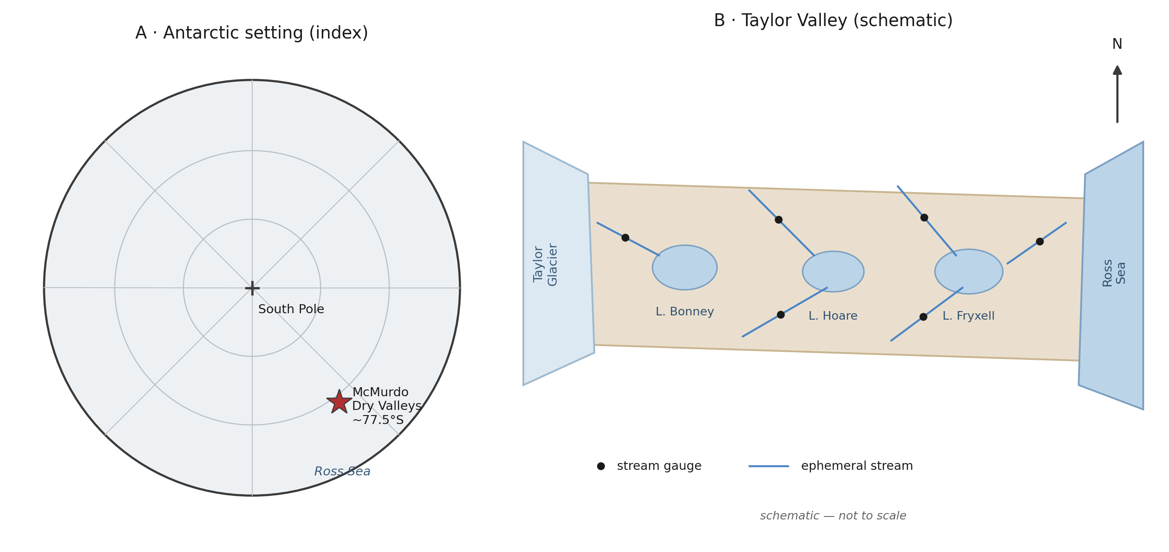
Figure 1. Study-area orientation (schematic): the McMurdo Dry Valleys within Antarctica (A) and the Taylor Valley stream-lake system (B). For orientation only - not to scale, no data shown.
Present Data
Barlow (2026) in her Ph.D. dissertation built the following function.
- A neural network through U-Net that finds stream channels from terrain shape alone (elevation, slope, aspect) without any existing need for water or color. This is an important part of the study given the lack of any water in any channels for upwards of eleven months in the year.
- Evidence that the continent wide REMA satellite elevation model is accurate enough to detect the stream corridor changes once it has been appropriately aligned to airborne LiDAR.
- Maps of elevation change due to erosion or deposition across four valleys and three survey periods (2001, 2014, 2021-2023).
Current Data Deficiencies
The dissertation is heavily descriptive in showing where change happens. But the larger question put forth by Barlow is why this happens. What climate variables are driving this change? Given that the original body of work was masked only to stream channels, everything the elevation differencing measures outside them (thawing ground, fans, and so on) was set aside for further work. This proposal aims to complete that unfinished work.
NASA Relevance
The 2001 baseline data utilized is NASA data. An airborne LiDAR swath that has never fully been utilized for surface change. The project aims to convert that dataset utilizing free satellite elevation models and reanalysis into continuing uncertainty calibrated records of climate altered surface change in the Dry Valleys. The methods deliverables extend not just at the study site but also into any elevation differencing problem including the surface change records that NASA missions such as ICESat-2 and NISAR produce. The Dry Valleys are also the canonical terrestrial analog for cold desert planetary surfaces, suggesting that this may also provide valuable insights into cold desert planetary surfaces, namely Mars. The project is to develop the skills that existing strategy calls for, namely open geospatial data, machine learning combined with remote sensing and honest uncertainty.
Objectives
Our main objectives are three fold.
- Attribution. Determine which climate drivers control each stream’s rate of geomorphic change. Candidate drivers for this include air temperature, incoming sunlight, meltwater discharge, glacial mass, and summer thaw. Current expectation is that melt energy predicts sediment movement better than water volume alone. This is testable. If discharge alone predicts fine, the hypothesis fails.
- Landscape wide geomorphic change. Extend the change measurement from inside the stream channels to the whole valley-floor surface, and classify each patch of significant change by the process responsible. Which would be channel shift or avulsion, subsidence impacted from thaw, slope movement, growth of any depositional fans, and lake margin modification.
It is worth noting that our satellite record past 2014 is only on the free REMA DEM, and satellite elevations are tricky to combine with LiDAR in terrain dependent methodology. Correcting that may be a part of the method but not a chief objective.
- Calibrated uncertainty. Replace the single valley noise estimate used in the dissertation with a per-pixel detection threshold accounting for slope, aspect, and sensor. The test of success is limited by: if the ground did not change, a 95% confidence threshold should be exceeded by 5% of pixels.
Approach
Our approach is as follows:
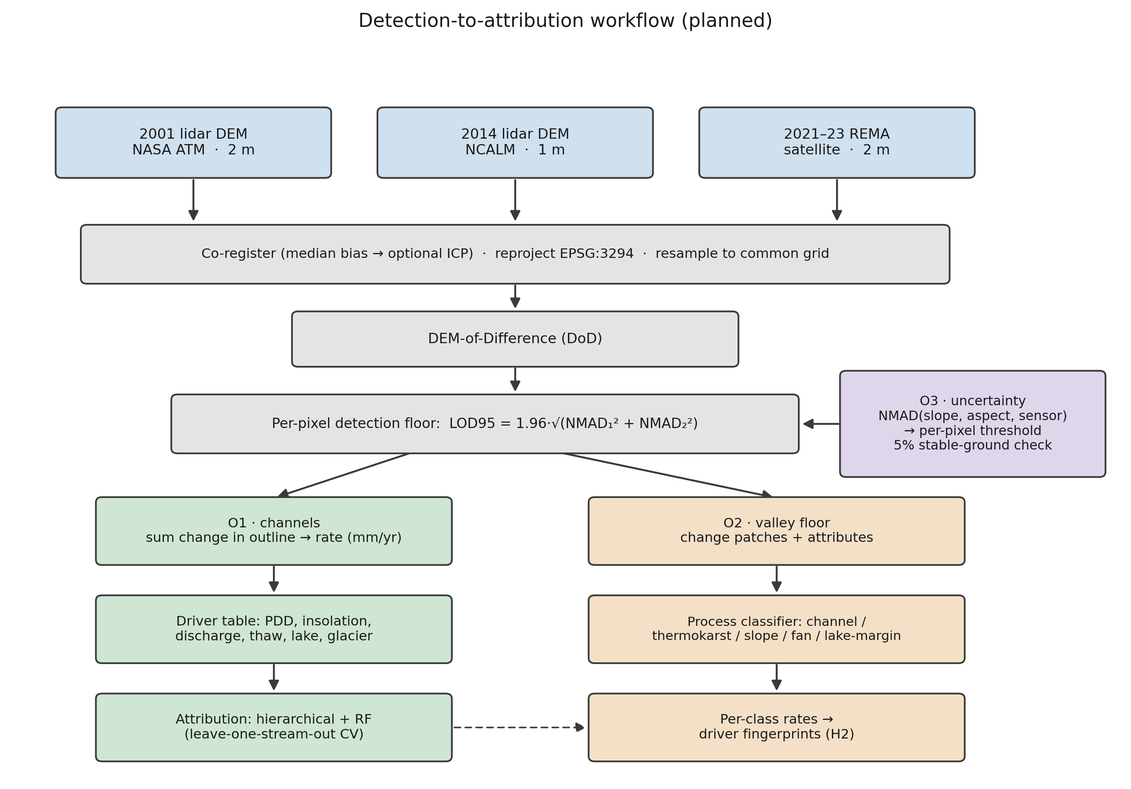
Figure 2. Planned detection-to-attribution workflow: three DEM epochs, co-registration, DEM-of-Difference, per-pixel detection floor, then the O1 (channel), O2 (valley-floor), and O3 (uncertainty) objectives. Method schematic; no results shown.
Objective 1:
- Compute each gauged stream's change rate. First I co-register the two elevation epochs (removing the median vertical offset over stable ground, with an optional ICP alignment to refine it), resample them to a shared grid, and difference them. I keep only the pixels whose change clears the detection floor (the per-pixel LOD95 threshold from objective 3), sum that surviving change inside the stream's channel outline, and normalize by channel area and by the years elapsed to get a specific rate in millimeters per year.
- Build each stream’s history from the MDV-LTER station records and from the ERA5 and AMPS weather models where coverage has existing gaps.
- Fit two models, a hierarchical regression (grouped by stream) and a random forest. Validate by leave-one-stream-out cross-validation, so every score comes from a stream held out of the fit, and check that the two model families agree.
- Test the melt energy hypothesis against the water volume alternative.
Objective 2:
- Apply the per-pixel thresholds from objective 3 across the whole valley-floor surface and pull out every patch of change as a connected group of pixels that clear the threshold. I drop patches smaller than a minimum mapping unit (a few pixels) to suppress isolated-pixel noise, and screen out near-level standing water, whose apparent change is lake-level rise rather than ground change — those go to the lake-margin class and the lake-level driver instead.
- Describe each patch by its area, mean elevation change, local slope and aspect, and distance to the nearest channel and lake, then classify it by process type from that signature. I start with rules on those attributes and only fall back to a learned classifier if the rules underperform.
- Run each type’s rates through the objective 1 driver models and compare.
- As mentioned before, I measure the REMA-minus-LiDAR difference over stable ground, model it against slope and aspect, and remove that bias before mixing the two sensors in any differencing.
Objective 3
- Model the noise as a function of slope, aspect, and sensor pair instead of a single valley-wide value. I bin the stable-ground differences on those variables, take the NMAD in each bin, and fit a smooth surface through the bins so every pixel carries its own LOD95 (= 1.96 x NMAD) threshold.
- Publish the result as a per pixel threshold map and verify the 5% on the ground property.
Note that all methods use robust statistics, since elevation errors here are heavy-tailed and an ordinary standard deviation would be thrown off by a few blunders. The noise scale throughout is the NMAD (1.4826 times the median absolute deviation from the median). For a single surface the detection floor is LOD95 = 1.96 x NMAD; since a difference subtracts two noisy surfaces, their NMADs add in quadrature, so the differencing floor is 1.96 x sqrt(NMAD1^2 + NMAD2^2), the change that noise alone clears only 5% of the time. Everything (DEMs, channel outlines, driver fields) is reprojected to one common Antarctic polar-stereographic grid (EPSG:3294) first, and the two lidar epochs (2 m and 1 m native) are resampled to a shared cell size before differencing.

Project Needs:
All data is freely available, or has been given with permission from the author.
Need | Source | Availability
2001 airborne lidar DEM (2 m) | NASA ATM via USGS ScienceBase | public, free
2014 airborne lidar DEM (1 m) + point cloud | NCALM via OpenTopography | public, free
REMA satellite DEM (2 m, 2021–23) | Polar Geospatial Center / AWS | public, free
Stream discharge, 21 gauges (daily) | MCM-LTER via EDI | public, free
Meteorology, glacier mass balance, soil temperature | MCM-LTER via EDI | public, free
ERA5 reanalysis; AMPS Antarctic weather model | Copernicus CDS; NCAR GDEX | public, free
Stream channel outlines (labels) | MCM-LTER via EDI | public, free
Barlow's hand-digitized training tiles | dissertation author | acquired directly from the author

Labels. The detector requires training examples. The gold-standard set are the dissertation author’s hand digitized tiles, and those have been requested and acquired directly.
Computing
A single workstation GPU is sufficient for training the segmentation models; the elevation processing is CPU-bound and modest. No supercomputer allocation is presently required. Full valley raster stacks run to tens of gigabytes and will require just local storage, not specialized infrastructure.
Skills and Mentoring
The researcher has experience in building terrain segmentation and change-detection pipelines on non-Antarctic data but is new to regional Antarctic hydrology and hierarchical statistical modeling. Coursework and mentorship is detailed elsewhere.
Community Contact
The dissertation author has been contacted presently and is responsive. Continued cooperation is helpful but not strictly vital. Every analysis moving forward can be conducted with public data.

Assessment
Moving forward in the project, we must consider the capabilities of processes going wrong, giving bad or incomplete information and so on.
Attribution Signal
The signal may be weak. With roughly 20 gauged streams and only 3 epochs, the sample is not terribly large. If no driver clearly outperforms another, the deliverable becomes a rigorous null result with calibrated uncertainty. Useful but not as dramatic or exciting. Our risk here is for impact, not feasibility.
Gauge Records
Gauge Records are patchy after 2015. Stream gauging in the MDVs declined and some streams only seem to have a few dozen recorded days in the satellite epoch. This is why objective one leans on us modeling the melt energy rather than relying on gauges alone. Unfortunately, this means the discharge side of the hypothesis is the weakest in the most recent period.
Satellite Coverage
Coverage is uneven. REMA quality varies by location and date. Taylor Valley has the best three epoch coverage and is useful to anchor our acceleration claims. Other valleys may have only two.
Change Scale
Outside of the channels, the change may be too small to detect. The valley floors beyond the streams change slowly so much of the surface may sit below our detection threshold. If so, our second objective goes back to in-channel change and the landscape wide result is adjusted accordingly.
Given all the potential difficulties, this proposal is worth doing anyway. The MDV streams are the most direct and measurable climate response in one of the most stable landscapes on Earth. The data to study them, two LiDAR epochs, a satellite record, and LTER station records already exist and are free.
Timeline
Period | Work | Deliverable
Stage 1 | Rebuild the change-detection chain from public data; harmonize driver records per stream; secure or rebuild training labels; first attribution model (Taylor Valley) | Attribution manuscript drafted; labeled training set archived
Stage 2 | Landscape-wide change detection + process-type classification (O2), gated by the O3 thresholds; driver tests per change type; sensor-disagreement correction | Process-classification paper; AGU presentation
Stage 3 | Per-pixel calibrated-uncertainty product; three-epoch acceleration analysis; extension beyond Taylor Valley where REMA supports it; synthesis | Synthesis paper; public data products with DOIs

Data Management and Open Science
All inputs are public and cited to source (NASA ATM, NCALM/OpenTopography, PGC REMA, MCM-LTER/EDI, Copernicus ERA5, AMPS/GDEX). All derived products — change rasters, process-classified change maps, per-stream rate tables, uncertainty layers, channel outlines, and processing code — will be released open-access with DOIs (Zenodo / EDI). Heavy regenerable rasters stay out of version control; scripts, tables, and figures are tracked. Products carry explicit coordinate-system, method, and uncertainty metadata.
References
[1] Barlow, M. C. (2026). A Comprehensive Spatial Analysis of Stream Boundary and Geomorphological Change Detection: McMurdo Dry Valleys, Antarctica. PhD Dissertation, University of Houston (chair: C. L. Glennie).
[2] Barlow, M. C., Zhu, X., & Glennie, C. L. (2022). Stream Boundary Detection of a Hyper-Arid, Polar Region Using a U-Net Architecture: Taylor Valley, Antarctica. Remote Sensing 14(1):234.
[3] Höhle, J., & Höhle, M. (2009). Accuracy assessment of digital elevation models by means of robust statistical methods. ISPRS J. Photogramm. Remote Sens. 64(4):398–406.
[4] Howat, I. M., et al. (2019). The Reference Elevation Model of Antarctica (REMA). The Cryosphere 13:665–674.
[5] Ronneberger, O., Fischer, P., & Brox, T. (2015). U-Net: Convolutional Networks for Biomedical Image Segmentation. MICCAI 234–241.
[6] McMurdo Dry Valleys LTER. Stream, meteorology, glacier, and soil datasets. Environmental Data Initiative (EDI), knb-lter-mcm.*.
[7] Hersbach, H., et al. (2020). The ERA5 global reanalysis. Q. J. R. Meteorol. Soc. 146:1999–2049.

Claude Fable was used for proofreading.

