Detection to Attribution: Linking Two Decades of Antarctic Stream-Channel Change to Climate Drivers Utilizing Terrain Data
Summary: A tool from Barlow (2026) can find where Antarctic Dry Valley streams are reshaping the land, but it stops at location. It says where, never why. This project starts at that line. I'll connect the measured change to the processes driving it (heat, melt, thawing ground), widen the measurement from the stream channels to the whole valley floor, and attach a real uncertainty value to every pixel.
The Setup and the Gap
The McMurdo Dry Valleys (MDVs) are the largest ice-free region of Antarctica. For most of a century they were treated as one of Earth's most stable landscapes, lacking strong erosive forces. That view is now an open question. The valleys are energy-limited: ice is everywhere, but there is barely enough summer heat to melt much of it. A small warming produces a measurable response — ephemeral streams (channels that flow only during a brief melt season) carry more water, move sediment, and reshape the terrain.
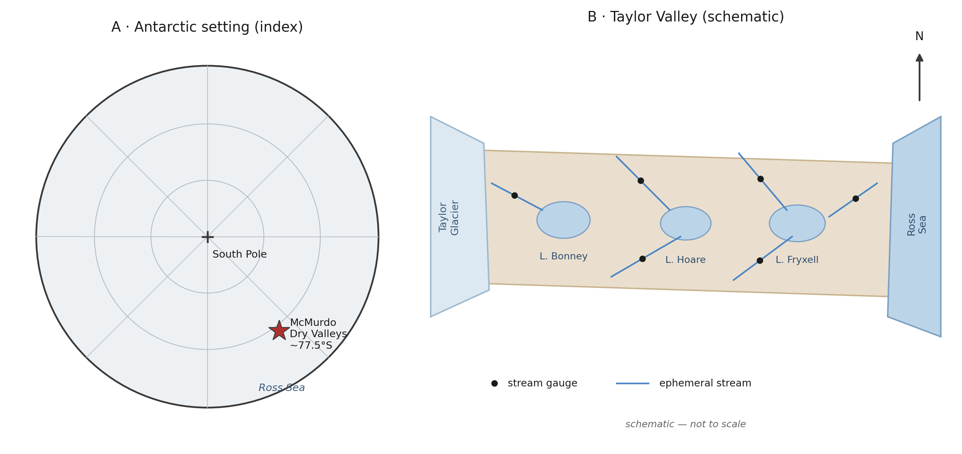
Figure 1. Study-area orientation (schematic): the McMurdo Dry Valleys within Antarctica (A) and the Taylor Valley stream-lake system (B). For orientation only - not to scale, no data shown.
Present Data
Barlow's (2026) dissertation built the following:
- A U-Net that finds stream channels from terrain shape alone (elevation, slope, aspect), with no need for water or color. This matters because the channels are dry for eleven months a year.
- Evidence that the continent-wide REMA satellite DEM is accurate enough to detect stream-corridor change once aligned to airborne LiDAR.
- Maps of elevation change (erosion and deposition) across four valleys and three survey periods (2001, 2014, 2021-23).
Current Data Deficiencies
The dissertation is descriptive: it shows where change happens. Barlow's larger question is why — which climate variables drive it. Because that work was masked to the stream channels, everything the elevation differencing measured outside them (thawing ground, fans) was set aside. This proposal completes it.
NASA Relevance
The 2001 baseline is NASA data — an airborne LiDAR swath never fully exploited for surface change. The project turns it, with free satellite DEMs and reanalysis, into a continuing, uncertainty-calibrated record of climate-driven surface change in the Dry Valleys. The methods travel beyond the site to any elevation-differencing problem, including the surface-change records NASA missions such as ICESat-2 and NISAR produce. The Dry Valleys are also the canonical terrestrial analog for cold-desert planetary surfaces such as Mars. It also develops the skills NASA's open-science strategy calls for: open geospatial data, machine learning on remote sensing, and honest uncertainty.
Objectives
Three objectives:
- Attribution. Determine which climate drivers control each stream's rate of geomorphic change. Candidate drivers: air temperature, incoming sunlight, meltwater discharge, glacial mass, and summer thaw. I expect melt energy to predict sediment movement better than water volume alone. It is testable: if discharge alone predicts as well, the hypothesis fails.
- Landscape-wide geomorphic change. Extend the measurement from the stream channels to the whole valley floor, and classify each patch of change by process: channel shift or avulsion, thaw subsidence, slope movement, fan growth, and lake-margin change.
The satellite record past 2014 exists only on the free REMA DEM, whose elevations are tricky to combine with LiDAR in terrain-dependent ways. Correcting that is part of the method, not a chief objective.
- Calibrated uncertainty. Replace the dissertation's single valley-wide noise estimate with a per-pixel detection threshold for slope, aspect, and sensor. Success test: on ground that did not change, a 95% confidence threshold should be exceeded by 5% of pixels.
Approach
By objective:
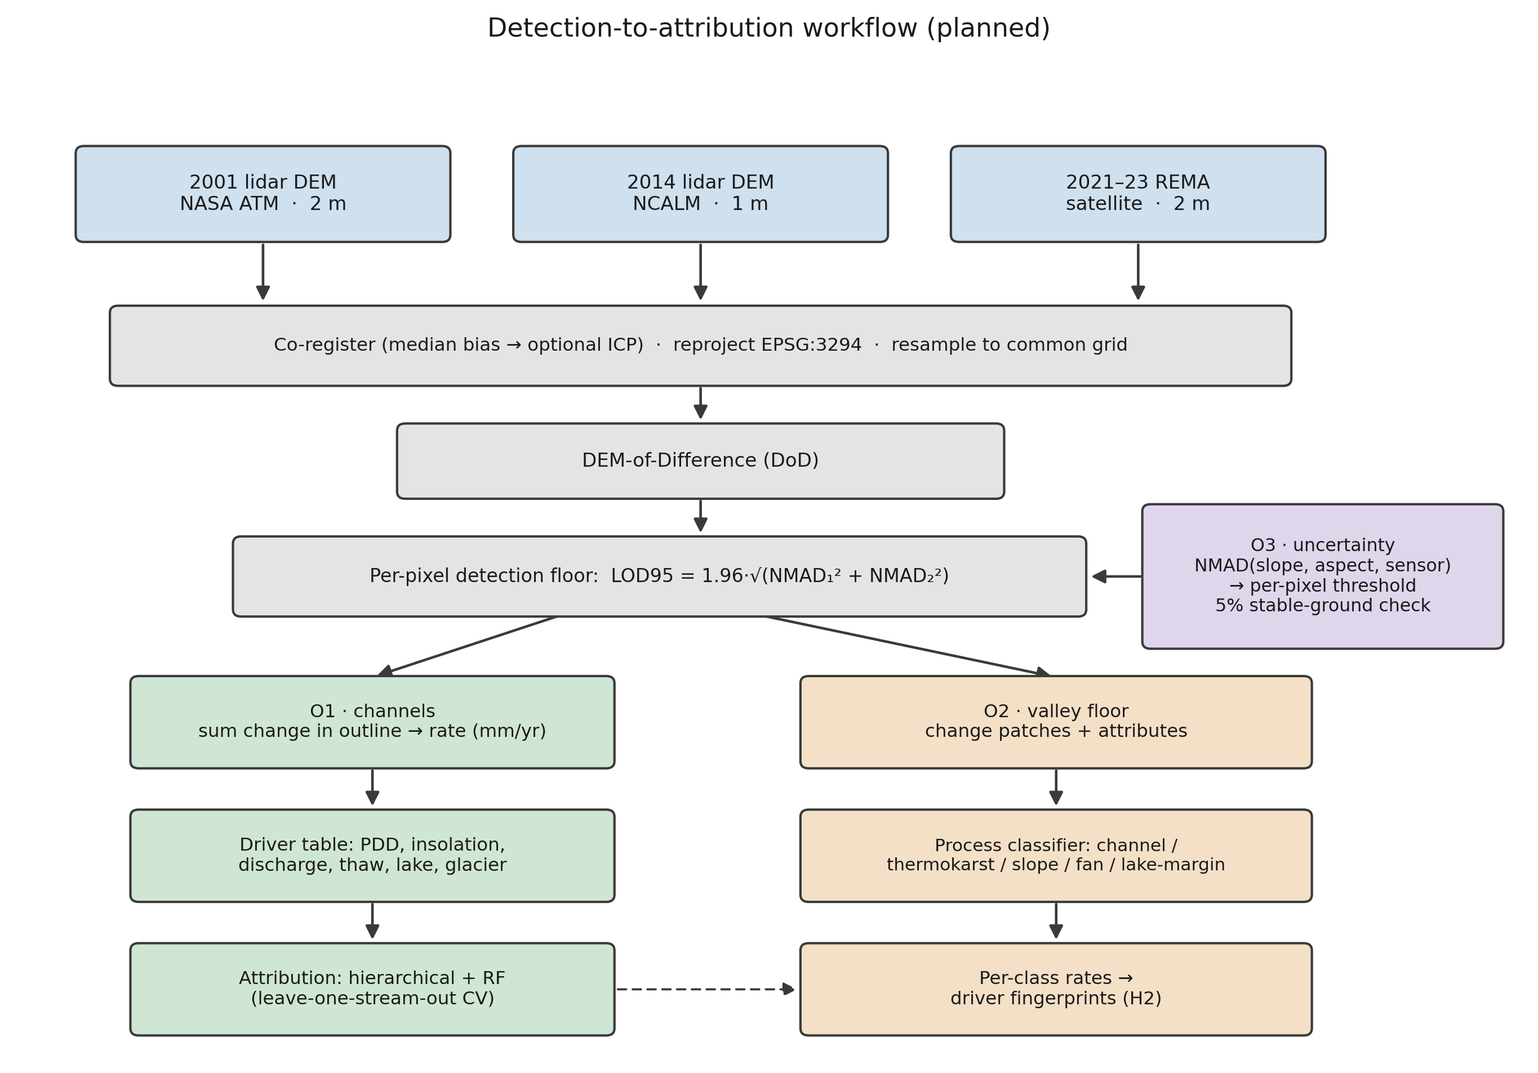
Figure 2. Planned detection-to-attribution workflow: three DEM epochs, co-registration, DEM-of-Difference, per-pixel detection floor, then the O1 (channel), O2 (valley-floor), and O3 (uncertainty) objectives. Method schematic; no results shown.
Objective 1:
- Compute each gauged stream's change rate. First I co-register the two elevation epochs (removing the median vertical offset over stable ground, with an optional ICP refinement), resample them to a shared grid, and difference them. I keep only pixels whose change clears the detection floor (the per-pixel LOD95 threshold from objective 3), sum that change inside the stream's channel outline, and normalize by channel area and years elapsed to a specific rate in mm/yr.
- Build each stream's driver history from MDV-LTER station records, filling coverage gaps with the ERA5 and AMPS weather models.
- Fit two models, a hierarchical regression (grouped by stream) and a random forest. Validate by leave-one-stream-out cross-validation, so every score comes from a stream held out of the fit, and check that the two model families agree.
- Test the melt energy hypothesis against the water volume alternative.
Objective 2:
- Apply the objective-3 per-pixel thresholds across the whole valley floor and pull out each change patch as a connected group of super-threshold pixels. I drop patches below a minimum mapping unit (a few pixels) to suppress isolated-pixel noise, and screen out near-level standing water, whose apparent change is lake-level rise, not ground change — those go to the lake-margin class and lake-level driver instead.
- Describe each patch by area, mean elevation change, local slope and aspect, and distance to the nearest channel and lake, then classify it by process type from that signature. I start with rules and fall back to a learned classifier only if they underperform.
- Run each type’s rates through the objective 1 driver models and compare.
- As mentioned before, I measure the REMA-minus-LiDAR difference over stable ground, model it against slope and aspect, and remove that bias before mixing the two sensors in any differencing.
Objective 3
- Model the noise as a function of slope, aspect, and sensor pair instead of a single valley-wide value. I bin the stable-ground differences on those variables, take the NMAD in each bin, and fit a smooth surface through the bins so every pixel carries its own LOD95 (= 1.96 x NMAD) threshold.
- Publish it as a per-pixel threshold map and verify the 5%-on-stable-ground property.
Note that all methods use robust statistics, since elevation errors here are heavy-tailed and an ordinary standard deviation would be thrown off by a few blunders. The noise scale throughout is the NMAD (1.4826 times the median absolute deviation from the median). For a single surface the detection floor is LOD95 = 1.96 x NMAD; since a difference subtracts two noisy surfaces, their NMADs add in quadrature, so the differencing floor is 1.96 x sqrt(NMAD1^2 + NMAD2^2), the change that noise alone clears only 5% of the time. Everything (DEMs, channel outlines, driver fields) is reprojected to one common Antarctic polar-stereographic grid (EPSG:3294) first, and the two lidar epochs (2 m and 1 m native) are resampled to a shared cell size before differencing.
Project Needs:
All data is freely available, or has been given with permission from the author.
Need | Source | Availability
2001 airborne lidar DEM (2 m) | NASA ATM via USGS ScienceBase | public, free
2014 airborne lidar DEM (1 m) + point cloud | NCALM via OpenTopography | public, free
REMA satellite DEM (2 m, 2021–23) | Polar Geospatial Center / AWS | public, free
Stream discharge, 21 gauges (daily) | MCM-LTER via EDI | public, free
Meteorology, glacier mass balance, soil temperature | MCM-LTER via EDI | public, free
ERA5 reanalysis; AMPS Antarctic weather model | Copernicus CDS; NCAR GDEX | public, free
Stream channel outlines (labels) | MCM-LTER via EDI | public, free
Barlow's hand-digitized training tiles | dissertation author | acquired directly from the author

Labels. The detector needs training examples. The gold-standard set — the dissertation author's hand-digitized tiles — has been requested and acquired directly.
Computing
A single workstation GPU trains the segmentation models; the elevation processing is CPU-bound and modest. No supercomputer allocation is required. Full-valley raster stacks reach tens of gigabytes and need only local storage, not specialized infrastructure.
Skills and Mentoring
The researcher has built terrain-segmentation and change-detection pipelines on non-Antarctic data but is new to Antarctic hydrology and hierarchical statistical modeling. Coursework and mentorship are detailed elsewhere.
Community Contact
The dissertation author has been contacted and is responsive. Continued cooperation helps but is not vital: every analysis can proceed from public data.
Assessment
Several things could go wrong and yield bad or incomplete results.
Attribution Signal
The signal may be weak. With roughly 20 gauged streams and only 3 epochs, the sample is small. If no driver clearly outperforms another, the deliverable becomes a rigorous null result with calibrated uncertainty — useful, if less exciting. The risk is to impact, not feasibility.
Gauge Records
Gauge records are patchy after 2015. Stream gauging in the MDVs declined, and some streams have only a few dozen recorded days in the satellite epoch. This is why objective 1 leans on modeled melt energy rather than gauges alone — though it means the discharge side of the hypothesis is weakest in the most recent period.
Satellite Coverage
Coverage is uneven. REMA quality varies by location and date. Taylor Valley has the best three-epoch coverage and will anchor the acceleration claims; other valleys may support only two.
Change Scale
Outside the channels, change may be too small to detect. The valley floors change slowly, so much of the surface may sit below our detection threshold. If so, objective 2 narrows back to in-channel change and the landscape-wide result is reported accordingly.
Even so, the proposal is worth doing. The MDV streams are the most direct, measurable climate response in one of Earth's most stable landscapes, and the data — two LiDAR epochs, a satellite record, and LTER station records — already exist and are free.
Timeline
Period | Work | Deliverable
Stage 1 | Rebuild the change-detection chain from public data; harmonize driver records per stream; secure or rebuild training labels; first attribution model (Taylor Valley) | Attribution manuscript drafted; labeled training set archived
Stage 2 | Landscape-wide change detection + process-type classification (O2), gated by the O3 thresholds; driver tests per change type; sensor-disagreement correction | Process-classification paper; AGU presentation
Stage 3 | Per-pixel calibrated-uncertainty product; three-epoch acceleration analysis; extension beyond Taylor Valley where REMA supports it; synthesis | Synthesis paper; public data products with DOIs

Data Management and Open Science
All inputs are public and cited to source (NASA ATM, NCALM/OpenTopography, PGC REMA, MCM-LTER/EDI, Copernicus ERA5, AMPS/GDEX). All derived products — change rasters, process-classified change maps, per-stream rate tables, uncertainty layers, channel outlines, and processing code — will be released open-access with DOIs (Zenodo / EDI). Heavy regenerable rasters stay out of version control; scripts, tables, and figures are tracked. Products carry explicit coordinate-system, method, and uncertainty metadata.
References
[1] Barlow, M. C. (2026). A Comprehensive Spatial Analysis of Stream Boundary and Geomorphological Change Detection: McMurdo Dry Valleys, Antarctica. PhD Dissertation, University of Houston (chair: C. L. Glennie).
[2] Barlow, M. C., Zhu, X., & Glennie, C. L. (2022). Stream Boundary Detection of a Hyper-Arid, Polar Region Using a U-Net Architecture: Taylor Valley, Antarctica. Remote Sensing 14(1):234.
[3] Höhle, J., & Höhle, M. (2009). Accuracy assessment of digital elevation models by means of robust statistical methods. ISPRS J. Photogramm. Remote Sens. 64(4):398–406.
[4] Howat, I. M., et al. (2019). The Reference Elevation Model of Antarctica (REMA). The Cryosphere 13:665–674.
[5] Ronneberger, O., Fischer, P., & Brox, T. (2015). U-Net: Convolutional Networks for Biomedical Image Segmentation. MICCAI 234–241.
[6] McMurdo Dry Valleys LTER. Stream, meteorology, glacier, and soil datasets. Environmental Data Initiative (EDI), knb-lter-mcm.*.
[7] Hersbach, H., et al. (2020). The ERA5 global reanalysis. Q. J. R. Meteorol. Soc. 146:1999–2049.

Claude Fable was used for proofreading.

