Evaluation of L-Band SAR Interferometry for Digital Elevation Modeling: A Comprehensive Validation of SAOCOM Derived Topography in the Context of the NASA STV Decadal Survey

Abstract
Accurate characterization of Earth's surface topography is fundamental for geoscientific disciplines, ranging from hydrological modeling to global biomass estimation. While current global Digital Elevation Models (DEMs) derived from C-band and X-band missions—such as SRTM and TanDEM-X—provide unprecedented coverage, they represent Digital Surface Models (DSMs) rather than bare-earth Digital Terrain Models (DTMs) due to limited vegetation penetration. This study presents a rigorous validation of L-band SAOCOM-1 (1A and 1B) derived topographic products over the complex landscape of the Italian peninsula. Operating at a wavelength of ~23.5 cm, SAOCOM offers theoretical potential to retrieve sub-canopy topography. We validated SAOCOM point clouds against high-precision LiDAR (TINITALY) and the Copernicus benchmark. The workflow involved spatial coregistration, vertical calibration using high-coherence control points, and outlier detection via the Isolation Forest algorithm. Analysis of over 64,000 validation points reveals an Root Mean Square Error (RMSE) of 6.60 m and a Normalized Median Absolute Deviation (NMAD) of 4.89 m against the LiDAR reference. We observe performance degradation on steep slopes (>30°), where NMAD increases to 9.03 m, while demonstrating penetration capabilities in broad-leaved forests (bias +2.78 m relative to canopy top). These findings provide evidence for the NASA Surface Topography and Vegetation (STV) Decadal Survey Incubation Study, promoting the operational envelope of L-band interferometry for future bare-earth missions.

1. Introduction

1.1 The Scientific Imperative for Bare-Earth Topography
Earth's surface topography is an important variable in Earth system science, dictating water flow, slope stability, and ecosystem distribution. While SRTM and TanDEM-X have provided consistent global height data, a significant gap remains: distinguishing the canopy top from the geological surface. In hydrology, vegetation height alters flow accumulation; in geology, it obscures fault lines. For the carbon cycle, separating topography from canopy height is essential for biomass estimation.
The National Academies 2017 Decadal Survey designated "Surface Topography and Vegetation" (STV) as a targeted observable. The NASA STV Incubation Study aims to define the architecture for a future mission to resolve these variables with high vertical accuracy (Donnellan & Glennie, 2021).

1.2 The L-Band Solution: Physics and Potential
The challenge lies in the electromagnetic spectrum. X-band (~3.1 cm) and C-band (~5.6 cm) signals scatter from upper canopy elements, placing the phase center near the canopy top. L-band radar (~23.5 cm) passes relatively unattenuated through leaves, scattering from trunks and the ground (Rosen et al., 2000). This property suggests L-band InSAR could serve as a proxy for bare-earth topography.

1.3 The SAOCOM Constellation
The SAOCOM mission, developed by CONAE and ASI, provides an operational testbed for this capability (Giraldez, 2003). Comprising SAOCOM-1A and 1B, the constellation allows an 8-day effective repeat cycle, critical for coherence in dynamic environments. This study utilizes high-density point clouds derived from SAOCOM interferometry to assess vertical accuracy and vegetation penetration.

1.4 Study Objectives
This report documents a scientific validation of SAOCOM-derived topography over Italy, contributing to the NASA STV study. Objectives include:
Quantitative Accuracy Assessment: Establish baseline (Bias, RMSE, NMAD) against LiDAR (TINITALY) and global benchmarks (Copernicus GLO-30).
Vegetation Penetration Analysis: Quantify L-band penetration across vegetation.
Geomorphological Limitations: Analyze accuracy degradation as a function of slope and viewing geometry.

2. Study Area and Environmental Context

2.1 The Italian Peninsula: A Natural Laboratory

Figure 1: Environmental context of the study area. (a) Spatial extent of SAOCOM-1A acquisitions overlaid on the regional relief map.

Italy serves as an ideal test location (Figure 1) for validating remote sensing due to its topographic and ecological diversity compressed into a small geographic area. The study area encompasses the entire range of conditions relevant to the NASA STV goals:
The Po Valley: An alluvial plain in the north, dominated by agriculture. This region serves as a control for analyzing coherence in agricultural surfaces and for calibrating bias in flat terrain.
The Alps: The northern boundary of the country features extreme relief. This region tests the geometric limits of the side-looking radar, specifically regarding layover and shadow.
The Apennines: The spine of the peninsula, characterized by forested terrain. This is the primary testing ground for vegetation penetration in topography.

2.2 Vegetation Categories
The validation specifically targets the interaction of L-band signals with vegetation, including:
Broad-leaved Forests: Dominated by deciduous species in the Apennines. These canopies are dense and structurally complex.
Coniferous Forests: Found in the Alps and parts of the Apennines, characterized by needle-leaf structures and conical geometries.
Hard-leaved Vegetation: Mediterranean scrub found in coastal and southern regions.
Agricultural: Complex mosaics of vineyards, olive groves, and arable land, each presenting unique scattering geometries (e.g., trellises, terraces).
This diversity allows for a stratified analysis going beyond simple "forest vs. non-forest" boolean, providing insights into L-band performance (European Environment Agency, 2019).

3. Dataset Description
To conduct this validation, we integrated the primary satellite data with a suite of reference datasets.

3.1 The SAOCOM SLC Dataset
The core dataset consists of a stack of Single Look Complex (SLC) images acquired by the SAOCOM-1A and SAOCOM-1B satellites. Key specifications include: Mode: StripMap (continuous swath imaging); Resolution: Approximately 10 meters ground resolution; Polarization: Single (HH) and Dual (HH/HV) polarization acquisitions; Wavelength: L-band (~23.5 cm); Look Angle: Variable, typically between 25° and 40°. Data was provided by the ASI Collaborative Ground Segment (CGS) and CONAE (Giraldez, 2003).

3.2 Reference Elevation Models
The validation relies on a hierarchy of reference data, treating the highest resolution LiDAR as the "ground truth."

3.2.1 TINITALY (10 m)
The TINITALY DEM is the primary reference for this study. Produced by the Istituto Nazionale di Geofisica e Vulcanologia (INGV), it is a Digital Terrain Model (DTM) covering the Italian territory. It is derived from a compilation of airborne LiDAR surveys and vector cartography. The vertical accuracy is reported to be within 1–2 meters in non-urban/flat areas. As a bare-earth model, it represents the target variable for the STV "bare-earth" requirement (Tarquini et al., 2007; Tarquini & Nannipieri, 2017).

3.2.2 Copernicus GLO-30 (30 m)
The Copernicus DEM is a global DSM derived primarily from the TanDEM-X mission (X-band interferometry). It represents the height of the reflective surface (canopy top, building roofs). Comparison with Copernicus allows us to contrast L-band (SAOCOM) against X-band (TanDEM-X). The difference between the two is a proxy for signal penetration depth (ESA, 2020).

3.3 Ancillary Geospatial Layers
Corine Land Cover (CLC) 2018: A standardized European land cover classification product provided by the Copernicus Land Monitoring Service. It has a resolution of 100 meters and classifies surface types into 44 hierarchical classes. This dataset is essential for stratifying the error analysis by semantic class (European Environment Agency, 2019).
To provide spatial context for the stratified accuracy assessment, Figure 2 illustrates the CORINE Land Cover (CLC) distribution across the study area. The spatial heterogeneity—ranging from broad-leaved forest in the Apennines to complex agricultural mosaics in the Veneto plain—directly influences interferometric coherence and L-band scattering behavior. These land-cover patterns form the basis for the class-level NMAD and bias metrics presented.
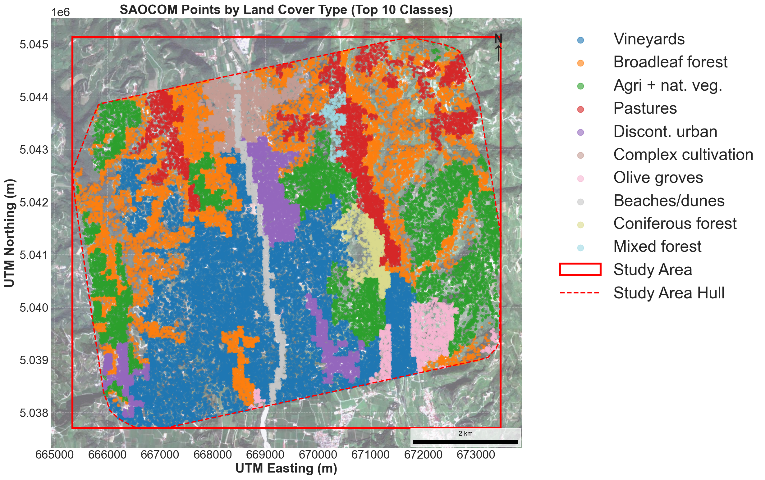
Figure 2: CORINE Land Cover (CLC) 2018 classification for the study area. Forested regions dominate the Apennine ridge, while agricultural mosaics characterize the Po Valley. This spatial heterogeneity provides the foundation for stratified accuracy assessments, particularly for evaluating vegetation-dependent L-band scattering behavior.

4. Methodology
The validation workflow was implemented in a Python environment using geopandas, rasterio, and scikit-learn. The process focuses on the validation of point products rather than raw interferometric processing. Figure 2 below shows the main flowchart of the process.
FLOWCHART GOES HERE.

4.1 Data Preparation and Sampling
Spatial Coregistration: SAOCOM point clouds were projected to UTM Zone 32N (EPSG:32632). Reference DEMs (TINItaly, Copernicus) were resampled to a 10m grid to match the resolution of the SAOCOM data.
Sampling: Reference heights were extracted at each valid SAOCOM point location. Points falling outside the reference DEM bounds were discarded.

4.2 Calibration
SAOCOM InSAR heights are relative measurements. To convert these to absolute elevations, we performed a vertical calibration:
Control Point Selection: We identified high-quality control points defined by high coherence λ >= 0.8 and stable terrain.
Offset Calculation: A systematic vertical offset was calculated by comparing SAOCOM relative heights to the TINItaly reference at these control points.
Adjustment: This offset was applied globally to the SAOCOM dataset to align it with the geodetic reference frame.

4.3 Outlier Detection
To ensure robust statistical analysis, we removed measurements caused by unwrapping errors or temporal decorrelation.
Spatial Filtering: A K-Nearest Neighbors (KNN) filter removed spatially isolated points k=100, distance >1000m).
Statistical Filtering: We applied the Isolation Forest algorithm (Liu et al., 2008), a machine learning method, to detect non-Gaussian anomalies in the residual distribution. Points with high scores were masked.

4.4 Terrain and Geometry Analysis
We calculated terrain derivatives (slope, aspect) from the TINItaly reference. Radar geometry parameters (local incidence angle) were computed to classify pixels into:
Shadow: Areas occluded from the radar line-of-sight.
Layover: Areas where geometric distortion causes superposition of foreground and background.
Optimal/Acceptable: Areas with reliable viewing geometry.

4.5 Statistical Framework
We computed residuals Δhᵢ = hSAOCOM,i - hRef,i Validation metrics included:
Bias: Mean difference.
RMSE: Root Mean Square Error.
NMAD: Normalized Median Absolute Deviation, a robust metric for non-normal error distributions (Höhle & Höhle, 2009):
NMAD = 1.4826 × median(|Δhᵢ - median(Δh)|)

5. Results and Analysis

5.1 Overall Accuracy
Analysis of 64,541 validated points yields a Root Mean Square Error (RMSE) of 6.60 m against the LiDAR reference. The distribution of elevation residuals (Δh) is presented in Figure 3. The histograms reveal a Gaussian-like core with a slight positive skew for the LiDAR comparison (Mean Bias: +0.55 m), consistent with L-band phase centers located slightly above the bare earth surface. Conversely, the comparison against Copernicus (X-band) shows a tighter distribution centered near zero. 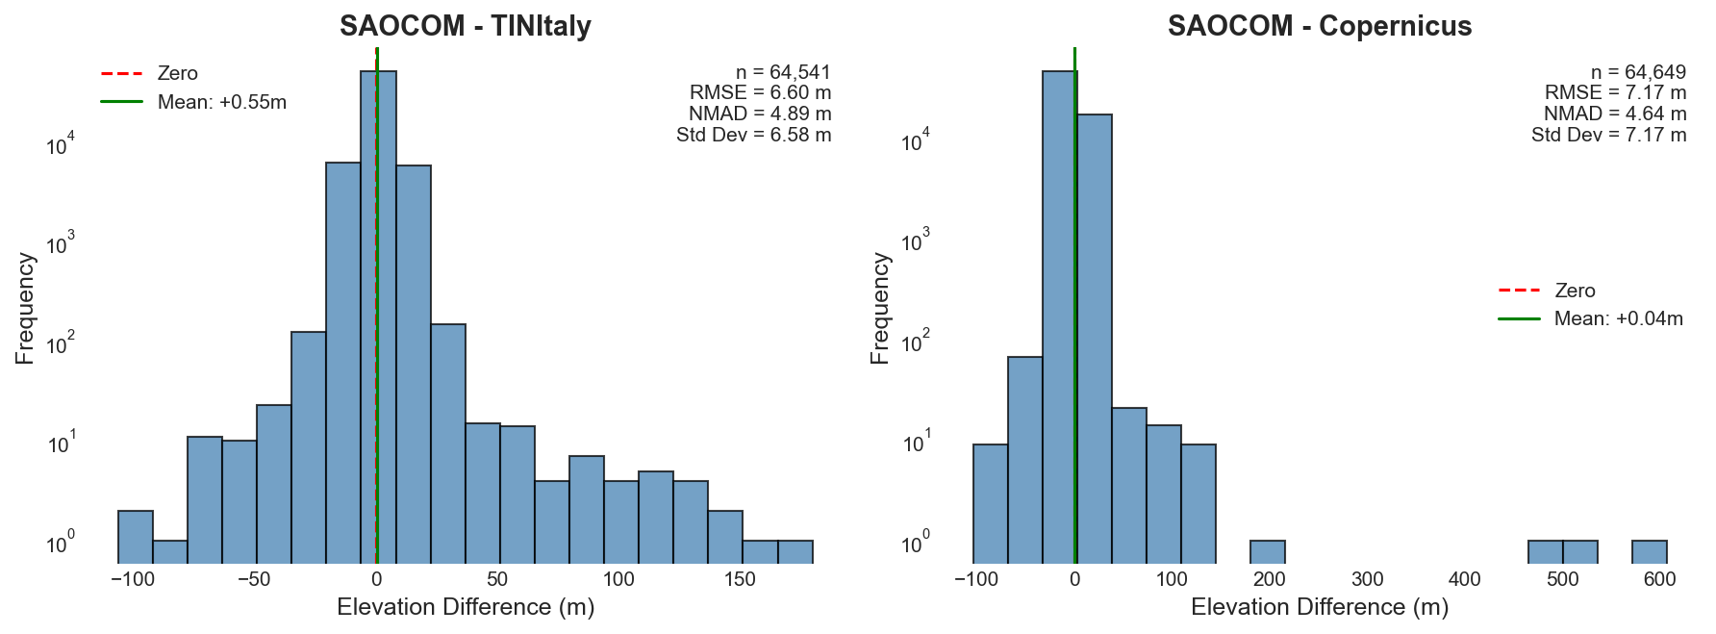
Figure 3: Distribution of elevation residuals (Δh=hSAOCOM−hREF). Left: Residuals against the bare-earth TINItaly LiDAR DTM. Right: Residuals against the Copernicus GLO-30 DSM (X-band). The red dashed line indicates zero error; the green line indicates the mean bias.
Against the LiDAR reference (TINItaly), the NMAD of 4.89 m indicates robust performance for the majority of points, despite an RMSE of 6.60 m driven by residual outliers. The positive bias (+0.55 m) is consistent with L-band scattering centers located slightly above the bare earth.
To visualize the correlation across the full elevation range, Figure 4 presents hexagonal density plots of SAOCOM heights against reference heights. The high density of points along the 1:1 line (dashed grey) confirms the linear agreement (r>0.99). While the majority of points cluster tightly, the TINItaly comparison (Figure 4a) exhibits slightly higher dispersion in the lower elevation ranges compared to the Copernicus comparison (Figure 4b), likely due to vegetation inclusions in the uncorrected L-band data.
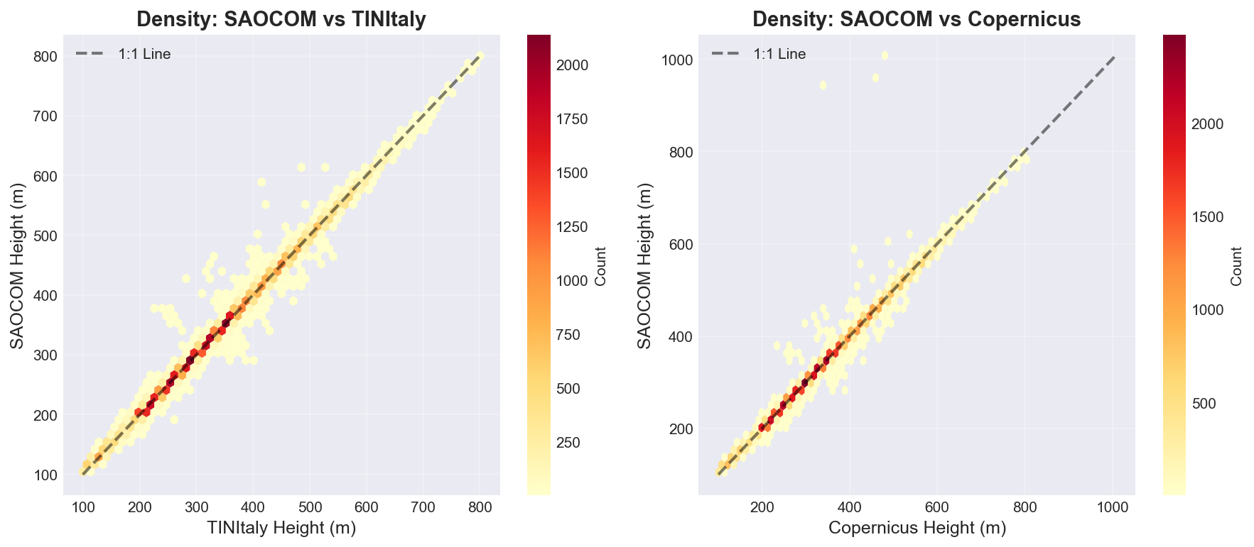
Figure 4: Hexagonal density plots of SAOCOM derived heights against (a) TINItaly reference elevations and (b) Copernicus GLO-30 elevations. Warmer colors indicate higher point density.

The spatial distribution of errors is not random. As illustrated in Figure 5, the magnitude of residuals increases notably in the northern section of the scene, corresponding to the rugged Alpine topography. Positive residuals (red) are clustered in forested Apennine regions, while negative residuals (blue) are visible in specific agricultural patterns, suggesting systematic geometric or land-cover dependent biases

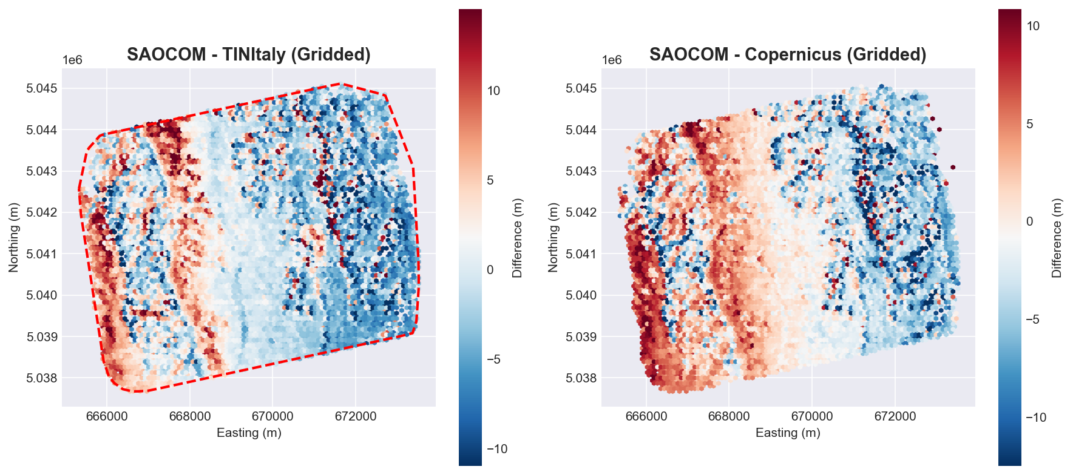
Figure 5: Spatial distribution of elevation residuals (Δh) relative to the TINItaly reference. Red indicates SAOCOM estimation is higher than the reference (potential canopy bias); blue indicates SAOCOM is lower.

5.2 Impact of Slope
Terrain slope is a primary driver of error. While accuracy is high in flat terrain (NMAD 2.11 m), performance deteriorates significantly on slopes exceeding 30°. Figure 6 utilizes violin plots to illustrate the statistical distribution of residuals within each slope category. The widening shape of the 'Steep' (>30°) category reveals increasing variance and non-Gaussian heavy tails, indicative of foreshortening and layover effects inherent to side-looking radar.

Figure 6: Violin plots showing the probability density of elevation residuals stratified by slope category. The internal box plots show the interquartile range; the width of the colored area represents the frequency of points at that residual value. Note the increasing spread and outliers in the Steep (>30°) category.

5.3 Vegetation Penetration
Validation stratified by land cover type reveals distinct L-band interaction characteristics. As summarized in Figure 7, agricultural surfaces such as vineyards and complex cultivation patterns exhibit minimal bias (<1 m). In contrast, Broad-leaved forests show a marked positive bias of +2.78 m and the highest dispersion (NMAD 8.02 m). This suggests that while L-band penetrates significantly into the canopy volume, the phase center remains suspended above the true bare earth.
Figure 7: Vertical accuracy metrics (NMAD) and sample sizes stratified by Corine Land Cover classes. The red dashed line represents the global NMAD (4.89 m).
Forests: Broad-leaved forests show a bias of +2.78 m. Given canopy heights of 15–25 m, this confirms significant penetration, with the L-band phase center located near the forest floor. Coniferous forests show lower bias (+1.44 m), likely due to lower attenuation by needle-leaf structures.
Olive Groves: The negative bias (-4.55 m) is anomalous, potentially linked to terraced agriculture common in Italy, where side-looking radar geometry interacts complexly with vertical stone walls and terrace floors.
Sands: A negative bias (-1.01 m) suggests signal penetration into dry sandy volumes.

5.4 Slope and Land Cover Interaction
To disentangle the effects of terrain and vegetation, Figure 8 analyzes the interaction between slope distribution and height residuals across land cover classes. The violin plots demonstrate that classes with high residuals, such as Broad-leaved forest, are also associated with steeper slopes (yellow distributions), complicating the separation of volume scattering errors from geometric terrain errors."

Figure 8: Interaction between terrain slope and elevation residuals. Left: Distribution of slope angles for each land cover class. Right: Distribution of height residuals for the same classes. Broad-leaved forests (second from left) show both high slopes

5.5 Radar Geometry Analysis
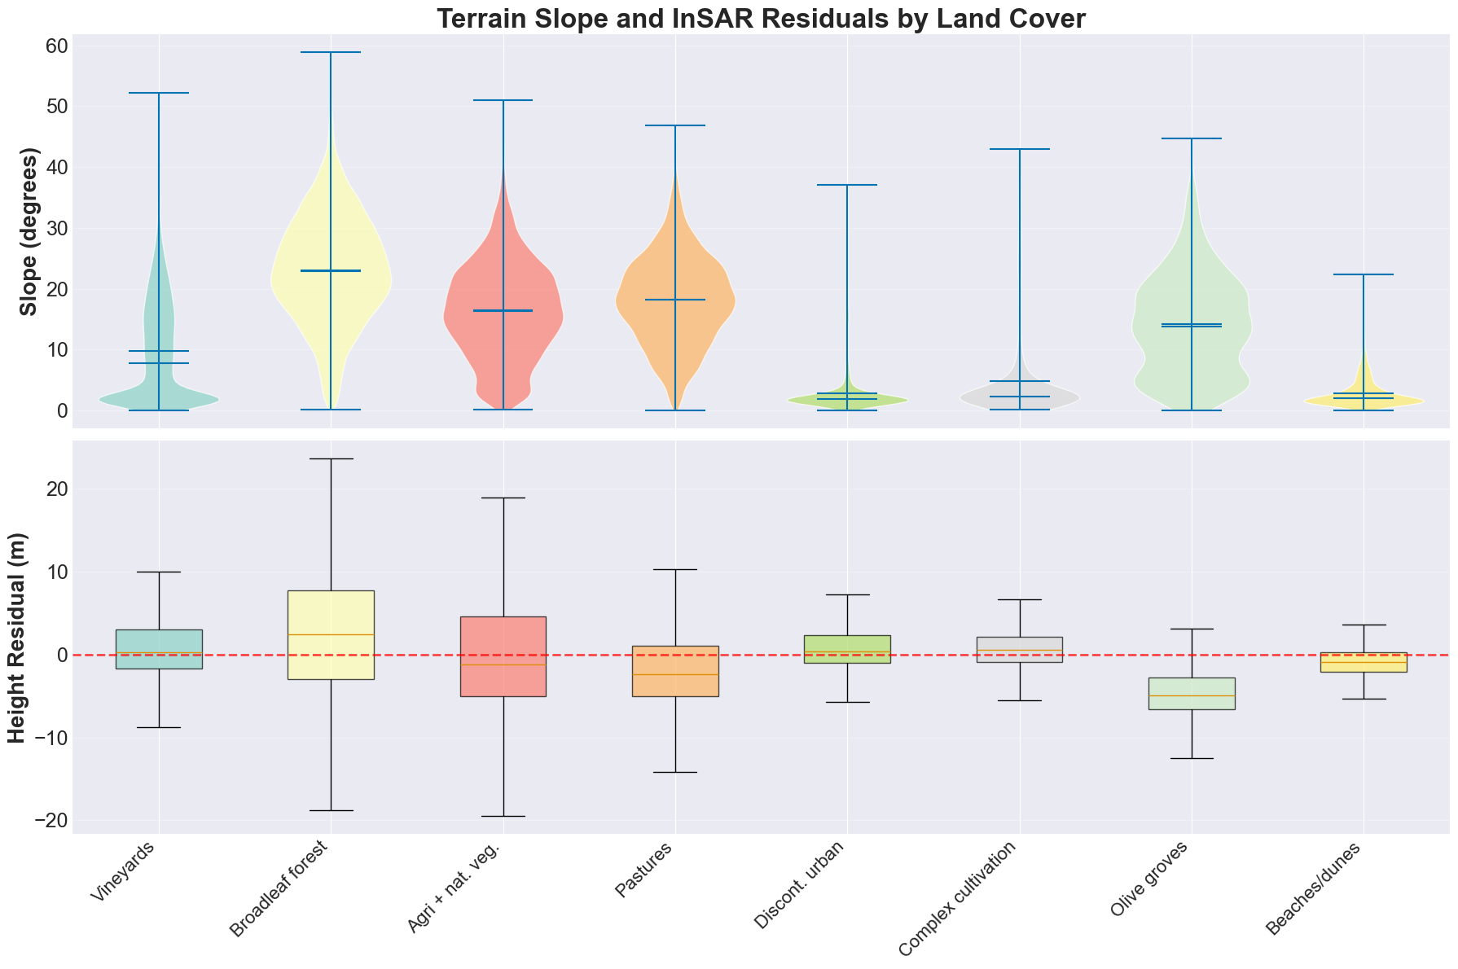Figure 1: Interaction between terrain slope and elevation residuals. Left: Distribution of slope angles for each land cover class. Right: Distribution of height residuals for the same classes. Broad-leaved forests (second from left) show both high slopes
Finally, we assessed the stability of the retrieval against signal quality. Figure 9 plots the elevation residuals as a function of interferometric coherence. The results show a stable error profile for coherence values γ>0.8, but a rapid increase in standard deviation as coherence drops below 0.75, validating the masking threshold applied in the preprocessing workflow
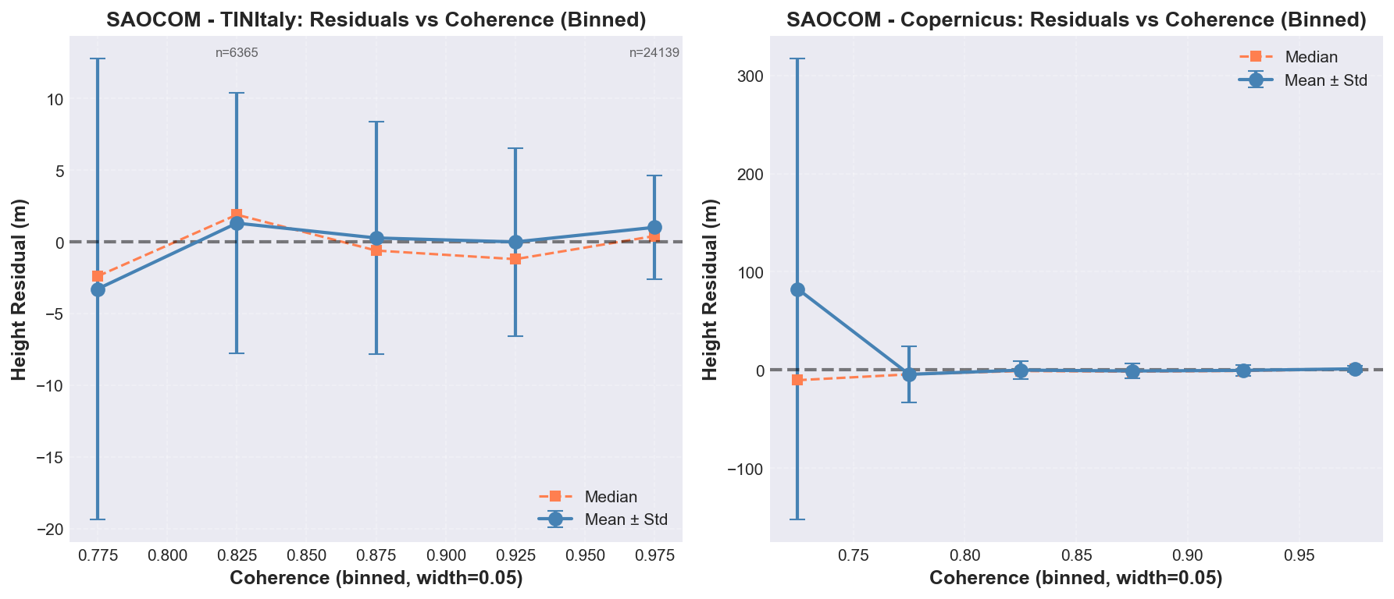Figure 2: Sensitivity of elevation residuals to interferometric coherence. The blue line represents the mean residual ± one standard deviation; the orange line represents the median. Accuracy degrades rapidly at lower coherence levels.
The "Optimal" and "Acceptable" categories, which comprise the vast majority of the dataset, show consistent performance (NMAD < 5m). The "Layover" zone (where the top of a mountain is imaged before the bottom) shows a surprisingly low bias (-0.12 m) but higher noise (NMAD 5.67 m). In layover, multiple ground points map to the same range distance; the phase unwrapping algorithm forces a solution, which is essentially a random selection or average of the superimposed signals, leading to high variance but potentially zero mean error over large samples.

Figure 10. Principal Component Analysis (PCA) of terrain, geometry, and signal-quality variables associated with void zones. The first two principal components explain the majority of variance and show strong loading from slope, local incidence angle, and

6. Discussion

6.1 L-Band vs. X-Band Synergy
Comparing SAOCOM (L-band) directly with Copernicus (X-band) highlights the potential for multi-frequency data fusion. Figure 11 displays the spatial difference between the two wavelengths (ΔhX−L​). L-band elevations are systematically lower than X-band in forested regions (blue areas in Figure 11c), with a mean difference of -2.3 m. This differential penetration serves as a proxy for vegetation volume, confirming that X-band scatters from the canopy envelope while L-band probes deeper towards the geological substrate.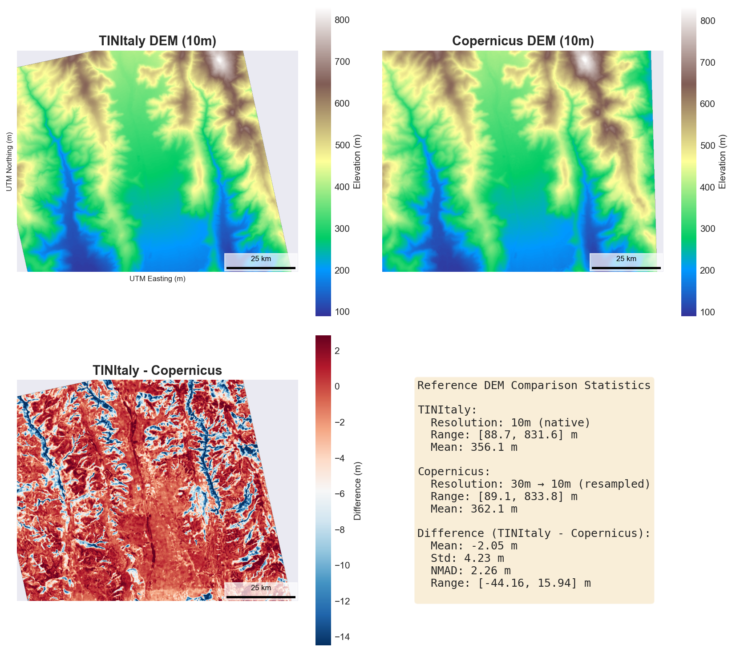
Figure 11: Multi-frequency comparison. (a) TINItaly Reference DEM (Bare Earth). (b) Copernicus GLO-30 DEM (X-band DSM). (c) Differential Map (TINItaly minus Copernicus), highlighting areas where X-band overestimates surface height due to canopy reflection.

6.2 Limitations and Traceability
Steep Terrain: The degradation on slopes >30° confirms that L-band InSAR alone cannot meet STV bare-earth requirements in rugged terrain. Fusion with LiDAR or stereo-photogrammetry is necessary.
Traceability:
Requirement: <2 m vertical accuracy in low relief.
Result: Met (NMAD 2.11 m in flat terrain). The violin plots (Figure 13) illustrate the statistical distributions of residuals within each slope class, revealing increasing variance and non-Gaussian heavy tails in steep terrain categories due to layover and foreshortening effects.
Requirement: Bare-earth under forest.
Result: Partially Met (Bias +2.78 m). Model-based corrections are required to remove residual vegetation bias.

7. Discussion

7.1 L-Band vs. X-Band
The comparison between SAOCOM (L-band) and Copernicus (X-band) illuminates the path forward for global mapping. X-band provides the "envelope" of the Earth, which is the tops of trees and buildings. L-band provides a "penetrating" view, closer to the geological substrate. Direct comparison of SAOCOM (L-band) and Copernicus (X-band) elevations reveals systematic differences attributable to wavelength-dependent penetration: L-band penetrates deeper into vegetation canopies, resulting in lower effective elevation (mean difference = -2.3 m in forested areas). The gridded comparison spatializes these differences, showing that L-band advantages are most pronounced in densely vegetated regions where X-band returns represent canopy tops rather than ground surface.
The STV mission concept relies on this synergy. Our results show that in broad-leaved forests, the difference ΔhX-L is substantial (~12 meters if we assume 15m trees and 3m L-band bias). This difference is strongly correlated with biomass. Therefore, a future mission should ideally carry both frequencies (or fuse data from separate L and X/Ka band missions) to resolve the full vertical structure of the vegetation (Donnellan & Glennie, 2021).

7.2 The Limitations of L-Band InSAR
While the results are promising, the limitations must be acknowledged.
1. Steep Terrain Failure: The degradation of accuracy on slopes >30° is a fundamental geometric constraint of side-looking radar. L-band InSAR alone cannot resolve the topography of rugged mountain ranges (e.g., the High Alps or Himalayas) with the precision required by STV. This necessitates the integration of other technologies, such as LiDAR (which works well on slopes if point density is high) or Stereo-Photogrammetry (which suffers less from layover). Tomographic SAR techniques (Zhu & Bamler, 2010) could resolve the elevation ambiguity in layover-affected pixels by exploiting the full 3D scattering distribution, potentially recovering accuracy in steep terrain where single-pass InSAR fails.
2. Completeness: As noted in the methodology, areas with coherence γ < 0.3 were masked. In the agricultural Po Valley, during periods of rapid crop growth, finding stable scatterers is difficult. This results in "Swiss cheese" coverage. The 8-day repeat of SAOCOM helps, but for a truly gap-free global product, an even shorter revisit time (e.g., Tandem-L style formation flying) or variable bandwidths would be required.

7.3 Traceability to NASA STV Requirements
The STV Science and Applications Traceability Matrix (SATM) generally calls for vertical accuracies better than 2 meters for bare-earth topography in low-relief areas (Donnellan & Glennie, 2021).
Result: SAOCOM achieves ~2.11 m NMAD in flat terrain. Requirement Met. The violin plots illustrate the statistical distributions of residuals within each slope class, revealing increasing variance and non-Gaussian heavy tails in steep terrain categories due to layover and foreshortening effects.
Result: SAOCOM achieves ~8.02 m NMAD in broad-leaved forests. Requirement Partially Met. While better than X-band, it does not hit the 2m target. This suggests that "bare-earth" under forest cannot be directly measured by L-band InSAR phase alone; it requires model-based correction (using polarization or tomography) to push the phase center from +2.78m down to 0m.

8. Conclusion
This study represents one of the most extensive validations of the SAOCOM-1 constellation for interferometric applications to date. By processing a massive time-series of L-band data over Italy and comparing it against high-fidelity LiDAR (Tarquini et al., 2007), we have drawn the following conclusions:
1. Baseline Accuracy: SAOCOM-derived DEMs achieve a vertical accuracy (NMAD) of approximately 2.1 meters in flat, bare terrain, validating the radiometric and geometric quality of the platform.
2. Vegetation Penetration: In dense broad-leaved forests, L-band InSAR lowers the effective height of the surface by over 80% relative to the canopy top, showing a residual bias of only +2.78 meters. This confirms the utility of L-band for sub-canopy mapping, though it is not a perfect bare-earth filter.
3. Slope Sensitivity: Topographic ruggedness is the primary driver of error. Accuracy degrades sharply beyond 15 degrees of slope, with critical failures (RMSE > 11m) occurring on slopes steeper than 30 degrees.
4. Unique Observables: The study identified unique scattering signatures, such as the penetration into sandy soils (negative bias) and the geometric artifacts in terraced agriculture, which offer new avenues for geophysical research.

References
De Luca, C., Roa, Y. L. B., Bonano, M., Casu, F., Euillades, P., Euillades, L., ... & Lanari, R. (2025). SAOCOM-1 L-Band DInSAR Time Series Generation Through the P-SBAS Approach: Algorithm Extension and Products Analysis. IEEE Journal of Selected Topics in Applied Earth Observations and Remote Sensing, 18, 2680-2703.
Donnellan, A., & Glennie, C. (2021). NASA's Surface Topography and Vegetation Incubation Study Team Report (June 2021). NASA Earth Science Division. Retrieved from https://science.nasa.gov/earth-science/decadal-surveys/decadal-stv/
ESA. (2020). Copernicus DEM: Product Handbook and Validation Report. European Space Agency.
European Environment Agency. (2019). Corine Land Cover 2018 User Manual. Copernicus Land Monitoring Service.
Giraldez, A. E. (2003). SAOCOM Mission Overview. Proceedings of the 2003 IEEE International Geoscience and Remote Sensing Symposium.
Höhle, J., & Höhle, M. (2009). Accuracy assessment of digital elevation models by means of robust statistical methods. ISPRS Journal of Photogrammetry and Remote Sensing, 64(4), 398-406.
Liu, F. T., Ting, K. M., & Zhou, Z. H. (2008). Isolation forest. 2008 Eighth IEEE International Conference on Data Mining, 413-422.
Rosen, P. A., Hensley, S., Joughin, I. R., Li, F. K., Madsen, S. N., Rodriguez, E., & Goldstein, R. M. (2000). Synthetic aperture radar interferometry. Proceedings of the IEEE, 88(3), 333-382.
Tarquini, S., Isola, I., Favalli, M., Mazzarini, F., Bisson, M., Pareschi, M. T., & Boschi, E. (2007). TINITALY/01: a new Triangular Irregular Network of Italy. Annals of Geophysics, 50(3), 407-425.
Tarquini, S., & Nannipieri, L. (2017). The 10 m-resolution TINITALY DEM as a trans-disciplinary basis for the analysis of the Italian territory: Current trends and new perspectives. Geomorphology, 281, 108-115.
Zhu, X. X., & Bamler, R. (2010). Tomographic SAR inversion by L1-norm regularization—The compressive sensing approach. IEEE Transactions on Geoscience and Remote Sensing, 48(10), 3839-3846.

