SAOCOM DEM Validation Analysis - Comprehensive Report
Generated: 2025-12-04 11:43:12

1. Overall Validation Statistics
Comparison of SAOCOM heights against reference DEMs. Metrics computed after calibration and outlier removal.
Reference DEM | N Points | Bias (m) | RMSE (m) | NMAD (m)
TINItaly | 64,541 | +0.55 | 6.60 | 4.89
Copernicus | 64,649 | +0.04 | 7.17 | 4.64

Note: NMAD (Normalized Median Absolute Deviation) is a robust accuracy metric less sensitive to outliers than RMSE.

2. Accuracy by Slope Category
Analysis of height accuracy stratified by terrain slope. Steeper slopes typically show larger residuals due to geometric distortions and shadow effects.
slope_category | count | mean | std | nmad
Flat (0-5°) | 19,181 | 0.33 | 2.82 | 2.11
Gentle (5-15°) | 15,544 | -0.09 | 5.88 | 5.62
Moderate (15-30°) | 25,231 | 0.71 | 7.72 | 6.91
Steep (>30°) | 4,550 | 2.86 | 11.16 | 9.03

3. Accuracy by Land Cover Type
Analysis of height accuracy stratified by land cover classification. Different surface types exhibit varying radar backscatter properties.
land_cover | count | mean | std | nmad
Beaches, dunes, sands | 1,614 | -1.01 | 1.98 | 1.70
Broad-leaved forest | 13,432 | 2.78 | 9.92 | 8.02
Complex cultivation patterns | 2,478 | 0.80 | 3.15 | 2.28
Coniferous forest | 1,260 | 1.44 | 6.41 | 5.93
Discontinuous urban fabric | 5,082 | 1.15 | 3.33 | 2.33
Land principally occupied by agriculture, with significant areas of natural vegetation | 11,092 | -0.49 | 7.19 | 6.84
Mixed forest | 254 | 0.19 | 5.79 | 5.07
Olive groves | 1,839 | -4.55 | 4.54 | 2.88
Pastures | 5,927 | -1.68 | 5.42 | 4.35
Vineyards | 21,563 | 0.65 | 4.18 | 3.49

5. Radar Geometry and Shadow Statistics
Statistics for different radar viewing geometry categories, including shadow and layover zones.
Category | Count | Bias (m) | RMSE (m) | NMAD (m)
optimal | 45,485 | +0.65 | 6.22 | 4.33
acceptable | 58,689 | +0.62 | 6.58 | 4.81
steep | 10 | +8.54 | 11.12 | 6.40
layover | 5,807 | -0.12 | 6.80 | 5.67

7. Key Figures

Residual Distributions
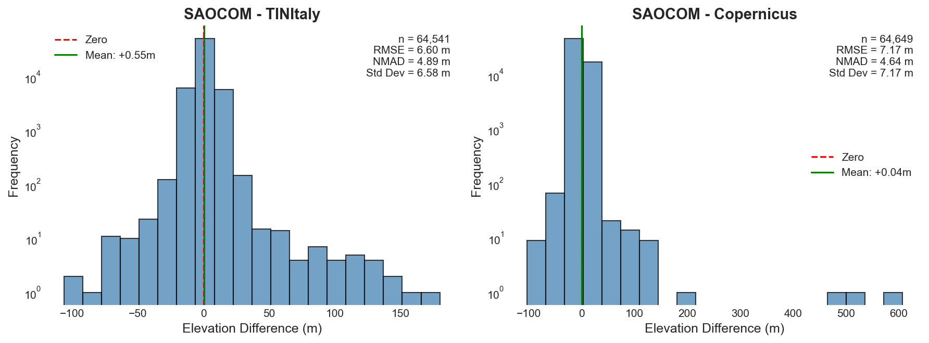

Accuracy by Land Cover
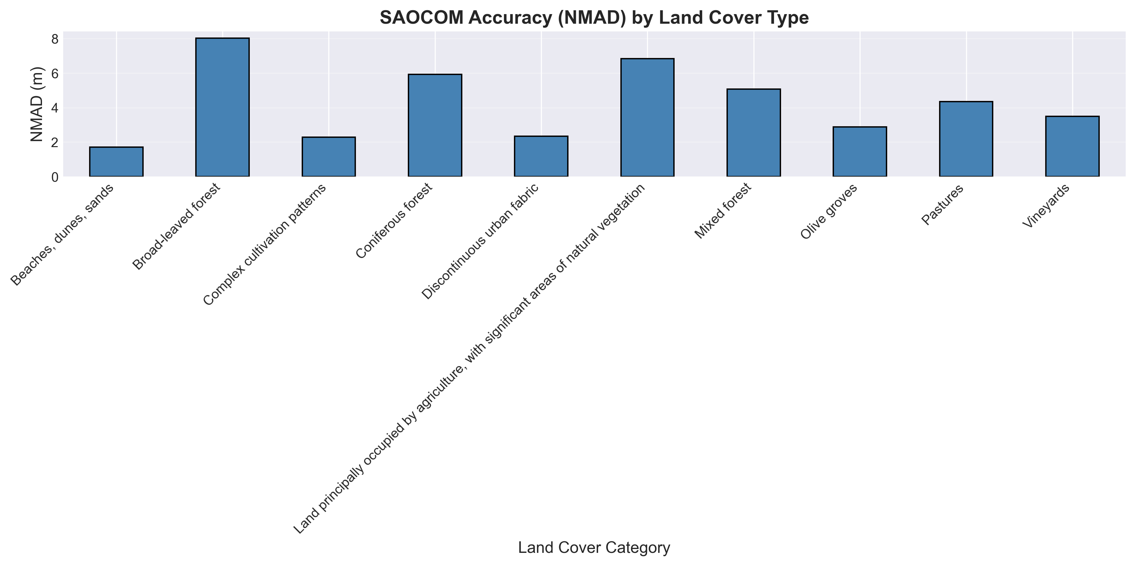

Accuracy by Elevation
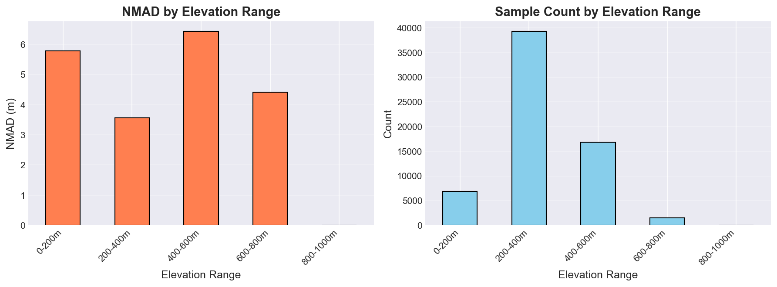

Terrain Slope Analysis
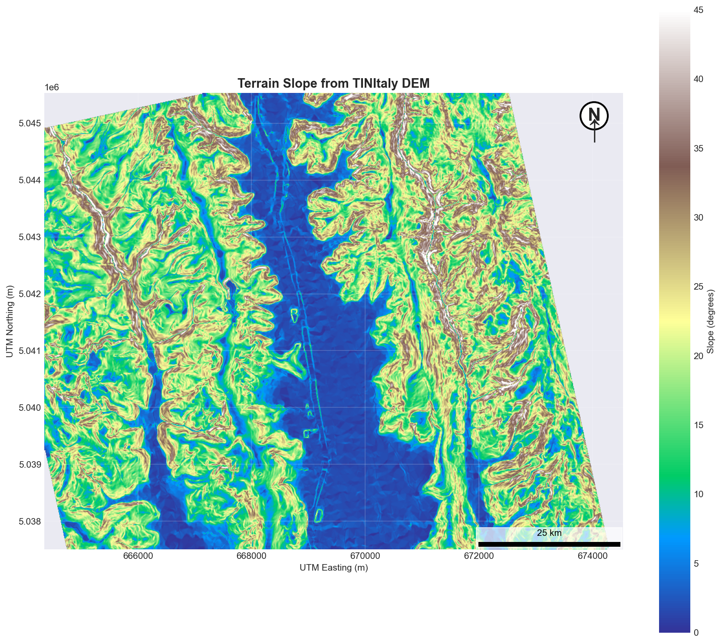

Coverage and Voids
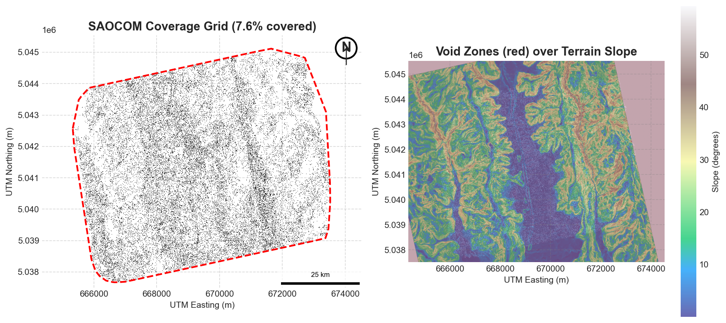

Radar Geometry Analysis
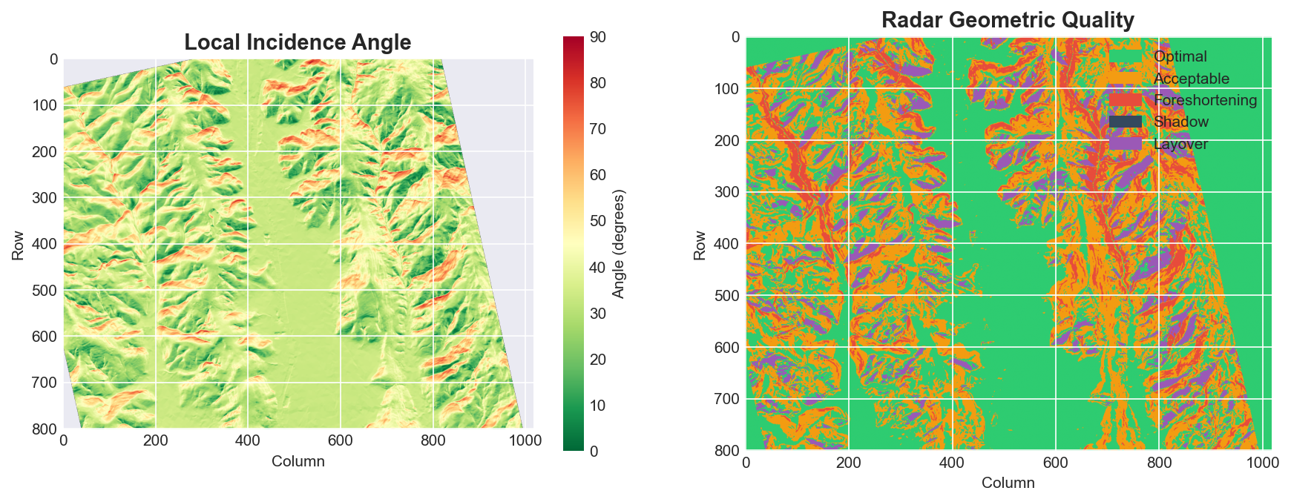

Summary Dashboard
