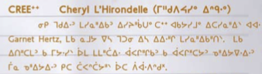

From *Critical Making*, edited by Garnet Hertz, UCLA-Irvine Campus publishers, Los Angeles, CA., USA

[CALLUM: there will need to be a button or a download option for this pdf

]