1. Issue0:

Login successful but password failed。

Solution:

Check /var/log/apt/history.log

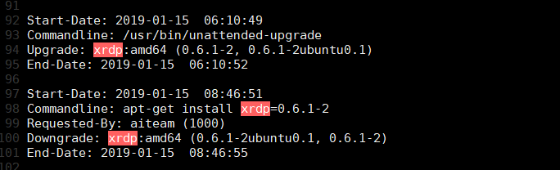

It’s upgraded by /usr/bin/unattended-upgrade at 2019-0.-1506:10:49.

Method 0:

Downgraded everytime when xrdp upgraded:

sudo apt-get install xrdp=0.6.1-2

Method 1:

Disable auto-update system-wide from the /etc/apt/apt.conf.d/10periodic file:

sudo vim /etc/apt/apt.conf.d/10periodic:

APT::Periodic::Update-Package-Lists "1";

APT::Periodic::Download-Upgradeable-Packages "0";

APT::Periodic::AutocleanInterval "0";

APT::Periodic::Unattended-Upgrade "0"; <--- line of interest, should be "0"

Method 2:

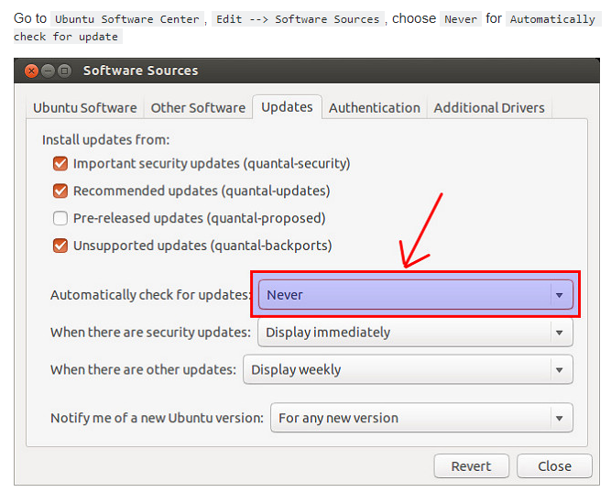

Ref: <http://ask.xmodulo.com/disable-automatic-updates-ubuntu.html>