CPP程式設計題
命題者︰SCY
題目名稱(中文/英文)：GuessNumber
主要測試觀念：
Basics | Functions
- C++ BASICS 1  - FLOW OF CONTROL  - FUNCTION BASICS  - PARAMETERS AND OVERLOADING  - ARRAYS  - STRUCTURES AND CLASSES  - CONSTRUCTORS AND OTHER TOOLS  - OPERATOR OVERLOADING, FRIENDS,AND REFERENCES  - STRINGS  - POINTERS AND DYNAMIC ARRAYS | - SEPARATE COMPILATION AND NAMESPACES  - STREAMS AND FILE I/O  - RECURSION  - INHERITANCE  - POLYMORPHISM AND VIRTUAL FUNCTIONS  - TEMPLATES  - LINKED DATA STRUCTURES  - EXCEPTION HANDLING  - STANDARD TEMPLATE LIBRARY  - PATTERNS AND UML

題目說明：
Listed below is code to play a guessing game in which two players attempt to guess a number. Your task is to extend the program with objects that represent either a human player or a computer player.

// you can modify the following codes to let your “guess” more smarter
bool checkForWin(int guess, int answer)
{
if (answer == guess)
{
cout << "You're right! You win!" << endl;
return true;
}
else if (answer < guess)
cout << "Your guess is too high." << endl;
else
cout << "Your guess is too low." << endl;
return false;
}

void play(Player &player1, Player &player2)
{
int answer = 0, guess = 0;
answer = rand() % 100;
bool win = false;

while (!win)
{
cout << "Player 1's turn to guess." << endl;
guess = player1.getGuess();
win = checkForWin(guess, answer);
if (win) return;

cout << "Player 2's turn to guess." << endl;
guess = player2.getGuess();
win = checkForWin(guess, answer);
}
}

The play function takes as input two Player objects.
Define the Player class with a virtual function named getGuess(). The implementation of Player::getGuess() can simply return 0.

Next, define a class named HumanPlayer derived from Player. The implementation of HumanPlayer::getGuess() should prompt the user to enter a number and return the value entered from the keyboard.

Next, define a class named ComputerPlayer derived from Player. The implementation of ComputerPlayer::getGuess() should be in smarter way (i.e., not randomly select a number from 0 to 100).

Finally, construct a main function that invokes play(Player &player1, Player &player2)with two instances of a HumanPlayer (human vs. human), an instance of a HumanPlayer and ComputerPlayer (human vs. computer), and two instances of ComputerPlayer (computer vs. computer).

Note that please use this following code snippets as your main()
// Main
int main()
{
HumanPlayer playerH1, playerH2;
ComputerPlayer playerC1, playerC2;

play(playerH1, playerH2);
play(playerH1, playerC1);
play(playerC1, playerC2);

return 0;
}

輸入說明：當你是HumanPlayer時，輸入猜測的數字，當是ComputerPlayer時則要由電腦自動輸入猜測的數字in smarter way (i.e., not randomly select a number from 0 to 100.)

輸出說明：
太小輸出Your guess is too low.
太大輸出Your guess is too high.
猜中數字輸出You’re right! You win!
IO範例 : 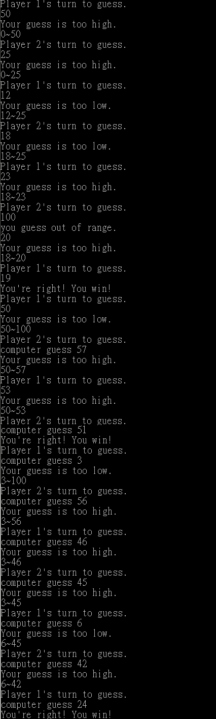
附屬資料︰
解答程式：GuessNumber.cpp(檔名)
測試資料：
- 易，僅需用到基礎程式設計語法與結構
- 中，需用到多項程式設計語法與結構
難，需用到多項程式結構或較為複雜之資料型態或結構
解題時間：30分鐘。
其他註記：
main使用input_main
除了輸出要求以外的output為方便debug的輸出，可有可無

