CPP Problem Design
Subject: Simple Drawing Program
Contributor: 謝宜杭, 林承達, 廖宣瑋
Main testing concept: 2-Dimension Array
Basics | Functions
□ C++ BASICS  □ FLOW OF CONTROL  □ FUNCTION BASICS  □ PARAMETERS AND OVERLOADING  ■ ARRAYS  □ STRUCTURES AND CLASSES  □ CONSTRUCTORS AND OTHER TOOLS  □ OPERATOR OVERLOADING, FRIENDS,AND REFERENCES  □ STRINGS  □ POINTERS AND DYNAMIC ARRAYS | □ SEPARATE COMPILATION AND NAMESPACES  □ STREAMS AND FILE I/O  □ RECURSION  □ INHERITANCE  □ POLYMORPHISM AND VIRTUAL FUNCTIONS  □ TEMPLATES  □ LINKED DATA STRUCTURES  □ EXCEPTION HANDLING  □ STANDARD TEMPLATE LIBRARY  □ PATTERNS AND UML

Description:
Please design a simple drawing program (fill the background with *), allow users to draw square, Isosceles right triangle and lines on the console (for figure, fill with Upper X)

Input:
At the beginning, allow users to enter the size of the drawing board(m*n).After that, enter the corresponding drawing code. S indicates square, T indicates Isosceles right triangle, L indicates lines. According to different figures, there follows various input information:
S: input integer width(the width of the square). And coord x,y, drawing will start from x,y(calculates from the left-up corner of the square).
T: input integer width(the side-length of the triangle). And coord x,y and the side the triangle faces. Which are respectively LU(Left Up),LD(Left Down),RU(Right Up),RD(Right Down).While drawing, the x,y indicates the position of right angle.
L: input two pairs of coord x1,y1 & x2,y2.Drawing from x1,y1 to x2,y2 (Except straight line, it would possible be tilted lines with +-45 Angle).
Enter EXIT,end the program.
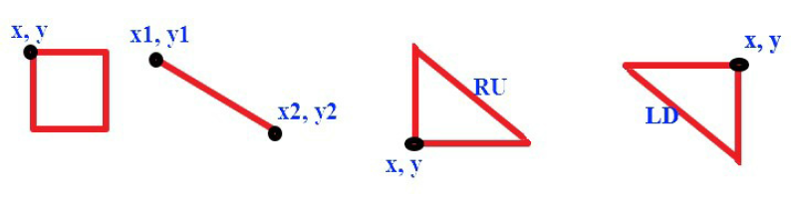
※Please notice the coordinate, the left-up corner is 0,0 while right-down corner is m-1,n-1.
※If the following figure violates the border of drawing board,please output
“Out of range.”.And there no need to modify the board.
※Notice that for any figure,if the given width is 1 you’ll need to draw a point.
※You need to output a result every draw,separates each with a line of space.
※Expect the test data testing border violation, we ensure all input data is drawable.
※Any operation about string,please implements with std::string,or not points will be given.

Output:
After drawing a figure or an error message,output a newline.

Sample Input / Output：
Sample Input | Sample Output
5 6  S  2  0 0  S  2  100 100  L  0 4 4 4  T  2  1 3  LU  EXIT | XX***  XX***  *****  *****  *****  *****  Out of range.  XX***  XX***  *****  *****  XXXXX  *****  XX***  XX***  *X***  XX***  XXXXX  *****

□ Eazy,Only basic programming syntax and structure are required.
■ Medium,Multiple programming grammars and structures are required.
□ Hard,Need to use multiple program structures or more complex data types.
Expected solving time:
30 minutes
Other notes:

