PHYS-512 PS5

Chuyang Li 260744689

**Q1.**

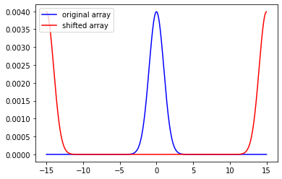

**Q2.**

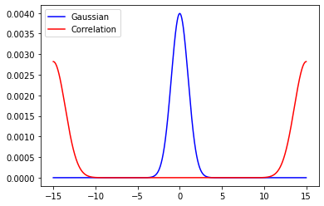

**Q3.**

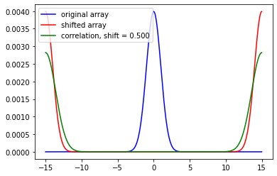

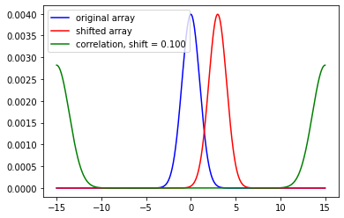

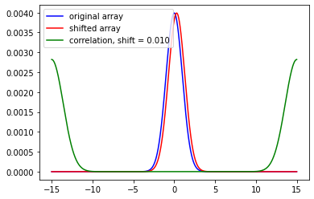

As shown in the graphs above, the correlation function (green) does not depend on the shift (red). Autocorrelation does not depend on the shift.

**Q4.**

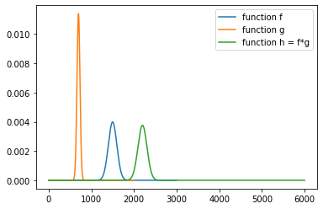

The output array is 2 times as long as the longest array between f and g.

**Q5.**

**a)**

**c)**

Std is 11.246715049499588.