**EECS 442 W17: Shape-from-Shading Competition**

**Task description**

Your task is to develop a system that can predict surface normals given a single image. In this competition, each image is a synthetic image showing one object under simple lighting. We also provide a mask (a binary png image) for each image. A pixel in the mask is white if it is occupied by the object. You are free to use the mask in any way you like (e.g. as an additional input to your system).

The predicted surface normals are stored in png files. You need to predict a 3D vector at each pixel. That is, for each input image, your output is a color image with three channels that represents per-pixel surface normals.

We provide 20K images as the training set and 2K images as the test set. The ground truth for the training set is provided. Your task is to generate predictions for the 2K images in the test set.

**Data and evaluation script**

The files can be downloaded at <https://goo.gl/A0bvuE>

We also provide an evaluation script in Python, which evaluates the “mean angle error” (MAE) of your predictions. This metric is defined as the average cosine value of the angle between the predicted normal and the ground truth normal on each pixel. Thus the lower the MAE, the better your predictions. Note that only pixels within the object region (as given by the mask) are evaluated.

Use the following command in a unix/linux system to run the script. The script requires the imageio package for python.

*python Evaluation_script_.py -p path_to_your_prediction_directory -g path_to_ground_truth_directory -m path_to_mask_directory*

Note that the ground truth for the test set is withheld, so you are not able to run this script on your predictions on the test set. To do that you need to submit your predictions on the 2K test images to our evaluation server (more details later). The evaluation server will tell you the MAE of your predictions on a fixed subset of 1K test images (this set is called TEST-DEV), but will not tell you the result on the remaining 1K test images (this set is called TEST-MAIN).

**Rules of competition**

* No collaboration between teams after 11:59pm 3/28. In particular, sharing of code or prediction files is prohibited at all times.
* You can use any publicly available datasets and/or source code. But you cannot use any web service (e.g. Google APIs) as part of your system. That is, your system must be able to process new images without access to the Internet.
* You can do whatever you want to the training set. But you can only use the test set to generate predictions. In particular, do not attempt to obtain the ground truth of the test set in any manner (e.g. through manual annotation).

**Final submission and deadline**

*The submission deadline is 11:59pm April 11. Your final predictions should be submitted to Canvas, NOT the evaluation server. Only submissions to Canvas will be used for grading. Submissions to the evaluation server will NOT be looked at.*

You will also need to submit your source code and a simple report by 11:59pm April 13. Details to follow shortly.

**Grading**

Your grade will depend on the MAE of your last submission on TEST-MAIN on Canvas. Note that the results on TEST-DEV are NOT used at all for grading.

Your grade will be a combination of your absolute performance and your ranking in the class. 70% of your grade will be based on your absolute performance. The remaining 30% will be based on your ranking in the class. We will announce the exact grading formula in a few days.

**Evaluation server**

The server is at [https://v1.eecs.umich.edu/eecs442_w17/.](https://v1.eecs.umich.edu/eecs442_w17/) Once you form a team, you should create a group on the website.  
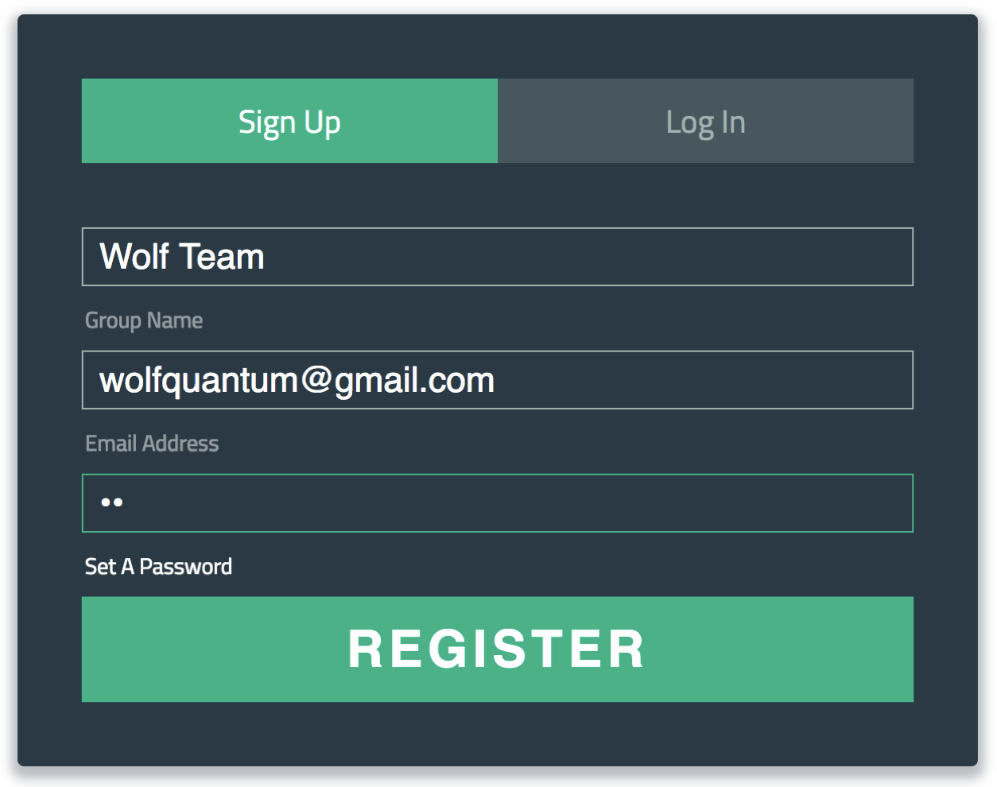

1. One group should only have one account, and you can decide on a member to receive the registration email. Give a name to your team!
2. You will receive an email from www-data@v1.eecs.umich.edu, for account activation. Check your spam folder if you do not receive anything.  
   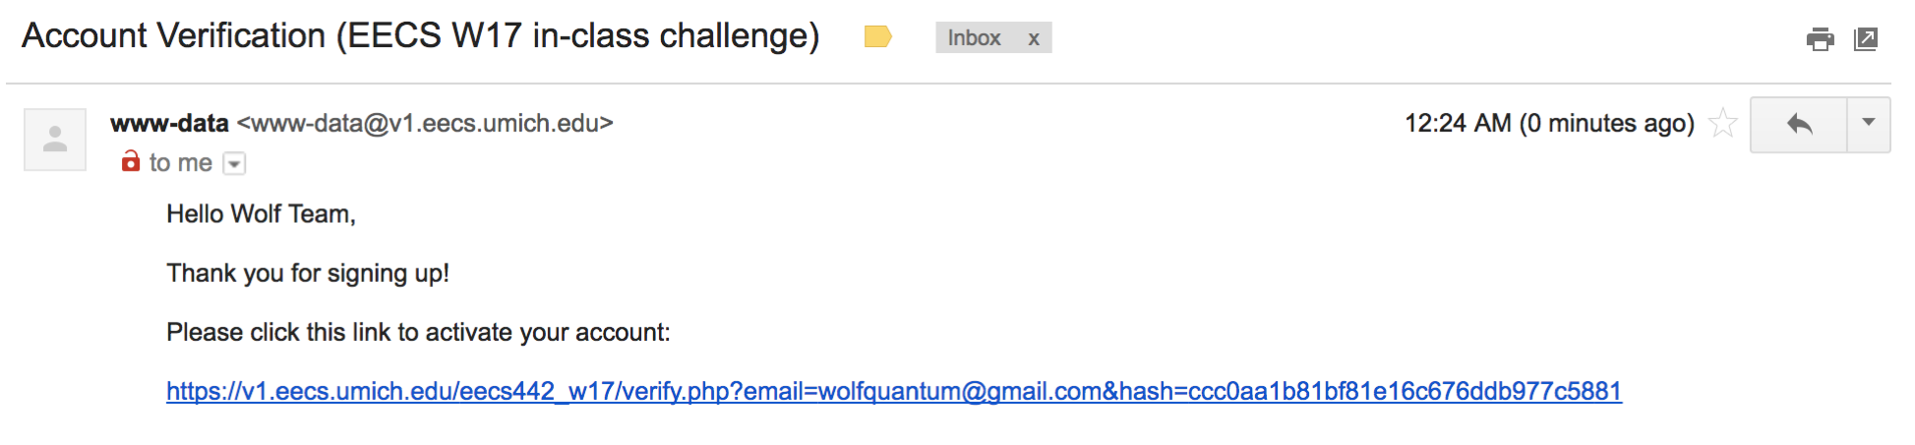
3. You can reset your password if you forget it.
4. For submission, we only accept zip files. Please zip your predictions (png files) without putting them into a folder first.   
   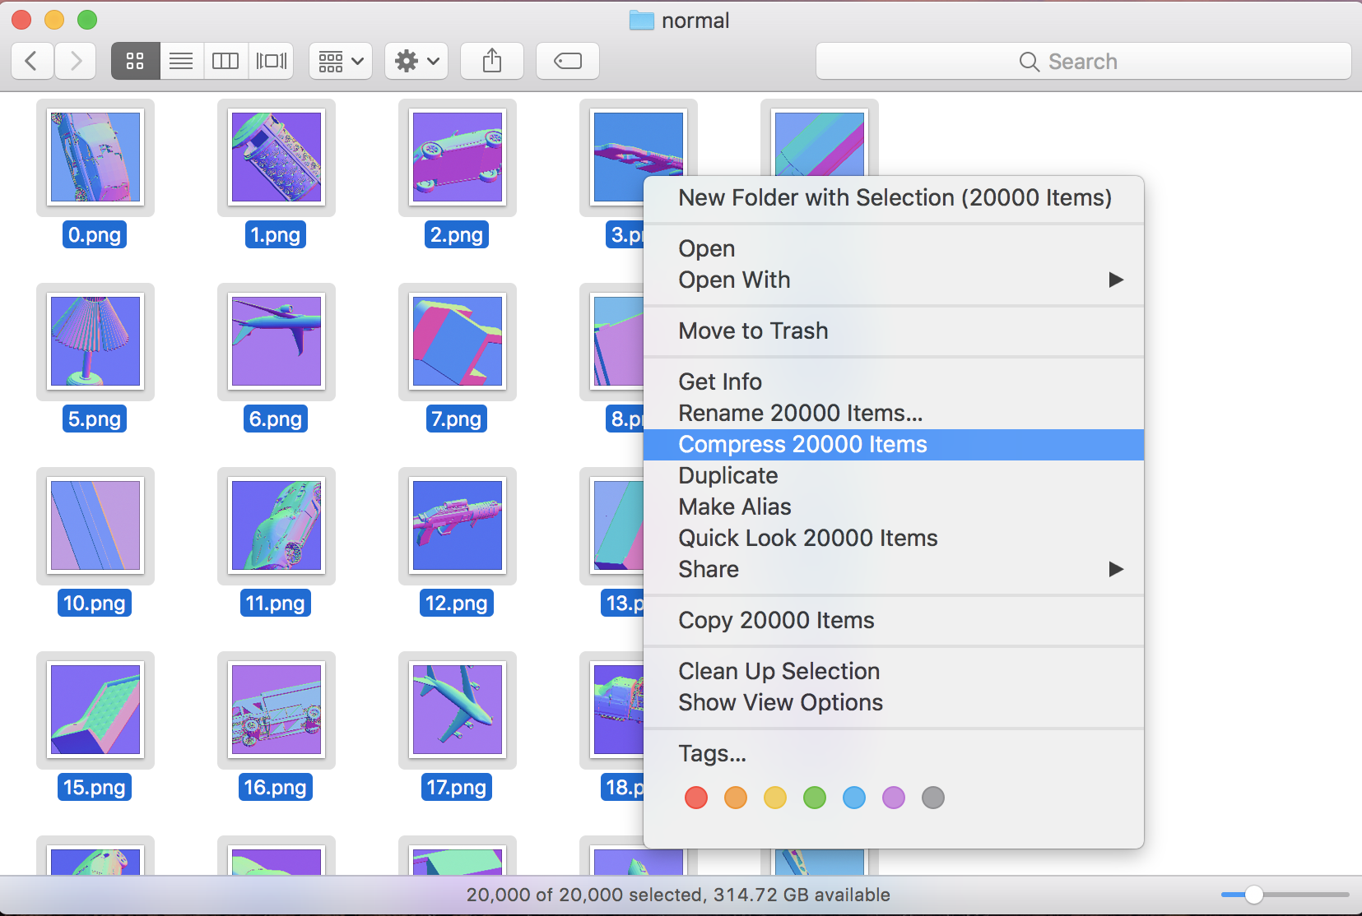
5. Click upload to see your performance. Wait for about 10 seconds after clicking.  
   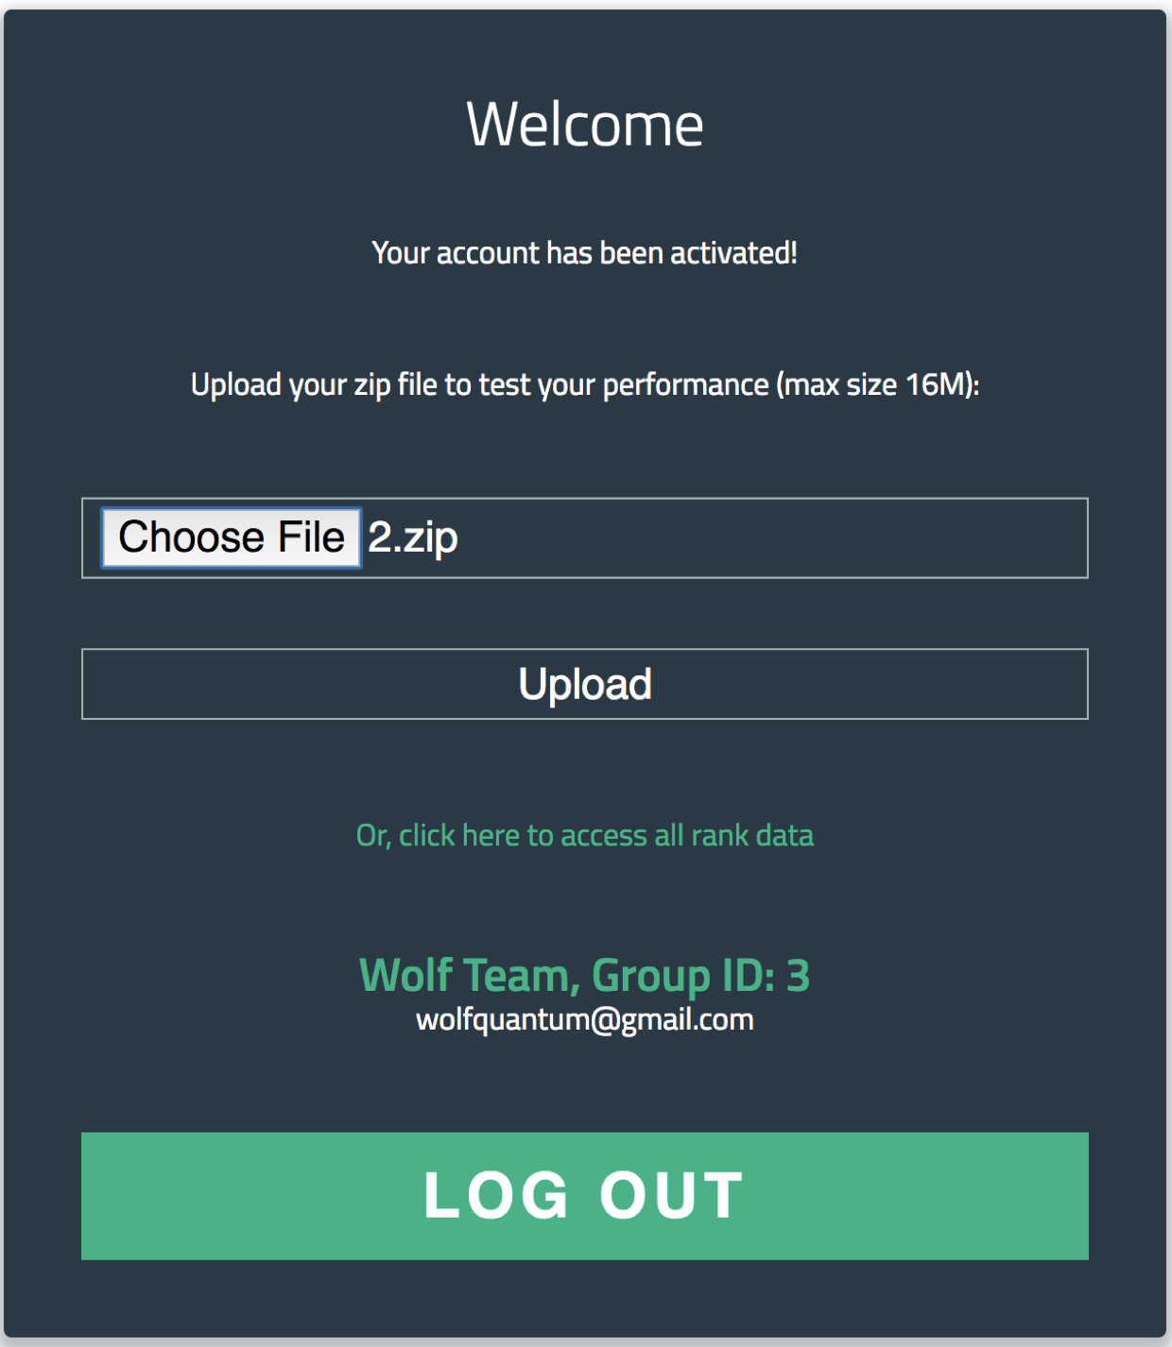
6. You’ll then receive your  
   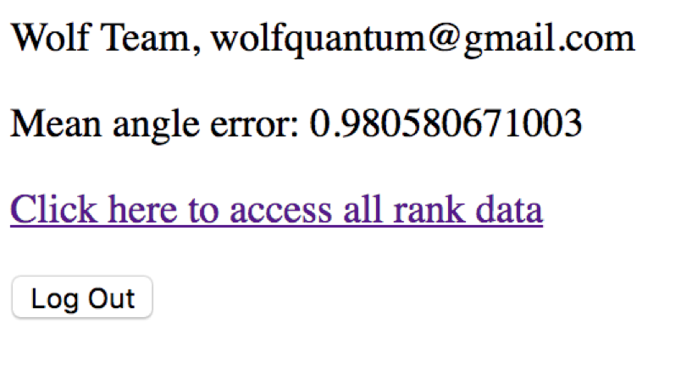
7. You can see your rank among all teams. Note that this ranking is based on TEST-DEV, so is not necessarily the same as the ranking based on TEST-MAIN. 