**Queries**

1. FOB Pricing of  A4 papers 80 GSM  and 70 GSM
2. FOB Pricing of  A3 papers 80 GSM  and 70 GSM
3. When we are ordering one container can we order 4000 reams of 80 GSM and balance from 70 GSM?
4. What is the maximum capacity which can deliver by your supplier per month?  ie can they  supply  more than 5 containers per month.
5. What is the brand?
6. Does manufacture can provide us the authorized certificate to sell in Sri Lanka.
7. Can Supplier rename the paper reams to our name?
8. Can you send us the photo of the paper box.
9. Paper ream wrapping paper comes with water proof
10. The price quoted earlier with pallet or not.  If is not with pallet then what is the additional cost involved?
11. If there is a production damage, then what is supplier responsibility?
12. How many days take to production and loading for two containers?

**Double A (Sample 1, S1)**

1. Price for A4 80 GSM FOB = $0.85 USD/Ream and CIF = $0.90 USD/Ream.  
   Price for A4 70 GSM FOB = $0.80 USD/Ream and CIF = $0.85 USD/Ream
2. Price for A3 80 GSM FOB = $0.80 USD/Ream and CIF = $0.85 USD/Ream.

Price for A3 70 GSM FOB = $0.75 USD/Ream and CIF = $0.80 USD/Ream

1. Yes you can order 4000 Reams of 80 GSM and 4000 Reams of 70 GSM.
2. Our maximum capacity per month is 15 containers.
3. Our brand name is DOUBLE A.
4. We can give you our Manufacturer license but the buyer need need import license or what certificate they are using to import from their country.
5. Yes is very possible to use your own brand name.
6. Kindly refer to the attach file
7. Kindly refer to the attach file
8. All the prices quotes are with pallets.
9. There is a draft contract that both parties will sign that will spells out everything in case of damage.
10. For packaging and loading for two container,maximum 6 days.

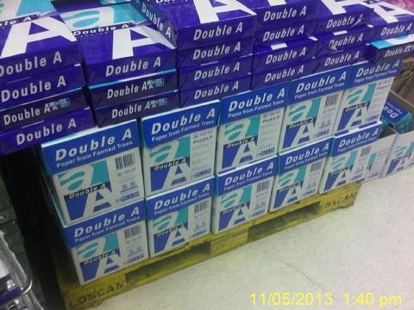

**IK Plus (Sample 2, S2)**

1. FOB pricing for A4 papers 80GSM is $0.76 USD per ream, 70GSM is  
   $0.74 USD per ream.
2. FOB pricing for A3 Papers 80GSM is $1.2 USD per ream 70GSM is $1.0  
   USD per ream.
3. You can order one container both 80 and 70 GSM. That is 4000 reams  
   of 80GSM and the rest will be 70GSM loaded in 1x20ft container  
   without pallet.
4. Our supply ability is 25x 20FT containers per month. We are able to supply more than 5 containers per month.
5. Brand name is IK Plus brand but we do produce other brands.
6. Papers can be sold worldwide including Sri Lanka. So you don't  
   need any certificate for that.
7. We can rename the paper reams to your name. You just have to  
   provide us with a name.
8. Find attached a photo.
9. Paper reams wrapping comes with water proof.
10. The price quoted earlier is without pallet. There is no additional  
    cost involved.
11. If there is production damage we will take full responsibility for it.
12. It will take 5 to 7 days for the production and loading of 2 containers.

