**Customer Behavior Analysis Report**

This report analyzes customer behavior, journey drop-offs, sentiment from reviews, marketing effectiveness, and product performance for ShopEasy. The goal is to provide data-driven insights to improve customer engagement and conversion rates.

**Customer Journey Drop-offs**

most drop-offs occur at the Checkout stage.

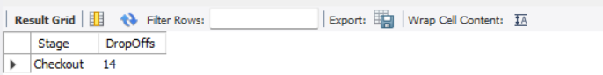

**Customer Sentiment Analysis**

customer reviews shows that most feedback is positive.

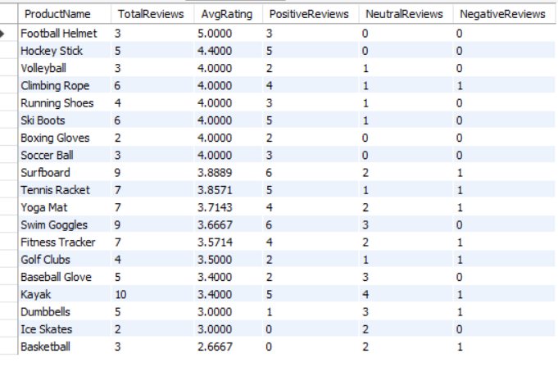

**High-Performing Products**

The top performing products contribute significantly to sales.

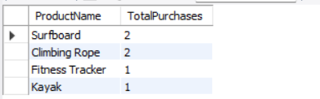

**Highest buyers**

## 

**actions leading to a purchase**

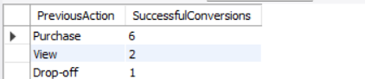

**Highest to Lowest Rated Products**

Highest : FootBall Helmet

Lowest : Basket Ball

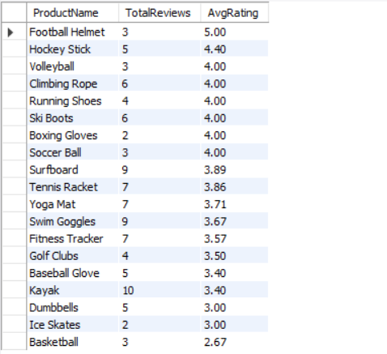

**product reviews with sales performance**

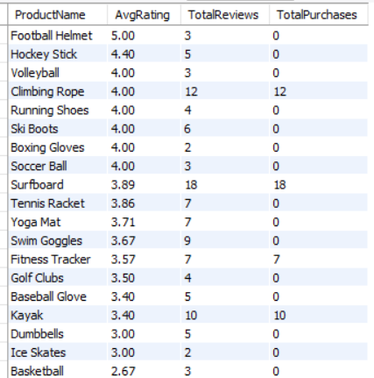

**top-selling products by country**

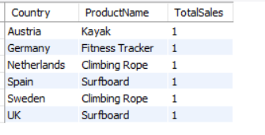

**Average Duration Per Stage**

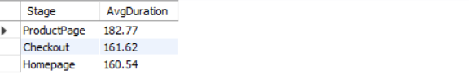

**Recommendations**

- Offer discounts or free shipping to reduce checkout abandonment.

- Streamline the checkout process to make purchasing easier.

- Address product pricing concerns to improve customer satisfaction.

- Investigate delivery issues and optimize logistics.

- Focus on high-performing products and improve low-performing ones.

- Reallocate marketing budget to high-conversion campaigns.