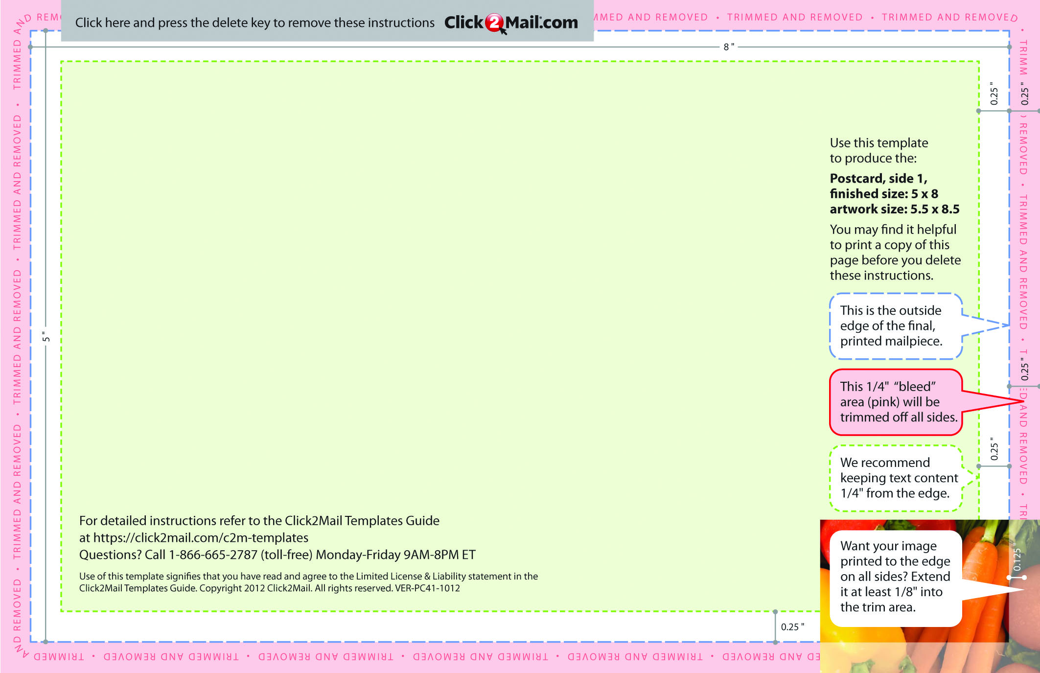

Placeholder text... Replace this placeholder text with text of your own. Use Click2Mail.com to print, finish, post, and deliver your mailpieces quickly and economically. Click2Mail.com makes it easy to design brilliant, full-color, affordable postal mail without permits, sorting, stamps, or

trips to the Post Office. How does it work? We use a network of strategically located,

high-quality printers to print, prep, and sort large volumes of mail daily. That network

and our understanding of strict postal requirements allows your mailpiece to receive

optimal handling and delivery. You benefit from high volume processing without

setup fees or minimum quantities.

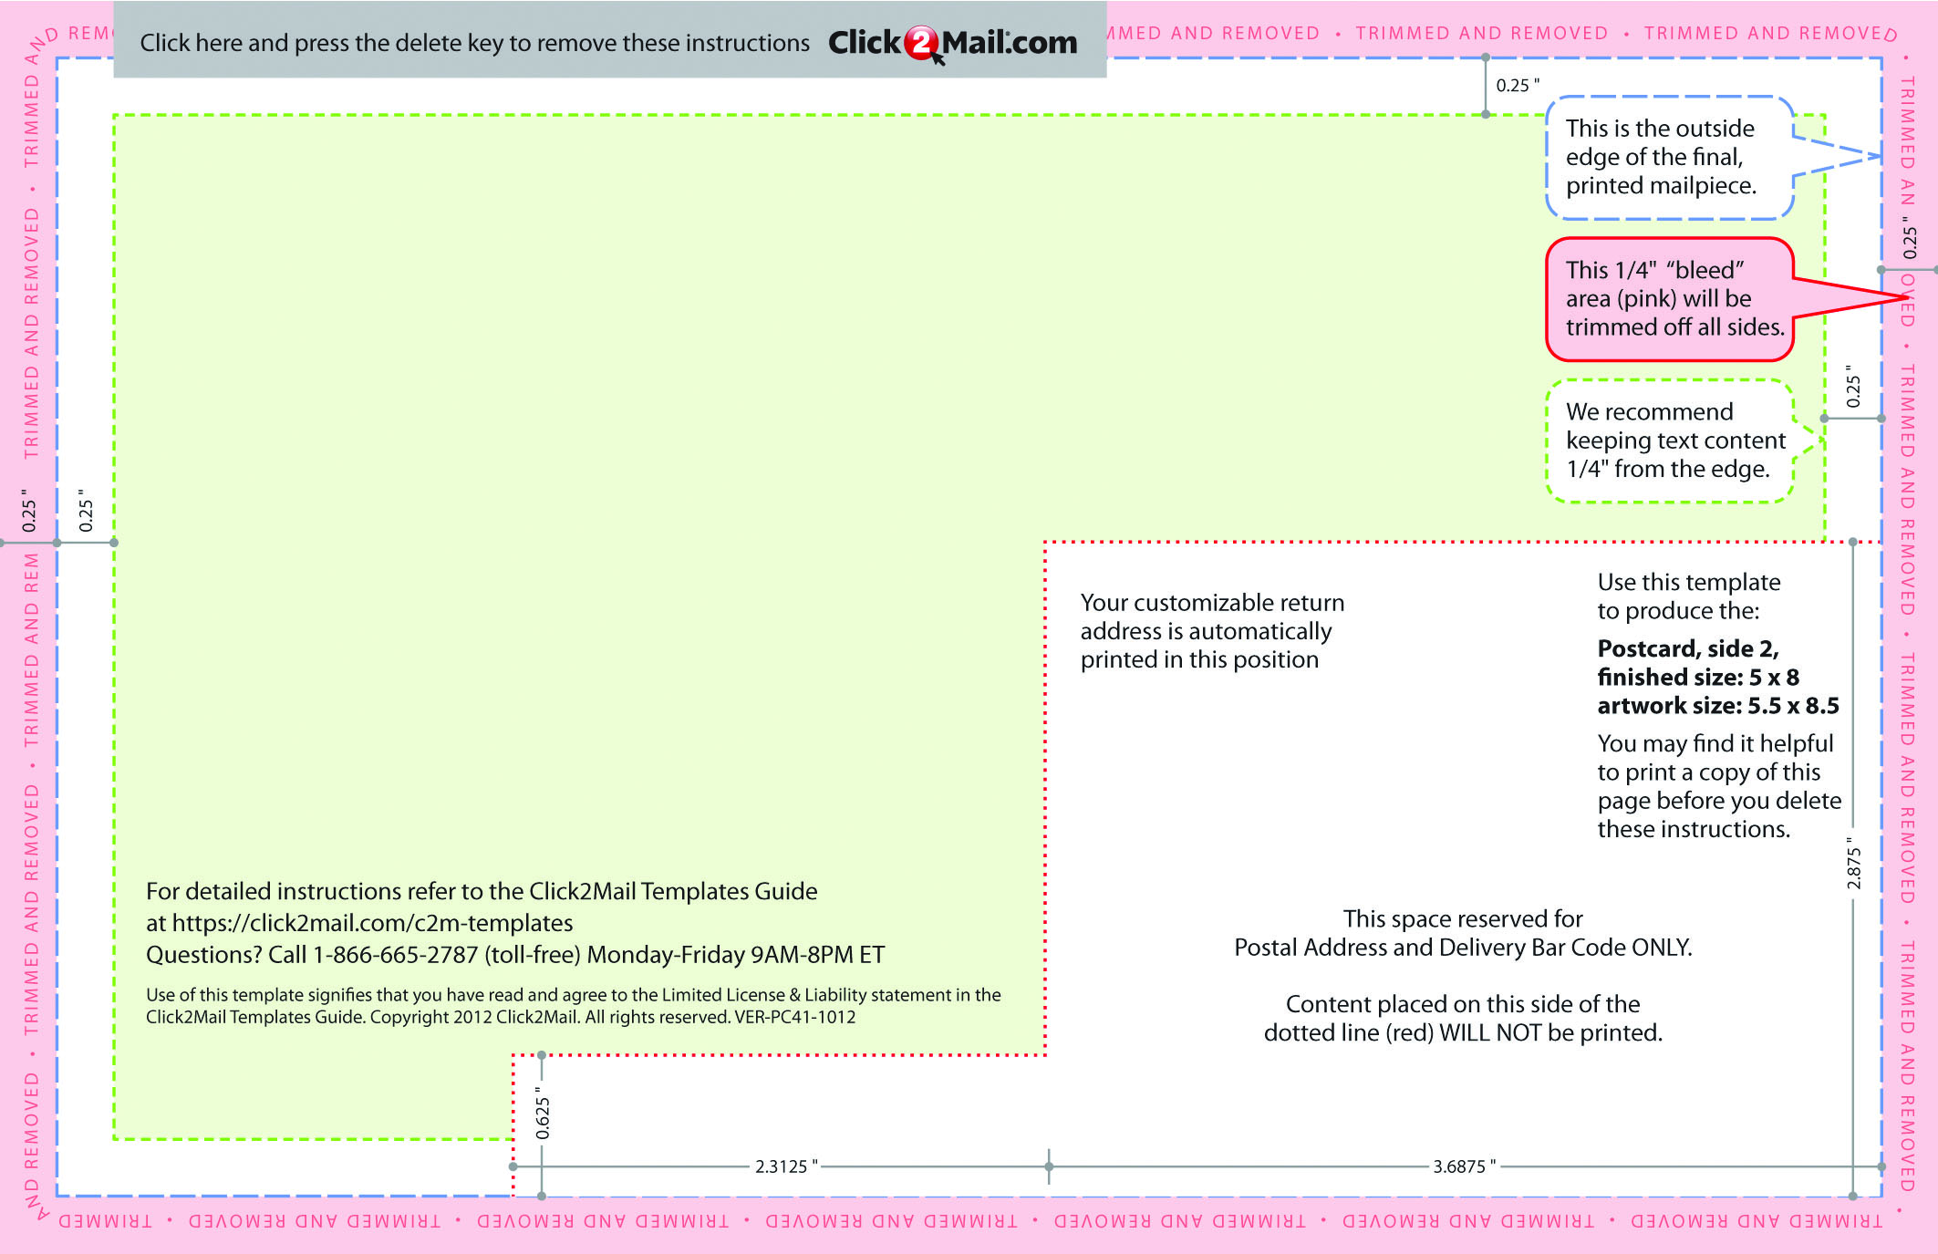

Placeholder text... Replace this placeholder text with text of your own. Use

Click2Mail.com to print, finish, post, and deliver your mailpieces quickly and

economically. Click2Mail.com makes it easy to design brilliant, full-color, affordable

postal mail without permits, sorting, stamps, or trips to the Post Office. How does it

work? We use a network of strategically located, high-quality printers to print, prep,

and sort large volumes of mail daily.