Functional Design Specification Functional-Design-IRS-Static-File- Version 1.0

Upload.docx

**IRS Integrated Enterprise Portal**



**Functional Design Specification**

**Table of Contents**

|  |  |  |  |
| --- | --- | --- | --- |
| 1 | Introduction ......................................................................................................................................................... | | 2 |
|  | 1.1 | Document purpose ....................................................................................................................................... | 2 |
|  | 1.2 | Project background ...................................................................................................................................... | 2 |
|  | 1.3 | Scope ............................................................................................................................................................ | 2 |
|  | 1.4 | Glossary ........................................................................................................................................................ | 3 |
|  | 1.5 | Reference documents .................................................................................................................................. | 3 |
| 2 | Module overview ................................................................................................................................................. | | 4 |
|  | 2.1 | Overview ...................................................................................................................................................... | 4 |
|  | 2.2 | Routing Information ..................................................................................................................................... | 4 |
|  | 2.3 | Dependencies ............................................................................................................................................... | 4 |
| 3 | Functionality to be supported .............................................................................................................................. | | 5 |
|  | 3.1 | Problem statement ...................................................................................................................................... | 5 |
|  | 3.2 | Solution ........................................................................................................................................................ | 5 |
|  | 3.3 | Business use cases ........................................................................................................................................ | 5 |
|  | 3.4 | Use case model ............................................................................................................................................ | 5 |
| 4 | Business rules ....................................................................................................................................................... | | 6 |
|  | 4.1 | Data validation rules .................................................................................................................................... | 6 |
|  | 4.2 | Conversion rules ........................................................................................................................................... | 6 |
|  | 4.3 | Scheduled processes .................................................................................................................................... | 6 |
| 5 | Reporting ............................................................................................................................................................. | | 7 |
| 6 | Integration ........................................................................................................................................................... | | 8 |
| 7 | Data | ...................................................................................................................................................................... | 9 |
| 8 | Workflows .......................................................................................................................................................... | | 10 |

©2016 Accenture. All Rights Reserved. 1 Last modified by: User

Functional Design Specification Functional-Design-IRS-Static-File- Version 1.0

Upload.docx

* **INTRODUCTION**



1. **Document purpose**

This document is the Functional Design Specification (FDS) for the configuration and implementation of Drupal 8 module components for the IRS Integrated Enterprise Portal Program.

1. **Project background**

The IRS mission is to provide America’s taxpayers top-quality services by helping them understand and meet their tax responsibilities and enforce the law with integrity and fairness to all. The IRS.gov website is the Agency’s gateway to online self-service options for taxpayers, tax professionals and other customers.

The IRS is in the process of migrating four key public-facing websites (irs.gov, eitc.irs.gov, marketingexpress.irs.gov and stayexempt.irs.gov) to a new Web Content Management System (WCMS), specifically, Drupal 8. The IRS intends to leverage industry leading practices and innovations to improve all four websites’ efficiency, effectiveness, quality, and process maturity while satisfying growing demands for secure, reliable, timely, and customer- centric Web solutions. In this project, the IRS expects to achieve more flexibility in managing and presenting web content to optimize website customer experience across a variety of modern digital devices, including mobile.

The overall effectiveness of these websites depends on the quality, organization, and presentation of the site’s content. IRS’s objective is to procure IT services to build and deploy a new Drupal Web Content Management System (WCMS) that enables IRS to recreate the IRS.gov public-facing website content as required to optimize user experience on the site and meets taxpayers’ needs. IRS expects the new WCMS will enable Web content managers throughout the IRS business organizations to easily, quickly, and reliably post and edit a variety of digital content to meet taxpayer needs, while meeting all business Web content management needs.

1. **Scope**

The objective of the WCMS Transition is to provide a new Web environment to replace the current IRS.gov website and Web Content Management System (WCMS) with a Drupal WCMS. The scope will include all support services required to develop, transition, deploy, operate, maintain, and safeguard an enterprise-wide Web content management system and new IRS.gov website based on a Drupal platform. This effort shall design, develop, and deploy an enterprise-computing environment applying infrastructure management, configuration management, network and communications management, all utilizing Federal security standards. This project involves the migration of IRS.gov content, managed as static pages in OpenText Web Experience Management content management solution, to a new, responsively designed IRS.gov website, managed in a Drupal WCMS.

In Scope for this document:

* Provide a descriptive process of how the CMS will be configured to create, manage, and publish content
* Provide initial baseline of content field mapping, content types, taxonomy, workflow, media assets, and configuration for the initial release
* Data conversion processes and analysis

©2016 Accenture. All Rights Reserved. 2 Last modified by: User

Functional Design Specification Functional-Design-IRS-Static-File- Version 1.0

Upload.docx

Out of scope for this document:

* + Architecture of content management – this is further described in the Drupal WCMS Platform Architecture and High Level Hosting Design Document
  + Website display of content – The current design for all sites will be used as the baseline for the Drupal Migration. Assuming that the display and design of the content will not change based on current requirements, unless inherently changing due to the way Drupal handles certain components, which will be called out as applicable.

1. **Glossary**

The following table contains some of the key terms and acronyms used throughout in this document.

|  |  |  |  |  |
| --- | --- | --- | --- | --- |
| **Term / Acronym** |  | **Definition** |  |  |
|  |  |  |
|  |  |  |  |  |
| **WCMS** | | Web Content Management System | |  |
|  |  |  |
| **IRS** | | Internal Revenue Service | |  |
|  |  |  |
| **CMS** | | Content Management System | |  |
|  |  |  |
|  |  |  |  |  |

1. **Reference documents**

The table below contains a list of all documents that have been used as background and references for the completion of this functional design specification.

|  |  |  |  |  |  |  |
| --- | --- | --- | --- | --- | --- | --- |
| **ID** | **Document Name** |  | **Version** | **Date** | **Link** |  |
|  |  |
|  |  |  |  |  |  |  |
| **WR1321** | Drupal WCMS System Design | | 1.0 | 8/25/16 |  |  |
|  | and Configuration | |  |  |  |  |
|  |  |  |  |  |  |  |
|  |  |  |  |  |  |  |
|  |  |  |  |  |  |  |

©2016 Accenture. All Rights Reserved. 3 Last modified by: User

Functional Design Specification Functional-Design-IRS-Static-File- Version 1.0

Upload.docx

* **MODULE OVERVIEW**



1. **Overview**

This module was created to change the Drupal behavior when uploading the document file in media bundle. When this module is installed, it checks for same file name, same file type exist in selected Path. If file exist it replace with old one and keep new file.

This new file uses the same URL for the document.

1. **Routing Information**

We are using below link for this module -admin/config/irspup/irs_file_operations

1. **Dependencies**

Irspup

Media_entity

Media_entity_document

File

Entity

This is the default container for all IRS PUP modules.

©2016 Accenture. All Rights Reserved. 4 Last modified by: User

Functional Design Specification Functional-Design-IRS-Static-File- Version 1.0

Upload.docx

* **FUNCTIONALITY TO BE SUPPORTED**



1. **Problem statement**

Accessibility to files at specific URLs is critical functionality that IRS employees, third-party services, and the public utilize frequently. Drupal’s core behavior does not overwrite files and implements its own version control. Additionally, the file is placed in a public location by default which also needs corrected.

1. **Solution**

The IRS Static File Operation module changes the current functionality to overwrite files with the same name. Rather than changing the name of the uploading file in selected location.

For the second part of this module, it will transfer files, under certain conditions, from published (public) and unpublished (private) folders. Different user types will have permissions to promote the status of these files.

1. **Business use cases**

A content editor uploads a new PDF file for 2017 to overwrite an existing 2016 form. The file should be put in a unpublish state in selected path. Until the content editor publish the file. Once publish, it will move from private to public directory also instead of renaming the file it will replace any existing file with the same name in the same directory.

1. **Use case model**

Current model exists and needs to be included in this document.

©2016 Accenture. All Rights Reserved. 5 Last modified by: User

Functional Design Specification Functional-Design-IRS-Static-File- Version 1.0

Upload.docx

* **BUSINESS RULES**



1. **Data validation rules**

Acceptable file formats: PDF, doc, docx, txt and all the document file format.

1. **Conversion rules**

No special rules for this module.

1. **Scheduled processes**

Cron job will run in every night and remove temp file and temp folder.

©2016 Accenture. All Rights Reserved. 6 Last modified by: User

Functional Design Specification Functional-Design-IRS-Static-File- Version 1.0

Upload.docx

* **REPORTING**



No specific reporting needs at this time.

©2016 Accenture. All Rights Reserved. 7 Last modified by: User

Functional Design Specification Functional-Design-IRS-Static-File- Version 1.0

Upload.docx

* **INTEGRATION**



This module hooks into delete, save_data, uri_scheme, move_file_to_destination. It will delete the current file, save a new file, and write the file at the correct URL.

©2016 Accenture. All Rights Reserved. 8 Last modified by: User

Functional Design Specification Functional-Design-IRS-Static-File- Version 1.0

Upload.docx

* **DATA**



Interacts with media and files, no additional content entities need created.

©2016 Accenture. All Rights Reserved. 9 Last modified by: User

Functional Design Specification Functional-Design-IRS-Static-File- Version 1.0

Upload.docx

* **WORKFLOWS**

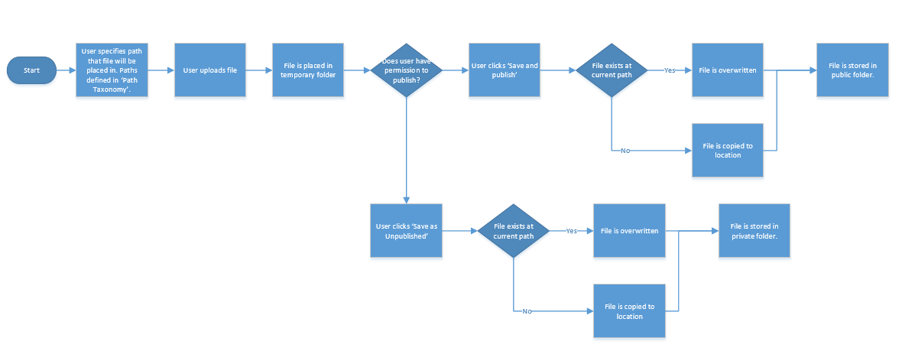

©2016 Accenture. All Rights Reserved. 10 Last modified by: User