The ShopKart Project Roadmap
The whole course builds one project, ShopKart, step by step. Every module adds one layer to it. Each module starts from the files the previous module produced and hands its own output to the next one.
By the end, a learner has taken one business question from a messy spreadsheet all the way to an automatic data pipeline, a prediction model and a presentation. Along the way they work as a data analyst (cleaning, SQL, EDA, charts), a data engineer (databases, a pipeline into a warehouse) and a data scientist (statistics, machine learning), each at a beginner level. That finished project is what goes into their portfolio.
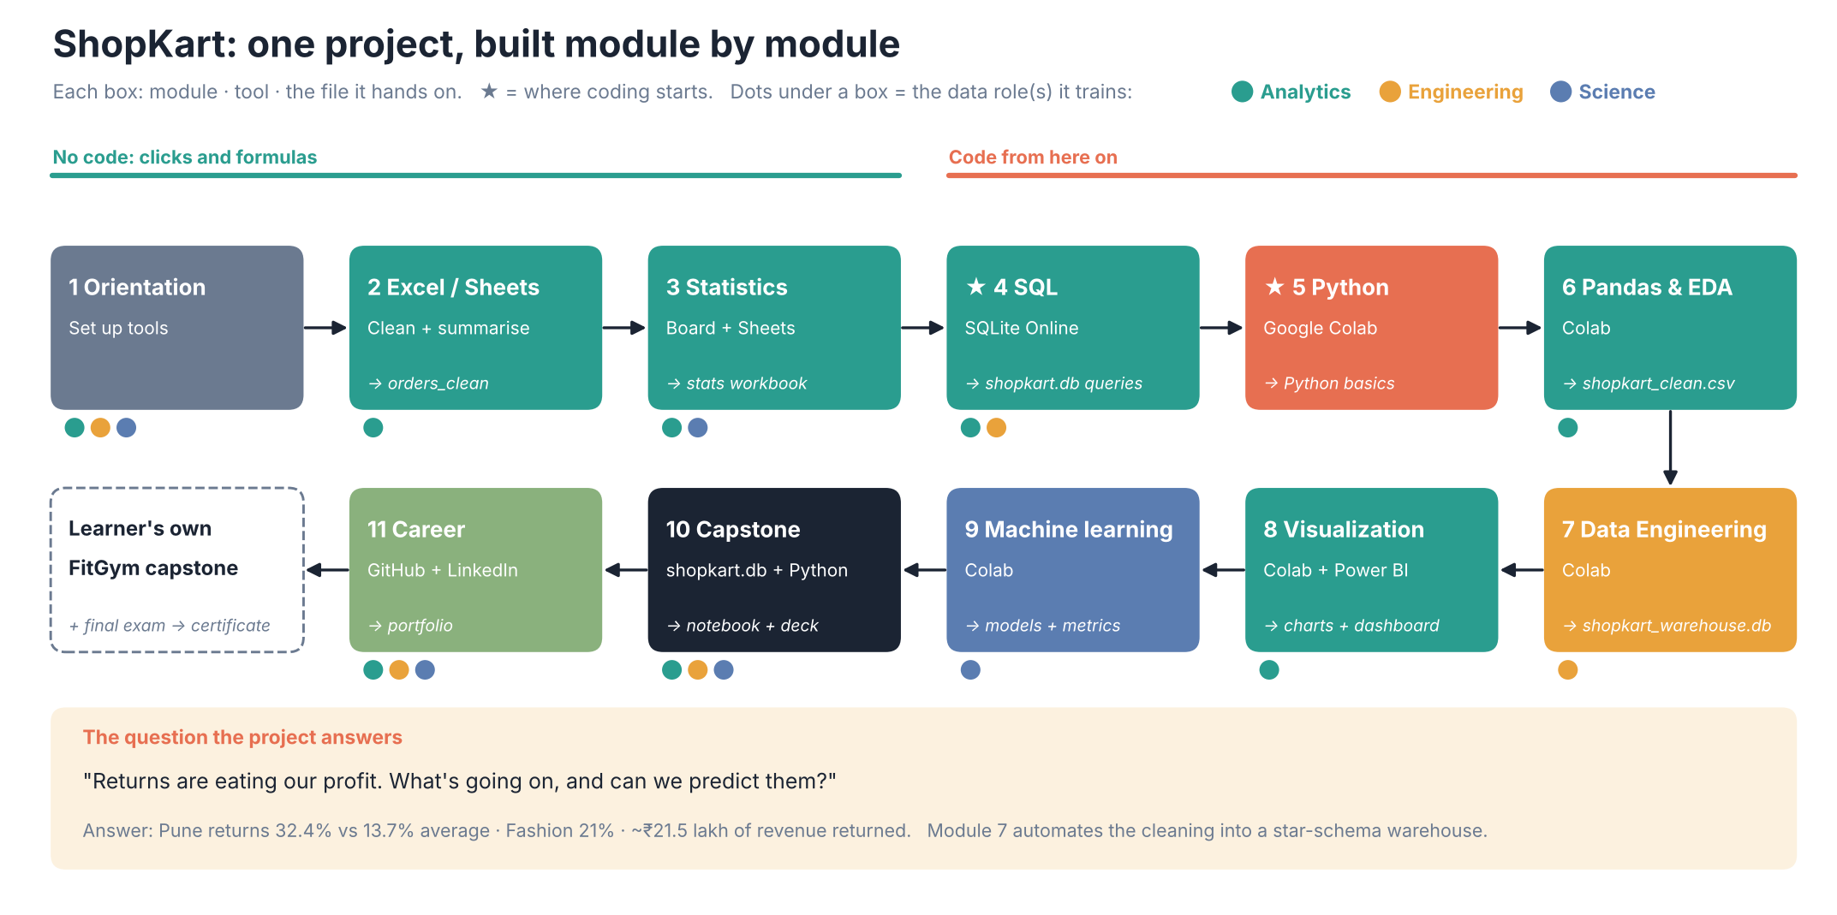

The business story
ShopKart is a fictional Indian online store that sells Electronics, Fashion, Home, Books and Beauty products in 10 cities. It has 5,000 orders from 2025, 800 customers and 60 products.
The data is messy on purpose: duplicate rows, "delhi" / "New Delhi" / "DELHI", prices typed as "₹1,299", blank discounts, mixed date formats and a few typos.
The question that runs through the course, and that the capstone finally answers, is:
"Returns are eating our profit. What's going on, and can we predict them?"
The answer the data gives, which learners discover gradually:
- 13.7% of orders are returned overall.
- Pune's return rate is 32.4%, about 2.4 times the average.
- Fashion has the highest return rate of any category (21%).
- Cash-on-delivery orders and slow deliveries come back more often.
- Returned orders were worth about ₹21.5 lakh of revenue.

Module-by-module: what we teach, what we build, the goal
Module | What we teach | What we build in ShopKart | Goal (learner can…) | Tool | Input → Output
1 Orientation (20 min) | Roles in data, the data lifecycle, the toolkit | Open the raw data in all three tools; first SQL query; first line of Python | Explain what analysts, engineers and scientists do; set up every tool | Sheets, SQLite Online, Colab | Course files → (nothing new)
2 Excel / Sheets (60 min) | Cleaning, formulas, SUMIFS, XLOOKUP, pivots, charts | Clean the raw orders sheet, add revenue, summarise by city/category/month, one-page report | Clean and summarise a raw sheet; build a pivot and chart | Google Sheets / Excel | shopkart_raw.xlsx → orders_clean sheet + Report (M02_SOLUTION_shopkart.xlsx)
3 Statistics (45 min) | Data types, mean/median, spread, distributions, correlation, A/B testing | Describe ShopKart order values and delivery times; find which relationships are real | Pick the right average, read spread and correlation, reason about a test | Handwriting board + Sheets | Cleaned orders → M03_statistics_shopkart.xlsx
4 SQL (65 min) ★ first code | SELECT, WHERE, GROUP BY, JOINs, CASE, subqueries, CTEs | Answer business questions straight from the database: revenue by city, customers who never ordered, top categories for Prime vs Free | Write queries across 3 linked tables | SQLite Online | shopkart.db (Module 2's cleaned data loaded into a database) → .sql answer files
5 Python basics (60 min) ★ Python + Colab start | Variables, lists, dicts, loops, functions, errors, libraries | Work with ShopKart-style values in plain Python: order bills, price conversion, a list of orders as a mini table | Read and write simple Python without fear | Google Colab | Small values typed in code (+ a first peek at orders_raw.csv)
6 Pandas & EDA (65 min) | DataFrames, filtering, cleaning, new columns, groupby, merge, EDA | Redo all Module 2 cleaning in code (repeatable), join the 3 tables, answer 5 business questions | Clean and explore a real dataset with pandas | Google Colab | orders_raw.csv + customers.csv + products.csv → shopkart_clean.csv
7 Data engineering (30 min) | Pipelines, ETL vs ELT, batch vs streaming, data quality checks, star schema, incremental loads, OLTP vs OLAP, scheduling (cron, Airflow), Spark, cloud warehouses, dbt | Turn the Module 6 cleaning into an automatic pipeline: extract() → transform() → quality_checks() → load() into a star-schema warehouse, then add January 2026 orders without duplicates | Explain what a data engineer builds and run a small, safe-to-rerun pipeline | Board + Google Colab | orders_raw.csv + customers.csv + products.csv + new_orders_2026_01.csv → shopkart_warehouse.db + shopkart_clean.csv (identical to Module 6's)
8 Visualization (40 min) | Chart choice, Matplotlib, Seaborn, Power BI, storytelling | Charts of returns and revenue, a Power BI dashboard, a 3-slide findings story | Pick the right chart and tell a story with data | Colab + Power BI | shopkart_clean.csv → charts, dashboard, findings deck
9 Machine learning (50 min) | ML workflow, train/test split, regression, classification, evaluation, overfitting | Predict order revenue; predict whether an order will be returned; evaluate honestly | Train and evaluate a simple model and explain its limits | Google Colab | shopkart_clean.csv → trained models + metrics
10 Capstone (35 min) | Putting it all together | Full pipeline: SQL → pandas → charts → return model → 5-slide presentation | Run an end-to-end project and present it | SQLite + Colab | shopkart.db → capstone notebook + deck
11 Career (10 min) | Portfolio, resume, LinkedIn, exam & certificate | Publish the capstone on GitHub; write the LinkedIn post | Present the project to employers | GitHub, LinkedIn | Capstone → portfolio
After Module 10, learners do the FitGym capstone on their own (gym members, predicting who will cancel). It uses the same steps on data they haven't seen. That submission and the final exam earn the certificate.

Where the coding starts and how it grows
Stage | Modules | What "code" means here
No code | 1, 2, 3 | Clicks and spreadsheet formulas only (=SUMIFS(...), =XLOOKUP(...)). This builds data sense first.
First code: SQL | 4 | The first real code. Learners type queries in the browser and see results instantly. Video 4.2 is where the first query is written.
Python starts | 5 | Google Colab opens in video 5.1. The first notebook cell is run in 5.1, plain Python only.
Python for data | 6, 8, 9 | pandas, then charts, then scikit-learn. Every notebook loads a ShopKart file and builds on the last module's output.
Python as a pipeline | 7 | The Module 6 cleaning wrapped in functions, plus sqlite3 to load a warehouse. Video 7.2 is in Colab; it ends by running the same code as a script with !python shopkart_pipeline.py. Videos 7.1 and 7.3 have no code.
All together | 10 | SQL inside Python (pd.read_sql), then pandas, charts and a model in one notebook.

How each module links to the next
- Module 2 cleans the raw orders in a spreadsheet. The story told in Module 4 is that this cleaned table was loaded into a database, which is shopkart.db.
- Module 4 queries that database, so learners see the same totals they got in Excel. For example, total revenue is ₹1,47,04,649.70 in both.
- Module 6 repeats the Module 2 cleaning in pandas, starting again from the raw CSV. The point is that code makes cleaning repeatable. It produces shopkart_clean.csv, and the numbers match Excel and SQL.
- Module 7 turns the Module 6 cleaning into a pipeline, as a data engineer would: extract the raw files, transform them with the same code, run quality checks that stop bad data, and load a star-schema warehouse (shopkart_warehouse.db: fact_orders, dim_customer, dim_product, dim_date). It also writes shopkart_clean.csv again, identical to Module 6's, then adds January 2026 orders (new_orders_2026_01.csv) with an incremental load that skips orders already loaded. Nothing later depends on the warehouse; it shows where shopkart_clean.csv comes from and how it would be refreshed every night.
- Modules 8 and 9 start from shopkart_clean.csv (2025 orders only).
- Module 10 goes back to the start: it pulls from the database with SQL inside Python and runs the whole pipeline in one place.
The fact that every module gets the same numbers is itself a teaching point. Show it on screen when you reach Modules 4, 6 and 7.

Key numbers to keep consistent in every video
Fact | Value
Orders (after removing 55 duplicates) | 5,000
Total revenue | ₹1,47,04,649.70
Total profit | ₹31,40,749.70
Average order value | ₹2,940.93 (median ₹1,524.80)
Top city by revenue | Delhi, ₹23,23,405
Electronics share of revenue | 49.9%
Overall return rate | 13.7% (687 orders)
Pune return rate | 32.4% (146 of 451), about 2.4× average
Highest-return category | Fashion, 21.0%
COD return rate | 19.1%
Revenue of returned orders | about ₹21.5 lakh (14.6% of revenue)
Peak month | October ₹19,78,317 (November nearly tied, ₹19,65,664)
Lowest month | May ₹7,86,912
Correlations | discount vs quantity +0.27, delivery days vs rating −0.33
Customers who never ordered | 42
Prime vs Free | Similar spend per order (₹2,934 vs ₹2,949), but Prime customers order about twice as often
Pipeline (Module 7) | 5,055 raw rows → 5,000 clean; 7 quality checks pass; warehouse fact_orders 5,000 → 5,036 after January (36 added, 2 re-sent 2025 orders skipped, 2 duplicate rows removed); dim_date 336 → 357
January 2026 (Module 7 only) | 36 orders, ₹1,73,149.15 revenue. Not part of any 2025 number above

