Install MCP Inspector
- Node should be installed
- To install the MCP Inspector, simply run the following command in your terminal:
npm i @modelcontextprotocol/inspector

Run MCP Inspector
- Run from the terminal the following
npx @modelcontextprotocol/inspector

Inspect MCP Server
- Connect to the MCP Server
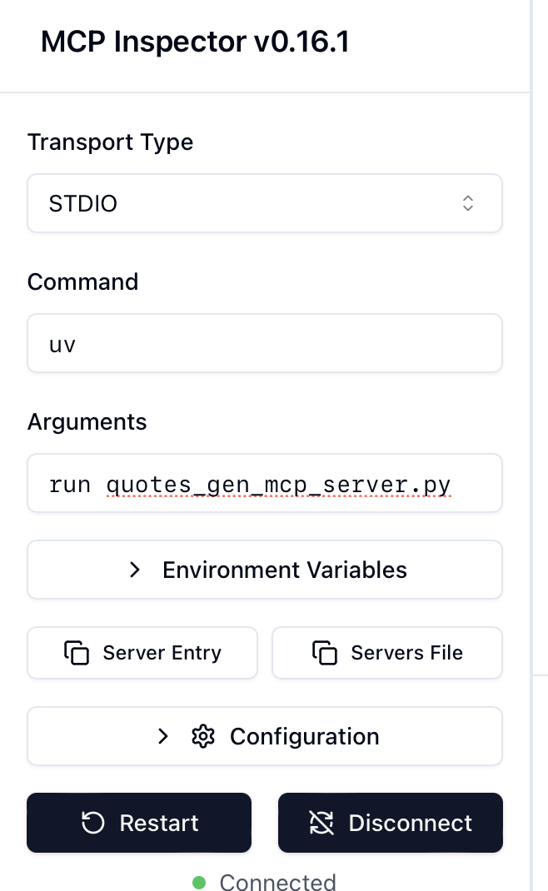
- The inspector can list tools, templates, resources and prompts from the MCP Server
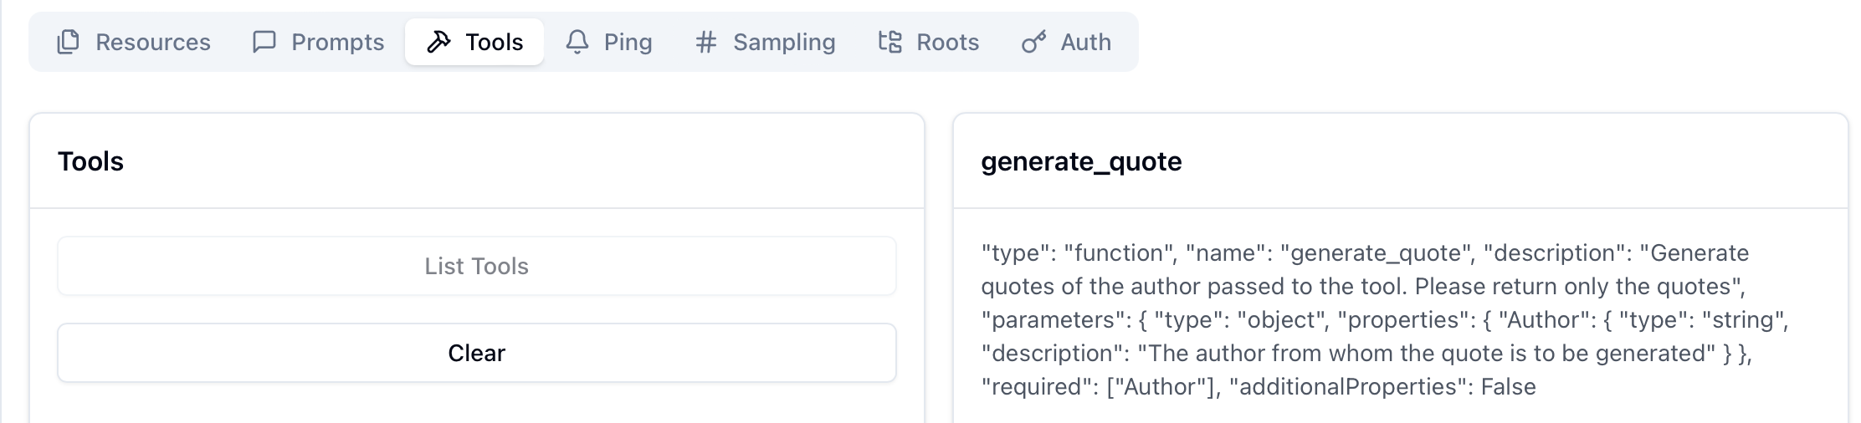

Reference
https://medium.com/@anil.goyal0057/how-to-test-your-mcp-server-using-mcp-inspector-c873c417eec1

