Usecase Modelchecking Responsepredictor
Author: Cor Lieftink
Date : March 18 2011
Version : 1.0

Table of Contents

Introduction 1
1. What is an Observation? 1
2. Steady state calculation of a model. 1
3. Resultmatrix of modelchecker 2
4. Changing the model 2
5. More observations 3

Introduction
The modelchecker checks for one or more observation(s) if the model has the same “steady state” outcome as the observation. “Steady state” in the model simulation means that the next iteration will not change the value of any of the nodes.

1. What is an Observation?
An Observation would be for example that if A is knock out (continuous Off ), B is On, and C is off. An observation contains an input and and an output component. The input contains start-values for all of the nodes in the network, as well information if the start-values are fixed. A value 0 set fixed mimics knockdown, a value of 1 fixed mimics continous active. The example observation above can be defined as:
 | Input |  | Output
Player | Start values | Fixed | End values
A | 0 | T | 0
B | 0 | F | 1
C | 0 | F | 0
Table 1: example observation

2. Steady state calculation of a model.
Assume we have the following model:
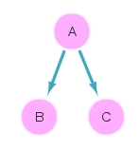
Figure 1: model 1

Running this model under the same input values as the observation from chapter 1, will give the following result:
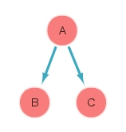
Figure 2: Simulation result of model 1 under input values observation 1

This result in tabular form:
 | Input |  | Output
Player | Start values | fixed | End values
A | 0 | T | 0
B | 0 | F | 0
C | 0 | F | 0
Table 2: steady state simulation result for model 1.

3. Resultmatrix of modelchecker
If you consider B en C the points to be checked than the result of the modelchecker will be:
 | Obser-vations
Point | 1
A
B
C
Table 3: Result matrix for model 1 of the modelchecker.

The score would be: 50% of the observation points are covered by the model.

4. Changing the model
If you assume that the data is correct, you can now change the model. For example you change the relation of A to B to an inhibiting one, see figure 2.
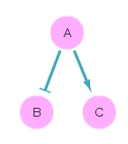
Figure 2: Example model 2

If you do the simulation for this model the result will be:
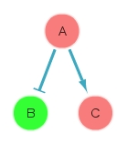
Figure 3: Steady state after simulating model 2 under input conditions observation 1.

The simulation outcome in tabular form:
 | Input |  | Output
Player | Start values | fixed | End values
A | 0 | T | 0
B | 0 | F | 1
C | 0 | F | 0
Table 2: steady state simulation result for model 2.

If you consider B en C the points to be checked than the result of the modelchecker will be:

 | Obser-vations
Point | 1
A
B
C
Table 3: Result matrix for model2.

The score is than: 100% of the observation points are covered by the model.

5. More observations
Assume one has second observation with the following values:
 | Input |  | Output
Player | Start values | Fixed | End values
A | 1 | T | 1
B | 0 | F | 0
C | 0 | F | 0
Table 1: example observation 2

The steady state values for model 2 under the input conditions of observation 2 are:
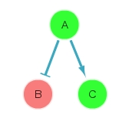
Figure 4: model 2 steady state under input conditions observation 2.

This result in tabular form:
 | Input |  | Output
Player | Start values | Fixed | End values
A | 1 | T | 1
B | 0 | F | 0
C | 0 | F | 1
Table 1: example observation

The resultmatrix of the Modelchecker now becomes:

 | Observations
Point | 1 | 2
A
B
C
This will give the model the following scores:
- 75% of all observation points are covered by the model.
- 50% of the observations are fully covered by the model

