Responsepredictor 2.0beta Userguide.

Document version: 1.0
Author: C. J. Lieftink.
Date: August 18th 2011

Table of Contents

1. Get started 1
2. Complete network 2
2.1 Import 2
2.2 Export Network to file 2
2.3 Load existing Network 3
3. Build network 3
3.1 Add/remove nodes/edges 3
3.3. Pan and zoom 3
4. Improve Network. 4
4.1 D 4
5. Simulate. 4
6. Check model 5
6.1 Loading observations from file 5
6.2 Add observation 5
6.3 Run check 6
6.4 Save observations to file 6
7 Run rp from commandline 7

1. Get started
Responsepredictor (RP) offers molecular biologists an easy to use tool for building, simulating and/or checking a synchronous boolean model. RP is a webapplication. To use it, go to your webbrowser and use the appropriate url. (see fig. 1)
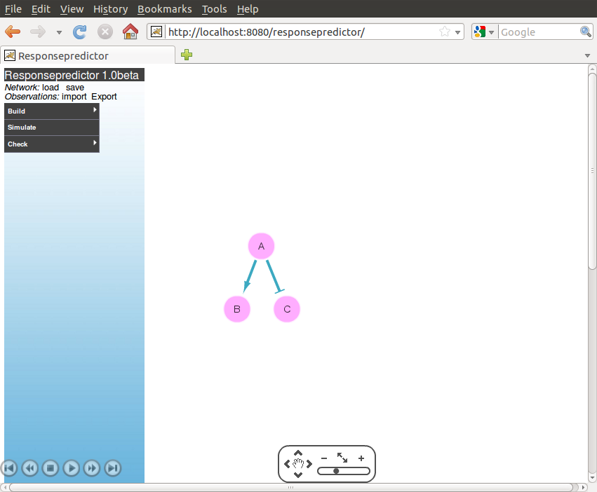
Figure 1: Start page responsepredictor
The left part of the window with the blue background is the menubar containing all the action options. The right part with the white background contains the graphical representation of the network.

2. Complete network

2.1 Import
If you have created a network before in RP or in the Cytoscape standalone application, after you removed the first line <?xml version="1.0" encoding="UTF-8" standalone="yes"?> you can load it via Complete Network: import.
A file created with the Cytoscape standalone application should follow the following rules:
- Names of the nodes should start with a letter.
- Add to each node the Integer attribute 'Type' (Starting with uppercase) . For 'and' gates give it the value -2, for regular node (='player') the value 1.
When loading the file, RP will automatically add the field state to each of the nodes with default value 0.
Networks created in RP can be saved in xgmml format, to be reloaded later.

2.2 Export Network to file
You can save your adjusted network to your filesystem by clicking on Network: save. A known issue is that the popwindow for selecting a file only remains open for 30 seconds. After that the popup and network will disappear. Changes to the network are then lost.

2.3 Load existing Network
Predefined networks can be loaded via Complete Network and then clicking the network of choice. Currently there is one network offered, that is the prior network of the Sach 2011 paper.

3. Build network

3.1 Add/remove nodes/edges
You can add nodes and/or edges to your network.
For a new node, click in the menu on Build, and then Node: add. Give a name to the node, which has to start with a letter. Maximum size for a name is 15 characters.
You also have to define the property Type. For a regular node, select 'player' . You select 'and-gate' to define an 'and' relationship between two or more incoming edges. For example, if you want C only to be active if both the activators A and B are on, you define an and-node. See figure 3.
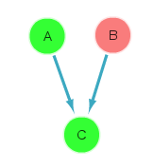 | 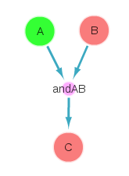 | 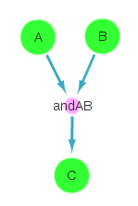
A. Incoming edges are default treated as 'OR' . In this case C gets on, because A is on, even though B is off. | B. Using 'and' gate . In this case C is set off, because B is off, even though A is on. | C. Using 'and' gate. C now is set On, because both A and B are on.
Figure 3 : OR and AND relations.
For datasets already present in the tool, you can select the measured node which corresponds to your specific node. This mapping is necessary in case you want to use the 'improve network' feature and want to use this dataset. For an overview of the measured nodes in the already present datasets see Appendix 1.
Then push the “Save” button. The new node will be presented in the network area, in the left upper corner. You can drag and drop the node to the desired location.
You can add an edge by clicking on Build and then Edge: add. A form pops up, in which you can define the source node, the target node and the interaction type. You can add references. Fill in the name field, f.e. Johnson 2011. In the url field provide the web address. Clicking on blue image with arrow will open the url in a new window. There is notes field for other information you want to store with the edge. After clicking on save, the edge will be drawn in the network. Click in the network on the edge will give you the details of this edge, which then can also be edit.
You can move more than 1 node at the time, by first selecting each of them, for example by drawing a rectangle around them.

3.3. Pan and zoom
For the network view, there are options for pan and zoom in the right lower corner. See figure 2:
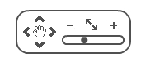

Figure 2: pan and zoom options in network view.
You can move the network by enabling panning by clicking on the hand. The hand image becomes blue. You can now click anywhere in the network view area , hold the left button and drag. You disable the panning by clcking angain on the hand. The hand image is black again.
You can zoom in by clicking on the plus sign, and zoom out on the minus sign. Clicking on the sign with up and down error, fits the network to the window.
You can also zoom in /out by clicking on the black dot in the slider with the left mouse button and hold it. Dragging the dot to the left is zoom out, where dragging it to right is zooming in.

4. Improve Network.
Improve network by running the Dynamic Bayesian Inference algorithm of Hill/Mukherjee (2011).

4.1 D

5. Simulate.
Click in the menu on Simulate to open a form to define the startvalues. First you have to choose between calculating “steady state” or “time course”. In case of “steady state” the tool calculates if there is a so called steady state. Steady state is the situation in which in the next iteration none of the nodes changes state. The steady state is depicted in the network view. In case no “steady state” can be found, you get a warning. In case of “time course” you get the results of all the single steps. Depicted in the network view are then the startvalues. You can then navigate through the different steps using the navigation buttons (see below).
Start values can only be 0 (“off”) or 1 (“on”). You can set a value as fixed by checking the checkbox. This way you can mimic knockout and constant activation. In case of “time course” you can enter the number of iterations.
If a scrollbar is shown, scroll all the way down to find the button “Get simulation results”. When you push this button, the states of the nodes for the consecutive iterations are calculated.
After the calculation is finished, in the network area the network is depicted with the startvalues. The red color means 'off', the green color means 'on'. The simulation navigation buttons in the lower left corner are now active, represented by the black in stead of grey color . The meaning of the buttons from left to right are “go to start situation”, “one iteration backward”, “stop simulation”, “start simulation”, “one iteration forward” and “last iteration”.


Figure 4: simulation navigation buttons.
You can rerun a simulation, as the simulation results are stored on the page. An example of the interface after running a simulation is shown in fig. 5.
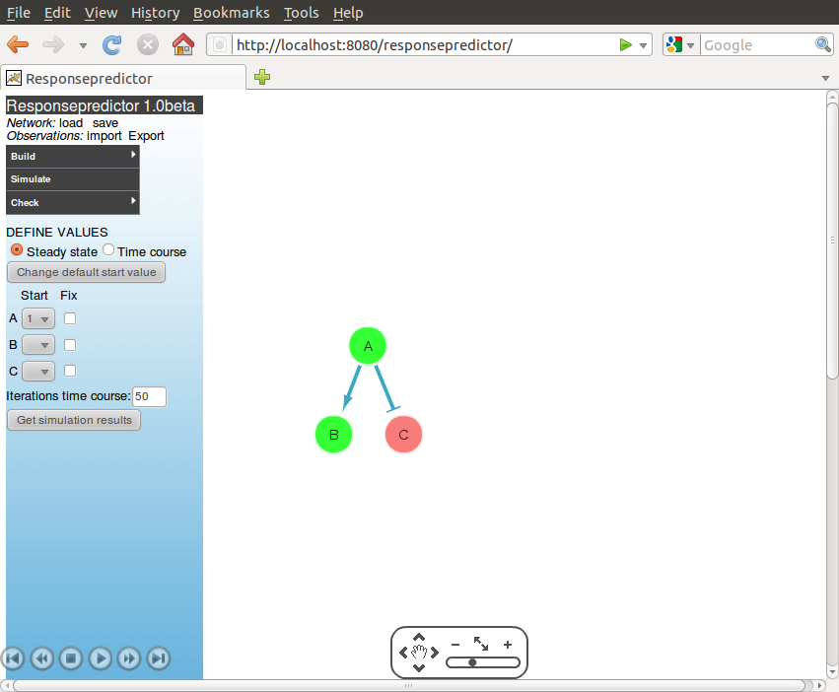
Figure 5: Interface after “get simulation results” and push play button.

Keep in mind that according to boolean rule, an downstream target get's on when the upstream target is off, even if there is no activation edge. (see fig. 6).
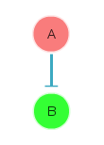

Fig 6. : downstream node on in case source node is off.

6. Check model

6.1 Loading observations from file
In RP you check the simulation oucome of the network against observations. Previously stored observations can be uploaded via Observations: import. RP stored observations in the json-format.

6.2 Add observation
You can add an observation via Check: Add observation. An observation contains for nodes of interest the startvalues, if it is a fixed value yes/nog and/or the end value. The observation are shown in a third panel, right of the network. In the upper part of the panel you find a list of all the observation, on the lower part the details of the marked row. You can click on other row to see the details of that observation. To remove an observation, click on the image of trash can.

6.3 Run check
To do the model check, by clicking on Check, and then Run check.
When checking, RP uses the start- and fixed values in the observation to run a simulation. In case the observation does not define a startvalue for a node, it will get the value 0. For the defined endvalues, the modelchecking shows the result. Green if the end value of the simulation and the observation are the same, red when not. See figure 7.
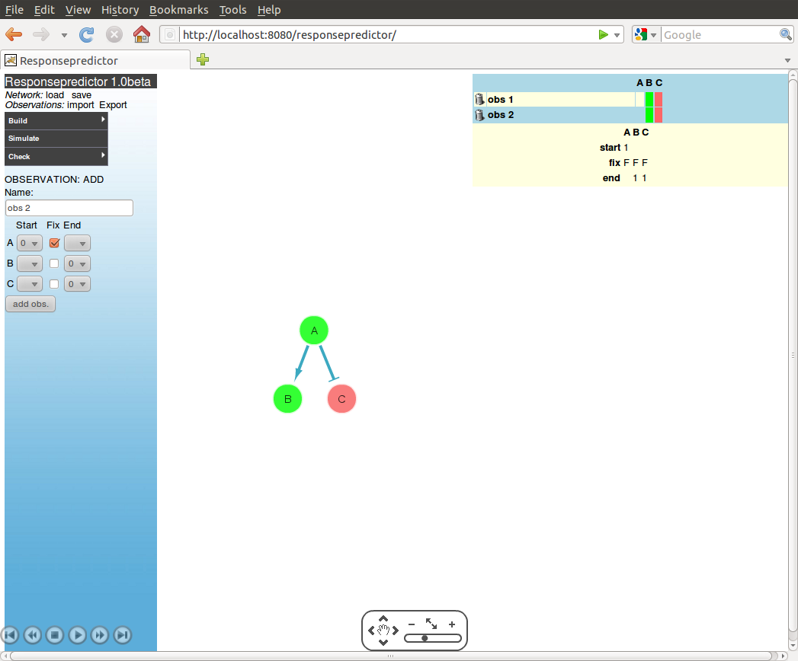
Figure 7: result of a model check run.

6.4 Save observations to file
You can save your observation to a file, by clicking on Observations: Export. As mentioned before, there is an issue with the popup menu only open for 30 seconds. After that it closes and changes are lost.

7 Run rp from commandline
One can calculate a modelchecking score on the commandline, using the following command:
java -jar responsepredictor.jar [path-network] [path-observations]
The path-network is the path to a network in xgmml format. The path-observations is the path to observations in json format. These files can be created in the web version of Responsepredictor and exported from there.

Appendix 1 Hill 2011 dataset
measured nodes:
1 AKT.pS473

2 AKT.pT308

3 AMPK.PT172

4 cJUN.pS73

5 EGFR.PY1173

6 GSK3.pS21

7 JNK.PT183

8 LKB1.pS428

9 MAPK.pT202

10 MEK1.2.PS217

11 mTOR.pS2448

12 p38.PT180

13 p70S6K.pT389

14 p90RSK.pT359

15 PDK1.pS241

16 PI3Kp110

17 STAT3.pT727

18 STAT3.pY705

19 STAT5.pY964

20 TSC2.PT1462

