Charge transfer in an Iron Ruthenium mixed valence complex probed with time resolved

XANES and XES

Chelsea Liekhus-Schmaltz∗

*Department of Chemistry, University of Washington, Seattle, WA, USA*

E-mail: cliekhus@uw.edu

Abstract

We have performed a time-resolved X-ray absorption near edge spectroscopy (XANES) and X-ray emission spectroscopy (XES) experiment following a metal to metal charge transfer (MMCT) excitation in the mixed valence complex [(CN)5FeIICNRuIII(NH3)5]– (FeRu) at the LINAC Coherent Light Source (LCLS). These measurements provide time resolved and localized information about the electron density around the Iron atom. We show that XANES measures the hole density around the Iron atom and XES reports on both the back electron transfer time and the local vibronic excitations caused by the MMCT. Combining these two measurements provides us with a unique look into the electronic and vibronic properties involved in electron transfer in FeRu.

Key: Things that need to be added. Missing reference. Editing comments for myself. Color for edits from the collaboration. To add your own comments to the latex document, please use this format: “\{COB}{Initials: Comment}”. For example: “\{COB}{CELS: This is how you write a comment.}” Thank you. Where appropriate,

I will reply to comments from the collaboration with this color.

# Introduction

Mixed valence transition metal complexes are important prototypical systems for studying electron transport and vibronic coupling in photosynthesis and photocell technology.1–3 Their properties are strongly determined by the degree of coupling between the two metal centers which governs electron delocalization in the molecule.4 Measuring all three of these properties, electron transport, vibronic coupling, and electron delocalization is therefore important for understanding these prototypical systems and their corresponding, more complex systems as well.

One such complex, [(CN)5FeIICNRuIII(NH3)5]–, FeRu for brevity, displays ultrafast electron transport following a metal to metal charge transfer (MMCT). Previous optical studies have made headway in measuring the charge transport and corresponding vibronic coupling.5–9 Transient IR experiments measured a back electron transfer (BET) time of 89 ± 10 fs,10 while 2D vibrational-electronic spectroscopy shows that the cyanide bridge stretching mode is strongly coupled to the MMCT state.3 Missing in these experiments is a direct measurement of the electron transport and the corresponding role of electron delocalization as well as the role vibronic coupling plays during the BET.

Both Fe K-edge X-ray Absorption Near Edge Spectroscopy (XANES) and X-ray Emission Spectroscopy (XES) are sensitive to the electron density and nuclear coordination around the Iron atom. These X-ray measurements can therefore directly measure the extent of electron delocalization during transport as well as the local nuclear motion. However, traditional X-ray sources, such as synchrotron radiation, cannot measure the MMCT given its short lifetime. In contrast, the Linac Coherent Light Source (LCLS) provides ultrafast X-ray pulses allowing us to perform time-resolved XANES and XES measurements. We will find that time-resolved XANES measurements give us unprecedented detail into the role of electron delocalization by directly measuring the hole density on the Iron atom immediately after a MMCT. We can also track the resulting BET with the time resolved XES signal which reports on not only the electron transport, but the resulting low frequency nuclear excitations. The combination of both of these measurements allows us to examine the electronic and nuclear dynamics that govern electron transport in transition metal mixed valence complexes.

# Methods

## Pump probe XANES and XES

We performed an optical pump, X-ray probe experiment at the X-ray Pump Probe (XPP) endstation at LCLS.11 This end station has the capability to measure three different signals, the spectrally resolved emission, the total flourescence yield (TFY), and the scattering signal. In this paper, we will focus on the emission and TFY signals. The time resolved scattering signal is examined in a sister paper found here: REF.

As shown in Fig 1, 30 mM of aqueous FeRu is introduced into the experiment via a 50 *µ*m round jet. A 4 *µ*J, 40 fs FWHM, 800 nm laser pulse with a X *µ*m focus excites FeRu to the MMCT state. The ensuing dynamics are probed with 45 fs FWHM X-ray pulses at and above the 7.1 keV Iron K-edge with a X *µ*m focus at 120 Hz. The time delay between the two pulses is varied from -0.4 ps to 1.5 ps for time scans while the jitter is measured using the XPP timing tool.12,13 The TFY is measured with a diode offset from the sample which provides us with a background free equivalent of absorption. The emission spectra is spectrally resolved with a Rowland spectrometer and imaged with an area detector such that it can monitor emission lines with X eV resolution. The total time for collection is approximately X hours.

We performed three types of measurements. First, time resolved XES, which involved scanning the Rowland Spectrometer over several emission energies at time delay of 0 fs. Second, XES kinetic traces, which involved measuring specific emission energies in the K-*α*1 emission line and varying the pump-probe delay. We chose to examine the emission energies of 6402.7, 6401.2, and 6404.1 eV where the differences between the ground state and excited state were seen to be maximally different. During both of these measurements, the incoming x-rays are tuned above the Iron K-edge and without the monochromator. This increases the x-ray flux to 1012 photons per pulse to ensure we are achieving maximal signal to noise.

The third measurement we took was time-resolved XANES, which involved scanning the incoming X-ray energies below the Iron K-edge using the monochromator, while maintaining the pump probe delay at 0 fs. Emission on the TFY diode and Rowland detector is collected for all of these conditions. The x-ray flux in this case is X, and the monochromaticity is X.

In addition to the signal detectors, it is necessary to collect data on the condition of each X-ray pulse. X-ray pulses in self-amplified stimulated emission (SASE) FELs lack time coherence between x-ray pulses, and therefore vary strongly in their characteristics from pulse to pulse. We therefore collect the intensity, and the energy of the electron bunch associated with each pulse. As well, the position of the jet can move as a function of experimental time. We monitor this change by measuring the forward scattering signal on the CSPAD, which will fluctuate with movement of the jet. Combining these measurements allows us to select for similar shots to reduce the noise of our measurement. Details of the filters we applied for both the XANES and XES measurements are shown in the Supplementary Information and are listed in Table 2 and 3 respectively.

UV-Vis Spectrum

Munira will add in UV-VIS info here.

TDDFT Calculations

Niri will add in the calculation details.

# Results

## UV-VIS

In Fig. 2 we show the measured UV-Vis spectrum taken of FeRu as well as the computed UV-Vis spectrum. The red line in the lower panel shows the excitation region. In the upper panel, we indicate which transition line this corresponds to. The unoccupied molecular orbital involved in this transition is also shown in the upper panel.

By identifying the molecular orbital involved in the MMCT, we can see the extent of delocalization in the excited state. With the molecular orbitals, I will add in more details about what can be seen.

## XES Kinetic Traces

The time-dependent emission signal, *S*XES(*t*), at each time, *t*, is computed as the sum of the emission intensity collected by the Rowland Spectrometer for each x-ray shot, *Ri*, normalized by the sum of the TFY diode, *Di*:

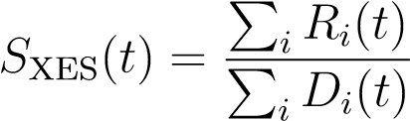 (1)

These traces were taken at 6402.7, 6401.2, and 6404.1 eV. To compute the uncertainty of each data point, we use the bootstrapping technique as is also done in Ref. 14. This method is detailed in the Supplementary Information.

Ground state XES spectra are also reported. Similar to the time-dependent traces, the emission spectra, *S*XES(~*ν*0), is computed as the sum of emission intensity, *Ri*, normalized by the sum of the TFY diode, *Di* taken at different emission energies, ~*ν*0:

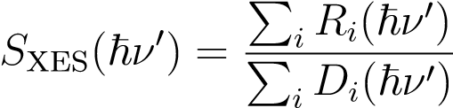 (2)

The percent change in the x-ray emission as a function of probe probe delay as well as the ground state emission spectra is shown in Fig. 3. We see that the peak of the emission spectra decreases, while the red shifted portion of the emission spectra immediately increases in intensity after the MMCT. This is consistent with ground state emission spectra taken of FeII(CN)6 and FeIII(CN)6 reported in Ref. 15. The FeIII(CN)6 emission spectra is both blue shifted and broadened with respect to FeII(CN)6. This is due to an increase in the effective charge of the Iron atom, increasing the ionization energy, and a resulting redistribution of the atomic and molecular orbitals.

Following the respective decrease in the peak emission energy and increase in the red shifted emission energies, the change in the emission spectra returns to the ground state spectra. We identify this process as the BET, and perform a global fit to all three decays to extract the BET time. While we do not find evidence of an intermediary state, we require with two exponential decays to properly fit the data. The equations of fit are:

*,* (3)

where *H*(*t*) is the Heaviside function, *t*0 is the time of overlap, *τ*1 is the BET, *τ*2 is a second, longer decay time, 2p2ln(2)*σ* is the FWHM IRF, *Ai* is the amplitude of the *τ*1 decay constant for each kinetic trace, *i*, and *Bi* is the amplitude of the *τ*2 decay constant.

We measure the BET to be 58 ± 10 fs, with a second decay time of 510 ± 120 fs which only has significant amplitude in the 6404.1 eV kinetic trace. The corresponding IRF (FWHM) is 86 ± 7 fs. The uncertainties we report are one standard deviation of the fit error. A full table of all the fitting parameters in shown in Table 1. Given that the IRF is much larger than the fit error, we should expect that given uncertainties underestimate the actual uncertainty.

|  |  |
| --- | --- |
| Table 1: Fit parameters | |
| Parameter | Value |
| *τ*1 | 58 ± 10 fs |
| *τ*2 | 510 ± 120 fs |
| 2*σ* | 86 ± 7 fs |
| *A*6402*.*7 | 2.7 ± 0.6 % |
| *A*6401*.*2 | 2.7 ± 0.5 % |
| *A*6404*.*1 | -2.3 ± 0.5 % |
| *B*6402*.*7 | 0.07 ± 0.05 % |
| *B*6401*.*2 | 0.04 ± 0.04 % |
| *B*6404*.*1 | -0.35 ± 0.08 % |

## XES Fourier Analysis

We observe small oscillations on top of the decay which are most strongly apparent for the 6402.7 and 6404.1 eV emission lines. To isolate the frequency components associated with the oscillations, we take the Fourier transform of the residuals before and after the first large oscillation which occurs at 400 fs in Fig. 4. The Fourier transform of the data before 400 fs (which includes negative time delays), gives the reader a sense of the noise of the measurement, while the data after 400 fs provides a measurement of the oscillations. We do not claim, however, that the oscillation specifically start after 400 fs. We do not have sufficient time resolution to perform the necessary time-frequency analysis to calculate the start of the oscillation. By comparing the pre-300 fs and post-300 fs Fourier analysis, we see that there is a significant oscillation strength from approximately 100 cm−1 and 200 cm−1.

## Time-resolved XANES

In Fig. 5a we show the transient difference XANES spectra immediately after the MMCT. We have plotted a version of XANES, called the HERFD-XANES (High Energy Resolution Fluorescence Detected-XANES) spectra. This high resolution detection method allows us to observe the small changes in our signal by monitoring changes in emission at the maximum of the K-alpha1 line. Details on this technique and how we ensured that the XANES peak positions are not shifted are discussed in the Supplementary Information and are shown in Fig. 8. The HERFD-XANES spectra, *S*XANES(~*ν*), at each incident photon energy, ~*ν*, is computed as the sum the of emission intensities taken at the peak of the K-*α*1 emission line and measured by the Rowland spectrometer, *Ri*, normalized by the sum of all x-ray intensities for each x-ray shot, *Ii*:

*S*XANES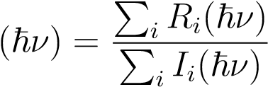 (4)

As with the XES calculation, to compute the uncertainty of each data point, we use the bootstrapping technique.

The ground state absorption is shown in the top panel of Fig. 5a. The transient difference HERFD-XANES spectra is the difference between the excited FeRu HERFD-XANES spectra and the unpumped, ground state FeRu HERFD-XANES spectra and is shown in the bottom panel of Fig. 5a. This is taken with a measured jitter delay of between -35 fs and 35 fs from time overlap.

In the ground state there are two distinct absorption peaks, one at 7113 eV, labeled the B peak, and one a 7116 eV, labeled the C peak. As shown in Fig. 6, these two peaks correspond to an excitation of an electron in the 1s Iron atomic orbital to the eg and *π*∗ molecular orbitals. The transient difference spectrum shows that after the MMCT the B and C peaks blue shift and a new peak appears at 7111.9 eV. This new peak, which we label the A peak, corresponds to an excitation from the 1s to t2g molecular orbital, which is normally filled in the ground electronic state.

In the discussion, we will show that the relative position of the A and B peak are relevant for measuring the electron hole density. Therefore, we have measured the A and excited state B peak positions. Given the low energy resolution in our plot, we do not have sufficient data points to fit a dispersive function to the B peak region in the difference plot. Instead, we fit both peaks with a gaussian with a linear baseline. While this provides the A peak position, it will provide a somewhat blueshifted B peak position. These fits are shown in the lower panel of Fig. 5a. The resulting measured energy splitting is: 2.3 eV.

# Discussion

## BET and Vibrational Decay

The global fit of our time dependent XES traces showed that the BET can be modeled with a simple two state model with two decay constants. By comparing to ground state XES spectra of FeII(CN)6 and FeIII(CN)6, we see that the XES of the MMCT state has characteristics of an FeIII complex and returns to an FeIII complex after the BET. This is consistent with Ref. 10 which also found two decay constants: an 89 ± 10 fs BET and a longer 1900 ± 1200 fs decay. These timescales are longer our measurements. Given the large IRF of our experiment, it is possible that our experiment has underestimated the BET and the second decay time. Critically though, both experiments identify two decay times, a shorter, less than 100 fs decay and a longer, greater than 500 fs decay.

As with in Ref. 10, we associate the shorter time decay with the BET which decay to a vibrationally hot ground state. The longer time delay is then associated with the corresponding vibrational cooling.

In addition to the hot vibrational ground state, the low frequency oscillations found in Fig. 4 are indicative of slow nuclear modes. Such low frequency oscillations of around 100 to 200 cm−1 have been observed in similar Ruthenium dimer complexes when excited with a 795 nm, < 20 fs pulse.10 Reid et.al. attribute these oscillations to Resonant Impulsive Stimulated Raman Scattering (RISRS) by clearly observing that the oscillations begin with the excitation. However in the same paper, they do not observe any low frequency oscillations in FeRu, which is excited under the same conditions. Given that our excitation pulse longer in pulse duration and is also centered at 800 nm, we expect we are not performing RISRS in FeRu in our experiment. Instead, we propose that the oscillations are the result of nuclear excitations in low frequency modes due to the BET.

It is not obvious that a nuclear excitation would affect the x-ray emission from such low lying atomic levels. To explore if nuclear motion could have an affect on our emission spectra, we performed ground state QM/MM calculations of the 1s-2p3*/*2 splitting on a particular trajectory. We found that low frequency modes can shift the K-*α* emission spectra by up to 0.5 eV, as shown in Fig. 14 in the Supplementary Information. Figure 14 also shows the Fourier transform of the this motion, and demonstrates that the low frequency modes can indeed manifest in the emission spectra.

To assign these frequencies to possible normal modes, we perform a harmonic analysis. As with the XANES calculations, we use a QM/MM environment with the PBE0 exchange correlation used for the solute. We find that the lowest frequency modes usually involve motion around the Iron-cyanide bonds. For example, a 175 cm−1 mode that involves the Iron and Ruthenium atoms oscillating relative to one another is shown in the Supplementary Information in Fig. 13. There are several low frequency modes in the region implicated by Fig. 4, and given the anharmonicity generally associated with such low frequency modes, and the fact that our solute is still vibrationally hot even after 510 fs, it is difficult to directly to connect the Fourier components we extract to any particular modes. Instead, we conclude that possibly several low frequency modes are excited after the MMCT.

Really check me on this paragraph. Am I stretching too much? I’d really like to tie what we are doing to larger ideas, but I don’t know if this is going too far. Critically though, we see that the modes that involve motion directly connected to the Iron atom are coupled to even low lying atomic orbitals on the Iron atom. This is consistent with 2D VE measurements of FeRu that showed that the bridge motion is strongly coupled to the MMCT. Those modes are directly involved in the charge motion during the BET. Similarly, these low frequency modes are strongly coupled to the Iron atom, which, as we will see in the next section, has a highly localized hole density after the MMCT. In both cases nuclear motion is excited in modes that are connected to locations of electronic change.

## Hole Density

The two states we identified in the XES are associated with FeII(CN)6 and FeIII(CN)6 character. This is consistent with the transient XANES spectra. Reference 16 showed that the A peak is only visible for the FeIII complex where the t2*g* orbital is unfilled. Additionally, the B and C peaks in FeIII are blue shifted compared to FeII due to an increase in the effective charge on the Iron atom, increasing the ionization potential.

We use a QM/MM calculation to predict how the XANES spectra should vary in FeRu as the hole denisty on the Iron atom changes. We assign the position of the B and C peaks by the strongest transition in their respective energy regions. The A peak energy is given by the lowest energy transition. As shown in Fig. 5b, the energy splitting between the A and B peak is nearly linearly dependent on the Iron hole density. Comparing the molecular orbitals involved in the A peak shown in Fig. 5b to the molecular orbitals in the B and C peaks in Fig. 6 in the Supplementary Information, the A peak is strongly localized on the Iron atom, making it a good probe of the localized electron density around the Iron atom. In contrast, the orbitals involved in the final state of the B and C transition are more delocalized. As a result the difference in energy between these two transitions reports on the hole density at the Iron atom.

The linear dependency we found between hole density on the Iron atom and the A-B splitting allows us to convert the measured A-B splitting into a measured hole density of 0.7 ± 0.1. I need to talk about this uncertainty. Right now I am bootstrapping to get this uncertainty, and comparing this to the energy resolution. Maybe I’ll put this in the SI. Or should I talk about it now. In this case the hole density on the Iron atom is near 1, meaning that the hole density is strongly localized primarily on either the Iron. In contrast, a hole density closer to 0 would be indicative of a more delocalized electron transfer between the two metal centers.

Once I get the transition densities of the MMCT, I will include some discussion about how this makes sense gives the distribution of the transition. Right now I am missing some details to make this part of the discussion more complete.

This measurement is demonstrates that time-resolved XANES measurements can provide detailed information about the electron density in mixed-valence metal complexes. We expect that as energy and time resolution increases at FEL facilities, time-resolved XANES measurements will be useful tools for probing electron delocalization.

# Conclusion

We performed both time-resolved XANES and XES measurements on aqueous FeRu after excitation to a MMCT. We were able to extract the key dynamics of both the MMCT and BET processes in our system, as summarized in Fig. 7. We were able to measure the transient hole density on the Iron atom to confirm a high level of localization in the molecule using XANES. Following the MMCT, we were able to measure the BET time and the vibrational cooling time using time-resolved XES. The XES signal also revealed that low frequency modes aligned with the molecular axis play an important part in the BET process. Observation of these modes leads us to conclude that these modes are coupled to even the low lying atomic orbitals in the Iron atom. The combination of these measurements leads us to conclude that the FeRu system has displays strongly localized electronic dynamics as well as vibronic during the BET of nuclear modes that directly involve the Iron atom. It is possible that the degree of localization of hole density on the Iron atom drives this coupling to low frequency modes. Should I put a statement here saying what kinds of measurements could get more into this?

As time and energy resolution improves at FEL experiments, we expect that these timeresolved XANES and XES measurements will become more useful. The methods we have demonstrated could be applied to many different systems to monitor both the level of electron delocalization and vibronic coupling, which will in turn provide us with information about electron transport in general.

Acknowledgement

The authors thank Need a list of everyone at the experiment.

# Supporting Information Available

## Comparing XANES and HERFD-XANES spectra

To ensure that the Rowland spectrometer has been properly tuned to the peak of the emission spectra so that we can straightforwardly interpret the HERFD-XANES spectra, we compare the ground state XANES spectra from the TFY diode to the ground state HERFD-XANES spectra. If the Rowland spectrometer is properly aligned, they will each have peaks in the same position. Figure 8 confirms that while there is a difference in shape for both spectra, their peak positions still overlap. Of particular importance is the position of the B peak, which we use directly in our measurement, and is clearly well overlapped between the two measurements.

## XANES filter parameters

X-ray pulses from self-amplified spontaneous emission FEL sources lack temporal coherence between x-ray pulses. In addition, the liquid jet that contains our sample can fluctuate in its position with respect to the x-ray pulses. Therefore, we filter out dissimilar x-ray and jet shots with 8 different shot-to-shot measurements. These measurements include:

* X-ray intensity
* Electron bunch energy
* Integrated CSPAD signal
* Integrated Rowland signal
* TFY diode signal
* Time Tool shift value
* Time Tool signal amplitude
* Time Tool signal width

Each of these values either report on the x-ray pulse characteristic, or the jet character. The x-ray pulse character is reported on by the x-ray intensity, the electron bunch energy, and the Time Tool values. The jet character is reported on by the integrated CSPAD signal, the integrated Rowland signal, and the TFY diode since for similar x-ray shots, the only thing affecting these signals are fluctuations of the jet. For each of these measurements, we filter out measurements that are a certain number of standard deviations away from the median value, as shown in Table 2.

In addition, we filter for a linear response between the x-ray intensity and the TFY signal. This filter is applied separately for each photon energy as well as for the unpumped shots. The filter on this condition is relatively tight at 0.5 standard deviations from the linear regime. Examples of these filters is shown in Fig. 9.

|  |  |
| --- | --- |
| Table 2: Filter settings | |
| Value | Number of STDs |
| X-ray intensity | 2 |
| Electron bunch energy | 1 |
| Integrated CSPAD signal | 2 |
| Integrated Rowland signal | 2 |
| TFY diode | 2 |
| Time Tool shift value | 5 |
| Time Tool signal amplitude | 2 |
| Time Tool signal width | 2 |

## XES filter parameters

Similar to the XANES measurements, we need to apply a series of filters to the data to create our final dataset. The number of standard deviations we take from the median for the XES data is shown in Table 3. Here we have more stringent constraints on the diode and the Rowland signals since they are essential to this measurement.

As with the XANES measurement, we apply a linearity filter to the XES data, except that this time we use the TFY diode versus the integrated Rowland signal. This filter ensures that the TFY diode and Rowland signal are linear to one another. The linearity filter is applied at each timepoint and for the laser off condition separately. Of all the filters we apply in to the XES data, the linearity filter is the most important filter for seeing the smaller, more sensitive changes in our data. We apply a 3 standard deviations of width to our linear filter.

In addition to using the linearity measurement to filter the data, we also use it to remove any offset in the signal due to non-linearities in our detectors at low signal sizes. The full data set after applying the threshold filters is used to create a linear fit between the Rowland signal and the TFY diode. Ideally, the line should pass through (0,0), however this is not true in reality. We therefore subtract the offset from our Rowland signal. This step is not necessary for the XANES measurement, since the signal sizes are larger.

|  |  |
| --- | --- |
| Table 3: Filter settings | |
| Value | Number of STDs |
| X-ray intensity | 3 |
| Electron bunch energy | 1 |
| Integrated CSPAD signal | 2 |
| Integrated Rowland signal | 1 |
| TFY diode | 1 |
| Time Tool shift value | 3 |
| Time Tool signal amplitude | 3 |
| Time Tool signal width | 3 |

## Bootstrapping

I really don’t know if I should keep at this in. I’m not sure if I am explaining the error part properly. I think this could annoy people, and maybe I should just stick to the description of the bootstrap. Bootstrapping allows us to estimate the uncertainty of each data point, without having to break our data up into sections or into individual shots to estimate the variance. This allows us to reduce the noise of our measurement. Recall that in our analysis, we compute

(5)

Of course, this equation ignores the uncertainty in our measurement. It would be more accurate to write that

(6)

where ∆*i* is the error in the measurement. Note, it is possible that there is some linear dependency between *Ri*, *Ii*, and ∆*i*. We should then write that

(7)

where *S*true XANES(ħ*ν*) is the true XANES spectra and *S*measured XANES(ħ*ν*), is the measured spectra. In this case, we can strive to minimize the contribution from the measurement error by averaging over many shots, since ∆*i* ideally randomly fluctuates about zero. The mean x-ray intensity will also converge to a single number with many laser shots. However, since we do not calculate an individual *S*measured XANES*,i*(ħ*ν*) for each x-ray shot, we cannot trivially find the measurement uncertainty by calculating the variance. (This method will be shown below for completeness.) Therefore we have to use a different technique for estimating the measurement uncertainty, and that method is the bootstrapping technique.

In comparison, we could compute

(8)

*.*

Then, as stated above, the estimated uncertainty in the measurement is given by the standard deviation of *S\**measured XANES*,i*(ħ*ν*). However, the measurement error,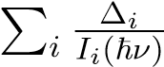 no longer trivially sums to zero since each ∆*i* term is weighted by the corresponding *Ii*(ħ*ν*) term which also fluctuates. While with sufficient x-ray shots, these two approaches will converge under the resolution of the experiment, we have chosen to use Eq. to ensure we have suppressed the noise to the best of our ability. As a result we must use the bootstrapping technique to calculate the measurement uncertainty.

A comprehensive guide to bootstrapping can be found in Ref. 17. In brief, bootstrapping is the technique of determining the desired measurement and its uncertainty by finding the mean and standard deviation of a collection of recalculated signals from a resampled data set. In more detail, each bootstrapped data set is generated by resampling the raw data with replacement. In our case we have done this 1000 times to generate 1000 different bootstrapped data sets. The bootstrapped data sets are then used to calculate 1000 different XANES spectra, *Sj*XANES(ħ*ν*). The final reported value *S*XANES(ħ*ν*) is the mean of the bootstrapped data sets, and the uncertainty, ∆(ħ*ν*) is the standard deviation:

(9)

(10)

A figure showing the first 100 bootstrapped datasets can be seen in Fig. 10.

## calculated A and B peak positions

To extract the A-B energy shift shown in Fig. 3, we much assign an A and B peak position from the calculated XANES spectra. We have use the position of the lowest energy root as the A peak for each hole density. The position of the B peak is given by the root in the B peak region with the largest amplitude. An example of this assignment is shown in Fig. 5b, with the A and B peak designations shown for a 0.6 hole density on the Iron atom. The additional calculated XANES spectra are shown for the other hole densities from that trajectory in Fig. 11.

## Molecular orbitals plots

This section will updated with new orbital plots soon. We have plotted the valence molecular orbitals for the A, B, and C peaks in the Fig. 12. We can see that both the B and C peaks are strongly associated with the ligands. In comparison, the A peak is strongly associated with electron density around the Iron atom. This differentiation helps to explain why the A peak is more sensitive to the local charge around the Iron atom compared to the B peak. Such a difference allows us to use the A-B peak splitting as a measure of the local charge around the Iron atom.

## Harmonic analysis

In Fig. 4 we identified a series of low frequency peaks in the time-resolved XES spectra. To associate these peaks with motion in the solute, we have conducted a harmonic analysis to identify the ground state nuclear modes. These low frequency modes are known to be strongly anharmonic, and as a result we are unable to directly relate any particular mode to the measured Fourier spectrum, however we expect that one or many of these modes could be involved in the BET process.

We have identified several energy regions corresponding to similar kinds of motion. The mode with the strongest transition amplitude is shown in the Fig. 13.

## Calculated 1s to 2p energy splitting

To confirm that low frequency modes could be having an affect on the Iron K-*α*1 emission spectra we have calculated the 1s to 2p3*/*2 energy splitting in the ground state of FeRu. The result of this calculation after allowing the molecule to equilibriate after 10 ps, is shown in Fig. 14 as well as the Fourier transform from 0 to 500 cm−1 is shown in Fig. 4. We can see that the nuclear motion is causing a shift of 0.5 eV in the 1s to 2p3*/*2 splitting. While it is computationally expensive to calculate the full XES spectra to recreate the time-resolved

## Additional XES kinetic traces

Should I include this at all? In addition to the three kinetic traces we utilized in Fig. 3, we have also included 3 additional kinetic traces in Fig. 15. These traces were taken at energies that were less sensitive to the MMCT state, compared to the three energies we presented in the main body of the text.

# References

1. Demadis, K. D.; Hartshorn, C. M.; Meyer, T. J. *Chemical Reviews* 2001, *101*, 2655– 2686.
2. Kubiak, C. P. *Inorganic Chemistry* 2013, *52*, 5663–5676.
3. Courtney, T. L.; Fox, Z. W.; Estergreen, L.; Khalil, M. *The Journal of Physical Chemistry Letters* 2015, *6*, 1286–1292.
4. Kaupp, M.; Renz, M.; Parthey, M.; Stolte, M.; WÃijrthner, F.; Lambert, C. *Physical Chemistry Chemical Physics* 2011, *13*, 16973.
5. Kambhampati, P.; Son, D. H.; Kee, T. W.; Barbara, P. F. *The Journal of Physical Chemistry A* 2000, *104*, 10637–10644.
6. Tivanski, A. V.; Wang, C.; Walker, G. C. *The Journal of Physical Chemistry A* 2003, *107*, 9051–9058.
7. Lynch, M. S.; Van Kuiken, B. E.; Daifuku, S. L.; Khalil, M. *The Journal of Physical*

*Chemistry Letters* 2011, *2*, 2252–2257.

1. Wang, C.; Mohney, B. K.; Akhremitchev, B. B.; Walker, G. C. *The Journal of Physical Chemistry A* 2000, *104*, 4314–4320.
2. Watson, D. F.; Tan, H. S.; Schreiber, E.; Mordas, C. J.; Bocarsly, A. B. *The Journal of Physical Chemistry A* 2004, *108*, 3261–3267.
3. Reid, P. J.; Silva, C.; Barbara, P. F.; Karki, L.; Hupp, J. T. *The Journal of Physical*

*Chemistry* 1995, *99*, 2609–2616.

1. Chollet, M. et al. *Journal of Synchrotron Radiation* 2015, *22*, 503–507.
2. Bionta, M. R.; Lemke, H. T.; Cryan, J. P.; Glownia, J. M.; Bostedt, C.; Cammarata, M.; Castagna, J.-C.; Ding, Y.; Fritz, D. M.; Fry, A. R.; Krzywinski, J.; Messerschmidt, M.; Schorb, S.; Swiggers, M. L.; Coffee, R. N. *Optics Express* 2011, *19*, 21855.
3. Harmand, M.; Coffee, R.; Bionta, M. R.; Chollet, M.; French, D.; Zhu, D.; Fritz, D. M.; Lemke, H. T.; Medvedev, N.; Ziaja, B.; Toleikis, S.; Cammarata, M. *Nature Photonics* 2013, *7*, 215–218.
4. Wolf, T. J. A. et al. *Nature Chemistry* 2019, *11*, 504–509.
5. Penfold, T. J.; Reinhard, M.; Rittmann-Frank, M. H.; Tavernelli, I.; Rothlisberger, U.;

Milne, C. J.; Glatzel, P.; Chergui, M. *The Journal of Physical Chemistry A* 2014, *118*, 9411–9418.

1. Ross, M.; Andersen, A.; Fox, Z. W.; Zhang, Y.; Hong, K.; Lee, J.-H.; Cordones, A.; March, A. M.; Doumy, G.; Southworth, S. H.; Marcus, M. A.; Schoenlein, R. W.;

Mukamel, S.; Govind, N.; Khalil, M. *The Journal of Physical Chemistry B* 2018, *122*, 5075–5086.

1. James, G.; Witten, D.; Hastie, T.; Tibshirani, R. *An Introduction to Statistical Learning*; Springer Texts in Statistics; Springer New York: New York, NY, 2013; Vol. 103.

# Figures

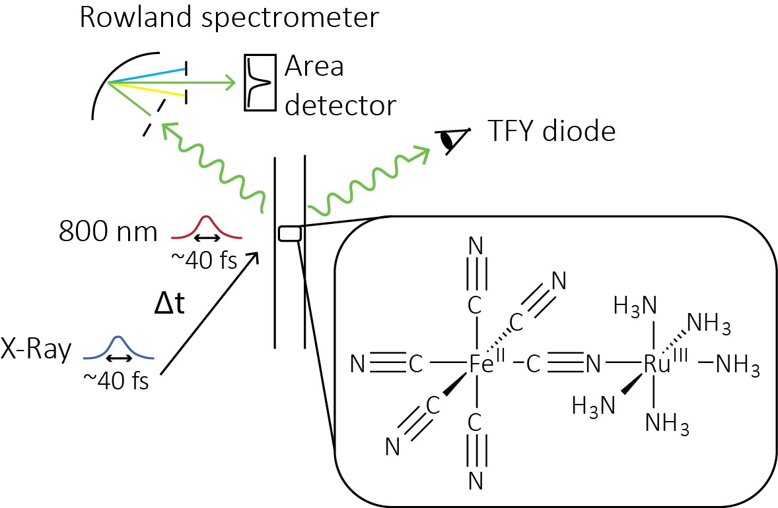

Figure 1: Experimental Setup. We performed an experiment at the X-ray Pump Probe endstation at LCLS. Our sample, FeRu, was dissolved in water and introduced to a Helium filled chamber via a liquid jet. We use an 800 nm, 40 fs FWHM long, optical pulse to induce a MMCT state in FeRu and then monitor the resulting dynamics with a 40 fs FWHM long Fe K-edge X-ray pulse. We measure both the total fluorescence yield with a diode and the spectrally resolved fluorescence with a Rowland spectrometer.

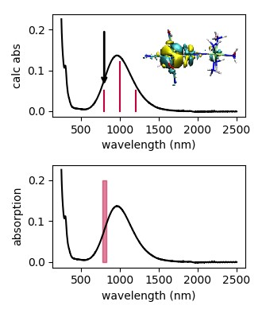

Figure 2: Measured and calculated UV-Vis spectrum. The lower panel is the measured UV-Vis spectrum of FeRu at the MMCT. The red bar shows the region of the excitation. The top panel shows the calculated UV-Vis spectrum of FeRu with the corresponding transitions. The strongest transition at the excitation wavelength is indicated by the black arrow. The unfilled valence molecular orbital involved in the transition is shown as well. The top panel is a placeholder for now until I have the calculated spectra.

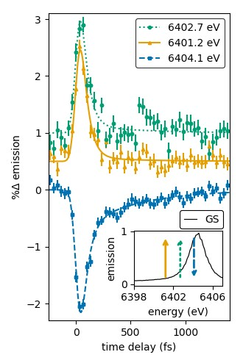

Figure 3: Time-resolved difference XES spectra. The ground state K-*α*1 emission of FeRu is shown in the insert. In the main figure we monitor the emission of FeRu as a function of pump probe delay at the three energies shown in the inset. Each kinetic trace is offset by 0.5% to improve visibility. We use a global fit to determine a BET of 58 ± 10 fs, an IRF of 86 ± 7 fs, and a second, longer decay of 510 ± 120 fs. Also visible are oscillations on top of the decay. Their corresponding frequencies are shown in Fig. 4.

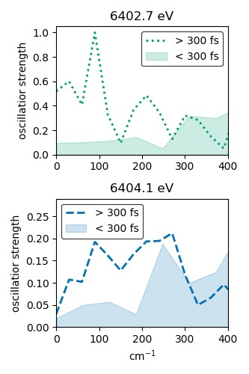

Figure 4: Fourier transform of XES residuals. The Fourier transform of the XES residuals are plotted for each of the three emission energies for both pump probe delays before 400 fs and after 400 fs. The Fourier transform before 400 fs is an estimate of the noise. We see one distinct peak for each color clearly above the noise at around 100 to 200 cm−1.

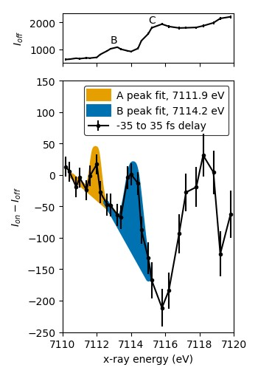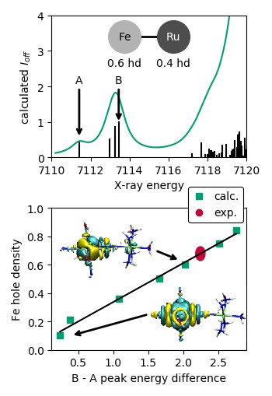

(a) (b)

Figure 5: Transient HERFD-XANES spectra. (a) The upper panel shows the ground state absorption spectra of FeRu. The B and C peaks are centered at 7113 eV and 7116 eV respectively. The lower panel shows difference spectra immediately after the MMCT. The A peak appears at approximately 7112 eV and dispersive line shapes appear at both the B and C peak positions. To measure the A and B peaks positions, we fit a gaussian peak with a linear offset to both the A peak and the dispersive shape at the B peak. This gives us a measured A-B peak splitting of 2.2 ± 0.1 eV. (b) The upper panel shows the calculated XANES spectra of FeRu with a hole density of 0.6 on the Iron atom. The position of the A and B peaks are given by the arrows. Similar calculations are performed along this trajectory to form the near linear dependency shown in the lower panel. A linear fit of the calculated hole density versus A-B peak energy difference is used to convert our measured A-B peak splitting. The corresponding hole density on the Fe atom immediately after the MMCT is 0.7 ± 0.1. The unfilled valence molecular orbitals involved in the A peak is shown in the lower panel as well. Right now we have only on trajectory shown in the linear plot. One additional trajectory will be included. Also, the molecular plots are just placeholders.

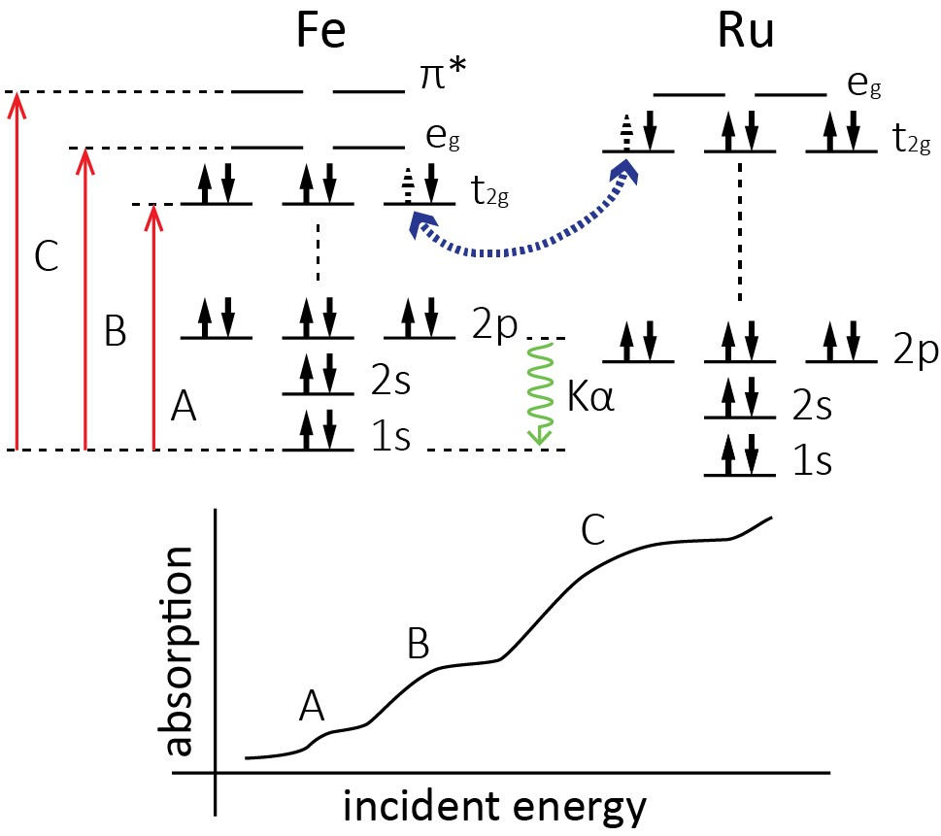

Figure 6: Relevant atomic and molecular orbitals. The optical pump pulse in our experiment moves an electron from the filled t2*g* orbital on the Fe atom to the partially open, higher energy, t2*g* orbital on the Ru atom. This is the MMCT state. During the BET, the molecule returns to the ground state where the Fe t2*g* orbital is filled. To observe this change, we perform both time-resolved HERFD-XANES and XES measurements. The HERFD-XANES measurement uses an Iron K-edge photon to promote an electron from the 1s atomic orbital to one of the three valence orbitals in FeRu, resulting in three different absorption lines, the A, B, and C lines. Before the MMCT and after the BET, the Iron t2*g* is filled again, causing the A peak to disappear. With the XES measurement, we monitor the K-*α*1 emission after ionizing the FeRu molecule with an above edge X-ray pulse. The K-*α*1 emission reports on the 2p3*/*2 to 1s atomic orbital splitting.

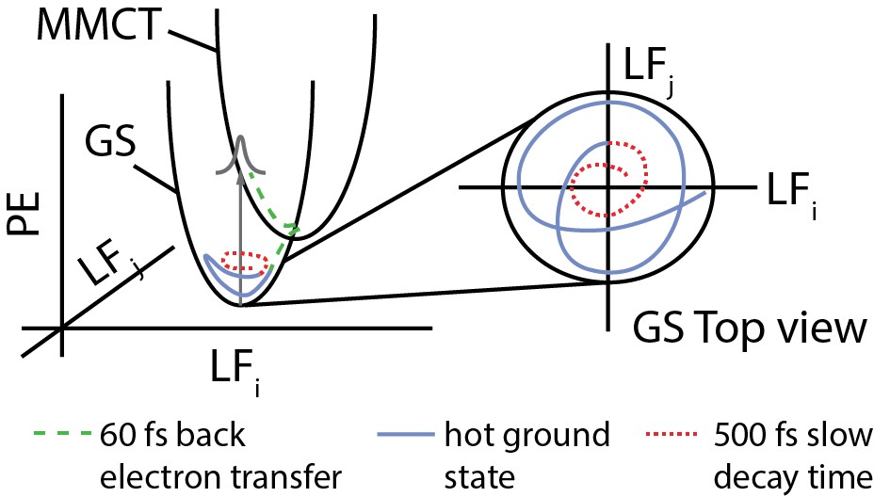

Figure 7: BET on a potential energy surface. We have shown evidence that as FeRu returns to the ground state, it settles into a hot ground state where at least one low frequency mode aligned along the Fe-Ru axis are excited. These vibrational excitations relax on a 500 fs timescale.

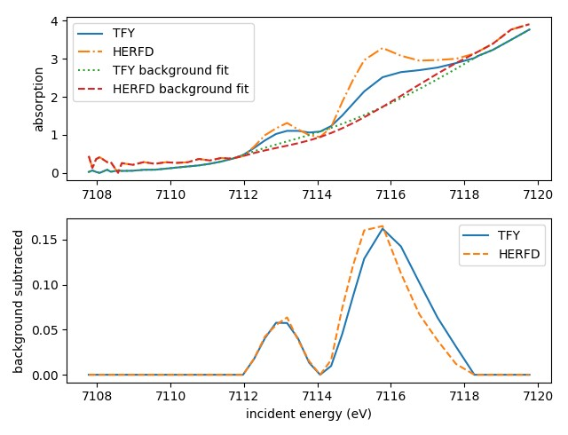

Figure 8: XANES and HERFD-XANES comparison. To confirm that we have appropriately set the Rowland spectrometer to the peak of the emission spectra so that we can straightforwardly use the HERFD-XANES measurement, we compare the XANES spectra from the TFY diode to the HERFD-XANES spectra. In the upper panel we see the raw spectra of both signals as well as the background fit we subtract to get the lower panel. The background is spline interpolation of the spectra excluding the peaks. The peak position for both spectra can be compared in the lower panel, where we see that in fact the B and C peaks are in alignment.

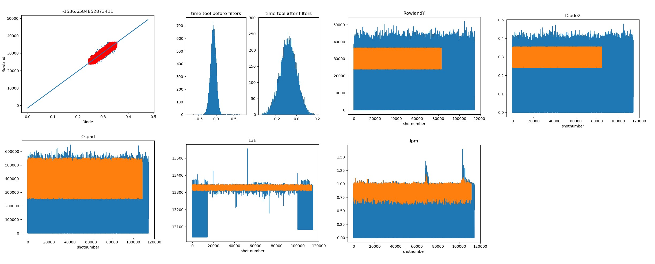

Figure 9: This is a placeholder for a nice filters figure. This shows the each of the different filters that are applied. Two to point out are the L3E filter, which is a measure of the electron energy, and the linear filter. The large spikes in the L3E energy are indicative of poorly aligned electron bunches with the FEL. Filtering out these shots ensures that the electron bunches were well aligned with the FEL undulators. The linear filter also

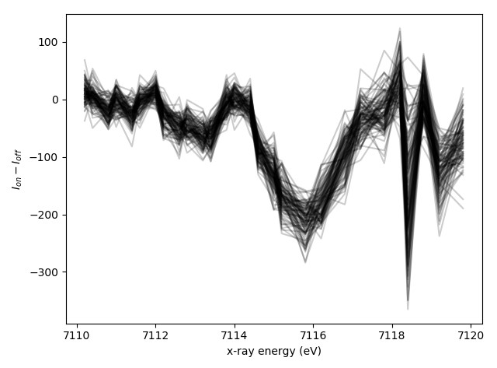

Figure 10: Bootstrapped dataset subset. To determine the uncertainty of our measurement, we use the bootstrapping technique to estimate the error. We create 1000 “bootstrapped” datasets by resampling our raw data with replacement 1000 times. We then perform our analysis to each of the datasets and use the mean and standard deviation of each point to report the final value and uncertainty of each data point respectively. The first 100 bootstrap datasets are plotted on top of each other here. We identify the point at 7118.4 eV as having an unusually large amount of error and eliminate it from our dataset. This is because this energy bin contains only ≈ 4% the number of x-ray shots of other energy bins. Each of the other shots have ≈ 1500 shots in them.

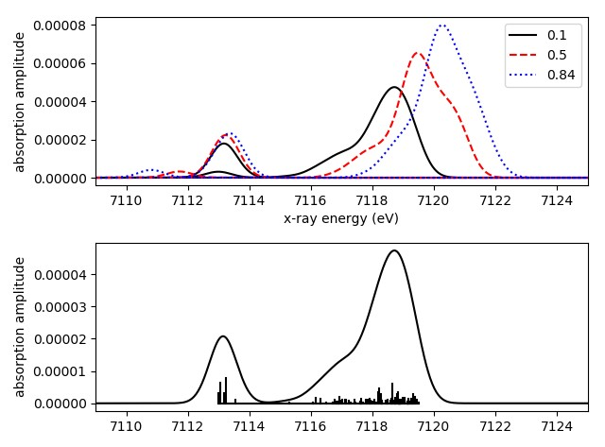

Figure 11: Three difference absorption spectra for each peak are shown in the upper panel, while the ground-state absorption is shown with its roots in the lower panel. The change in the B-A splitting is clearly seen in the upper panel as the A peak strongly red shifts with increasing hole density. At the same time, the B peak blue shifts. Should I just show the A and B peaks?

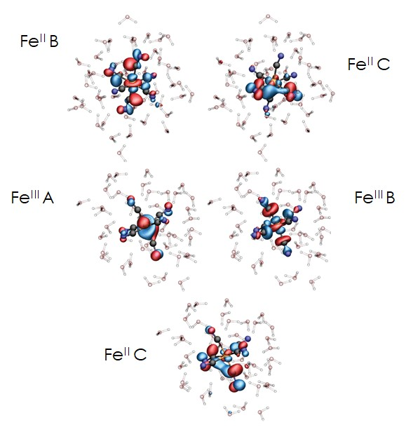

Figure 12: This will be updated when the new figure comes in.

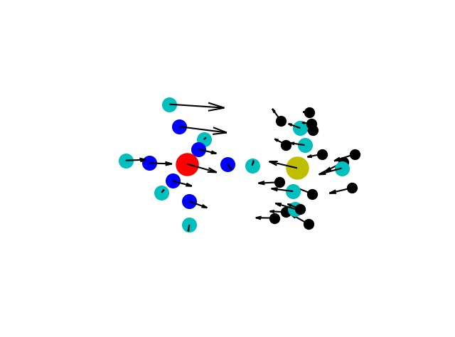

Figure 13: This figure will show several different low frequency modes, along with an IR spectra showing the intensity of each mode. Right now is just the lowest frequency mode.

XES spectra we measured in Fig. 3, since the XES spectra is directly related to the 1s to 2p3*/*2 energy splitting, we can be confident that the emission spectra should shift as well. We cannot, however, comment on how the width or shape of the spectra should change. We can confirm that the K-*α*1 spectra should be sensitive to low frequency modes that involve motion directly connected to the Iron atom.

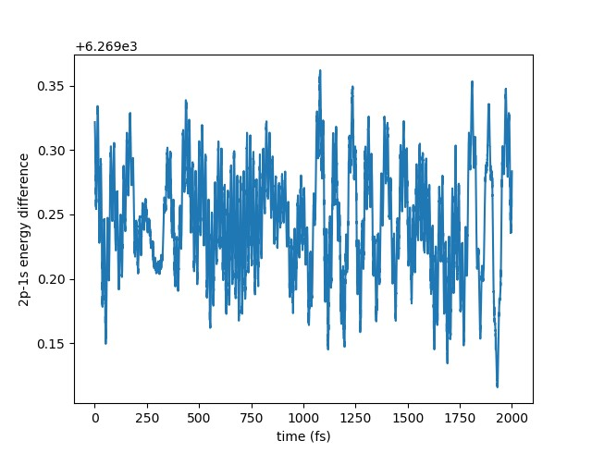

Figure 14: This figure needs to be updated with one with the Fourier transform and also it needs to look nicer.

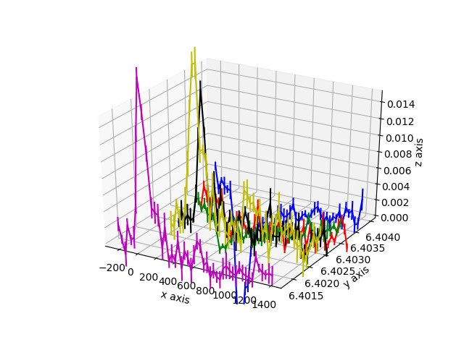

Figure 15: This plot needs to be heavily altered. But it is an okay placeholder.