AN ANALYSIS AND DISCOURSE
on the Origins of the World’s Seafood Supply with Respect to Our Cherished Continent’s
SEA TURTLES
and the Most Glorious Differences betwixt Their and Their Well-Known Counterpart’s
SPINY BRISTLES’ EFFECTIVENESS
Regarding Defensive Abilitiyes Most Numerous Vis-à-vis Our
MAGNIFICENT FISHERMEN’S
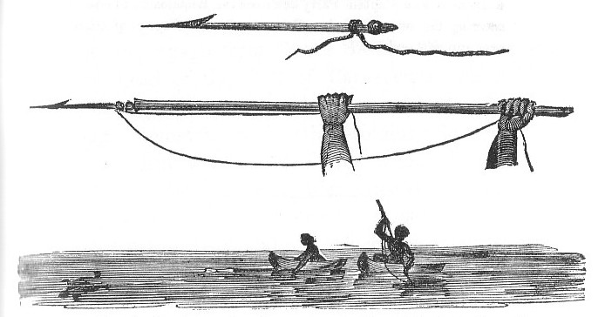
Assiduous and Persistent Intrusions into Their Private Affairs

