Caren Lierz

Assignment 9.4: Client-side debugging in Chrome

Instructions on how you can use client-side debugging to set a break point:

1. Open up your file and press F12
2. Click on the Sources tab
3. Open up file you are debugging
4. Select the line of code where you want to introduce a pause/break point
5. Re-run your code and observe that the page/script pauses right before that line of code
6. In the below example I am using a script to render the PayPal button and I want the code to pause right before it renders them:

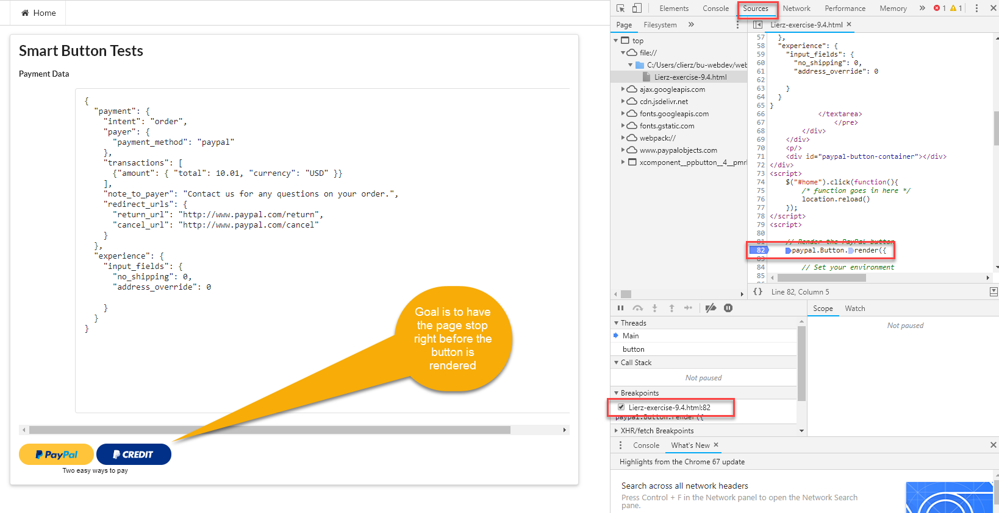

When I re-run the page this is what happens:

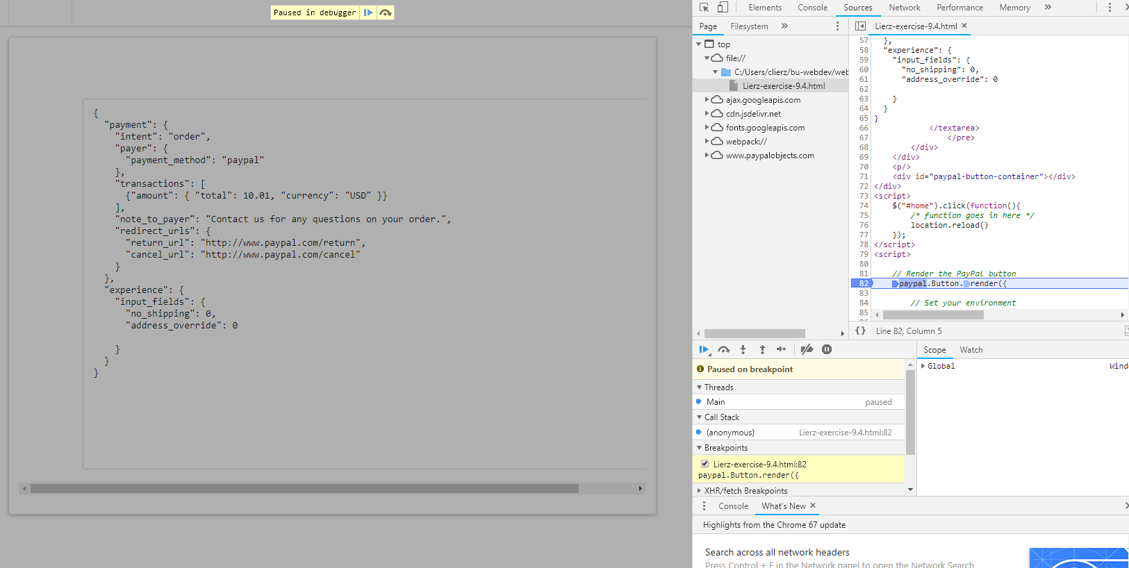

Logging and reading messages in Chrome dev tools:

1. In my code I have a JSon string which I am logging out to the console
2. When I have chrome developer tools open, I can click on Console and see what I have logged out. One could also do this for error message or anything else that makes sense.

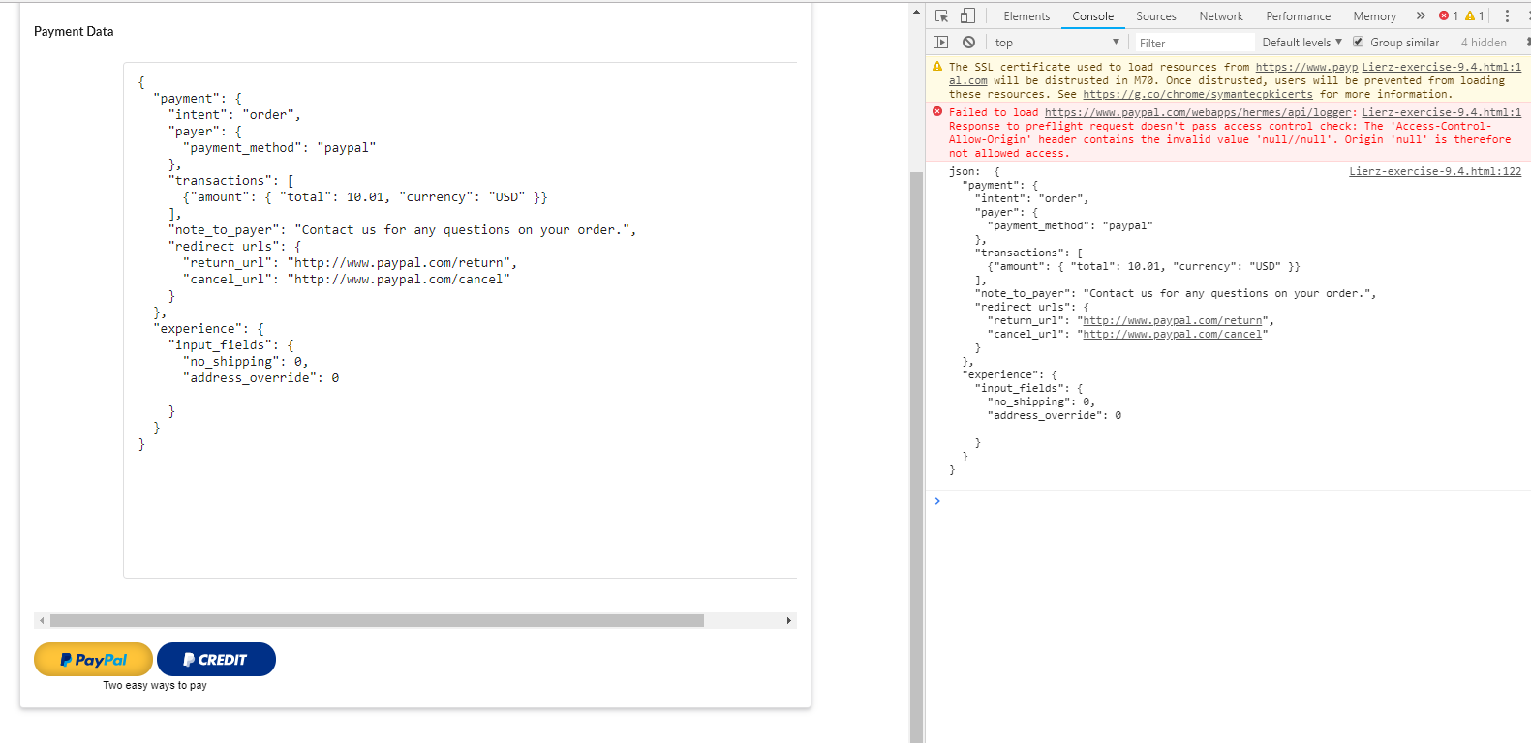

Chrome developer tools can also be used to select HTML and CSS elements to make changes and see what they will look like.

1. In Chrome developer tools click on Elements
2. Select the HTML tag you want to dig into
3. Select the declaration you want to change
4. In the example below, I have changed the background from white (as seen in prior screenshots) to blue.

