Cedar Creek Reservoir Data Analysis Sections to be Inserted in Catawba Chlorophyll-a Document

Clifton Bell

2024-08-29

## 4.2 CEDAR CREEK RESERVOIR

Cedar Creek Reservoir (also known as Stumpy Pond or Rocky Creek Lake) is downstream of Fishing Creek Lake and Great Falls Reservoir and upstream of Lake Wateree. This smaller (~850 acre) was created in 1909 as part of the hydroelectric projects along the Catawba-Wateree River. Duke Energy currently operates the Cedar Creek Hydropower Station at the downstream end of the reservoir. Several islands divide Cedar Creek Reservoir into channel-like segments. No public water supply intakes are located on Cedar Creek Reservoir.

### 4.2.1 Assessment History

### 4.2.2 Chlorophyll-a Conditions

There are three stations on Cedar Creek Reservoir with 10 or more data over 2000-2023, and a large number of stations with 6-9 data (Table X). The geometric mean chlorohyll-a ranged from 4.8 ug/L at the tailrace station CW-174 (just below the Dearborn Hydro Station) to 23.9 ug/L at station RL-01007 on the east side channel of the reservoir. The 90th percentile chlorophyll-a ranged (only computed for three stations with >10 data) range from 10.2 ug/L at CW-174 to 38.3 ug/L at station RL-19149 on the east side channel of the reservoir. Station CW-033 is representative of the lower mainstem and had a geometric mean chlorohphyll-a of 11.5 ug/L and a 90th percentile chlorophyll-a of 25.9 ug/L. These data indicate that chlorophyll-a is highest in the east side channel.

Table X - Chlorophyll-a Summary Statistics for Cedar Creek Reservoir, Apr-Oct data <= 1 m

|  | **Chla in CEDAR CREEK RESERVOIR** | **Chla in CEDAR CREEK RESERVOIR** | **Chla in CEDAR CREEK RESERVOIR** | **Chla in CEDAR CREEK RESERVOIR** | **Chla in CEDAR CREEK RESERVOIR** | **Chla in CEDAR CREEK RESERVOIR** | **Chla in CEDAR CREEK RESERVOIR** | **Chla in CEDAR CREEK RESERVOIR** | **Chla in CEDAR CREEK RESERVOIR** | **Chla in CEDAR CREEK RESERVOIR** |
| --- | --- | --- | --- | --- | --- | --- | --- | --- | --- | --- |
| **StationID** | **Count** | **Max** | **Perc_90th** | **Perc_75th** | **Arith_Mean** | **Geo_Mean** | **Median** | **Perc_25th** | **Perc_10th** | **Min** |
| RL-04379 | 6 | 21.6 | 17.4 | 12.6 | 10.0 | 7.5 | 10.2 | 4.3 | 2.4 | 2.3 |
| RL-19254 | 6 | 34.4 | 32.3 | 28.2 | 22.5 | 21.3 | 19.9 | 17.0 | 15.2 | 13.7 |
| RL-01007 | 6 | 55.8 | 54.4 | 49.2 | 31.2 | 23.9 | 30.8 | 13.6 | 8.5 | 6.8 |
| RL-23120 | 6 | 37.9 | 30.9 | 23.5 | 20.7 | 19.0 | 19.4 | 13.2 | 11.8 | 11.5 |
| CW-174 | 55 | 32.0 | 10.2 | 7.2 | 5.8 | 4.8 | 4.5 | 3.2 | 2.5 | 1.4 |
| RL-19149 | 13 | 45.7 | 38.3 | 26.2 | 21.7 | 17.6 | 18.9 | 15.5 | 6.1 | 4.1 |
| RL-04375 | 6 | 36.1 | 32.6 | 29.0 | 21.8 | 16.5 | 27.7 | 10.5 | 5.0 | 4.9 |
| RL-14147 | 6 | 36.0 | 27.5 | 18.4 | 18.7 | 17.3 | 16.1 | 13.4 | 12.4 | 12.1 |
| RL-21277 | 8 | 26.2 | 20.5 | 17.9 | 11.7 | 9.4 | 7.8 | 6.5 | 4.2 | 4.0 |
| RL-06443 | 7 | 36.4 | 28.6 | 22.8 | 16.6 | 13.0 | 15.1 | 7.5 | 5.6 | 4.0 |
| RL-02319 | 9 | 38.3 | 27.3 | 13.2 | 12.9 | 9.0 | 11.3 | 4.2 | 3.4 | 2.4 |
| RL-01017 | 6 | 41.0 | 35.1 | 26.4 | 19.6 | 16.3 | 15.2 | 10.2 | 8.5 | 7.4 |
| RL-23116 | 6 | 28.8 | 27.7 | 25.0 | 19.2 | 17.6 | 20.1 | 13.6 | 10.0 | 8.5 |
| CW-033 | 95 | 33.0 | 25.9 | 18.9 | 13.9 | 11.5 | 12.2 | 8.5 | 4.0 | 1.8 |
| RL-18146 | 6 | 38.6 | 38.3 | 36.1 | 25.3 | 23.0 | 24.1 | 15.0 | 13.6 | 13.2 |

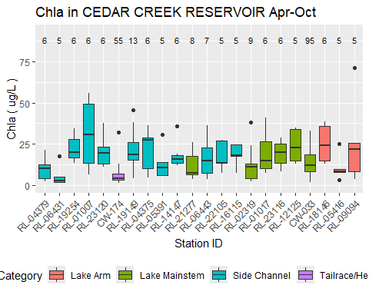

Figure X - Spatial pattern in chl-a in Cedar Creek Reservoir. Apr-Oct data <= 1 m

The growing season geometric mean is a candidate metric for expression of site-specific criteria. Table X shows the Apr-Oct geometric mean chlorophyll-a values for individual years and stations in Cedar Creek Reservoir, and presents values only for year-station combinations with at least 5 data. The table also presents the minimum, median, maximum, and standard deviation of the Apr-Oct geometric means for individual years. The maximum growing season geometric mean (36.8 ug/L) occurred at station CW-208 in 2002.

Table X - Chlorophyll-a Annual Geometric Means for Cedar Creek Reservoir, Apr-Oct data <= 1 m

| **Year** | **RL-04379** | **RL-15104** | **RL-06431** | **RL-10102** | **RL-19254** | **RL-01007** | **RL-23120** | **CW-174** | **RL-19149** | **CW-175** | **RL-04375** | **RL-07003** | **RL-05391** | **RL-03353** | **RL-14147** | **RL-08046** | **RL-21277** | **RL-06443** | **RL-02452** | **RL-22105** | **RL-16115** | **RL-02319** | **RL-01017** | **RL-23116** | **RL-12125** | **CW-033** | **RL-18146** | **RL-05416** | **RL-09094** |
| --- | --- | --- | --- | --- | --- | --- | --- | --- | --- | --- | --- | --- | --- | --- | --- | --- | --- | --- | --- | --- | --- | --- | --- | --- | --- | --- | --- | --- | --- |
| 2001 |  |  |  |  |  | 23.9 |  |  |  |  |  |  |  |  |  |  |  |  |  |  |  |  | 16.3 |  |  |  |  |  |  |
| 2002 |  |  |  |  |  |  |  |  |  |  |  |  |  |  |  |  |  |  |  |  |  |  |  |  |  |  |  |  |  |
| 2003 |  |  |  |  |  |  |  |  |  |  |  |  |  |  |  |  |  |  |  |  |  |  |  |  |  |  |  |  |  |
| 2004 | 7.5 |  |  |  |  |  |  |  |  |  | 16.5 |  |  |  |  |  |  |  |  |  |  |  |  |  |  |  |  |  |  |
| 2005 |  |  |  |  |  |  |  |  |  |  |  |  | 11.3 |  |  |  |  |  |  |  |  |  |  |  |  |  |  | 9 |  |
| 2006 |  |  | 4.1 |  |  |  |  |  |  |  |  |  |  |  |  |  |  | 13 |  |  |  |  |  |  |  |  |  |  |  |
| 2007 |  |  |  |  |  |  |  |  |  |  |  |  |  |  |  |  |  |  |  |  |  |  |  |  |  |  |  |  |  |
| 2008 |  |  |  |  |  |  |  |  |  |  |  |  |  |  |  |  |  |  |  |  |  |  |  |  |  |  |  |  |  |
| 2009 |  |  |  |  |  |  |  |  |  |  |  |  |  |  |  |  |  |  |  |  |  |  |  |  |  |  |  |  | 17 |
| 2010 |  |  |  |  |  |  |  |  |  |  |  |  |  |  |  |  |  |  |  |  |  |  |  |  |  |  |  |  |  |
| 2011 |  |  |  |  |  |  |  |  |  |  |  |  |  |  |  |  |  |  |  |  |  |  |  |  |  |  |  |  |  |
| 2012 |  |  |  |  |  |  |  |  |  |  |  |  |  |  |  |  |  |  |  |  |  |  |  |  | 22.1 |  |  |  |  |
| 2013 |  |  |  |  |  |  |  |  |  |  |  |  |  |  |  |  |  |  |  |  |  |  |  |  |  |  |  |  |  |
| 2014 |  |  |  |  |  |  |  |  |  |  |  |  |  |  | 17.3 |  |  |  |  |  |  |  |  |  |  |  |  |  |  |
| 2015 |  |  |  |  |  |  |  |  |  |  |  |  |  |  |  |  |  |  |  |  |  |  |  |  |  |  |  |  |  |
| 2016 |  |  |  |  |  |  |  |  |  |  |  |  |  |  |  |  |  |  |  |  | 17.2 |  |  |  |  | 12.2 |  |  |  |
| 2017 |  |  |  |  |  |  |  | 6.9 |  |  |  |  |  |  |  |  |  |  |  |  |  |  |  |  |  | 15.8 |  |  |  |
| 2018 |  |  |  |  |  |  |  | 3.6 |  |  |  |  |  |  |  |  |  |  |  |  |  |  |  |  |  | 9.7 | 23 |  |  |
| 2019 |  |  |  |  | 21.3 |  |  | 5.3 | 24.6 |  |  |  |  |  |  |  |  |  |  |  |  |  |  |  |  | 14.2 |  |  |  |
| 2020 |  |  |  |  |  |  |  | 4.1 | 11.9 |  |  |  |  |  |  |  |  |  |  |  |  | 6.1 |  |  |  | 8.2 |  |  |  |
| 2021 |  |  |  |  |  |  |  | 7.4 |  |  |  |  |  |  |  |  | 9.4 |  |  |  |  |  |  |  |  | 13.1 |  |  |  |
| 2022 |  |  |  |  |  |  |  | 4.8 |  |  |  |  |  |  |  |  |  |  |  | 15.9 |  |  |  |  |  | 16.9 |  |  |  |
| 2023 |  |  |  |  |  |  | 19 | 3.5 |  |  |  |  |  |  |  |  |  |  |  |  |  |  |  | 17.6 |  | 18.8 |  |  |  |
| Years with ≥ 5 values | 1.0 | 0 | 1.0 | 0 | 1.0 | 1.0 | 1 | 7.0 | 2.0 | 0 | 1.0 | 0 | 1.0 | 0 | 1.0 | 0 | 1.0 | 1 | 0 | 1.0 | 1.0 | 1.0 | 1.0 | 1.0 | 1.0 | 8.0 | 1 | 1 | 1 |
| Min Geom Mean | 7.5 |  | 4.1 |  | 21.3 | 23.9 | 19 | 3.5 | 11.9 |  | 16.5 |  | 11.3 |  | 17.3 |  | 9.4 | 13 |  | 15.9 | 17.2 | 6.1 | 16.3 | 17.6 | 22.1 | 8.2 | 23 | 9 | 17 |
| Median Geom Mean | 7.5 |  | 4.1 |  | 21.3 | 23.9 | 19 | 4.8 | 18.3 |  | 16.5 |  | 11.3 |  | 17.3 |  | 9.4 | 13 |  | 15.9 | 17.2 | 6.1 | 16.3 | 17.6 | 22.1 | 13.6 | 23 | 9 | 17 |
| Max Geom Mean | 7.5 |  | 4.1 |  | 21.3 | 23.9 | 19 | 7.4 | 24.6 |  | 16.5 |  | 11.3 |  | 17.3 |  | 9.4 | 13 |  | 15.9 | 17.2 | 6.1 | 16.3 | 17.6 | 22.1 | 18.8 | 23 | 9 | 17 |
| SD Geom Mean |  |  |  |  |  |  |  | 1.6 | 9.0 |  |  |  |  |  |  |  |  |  |  |  |  |  |  |  |  | 3.6 |  |  |  |

Time series plots (Figure X) do not show marked trends in chlorophyll-a in Cedar Creek Reservoir since 2000. Seasonal plots do not show a strong seasonal pattern in chlorophyll-a (Figure X). At the station with the highest chlorophyll-a (CW-208), chlorophyll-a tended to be higherin August-October than May-July. But this was not the case at other Cedar Creek Reservoir stations.

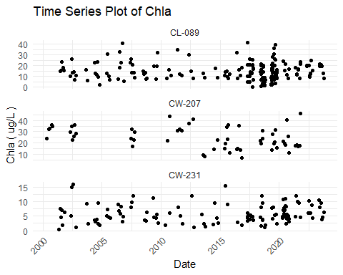

Figure X - Chl-a over time at Cedar Creek Reservoir stations. Data <= 1 m

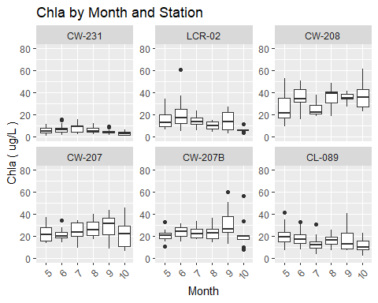

Figure X - Seasonal pattern in chl-a at Cedar Creek Reservoir stations. Data < 1 m

### 4.2.3 Water Quality Indicators

Apart from chlorophyll-a, other important water quality indicators include dissolved oxygen (DO), pH, water clarity, and cyanotoxins. Exceedances of related criteria or thresholds might or might not be related to eutrophication or high chlorophyll-a values. However, these water quality indicators provide insights into the overall use status of a reservoir, and relations of these indicators with chlorophyll-a (or lack thereof) can inform site-specific chlorophyll-a criteria.

#### 4.2.3.1 Dissolved Oxygen

The applicable DO water quality criteria for Cedar Creek Reservoir include a daily average not less than 5.0 mg/L with a low of 4.0 mg/L. For water quality assessment purposes, measurements are made at the surface. The only station that had a minimum DO of less than 4.0 mg/L was stations CL-089 in the lower reservoir (Table X). This station was also the only station with 10 or more data that had a 10th percentile DO less than 5 mg/L. Hence, it appears that most of Cedar Creek Reservoir has adequate surface DO but that a region in the lower reservoir can sometime experience lower surface DO concentrations. A plot of DO vs depth (Figure X) indicates that DO decreases with depth as in most deep, stratified reservoirs.

Table X - Dissolved Oxygen Summary Statistics for Cedar Creek Reservoir, Apr-Oct data <= 1 m

|  | **DO in CEDAR CREEK RESERVOIR** | **DO in CEDAR CREEK RESERVOIR** | **DO in CEDAR CREEK RESERVOIR** | **DO in CEDAR CREEK RESERVOIR** | **DO in CEDAR CREEK RESERVOIR** | **DO in CEDAR CREEK RESERVOIR** | **DO in CEDAR CREEK RESERVOIR** | **DO in CEDAR CREEK RESERVOIR** | **DO in CEDAR CREEK RESERVOIR** | **DO in CEDAR CREEK RESERVOIR** |
| --- | --- | --- | --- | --- | --- | --- | --- | --- | --- | --- |
| **StationID** | **Count** | **Max** | **Perc_90th** | **Perc_75th** | **Arith_Mean** | **Geo_Mean** | **Median** | **Perc_25th** | **Perc_10th** | **Min** |
| RL-04379 | 7 | 12.0 | 10.6 | 9.5 | 8.7 | 8.5 | 8.6 | 7.2 | 7.0 | 6.7 |
| RL-15104 | 7 | 10.4 | 10.0 | 8.7 | 8.2 | 8.1 | 7.6 | 7.5 | 7.4 | 7.3 |
| RL-06431 | 7 | 6.9 | 6.9 | 6.7 | 5.8 | 5.7 | 6.2 | 5.2 | 4.7 | 3.8 |
| RL-10102 | 7 | 11.2 | 10.5 | 9.5 | 8.5 | 8.4 | 7.8 | 7.5 | 7.2 | 6.9 |
| RL-19254 | 7 | 9.9 | 9.7 | 9.1 | 8.8 | 8.8 | 8.6 | 8.4 | 8.3 | 8.1 |
| RL-01007 | 14 | 11.0 | 9.4 | 8.7 | 7.7 | 7.4 | 8.2 | 7.3 | 4.5 | 3.9 |
| CW-174 | 89 | 9.8 | 8.4 | 7.5 | 6.6 | 6.5 | 6.6 | 5.5 | 4.9 | 3.3 |
| RL-19149 | 13 | 11.5 | 11.1 | 9.3 | 9.0 | 9.0 | 8.6 | 8.4 | 8.0 | 7.9 |
| CW-175 | 26 | 9.0 | 7.9 | 6.9 | 6.2 | 6.0 | 6.2 | 5.0 | 4.6 | 3.4 |
| RL-04375 | 7 | 13.3 | 12.5 | 11.3 | 10.0 | 9.8 | 9.6 | 8.3 | 7.6 | 7.6 |
| RL-07003 | 7 | 10.8 | 10.6 | 9.2 | 7.8 | 7.6 | 7.3 | 6.5 | 5.7 | 5.4 |
| RL-05391 | 7 | 11.2 | 10.5 | 9.8 | 8.2 | 7.9 | 7.7 | 6.4 | 6.0 | 5.9 |
| RL-03353 | 7 | 10.6 | 10.2 | 9.5 | 8.3 | 8.1 | 8.0 | 7.6 | 6.5 | 5.2 |
| RL-14147 | 7 | 10.9 | 10.8 | 9.8 | 8.3 | 8.0 | 8.3 | 7.2 | 5.9 | 4.7 |
| RL-08046 | 7 | 7.2 | 7.2 | 7.1 | 6.3 | 6.1 | 6.9 | 5.8 | 4.7 | 4.0 |
| RL-17127 | 7 | 12.1 | 10.9 | 10.1 | 9.5 | 9.3 | 10.0 | 8.6 | 7.6 | 6.9 |
| RL-21277 | 7 | 10.9 | 10.6 | 9.4 | 8.5 | 8.4 | 8.3 | 7.7 | 7.0 | 6.4 |
| RL-06443 | 8 | 10.3 | 8.8 | 7.9 | 7.5 | 7.4 | 7.1 | 6.6 | 6.5 | 6.4 |
| RL-22105 | 6 | 11.8 | 10.4 | 8.9 | 8.9 | 8.8 | 8.5 | 8.2 | 7.8 | 7.4 |
| RL-16115 | 7 | 13.4 | 10.1 | 7.7 | 7.8 | 7.5 | 7.3 | 6.4 | 6.0 | 5.7 |
| RL-02319 | 11 | 9.9 | 8.6 | 7.6 | 7.2 | 7.1 | 6.9 | 6.6 | 6.3 | 5.5 |
| RL-01017 | 6 | 9.3 | 9.2 | 8.9 | 7.2 | 6.9 | 7.8 | 5.6 | 4.5 | 4.0 |
| RL-12125 | 7 | 9.8 | 8.8 | 7.9 | 7.6 | 7.6 | 7.4 | 7.1 | 6.7 | 6.4 |
| CW-033 | 98 | 12.4 | 10.2 | 8.7 | 7.8 | 7.6 | 7.5 | 6.6 | 5.8 | 4.7 |
| RL-18146 | 6 | 10.7 | 9.8 | 8.7 | 7.9 | 7.8 | 7.5 | 6.6 | 6.4 | 6.3 |
| RL-05416 | 7 | 8.5 | 8.0 | 7.6 | 7.0 | 6.9 | 7.1 | 6.2 | 5.8 | 5.8 |
| RL-09094 | 6 | 10.7 | 10.7 | 10.4 | 8.6 | 8.4 | 8.9 | 6.8 | 6.2 | 6.0 |

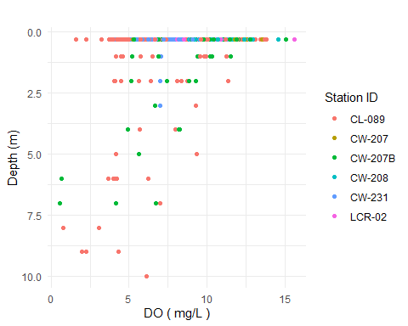

Figure X - Dissolved Oxygen v Depth at Selected Cedar Creek Reservoir stations.

A plot of DO vs chlorophyll-a (Figure X) indicates a positive relation between the two parameters. The plot also shows that the relation between DO and chlorophyll-a is not strong at all individual stations, so the overall relation may be driven more by spatial patterns in DO and chlorophyll-a than temporal variations in photosynthesis. Box and whisker plots of the longitudinal DO pattern (Figure X) confirm that upper and lower reservoir have somewhat lower DO than the middle reservoir station, and that DO values less than 5 mg/L are uncommon. The driver(s) of the occasional low DO values at station CL-089 are uncertain. One possibility is the upwelling of deeper water caused be destratification or a hydraulic effect related to dam operation.

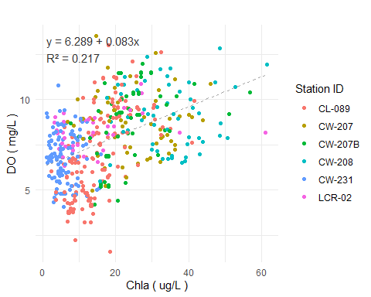

Figure X - Dissolved Oxygen v Chlorophyll-a at Selected Cedar Creek Reservoir stations.

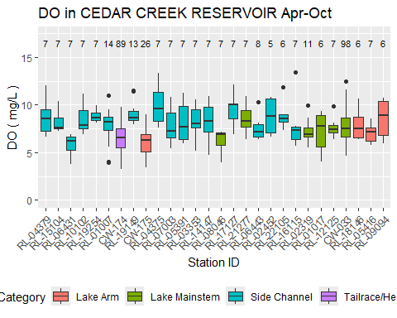

Figure X - Spatial pattern in DO in Cedar Creek Reservoir. Apr-Oct data <= 1 m

#### 4.2.3.2 pH

The applicable water quality criterion for pH for SC freshwaters is a range between 6.0 and 8.5. Many stations on Cedar Creek Reservoir reservoir have 90th percentile pH values that exceed the upper limit of this range (Table X), and some exceed 9.0. A scatterplot of pH vs chlorophyll-a (Figure X) demonstrate a great deal of variance but a positive relation between the parameters. A significant proportion of samples exceeded pH of 8.5 at chlorophyll-a values of 16 ug/L and higher.

Table X - pH Summary Statistics for Cedar Creek Reservoir, Apr-Oct data <= 1 m

|  | **pH in CEDAR CREEK RESERVOIR** | **pH in CEDAR CREEK RESERVOIR** | **pH in CEDAR CREEK RESERVOIR** | **pH in CEDAR CREEK RESERVOIR** | **pH in CEDAR CREEK RESERVOIR** | **pH in CEDAR CREEK RESERVOIR** | **pH in CEDAR CREEK RESERVOIR** | **pH in CEDAR CREEK RESERVOIR** | **pH in CEDAR CREEK RESERVOIR** | **pH in CEDAR CREEK RESERVOIR** |
| --- | --- | --- | --- | --- | --- | --- | --- | --- | --- | --- |
| **StationID** | **Count** | **Max** | **Perc_90th** | **Perc_75th** | **Arith_Mean** | **Geo_Mean** | **Median** | **Perc_25th** | **Perc_10th** | **Min** |
| RL-04379 | 7 | 8.1 | 7.7 | 7.5 | 7.1 | 7.1 | 7.2 | 6.7 | 6.3 | 6.0 |
| RL-15104 | 7 | 7.7 | 7.4 | 6.9 | 6.5 | 6.5 | 6.5 | 6.1 | 5.8 | 5.6 |
| RL-06431 | 7 | 7.5 | 7.4 | 7.2 | 7.2 | 7.1 | 7.1 | 7.0 | 7.0 | 6.9 |
| RL-10102 | 7 | 8.2 | 8.2 | 7.8 | 6.9 | 6.7 | 7.1 | 7.0 | 5.6 | 3.5 |
| RL-19254 | 7 | 8.1 | 8.1 | 8.1 | 7.7 | 7.6 | 7.5 | 7.4 | 7.3 | 7.2 |
| RL-01007 | 14 | 8.5 | 8.2 | 7.5 | 7.3 | 7.2 | 7.2 | 6.8 | 6.6 | 6.5 |
| CW-174 | 90 | 8.3 | 7.3 | 7.1 | 6.7 | 6.7 | 6.8 | 6.3 | 5.9 | 5.6 |
| RL-19149 | 14 | 9.4 | 8.5 | 8.3 | 7.8 | 7.8 | 7.9 | 7.3 | 6.8 | 6.5 |
| CW-175 | 26 | 7.3 | 7.2 | 7.1 | 6.9 | 6.9 | 6.9 | 6.7 | 6.5 | 6.2 |
| RL-04375 | 7 | 8.7 | 8.4 | 8.2 | 7.5 | 7.5 | 7.7 | 6.9 | 6.3 | 6.2 |
| RL-07003 | 7 | 9.1 | 8.8 | 8.6 | 8.0 | 8.0 | 8.4 | 7.1 | 7.0 | 6.9 |
| RL-05391 | 7 | 9.1 | 8.6 | 7.6 | 7.4 | 7.3 | 7.0 | 6.9 | 6.7 | 6.5 |
| RL-03353 | 7 | 7.5 | 7.3 | 7.0 | 6.9 | 6.9 | 7.0 | 6.8 | 6.4 | 6.0 |
| RL-14147 | 7 | 8.9 | 8.4 | 8.1 | 7.9 | 7.9 | 7.8 | 7.6 | 7.3 | 7.1 |
| RL-08046 | 7 | 7.4 | 7.2 | 7.1 | 6.8 | 6.8 | 6.9 | 6.7 | 6.4 | 5.9 |
| RL-17127 | 7 | 9.1 | 9.0 | 8.5 | 7.8 | 7.8 | 7.4 | 7.1 | 7.0 | 7.0 |
| RL-21277 | 7 | 8.8 | 8.5 | 7.6 | 7.3 | 7.3 | 7.0 | 6.9 | 6.7 | 6.6 |
| RL-06443 | 8 | 8.6 | 8.5 | 8.5 | 7.8 | 7.8 | 7.8 | 7.3 | 7.1 | 7.1 |
| RL-22105 | 6 | 9.1 | 8.7 | 8.3 | 8.0 | 8.0 | 8.0 | 7.6 | 7.5 | 7.3 |
| RL-16115 | 7 | 8.9 | 8.1 | 7.2 | 7.0 | 6.9 | 6.6 | 6.3 | 6.2 | 6.2 |
| RL-02319 | 12 | 8.0 | 7.5 | 7.3 | 7.0 | 7.0 | 7.0 | 6.7 | 6.5 | 6.5 |
| RL-01017 | 6 | 7.4 | 7.3 | 7.2 | 6.9 | 6.9 | 6.9 | 6.7 | 6.6 | 6.5 |
| RL-12125 | 7 | 8.4 | 8.1 | 7.8 | 7.7 | 7.7 | 7.6 | 7.4 | 7.4 | 7.4 |
| CW-033 | 99 | 9.3 | 8.4 | 7.6 | 7.2 | 7.2 | 7.2 | 6.7 | 6.1 | 5.7 |
| RL-18146 | 6 | 7.3 | 7.1 | 6.9 | 6.7 | 6.6 | 6.6 | 6.3 | 6.2 | 6.2 |
| RL-05416 | 7 | 7.2 | 7.2 | 7.2 | 6.9 | 6.9 | 7.0 | 6.8 | 6.5 | 6.3 |
| RL-09094 | 6 | 8.3 | 8.3 | 8.1 | 7.6 | 7.6 | 7.6 | 7.1 | 6.9 | 6.9 |

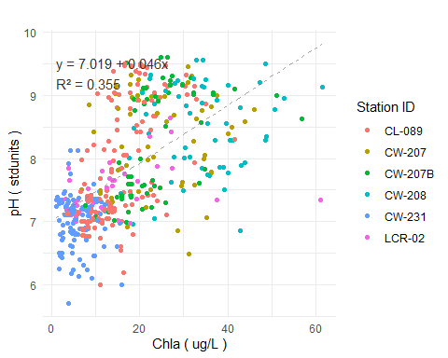

Figure X - pH v Chlorophyll-a at Selected Cedar Creek Reservoir stations.

There are relatively few station-year combinations that have sufficient data (>= 10) to calculate a 90th percentile pH. Those that are available demonstrate that the seasonal (Apr-Oct) 90th percentile pH had a positive relation with the seasonal geometric mean chlorophyll-a concentration as expected (Figure X). No stations had a 90th percentile pH greater than 9.5. Based on the overall trend, the seasonal 90th percentile pH was less than 9.0 when the seasonal geometric mean chlorophyll-a was less than about 18 ug/L. But station CL-089 in the the lower reservoir had a 90th pH higher than 9.0 even in years with seasonal geometric mean chlorophyll-a concentrations of 12 - 17 ug/L.

## `geom_smooth()` using formula = 'y ~ x'

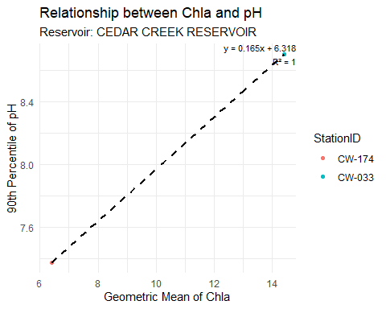

Figure X - Seasonal 90th percentile pH v seasonal geoemetric mean chlorophyll-a at Cedar Creek Reservoir stations.

The spatial pattern of pH in Cedar Creek Reservoir indicates increasing values from the headwater through the upper reservoir, and the highest valures in the upper and mid-reservoir sections (Figure X).

## Warning: Removed 2 rows containing non-finite outside the scale range  
## (`stat_boxplot()`).

## Warning: Removed 2 rows containing non-finite outside the scale range  
## (`stat_summary()`).

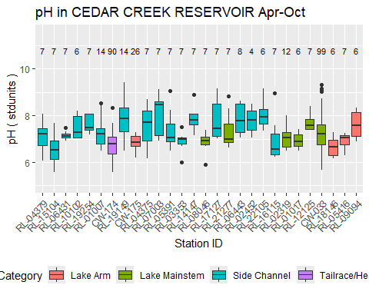

Figure X - Spatial pattern in pH in Cedar Creek Reservoir. Apr-Oct data <= 1 m

The South Carolina upper pH limit of 8.5 is more stringent than the USEPA criterion of 9.0. The USEPA upper limit was primarily derived for salmonid protection, and most warmwater fish species do not experience adverse effects at pH values less than 9.5 or higher (reference). Hence, the pH exceedances in Cedar Creek Reservoir are not necessarily associated with aquatic life or fishery impacts.

#### 4.2.3.3 Water Clarity

Water clarity in reservoirs is typically measured by Secchi depth. South Carolina does not have a recreationally-based criterion for Secchi depth. As discussed in section X, a Secchi depth of <= 1 m has sometimes been cited in reservoir management literature as threshold for recreational users that are accustomed to clear water. The median Secchi depth is between 0.5 and 0.75 m at most upper and middle Cedar Creek Reservoir stations (Figure X), increasing to between 0.75 and 1.0 m in the lower reservoir. There was no strong relation between Secchi depth and chlorophyll-a (R2 = 0.02) (Figure X). Secchi depth value greater than 1.0 m were mostly restricted to chlorophyll-a values less than 30 ug/L, but the typical Secchi depth values were less than 1.0 m even at very low chlorophyll-a values. Secchi depth had stronger (inverse) relations with turbidity (Figure X) and total suspended solids (TSS) (Figure X).

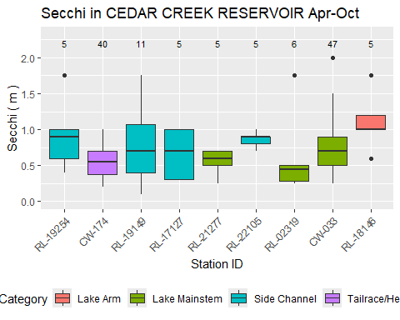

Figure X - Spatial pattern in Secchi depth in Cedar Creek Reservoir.

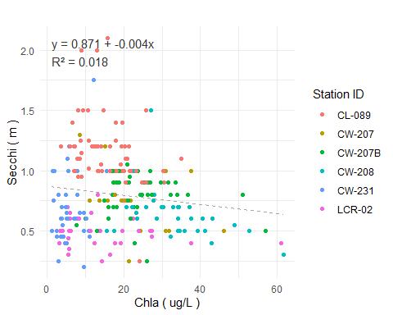

Figure X - Secchi depth v Chlorophyll-a at Cedar Creek Reservoir stations.

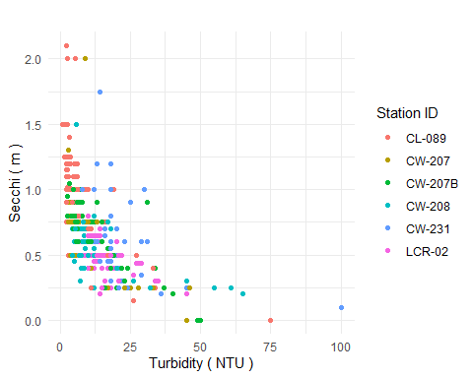

Figure X - Secchi depth v Turbidity at Cedar Creek Reservoir stations.

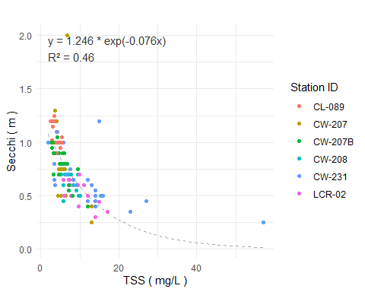

Figure X - Secchi depth v TSS at Cedar Creek Reservoir stations.

#### 4.2.3.4 Cyanotoxins

SCDES has routinely monitored microcystin at several Cedar Creek Reservoir reservoir stations since 2018. No samples have exceeded the SC recreational water quality criterion of 8.0 ug/L (Table X). The single highest value detected in routine monitoring was 0.6 ug/L, and the great majority of result have been below the detection or less than 0.1 ug/L. Microcystin concentrations have been somewhat higher in samples taken based on complaints of algal blooms (Table X), with a maximum value of 4.45 ug/L measured in the lower reservoir in June 2019.

Table X - Microcystin Summary Statistics for CEDAR CREEK RESERVOIR

|  | **Microcystin in CEDAR CREEK RESERVOIR** | **Microcystin in CEDAR CREEK RESERVOIR** | **Microcystin in CEDAR CREEK RESERVOIR** | **Microcystin in CEDAR CREEK RESERVOIR** | **Microcystin in CEDAR CREEK RESERVOIR** | **Microcystin in CEDAR CREEK RESERVOIR** | **Microcystin in CEDAR CREEK RESERVOIR** | **Microcystin in CEDAR CREEK RESERVOIR** | **Microcystin in CEDAR CREEK RESERVOIR** | **Microcystin in CEDAR CREEK RESERVOIR** |
| --- | --- | --- | --- | --- | --- | --- | --- | --- | --- | --- |
| **StationID** | **Count** | **Max** | **Perc_90th** | **Perc_75th** | **Arith_Mean** | **Geo_Mean** | **Median** | **Perc_25th** | **Perc_10th** | **Min** |
| CW-174 | 32 | 0.3 | 0.2 | 0.1 | 0.1 | 0.1 | 0.1 | 0.0 | 0 | 0 |
| CW-033 | 33 | 0.3 | 0.2 | 0.1 | 0.1 | 0.1 | 0.1 | 0.1 | 0 | 0 |

Table X - Results of Complaint-Driven Cyanotoxin Sampling in Cedar Creek Reservoir

| **Sample Location** | **Sample Description** | **Collection Date** | **Microcystins (ug/L)** | **Cylindrospermopsin (ug/L)** |
| --- | --- | --- | --- | --- |
| Lake Wateree | Lyngbya wollei bloom by Lugoof-Elgin drinking water intake | 2019-06-07 00:00:00 | 4.450 | <0.040 |
| Lake Wateree | Trichormus sp. bloom near Molly Creek arm | 2019-09-23 00:00:00 | 0.720 | - |
| Lake Wateree | Phormidium sp. bloom by Wateree Key Court | 2020-07-23 00:00:00 | 1.000 | - |
| Lake Wateree | Phormidium sp. bloom by Wateree Key Court | 2021-07-09 00:00:00 | 0.115 | - |
| Lake Wateree | Phormidium sp. bloom by station LCR-02 | 2022-06-29 00:00:00 | 0.337 | - |
| Fishing Creek Reservoir | Green (non toxin producing) algal bloom on entire reservoir- Carteria sp. | 2024-06-17 00:00:00 | 0.168 | - |

#### 4.2.3.5 Other Algal Indicators

SCDES has monitored algal taxa at two stations on Cedar Creek Reservoir:

* CW-207A, mid reservoir
* CL-089, near dam

Both were sampled sampled five times in 2017 between late June and mid October. Algal taxa were identified to the genus level and also categorized by major algal group (diatoms, green algae, cyanobacteria, etc.). Algae were quantified with regard to density (cells per mL) and biovolume (um3 per mL).

Cyanobacteria dominated the cell counts at both Cedar Creek Reservoir stations in 2017.The algal biovolume breakdown showed significant proportions of cyanobacteria, green algae, and diatoms. Cyanobacteria were the majority biovolume group in many samples including all fall samples at the mid-reservoir station.

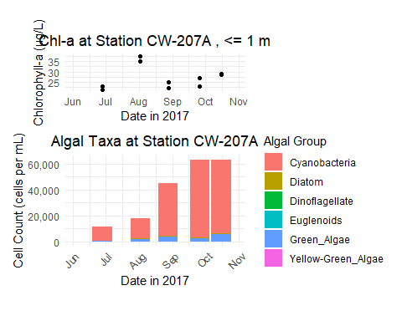

Figure X: CW-207A (Cedar Creek Reservoir) Chlorophyll-a and Algae Density

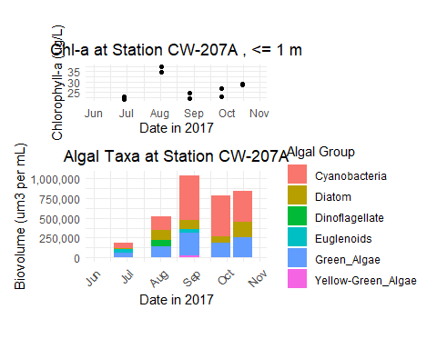

Figure X: CW-207A (Cedar Creek Reservoir) Chlorophyll-a and Algae Biovolume

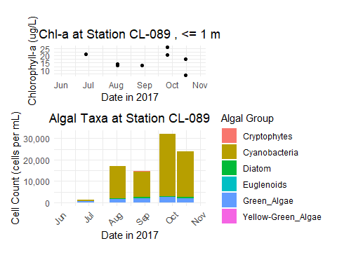

Figure X: CW-089 (Cedar Creek Reservoir) Chlorophyll-a and Algae Density

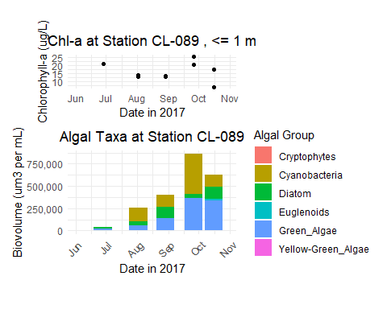

Figure X: CW-089 (Cedar Creek Reservoir) Chlorophyll-a and Algae Biovolume

A strong relationship between chlorophyll-a and cyanobacterial cell counts was not apparent from the relatively few data available (Figure X). No samples exceed the WHO high risk threshold for cyanobacteria density (100,000 counts/mL), although some exceeded the threshold of moderate risk (20,000 cells/mL) These thresholds are indirect measures of the potential for cyanotoxin impacts. The low concentrations of microcystin in Cedar Creek Reservoir (as discussed ion section x.x.x.x) indicates the WHO thresholds may not be useful risk thresholds for this water body.

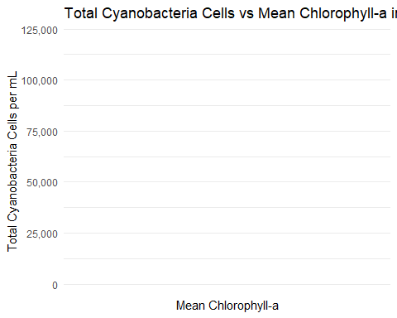

Figure X: Cyanobacteria count vs. chla, Cedar Creek Reservoir

## 4.3 Other Status Indicators

The previous section explored water quality indicators and their relation with chlorophyll-a. Some indicators are less quantitative but still informative regarding the use status of the reservoir. This subsection discusses three such indicators: fishery quality, potable water supply, and aesthetics.

## 4.3.1 Fishery Quality

## 4.3.2 Potable Water Supply

The Town of Camden’s water intake is located in the lower part of Cedar Creek Reservoir. PLACEHOLDER

The Lugoff-Elgin Water Authority’s water intake is also located near the Cedar Creek Reservoir Dam. The water authority increases water treatment (specifically, the addition of powdered activated carbon) on a seasonal basis to reduce taste and odor in the finished water. The need for increased treatment is correlated to temperature, and usually starts around May. Engineering staff report that the T&O issues can be readily addressed by treatment as long as the seasonal pattern is anticipated and treatment starts before it become a problem (pers. comm., Tyler Lind, Asst. Superintendent, 8 July 2024). If T&O issue is allowed to develop, it can take some time to flush the affected water from the distribution system. The water authority reports no other specific issues related to algae in Cedar Creek Reservoir.

## 4.3.3 Reports of Algal Blooms

In addition to routine monitoring for microcystin, SCDES performs sampling associated with algal bloom complaints. The associated database includes five such sampling events for Cedar Creek Reservoir (Table X) between 2019 and 2022. Blooming species were cited as Lyngbya wollei, Trichormus sp., and Phormidium sp. Shallow coves of Cedar Creek Reservoir have been known to host noticeable mats of Lyngbya wollei (or Microseira wollei) since about 2012.