Graphic and Table Examples

Clifton Bell

2024-08-09

This file contains examples of graphics and tables to support the Catawba River reservoir water quality evaluation. I’m sharing to give Tom and Bill a flavor of what we have to work with, which is quite a bit actually. Formatting of these plots can be adjusted as needed, and stations and parameters can easily be swapped out.

I have not written any interpretation yet although a few things do pop out. Overall I conclude that Lake Wateree shows the most signals of potential eutrophication-related use impacts such as high pH, high cyanobacteria, T&O in drinking water, etc. Upon coming back from vacation I plan on starting to write interpretative report sections around these plots.

## Chlorophyll-a Boxplots

These plots help characterize the existing chla conditions in the reservoirs. They only use growing season data from the upper meter of the water column. Only stations with 5 or more data are used. The stations are plotted from upstream to downstream.

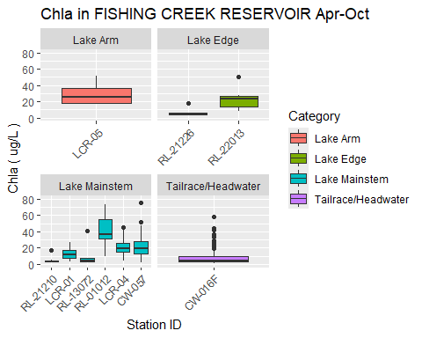

Figure X - Spatial pattern in chl-a in Fishing Creek Reservoir.

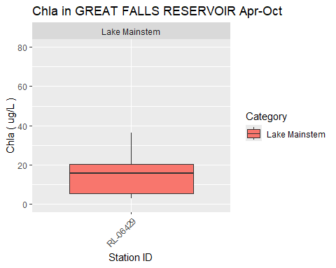

Figure X - Chl-a in Great Falls Reservoir.

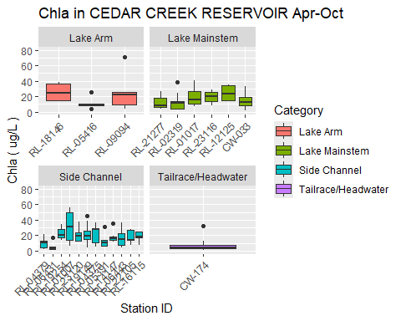

Figure X - Spatial pattern in chl-a in Cedar Creek Reservoir.

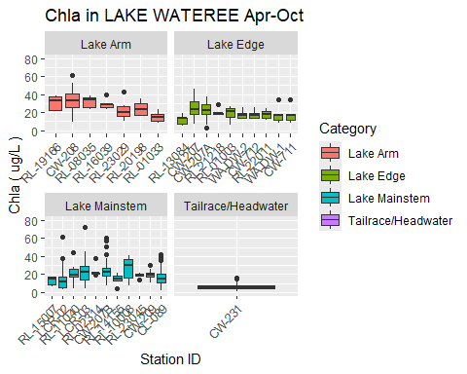

Figure X - Spatial pattern in chl-a in Lake Wateree.

## Chlorophyll Time Series Plots

These plots would be used to infer trends in chla. Major trends are not apparent in the charts. If there is more interest in trends we could perform a seasonal Kendall trend test on selected stations.

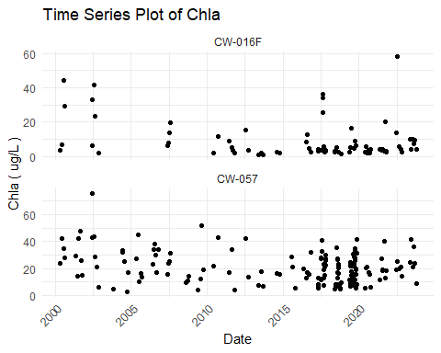

Figure X - Chl-a over time at Fishing Creek Reservoir stations.

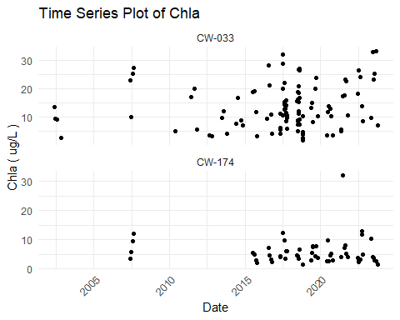

Figure X - Chl-a over time at Fishing Creek Reservoir stations.

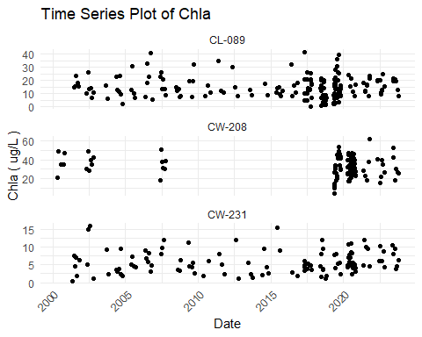

Figure X - Chl-a over time at Fishing Creek Reservoir stations.

## Seasonal Plots for Chlorophyll-a, DO, and pH

These plots display the seasonal pattern in chlorophyll-a, DO, and pH. They only use growing season data from the upper meter of the water column. Only stations with 5 or more data are used.

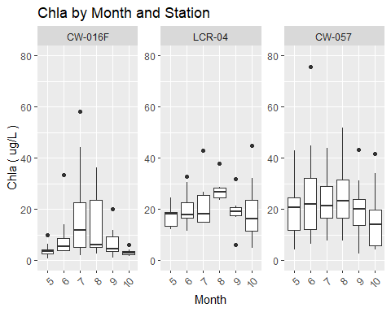

Figure X - Seasonal pattern in chl-a at Fishing Creek Reservoir stations.

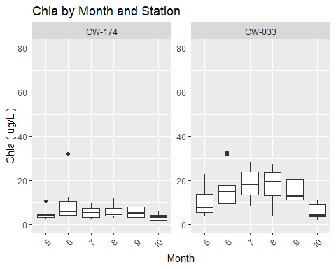

Figure X - Seasonal pattern in chl-a at Cedar Creek Reservoir stations.

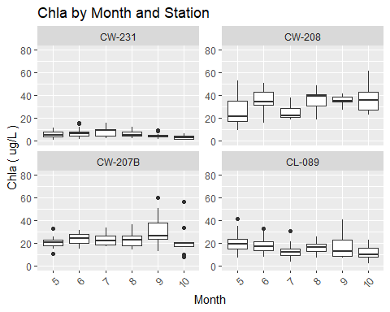

Figure X - Seasonal pattern in chl-a at Lake Wateree Reservoir stations.

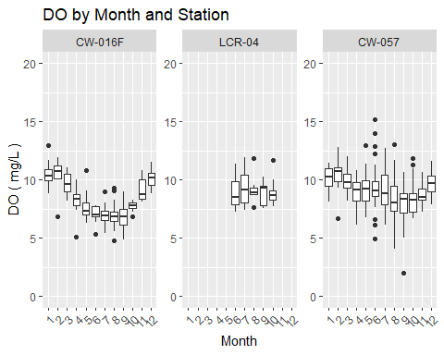

Figure X - Seasonal pattern in DO at Fishing Creek Reservoir stations.

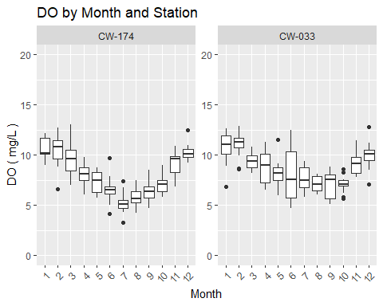

Figure X - Seasonal pattern in DO at Cedar Creek Reservoir stations.

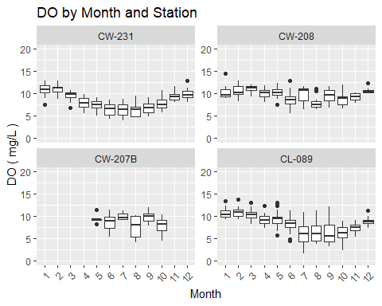

Figure X - Seasonal pattern in DO at Lake Wateree Reservoir stations.

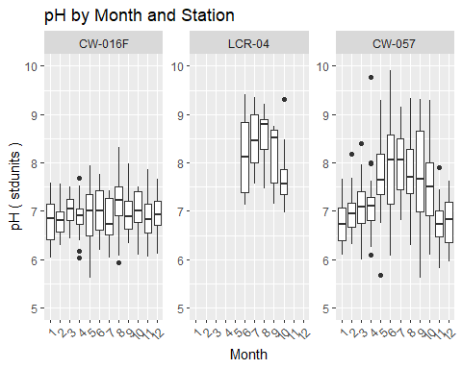

Figure X - Seasonal pattern in pH at Fishing Creek Reservoir stations.

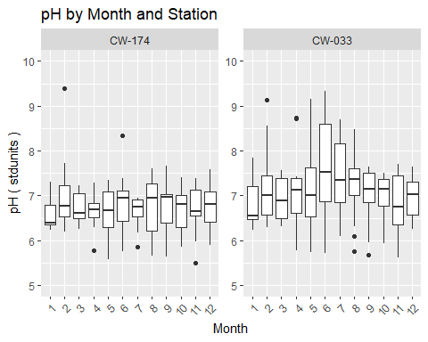

Figure X - Seasonal pattern in pH at Cedar Creek Reservoir stations.

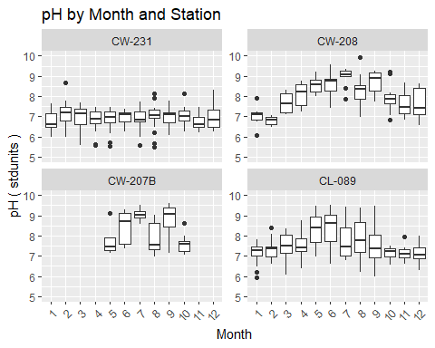

Figure X - Seasonal pattern in pH at Lake Wateree stations.

## Summary Tables for Chlorophyll-a, DO, pH, and Secchi depth

The following tables present summary statistics for chla, DO, pH, and Secchi depth by reservoir and station. The stats are calculated from data from the growing season, <= 1 m depth, and stations with at least five data.

All values in ug/L except Count

|  | **Chla in FISHING CREEK RESERVOIR** | **Chla in FISHING CREEK RESERVOIR** | **Chla in FISHING CREEK RESERVOIR** | **Chla in FISHING CREEK RESERVOIR** | **Chla in FISHING CREEK RESERVOIR** | **Chla in FISHING CREEK RESERVOIR** | **Chla in FISHING CREEK RESERVOIR** | **Chla in FISHING CREEK RESERVOIR** | **Chla in FISHING CREEK RESERVOIR** | **Chla in FISHING CREEK RESERVOIR** |
| --- | --- | --- | --- | --- | --- | --- | --- | --- | --- | --- |
| **StationID** | **Count** | **Max** | **Perc_90th** | **Perc_75th** | **Arith_Mean** | **Geo_Mean** | **Median** | **Perc_25th** | **Perc_10th** | **Min** |
| CW-016F | 80 | 58.2 | 23.8 | 9.4 | 9.1 | 5.7 | 4.3 | 3.2 | 2.2 | 0.8 |
| RL-21226 | 6 | 17.5 | 11.6 | 5.7 | 6.8 | 5.8 | 5.2 | 4.0 | 3.8 | 3.8 |
| RL-21210 | 7 | 16.9 | 9.8 | 4.4 | 5.6 | 4.5 | 3.6 | 3.3 | 3.1 | 3.0 |
| LCR-01 | 12 | 26.8 | 21.2 | 17.3 | 12.9 | 10.9 | 11.4 | 7.6 | 4.4 | 3.6 |
| RL-01012 | 6 | 73.8 | 66.7 | 55.1 | 41.4 | 34.7 | 36.9 | 31.8 | 20.5 | 9.3 |
| RL-22013 | 6 | 50.2 | 38.6 | 26.9 | 23.8 | 20.1 | 22.9 | 13.6 | 9.8 | 8.0 |
| LCR-05 | 12 | 51.7 | 39.9 | 36.4 | 27.8 | 25.8 | 25.9 | 17.6 | 16.9 | 16.7 |
| LCR-04 | 44 | 44.8 | 32.5 | 26.2 | 21.0 | 19.0 | 19.0 | 14.8 | 11.5 | 4.6 |
| CW-057 | 139 | 75.7 | 38.5 | 28.4 | 21.5 | 17.9 | 19.8 | 13.3 | 6.6 | 2.5 |

All values in ug/L except Count

|  | **Chla in GREAT FALLS RESERVOIR** | **Chla in GREAT FALLS RESERVOIR** | **Chla in GREAT FALLS RESERVOIR** | **Chla in GREAT FALLS RESERVOIR** | **Chla in GREAT FALLS RESERVOIR** | **Chla in GREAT FALLS RESERVOIR** | **Chla in GREAT FALLS RESERVOIR** | **Chla in GREAT FALLS RESERVOIR** | **Chla in GREAT FALLS RESERVOIR** | **Chla in GREAT FALLS RESERVOIR** |
| --- | --- | --- | --- | --- | --- | --- | --- | --- | --- | --- |
| **StationID** | **Count** | **Max** | **Perc_90th** | **Perc_75th** | **Arith_Mean** | **Geo_Mean** | **Median** | **Perc_25th** | **Perc_10th** | **Min** |
| RL-06429 | 6 | 36.3 | 28.5 | 20.5 | 15.8 | 11 | 15.7 | 5.5 | 3.2 | 2.8 |

All values in ug/L except Count

|  | **Chla in CEDAR CREEK RESERVOIR** | **Chla in CEDAR CREEK RESERVOIR** | **Chla in CEDAR CREEK RESERVOIR** | **Chla in CEDAR CREEK RESERVOIR** | **Chla in CEDAR CREEK RESERVOIR** | **Chla in CEDAR CREEK RESERVOIR** | **Chla in CEDAR CREEK RESERVOIR** | **Chla in CEDAR CREEK RESERVOIR** | **Chla in CEDAR CREEK RESERVOIR** | **Chla in CEDAR CREEK RESERVOIR** |
| --- | --- | --- | --- | --- | --- | --- | --- | --- | --- | --- |
| **StationID** | **Count** | **Max** | **Perc_90th** | **Perc_75th** | **Arith_Mean** | **Geo_Mean** | **Median** | **Perc_25th** | **Perc_10th** | **Min** |
| RL-04379 | 6 | 21.6 | 17.4 | 12.6 | 10.0 | 7.5 | 10.2 | 4.3 | 2.4 | 2.3 |
| RL-19254 | 6 | 34.4 | 32.3 | 28.2 | 22.5 | 21.3 | 19.9 | 17.0 | 15.2 | 13.7 |
| RL-01007 | 6 | 55.8 | 54.4 | 49.2 | 31.2 | 23.9 | 30.8 | 13.6 | 8.5 | 6.8 |
| RL-23120 | 6 | 37.9 | 30.9 | 23.5 | 20.7 | 19.0 | 19.4 | 13.2 | 11.8 | 11.5 |
| CW-174 | 55 | 32.0 | 10.2 | 7.2 | 5.8 | 4.8 | 4.5 | 3.2 | 2.5 | 1.4 |
| RL-19149 | 13 | 45.7 | 38.3 | 26.2 | 21.7 | 17.6 | 18.9 | 15.5 | 6.1 | 4.1 |
| RL-04375 | 6 | 36.1 | 32.6 | 29.0 | 21.8 | 16.5 | 27.7 | 10.5 | 5.0 | 4.9 |
| RL-14147 | 6 | 36.0 | 27.5 | 18.4 | 18.7 | 17.3 | 16.1 | 13.4 | 12.4 | 12.1 |
| RL-21277 | 8 | 26.2 | 20.5 | 17.9 | 11.7 | 9.4 | 7.8 | 6.5 | 4.2 | 4.0 |
| RL-06443 | 7 | 36.4 | 28.6 | 22.8 | 16.6 | 13.0 | 15.1 | 7.5 | 5.6 | 4.0 |
| RL-02319 | 9 | 38.3 | 27.3 | 13.2 | 12.9 | 9.0 | 11.3 | 4.2 | 3.4 | 2.4 |
| RL-01017 | 6 | 41.0 | 35.1 | 26.4 | 19.6 | 16.3 | 15.2 | 10.2 | 8.5 | 7.4 |
| RL-23116 | 6 | 28.8 | 27.7 | 25.0 | 19.2 | 17.6 | 20.1 | 13.6 | 10.0 | 8.5 |
| CW-033 | 95 | 33.0 | 25.9 | 18.9 | 13.9 | 11.5 | 12.2 | 8.5 | 4.0 | 1.8 |
| RL-18146 | 6 | 38.6 | 38.3 | 36.1 | 25.3 | 23.0 | 24.1 | 15.0 | 13.6 | 13.2 |

All values in ug/L except Count

|  | **Chla in LAKE WATEREE** | **Chla in LAKE WATEREE** | **Chla in LAKE WATEREE** | **Chla in LAKE WATEREE** | **Chla in LAKE WATEREE** | **Chla in LAKE WATEREE** | **Chla in LAKE WATEREE** | **Chla in LAKE WATEREE** | **Chla in LAKE WATEREE** | **Chla in LAKE WATEREE** |
| --- | --- | --- | --- | --- | --- | --- | --- | --- | --- | --- |
| **StationID** | **Count** | **Max** | **Perc_90th** | **Perc_75th** | **Arith_Mean** | **Geo_Mean** | **Median** | **Perc_25th** | **Perc_10th** | **Min** |
| CW-231 | 115 | 15.8 | 10.2 | 7.9 | 5.8 | 4.9 | 4.9 | 3.7 | 2.1 | 0.5 |
| LCR-02 | 54 | 61.0 | 27.1 | 17.4 | 13.4 | 10.3 | 11.3 | 5.8 | 4.1 | 3.0 |
| RL-11040 | 6 | 44.3 | 36.3 | 26.2 | 22.0 | 18.0 | 19.4 | 16.7 | 10.3 | 4.6 |
| RL-19166 | 7 | 38.0 | 37.8 | 37.5 | 30.3 | 29.3 | 33.3 | 22.4 | 21.0 | 20.9 |
| CW-208 | 69 | 61.6 | 45.5 | 40.0 | 32.8 | 31.0 | 32.9 | 25.8 | 18.6 | 9.7 |
| LCR-03 | 39 | 72.3 | 39.3 | 28.9 | 23.2 | 20.0 | 22.1 | 14.0 | 10.1 | 4.6 |
| RL-23029 | 6 | 42.7 | 35.3 | 26.7 | 22.9 | 20.8 | 20.4 | 16.2 | 13.1 | 10.5 |
| CW-207 | 59 | 46.0 | 36.2 | 32.2 | 24.7 | 22.8 | 23.1 | 17.8 | 13.8 | 6.7 |
| CW-207A | 18 | 37.3 | 32.0 | 28.2 | 21.9 | 18.7 | 22.6 | 18.1 | 6.9 | 2.8 |
| CW-207B | 65 | 60.1 | 34.4 | 26.9 | 24.4 | 22.8 | 22.7 | 18.7 | 15.5 | 7.7 |
| RL-14155 | 7 | 21.1 | 21.0 | 17.9 | 14.5 | 13.3 | 14.7 | 12.7 | 9.3 | 4.7 |
| RL-23045 | 6 | 21.1 | 20.9 | 20.5 | 18.7 | 18.5 | 19.2 | 18.0 | 15.9 | 13.9 |
| RL-01003 | 6 | 26.6 | 25.8 | 24.6 | 18.8 | 17.0 | 21.1 | 14.2 | 9.5 | 6.4 |
| CW-209 | 17 | 30.5 | 25.7 | 21.6 | 19.6 | 18.9 | 19.5 | 17.1 | 12.8 | 11.2 |
| RL-01033 | 6 | 23.0 | 21.0 | 18.0 | 14.7 | 13.8 | 14.5 | 10.2 | 8.7 | 8.4 |
| WA-DW-2 | 6 | 25.8 | 23.1 | 19.4 | 17.3 | 16.8 | 16.5 | 13.7 | 12.5 | 12.2 |
| CW-712 | 6 | 25.8 | 23.1 | 19.4 | 17.3 | 16.8 | 16.5 | 13.7 | 12.5 | 12.2 |
| RL-22011 | 6 | 24.2 | 22.9 | 20.9 | 17.5 | 16.8 | 18.0 | 13.5 | 11.6 | 11.0 |
| CL-089 | 143 | 41.5 | 25.5 | 20.1 | 15.9 | 14.3 | 14.7 | 10.5 | 7.9 | 2.4 |
| WA-DW-1 | 6 | 34.0 | 26.1 | 18.0 | 17.3 | 15.5 | 16.8 | 11.8 | 9.0 | 7.8 |
| CW-711 | 6 | 34.0 | 26.1 | 18.0 | 17.3 | 15.5 | 16.8 | 11.8 | 9.0 | 7.8 |

All values in mg/L except Count

|  | **DO in FISHING CREEK RESERVOIR** | **DO in FISHING CREEK RESERVOIR** | **DO in FISHING CREEK RESERVOIR** | **DO in FISHING CREEK RESERVOIR** | **DO in FISHING CREEK RESERVOIR** | **DO in FISHING CREEK RESERVOIR** | **DO in FISHING CREEK RESERVOIR** | **DO in FISHING CREEK RESERVOIR** | **DO in FISHING CREEK RESERVOIR** | **DO in FISHING CREEK RESERVOIR** |
| --- | --- | --- | --- | --- | --- | --- | --- | --- | --- | --- |
| **StationID** | **Count** | **Max** | **Perc_90th** | **Perc_75th** | **Arith_Mean** | **Geo_Mean** | **Median** | **Perc_25th** | **Perc_10th** | **Min** |
| CW-016F | 101 | 10.8 | 8.8 | 8.0 | 7.4 | 7.3 | 7.3 | 6.8 | 6.1 | 4.8 |
| RL-21226 | 7 | 9.0 | 8.6 | 8.0 | 7.2 | 7.2 | 6.8 | 6.5 | 6.2 | 5.8 |
| RL-17071 | 7 | 7.9 | 7.6 | 7.3 | 6.8 | 6.7 | 7.0 | 6.4 | 5.7 | 5.2 |
| RL-21210 | 7 | 8.4 | 8.2 | 8.0 | 7.3 | 7.2 | 7.7 | 6.5 | 6.1 | 5.9 |
| LCR-01 | 11 | 10.1 | 8.8 | 8.5 | 8.2 | 8.1 | 8.0 | 7.7 | 7.4 | 7.2 |
| RL-13072 | 7 | 9.2 | 9.0 | 8.4 | 7.8 | 7.7 | 7.5 | 7.3 | 6.9 | 6.5 |
| RL-01012 | 6 | 12.7 | 11.9 | 11.0 | 9.4 | 9.2 | 9.5 | 7.4 | 6.9 | 6.6 |
| RL-15023 | 7 | 10.2 | 9.0 | 8.1 | 8.0 | 8.0 | 7.7 | 7.4 | 7.3 | 7.3 |
| RL-22013 | 7 | 11.0 | 9.7 | 8.7 | 8.7 | 8.6 | 8.5 | 8.0 | 7.7 | 7.7 |
| LCR-05 | 11 | 11.7 | 10.6 | 9.7 | 8.8 | 8.7 | 8.8 | 7.6 | 6.8 | 6.7 |
| LCR-04 | 42 | 12.0 | 11.1 | 9.6 | 9.0 | 8.9 | 8.9 | 7.9 | 7.5 | 6.6 |
| CW-057 | 168 | 15.2 | 10.9 | 9.7 | 8.8 | 8.6 | 8.6 | 7.6 | 6.7 | 2.0 |

All values in mg/L except Count

|  | **DO in GREAT FALLS RESERVOIR** | **DO in GREAT FALLS RESERVOIR** | **DO in GREAT FALLS RESERVOIR** | **DO in GREAT FALLS RESERVOIR** | **DO in GREAT FALLS RESERVOIR** | **DO in GREAT FALLS RESERVOIR** | **DO in GREAT FALLS RESERVOIR** | **DO in GREAT FALLS RESERVOIR** | **DO in GREAT FALLS RESERVOIR** | **DO in GREAT FALLS RESERVOIR** |
| --- | --- | --- | --- | --- | --- | --- | --- | --- | --- | --- |
| **StationID** | **Count** | **Max** | **Perc_90th** | **Perc_75th** | **Arith_Mean** | **Geo_Mean** | **Median** | **Perc_25th** | **Perc_10th** | **Min** |
| RL-05414 | 6 | 10.6 | 9.4 | 8.1 | 7.1 | 6.9 | 6.8 | 5.9 | 5.2 | 4.5 |
| RL-03332 | 6 | 8.5 | 8.0 | 7.4 | 6.9 | 6.8 | 6.8 | 6.1 | 5.9 | 5.7 |
| RL-03458 | 6 | 8.4 | 8.1 | 7.6 | 6.8 | 6.8 | 6.7 | 6.0 | 5.8 | 5.6 |
| RL-08062 | 7 | 7.0 | 7.0 | 6.7 | 5.8 | 5.8 | 5.7 | 5.3 | 4.8 | 4.2 |
| RL-13134 | 7 | 8.2 | 8.0 | 7.5 | 6.7 | 6.6 | 6.8 | 6.1 | 5.3 | 4.6 |
| RL-03351 | 6 | 8.4 | 8.2 | 7.8 | 6.8 | 6.7 | 6.7 | 5.6 | 5.5 | 5.4 |
| RL-06429 | 14 | 10.8 | 7.9 | 7.0 | 6.4 | 6.3 | 6.3 | 5.4 | 4.8 | 4.4 |
| RL-11117 | 7 | 6.0 | 5.9 | 5.5 | 4.5 | 4.4 | 4.6 | 3.6 | 2.9 | 2.9 |

All values in mg/L except Count

|  | **DO in CEDAR CREEK RESERVOIR** | **DO in CEDAR CREEK RESERVOIR** | **DO in CEDAR CREEK RESERVOIR** | **DO in CEDAR CREEK RESERVOIR** | **DO in CEDAR CREEK RESERVOIR** | **DO in CEDAR CREEK RESERVOIR** | **DO in CEDAR CREEK RESERVOIR** | **DO in CEDAR CREEK RESERVOIR** | **DO in CEDAR CREEK RESERVOIR** | **DO in CEDAR CREEK RESERVOIR** |
| --- | --- | --- | --- | --- | --- | --- | --- | --- | --- | --- |
| **StationID** | **Count** | **Max** | **Perc_90th** | **Perc_75th** | **Arith_Mean** | **Geo_Mean** | **Median** | **Perc_25th** | **Perc_10th** | **Min** |
| RL-04379 | 7 | 12.0 | 10.6 | 9.5 | 8.7 | 8.5 | 8.6 | 7.2 | 7.0 | 6.7 |
| RL-15104 | 7 | 10.4 | 10.0 | 8.7 | 8.2 | 8.1 | 7.6 | 7.5 | 7.4 | 7.3 |
| RL-06431 | 7 | 6.9 | 6.9 | 6.7 | 5.8 | 5.7 | 6.2 | 5.2 | 4.7 | 3.8 |
| RL-10102 | 7 | 11.2 | 10.5 | 9.5 | 8.5 | 8.4 | 7.8 | 7.5 | 7.2 | 6.9 |
| RL-19254 | 7 | 9.9 | 9.7 | 9.1 | 8.8 | 8.8 | 8.6 | 8.4 | 8.3 | 8.1 |
| RL-01007 | 14 | 11.0 | 9.4 | 8.7 | 7.7 | 7.4 | 8.2 | 7.3 | 4.5 | 3.9 |
| CW-174 | 89 | 9.8 | 8.4 | 7.5 | 6.6 | 6.5 | 6.6 | 5.5 | 4.9 | 3.3 |
| RL-19149 | 13 | 11.5 | 11.1 | 9.3 | 9.0 | 9.0 | 8.6 | 8.4 | 8.0 | 7.9 |
| CW-175 | 26 | 9.0 | 7.9 | 6.9 | 6.2 | 6.0 | 6.2 | 5.0 | 4.6 | 3.4 |
| RL-04375 | 7 | 13.3 | 12.5 | 11.3 | 10.0 | 9.8 | 9.6 | 8.3 | 7.6 | 7.6 |
| RL-07003 | 7 | 10.8 | 10.6 | 9.2 | 7.8 | 7.6 | 7.3 | 6.5 | 5.7 | 5.4 |
| RL-05391 | 7 | 11.2 | 10.5 | 9.8 | 8.2 | 7.9 | 7.7 | 6.4 | 6.0 | 5.9 |
| RL-03353 | 7 | 10.6 | 10.2 | 9.5 | 8.3 | 8.1 | 8.0 | 7.6 | 6.5 | 5.2 |
| RL-14147 | 7 | 10.9 | 10.8 | 9.8 | 8.3 | 8.0 | 8.3 | 7.2 | 5.9 | 4.7 |
| RL-08046 | 7 | 7.2 | 7.2 | 7.1 | 6.3 | 6.1 | 6.9 | 5.8 | 4.7 | 4.0 |
| RL-17127 | 7 | 12.1 | 10.9 | 10.1 | 9.5 | 9.3 | 10.0 | 8.6 | 7.6 | 6.9 |
| RL-21277 | 7 | 10.9 | 10.6 | 9.4 | 8.5 | 8.4 | 8.3 | 7.7 | 7.0 | 6.4 |
| RL-06443 | 8 | 10.3 | 8.8 | 7.9 | 7.5 | 7.4 | 7.1 | 6.6 | 6.5 | 6.4 |
| RL-22105 | 6 | 11.8 | 10.4 | 8.9 | 8.9 | 8.8 | 8.5 | 8.2 | 7.8 | 7.4 |
| RL-16115 | 7 | 13.4 | 10.1 | 7.7 | 7.8 | 7.5 | 7.3 | 6.4 | 6.0 | 5.7 |
| RL-02319 | 11 | 9.9 | 8.6 | 7.6 | 7.2 | 7.1 | 6.9 | 6.6 | 6.3 | 5.5 |
| RL-01017 | 6 | 9.3 | 9.2 | 8.9 | 7.2 | 6.9 | 7.8 | 5.6 | 4.5 | 4.0 |
| RL-12125 | 7 | 9.8 | 8.8 | 7.9 | 7.6 | 7.6 | 7.4 | 7.1 | 6.7 | 6.4 |
| CW-033 | 98 | 12.4 | 10.2 | 8.7 | 7.8 | 7.6 | 7.5 | 6.6 | 5.8 | 4.7 |
| RL-18146 | 6 | 10.7 | 9.8 | 8.7 | 7.9 | 7.8 | 7.5 | 6.6 | 6.4 | 6.3 |
| RL-05416 | 7 | 8.5 | 8.0 | 7.6 | 7.0 | 6.9 | 7.1 | 6.2 | 5.8 | 5.8 |
| RL-09094 | 6 | 10.7 | 10.7 | 10.4 | 8.6 | 8.4 | 8.9 | 6.8 | 6.2 | 6.0 |

All values in mg/L except Count

|  | **DO in LAKE WATEREE** | **DO in LAKE WATEREE** | **DO in LAKE WATEREE** | **DO in LAKE WATEREE** | **DO in LAKE WATEREE** | **DO in LAKE WATEREE** | **DO in LAKE WATEREE** | **DO in LAKE WATEREE** | **DO in LAKE WATEREE** | **DO in LAKE WATEREE** |
| --- | --- | --- | --- | --- | --- | --- | --- | --- | --- | --- |
| **StationID** | **Count** | **Max** | **Perc_90th** | **Perc_75th** | **Arith_Mean** | **Geo_Mean** | **Median** | **Perc_25th** | **Perc_10th** | **Min** |
| CW-231 | 149 | 10.8 | 8.8 | 8.0 | 7.0 | 6.8 | 7.0 | 5.8 | 5.0 | 4.0 |
| RL-15007 | 6 | 8.4 | 8.3 | 7.8 | 6.9 | 6.8 | 6.4 | 6.2 | 6.0 | 5.9 |
| LCR-02 | 41 | 10.9 | 9.4 | 8.9 | 8.3 | 8.2 | 8.2 | 7.5 | 7.2 | 6.3 |
| RL-11040 | 7 | 10.9 | 9.1 | 7.8 | 7.3 | 7.1 | 7.2 | 6.2 | 5.3 | 5.0 |
| RL-19166 | 7 | 11.6 | 11.3 | 10.8 | 10.3 | 10.3 | 10.5 | 9.8 | 9.3 | 8.9 |
| CW-208 | 70 | 12.8 | 11.5 | 10.8 | 9.2 | 9.1 | 9.2 | 7.9 | 6.9 | 5.5 |
| RL-12056 | 6 | 10.3 | 9.8 | 9.4 | 8.3 | 8.1 | 9.0 | 7.2 | 6.1 | 5.6 |
| RL-08035 | 7 | 10.6 | 10.2 | 9.4 | 8.3 | 8.2 | 8.6 | 7.0 | 6.6 | 6.6 |
| LCR-03 | 32 | 12.0 | 11.3 | 10.7 | 9.4 | 9.2 | 9.4 | 8.2 | 7.2 | 6.1 |
| RL-16039 | 7 | 13.8 | 11.7 | 9.6 | 8.5 | 8.1 | 8.2 | 6.8 | 5.3 | 4.9 |
| RL-13084 | 7 | 12.0 | 11.9 | 11.2 | 9.3 | 9.1 | 8.5 | 8.2 | 7.3 | 6.0 |
| RL-02314 | 7 | 11.1 | 10.6 | 9.8 | 8.7 | 8.6 | 9.1 | 7.4 | 6.9 | 6.4 |
| RL-17055 | 7 | 11.2 | 10.6 | 9.6 | 9.0 | 9.0 | 8.8 | 8.4 | 7.9 | 7.3 |
| CW-207 | 90 | 13.5 | 10.9 | 10.1 | 8.8 | 8.7 | 8.9 | 7.6 | 6.7 | 5.0 |
| CW-207A | 16 | 11.2 | 10.6 | 10.3 | 9.4 | 9.4 | 8.9 | 8.5 | 8.4 | 8.2 |
| CW-207B | 53 | 12.0 | 11.2 | 10.2 | 8.9 | 8.6 | 9.2 | 8.0 | 5.4 | 4.2 |
| RL-21218 | 6 | 11.8 | 11.6 | 11.0 | 9.5 | 9.3 | 9.3 | 8.7 | 7.5 | 6.4 |
| RL-14155 | 8 | 9.6 | 9.0 | 8.4 | 7.4 | 7.3 | 7.7 | 6.4 | 5.2 | 5.2 |
| RL-03336 | 7 | 10.8 | 10.0 | 9.2 | 8.6 | 8.5 | 8.7 | 7.7 | 7.4 | 7.0 |
| RL-09099 | 6 | 9.9 | 9.6 | 9.2 | 8.2 | 8.2 | 8.4 | 7.1 | 6.8 | 6.7 |
| RL-10008 | 7 | 10.4 | 9.8 | 9.3 | 8.6 | 8.5 | 8.9 | 8.1 | 7.0 | 6.2 |
| RL-01003 | 6 | 10.7 | 10.2 | 9.8 | 8.6 | 8.3 | 9.6 | 7.6 | 6.0 | 5.0 |
| CW-209 | 28 | 11.2 | 10.0 | 8.7 | 7.8 | 7.7 | 7.8 | 6.4 | 5.7 | 4.9 |
| RL-20198 | 7 | 10.7 | 10.2 | 9.7 | 8.8 | 8.8 | 8.7 | 7.8 | 7.6 | 7.5 |
| RL-01033 | 6 | 17.0 | 13.6 | 10.0 | 10.0 | 9.5 | 9.3 | 8.8 | 7.2 | 5.8 |
| RL-22011 | 6 | 11.0 | 9.9 | 8.8 | 7.4 | 7.1 | 7.5 | 5.8 | 4.8 | 4.1 |
| CL-089 | 160 | 13.0 | 10.1 | 9.1 | 7.4 | 7.0 | 7.7 | 5.5 | 4.3 | 1.6 |

All values in stdunits except Count

|  | **pH in FISHING CREEK RESERVOIR** | **pH in FISHING CREEK RESERVOIR** | **pH in FISHING CREEK RESERVOIR** | **pH in FISHING CREEK RESERVOIR** | **pH in FISHING CREEK RESERVOIR** | **pH in FISHING CREEK RESERVOIR** | **pH in FISHING CREEK RESERVOIR** | **pH in FISHING CREEK RESERVOIR** | **pH in FISHING CREEK RESERVOIR** | **pH in FISHING CREEK RESERVOIR** |
| --- | --- | --- | --- | --- | --- | --- | --- | --- | --- | --- |
| **StationID** | **Count** | **Max** | **Perc_90th** | **Perc_75th** | **Arith_Mean** | **Geo_Mean** | **Median** | **Perc_25th** | **Perc_10th** | **Min** |
| CW-016F | 102 | 8.3 | 7.5 | 7.3 | 7.0 | 7.0 | 7.0 | 6.6 | 6.3 | 5.6 |
| RL-21226 | 7 | 7.1 | 7.1 | 7.0 | 6.9 | 6.9 | 6.9 | 6.8 | 6.7 | 6.6 |
| RL-17071 | 7 | 7.6 | 7.2 | 6.9 | 6.5 | 6.5 | 6.3 | 6.0 | 5.8 | 5.6 |
| RL-21210 | 7 | 7.5 | 7.4 | 7.2 | 7.0 | 7.0 | 7.0 | 6.9 | 6.8 | 6.7 |
| LCR-01 | 11 | 8.7 | 8.2 | 8.1 | 7.8 | 7.8 | 7.8 | 7.5 | 7.4 | 6.8 |
| RL-13072 | 7 | 7.8 | 7.6 | 7.1 | 6.8 | 6.8 | 6.5 | 6.5 | 6.3 | 6.1 |
| RL-01012 | 6 | 9.0 | 8.7 | 8.1 | 7.6 | 7.5 | 7.3 | 7.0 | 6.7 | 6.4 |
| RL-15023 | 7 | 7.7 | 7.4 | 6.8 | 6.5 | 6.5 | 6.3 | 6.2 | 5.9 | 5.7 |
| RL-22013 | 7 | 9.3 | 8.9 | 8.5 | 8.0 | 8.0 | 7.5 | 7.4 | 7.3 | 7.3 |
| LCR-05 | 11 | 9.4 | 9.1 | 8.9 | 8.5 | 8.5 | 8.5 | 8.4 | 7.4 | 7.3 |
| LCR-04 | 43 | 9.4 | 9.2 | 8.8 | 8.1 | 8.0 | 8.1 | 7.5 | 7.1 | 6.7 |
| CW-057 | 169 | 9.9 | 9.1 | 8.3 | 7.7 | 7.6 | 7.6 | 7.0 | 6.6 | 5.6 |

All values in stdunits except Count

|  | **pH in GREAT FALLS RESERVOIR** | **pH in GREAT FALLS RESERVOIR** | **pH in GREAT FALLS RESERVOIR** | **pH in GREAT FALLS RESERVOIR** | **pH in GREAT FALLS RESERVOIR** | **pH in GREAT FALLS RESERVOIR** | **pH in GREAT FALLS RESERVOIR** | **pH in GREAT FALLS RESERVOIR** | **pH in GREAT FALLS RESERVOIR** | **pH in GREAT FALLS RESERVOIR** |
| --- | --- | --- | --- | --- | --- | --- | --- | --- | --- | --- |
| **StationID** | **Count** | **Max** | **Perc_90th** | **Perc_75th** | **Arith_Mean** | **Geo_Mean** | **Median** | **Perc_25th** | **Perc_10th** | **Min** |
| RL-05414 | 6 | 8.1 | 7.6 | 7.2 | 7.2 | 7.2 | 7.1 | 7.0 | 6.9 | 6.9 |
| RL-03332 | 6 | 6.9 | 6.8 | 6.7 | 6.6 | 6.6 | 6.7 | 6.5 | 6.3 | 6.2 |
| RL-03458 | 6 | 6.8 | 6.8 | 6.8 | 6.6 | 6.6 | 6.8 | 6.5 | 6.3 | 6.2 |
| RL-08062 | 7 | 7.2 | 7.1 | 7.1 | 6.9 | 6.9 | 7.1 | 6.8 | 6.5 | 6.4 |
| RL-13134 | 7 | 7.4 | 7.2 | 6.6 | 6.3 | 6.3 | 6.1 | 5.9 | 5.8 | 5.8 |
| RL-03351 | 6 | 7.0 | 6.9 | 6.9 | 6.7 | 6.7 | 6.8 | 6.5 | 6.3 | 6.3 |
| RL-06429 | 14 | 8.6 | 7.3 | 7.3 | 7.2 | 7.2 | 7.2 | 7.1 | 6.7 | 6.6 |
| RL-11117 | 7 | 6.7 | 6.7 | 6.7 | 6.6 | 6.6 | 6.5 | 6.5 | 6.4 | 6.3 |

All values in stdunits except Count

|  | **pH in CEDAR CREEK RESERVOIR** | **pH in CEDAR CREEK RESERVOIR** | **pH in CEDAR CREEK RESERVOIR** | **pH in CEDAR CREEK RESERVOIR** | **pH in CEDAR CREEK RESERVOIR** | **pH in CEDAR CREEK RESERVOIR** | **pH in CEDAR CREEK RESERVOIR** | **pH in CEDAR CREEK RESERVOIR** | **pH in CEDAR CREEK RESERVOIR** | **pH in CEDAR CREEK RESERVOIR** |
| --- | --- | --- | --- | --- | --- | --- | --- | --- | --- | --- |
| **StationID** | **Count** | **Max** | **Perc_90th** | **Perc_75th** | **Arith_Mean** | **Geo_Mean** | **Median** | **Perc_25th** | **Perc_10th** | **Min** |
| RL-04379 | 7 | 8.1 | 7.7 | 7.5 | 7.1 | 7.1 | 7.2 | 6.7 | 6.3 | 6.0 |
| RL-15104 | 7 | 7.7 | 7.4 | 6.9 | 6.5 | 6.5 | 6.5 | 6.1 | 5.8 | 5.6 |
| RL-06431 | 7 | 7.5 | 7.4 | 7.2 | 7.2 | 7.1 | 7.1 | 7.0 | 7.0 | 6.9 |
| RL-10102 | 7 | 8.2 | 8.2 | 7.8 | 6.9 | 6.7 | 7.1 | 7.0 | 5.6 | 3.5 |
| RL-19254 | 7 | 8.1 | 8.1 | 8.1 | 7.7 | 7.6 | 7.5 | 7.4 | 7.3 | 7.2 |
| RL-01007 | 14 | 8.5 | 8.2 | 7.5 | 7.3 | 7.2 | 7.2 | 6.8 | 6.6 | 6.5 |
| CW-174 | 90 | 8.3 | 7.3 | 7.1 | 6.7 | 6.7 | 6.8 | 6.3 | 5.9 | 5.6 |
| RL-19149 | 14 | 9.4 | 8.5 | 8.3 | 7.8 | 7.8 | 7.9 | 7.3 | 6.8 | 6.5 |
| CW-175 | 26 | 7.3 | 7.2 | 7.1 | 6.9 | 6.9 | 6.9 | 6.7 | 6.5 | 6.2 |
| RL-04375 | 7 | 8.7 | 8.4 | 8.2 | 7.5 | 7.5 | 7.7 | 6.9 | 6.3 | 6.2 |
| RL-07003 | 7 | 9.1 | 8.8 | 8.6 | 8.0 | 8.0 | 8.4 | 7.1 | 7.0 | 6.9 |
| RL-05391 | 7 | 9.1 | 8.6 | 7.6 | 7.4 | 7.3 | 7.0 | 6.9 | 6.7 | 6.5 |
| RL-03353 | 7 | 7.5 | 7.3 | 7.0 | 6.9 | 6.9 | 7.0 | 6.8 | 6.4 | 6.0 |
| RL-14147 | 7 | 8.9 | 8.4 | 8.1 | 7.9 | 7.9 | 7.8 | 7.6 | 7.3 | 7.1 |
| RL-08046 | 7 | 7.4 | 7.2 | 7.1 | 6.8 | 6.8 | 6.9 | 6.7 | 6.4 | 5.9 |
| RL-17127 | 7 | 9.1 | 9.0 | 8.5 | 7.8 | 7.8 | 7.4 | 7.1 | 7.0 | 7.0 |
| RL-21277 | 7 | 8.8 | 8.5 | 7.6 | 7.3 | 7.3 | 7.0 | 6.9 | 6.7 | 6.6 |
| RL-06443 | 8 | 8.6 | 8.5 | 8.5 | 7.8 | 7.8 | 7.8 | 7.3 | 7.1 | 7.1 |
| RL-22105 | 6 | 9.1 | 8.7 | 8.3 | 8.0 | 8.0 | 8.0 | 7.6 | 7.5 | 7.3 |
| RL-16115 | 7 | 8.9 | 8.1 | 7.2 | 7.0 | 6.9 | 6.6 | 6.3 | 6.2 | 6.2 |
| RL-02319 | 12 | 8.0 | 7.5 | 7.3 | 7.0 | 7.0 | 7.0 | 6.7 | 6.5 | 6.5 |
| RL-01017 | 6 | 7.4 | 7.3 | 7.2 | 6.9 | 6.9 | 6.9 | 6.7 | 6.6 | 6.5 |
| RL-12125 | 7 | 8.4 | 8.1 | 7.8 | 7.7 | 7.7 | 7.6 | 7.4 | 7.4 | 7.4 |
| CW-033 | 99 | 9.3 | 8.4 | 7.6 | 7.2 | 7.2 | 7.2 | 6.7 | 6.1 | 5.7 |
| RL-18146 | 6 | 7.3 | 7.1 | 6.9 | 6.7 | 6.6 | 6.6 | 6.3 | 6.2 | 6.2 |
| RL-05416 | 7 | 7.2 | 7.2 | 7.2 | 6.9 | 6.9 | 7.0 | 6.8 | 6.5 | 6.3 |
| RL-09094 | 6 | 8.3 | 8.3 | 8.1 | 7.6 | 7.6 | 7.6 | 7.1 | 6.9 | 6.9 |

All values in stdunits except Count

|  | **pH in LAKE WATEREE** | **pH in LAKE WATEREE** | **pH in LAKE WATEREE** | **pH in LAKE WATEREE** | **pH in LAKE WATEREE** | **pH in LAKE WATEREE** | **pH in LAKE WATEREE** | **pH in LAKE WATEREE** | **pH in LAKE WATEREE** | **pH in LAKE WATEREE** |
| --- | --- | --- | --- | --- | --- | --- | --- | --- | --- | --- |
| **StationID** | **Count** | **Max** | **Perc_90th** | **Perc_75th** | **Arith_Mean** | **Geo_Mean** | **Median** | **Perc_25th** | **Perc_10th** | **Min** |
| CW-231 | 149 | 8.1 | 7.4 | 7.2 | 6.9 | 6.9 | 7.0 | 6.7 | 6.3 | 5.5 |
| RL-15007 | 6 | 7.6 | 7.5 | 7.5 | 7.3 | 7.3 | 7.3 | 7.2 | 7.1 | 7.1 |
| LCR-02 | 42 | 8.6 | 7.9 | 7.7 | 7.5 | 7.5 | 7.4 | 7.2 | 7.0 | 6.8 |
| RL-11040 | 7 | 8.8 | 8.4 | 7.9 | 7.5 | 7.5 | 7.3 | 7.0 | 6.7 | 6.5 |
| RL-19166 | 7 | 9.2 | 9.1 | 9.1 | 8.7 | 8.6 | 8.8 | 8.4 | 8.1 | 7.7 |
| CW-208 | 69 | 9.9 | 9.2 | 9.0 | 8.4 | 8.4 | 8.5 | 7.9 | 7.5 | 6.9 |
| RL-12056 | 6 | 8.6 | 8.5 | 8.4 | 8.2 | 8.2 | 8.2 | 8.1 | 7.8 | 7.6 |
| RL-08035 | 7 | 9.1 | 9.0 | 8.7 | 8.2 | 8.2 | 8.2 | 7.7 | 7.5 | 7.2 |
| LCR-03 | 32 | 9.6 | 9.2 | 9.0 | 8.2 | 8.1 | 8.3 | 7.4 | 7.2 | 7.0 |
| RL-16039 | 7 | 8.9 | 8.8 | 8.5 | 7.9 | 7.9 | 7.9 | 7.3 | 7.1 | 6.8 |
| RL-13084 | 7 | 9.0 | 9.0 | 9.0 | 8.2 | 8.2 | 8.8 | 7.6 | 7.2 | 6.8 |
| RL-02314 | 7 | 9.0 | 8.9 | 8.7 | 8.2 | 8.1 | 8.2 | 7.8 | 7.4 | 6.8 |
| RL-17055 | 6 | 8.5 | 8.5 | 8.4 | 7.9 | 7.9 | 7.9 | 7.5 | 7.4 | 7.4 |
| CW-207 | 88 | 9.5 | 9.1 | 8.9 | 8.2 | 8.2 | 8.2 | 7.6 | 7.3 | 5.7 |
| CW-207A | 16 | 9.6 | 9.5 | 9.1 | 8.7 | 8.7 | 8.8 | 8.6 | 7.6 | 7.4 |
| CW-207B | 53 | 9.6 | 9.2 | 9.0 | 8.2 | 8.2 | 8.0 | 7.4 | 7.2 | 7.0 |
| RL-21218 | 6 | 9.1 | 9.1 | 9.0 | 8.4 | 8.4 | 8.8 | 8.1 | 7.5 | 7.0 |
| RL-14155 | 8 | 9.3 | 8.7 | 8.0 | 7.7 | 7.6 | 7.6 | 7.4 | 6.9 | 6.0 |
| RL-03336 | 7 | 8.6 | 8.5 | 8.5 | 7.9 | 7.9 | 8.0 | 7.3 | 7.2 | 7.2 |
| RL-09099 | 6 | 9.5 | 9.1 | 8.6 | 7.9 | 7.9 | 7.7 | 7.3 | 7.0 | 6.7 |
| RL-10008 | 7 | 8.9 | 8.7 | 8.5 | 8.2 | 8.2 | 8.2 | 7.8 | 7.7 | 7.5 |
| RL-01003 | 6 | 7.4 | 7.2 | 7.1 | 7.0 | 6.9 | 7.0 | 6.8 | 6.6 | 6.5 |
| CW-209 | 27 | 9.4 | 8.8 | 8.6 | 8.2 | 8.1 | 8.3 | 7.7 | 7.3 | 6.8 |
| RL-20198 | 7 | 9.5 | 8.8 | 8.2 | 7.9 | 7.8 | 7.6 | 7.3 | 7.1 | 7.0 |
| RL-01033 | 6 | 7.4 | 7.3 | 7.2 | 7.0 | 6.9 | 7.0 | 6.7 | 6.6 | 6.5 |
| RL-22011 | 7 | 9.0 | 8.6 | 8.1 | 7.8 | 7.7 | 7.5 | 7.2 | 7.1 | 7.1 |
| CL-089 | 160 | 9.5 | 9.1 | 8.6 | 7.8 | 7.8 | 7.6 | 7.2 | 6.9 | 6.0 |

All values in m except Count

|  | **Secchi in FISHING CREEK RESERVOIR** | **Secchi in FISHING CREEK RESERVOIR** | **Secchi in FISHING CREEK RESERVOIR** | **Secchi in FISHING CREEK RESERVOIR** | **Secchi in FISHING CREEK RESERVOIR** | **Secchi in FISHING CREEK RESERVOIR** | **Secchi in FISHING CREEK RESERVOIR** | **Secchi in FISHING CREEK RESERVOIR** | **Secchi in FISHING CREEK RESERVOIR** | **Secchi in FISHING CREEK RESERVOIR** |
| --- | --- | --- | --- | --- | --- | --- | --- | --- | --- | --- |
| **StationID** | **Count** | **Max** | **Perc_90th** | **Perc_75th** | **Arith_Mean** | **Geo_Mean** | **Median** | **Perc_25th** | **Perc_10th** | **Min** |
| CW-016F | 41 | 2.0 | 1.2 | 1.0 | 0.7 | 0.6 | 0.6 | 0.4 | 0.3 | 0.0 |
| RL-21226 | 7 | 0.9 | 0.9 | 0.7 | 0.6 | 0.5 | 0.5 | 0.5 | 0.4 | 0.3 |
| RL-21210 | 7 | 0.9 | 0.9 | 0.9 | 0.7 | 0.6 | 0.7 | 0.4 | 0.4 | 0.4 |
| LCR-01 | 11 | 0.8 | 0.7 | 0.6 | 0.6 | 0.6 | 0.6 | 0.5 | 0.5 | 0.3 |
| RL-22013 | 6 | 0.9 | 0.9 | 0.8 | 0.7 | 0.6 | 0.6 | 0.5 | 0.4 | 0.4 |
| LCR-05 | 11 | 0.9 | 0.8 | 0.8 | 0.7 | 0.6 | 0.7 | 0.6 | 0.4 | 0.3 |
| LCR-04 | 38 | 1.8 | 0.9 | 0.9 | 0.7 | 0.7 | 0.7 | 0.6 | 0.5 | 0.3 |
| CW-057 | 53 | 2.0 | 1.1 | 0.9 | 0.8 | 0.7 | 0.7 | 0.5 | 0.4 | 0.2 |

## Warning: There were 2 warnings in `summarise()`.  
## The first warning was:  
## ℹ In argument: `Max = round(max(Secchi, na.rm = TRUE), 1)`.  
## Caused by warning in `max()`:  
## ! no non-missing arguments to max; returning -Inf  
## ℹ Run `dplyr::last_dplyr_warnings()` to see the 1 remaining warning.

All values in m except Count

|  | **Secchi in GREAT FALLS RESERVOIR** | **Secchi in GREAT FALLS RESERVOIR** | **Secchi in GREAT FALLS RESERVOIR** | **Secchi in GREAT FALLS RESERVOIR** | **Secchi in GREAT FALLS RESERVOIR** | **Secchi in GREAT FALLS RESERVOIR** | **Secchi in GREAT FALLS RESERVOIR** | **Secchi in GREAT FALLS RESERVOIR** | **Secchi in GREAT FALLS RESERVOIR** | **Secchi in GREAT FALLS RESERVOIR** |
| --- | --- | --- | --- | --- | --- | --- | --- | --- | --- | --- |
| **StationID** | **Count** | **Max** | **Perc_90th** | **Perc_75th** | **Arith_Mean** | **Geo_Mean** | **Median** | **Perc_25th** | **Perc_10th** | **Min** |

All values in m except Count

|  | **Secchi in CEDAR CREEK RESERVOIR** | **Secchi in CEDAR CREEK RESERVOIR** | **Secchi in CEDAR CREEK RESERVOIR** | **Secchi in CEDAR CREEK RESERVOIR** | **Secchi in CEDAR CREEK RESERVOIR** | **Secchi in CEDAR CREEK RESERVOIR** | **Secchi in CEDAR CREEK RESERVOIR** | **Secchi in CEDAR CREEK RESERVOIR** | **Secchi in CEDAR CREEK RESERVOIR** | **Secchi in CEDAR CREEK RESERVOIR** |
| --- | --- | --- | --- | --- | --- | --- | --- | --- | --- | --- |
| **StationID** | **Count** | **Max** | **Perc_90th** | **Perc_75th** | **Arith_Mean** | **Geo_Mean** | **Median** | **Perc_25th** | **Perc_10th** | **Min** |
| CW-174 | 40 | 1.0 | 0.8 | 0.7 | 0.6 | 0.5 | 0.6 | 0.4 | 0.3 | 0.2 |
| RL-19149 | 11 | 1.8 | 1.5 | 1.1 | 0.8 | 0.6 | 0.7 | 0.4 | 0.4 | 0.1 |
| RL-02319 | 6 | 1.8 | 1.1 | 0.5 | 0.6 | 0.5 | 0.4 | 0.3 | 0.2 | 0.2 |
| CW-033 | 47 | 2.0 | 1.0 | 0.9 | 0.7 | 0.6 | 0.7 | 0.5 | 0.3 | 0.2 |

All values in m except Count

|  | **Secchi in LAKE WATEREE** | **Secchi in LAKE WATEREE** | **Secchi in LAKE WATEREE** | **Secchi in LAKE WATEREE** | **Secchi in LAKE WATEREE** | **Secchi in LAKE WATEREE** | **Secchi in LAKE WATEREE** | **Secchi in LAKE WATEREE** | **Secchi in LAKE WATEREE** | **Secchi in LAKE WATEREE** |
| --- | --- | --- | --- | --- | --- | --- | --- | --- | --- | --- |
| **StationID** | **Count** | **Max** | **Perc_90th** | **Perc_75th** | **Arith_Mean** | **Geo_Mean** | **Median** | **Perc_25th** | **Perc_10th** | **Min** |
| CW-231 | 51 | 1.8 | 1.0 | 0.9 | 0.7 | 0.6 | 0.6 | 0.5 | 0.3 | 0.2 |
| LCR-02 | 37 | 0.8 | 0.7 | 0.5 | 0.5 | 0.5 | 0.5 | 0.4 | 0.3 | 0.2 |
| CW-208 | 37 | 1.5 | 0.7 | 0.7 | 0.6 | 0.6 | 0.6 | 0.5 | 0.4 | 0.2 |
| LCR-03 | 27 | 1.0 | 0.9 | 0.8 | 0.6 | 0.6 | 0.6 | 0.5 | 0.4 | 0.2 |
| RL-17055 | 7 | 0.8 | 0.8 | 0.8 | 0.6 | 0.6 | 0.5 | 0.5 | 0.5 | 0.4 |
| CW-207 | 36 | 1.3 | 1.0 | 0.8 | 0.7 | 0.7 | 0.8 | 0.5 | 0.4 | 0.2 |
| CW-207A | 9 | 1.1 | 0.9 | 0.9 | 0.8 | 0.8 | 0.8 | 0.8 | 0.7 | 0.7 |
| CW-207B | 42 | 1.0 | 1.0 | 0.9 | 0.8 | 0.7 | 0.8 | 0.6 | 0.5 | 0.2 |
| RL-22011 | 7 | 1.5 | 1.4 | 1.2 | 0.9 | 0.9 | 0.9 | 0.6 | 0.5 | 0.4 |
| CL-089 | 62 | 2.1 | 1.5 | 1.2 | 1.1 | 1.0 | 1.0 | 1.0 | 0.8 | 0.2 |

## Scatterplots of DO and pH vs Chlorophyll-a

The following plots help explore the relation between DO and pH and chlorophyll-a. The regression lines can be turned off. The plots only use data <= 1 m.

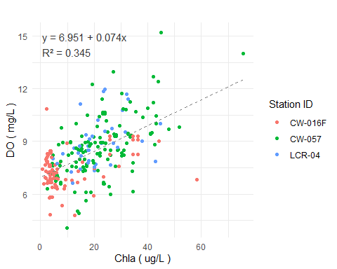

Figure X - DO vs chla at Fishing Creek Reservoir stations.

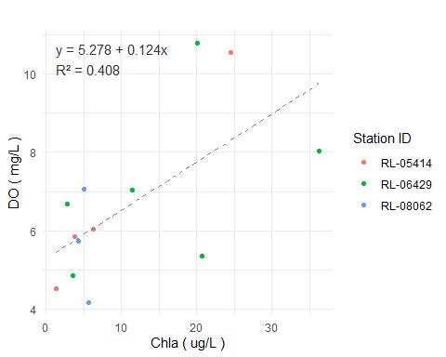

Figure X - DO vs chla at Great Falls Reservoir stations.

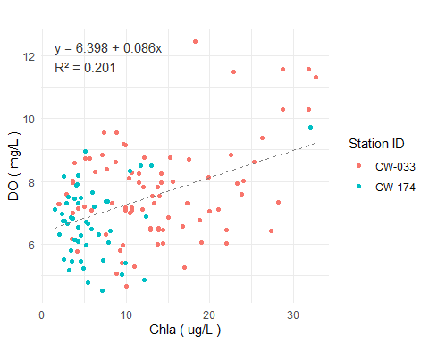

Figure X - DO vs chla at Cedar Creek Reservoir stations.

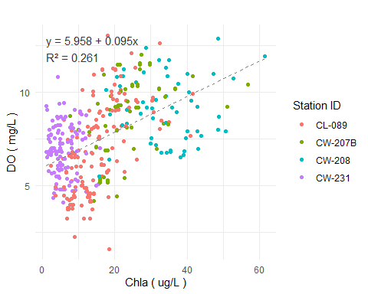

Figure X - DO vs chla at Lake Wateree Reservoir stations.

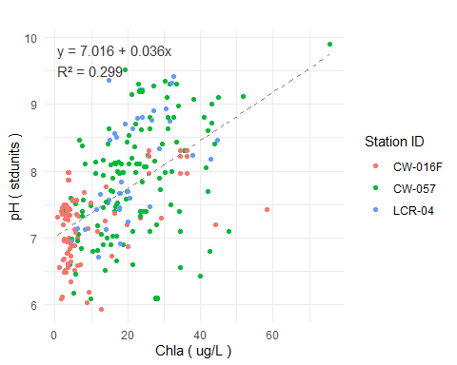

Figure X - pH vs chla at Fishing Creek Reservoir stations.

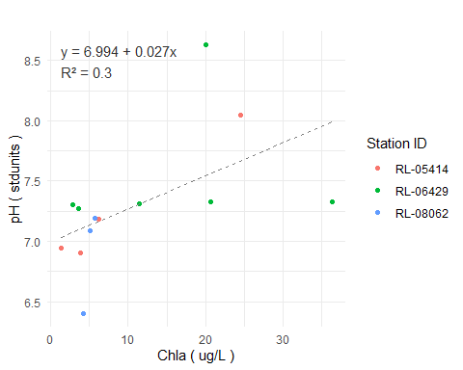

Figure X - pH vs chla at Great Falls Reservoir stations.

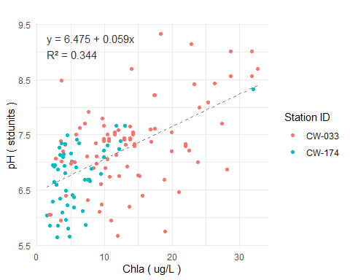 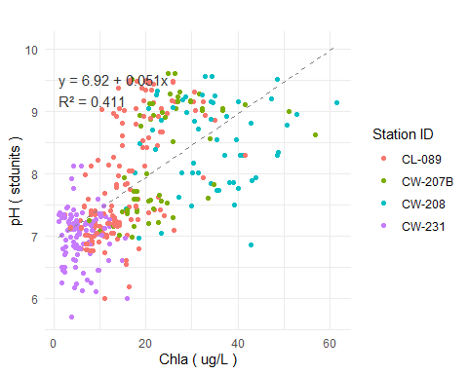

## Scatterplots of DO vs Depth

Our report might not say anything about DO at depth, but these plots provide some information on that topic.

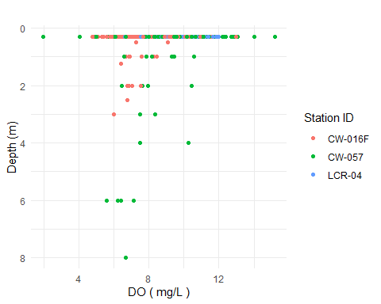

Figure X - DO vs depth at Fishing Creek Reservoir stations.

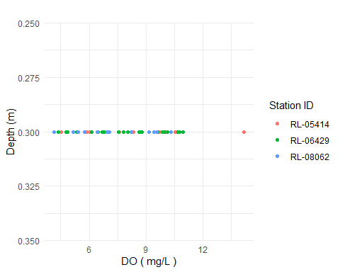

Figure X - DO vs depth at Great Falls Reservoir stations.

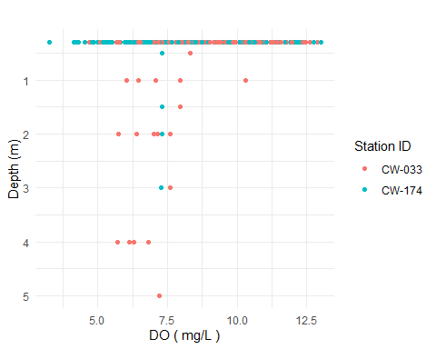

Figure X - DO vs depth at Cedar Creek Reservoir stations.

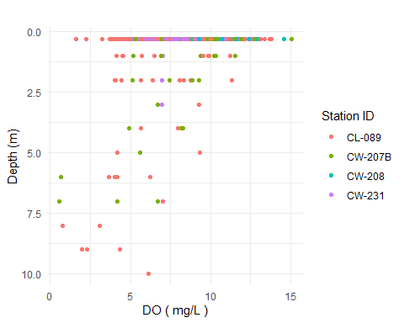

Figure X - DO vs depth at Lake Wateree stations.

## DO and pH Exceedance Tables

These tables are intended to help interpret if the stations/reservoirs have excessive DO (<5) or pH (> 8.5) violations. They only use data <= 1 m depth and stations with at least five data.

|  | **DO in FISHING CREEK RESERVOIR Threshold = 5.0 mg/L** | | |
| --- | --- | --- | --- |
| **StationID** | **Count** | **Below_Threshold_Count** | **Percentage_Below** |
| CW-016F | 172 | 2 | 1.2 |
| RL-21226 | 13 | 0 | 0.0 |
| RL-17071 | 12 | 0 | 0.0 |
| RL-21210 | 13 | 0 | 0.0 |
| LCR-01 | 11 | 0 | 0.0 |
| RL-13072 | 12 | 0 | 0.0 |
| RL-01012 | 10 | 0 | 0.0 |
| RL-15023 | 12 | 0 | 0.0 |
| RL-22013 | 12 | 0 | 0.0 |
| LCR-05 | 11 | 0 | 0.0 |
| LCR-04 | 58 | 0 | 0.0 |
| CW-057 | 275 | 3 | 1.1 |

|  | **DO in GREAT FALLS RESERVOIR Threshold = 5.0 mg/L** | | |
| --- | --- | --- | --- |
| **StationID** | **Count** | **Below_Threshold_Count** | **Percentage_Below** |
| RL-19258 | 9 | 0 | 0.0 |
| RL-05414 | 11 | 1 | 9.1 |
| RL-03332 | 10 | 0 | 0.0 |
| RL-03458 | 10 | 0 | 0.0 |
| RL-11119 | 6 | 0 | 0.0 |
| RL-08062 | 12 | 1 | 8.3 |
| RL-15108 | 6 | 0 | 0.0 |
| RL-13134 | 12 | 1 | 8.3 |
| RL-03351 | 10 | 1 | 10.0 |
| RL-06429 | 24 | 3 | 12.5 |
| RL-11117 | 12 | 4 | 33.3 |

|  | **DO in CEDAR CREEK RESERVOIR Threshold = 5.0 mg/L** | | |
| --- | --- | --- | --- |
| **StationID** | **Count** | **Below_Threshold_Count** | **Percentage_Below** |
| RL-04379 | 11 | 0 | 0.0 |
| RL-15104 | 12 | 0 | 0.0 |
| RL-06431 | 12 | 1 | 8.3 |
| RL-10102 | 11 | 0 | 0.0 |
| RL-19254 | 12 | 0 | 0.0 |
| RL-01007 | 24 | 3 | 12.5 |
| CW-174 | 142 | 10 | 7.0 |
| RL-19149 | 23 | 0 | 0.0 |
| CW-175 | 37 | 6 | 16.2 |
| RL-04375 | 11 | 0 | 0.0 |
| RL-07003 | 10 | 0 | 0.0 |
| RL-05391 | 12 | 0 | 0.0 |
| RL-03353 | 11 | 0 | 0.0 |
| RL-14147 | 12 | 1 | 8.3 |
| RL-08046 | 13 | 1 | 7.7 |
| RL-17127 | 12 | 0 | 0.0 |
| RL-21277 | 12 | 0 | 0.0 |
| RL-06443 | 12 | 0 | 0.0 |
| RL-02452 | 10 | 0 | 0.0 |
| RL-22105 | 11 | 0 | 0.0 |
| RL-16115 | 12 | 0 | 0.0 |
| RL-02319 | 21 | 0 | 0.0 |
| RL-01017 | 11 | 1 | 9.1 |
| RL-12125 | 12 | 0 | 0.0 |
| CW-033 | 160 | 1 | 0.6 |
| RL-18146 | 11 | 0 | 0.0 |
| RL-05416 | 12 | 0 | 0.0 |
| RL-09094 | 10 | 0 | 0.0 |

|  | **DO in LAKE WATEREE Threshold = 5.0 mg/L** | | |
| --- | --- | --- | --- |
| **StationID** | **Count** | **Below_Threshold_Count** | **Percentage_Below** |
| CW-231 | 228 | 15 | 6.6 |
| RL-15007 | 10 | 0 | 0.0 |
| LCR-02 | 56 | 0 | 0.0 |
| RL-11040 | 12 | 0 | 0.0 |
| RL-19166 | 12 | 0 | 0.0 |
| RL-18083 | 10 | 0 | 0.0 |
| CW-208 | 106 | 0 | 0.0 |
| RL-12056 | 11 | 0 | 0.0 |
| RL-08035 | 12 | 0 | 0.0 |
| LCR-03 | 40 | 0 | 0.0 |
| RL-16039 | 12 | 1 | 8.3 |
| RL-23029 | 6 | 0 | 0.0 |
| RL-13084 | 11 | 0 | 0.0 |
| RL-02314 | 12 | 0 | 0.0 |
| RL-17055 | 11 | 0 | 0.0 |
| CW-207 | 155 | 1 | 0.6 |
| CW-207A | 16 | 0 | 0.0 |
| CW-207B | 69 | 2 | 2.9 |
| RL-21218 | 10 | 0 | 0.0 |
| RL-14155 | 13 | 0 | 0.0 |
| RL-03336 | 12 | 0 | 0.0 |
| RL-09099 | 10 | 0 | 0.0 |
| RL-10008 | 12 | 0 | 0.0 |
| RL-23045 | 6 | 0 | 0.0 |
| RL-01003 | 11 | 0 | 0.0 |
| CW-209 | 48 | 1 | 2.1 |
| RL-20198 | 11 | 0 | 0.0 |
| RL-01033 | 11 | 0 | 0.0 |
| RL-22011 | 11 | 1 | 9.1 |
| CL-089 | 253 | 34 | 13.4 |

## Warning in set_formatter_type(., fmt_double = function(x) sprintf("%.1f", : Use  
## `colformat_*()` instead.

|  | **pH in FISHING CREEK RESERVOIR Threshold = 8.5 stdunits** | | |
| --- | --- | --- | --- |
| **StationID** | **Count** | **Above_Threshold_Count** | **Percentage_Above** |
| CW-016F | 173 | 0 | 0.0 |
| RL-21226 | 13 | 0 | 0.0 |
| RL-17071 | 12 | 0 | 0.0 |
| RL-21210 | 13 | 0 | 0.0 |
| LCR-01 | 11 | 1 | 9.1 |
| RL-13072 | 12 | 0 | 0.0 |
| RL-01012 | 10 | 1 | 10.0 |
| RL-15023 | 12 | 0 | 0.0 |
| RL-22013 | 12 | 2 | 16.7 |
| LCR-05 | 11 | 6 | 54.5 |
| LCR-04 | 59 | 16 | 27.1 |
| CW-057 | 276 | 33 | 12.0 |

## Warning in set_formatter_type(., fmt_double = function(x) sprintf("%.1f", : Use  
## `colformat_*()` instead.

|  | **pH in GREAT FALLS RESERVOIR Threshold = 8.5 stdunits** | | |
| --- | --- | --- | --- |
| **StationID** | **Count** | **Above_Threshold_Count** | **Percentage_Above** |
| RL-19258 | 9 | 0 | 0.0 |
| RL-05414 | 11 | 0 | 0.0 |
| RL-03332 | 10 | 0 | 0.0 |
| RL-03458 | 10 | 0 | 0.0 |
| RL-11119 | 6 | 0 | 0.0 |
| RL-08062 | 12 | 0 | 0.0 |
| RL-15108 | 6 | 0 | 0.0 |
| RL-13134 | 12 | 0 | 0.0 |
| RL-03351 | 10 | 0 | 0.0 |
| RL-06429 | 24 | 1 | 4.2 |
| RL-11117 | 12 | 0 | 0.0 |

## Warning in set_formatter_type(., fmt_double = function(x) sprintf("%.1f", : Use  
## `colformat_*()` instead.

|  | **pH in CEDAR CREEK RESERVOIR Threshold = 8.5 stdunits** | | |
| --- | --- | --- | --- |
| **StationID** | **Count** | **Above_Threshold_Count** | **Percentage_Above** |
| RL-04379 | 11 | 0 | 0.0 |
| RL-15104 | 12 | 0 | 0.0 |
| RL-06431 | 12 | 0 | 0.0 |
| RL-10102 | 11 | 0 | 0.0 |
| RL-19254 | 12 | 0 | 0.0 |
| RL-01007 | 24 | 1 | 4.2 |
| CW-174 | 143 | 1 | 0.7 |
| RL-19149 | 24 | 2 | 8.3 |
| CW-175 | 37 | 0 | 0.0 |
| RL-04375 | 11 | 1 | 9.1 |
| RL-07003 | 11 | 3 | 27.3 |
| RL-05391 | 12 | 1 | 8.3 |
| RL-03353 | 11 | 0 | 0.0 |
| RL-14147 | 12 | 1 | 8.3 |
| RL-08046 | 13 | 0 | 0.0 |
| RL-17127 | 12 | 2 | 16.7 |
| RL-21277 | 12 | 1 | 8.3 |
| RL-06443 | 12 | 2 | 16.7 |
| RL-02452 | 10 | 0 | 0.0 |
| RL-22105 | 11 | 1 | 9.1 |
| RL-16115 | 12 | 1 | 8.3 |
| RL-02319 | 22 | 0 | 0.0 |
| RL-01017 | 11 | 0 | 0.0 |
| RL-12125 | 12 | 1 | 8.3 |
| CW-033 | 161 | 11 | 6.8 |
| RL-18146 | 11 | 0 | 0.0 |
| RL-05416 | 12 | 0 | 0.0 |
| RL-09094 | 10 | 0 | 0.0 |

## Warning in set_formatter_type(., fmt_double = function(x) sprintf("%.1f", : Use  
## `colformat_*()` instead.

|  | **pH in LAKE WATEREE Threshold = 8.5 stdunits** | | |
| --- | --- | --- | --- |
| **StationID** | **Count** | **Above_Threshold_Count** | **Percentage_Above** |
| CW-231 | 229 | 1 | 0.4 |
| RL-15007 | 10 | 0 | 0.0 |
| LCR-02 | 57 | 1 | 1.8 |
| RL-11040 | 12 | 2 | 16.7 |
| RL-19166 | 12 | 5 | 41.7 |
| RL-18083 | 10 | 2 | 20.0 |
| CW-208 | 105 | 39 | 37.1 |
| RL-12056 | 11 | 2 | 18.2 |
| RL-08035 | 12 | 2 | 16.7 |
| LCR-03 | 40 | 12 | 30.0 |
| RL-16039 | 12 | 2 | 16.7 |
| RL-23029 | 6 | 1 | 16.7 |
| RL-13084 | 12 | 4 | 33.3 |
| RL-02314 | 12 | 3 | 25.0 |
| RL-17055 | 10 | 1 | 10.0 |
| CW-207 | 153 | 41 | 26.8 |
| CW-207A | 16 | 13 | 81.2 |
| CW-207B | 69 | 24 | 34.8 |
| RL-21218 | 10 | 4 | 40.0 |
| RL-14155 | 13 | 1 | 7.7 |
| RL-03336 | 12 | 3 | 25.0 |
| RL-09099 | 10 | 2 | 20.0 |
| RL-10008 | 12 | 2 | 16.7 |
| RL-23045 | 6 | 2 | 33.3 |
| RL-01003 | 11 | 0 | 0.0 |
| CW-209 | 47 | 12 | 25.5 |
| RL-20198 | 11 | 1 | 9.1 |
| RL-01033 | 11 | 0 | 0.0 |
| RL-22011 | 12 | 1 | 8.3 |
| CL-089 | 253 | 44 | 17.4 |

## Algal Taxonomy Charts

These charts display both algal count and biovolume by major algal group. Chlorophyll-a (<= 1 m) is displayed for comparison. All data were collected in 2017.

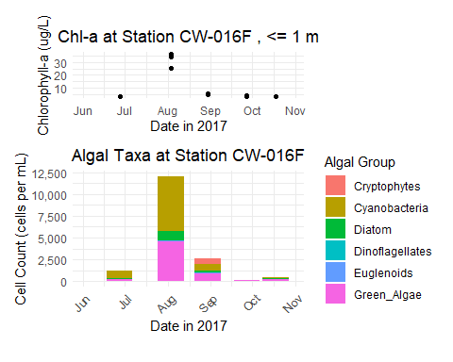

Figure X: CW-016F (Fishing Creek Res.) Chlorophyll-a and Algae Count

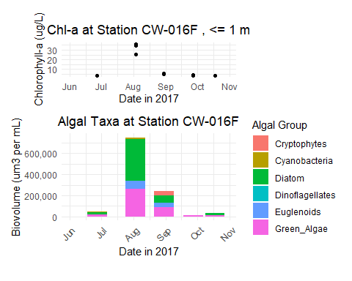

Figure X: CW-016F (Fishing Creek Res.) Chlorophyll-a and Algae Biovolume

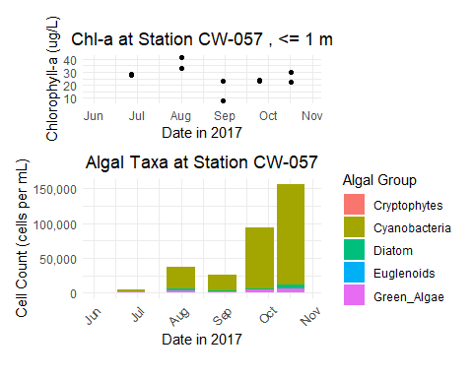

Figure X: CW-057 (Fishing Creek Res.) Chlorophyll-a and Algae Count

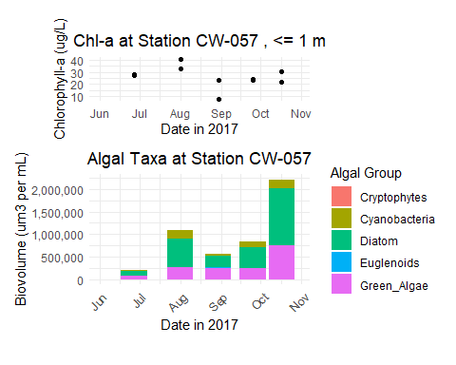

Figure X: CW-057 (Fishing Creek Res.) Chlorophyll-a and Algae Biovolume

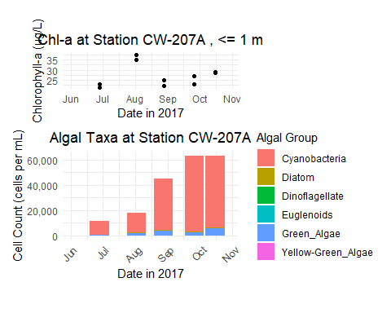

Figure X: CW-207A (Lake Wateree) Chlorophyll-a and Algae Count

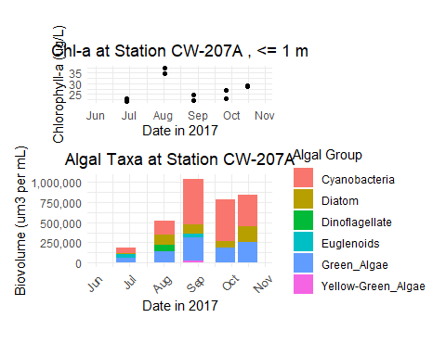

Figure X: CW-207A (Lake Wateree) Chlorophyll-a and Algae Biovolume

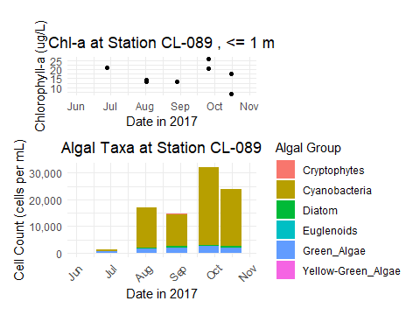

Figure X: CL-089 (Lake Wateree) Chlorophyll-a and Algae Count

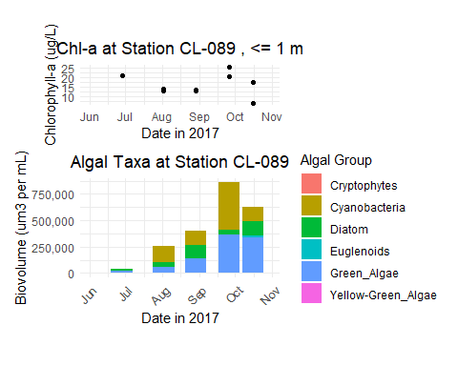

Figure X: CL-089 (Lake Wateree) Chlorophyll-a and Algae Biovolume

## Cyanobacteria Counts and WHO Risk Thresholds

These charts compare the 2017 cyanobacteria counts to WHO risk thresholds

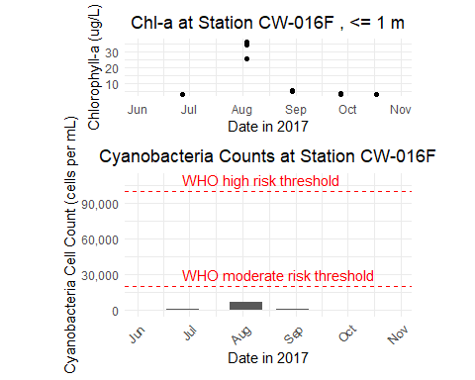

Figure X: Cyanobacteria counts at station CW-16F (Fishing Creek Reservoir).

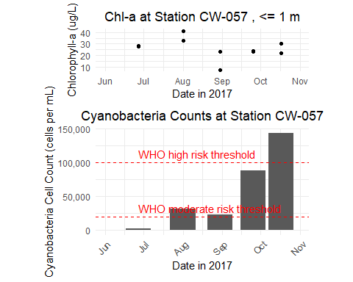

Figure X: Cyanobacteria counts at station CW-057 (Fishing Creek Reservoir).

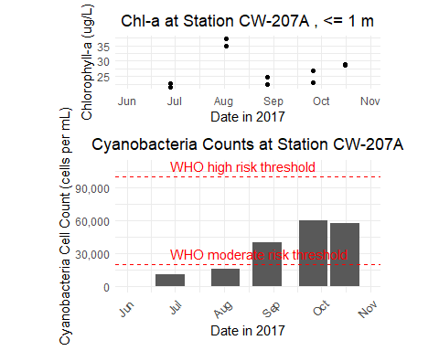

Figure X: Cyanobacteria counts at station CW-207A (Lake Wateree).

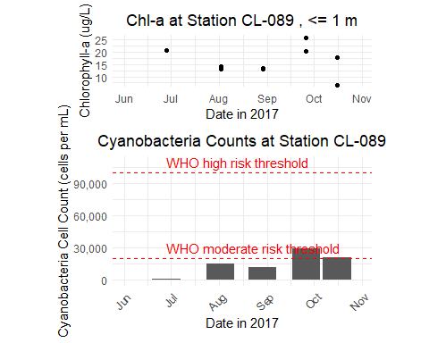

Figure X: Cyanobacteria counts at station CL-089 (Lake Wateree).

## Scatterplot of Cyanobacteria Counts vs. Chlorophyll-a

These plots are intended to explore the relation between cyanobacteria cell counts and chlorophyll-a.

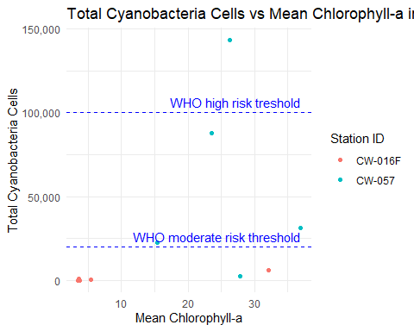

Figure X: Cyanobacteria count vs. chla, Fishing Creek Reservoir

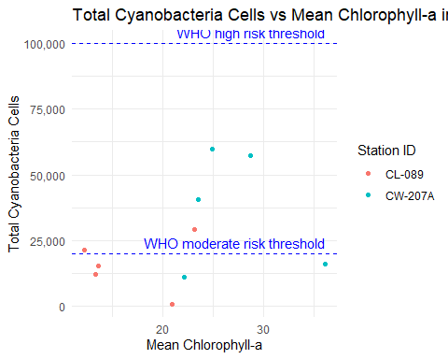

Figure X: Cyanobacteria count vs. chla, Lake Wateree

# Percent Cynaobacteria Biovolume vs Chlorophyll-a

These plots are intended to explore the relation between percent cyanobacteria biovolume and chlorophyll-a.

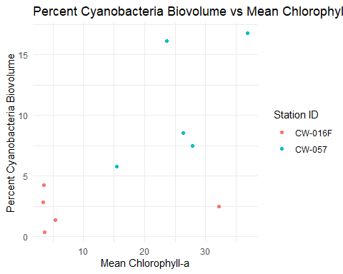

Figure X: Cyanobacteria biovolume vs. chla, Fishing Creek Reservoir

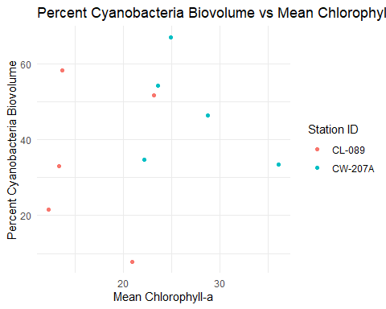

Figure X: Cyanobacteria biovolume vs. chla, Lake Wateree